Bubble Aeration - Design Mode
The following problem will be used to show sample calculations for bubble aeration in design mode. In addition, a sample program run of ASAP™ will be used to verify that the program is correctly duplicating the results of the sample calculations.

Problem Statement
The city of Anytown, USA recently discovered that one of its wells was contaminated with the compounds listed in Table 1. In order for them to continue using the well, they were required to remove these compounds below their MCLs, also shown in Table 1. During normal pumping operations, the well produces about 2000 gpm, the water temperature is 10°C, and the barometric pressure is 1 atm. The air flow rate through each tank is 1.388 m³/s.
Design a bubble aeration system with trichloroethylene as the basis for design consisting of three tanks in series. Obtain physical and chemical properties for the design from StEPP™. Use oxygen as the reference compound in finding mass transfer coefficient. Estimate the oxygen mass transfer coefficient from clean water oxygen transfer test data: SOTR = 1469.6 kg O₂/d, volumetric air flow rate = 1699 m³/h, tank volume = 485.6 m³ (note that this is for the oxygen transfer test conditions, not the current design). Assume a water depth of 4 m.
Calculate the effluent concentrations of trichloroethylene (both liquid and gas phase) from each tank. Estimate the blower brake power requirements (assume a blower efficiency of 35%).
Table 1 - Contaminant Influent Concentrations and Treatment Objectives (MCLs)
Compound | Concentration Discharged, C₀ | MCL, C_{TO}
 | (μg/L) | (μg/L)
Trichloroethylene | 200.0 | 5.0
Tetrachloroethylene | 150.0 | 5.0
Vinyl Chloride | 60.0 | 1.0
Ethylbenzene | 30.0 | 5.0
Toluene | 80.0 | 5.0
1,1-Dichloroethene | 85.0 | 7.0

Properties Needed to Perform Sample Calculations and Program Run
Table 2 shows the chemical properties retrieved from StEPP™ required for bubble aeration at 10°C and 1 atm.
Table 2 - Chemical Properties from StEPP™ at 10° C and 1 atm
Compound | MW | H | V_{b} | T_{NBP} | D_{l} | D_{g}
 | (kg/kmol) | (-) | (m³/kmol) | (°C) | (m²/s) | (m²/s)
Trichloroethylene | 131.39 | 0.230 | 0.1020 | 87.0 | 6.44E-10 | 7.89E-06
Tetrachloroethylene | 165.84 | 0.361 | 0.1190 | 121.0 | 5.86E-10 | 7.13 E-06
Vinyl Chloride | 62.50 | 0.546 | 0.0665 | -13.9 | 8.26 E-10 | 1.08E-05
Ethylbenzene | 106.17 | 0.170 | 0.1400 | 136.0 | 5.33 E-10 | 6.88 E-06
Toluene | 92.15 | 0.167 | 0.1190 | 111.0 | 5.86 E-10 | 7.57 E-06
1,1-Dichloroethene | 96.95 | 0.680 | 0.0840 | 31.6 | 7.20 E-10 | 9.05 E-06
Table 3 shows the properties used in the calculation of oxygen mass transfer coefficient in bubble aeration.
Table 3 - Properties for Calculation of Oxygen Mass Transfer Coefficient from StEPP™ and ASAP™ at 10° C and 1 atm
Property | Units | Value
Tabulated Value of Dissolved Oxygen Surface Saturation Concentration at 20°C, 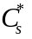 | mg/L | 9.09
Molecular Weight, 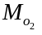 | amu | 32.0
Henry’s Constant, 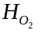 | mg/L*atm | 50
Weight Density of Water, 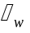 | lb/ft³ | 62.4
Vapor Pressure of Water at 20°C, | kPa | 2.34
Molecular Weight of Air,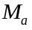 | amu | 28.95
Density of Air at 20°C, 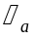 | mg/L | 1240
Barometric Pressure at Standard Conditions, | atm | 1.0
Parameter Used for Temperature Correlation, | (-) | 1.024
Water Depth, | m | 4
Fitting Parameter, | (-) | 3.15
Fitting Parameter, | (-) | -831.0

Table 4 shows the physical properties of water used in this bubble aeration design.
Table 4 - Properties of Water
Property | Units | Value
Water Density, ρ_{l} | kg/m³ | 999.75
Water Viscosity, μ_{l} | kg/m/s | 0.00131

Note Regarding Comparison of Sample Calculation Values to Sample Program Run
In certain cases, the numbers that appear in the sample calculations are slightly different from the values displayed in the sample program run. These variations can be attributed to rounding.

Sample Design Mode Calculation of Tank Volume for Trichloroethylene as the Design Compound Including Supplementary Parameter Calculations

Total Volume
The total volume of the system, 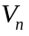, is calculated using the volume of each tank in the series found in Eq. 2. This relationship is shown in Eq. 1:
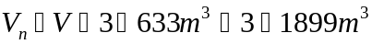
Eq. 1
The parameters required to calculate in Eq. 1 can be found as follows:
Parameter Location
Eq. 2
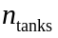 Given in problem statement

Tank Volume
The calculation of the volume of each tank, , in the series for the case described above at an air flow rate of 1.388 m³/s is shown in Eq. 2.
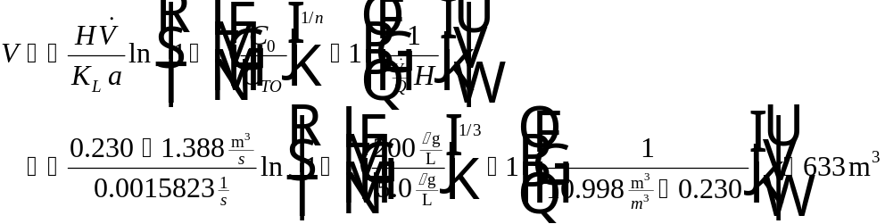
Eq. 2
The parameters required to calculate in Eq. 2 can be found as follows:
Parameter Location
Table 2
User-specified
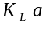 Eq. 4
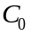 Table 1
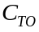 Table 1
Given in problem statement
Eq. 3

Air to Water Ratio
Calculation of required in Eq. 2 is given in Eq. 3:
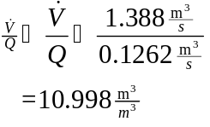
Eq. 3
The parameters required to calculate in Eq. 3 can be found as follows:
Parameter Location
User-specified
Given in the problem statement

Mass Transfer Coefficient
In order to determine overall mass transfer coefficient of a compound for bubble aeration, , it is necessary to relate the mass transfer coefficient of a given compound, 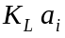, to the mass transfer coefficient of a reference compound, 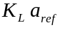 as shown in Eq. 4. For the purposes of this design, oxygen will be used as the reference compound.
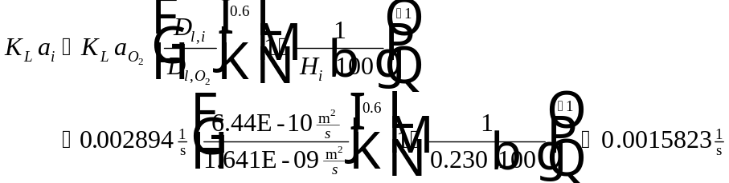
Eq. 4
The parameters required to calculate in Eq. 4 can be found as follows:
Parameter Location
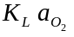 Eq. 5
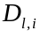 Table 2
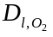 Eq. 11
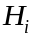 Table 2
Mass Transfer Coefficient of Oxygen
The true mass transfer coefficient of oxygen, 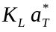, can be estimated using Eq. 5.
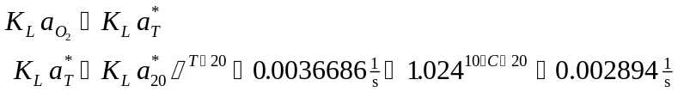
Eq. 5
The parameters required to calculate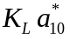 in Eq. 5 can be found as follows:
Parameter Location
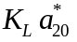 Eq. 6
Table 3
Given in problem statement
Mass Transfer Coefficient of Oxygen at 20°C
The true mass transfer coefficient of oxygen, , can be calculated at 20°C, , by the following relationship:
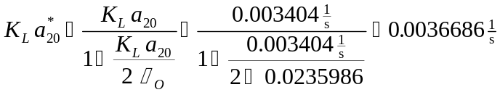
Eq. 6
The parameters required to calculate in Eq. 6 can be found as follows:
Parameter Location
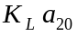 Eq. 9
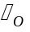 Eq. 7
Oxygenation Coefficient
The oxygenation coefficient, , required in Eq. 6 is found with Eq. 7.
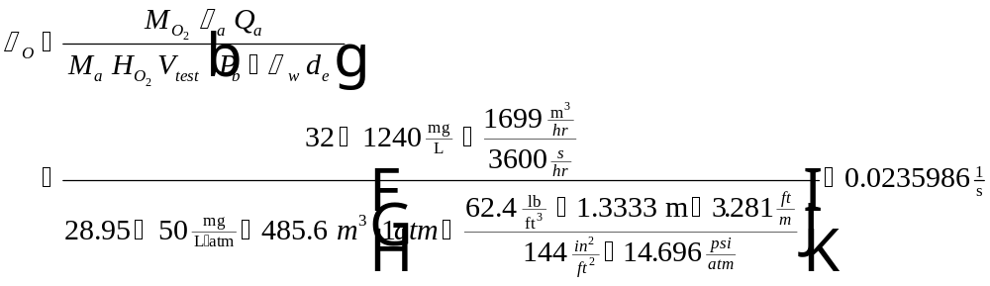
Eq. 7
The parameters required to calculate in Eq. 7 can be found as follows:
Parameter Location
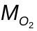 Table 3
Table 3
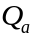 Given in problem statement from clean water oxygen transfer test data
Table 3
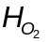 Table 3
Given in problem statement
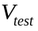 Given in problem statement from clean water oxygen transfer test data
Table 3
Eq. 8
Effective Saturation Depth
Effective saturation depth, , at water depth of 4 m is found using Eq. 8:
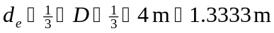
Eq. 8
The parameters required to calculate in Eq. 8 can be found as follows:
Parameter Location
User-specified
Observed Mass Transfer Coefficient for Oxygen at 20°C
The observed mass transfer coefficient for oxygen at 20°C, , can be calculated for a volume of 485.6 m³ by the following equation:
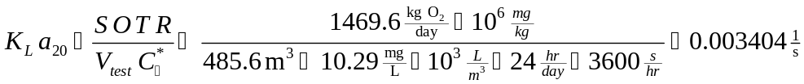
Eq. 9
The parameters required to calculate in Eq. 9 can be found as follows:
Parameter Location
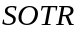 Given in problem statement from clean water oxygen transfer test data
Given in problem statement from clean water oxygen transfer test data
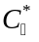 Eq. 10
Dissolved O₂ Saturation Concentration Attained at Infinite Time
The dissolved oxygen saturation concentration attained at infinite time, , can be calculated by the following relationship:
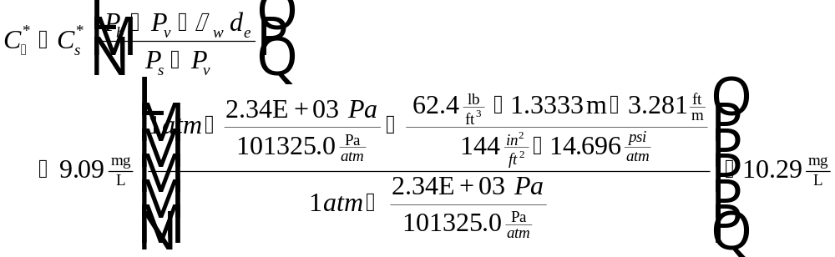
Eq. 10
The parameters required to calculate in Eq. 10 can be found as follows:
Parameter Location
Table 3
Given in problem statement
Table 3
Table 3
Eq. 8
Table 3
Liquid Diffusivity of Oxygen
The liquid diffusivity of oxygen, 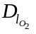, is calculated in the following equation:
Eq. 11
To calculate in Eq. 11, the following parameters are required:
Parameter Location
Table 3
Table 3
Given in problem statement

Hydraulic Retention Time
The hydraulic retention time of one tank, , in the series is calculated as follows:
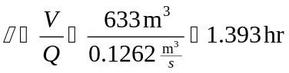
Eq. 12
To calculate in Eq. 12, the following parameters are needed:
Parameter Location
Eq. 2
Given in problem statement

Total Hydraulic Retention Time
The total hydraulic retention time of the system, 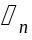, is estimated using the following equation:
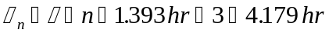
Eq. 13
To find in Eq. 13, the following parameters are required:
Parameter Location
Eq. 12
Given in problem statement

Liquid Phase Effluent Concentration from Tank Number i
The calculation of liquid phase effluent concentration from tank number i, 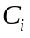, of a bubble aeration system with tanks in series is shown in Eq. 14.
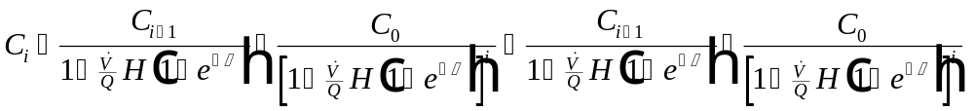
Eq. 14
The parameters required to calculate in Eq. 14 can be found as follows:
Parameter Location
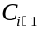 Calculated value
Eq. 3
Table 2
Eq. 15
Table 1
User-specified

Stanton Number,
Stanton number, is calculated with the following relationship:
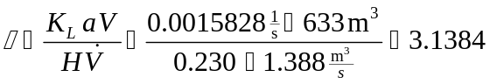
Eq. 15
The parameters required to calculate in Eq. 15 can be found as follows:
Parameter Location
Eq. 4
Eq. 2
Table 2
User-specified

Liquid Phase Effluent Concentration from Tank Number 1
Calculation of 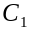 from Eq. 14 is given in Eq. 16:
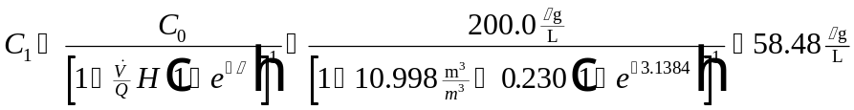
Eq. 16
The parameters required to determine in Eq. 16 can be found as follows:
Parameter Location
Eq. 3
Table 2
Eq. 15
Table 1

Liquid Phase Effluent Concentration from Tank Number 2
Calculation of the liquid phase effluent concentration from tank number 2 in the series of tanks forming the bubble aeration system, 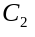 from Eq. 14 is given in Eq.17:
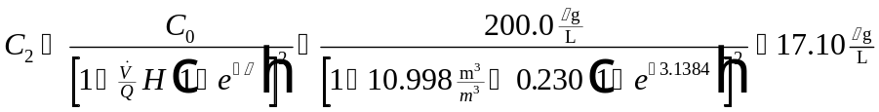
Eq. 17
The parameters required to obtain in Eq. 17 can be found as follows:
Parameter Location
Eq. 3
Table 2
Eq. 15
Table 1

Liquid Phase Effluent Concentration from Tank Number 3
The liquid phase effluent concentration from tank number 3 in the series, 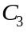 is calculated in Eq. 18:
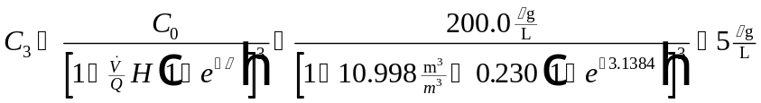
Eq. 18
The parameters required to determine in Eq. 18 can be found as follows:
Parameter Location
Eq. 3
Table 2
Eq. 15
Table 1

Gas Phase Effluent Concentration from Tank Number i
The gas phase effluent concentration, , corresponding to the liquid phase effluent concentrations for each tank calculated above can be found using Eq. 19:
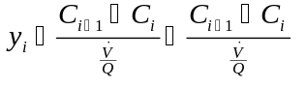
Eq. 19
The parameters required to find in Eq. 19 can be found as follows:
Parameter Location
Eq. 14
Eq. 14
Eq. 3

Gas Phase Effluent Concentration from Tank Number 1
Gas phase effluent concentration from tank number 1, , is found using Eq. 20:
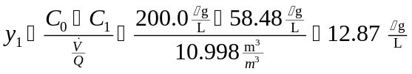
Eq. 20
The parameters required to find in Eq. 20 can be found as follows:
Parameter Location
Table 1
Eq. 16
Eq. 3

Gas Phase Effluent Concentration from Tank Number 2
The gas phase effluent concentration tank number 2, , is calculated using Eq. 21:
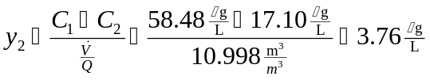
Eq. 21
The parameters required to find in Eq. 21 can be found as follows:
Parameter Location
Eq. 16
Eq. 17
Eq. 3

Gas Phase Effluent Concentration from Tank Number 3
The gas phase effluent concentration tank number 3, , is calculated using Eq. 22:
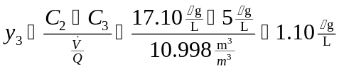
Eq. 22
The parameters required to find in Eq. 22 can be found as follows:
Parameter Location
Eq. 17
Eq. 18
Eq. 3

Blower Brake Power
The blower brake power in bubble aeration, 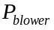, is determined from the following equation. Note that this is the blower brake power per tank. The total power requirement would simply be obtained by multiplying times the number of tanks, times the number of blowers per tank.
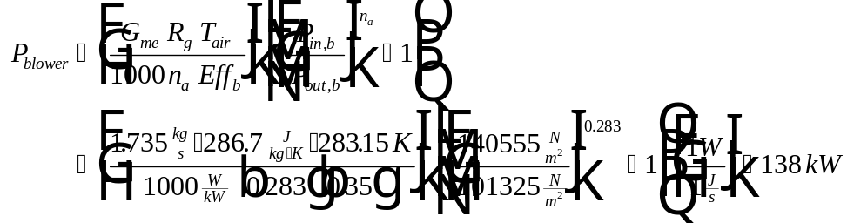
Eq. 23
The parameters required to determine in Eq. 22 can be found as follows:
Parameter Location
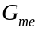 Eq. 24
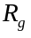 Universal gas constant
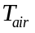 Typically assumed equal to water temperature
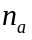 Constant (see nomenclature)
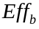 Given in problem statement
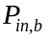 Eq. 26
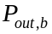 Assumed equal to 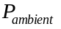

Air Mass Flow Rate
The air mass flow rate, , is calculated below:
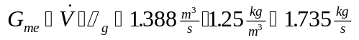
Eq. 24
The parameters required to calculate in Eq. 24 can be found as follows:
Parameter Location
Given in problem statement
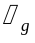 Eq. 25

Air Density
The air density, , is determined from the ideal gas law:
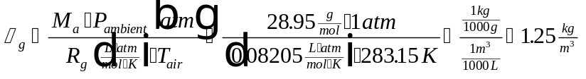
Eq. 25
The parameters required to calculate in Eq. 25 can be found as follows:
Parameter Location
Known
Given
Universal Gas Constant
Assumed equal to T

Inlet Air Pressure to Bubble Aeration Tank
The term refers to the pressure at the top of the tank, which represents the sum of the ambient pressure and the head required to raise the water to the inlet of the tank. The equation used to find is:
Eq. 26
The parameters required to calculate 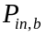 in Eq. 26 can be found as follows:
Parameter Location
Given
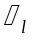 Table 4
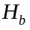 Assumed equal to water depth
Gravitational acceleration

Sample Program Run of ASAP™ to Verify Sample Calculations for Bubble Aeration in Design Mode
To start the ASAP™ program, double click on the ASAP™ icon in the ETDOT Programs group in windows. The screen shown in Figure 1 will appear.
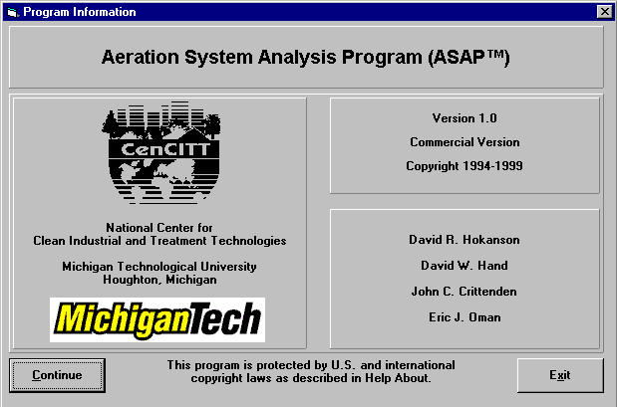
Figure 1 - ASAP™ Title Window
Click on the Continue button on the screen shown in Figure 1 and the menu shown in Figure 2 will appear.
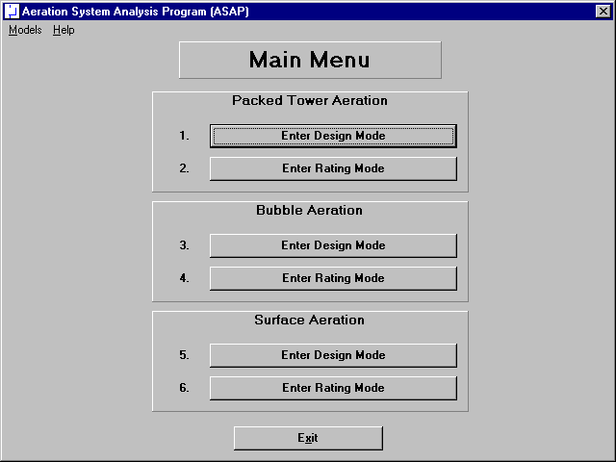
Figure 2 - Main Menu Window in ASAP™
Click on the Enter Design Mode button for Bubble Aeration (option 3 in Figure 2) and the design mode screen for bubble aeration shown in Figure 3 will appear.

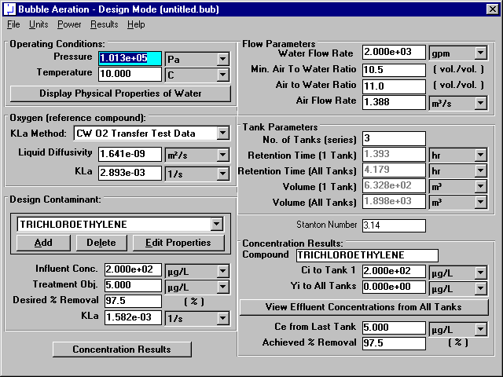
Figure 3 - Design Mode Window for Bubble Aeration

Physical Properties of Water
Specify pressure and temperature in the upper left-hand corner of the window shown in Figure 3. This portion of the bubble aeration design mode window is shown in Figure 4.
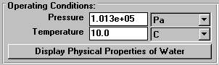
Figure 4 - Operating Conditions Portion of Design Mode Window
Click on the Display Physical Properties of Water button in Figure 3 (and highlighted in Figure 4) to show the properties of water at the specified temperature and pressure (101325 Pa and 10°C). Figure 5 shows the water properties window for this case.
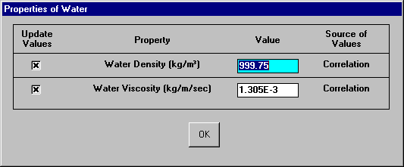
Figure 5 - Water Properties Window
The properties shown in Figure 5 are by default calculated from correlations so the user should not have to change his values. In the rare case that the user would like to enter a value for any of these properties instead of using the correlations, it is possible to do so on the window shown in Figure 5. Click on the OK button shown in Figure 5 to close the window.
It can be seen that the water properties shown in Figure 5 agree with the properties shown in Table 4.

Properties of Oxygen (reference compound)
The mass transfer coefficient for the design contaminant is calculated using its relationship to the mass transfer coefficient of oxygen under similar conditions. The mass transfer coefficient of oxygen is estimated using clean water oxygen transfer test data. This portion of the design mode window is shown in Figure 6.
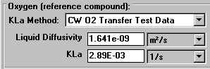
Figure 6 - Oxygen Section of Design Mode Window
Oxygen mass transfer coefficient at 10°C is determined as 2.89E-03 1/s. This agrees with the value from the sample calculations (see Eq. 5). To view additional information about calculation of oxygen mass transfer coefficient by this method, click on the  button to display a choice between CW O2 Transfer Test Data and User Input. Click on CW O2 Transfer Test Data button to obtain the window shown in Figure 7.
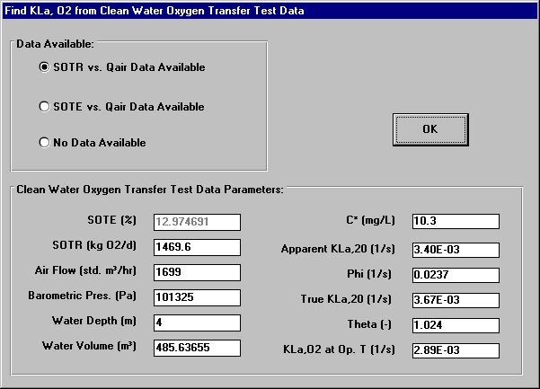
Figure 7 - Mass Transfer Coefficient of O₂ from Clean Water Oxygen
Transfer Test Data
The values shown in Figure 7 agree with values shown in sample calculations. Dissolved oxygen saturation concentration attained at infinite time was determined as 10.3, which agrees with sample calculations (see Eq. 10). Apparent K_{L}a at 20°C was calculated as 3.40E-03 1/s by the program and the sample calculations (see Eq. 9). The program found the oxygenation coefficient to be 0.0236 1/s as the sample calculations show (see Eq. 7). True K_{L}a at 20°C was determined to be 3.67E-03 1/s as calculated by the program and shown by the sample calculations (see Eq. 6). True K_{L}a at operating temperature is 2.89E-03 which agrees with the sample calculations (see Eq. 5).
Additional parameters shown in Figure 7 were either specified in the problem statement or chosen for the purposes of this design.

Chemical Properties
Chemical properties for each of the six components can be retrieved from StEPP™. When the screen shown in Figure 3 loads, the properties of the six contaminants load as a default design case. Before retrieving the chemical properties of the six chemicals required in the current design, it is necessary to delete the six default chemicals shown in the Design Contaminant list box on the bottom of the left-hand column shown in Figure 3. This portion of the design mode window is highlighted in Figure 8.
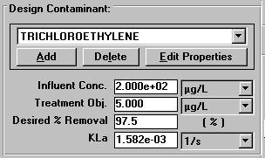
Figure 8 - Contaminant Selection Portion of Design Mode Window
It can be seen that the value for mass transfer coefficient of trichloroethylene calculated by the program as 1.58E-03 1/s agrees with sample calculations (see Eq. 4).
To delete each chemical click on the Delete button located between the Add and Edit Properties buttons shown in Figure 3 (and highlighted in Figure 8). Click the Delete button once for each chemical until all chemicals have been deleted.

Transferring Properties from StEPP™ to ASAP™
ASAP™ has the capability of transferring the physical properties of contaminants from Software to Estimate Physical Properties (StEPP™). There are two choices available in the Options menu within StEPP for transferring data from StEPP into ASAP: (a) Create Export File for AdDesignS/ASAP and (b) Copy to Clipboard for AdDesignS/ASAP. The StEPP™ main window highlighting the Options menu is shown in Figure 9 (refer to StEPP manual for more information on selecting compounds within StEPP).
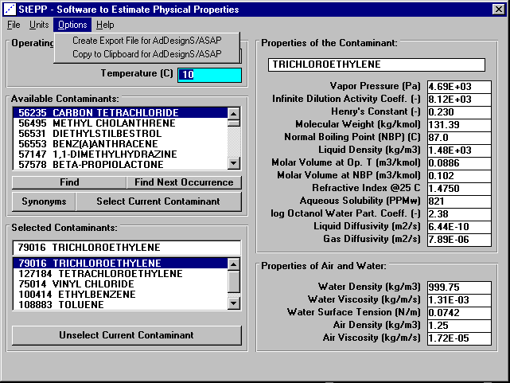
Figure 9 - StEPP™ Main Window for This Design

Transferring Chemical Properties from StEPP™ to ASAP™ Using the Create Export File for AdDesignS/ASAP Option
To create an export file within StEPP™ for use in ASAP™, click on the Create Export File for AdDesignS™/ASAP™ in the StEPP™ Options menu. This option is shown in Figure 9. After clicking this option, the Save StEPP™ Export File window shown in Figure 10 appears. Give the export file a .exp extension (the default), such as bub10.exp, and the file will be readily importable into ASAP™, as described below.
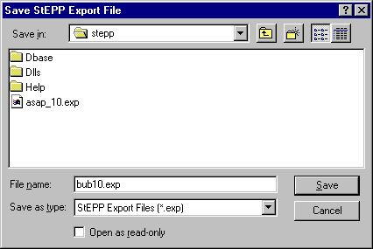
Figure 10 - Save StEPP™ Export File Window
To import the StEPP™ export file described above (bub10.exp), click on the Add button shown on the bottom left-hand corner of the window shown in Figure 3 (and highlighted in Figure 8). Figure 11 shows the window that will appear.
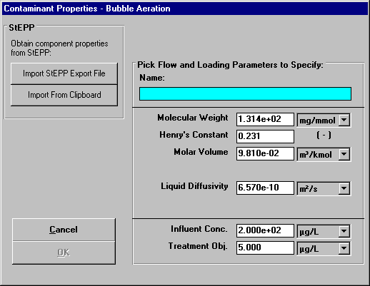
Figure 11 - Contaminant Properties Input Window
Click on the Import StEPP™ Export File button shown in Figure 11. The window shown in Figure 12 will appear.
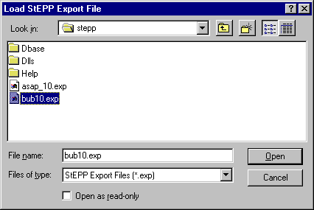
Figure 12 - Load StEPP™ Export File Window
Select the file bub10.exp that was created earlier and the chemicals selected in StEPP™ for the given design will be imported into ASAP™. Figure 13 appears after the import and shows a successful import was achieved.
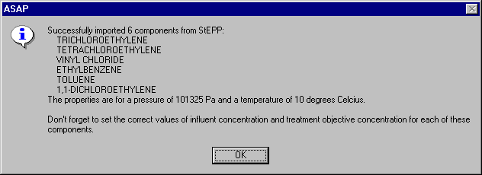
Figure 13 - Successful StEPP™ Property Retrieval Indication Window

Transferring Chemical Properties from StEPP™ to ASAP™ Using the Copy to Clipboard for AdDesignS/ASAP Option
To copy selected StEPP™ data to the Windows clipboard for export into ASAP, select Copy to Clipboard for AdDesignS/ASAP from the Options menu within StEPP. The message box shown in Figure 14 will appear, verifying that all of the StEPP data is now stored in the Windows clipboard.
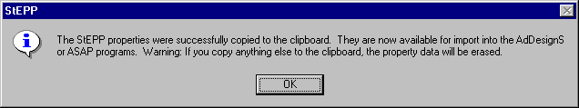
Figure 14 – Successful Copy to Clipboard from StEPP™ Message Box
To import the chemicals and their physical properties to ASAP™ from the data on the clipboard, click on the Add button in the Component Properties block of the ASAP™ main window. The Component Properties window shown in Figure 15 will appear.
Figure 15 - Component Properties window (adding new components)
To import the StEPP™ data from the Windows clipboard, click the Import from Clipboard button on the Component Properties window. The window shown in Figure 16 will appear, showing that the properties have been successfully transferred into ASAP.
Figure 16 – Successful Import from StEPP™ Window

Manipulation of Data Required after Transferring Properties from StEPP™ to ASAP™
Click on the OK button to continue. Figure 3 appears. As shown in Figure 13 or Figure 16, it is necessary to input influent concentrations and treatment objectives for each of the six components retrieved. To do so, select each contaminant one at a time in the Design Contaminant list box shown in the lower left-hand corner of Figure 3. Then click on the Edit Properties button. Figure 17 shows the window that appears for trichloroethylene.
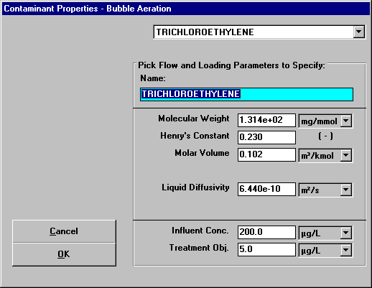
Figure 17 - Specify Contaminant Properties Window for Trichloroethylene
The properties molecular weight, Henry’s constant, molar volume, and liquid diffusivity are already correct since they were retrieved from StEPP™. The influent concentration and treatment objective shown at the bottom of the screen must be input since they will vary from case to case. These properties shown in Figure 17 already reflect the values for the current design case. It is seen that the properties shown in Figure 17 agree with the trichloroethylene properties shown in Tables 1 and 2.
Figure 18 shows the Specify Contaminant Properties window for tetrachloroethylene. It can be seen that the properties shown in Figure 18 agree with the properties of tetrachloroethylene shown in Tables 1 and 2.
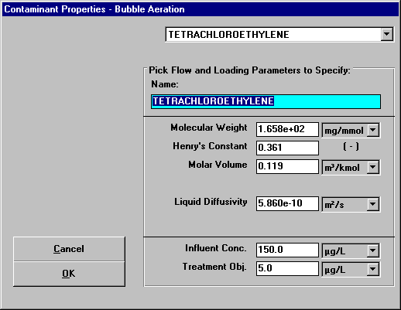
Figure 18 - Specify Contaminant Properties Window for Tetrachloroethylene
Figure 19 shows the Specify Contaminant Properties window for vinyl chloride. It can be seen that the properties shown in Figure 19 agree with the properties of vinyl chloride shown in Tables 1 and 2.
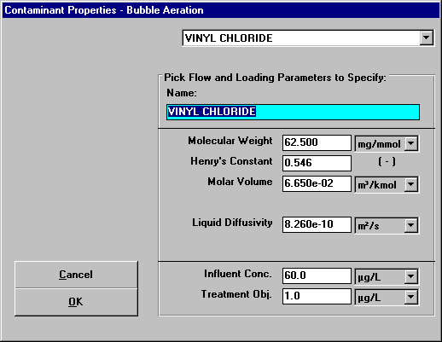
Figure 19 - Specify Contaminant Properties Window for Vinyl Chloride
Figure 20 shows the Specify Contaminant Properties window for ethylbenzene. It can be seen that the properties shown in Figure 20 agree with the properties of ethylbenzene shown in Tables 1 and 2.
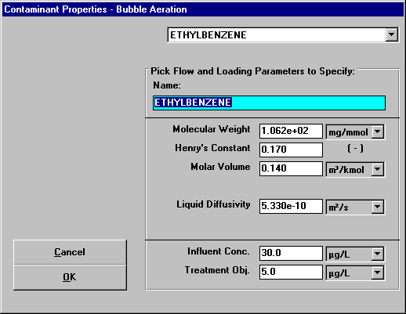
Figure 20 - Specify Contaminant Properties Window for Ethylbenzene
Figure 21 shows the Specify Contaminant Properties window for toluene. It can be seen that the properties shown in Figure 21 agree with the properties of toluene shown in Tables 1 and 2.
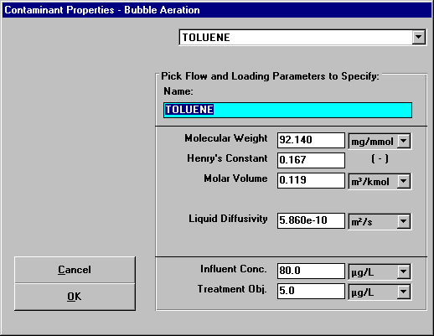
Figure 21 - Specify Contaminant Properties Window for Toluene
Figure 22 shows the Specify Contaminant Properties window for 1,1-dichloroethene. It can be seen that the properties shown in Figure 22 agree with the properties of 1,1-dichloroethene shown in Tables 1 and 2.
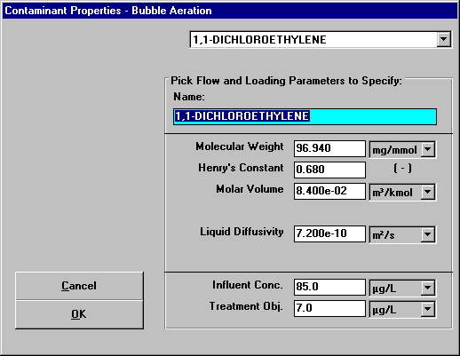
Figure 22 - Specify Contaminant Properties Window for 1,1-Dichloroethene

Flow Parameters
Flow parameters are shown in the upper right-hand column of Figure 3. This portion of Figure 3 is reproduced here as Figure 23.
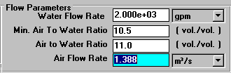
Figure 23 - Flow Parameters of Design Mode Window
Explanation of the origin of the values for the properties shown in Figure 23 is provided here. The water flow rate of 2000 gpm is given in the problem statement. The minimum air to water ratio of 10.5 was calculated by the program. An air to water ratio of 11 was chosen to satisfy this minimum. This value agrees with the value calculated in the sample calculations for this design case (see Eq. 3 in the sample calculations section). An air flow rate of 1.39 m³/s was chosen for design purposes (see Eq. 2).

Tank Parameters
The tank parameters are shown in the middle of the right-hand column of the design mode window shown in Figure 3, as shown in Figure 24.
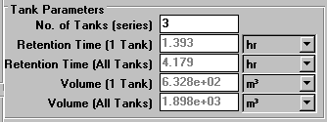
Figure 24 - Tank Parameters Section of Design Mode Window
The values of the tank parameters shown in Figure 3 (and highlighted in Figure 24) agree with the sample calculations section. The number of tanks in the series is given in the problem statement. The retention time of 1.393 hr calculated by the program agrees with the sample calculations performed previously (see Eq. 12). The total retention time for the system determined by the program to be 4.179 hr corresponds to the value calculated in the sample calculations (see Eq. 13). The volume of 6.333E+02 m³ calculated by the program agrees with the sample calculations performed previously (see Eq. 2). The volume of the entire system shown to be 1.899E+03 m³ reflects the sample calculations provided (see Eq. 1).

Stanton Number
The Stanton number used in the calculation of the liquid phase effluent concentrations is located beneath the tank parameters in the middle of the right-hand column as shown in Figure 3 (and highlighted in Figure 25).
Figure 25 - Stanton Number Section of Design Mode Window
The Stanton number calculated by the program is 3.14 and can be seen in the sample calculations (see Eq. 15).

Concentration Results
The effluent concentrations of both the liquid phase and the gas phase of the contaminant as well as the achieved percent removal are found in the lower right-hand corner of the design mode window as shown in Figure 3 (and highlighted in Figure 26).
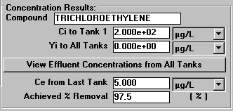
Figure 26 - Concentration Results Portion of Design Mode Window
Click on the View Effluent Concentrations from All Tanks button shown in Figure 3 (and highlighted in Figure 26) to see the effluent concentrations of both the liquid phase and the gas phase of the contaminant from each tank. The window that appears is shown in Figure 27.
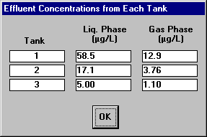
Figure 27 - Effluent Concentrations from Each Tank

It can be seen that the values calculated by the program for the liquid phase effluent concentrations; 58.5 μg/L from tank 1 (see Eq. 16), 17.1 μg/L from tank 2 (see Eq. 17), and 5.00 μg/L from tank 3 (see Eq. 18); and the gas phase concentrations; 12.9 μg/L from tank 1 (see Eq. 20), 3.76 μg/L from tank 2 (see Eq. 21), and 1.10 μg/L from tank 3 (see Eq. 22), match the values shown in the sample calculations.
Click the OK button shown in Figure 27 to return to the design mode window shown in Figure 3.

Power Parameters
The power calculations window can be opened by selecting Perform Power Calculations from the Power menu. The resultant window is shown in Figure 28:
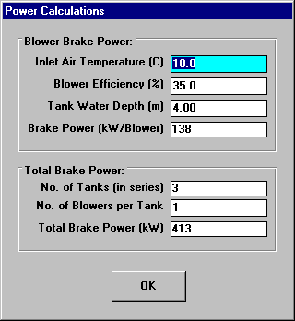
Figure 28 - Power Window

Viewing Effluent Concentration Results for Contaminants Other than the Design Contaminant
For a given design, it is useful to see what the effluent concentrations of contaminants other than the design contaminant would be. ASAP provides a convenient method for seeing these results without having to switch to rating mode. (of course, the user will have to switch to rating mode to investigate commercially available packed tower sizes).
By clicking on the Concentration Results button in the lower left-hand corner of the bubble aeration – design mode window shown in Figure 3, the user will see the concentration results for all contaminants using the given design.
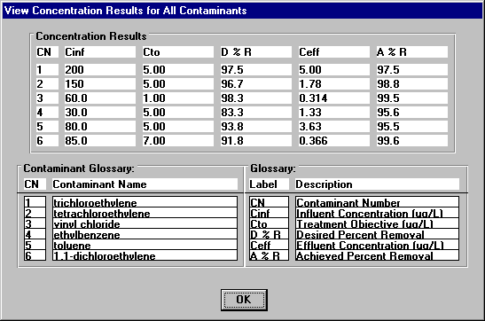
Figure 29 – View Concentration Results for All Contaminants Window
This window provides a quick method to see whether the given design will meet the treatment objectives for all contaminants.

Switching to Rating Mode
Once the bubble aeration system has been specified in design mode, the user can take the established properties and switch to rating mode in order to examine the effect of modifications of various properties. The procedure for switching to rating mode is described here.
Figure 30 shows the File menu for bubble aeration, design mode.
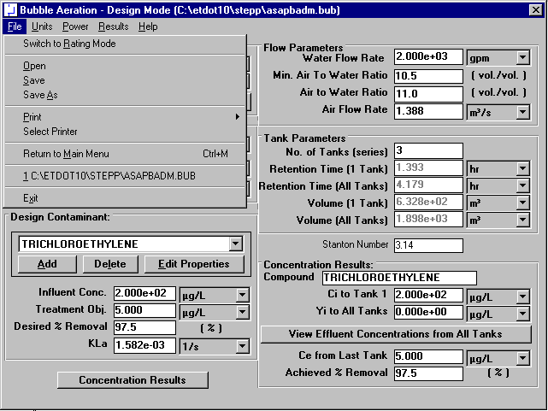
Figure 30 – File Menu for Bubble Aeration – Design Mode
Click on the menu option called Switch to Rating Mode in Figure 30. The bubble aeration – rating mode window will appear, as shown in Figure 31.
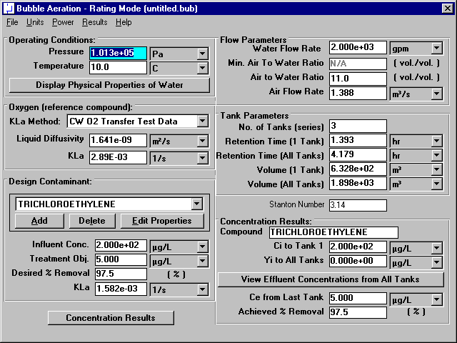
Figure 31 - – Bubble Aeration – Rating Mode Window
Use of Bubble Aeration – Rating Mode will be described in the next section.

