Estimation of the Cross-Sectional Area of a Packed Tower (Design Mode)

Development
In design mode, the cross-sectional area of a packed tower is estimated based on the generalized pressure drop curves developed by Eckert (1961), which are shown in Treybal (1980) and reprinted by permission in Hand, et al (1986). Once the packing factor for the media, the air to water ratio, and the gas pressure drop per packing height have been specified, it is possible to determine the gas loading rate and the tower diameter from the Eckert curves. The Eckert pressure drop curves were fit by Cummins and Westrick (1983) in order to develop correlations capable of predicting gas loading rate and tower area. The correlations developed by Cummins and Westrick are shown below:
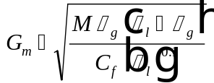
Eq. 1
The empirical parameter is defined by the following relationship:
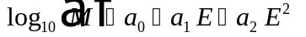
Eq. 2
The parameter is defined as follows:
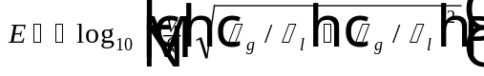
Eq. 3
The parameters 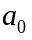, , and 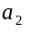 are given in the following relationships:
Eq. 4
Eq. 5
Eq. 6
The parameter that appears in Eq. 4 - Eq. 6 is defined as:
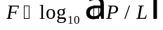
Eq. 7
Validity ranges for the equations presented above include:
Pressure Drop Gradient, 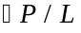 (N/m²/m) 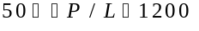
Empirical Parameter, 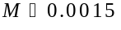
Parameter, 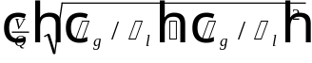 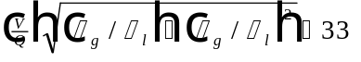
The correlations used to estimate gas loading rate presented in Eq. 1 - Eq. 6 were fit for a particular set of units. When applying this method, it must be assured that values are supplied in the appropriate set of units. A summary of the parameters required and proper units needed to apply the correlations of Cummins and Westrick is provided below (note that for calculated empirical parameters, units are not applicable):
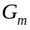 Gas mass loading rate (kg/m²/s)
Calculated empirical parameter
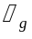 Air density (kg/m³)
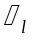 Water density (kg/m³)
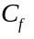 Packing factor (dimensionless)
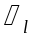 Liquid viscosity (kg/m/s)
Calculated empirical parameter
Calculated empirical parameter
Calculated empirical parameter
Calculated empirical parameter
Air to water ratio on a volumetric basis (m³/m³)
Calculated empirical parameter
Pressure drop gradient (N/m²/m)
Once gas loading rate is known from Eq. 1, it is possible to determine the cross-sectional area of the tower. First, it is necessary to calculate liquid loading rate:
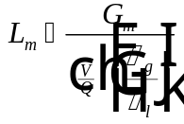
Eq. 8
Once liquid loading rate is known from Eq. 8, the cross-sectional area of the tower, , can be found from the relationship:
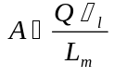
Eq. 9
Once tower area is known, it is a simple matter to calculate the diameter of the tower, :
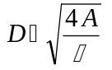
Eq. 10

Nomenclature
, , Calculated empirical parameters
Cross-sectional area of the tower (L²)
Packing factor (dimensionless)
Diameter of the tower (L²)
Calculated empirical parameter
Calculated empirical parameter
Gas mass loading rate (M/L²/T)
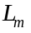 Liquid mass loading rate (M/L²/T)
Calculated empirical parameter
Pressure drop gradient (F/L²/L)
Water flow rate (L³/T)
Air to water ratio (L³/L³)
Greek Letters
Liquid viscosity (M/L/T)
Liquid density (M/L³)
Gas density (M/L³)

References
Cummins, M. D. and J. J. Westrick, Proc. ASCE Envir. Engrg. Conf., Boulder, Colorado (July 1983).
Eckert, J. S., “Design Techniques for Sizing Packed Towers,” Chem. Eng. Prog., 57, 9 (1961).
Hand, D. W., J. C. Crittenden, J. L. Gehin, and Benjamin W. Lykins, Jr., “Design and Evaluation of an Air-Stripping Tower for Removing VOCs from Groundwater,” Journal AWWA, 78, 9, 87-97 (1986).
Treybal, R. E., Mass Transfer Operations, Chem. Engrg. Series, McGraw-Hill Book Co., New York, 3rd Ed. (1980).

