

GroundWater Seepage Calculator

(GWSC)

Steady-State Single-Event Non-Redistribution & Transient Single-Event Non-Redistribution.

Web-Based Tool

Version .01

**User Manual**



IMPORTANT LINKS

<https://groundwatercalculator.epa.gov/>

<https://github.com/USEPA/GSC_SSSENR>

ORD QA TRACK #: G-LRPCD-0030041-MN-1-0

Software Name: GroundWater Seepage Calculator (GWSC)

Version Number: .01

Software Baseline Documentation

**Project Tracking #:** G-LRPCD-0030041

**Repository:** <https://github.com/USEPA/GSC_SSSENR>

**Software**

**Web Address:** [https://](https://github.com/USEPA/GSC_SSSENR)groundwatercalculator.epa.gov/

**ORIGINATED BY:** Daniel Young, Physical Scientist, U.S. EPA, NRMRL, LMMD, ECEB.

Jacob Specht, Computer Engineer, Global Quality Corporation

**Date:** 12/12/2018

**REVIEWED BY:** Bob Lien, Physical Scientist, U.S. EPA, NRMRL, LMMD, RTEB.

**Date:** 12/12/2018

Office of Research and Development

National Risk Management Research Laboratory

Land and Materials Management Division

Emerging Chemistry and Engineering Branch

U.S. Environmental Protection Agency

Cincinnati, OH 45268

GroundWater Seepage Calculator (GWSC)

Version alpha.01

Steady-State Single-Event Non-Redistribution & Transient Single-Event Non-Redistribution.

Web-Based Tool

Version alpha.01



<https://groundwatercalculator.epa.gov/>

<https://github.com/USEPA/GSC_SSSENR>

**User Manual**

**2018-12-12**

DISCLAIMER

This User Manual was prepared as an account of work sponsored by an agency of the United States Government. Neither the United States Government nor any agency thereof, nor any of their employees, nor any of their contractors, subcontractors or their employees, make any warranty, express or implied, or assumes any legal liability or responsibility for the accuracy, completeness, or any third party’s use or the results of such use of any information, apparatus, product or process disclosed, or represents that its use would not infringe privately owned rights. Reference herein to any specific commercial product, process, or service by trade name, trademark, manufacturer, or otherwise, does not necessarily constitute or imply its endorsement, recommendation, or favoring by the United States Government or any agency thereof or its contractors or subcontractors. The view and opinions of authors expressed herein do not necessarily state or reflect those of the United States Government or any agency thereof.

Approval Page

Written by:

_______________________________________ ________________________

Daniel Young Date

Principal Investigator/Author

LMMD, ECEB

_______________________________________ ________________________

Jacob Specht Date

Computer Engineer, Co-Author

Global Quality Corporation

Approved by:

_______________________________________ ________________________

Michael Gonzalez

Branch Chief

LMMD, ECEB Date

Reviewed by:

_______________________________________ ________________________

Jill Hoelle, LMMD QAM Date

National Risk Management Research Laboratory Office of Research and Development

U.S. Environmental Protection Agency

Cincinnati, OH 45268

Table of Contents

1.0 Introduction 6

1.1 Purpose 6

1.2 About the Tool 7

1.3 Servers 7

2.0 Dashboard 8

2.1 GroundWater Seepage Calculator (GWSC) Scenario 8

2.2 Export to pdf 11

2.3 Export to Excel 11

3.0 Measurements 12

3.1 Projects 12

3.2 Sediments 12

4.0 Parameters 13

4.1 xxx 13

4.2 xxx 13

5.0 Tags 14

5.1 xxx 14

5.2 xxx 14

6.0 User Documentation 15

6.1 User Manual 15

6.2 Release Notes 15

7.0 Help/Suggestions 16

7.1 Request Help 16

7.2 Suggestions 16

8.0 My Account 17

8.1 My Profile 17

8.2 Change Password 17

References 18

List of Figures

Figure 1: Designated input data space for the Bredehoeft worksheet 8

Figure 2: Example of an executed Bredehoeft worksheet 9

Figure 3: Designated input data space for the Schmidt worksheet 10

Figure 4: Example of an executed Schmidt worksheet 11

List of Tables

xxx

GroundWater Seepage Calculator (GWSC): Steady-State Single-Event Non-Redistribution and Transient Single-Event Non-Redistribution.

# 1.0 Introduction

This web application utilizes Steady-State Sediment and Transient Single-Event Non-Redistribution temperature profile to estimate groundwater seepage flux. Users are encouraged to familiarize with the theory beforehand. The only assumed parameters in the steady-state models are volumetric heat capacity of water (ρfcf) and thermal conductivity (k) of the saturated porous media. Solution of the analytical equations for steady-state conditions depends on input of values for the volumetric heat capacity of water and the thermal conductivity of sediment. The value of the volumetric heat capacity of water will vary between 4.19x106 and 4.12x106 J/m3-°C as a function of salinity from freshwater (salinity 0 ppt) to seawater (salinity 35 ppt) at 20°C. Sharqawy et al. (2010) provide a review of mathematical relationships that can be used to calculate values at other temperatures and salinity.

A description of the factors that influence sediment thermal conductivity has been summarized in Stonestrom and Constanz (2003). The grain size of sediment materials and the organic matter content are two important factors that influence the value of this parameter. Stonestrom and Constanz (2003) provided a review of measured or estimated values for a variety of porous materials and a commonly recommended default value for sediments is 1.84 J/m.s.°C. This value is representative of a sandy sediment with little or no organic matter. However, Duque et al (2016) have shown that use of this default value can lead to overestimation of calculated seepage flux by a factor of 30%, which can be significant in locations with seepage flux on the order of 1 cm/day or less.

The local surficial geology, sediment depositional environment, and the presence of vegetation or other sources of organic matter will influence characteristics of the sediment material. To provide an updated point of reference for selection of sediment thermal conductivity for a range of depositional systems for inland and coastal environments, a review was conducted of studies where sediment thermal conductivity was measured directly or specifically optimized during model calibration. These results are summarized in the table at left, which indicates that the common default value of 1.84 J/m.s. °C represents the high end of the distribution. The sediment origin, type and texture descriptors listed in the table can be used to select a value that seems appropriate for the investigated water body. Alternatively, measurements of thermal conductivity on sampled sediment cores can provide a more direct assessment of the value(s) to use for modeling.

## 1.1 Purpose

Ground Water Seepage Calculator (GWSC): Steady-State Single-Event Non-Redistribution and Transient Single-Event Non-Redistribution. This web application utilizes steady-state sediment temperature profile to estimate groundwater seepage flux as well as Transient Single-Event Non-Redistribution.

## 1.2 About the Tool

This application is based on the groundwater seepage calculator based on the analytical solutions from the following journal articles:

1. Bredehoeft, J.D. and Papadopulos, I.S., 1965. Rates of vertical groundwater movement estimated from the Earth's thermal profile. Water Resour. Res., 1(2): 325-328.
2. Schmidt, C., Conant Jr, B., Bayer-Raich, M. and Schirmer, M., 2007. Evaluation and field-scale application of an analytical method to quantify groundwater discharge using mapped streambed temperatures. Journal of Hydrology, 347(3–4): 292-307.

## 1.3 Servers

The GWSC web tool and stand-alone version has been developed primarily using Django web framework and PostgreSQL for database management. While we tested the site with Internet Explorer, Safari, Chrome, and Firefox, there are some sections of the site that may not look correct using Internet Explorer browsers. Firefox (https://www.mozilla.org/en-US/firefox/new/) is the recommended browser for use on the GEMM website.

The GWSC server is currently located on the following static IP addresses: <https://134.67.216.102/>

End section

# 2.0 Dashboard

## 2.1 GroundWater Seepage Calculator (GWSC) Scenario

### 2.1.1 Steady-State Models

#### 2.1.1.1 [Bredehoeft Model](http://localhost:59486/scenario/bredehoeft/)

Using the Bredehoeft worksheet. The example below in figure 1 demonstrates how to quantify groundwater discharge through a sandy stream bed when deciding to employ the steady-state temperature method. The Bredehoeft model (Bredehoeft and Papadopulos 1965){Bredehoeft, 1965 #17@@author-year;Bredehoeft, 1965 #17} requires steady-state sediment temperatures from three different depths, so figure 1 below demonstrates a snapshot temperature profile measurement at 15 cm, 45 cm, and 85 cm below the sediment-water interface. Based on his measurements, the user compiled the following input data for the Bredehoeft worksheet:

❶ TO, sediment temperature at the shallow depth = 19.87 (oC)

❷ TZ, sediment temperature at the middle depth = 17.53 (oC)

❸ TL, sediment temperature at the deeper depth = 16.21 (oC)

❹ Z, distance between the measurement points of TO and TZ = 0.30 (m)

❺ L, distance between the measurement points of TO and TL = 0.70 (m)

In addition, the user looked up the Parameter Metadata worksheet for the following estimated input parameter values he deemed appropriate for the particular site:

❻ k, thermal conductivity of saturated sandy sediment-water system = 1.56 (J m-1 s-1 C-1)

❼ ρfCf, heat capacity of water = 4.19x106 (J m-3 C-1)

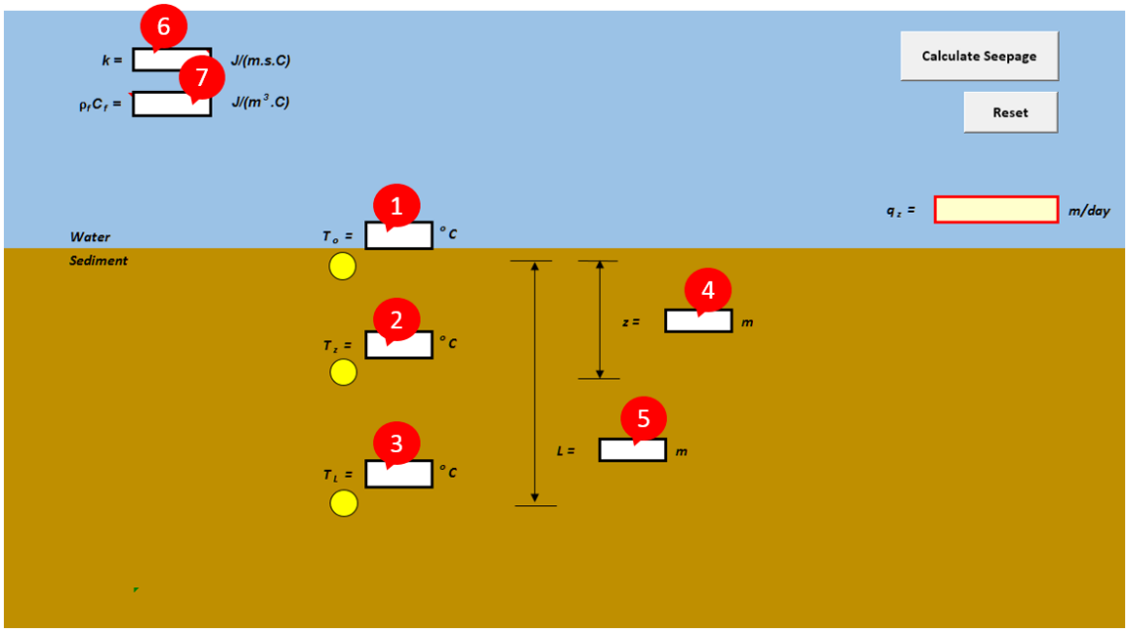

Figure 1: Designated input data space for the Bredehoeft worksheet

The user then entered each input value to its designated space in the Bredehoeft worksheet as shown in Error: Reference source not found, then clicked the Calculate Seepage button. Instantaneously, the seepage flux qZ was automatically calculated with an arrow indicator of the flow direction (Error: Reference source not found). The arrow indicator points upward when qZ is positive, points downward when qZ is negative. In situation of no flow, the arrow indicator will not appear.

User Tip: To start a new data set, simply overwrite the content(s) you want to replace or click the Reset button to start over blank.

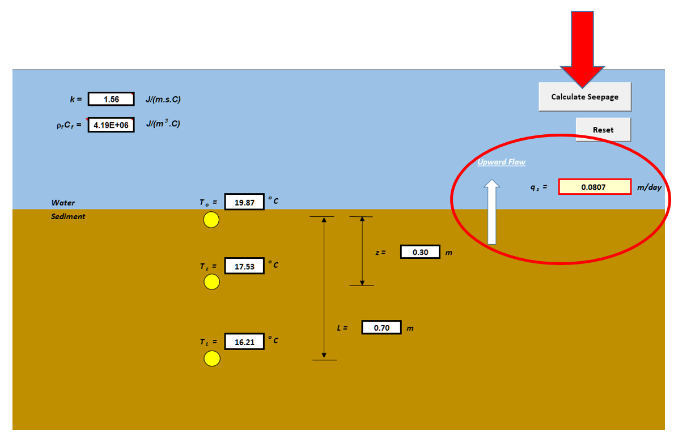

Figure 2: Example of an executed Bredehoeft worksheet

2.1.1.2 [Schmidt Model](http://localhost:59486/scenario/schmidt/)

Using the Schmidt worksheet. At the request of the Jedi Order, Luke Skywalker traveled to the swampy world of Dagobah in an expedition to quantify groundwater seepage through a silty lakebed as part of his Jedi training. Limited by his rookie skill, Luke was only able to yield the Force to obtain a snapshot sediment temperature at depth 15 cm and 60 cm. From Master Yoda, Luke had learned that the Schmidt model (Schmidt, Conant Jr et al. 2007) only requires steady-state sediment temperatures from two different depths if the regional constant groundwater temperature is also known. So based on his measurements in addition to the groundwater temperature data provided by R2-D2, Luke compiled the following input data set for the Schmidt worksheet:

❶ TO, sediment temperature at the shallow depth = 25.36 (oC)

❷ TZ, sediment temperature at the middle depth = 16.11 (oC)

❸ Tgw, constant groundwater temperature of the region = 12.98 (oC)

❹ Z, distance between the measurement points of TO and TZ = 0.45 (m)

In addition, Luke looked up the Parameter Metadata worksheet for the following estimated input parameter values applicable to the site:

❺ k, thermal conductivity of saturated silty sediment-water system = 0.70 (J m-1 s-1 C-1)

❻ ρfCf, heat capacity of water = 4.19x106 (J m-3 C-1)

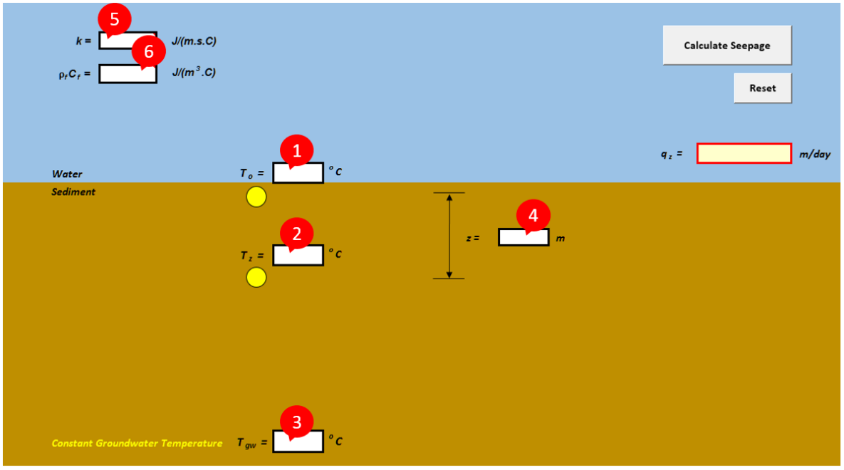

Figure 3: Designated input data space for the Schmidt worksheet

Luke typed in each input value to its designated space in the Schmidt worksheet as shown in Error: Reference source not found, then clicked the Calculate Seepage button. Instantaneously, the seepage flux qZ was automatically calculated with an arrow indicator of the flow direction (Error: Reference source not found). Note that the Schmidt model only yields positive qZ, hence the arrow indicator will always point to the upward direction. In situation of no flow, the arrow indicator will not appear.

Luke's Tip: To start a new data set, simply overwrite the content(s) you want to replace, or click the Reset button to start over blank.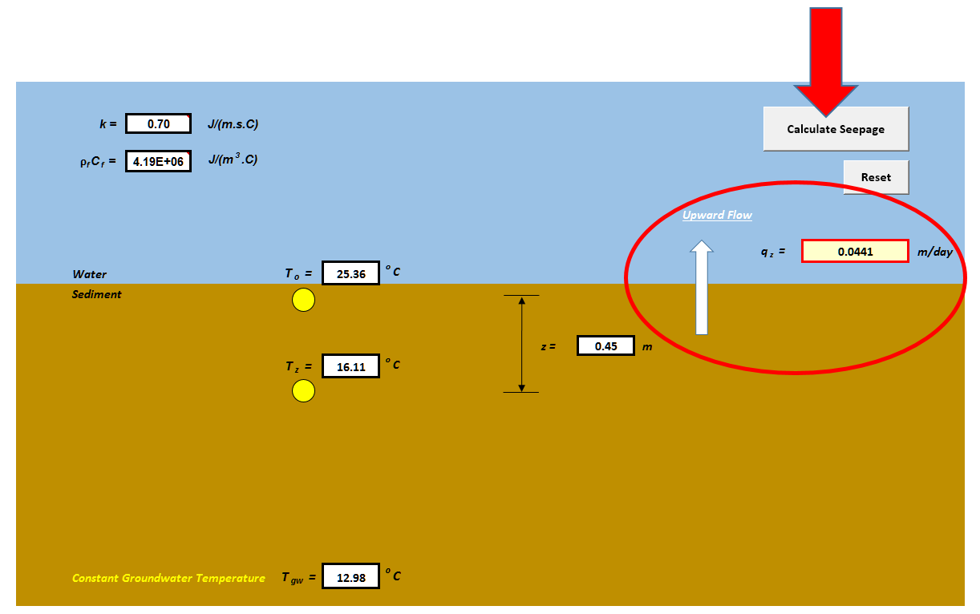

Figure 4: Example of an executed Schmidt worksheet

### 2.1.2 Transient Models

#### 2.1.2.1 [Hatch Model](http://localhost:59486/scenario/hatch/)

#### 

#### 2.1.2.2 [McCallum Model](http://localhost:59486/scenario/mccallum/)

## 2.2 Export to pdf

Each steady state and transient models provide an ‘export as pdf’ function once the data has been entered. To use the ‘export as pdf’ function enter your calculation in the appropriate model, click on the ‘Calculate Seepage’ function in the top right corner of the calculator, then click on the ‘Export as PDF’ blue button bottom left corner of the calculator selected.

## 2.3 Export to Excel

Each steady state and transient models provide an ‘export as excel’ function once the data has been entered. To use the ‘export as excel’ function enter your calculation in the appropriate model, click on the ‘Calculate Seepage’ function in the top right corner of the calculator, then click on the ‘Export as Excel’ blue button bottom left corner of the calculator selected.

End section

# 3.0 Measurements

## 3.1 Projects

EPA Project Information tracking. User enter the project specific information in this section from ORD QA TRACK.

## 3.2 Sediments

The Data Collected at The Site is Taken By a User and enter in this section.

# 4.0 Parameters

## 4.1 Metadata

A Source Reference is the Source on the Excel File.

## 4.2 Value

A Parameter is value in the Excel File.

# 5.0 Tags

## 5.1 Hastags

For future use with Twitter and other social media tool integration.

# 6.0 User Documentation

## 6.1 User Manual

From the drop down menu select User Manual to download a copy of the User Manual for this web-based application.

## 6.2 Fact Sheet

A fact sheet is available from the drop down menu.

## 6.3 Frequently Asked Questions (FAQs)

A copy of frequently asked questions and answers are available for download.

## 6.4 Training

A list of upcoming and past training offered for the GWSC.

## 6.5 Release Notes

A copy of the release notes is available for download. The source code for each release is maintained on the US EPA GitHub repository @ <https://github.com/USEPA/GSC_SSSENR>. Contact the SCM Manager, Daniel L. Young, [young.daniel@epa.gov](mailto:young.daniel@epa.gov) for information on software releases and source code availability.

# 7.0 Help/Suggestions

## 7.1 Request Help

From the drop down menu select ‘Request Help’ and complete the following fields:

1. Subject
2. Description (brief description of your issue or problem with the GWSC)
3. Your email address (preferable work email)
4. Reference Number (assigned by GWSC)

## 7.2 Show Help Request

xxx

## 7.3 Make Suggestion

Xxx

## 7.4 Show Submitted Suggestions

xxx

# 8.0 My Account

## 8.1 My Profile

xxx

## 8.2 Change Password

xxx

# References

Bredehoeft, J. D. and I. S. Papadopulos (1965). "Rates of vertical groundwater movement estimated from the Earth's thermal profile." Water Resour. Res. 1(2): 325-328.

Schmidt, C., B. Conant Jr, M. Bayer-Raich and M. Schirmer (2007). "Evaluation and field-scale application of an analytical method to quantify groundwater discharge using mapped streambed temperatures." Journal of Hydrology 347(3–4): 292-307.