# What is the GWSC?

The **G**round**W**ater **S**eepage **C**alculator (GWSC) is developed and supported by the EPA Office of Research and Development. The tool is an easy-to-use web application designed for calculating one-dimensional groundwater seepage direction and velocity using vertical temperature profile in sediments. The specific project goals are to produce an easy to use tool for performing the automated computation, with supplementary pop-up instructions embedded with the tool.

GWSC is designed for quick, easy use, such that little to no instruction is required. Users can log on using the GWSC icon found at https://groundwatercalculator.epa.gov and start entering data.

All activities associated with GWSC are coordinated through the ORD/NRMRL/LMMD and are implemented through the team of Environmental Chemistry and Engineering Branch (ECEB).

## How Can I Learn More About GWSC?

Contact a member of the LMMD Program Support Coordinators Team:

**US EPA:**  Daniel Young @ [young.daniel@epa.gov](mailto:young.daniel@epa.gov)

**Pegasus:** Raghu Venkatapathy @ [Venkatapathy.Raghuraman@epa.gov](mailto:Venkatapathy.Raghuraman@epa.gov)

**US EPA:** Bob Lien @ [lien.bob@epa.gov](mailto:lien.bob@epa.gov)

**GQC:** Jacob Specht @ [jacob@gqc.com](mailto:jacob@gqc.com)

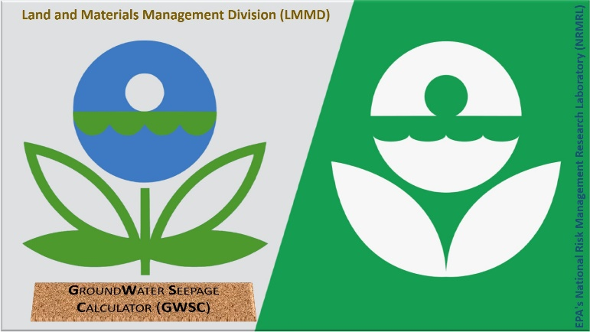

## Why is the GWSC Important?

The interaction of groundwater and surface water can affect the subsurface thermal distribution. The relation between advection of water and heat transfer has led researchers to developed methods utilizing sediment temperatures to inversely quantify groundwater seepage fluxes. The GWSC provides a web-based tool to assist researchers with the application of these methods in seepage flux calculation.

groundwater-surface water interaction

determine magnitude of groundwater seepage flux

determine direction of groundwater seepage flux