**Cloning LCA**

**clone the lca_repo.git repo on iris1**

git clone [tsb@iris1:/project/LCA/repos/lca_repo.git](mailto:tsb@iris1:/project/LCA/repos/lca_repo.git)

In a new workspace, right click in Package Explorer -> Import …

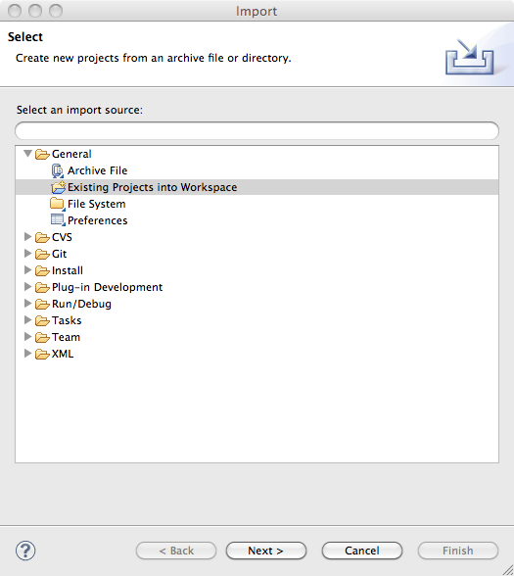

Do not select "Copy projects into workspace"

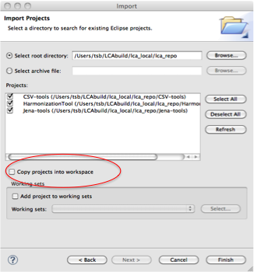

**Execute LCA**

run HT by selecting Harmonization.product

select "Launch an Eclipse application"

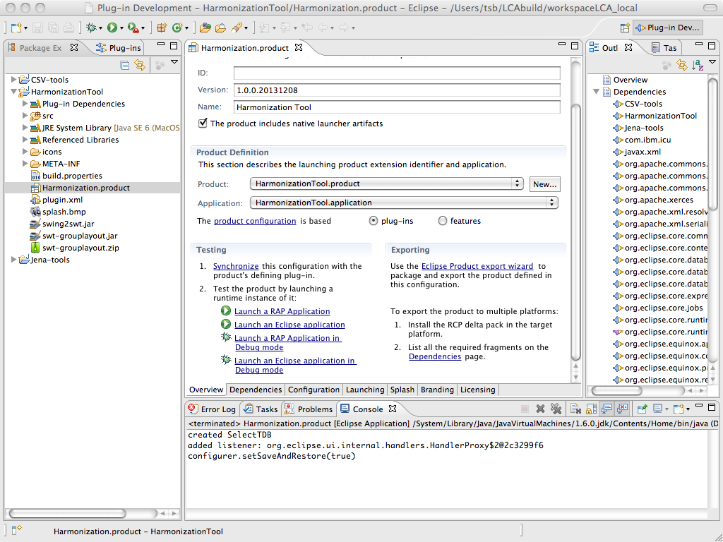

**Installing Delta Pack**

If you already installed the Delta Pack for this workspace, then skip ahead. If you created a new workspace, then you will need to repeat at least some of the steps below.

Download delta pack eclipse-3.7.2-delta-pack.zip at

<http://archive.eclipse.org/eclipse/downloads/drops/R-3.7.2-201202080800/>

unzip eclipse-3.7.2-delta-pack.zip somewhere outside of eclipse

We still have to tell Eclipse where to find the delta pack, but we can’t do that until we set up our workspace, since Eclipse stores that setting in your workspace’s “.metadata” directory.

Eclipse -> Preferences -> Plug-in Development -> Target Platform

select Running Platform (Active) -> select Edit…

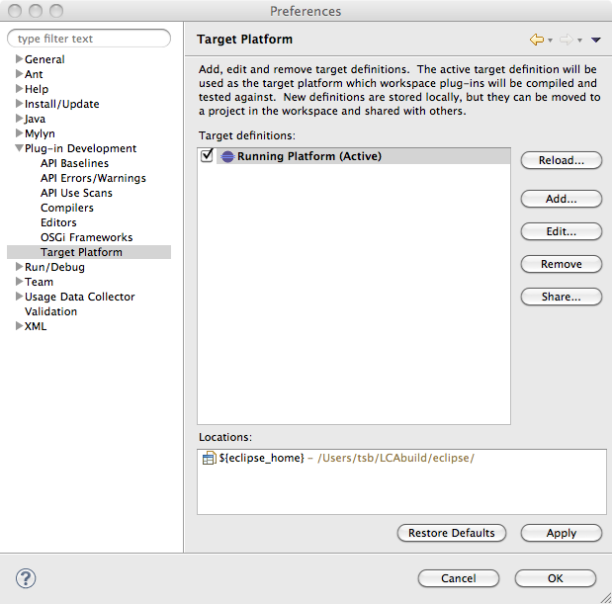

select Add…

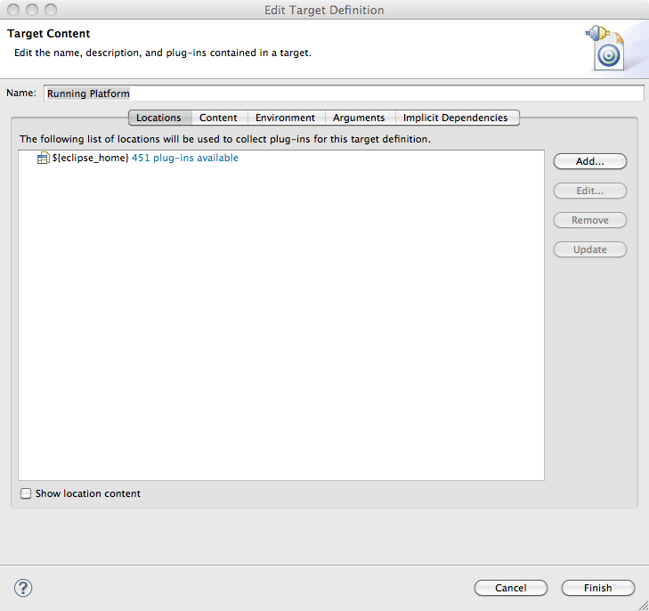

select Directory

select Next

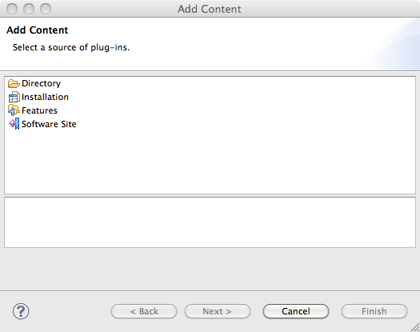

Enter the directory where you put the delta pack. Mine is right beside Eclipse, so I can do it like this: ${eclipse_home}/../eclipse-3.7.2-delta-pack/eclipse. Then click “Finish”.

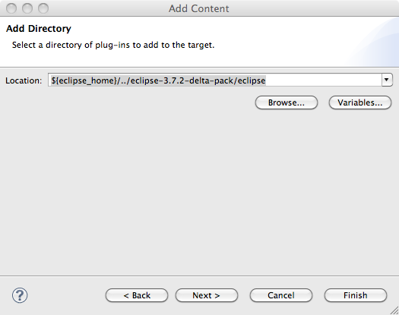

click Finish

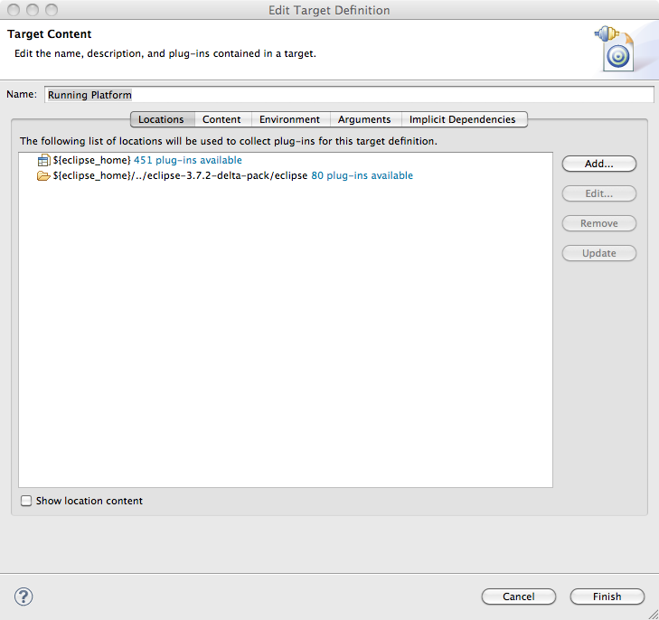

click OK

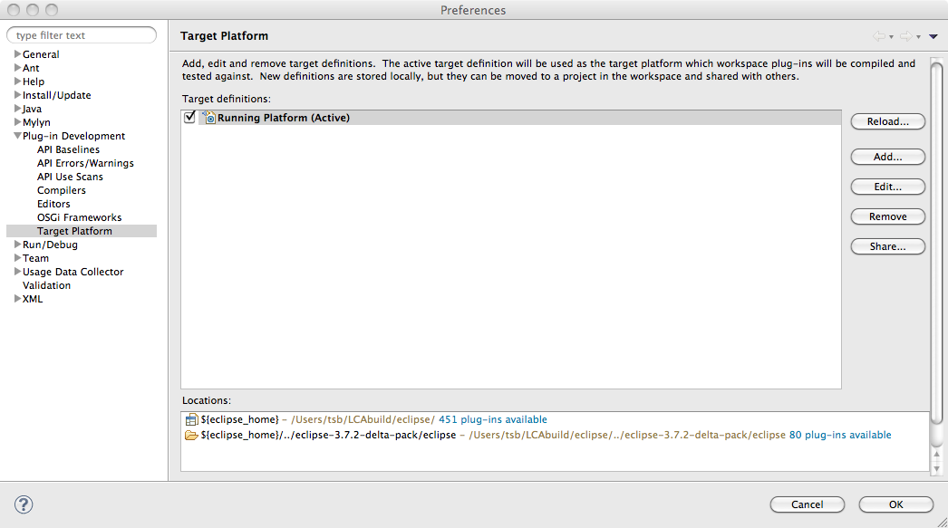

Eclipse will do some processing.

**Exporting LCA Executables**

Create an export directory to hold exported code. Mine is /Users/tsb/LCAbuild/exportDir

In the Harmonization.product select Eclipse Product export wizard

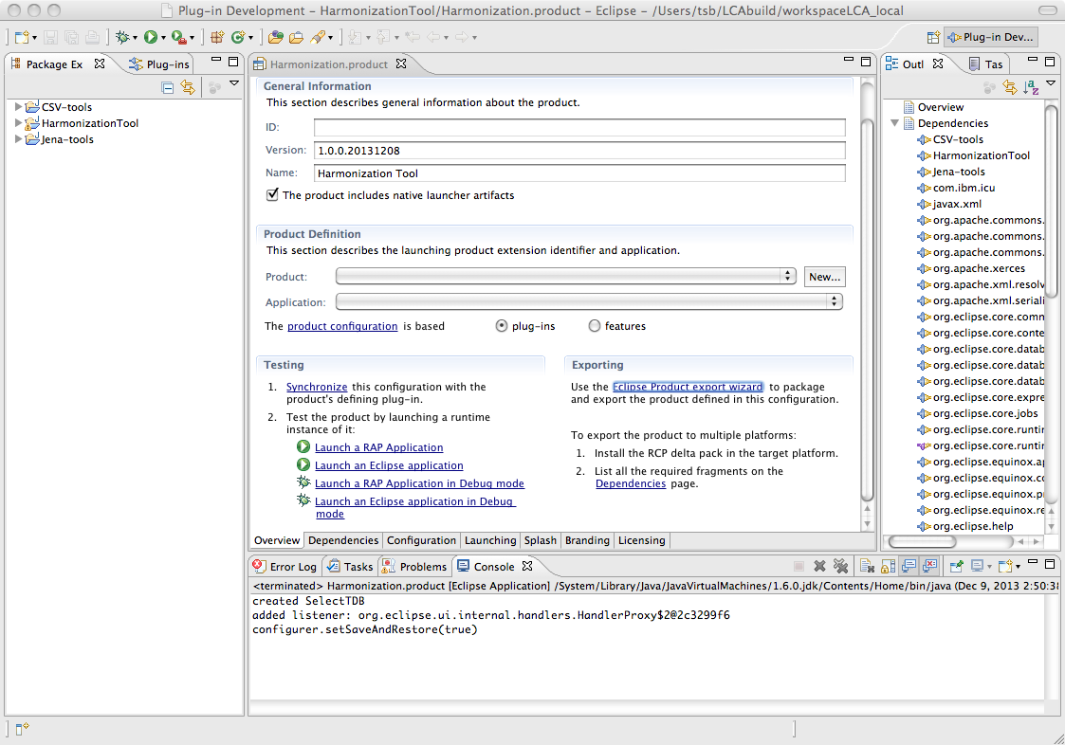

set the Destination Directory; select Export for multiple platforms

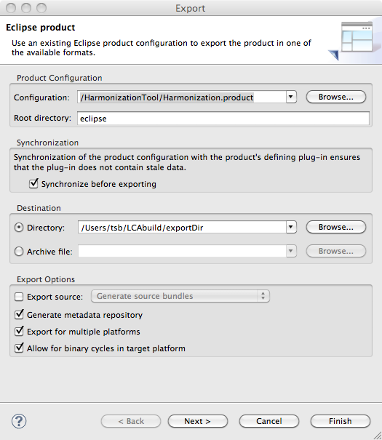

select Next

select desired platforms

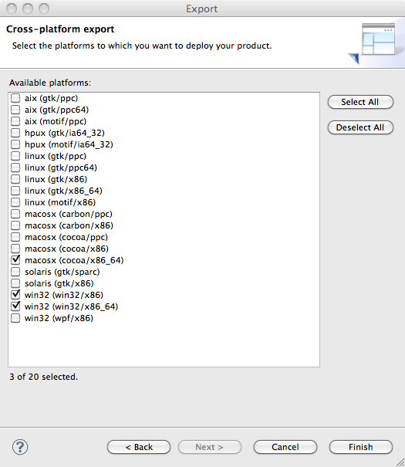

select Finish

Eclipse will do some processing.

Code for selected platforms will appear in your destination directory.

