Geographic Characterization of Benzene Plumes in California

Underground storage tanks are tanks buried underground for the purpose of storing and dispensing a wide range of hazardous products, primarily fuel products such as gasoline and diesel. In the United States there are currently 540,000 open (in operation) tanks. Since 2000, there have been more than 118,000 reported releases. When fuel products release into the ground or onto the surface they can contaminate local soil and groundwater resources, as well as pollute the air by means of vapor intrusion. Petroleum hydrocarbons, which are known carcinogens, pose a threat to human and environmental health. They can persist in the environment for decades, and can contaminate drinking water to unsafe levels which are less than the human threshold for smell or taste. Benzene is a carcinogenic petroleum hydrocarbon found in fuel products and several studies have been conducted on it’s potential for mobilization in the environment, however these studies generally contain a limited number of sites within a limited geographic area and much remains to be understood related to environmental drivers.

# Introduction

Benzene, a carcinogenic component of petroleum products such as gasoline is known to be released into the environment as the result of leaking underground storage tanks (LUST). There are currently about 540,000 active petroleum underground storage tank (UST) systems and a backlog of 62,000 LUST sites in the United States . The definition of a LUST or a release can vary depending on which state or federal regulations you consider. The federal government considers reportable quantities of petroleum products to be anything over 25 gallons, or a spill that cannot be cleaned up within 24 hours . Nationally, for about every 7 active USTs, one will report a release in it’s lifetime . Many studies have been done on benzene plume length and attenuation . However, much is still unknown about the behavior and extent of benzene plumes. For example, while most papers focus on distance (one-dimensional), fewer characterize total impacted area (two-dimensional), and those that do, typically focus on only a small number of contaminated sites. A review paper on studies of benzene plume length showed that research in this area included between 22 to 289 LUST sites per study . included over 4,000 LUST sites, however this was not focused on distance or area but rather trends in concentration over time. A key reason for the limited number of sites included in these studies is data availability. Although states are required to test and characterize sites contaminated or suspected to be contaminated by LUSTs, very limited amounts of these data are made public. In prior studies, authors accumulated limited amounts of field data from multiple agencies and sources. An exception to this limited data availability is California’s Geotracker database, the largest publicly available database of its kind, which includes field data for LUST cleanup sites dating back to 2000.

There has yet to be a study done on benzene plume areas that sufficiently considers a large number of field studies, geographic diversity of sites, and two-dimensional plume shape. Further, no study has been able to offer insight into how well plume areas are being captured by monitoring wells, which could help to make future testing campaigns more efficient and accurate. In this paper, we consider the largest number of field studies to date in a two-dimensional study and use publicly available data obtained from California’s GeoTracker database to compare our findings with those of to determine how a larger and more diverse sample size supports or disagrees with the findings of other studies. We then spatially normalize plumes by determining the mean linear direction of benzene flow and rotate them so as to artificially overlay them and determine the two-dimensional areas that are most commonly impacted relative to the LOP. Finally, we characterize two-dimensional benzene plume areas to determine how effective monitoring wells are at completely capturing benzene plumes in California and discuss the implications of our results. We find that in the vast majority of LUST cleanup sites, it is likely that plume areas are larger than previously thought. These essential investigations will help to determine if plumes are being effectively measured and inform future efforts to estimate plume extents.

# Materials and Methods

## California release definitions

The definition of a release varies from state to state, however all states must report releases that meet or exceed the criteria of the federal reporting requirements. Many releases do not meet this threshold but may still appear in California’s geotracker database. California defines a release as “any spilling, leaking, emitting, discharging, escaping, leaching, or disposing from an underground storage tank into or on the waters of the state, the land, or the subsurface soils” . In California, operators are not required to report a release or spill if they are “able to clean up within eight hours after the release was detected or should reasonably have been detected, and which does not escape from the secondary containment, does not increase the hazard of fire or explosion, and does not cause any deterioration of the secondary containment of the underground storage tank.” However the operator must record the incident in monitoring reports . If these thresholds are exceeded, the operator must report the spill to the appropriate state agency .

## Determining Plume Length

The data obtained from GeoTracker contains groundwater samples from 42,045 unique LUST sites, however the majority of these sites do not have multiple geolocated monitoring wells with groundwater samples in excess of the fedral MCL (5 ug/L). All data was downloaded from the Geotracker public data portal by county, merged together and filtered to only sites defined as a ‘LUST Cleanup Site’. There is no specific way of determining origin point of a release. This is common as most releases are discovered as a result of tank removal and it is often unclear from exactly where a release occurred. While the geotracker database does provide xy locations for both ‘UST / UST pit’ and ‘former UST’ locations, these data only exist at less than 200 of LUST cleanup sites. Therefore, we define the leak origin point (LOP) as the point where benzene concentration was the highest at a given site. If there were multiple measurements of the maximum concentration at different points, the earliest measurement was used. As in , the plume is defined as the distance between the LOP and the farthest monitoring well which had a sample above two separate thresholds, 5 ug/L and 10 ug/L to match with methods used by previous studies. To be clear, the current federal MCL for benzene is 5 ug/L. We only use the 10 ug/L threshold for comparison of benzene distance. To delineate two-dimensional areas of plumes, we use the EPA 5 ug/L MCL. Geolocations of wells were projected to the California Albers projection and measured in meters using the sf package . All analysis in this paper was done with R statistical software and RStudio .

## Evaluating Capture of Plumes by Monitoring Wells

Benzene plumes have been shown to spread over time and can persist for decades. Additionally, benzene plumes can disconnect over time and it is possible to have separation into two plumes , which could lead to undetected plumes beyond testing boundaries, especially if the leak was detected years after a release began. We evaluate plume extents compared with monitoring well extents to determine if plumes are completely captured by monitoring wells or if concentrations greater than 5 ug/L are possibly extending beyond monitoring wells. To test this, we create convex hulls of the monitoring wells which measured $≥5ug/L$ for every site and also convex hulls for monitoring wells for every site. If a site has a sample that exceeds the federal MCL of 5 ug/L that is spatially coincident with the maximum testing boundary, we consider this ‘boundary exceedance’. If the testing boundary and the plume boundary do not intersect, and the plume is entirely within the testing boundary, we consider this ‘plume capture’ (Figure 1).

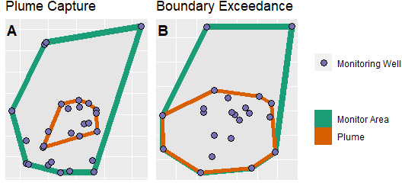

Example of Plumes that are completely captured by monitoring wells (A) and plumes which likely travel beyond he extent of moniotring wells (B).

## Normalizing Plume Direction

We map the distribution of monitoring wells relative to the mean linear direction of a benzene plume. To determine the mean linear direction of benzene movement through the ground, we use weighted vector addition to determine the mean angle of flow in degrees from north. We then artificially rotate the plumes so that they are normalized to one direction (due north) and overlay them to map out monitoring wells relative to the leak point and direction of flow and regardless to actual location. Coordinate math was done using the sf package and bearing directions were calculated using the stplanr package . Data cleaning relied on the tidyverse package . To weight monitoring wells, benzene concentrations were multiplied by the distance in meters of the monitoring well from the LOP. Lines were then created using existing bearings for each monitoring well from the LOP and lengths from weighted distances. Lines were then redrawn end to end and the mean linear direction was calculated as the bearing between the LOP and the end vertex of the final weighted line (Figure 2).

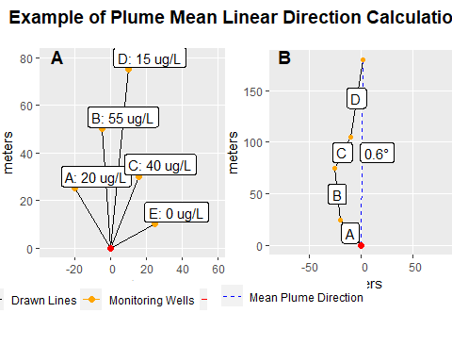

Illustration of mean direction calculation. Panel A shows actual locations and concentrations of benzene relative to LOP. Panel B shows weighted vector math result with mean linear direction calculation.

For area analyses, we included all benzene samples in Geotracker which were taken at LUST cleanup sites and were analyzed as either ug/L or mg/L (91.3% of all samples). Measurements in mg/L were converted to ug/L. In total, we included 3,495 sites which had at least 3 monitoring wells with benzene concentrations exceeding 5 ug/L so that a two-dimensional space could be delineated. These sites contained 63,916 spatially unique monitoring wells, with 1,545,731 benzene samples, 526,060 of which met or exceeded 5 ug/L.

## Statistical Analysis

To determine if there is a statistically significant difference in plume sizes depending on whether a site exhibited boundary exceedance or plume capture we used the Wilcox test. If sites exhibiting plume capture are significantly different then sites exhibiting boundary exceedance, it could indicate that testing at sites that exhibit boundary exceedance are not effectively monitoring the plumes. Finally, we show the measured distances from the LOP for all monitoring wells used in the two-dimensional analysis to contextualize the findings of the Wilcox test.

# Results

## Maximum Plume Distance

Plume maximum distances were calculated for 5,624 sites which had measurable distances (at least 2 unique monitoring wells) with $≥10ug/L$ and 5,881 sites which had measurable distances with $≥5ug/L$ (Figure 3). The median distance for plumes delineated at 10 ug/L was 27.7249 meters. The 90th percentile distance of plumes delineated at 10 ug/L was 84.2 meters. The median distance for plumes delineated at 5 ug/L was 29.42471 meters. The 90th percentile distance of plumes delineated at 5 ug/L was 87.4 meters

Figure 3 shows the maximum distance benzene that was measured from the point of origination. The 90th percentile for benzene distance is 595 feet for 5 ug/L which falls within the findings of . 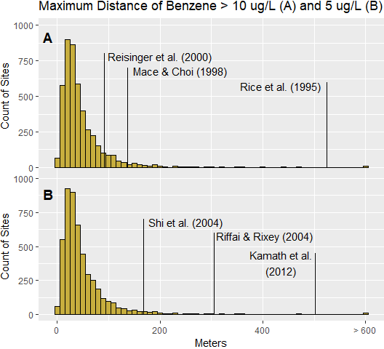

## Directionally Normalized Plumes and Study Areas

We found 3,495 plumes with at least 3 points with benzene concentrations $≥5ug/L$. We calculated mean linear direction of benzene flow and rotated each plume to due north. Each plume was overlaid by shifting the leak origination point to the coordinates (0,0) in the California albers projection.

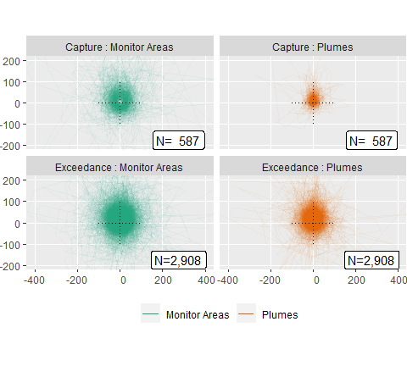

Visualization of all monitoring areas and plume areas superimposed on top of eachother. Line transparency = 95 percent.

## Wilcox Test

2,908 of 3,495 cleanup sites had an exceedance of 5 ug/L at the testing boundary (83.20458). Figure 4 illustrates that when plumes are completely captured (spatially), they are generally smaller than if plumes extend to the boundary of a monitoring network. The results of the Wilcox test (Table 1) show a significant difference between the measured plume areas at sites where boundary exceedance was observed and at sites where entire plume capture was observed (figure 5). Plume areas are statistically larger at sites where plumes were entirely captured, and the majority of plumes exhibited boundary exceedance across their monitoring well extents. The median plume area where plume capture was observed was 416 m2. The median plume area where boundary exceedance was observed was 983 m2, more than twice as much area as plumes that were spatially captured.

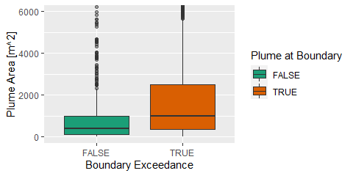

Visulization of plume areas by whether they exhibited boundary capture (green/left) or boundary exceedance (brown/right).

Wilcox Test Results

Y

Group 1

Group 2

n1

n2

Statistic

p

Effect

Area_m

FALSE

TRUE

587

2908

559822

0

0.2228

## Monitoring Well Distances

The distances of all spatially unique monitoring wells were measured from their respective LOPs. Figure 6 shows a histogram as well as the 25th, 50th, 75th and 90th percentiles of maximuim benzene plume distances. The median distance of all monitoring wells from the LOP was 30.03 meters. 90% of monitoring wells were within 87.78 meters of the LOP.

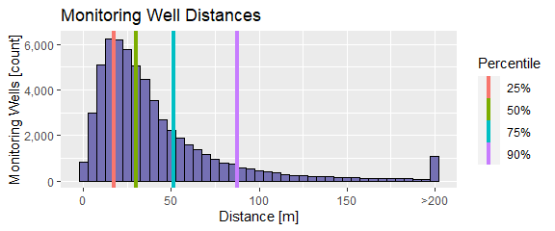

Histogram of monitoring well distances used in area analysis with the 25th, 50th, 75th and 90th percentiles overlaid. Bin width = 5m

# Conclusions & Discussion

While statistically, the maximum distance of 90% of plumes falls within the bounds of previous research, this is not necessarily the best way to consider potential impacts of petroleum hydrocarbons in the environment. California for example has particularly strict reporting requirements, meaning that even very small releases are documented, and the sites undergo soil and groundwater testing, leading to a disproportionate weighting of plumes towards smaller releases relative to documented releases in other states which have reporting requirements more aligned with federal regulations. However, there are still many plumes of concern that reach beyond the ninetieth percentile, in this case 589 sites. Further, our research finds that the vast majority of plumes recorded are likely larger then previously thought, with maximum distances that are longer than have been reported in the data. While previous research has not stated whether or not plumes were entirely captured by monitoring, it stands to reason that prior site investigations may have suffered from the same limitations as are present in the geotracker data. Limitations to testing often include both physical impediments and property boundaries. For example, many gas stations are located in urbanized areas, meaning that impervious, paved surfaces and other structures can limit the areas where testing is possible. Additionally, there may be several other private properties within a very small distance, making getting permission to test difficult. Releases can enter the ground in many ways. The release can originate underground, directly from a tank that has suffered corrosion, or from leaky piping connections, or it can originate on the surface from a spill or overfill and migrate into the ground directly, or through overland flow and via preferential pathways such as cracked pavement.

Our findings suggest that plumes are larger than the data suggests. Plumes are significantly larger when they are not captured by monitoring wells, suggesting that the sites which exhibit plume capture may be doing so simply because they are smaller in tw0-dimensional area. Larger plumes are less likely to be completely captured because the burden for doing so is higher. While the limitations of testing in the real world are clear, and are not likely to be overcome in their entirety, this research clearly shows that there is still much that is unknown about how benzene plumes move through the environment and how much area they can impact in unsafe levels. There is a need for better modelling and understanding of these plumes. If we are able to more effectively model the full extent of benzene plumes, we may be able to aid in future site investigations without an additional burden on agencies responsible for site testing and characterization. While on-site sampling will always be the most reliable way to characterize a plume, additional modelling and understanding may help future site investigations to be more efficient by helping to prioritize monitoring well locations.

The authors of this paper have no conflicts of interest to declare. The views expressed in this paper are those of the authors and do not necessarily represent the views or policies of the U.S. Environmental Protection Agency. All analysis, statistics and spatial analyses were completed using R version 4.1.2. All California LUST data were obtained from the California Water Board’s Geotracker public portal (<https://geotracker.waterboards.ca.gov/data_download_by_county>). All code used in this research is publicly available on GitHub (<https://github.com/USEPA/ORD_Plume_Paper>).