# Proximity Tool User’s Guide

**2020 Census Version with 2018-2022 American Community Survey Demographic Data**

Prepared by:

SC&A, Inc.



1414 Raleigh Road, Suite 450

Chapel Hill, NC 27517

GSA BPA No. 68HERD21A0003

Task Order No. 68HERH22F0003

Prepared for:

Air Toxics Assessment Group

Health and Environmental Impacts Division

Office of Air Quality Planning and Standards

U.S. Environmental Protection Agency

Research Triangle Park, North Carolina 27711

September 2024

Disclaimer

The software tool described in this document has been funded by the United States Environmental Protection Agency under GSA contract 47QRAA20D002W / BPA 68HERD21A0003 to SC&A Incorporated. However, the information presented in this User’s Guide does not necessarily reflect the views of the Agency, and no official endorsement should be inferred of the products referenced.

Contents

1. Proximity Tool Overview 4

2. How to Use the Proximity Tool 5

2.1 Downloading the Proximity Tool 5

2.2 Preparing the Input File 5

2.3 Running the Proximity Tool 6

2.4 Run Completion 6

3. Census Data Used by the Tool 8

4. Computations Performed by the Tool 10

4.1 Race, Ethnicity and Age Categories 11

4.2 Low-Income Level 11

4.3 Level of Education 12

4.4 Limited English Speaking Households 12

4.5 Disabilities 13

4.6 Defaults 13

5. Outputs Produced by the Tool 15

6. Uncertainty Discussion 19

Figures and Tables

Figure 1. User Interface of Proximity Tool 6

Figure 2. Sample Proximity Tool Output of “Facility Demographics” Tab 18

Figure 3. Sample Proximity Tool Output of “Sortable %” Tab 18

Table 1. Sample Input File for Proximity Tool 5

Table 2. Summary of Census Data Used for Different Demographic Groups 9

Table 3. Sample Summary of Proximity Tool Results 17

## Proximity Tool Overview

The Proximity Tool is used to characterize the size and demographic make-up of populations living within a user specified area around facilities or other locations of interest. User inputs to the tool include an ID for each facility/location, the latitude and longitude for each facility/location, and the radius of the circular area of interest surrounding each facility/location in kilometers (km) ranging from 1 km to 50 km (e.g., a circle with a 5 km radius).

The total population within a specified radius around each facility is the sum of the population for every census block within that radius, based on each block’s population provided by the 2020 Decennial Census.[1] For the demographic analysis, statistics on total population, race, ethnicity, age, poverty status, education level, limited English speaking, and disabilities are obtained from the Census’ American Community Survey (ACS) 5-year averages for 2018-2022.[2] These data are provided at the block group and tract level.

The Proximity Tool identifies all census blocks located within the user specified radius of the latitude/longitude location of each facility/location, and then links each block with census-based demographic data. To estimate block level demographic percentages based on race, ethnicity, age, income relative to the poverty level, adults without a high school diploma, and limited English speaking, the demographic characteristics of a given block group are presumed to also describe each census block located within that block group. To estimate block level demographic percentages for people with one or more disabilities, the demographic characteristics of a given tract are presumed to also describe each census block located within that tract.

In addition to facility-specific demographics, the Proximity Tool also computes the demographic composition of the populations within the specified radii for the group of facilities as a whole (e.g., source category-wide). The source category-wide computation accounts for neighboring facilities with overlapping study areas and ensures populations in common are counted only once in the demographic analysis. Finally, the Proximity Tool allows comparison of the facility-specific and source category-wide demographics at each user specified radius (e.g., 5 km) to the demographic composition of the nationwide U.S. population.

This User’s Guide describes how to use the Proximity Tool and the census data and algorithms used to compute the populations and percentages of each demographic category analyzed by the tool. The Proximity Tool is available for download as a zipped executable file on EPA’s Fate, Exposure, and Risk Analysis ([FERA](https://www.epa.gov/fera)) website. It should be noted that proximity to analyzed facilities does not indicate that any exposures or impacts will occur and should not be interpreted as a direct measure of exposure or impact.

## How to Use the Proximity Tool

The Proximity Tool is written in the open-source software language PythonTM and is simple to use with a single user interface, which requires one input file. The tool can be run on any Windows™-based personal computer running Windows XP™ or later. Disk space requirements depend on the number of facilities/locations to be analyzed. The Proximity Tool will also need a minimum of 8 GB of random-access memory (RAM).

### Downloading the Proximity Tool

1. Download the Proximity Tool’s executable zip file from EPA’s Fate, Exposure, and Risk Analysis ([FERA](https://www.epa.gov/fera)) website. The Proximity Tool is approximately 1.43 gigabytes (GB) in size, once uncompressed, and includes all the Census population and demographic data needed for runs in the 50 U.S. states, D.C. and Puerto Rico.
2. After downloading, unzip the file in the desired computer location. (The program does not have to be located at the root C:\ drive but can be.)
3. Once uncompressed, before initiating a run, open the Inputs folder and then open the “Sample_Template_for_Inputs.xlsx” file, which is discussed in the next section.

### Preparing the Input File

You can modify the sample template file provided in the Inputs folder with custom inputs for your run. **Table 1** illustrates the three columns that are needed in the ExcelTM file “Sample_Template_for_Inputs.xlsx”. These columns provide the name/ID, longitude, and latitude of the facilities/locations to be analyzed.

Table . Sample Input File for Proximity Tool

|  |  |  |
| --- | --- | --- |
| **Facility ID** | **Facility Longitude** | **Facility Latitude** |
| Facility 1 | -91.132148 | 37.63622 |
| Facility 2 | -95.23368 | 40.031182 |
| Facility 3 | -85.41764 | 40.156814 |

1. Customize the top header row to include any text you wish. The program does not read the top header row.
2. Beginning in the second row, enter one row for each facility/location you wish to be analyzed. The input file can contain many thousands of rows of facility locations (or other locations of interest).
3. Enter the facility or location ID in the first column (it can be as simple as a numerical listing).
4. For each facility/location, enter the longitude in the second column and the latitude in the third column. Note that the longitude values should be negative to match the longitudes in the Census data. Use decimal longitude and latitudes with as much precision (numbers after the decimal place) as warranted. Note: Four decimal place latitude precision represents about 11 meters, five decimal place latitude precision represents about 1 meter, and longitude precision varies by latitude.

### Running the Proximity Tool

After you have prepared your input file, double-click on the **ProxTool.exe** file to initiate a run. When you launch this executable file, the user interface depicted in **Figure 1** will open.

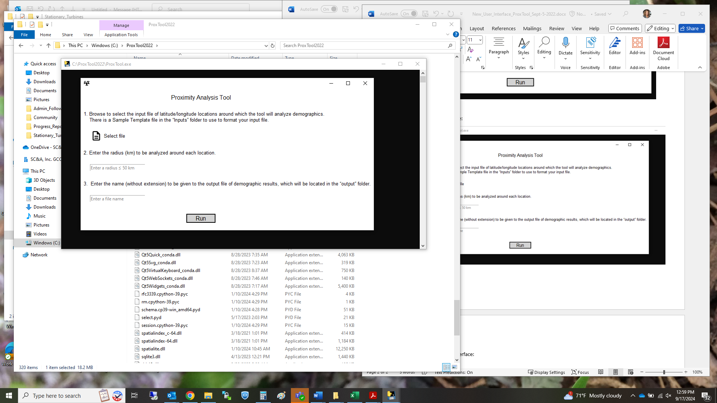

Figure . User Interface of Proximity Tool

As shown in the **Figure 1** screenshot, the user interface indicates the simple 4-step process for initiating a Proximity Tool run:

1. Browse to select your input file (discussed in the previous section).
2. Enter a whole number radius in kilometers (km) that is between 1 km and 50 km (e.g., “3” not “3.1”).
3. Enter the name to be assigned to your output file.
4. Click the Run button.

After clicking “Run” on the user interface, a DOS window will open to show the Proximity Tool’s progress. During the run, the tool will evaluate census blocks surrounding the facilities/locations (provided in the input file) with census-based demographic data within the user specified radius to these facilities/locations. The census data used in the Proximity Tool is described in Section 3. The algorithms used to compute the population of each demographic category surrounding each facility/location are presented in Section 4.

### Run Completion

When the analysis is finished, a pop-up will note “Run complete. Check your output folder for results.” During downloading of the Proximity Tool an output folder was automatically created in the tool directory. Check this output folder for the results. The Proximity Tool will output the demographic composition of the population surrounding each individual facility/location within the user specified radius, including for the run group as a whole, based on the following socio-economic groups:

* Total population,
* White,
* People of Color,
* Black,
* American Indian and Alaskan Native,
* Asian,
* Other races and multiracial,
* Hispanic or Latino,
* Children 17 years of age and under,
* Adults 18 to 64 years of age,
* Adults 65 years of age and over,
* People living below the poverty level,
* People living below twice the poverty level,
* Adults 25 years of age and older without a high school diploma,
* People living in limited English speaking households, and
* People living with one or more disabilities.

The Proximity Tool’s outputs also include nationwide demographics, which allow the individual facility/location and run group demographics at the user specified radius to be compared to the demographic composition of the nationwide U.S. population. The Proximity Tool outputs are discussed in more detail in Section 5.

## Census Data Used by the Tool

The total population within a specified radius around each facility/location of interest is the sum of the population for every census block within that radius, based on each block’s population provided by the 2020 Decennial Census.[3] A census block is the smallest geographic area that the U.S. Census Bureau uses to collect and tabulate census data. For the demographic analysis, statistics on total population, race, ethnicity, age, low income (relative to the poverty level), low educational attainment (adults without a high school diploma), limited English speaking, and disabilities are obtained from the Census’ American Community Survey (ACS) 5-year averages for 2018-2022.[4] These demographic data are provided at the block group level, except for the disabilities data, which are provided at the tract level.

For the 2020 Census, there were approximately 240,000 block groups and 85,000 census tracts in the U.S. and Puerto Rico.[5] A census tract typically contains about three block groups and is designed to average 4,000 people. A census block group contains about 30 populated census blocks on average, with about 1,400 people in the block group. There are approximately 8.2 million census blocks in the 2020 Census and approximately 5.8 million of these are populated, with a block population of 58 people on average for these populated blocks (or 41 people on average for all census blocks including those with zero population). Note: These statistics are merely averages, which can vary widely.

**Table 2** summarizes the census data used by the Proximity Tool, showing the source of each dataset and the level of geographic resolution. The statistics for race/ethnicity categories, age groups, poverty status, educational attainment, limited English speaking, and disabilities are consistent with the demographic statistics used in EPA’s EJScreen tool for Environmental Justice screening analyses.[6] The Proximity Tool’s demographic statistics are derived from the ACS, which is the source of data for EJScreen’s statistics.

Table . Summary of Census Data Used for Different Demographic Groups

| **Type of population category** | **Source of data** | **Level of geographic resolution** |
| --- | --- | --- |
| Total population (sum of block centroid counts) | 2020 Census, P.L. 94-171 Tables (a) | Census block |
| Total population (sum of block group counts, used for demographic percentages) | 2018-2022 ACS (b) Table B03002 (e1) | Census block group |
| Race/ethnicity categories (percentages): | ACS Table B03002, Hispanic or Latino Origin by Race (Tiger table X03):   * **White (non-hispanic):** e3/e1 * **People of Color (non-white and hispanic):**  (e1-e3)/e1 * **Black (non-hispanic):** e4/e1 * **American Indian and Alaskan Native (non-hispanic):** e5/e1 * **Asian:** e6/e1 * **Other and Multiracial (non-hispanic):** (e7+e8+e9)/e1 * **Hispanic (all races):** e12/e1 | Census block group |
| Age groups | ACS Table B01001, Sex by Age (Tiger table X01) | Census block group |
| Individuals living in households earning below the poverty level (percentage of individuals) | ACS Table C17002, Ratio of Income to Poverty Level (Tiger table X17): (e2+e3)/e1 | Census block group |
| Individuals living in households earning below twice the poverty level (percentage of individuals) | ACS Table C17002, Ratio of Income to Poverty Level (Tiger table X17): (e1-e8)/e1 | Census block group |
| Adults 25 years and older without a high school diploma | ACS Table B15002, Sex by Educational Attainment (Tiger table X15) | Census block group |
| Individuals living in limited English-speaking households (percentage of households) | ACS Table C16002, Household Language by Household (Tiger table X16): (e4+e7+e10+e13)/e1 | Census block group |
| Individuals with one or more disabilities | ACS Table B99181, Allocation of Disability Items for the Civilian Noninstitutionalized Population: e2/e1 | Census tract |

(a) U.S. Census Bureau, 2022. USA Census 2020 Redistricting Blocks. ArcGIS feature layer from Esri containing block level 2020 Decennial Census data as reported by the U.S. Census Bureau with attributes from the 2020 Public Law 94-171 (P.L. 94-171) tables. Available at <https://www.arcgis.com/home/item.html?id=b3642e91b49548f5af772394b0537681>. January 25, 2022. Also refer to <https://www.census.gov/programs-surveys/decennial-census/about/rdo/summary-files.html#P2>.

(b) U.S. Census Bureau, 2023. 2022 American Community Survey. 2018-2022 ACS Five-year Estimates in ACS Summary File Table-Based Format: <https://www.census.gov/programs-surveys/acs/data/summary-file.html>. Downloaded from: <https://www2.census.gov/programs-surveys/acs/summary_file/2022/table-based-SF/data/5YRData/>. U.S. Census Bureau data release December 2023. Also refer to <https://www.census.gov/programs-surveys/acs/about.html>.

## Computations Performed by the Tool

During the run, the Proximity Tool (1) identifies all census blocks with centroids[7] located within the user specified radius (circular area) of the latitude/longitude location of each facility/point-of-interest, and then (2) links each block with census-based demographic data. It should be noted that, if the centroid of a census block is located within the analyzed radius, the entire population of that census block is counted as within the radius. Likewise, if the census block centroid is located outside of the analyzed radius, the entire population of that census block is not included in the analysis, even if a portion of the census block area falls within the analyzed radius. In addition to facility/location-specific demographics, the Proximity Tool also computes the demographic composition of the populations within the analyzed radius for all facilities/locations grouped as a whole (e.g., source category-wide). For the run group computations, the Proximity Tool accounts for neighboring facilities/locations with overlapping study areas and ensures populations in common are counted only once in the demographic analysis. It should therefore be noted that, if there are overlapping populations, the sum of the facility specific populations will be greater than the run group total because the run group total removes the duplicate populations.

The Proximity Tool uses the census block, census block group, and tract identification codes to link each block to the appropriate ACS block group demographic statistics, or (in the case of people with one or more disabilities) tract demographic statistics. This allows estimation of the number of people in different demographic categories for each census block in a specified radius around each facility/location. As noted in Section 3, demographic data is available at the census block group and tract level. To estimate more detailed block level demographic percentages, the demographic characteristics of a given block group or tract – that is, the block group percentage of people of different races/ethnicities, the block group percentage in different age groups, the block group percentage in low income categories (below the poverty level and below twice the poverty level), the block group percentage of adults without a high school diploma, the block group percentage that are living in limited English speaking households, and the tract percentage with one or more disabilities – are presumed to also describe each census block located within that block group or tract.

For comparison, the nationwide demographic percentages are computed from the Census’ ACS 5-year averages for 2018-2022 (“2022 ACS”). The denominator for these nationwide percentages uses the total nationwide population, which is likewise computed from the 2022 ACS and determined by summing the total population of all census block groups and tracts. We also provide the total nationwide population based on the 2020 Decennial Census for comparison, because the census block populations are based on 2020 Decennial Census data, as noted in Section 3.

Sections 4.1 through 4.5 describe calculation methods for racial, ethnic, age, low-income (poverty) status, education status, limited English speaking household, and disability demographic categories. Section 4.6 describes the gap-filling approach used when block group or tract statistics are not available for a given block, based on computing default averages for the missing demographic(s). Section 6 notes the primary uncertainties associated with the Proximity Tool data and methodology.

### Race, Ethnicity and Age Categories

Table B03002 (Hispanic or Latino origin by race) of the ACS data provides race/ethnicity statistics for each census block group nationwide. Table B01001 provides age statistics for the population by ranges (in years) for each census block group nationwide. For each census block in a Proximity Tool analysis, the race/ethnicity (White, Black, American Indian and Alaskan Native, Asian, Other and Multiracial, and Hispanic or Latino) and age range (0-17, 18-64 and ≥65 years) for that block is estimated based on the demographic information provided at the block group level, as follows:

N(s,b/bg) = N(t,b/bg) × P(s,bg) ∕ 100

where:

N(s,b/bg) is the number of people in racial/ethnic or age subgroup “s”, in census block “b” of block group “bg”

N(t,b/bg) is the total number of people in census block “b” of block group “bg”

P(s,bg) is the percentage of people in racial/ethnic or age subgroup “s”, in census block group “bg”

The number of people in each racial/ethnic and age category is calculated using the above equation, summed over all blocks that fall within the user specified radius of each facility.

### Low-Income Level

Table C17002 (poverty) of the ACS estimates the numbers of individuals within a Census block group who live in households where the household income is below the poverty line, and below various multiples of the poverty line. The Proximity Tool calculates two low-income statistics based on the fractions of (1) individuals living in households earning incomes below the poverty level, and (2) individuals living in households earning incomes below two times the poverty level, respectively. For each census block in a Proximity Tool analysis, the block’s household income level is estimated based on the demographic information provided at the block group level, as follows:

N(hi,b/bg) = N(t,b/bg) × P(hi,bg) ∕ 100

where “hi” indicates household income, whether below the poverty level or below two times the poverty level, depending on the income statistic relative to the poverty level, and:

N(hi,b/bg) is the number of people living in low-income households “hi” relative to the poverty level, in census block “b” of block group “bg”

N(t,b/bg) is the total number of people in census block “b” of block group “bg”

P(hi,bg) is the percentage of people living in households “hi” relative to the poverty level, among the population for which poverty status is known, in census block group “bg”

The numbers of people living in households earning (1) below the poverty level and (2) below two times the poverty level are calculated using the above equation, summed over all blocks that fall within the user specified radius of each facility.

### Level of Education

Table B15002 (educational attainment) of the ACS provides education attainment statistics for each census block group nationwide. For each census block in a Proximity Tool analysis, the number of people 25-years and older without a high school diploma is estimated based on the demographic information provided at the block group level, as follows:

N(nhs,b/bg) = N(t,b/bg) × P(nhs,bg) ∕ 100

where:

N(nhs,b/bg) is the number of people 25-years and older without a high school diploma “nhs”, in census block “b” of block group “bg”

N(t,b/bg) is the number of people 25-years and older in census block “b” of block group “bg”

P(nhs,bg) is the percentage of people 25-years and older without a high school diploma “nhs”, in census block group “bg”

The number of people 25-years and older without a high school diploma is calculated using the above equation, summed over all blocks that fall within the user specified radius of each facility.

### Limited English Speaking Households

Limited English speaking households are households that may need English-language assistance and are defined in the ACS as a household “in which in which no member 14 years old and over (1) speaks only English at home or (2) speaks a language other than English at home and speaks English ‘Very well’.”[8] The previous term for this ACS demographic was “Linguistic Isolation”. Table C16002 (Tiger table X16_language_spoken_at_home) of the ACS provides the number of limited English speaking households in each block group. For each census block in a Proximity Tool analysis, the number of people living in limited English speaking households is estimated based on the demographic information provided at the block group level, as follows:

N(le,b/bg) = N(t,b/bg) × P(le,bg) ∕ 100

where:

N(le,b/bg) is the number of people living in limited English speaking households “le”, in census block “b” of block group “bg”

N(t,b/bg) is the total number of people in census block “b” of block group “bg”

P(le,bg) is the percentage of limited English speaking households “le”, in census block group “bg”

The number of people living in limited English speaking households is calculated using the above equation, summed over all blocks that fall within the user specified radius of each facility.

### Disabilities

The demographic percentages for people with one or more disabilities are based on Census ACS surveys at the tract level and include people who report having any one or more of six disabilities: hearing difficulty, vision difficulty, cognitive difficulty, ambulatory difficulty, self-care difficulty, and independent living difficulty.[9] Table B99181 of the ACS provides the number of civilian non-institutionalized people (i.e., all U.S. civilians not residing in institutional group quarters facilities such as correctional institutions, juvenile facilities, skilled nursing facilities, and other long-term care living arrangements) living with one or more disabilities. For each census block in a Proximity Tool analysis, the number of people living with one or more disabilities is estimated based on the demographic information provided at the tract level, as follows:

N(di,b/T) = N(t,b/T) × P(di,T) ∕ 100

where:

N(di,b/T) is the number of people living with one or more disability “di”, in census block “b” of tract “T”

N(t,b/T) is the total number of people in census block “b” of tract “T”

P(di,T) is the percentage of people in the census tract who were identified in the ACS survey as living with one or disabilities “di”, in tract “T”

The number of people living with one or more disabilities is calculated using the above equation, summed over all blocks that fall within the user specified radius of each facility.

### Defaults

Block and block group designations used in the Census may be modified to accommodate population growth in some regions. As a result, certain blocks which are based on the last Decennial Census, may not map to the block group designations used in the latest 5-year ACS survey. In addition, some statistics may not be reported in the ACS for every block group. Race, ethnicity, and age statistics are generally reported for all block groups. However, low income, low educational attainment, and limited English speaking household are not available for some block groups.

In these cases, the Proximity Tool computes default estimates for the missing demographic statistics based on the average statistics for the tract in which the block is located. If no tract-level data are available, demographic statistics are estimated based on the statistics of the nearest (non-zero population) block group neighbor to the unmatched block location. This gap-filling exercise is performed separately for each type of demographic data. That is, in the case where some categories of data are available (for instance, race, age and ethnicity) and others are not available (low income, educational attainment, or limited English speaking household) the Proximity Tool computes defaults for only the categories of data that are missing. Note: Disability is only available at the tract level and does not need defaulting for the 2018-2022 ACS, because disability data is available for all tracts. However, if defaulting were needed for future ACS versions, the county average would be used.

The tract level defaults are computed using weighted averages based on all of the other block groups in the tract for which data are available. Tract level defaults are calculated as follows for race, ethnicity, and age subgroups:

P(s,T) = { ∑ P(s,bg/T) × N(t,bg) } ∕ {∑ N(t,bg)}

where:

P(s,T) is the percentage of people in race, ethnicity, or age subgroup “s”, in tract “T”

∑ refers to the summation over all census block groups in tract “T” for which data are available

P(s,bg/T) is the percentage of people in race, ethnicity, or age subgroup “s”, in census block group “bg” of tract “T”

N(t,bg) is the total number of people in census block group “bg”

Defaults for low income, educational attainment, and limited English speaking household are calculated in a similar fashion, except that the population weighting term N is replaced by the population for which low-income status is known, the population over age 25, and the number of households, respectively.

## Outputs Produced by the Tool

The Proximity Tool outputs for each run are provided in an ExcelTM workbook of results. The workbook will be located in the “output” folder of the Proximity Tool with the filename you indicated on the user interface when initiating the run. The workbook contains three tabs of spreadsheets, described below.

* Background ReadMe tab: This first tab of the output provides brief information on the Proximity Tool including its basic methodology, its development, and the vintage of the Decennial Census population data and ACS demographic data it contains.
* Facility Demographics tab: This second tab of the output provides both population totals “(pop.)” and population percentages “(pop.%)” by demographic category for the run group as a whole (“Run group total”) and for each facility/location individually analyzed in the run, based on the user specified radius around each facility. The tab also provides the nationwide population total and nationwide demographic percentages based on the 2018-2022 ACS, as well as the similar nationwide population total based on the 2020 Decennial Census (for reference, since the block populations provided are based on the Decennial Census). Finally, the tab provides detailed footnotes describing important aspects of the methodology and key definitions and assumptions underlying certain demographic categories.
* Sortable % tab: This third tab of the output provides the longitude and latitude of each facility/location analyzed by the Proximity Tool, the total population within the user specified radius around each facility/location and for the group as a whole (“Run group total”), and the population percentages by demographic category. This tab includes only a single row each for the nationwide demographics, run group demographics, and individual facility/location demographics and therefore is sortable by demographic category columns, allowing for easy comparison.

In addition to the ExcelTM workbook of results described above, the output folder of the Proximity Tool often contains a text file listing the block group IDs that required defaulting, because they are not included in the 2018-2022 ACS. This defaulting allows all block populations located within the user specified radius to be represented in the run, even blocks that do not map directly to a block group. The reasons and methodology for defaulting are discussed in more detail in Section 4.6. In general, the larger the radius, the more defaulting that will be necessary, because more census blocks are analyzed. However, it should be noted that there are over 8 million census blocks in the 2020 Decennial Census with nearly 6 million of them populated. Therefore, even a seemingly long list of defaulted block group IDs in this text file will generally represent a small fraction of the blocks analyzed by the Proximity Tool in the run. Note: If no defaulting is necessary at all, no text file will be present in the outputs folder.

A sample summary of Proximity Tool results for 130 facilities analyzed at a radius of 5 km is provided in **Table 3**. In this example, the Proximity Tool identified census block centroids with approximately 6,180,000 people living within 5 km of the 130 facilities as a group. The demographic breakdown of these 6,180,000 people was provided by the Proximity Tool and the results presented in Table 3 indicate that the population percentages for certain demographic groups within 5 km of the facilities are greater than the corresponding nationwide percentages for those same demographics. The demographic percentage for populations residing within 5 km of the facilities is 6 percentage points greater than its corresponding nationwide percentage for the People of Color population (48% within 5 km of the facilities compared to 42% nationwide), 6 percentage points greater than its corresponding nationwide percentage for people aged 18 to 64 years old (67% within 5 km of the facilities compared to 61% nationwide), 3 percentage points greater than its corresponding nationwide percentage for the Asian population (9% within 5 km of the facilities compared to 6% nationwide), 2 percentage points greater than its corresponding nationwide percentage for the Black population (14% within 5 km of the facilities compared to 12% nationwide), 2 percentage points greater than its corresponding nationwide percentage for people living below the poverty level (15% within 5 km of the facilities compared to 13% nationwide), 1 percentage point greater than its corresponding nationwide percentage for people living in limited English speaking households (6% within 5 km of the facilities compared to 5% nationwide), 1 percentage point greater than its corresponding nationwide percentage for people with one or more disabilities (13% within 5 km of the facilities compared to 12% nationwide), 1 percentage point greater than its corresponding nationwide percentage for the Hispanic population (20% within 5 km of the facilities compared to 19% nationwide), and 1 percentage point greater than its corresponding nationwide percentage for people living below twice the poverty level (30% within 5 km of the facilities compared to 29% nationwide). The remaining demographic groups within 5 km of the facilities are less than or equal to the corresponding nationwide percentages.

As noted above in this section, the Proximity Tool’s actual ExcelTM workbook outputs will also contain population counts and demographic percentages for the 130 individual facilities. Note: Table 3 is not an actual output from the Proximity Tool, but rather a table created using those outputs; it merely represents a summary of the run group demographic results along with the nationwide demographic breakdown for comparison. Following Table 3, Figures 2 and 3 show two spreadsheet tabs as an example of the Excel workbook output generated by the Proximity Tool for a different run of 10 facilities at a radius of 1 km. **Figure 2** shows the “Facility Demographics” tab of the Proximity Tool output, which provides rows for both population counts and population percentages for each demographic category analyzed in the run. **Figure 3** shows the “Sortable %” tab, which provides one row for each facility including the total population count for each facility and the percentage breakdown per demographic category, in a format suitable to sorting.

Table . Sample Summary of Proximity Tool Results

|  |  |  |
| --- | --- | --- |
| **Demographic Category (a)** | **Nationwide Demographics**  (2018–2022 ACS) | Sample Proximity Tool Results from Facility Group (130 facilities)  **5 km Proximity(f)** |
| Total Population | 334,369,975 | 6,177,476 |
| White | 58% | 52% |
| People of Color**(b)** | 42% | 48% |
| Black | 12% | 14% |
| American Indian or Alaska Native | 0.5% | 0.3% |
| Asian | 6% | 9% |
| Other and Multiracial | 4% | 4% |
| Hispanic or Latino**(c)** | 19% | 20% |
| Ages 0 to 17 | 22% | 19% |
| Ages 18 to 64 | 61% | 67% |
| Ages 65 and up | 17% | 14% |
| Below the Poverty Level | 13% | 15% |
| Below Twice the Poverty Level | 29% | 30% |
| Over 25 Without a High School Diploma | 11% | 10% |
| Limited English Speaking Household **(d)** | 5% | 6% |
| With One or More Disabilities**(e)** | 12% | 13% |

(a) The demographic percentages and total nationwide population of 334,369,975 are based on the Census’ 2018-2022 American Community Survey five-year averages, at the block group level, and include the 50 states, the District of Columbia, and Puerto Rico. Demographic percentages based on different averages may differ. The total population surrounding all facilities at each proximity are based on block level data from the 2020 Decennial Census. Populations by demographic group are determined by multiplying each 2020 Decennial block population within the indicated radius (proximity) by the ACS demographic percentages describing the block group or tract containing each block, and then summing over the indicated circular area. Note: The total population based on the 2020 Decennial Census is 334,735,155.

(b) The People of Color population is the Total Population minus the White population and includes the following five racial/ethnic categories: Black, American Indian or Alaska Native, Asian, Other and Multiracial, and Hispanic/Latino.

(c) To avoid double counting, the "Hispanic or Latino" category is treated as a distinct demographic category for these analyses. A person who identifies as Hispanic or Latino is counted as Hispanic/Latino for this analysis, regardless of what race this person may have also identified as in the Census.

(d) The Limited English-Speaking Household population is estimated at the block group level by taking the product of the block group population and the fraction of limited English-speaking households in the block group, assuming that the number of individuals per household is the same for Limited English-Speaking Households as for the general population.

(e) The demographic percentages for people with one or more disabilities are based on Census ACS surveys at the tract level of civilian non-institutionalized people (i.e., all U.S. civilians not residing in institutional group quarters facilities such as correctional institutions, juvenile facilities, skilled nursing facilities, and other long-term care living arrangements). The nationwide demographic percentage is the sum of all tract level tallies in the nation divided by the total U.S. population based on the 2018-2022 ACS. The study areas’ population counts are based on applying the Census tract level percentage of people with one or more disabilities to each block within the respective tract.

(f) The population tally and demographic analysis of the total population surrounding all facilities as a whole account for neighboring facilities with overlapping study areas and ensure populations in common are counted only once.

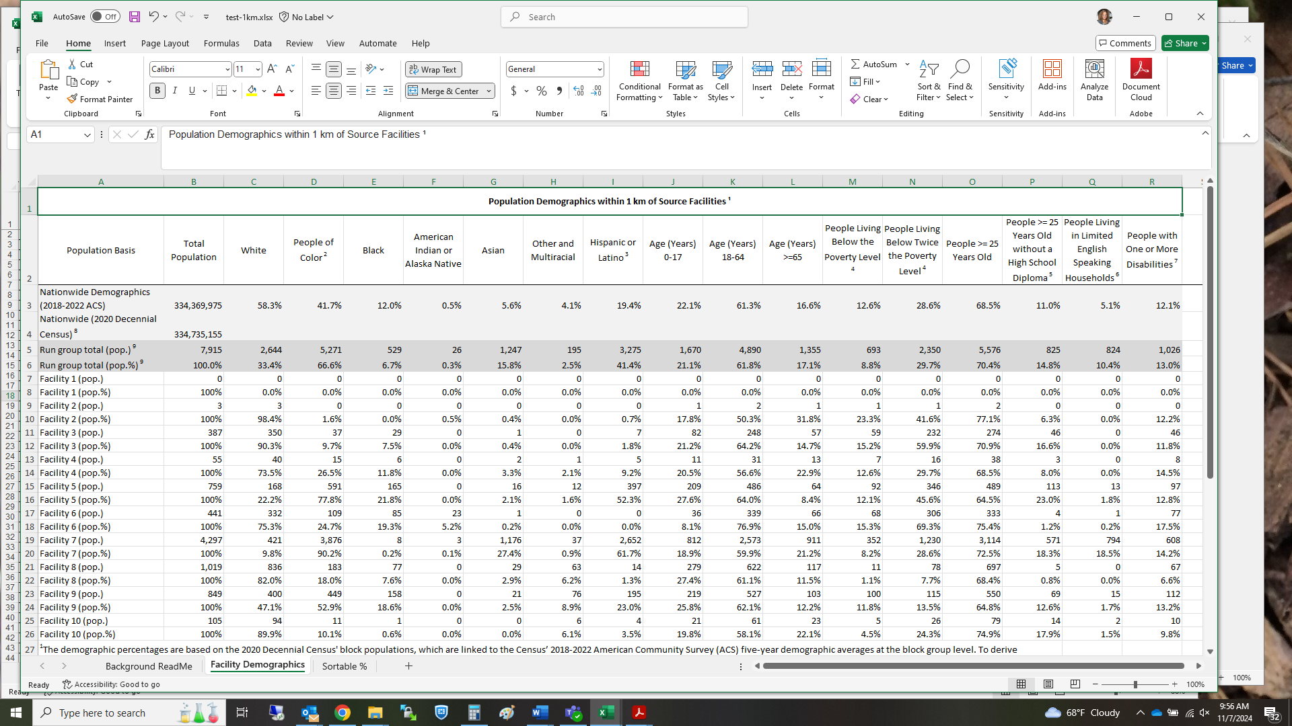

Figure 2. Sample Proximity Tool Output of “Facility Demographics” Tab

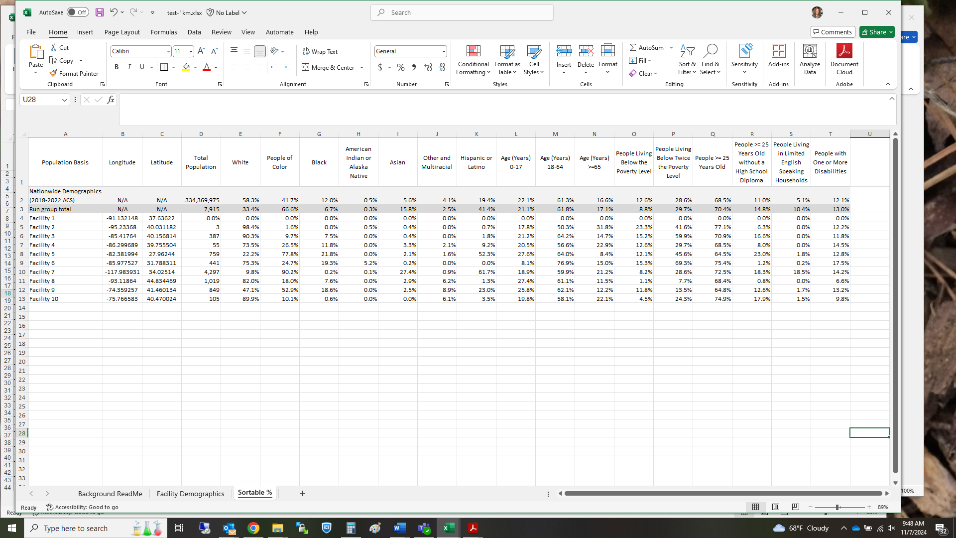

Figure 3. Sample Proximity Tool Output of “Sortable %” Tab

## Uncertainty Discussion

The methodology for the Proximity Tool’s demographic analyses applies demographic data from the Census’ American Community Survey (ACS). The Proximity Tool’s analysis of the distribution of population across demographic groups is subject to the uncertainties associated with the ACS. The demographic statistics reported by the ACS are not based on a count of all people in a geographic area, as in the case of the decennial Census, but on surveys of a fraction of the people. The uncertainty of ACS survey results depends strongly on the number of people in the cohort being analyzed. For a typical proximity analysis, the uncertainty associated with the survey results is about ±10%. However, if the number of people in the counted group is less than 100, the uncertainty can be ±100% or more.

In addition, the geographical resolution of the ACS is at the level of a Census Block Group or a Census Tract, typically 2 to 5 kilometers. This will add to the uncertainty, especially for areas of low population density. Any uncertainty in the location inputs (of emission sources or other areas of interest) to the Proximity Tool would also add to the uncertainty.

The EPA has developed technical guidance for environmental justice analyses, and the guidance and resulting analyses are continuously advancing. The Proximity Tool’s analysis, with its associated uncertainties, provides additional information for evaluation by EPA decision makers and the public to inform assessments such as Risk and Technology Reviews and other analyses. It should be noted that proximity to analyzed facilities does not indicate that any exposures or impacts will occur and should not be interpreted as a direct measure of exposure or impact.

1. . U.S. Census Bureau, 2020 Census, United States: <https://www.census.gov/programs-surveys/decennial-census/decade/2020/2020-census-main.html>
2. . U.S. Census Bureau, Five-year American Community Survey: 2018-2022, United States: <https://www.census.gov/programs-surveys/acs/news/data-releases/2022/release.html>. For more information about the ACS visit <https://www.census.gov/programs-surveys/acs/about.html>.
3. . U.S. Census Bureau, 2022. USA Census 2020 Redistricting Blocks. ArcGIS feature layer from Esri containing block level 2020 Decennial Census data as reported by the U.S. Census Bureau with attributes from the 2020 Public Law 94-171 (P.L. 94-171) tables. Available at <https://www.arcgis.com/home/item.html?id=b3642e91b49548f5af772394b0537681>. January 25, 2022. Also refer to <https://www.census.gov/programs-surveys/decennial-census/about/rdo/summary-files.html#P2>.
4. . U.S. Census Bureau, 2023. 2022 American Community Survey. 2018-2022 Five-year Estimates in ACS Summary File Table-Based Format: <https://www.census.gov/programs-surveys/acs/data/summary-file.html>. Downloaded from: <https://www2.census.gov/programs-surveys/acs/summary_file/2022/table-based-SF/data/5YRData/>. U.S. Census Bureau data release December 2023. Also refer to <https://www.census.gov/programs-surveys/acs/about.html>.
5. . 2020 Census Tallies are provided by the U.S. Census Bureau at <https://www.census.gov/geographies/reference-files/2020/geo/tallies.html>.
6. . U.S. Environmental Protection Agency. August 9, 2024. EJScreen: Environmental Justice Screening and Mapping Tool (Version 2.3). <https://www.epa.gov/ejscreen>. Also refer to the [EJScreen Technical Documentation for Version 2.3](https://www.epa.gov/system/files/documents/2024-07/ejscreen-tech-doc-version-2-3.pdf).
7. . A census block centroid is considered a central location of the block polygon it represents and contains the same census-based information as the block polygon (e.g., the same population). Also refer to <https://www2.census.gov/geo/pdfs/reference/GARM/glosGARM.pdf>
8. . U.S. Census Bureau, 2022. American Community Survey and Puerto Rican Community Survey 2022 Subject Definitions, p. 52. <https://www2.census.gov/programs-surveys/acs/tech_docs/subject_definitions/2022_ACSSubjectDefinitions.pdf>. Also refer to the ACS Technical Documentation webpage: [Code Lists, Definitions, and Accuracy](https://www.census.gov/programs-surveys/acs/technical-documentation/code-lists.2022.html#list-tab-155790978).
9. . Ibid., pp. 64-66.