Version
1.3
QR Toolbox
U.S. Environmental Protection Agency

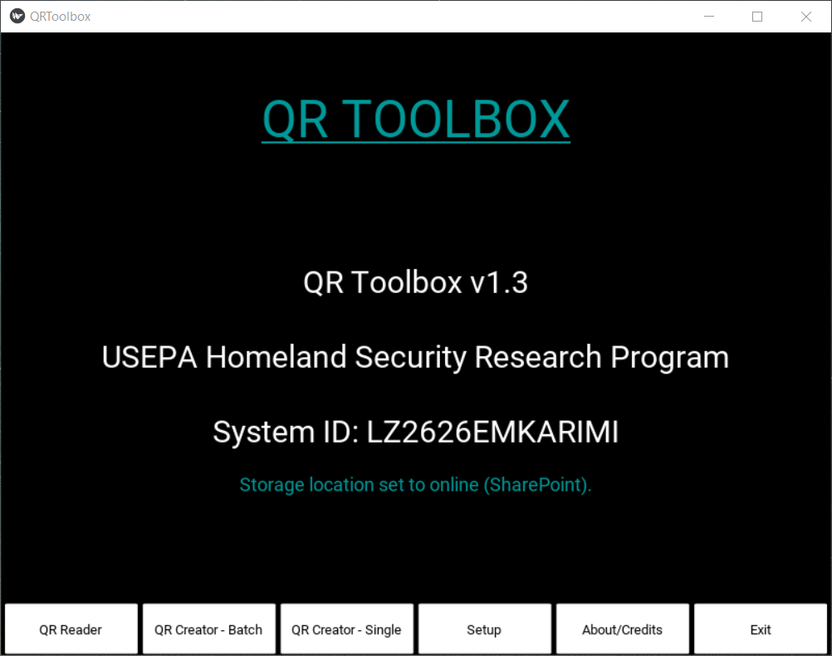
User’s Guide

u.s. Environmental protection agency

QR TOOLBOX
U.S. Environmental Protection Agency
Homeland Security Research Program
Research Triangle Park, NC 27711

Disclaimer

This tool was created by the U.S. Environmental Protection Agency through its Office of Research and Development’s Homeland Security Research Program (HSRP). The contents of this guide do not necessarily reflect the views of the Agency. Mention of trade names, products, or services does not convey official EPA approval, endorsement, or recommendation.

Acknowledgements:

Timothy Boe,

Acronym/Abbreviation List
Acronym | Definition
CESER | Center for Environmental Solutions and Emergency Response
CSV | Comma Separated Values
EPA | U.S. Environmental Protection Agency
HSRP | Homeland Security Research Program
URL  QR Code | Uniform Resource Locator  Quick Response Code

Table of Contents
- Introduction 1
How to Use This Guide 2
Point of Contact 2
- Design 3
Design Components 3
- How to setup SharePoint Online 7
- Run the Tool 10
Starting the Tool 10
FUNCTIONS 11
QR Reader 11
QR Creator - Batch 11
QR Creator - Single 12
Upload/Consolidate 12
About/Credits 13
SETTINGS 13
Change Camera Source 14
Change Storage Location 14
Ask Special Character Conversion 14
- Troubleshooting 31
Appendix A – Quick Start Guide A-1

List of Figures
Figure 1. QR-Toolbox Design Components 3
Figure 2. SharePoint Client ID and Secret Generation 4
Figure 3. SharePoint Application Key Activation 5
FIgure 4. QR-Toolbox Icon 7
Figure 5. QR-Toolbox Startup 8
Figure 6. QR-Toolbox Reader 9
Figure 7. QR-Toolbox Upload Fail 10
Figure 8. QR-Toolbox New Session or Restart Session 11
Figure 9. QR-Toolbox Restart Session Example 12
FIgure 10. QR Creator - Batch Example 13
Figure 11. QR Creator - Batch Example 2 14
Figure 12. QR Creator - Single Example 15
Figure 13. QR Creator - Single Example 2 16
Figure 14. Upload/Consolidate Function 17
Figure 15. Upload Triggered but no data Example 18
Figure 16. Consolidate Records Function Example 19
Figure 17. About/Credits Button 20
Figure 18. Exit Button 21
Figure 19. Setup Options 22
Figure 20. Change Camera Source Options 23
Figure 21. Change Storage Location 24
Figure 22. Special Character Conversion Options 25
Figure 23. Special Character Conversion - Choosing Yes Example 26
Figure 24. Special Character Conversion - Choosing No Example 27

List of Tables
Table 1. Troubleshooting Guide 28


Introduction
1
CHAPTER
Learn about this desktop-based Quick Response Code tool that allows users to create QR Codes one-by-one or en masse, along with the ability to read and log those codes to keep track of personnel or items/equipment.
EPA’s Center for Environmental Solutions and Emergency Response (CESER) within the Office of Research and Development (ORD) conducts applied, stakeholder-driven research and provides responsive technical support to help solve the Nation’s environmental challenges. The Center’s research focuses on innovative approaches to address environmental challenges associated with the built environment. CESER develops technologies and decision-support tools to help safeguard public water systems and groundwater, guide sustainable materials management, remediate sites from traditional contamination sources and emerging environmental stressors, and address potential threats from terrorism and natural disasters. In order to keep track of personnel and items/equipment during the various field work, research, and disaster/remediation response, a logistics and tracking tool would be very useful.
For this reason, the EPA Homeland Security Research Program developed the QR Toolbox, specializing in creating and reading QR Codes, which can contain various data types. The Toolbox allows the user to read the Codes into a tracking system, which records location and time of the scan, among other information. This information can be used to determine a worker’s time elapsed in a field, or to measure the efficiency of a team in sampling, or to ensure safety of individuals by checking who checked-in or out and their time of doing so, or even to inventory equipment. The tool also allows the user to change the camera that does the reading, and the location that the data is stored.

How to Use This Guide
The purpose of this guide is to provide the necessary information to operate the tool. Described in this guide are the design and development details and choices for the program, as well as the information describing how to access and operate the tool. Appendix A provides a brief Quick Start Guide.

icon keY

 Valuable Tip

 Important Note

The “icon key” to the right contains symbols used throughout this guide to highlight important information and additional guidance.

Point of Contact
Timothy Boe
US EPA Office of Research and Development
Center for Environmental Solutions and Emergency Response
Systems Tools and Materials Management Branch
919-541-2617 office
919-541-0496 fax
boe.timothy@epa.gov


Design
2
CHAPTER
Understand the tool’s underlying design, methodology, and workflow
QR Toolbox is a desktop application that only requires a Windows computer with Windows 10 to use its basic functionality. Online storage requires an internet connection and using the QR Reader function requires a camera (built-in or external).

Design Components
Python, Kivy, Office365 REST Python API, and SharePoint Online were used to develop the graphical user interface (GUI) and support the functions of the Toolbox. Python 3.7.4 and one of Python’s many GUI frameworks, Kivy, were used to develop the logic and GUI of the Toolbox. SharePoint Online is where the Toolbox stores QR Codes and any files that result from its functions when it is in online mode (the Toolbox can be used locally, without an internet connection, or online). The Toolbox uses the Office365 REST Python API to connect to the SharePoint Online Service, in order to upload or download the necessary files for the functions of the Toolbox.
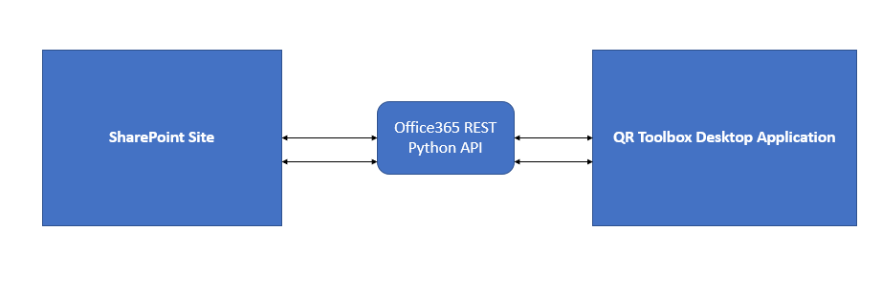
Figure 1. QR Toolbox Design Components


Setting up SharePoint Online
3
CHAPTER
Understand how to setup SharePoint Online so you can use the Toolbox’s Online Mode
As described above, QR Toolbox has both a local and an online mode. The online mode stores data and reads data from SharePoint, and requires some steps be taken before the online mode can be used.
If you need to write a QR Code(s) to a SharePoint Site, or save a file to it, you need to create an Application Key for the site so the Python script can access the SharePoint site. You’ll need to have admin rights to create an application key.
The instructions for setting up the application key are located here: https://docs.microsoft.com/en-us/sharepoint/dev/solution-guidance/security-apponly-azureacs
Here is an example SharePoint site URL: https://usepa.sharepoint.com/sites/Emergency%20Response/EOCIncident/
To create an application key, run the URL (example): https://usepa.sharepoint.com/sites/Emergency%20Response/EOCIncident/_layouts/15/AppRegNew.aspx
The following screen will show:
Figure 2. SharePoint Client ID and Secret Generation
Click the “Generate” button to generate a Client Id and a Client Secret. Write down the Client Id and Client Secret for use in the next step. Enter a Title that is meaningful for you.
Title: your title
App Domain: www.localhost.com
Redirect URI: https://www.localhost.com
Click the “Create” button to create.
Then run the following URL (example): https://usepa.sharepoint.com/sites/Emergency%20Response/EOCIncident/_layouts/15/AppInv.aspx
Figure 3. SharePoint Application Key Activation
Enter the Client id and click the ‘Lookup’ button.
In the ‘Permission Request XML:’ box, enter the following:
<AppPermissionRequests AllowAppOnlyPolicy="true">
<AppPermissionRequest Scope="http://sharepoint/content/sitecollection/web"
Right="FullControl"/>
</AppPermissionRequests>

Click the ‘Create’ button to finish.
Modify settings.py
Locate and modify the settings.py file, which if you did not change the default installation location during installation would be in “C:/Users/<user>/AppData/Local/Programs/QR-Toolbox/Setup”, where <user> is your user name for the computer the Toolbox is installed on. The settings.py file should look like below when you initially open it. Using the information generated from the last step, replace where it says ‘<Your URL>’ with your SharePoint site URL, but leave the single quotes around it. Then, replace where it says ‘<Your Client Id>’ with the Client Id you generated, and the ‘<Your Client Secret>’ with the Client Secret you generated.
settings = {
'url': '<Your URL>',
'client_id': '<Your Client Id>',
'client_secret': '<Your Client Secret>'
}


Run the Tool
4
CHAPTER
Understand the steps that are required to run the tool and what the different functions are

Access the Tool
To start the tool, either double-click the shortcut named “QR-Toolbox” (pictured below) on your desktop (if you selected this option during installation), or go to your Start Menu and find the QR-Toolbox application there (same icon as shown below).
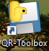
Figure 4. QR-Toolbox Icon

Startup
At startup, you will be asked to choose a storage location (pictured below). Simply choose whether you want to use local (stored on your computer) or online. If you choose online, make sure you have a working internet connection and that you’ve done the steps regarding using SharePoint. If you choose local, you can then choose where on your computer you want the files to be stored. (See SETTINGS | Choose Storage Location) for more information.
The Application is one window, with a series of buttons at the bottom. Each button has its own function, except for the ‘Setup’ button, which brings up one more function and several settings. All important information will appear in the screen that is right above the buttons. The screen is scrollable, either by using a mouse’s scroll wheel or by clicking the screen and dragging up and down (Note: laptop touchpad scrolling is somewhat difficult and finicky, it is better to use one of the other two methods).
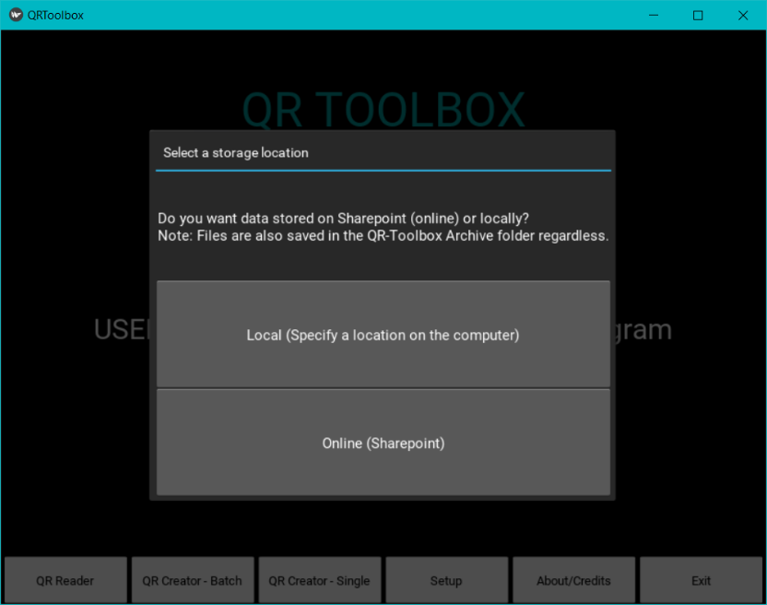
Figure 5. QR-Toolbox Startup

FUNCTIONS

QR Reader
This function allows you to start up a camera connected to your computer and read in QR Codes. The QR Codes, when read, will be highlighted on the camera window with a red box around them. The data stored in the code will then show up on the screen, along with other information, such as the Desktop currently in use, the current time, and whether the data corresponding to that QR Code is ‘checking in’ or ‘checking out’.
Note: QR Codes not generated by the QR Creator (described below) may or may not be rejected by the system due to incompatibility issues.

The QR Reader uses the ‘checking in’ and ‘checking out’ mechanism to keep track of what is read in, and this can be used for personnel as well as items/equipment. When a code is checked out, the system will also include the time elapsed since check in. All of this data will be stored in a .txt file, and at the end of the session, the data will be transferred to and stored in a .CSV file. You can find this CSV file in 3 places, depending on the systems settings:
- Archive folder – this folder is located in the root folder of the Program, so in a default installation, it should be here: “C:/Users/<your user>/AppData/Local/Programs/QR-Toolbox/Archive”. The system will store all CSV and generated QR Codes here by default.
- If local mode – the system will also store the CSV file wherever you told it to.
- If online mode – the system will also store the CSV file on the SharePoint site.
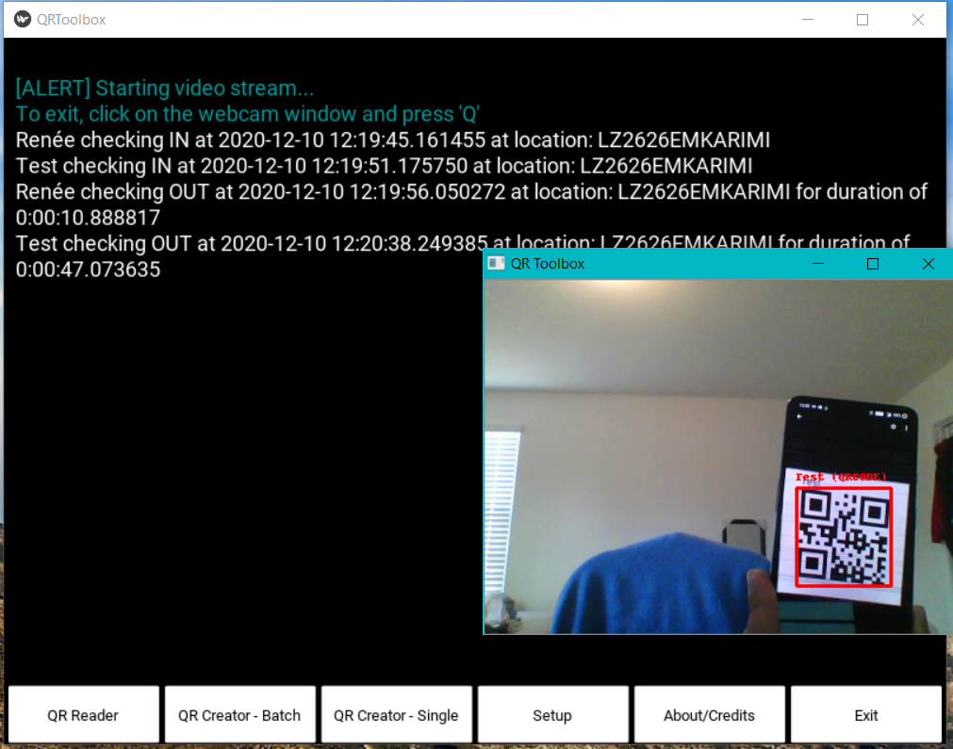
Figure 6. QR-Toolbox Reader
If you are in online mode and for some reason the system is unable to upload any QR Codes or the CSV file to the SharePoint site, it will wait for 10 seconds and then try again, and if there is another fail, it will wait 30 seconds and then try again. If it fails again, the data will be backed up in a local file, and the system will attempt to upload the data again next time it makes a connection (either in the QR Reader function, or in the QR Creator functions). You can also trigger this upload manually via the “Setup->Upload/Consolidate” function that is described later in this chapter.
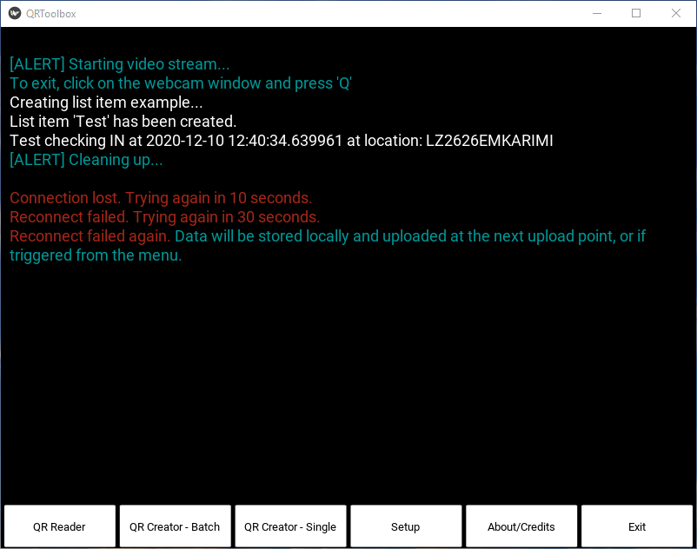
Figure 7. QR-Toolbox Upload Fail
Sessions
On starting the QR Tool, you will get another popup asking you to choose whether you want to restart an old session or not. This is another feature of the QR Reader. The QR Reader saves the data from its last run or session automatically, even in the case of a crash, so that you can start the Reader again and pick up from where you left off. However, if you don’t want to restart and instead want to start afresh, just choose the ‘New Session’ button. Note that it will delete any past records.
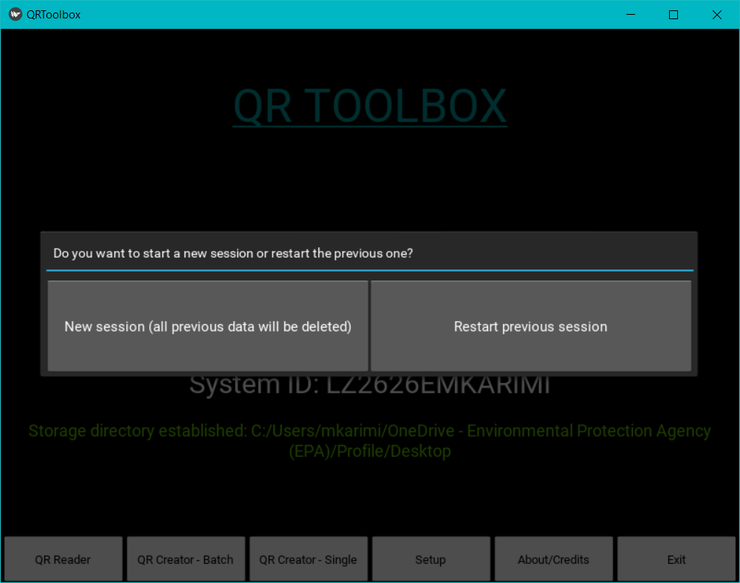
Figure 8. QR-Toolbox New Session or Restart Session
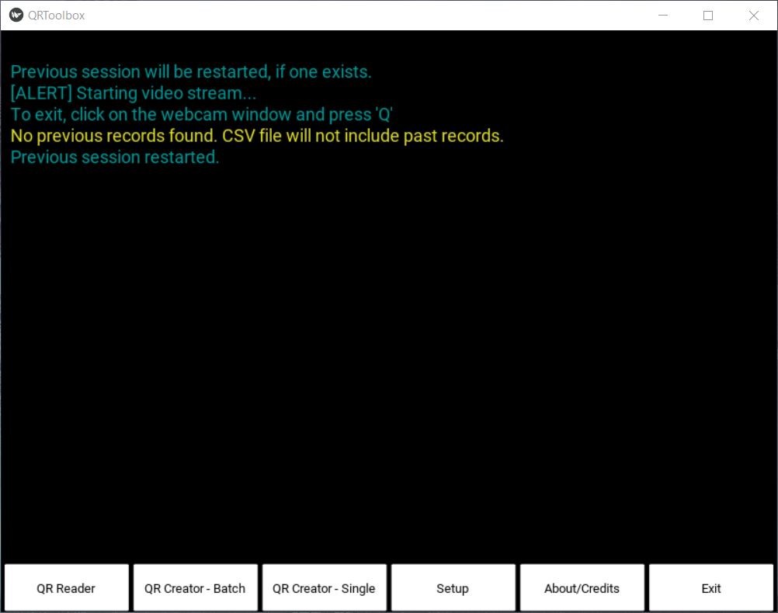
Figure 9. QR-Toolbox Restart Session Example
Exiting the Session
If you want to exit the QR Reader, simply click on the window with the video stream in it and tap ‘Q’ on your keyboard. Note that clicking the ‘X’ close button will not work.

QR Creator - Batch

This function allows you to generate a large number of QR Codes quickly, without having to do each one manually. When you click the button, the system will go ahead and generate the codes, and it will pause for a short period while it does so. Once it’s done, you will see text on the screen as to whether or not it was successful, and any other errors.

Setup

In order to set up and run this function properly, you need to do a few things:

If you’re in local mode:

Locate the installation folder for the QR-Toolbox, if default it will be “C:/Users/<Your user>/AppData/Local/Programs/QR-Toolbox”

Then, create and place a CSV file called ‘names.csv’. In this file, you should fill in the 1st or the 2nd column, or both, with whatever data/name/information you want converted into a QR Code. Each line is a new code, and you can have as many lines as you would like.

If you’re in online mode:

The concept is the same as above, the only difference is that you need to store that ‘names.csv’ file on the SharePoint site where the QR Codes are saved to.

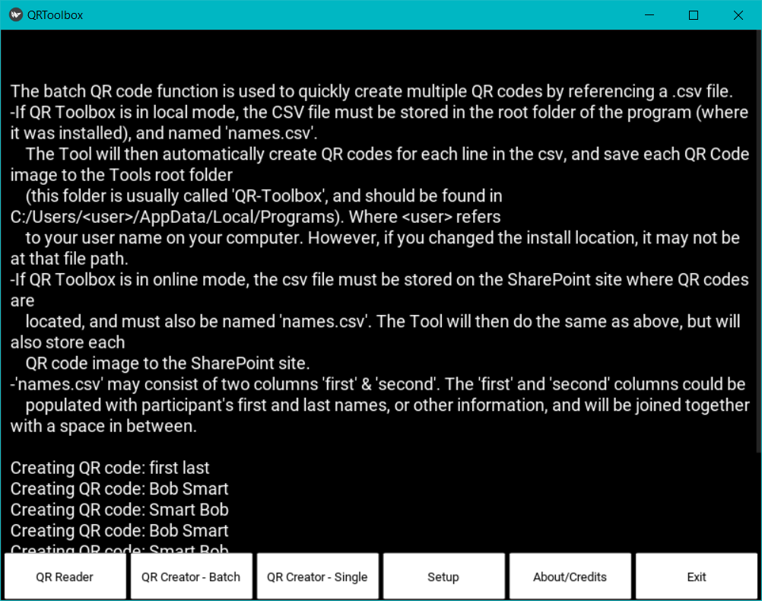
Figure 10. QR Creator – Batch Example

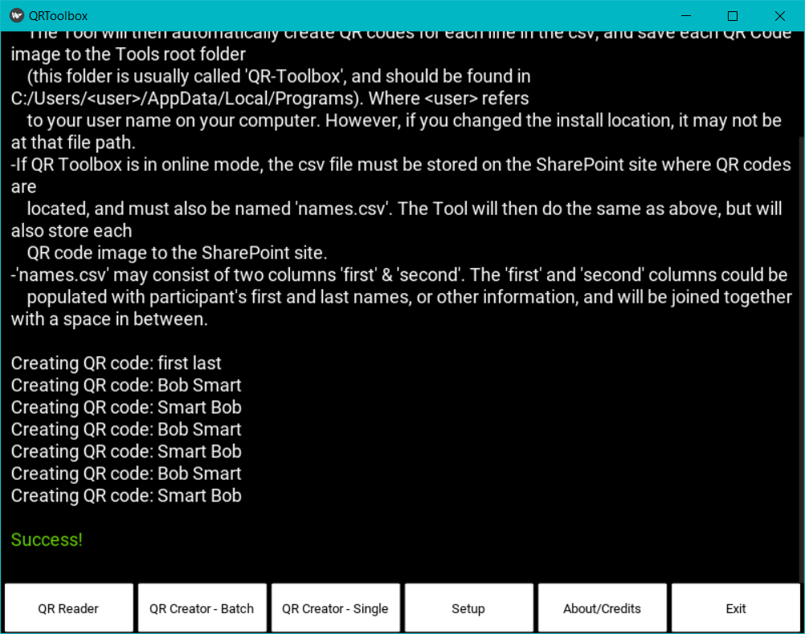
Figure 11. QR Creator – Batch Example 2

QR Creator - Single

This function allows you to create a single QR Code. In order to do this, just click the ‘QR Creator – Single’ button on the application window, and then type into the text box whatever data you want converted into a QR Code (Note: Only English and Latin characters accepted.). Once you’ve done this, press “OK’ and the system will let you know if it was successful or not.

If you are in online mode, make sure you’ve set up SharePoint and the settings.py file properly. If you’re in local mode, nothing else needs to be done.

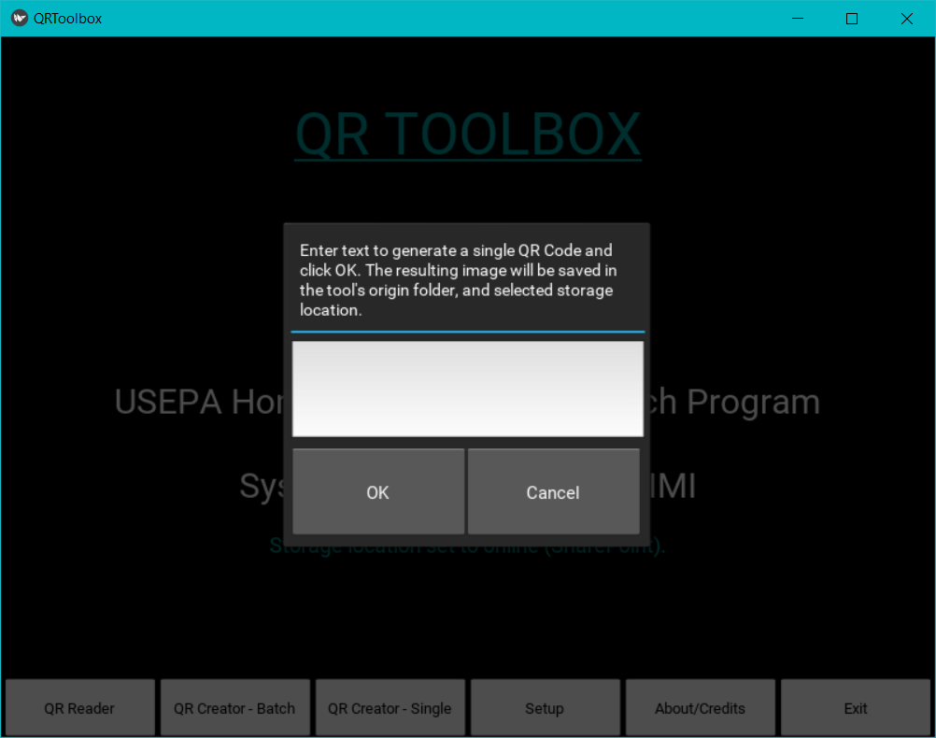
Figure 12. QR Creator – Single Example

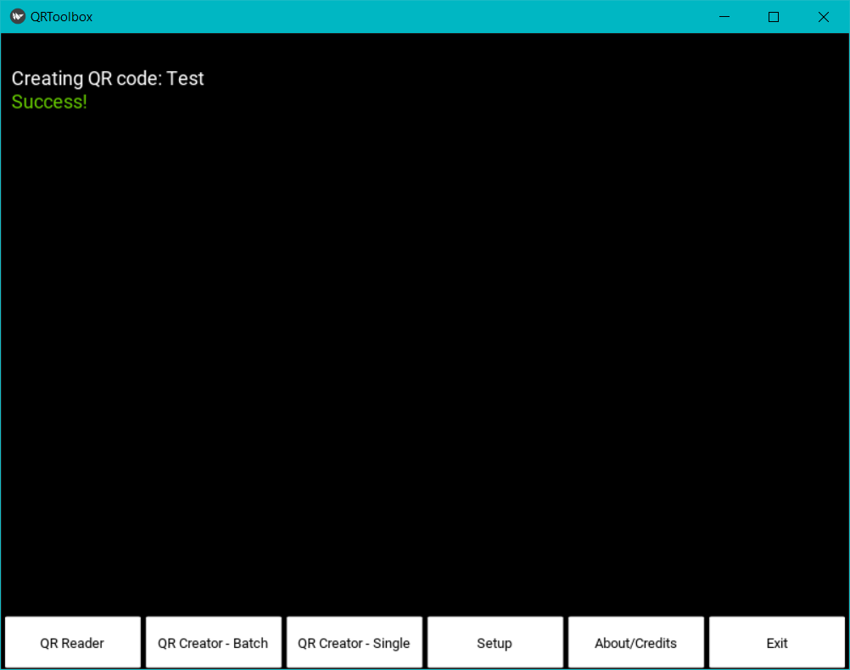
Figure 13. QR Creator – Single Example 2

Upload/Consolidate

This function depends on whether you are in online mode or local mode.

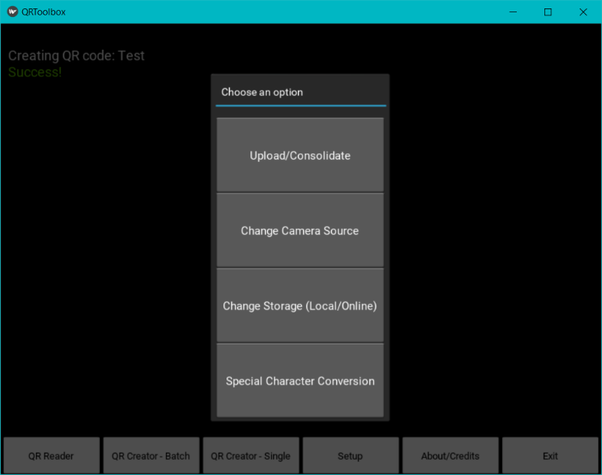
Figure 14. Upload/Consolidate Function

If you are in online mode: It will run the ‘Upload Backed-up Data’ function, and upload any data that failed to upload in the past, and if there isn’t any, it will let you know with a message on the screen.

Note: if the upload fails, the system will pause and for 10 seconds and then try again, and if it fails again it will pause for 30 seconds and then try again. If it fails again, then it will back up the data again, and attempt the upload at a later time (or you can trigger it again manually via this function).

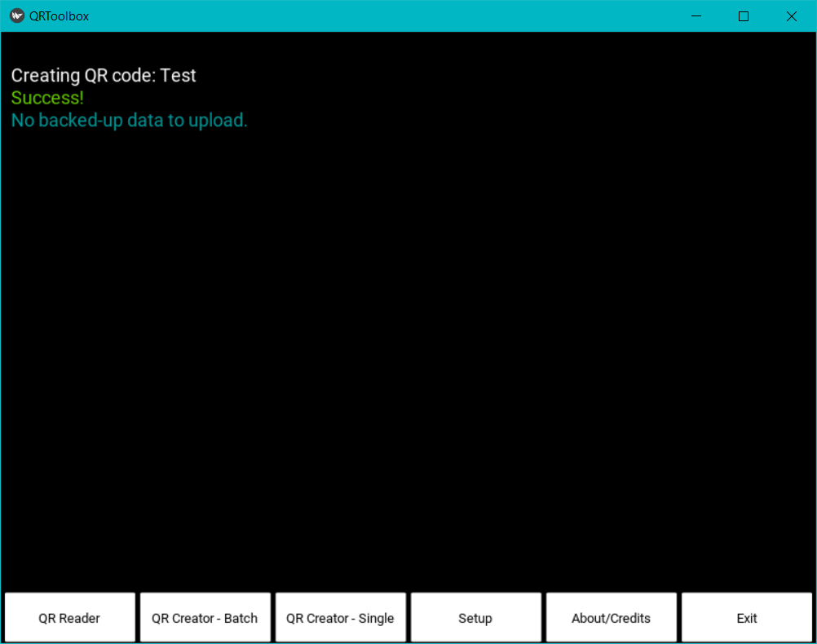
Figure 15. Upload Triggered, no data example

If you are in local mode: It will run the ‘Consolidate’ function, which will take all of the CSV files you have generated in your local folder (which is chosen by you), and consolidate them all into one CSV file, so that you can now delete the other CSV files, if you would like.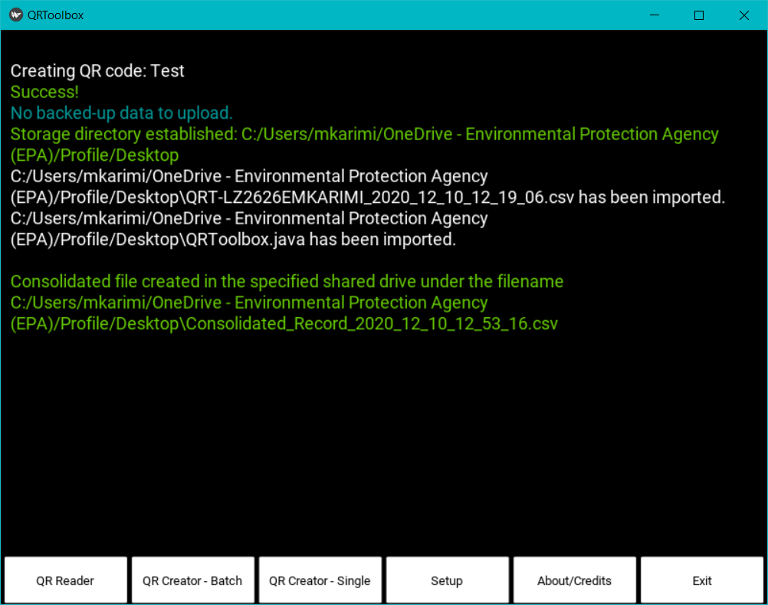
Figure 16. Consolidate Records Function Example

About/Credits

This function shows information about the QR-Toolbox, and the Credits as well. Note: It will erase everything else currently on the screen.

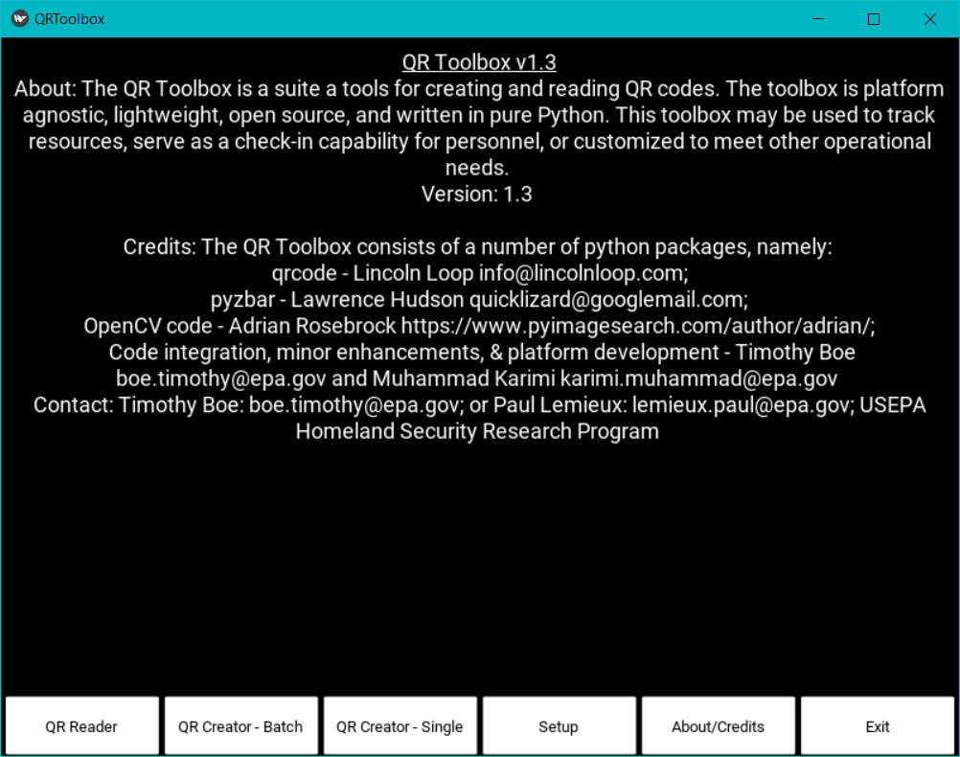
Figure 17. About/Credits Button

Exit

This function brings up the Exit Popup, which confirms that you want to exit the program. The ‘X’ Close button in the top right corner will also bring up this Popup. The popup ensures that you actually want to close the program, as closing the program during other functions may cause you to lose data (Note: If the QR Reader function is running and you exit the program, data will be lost).

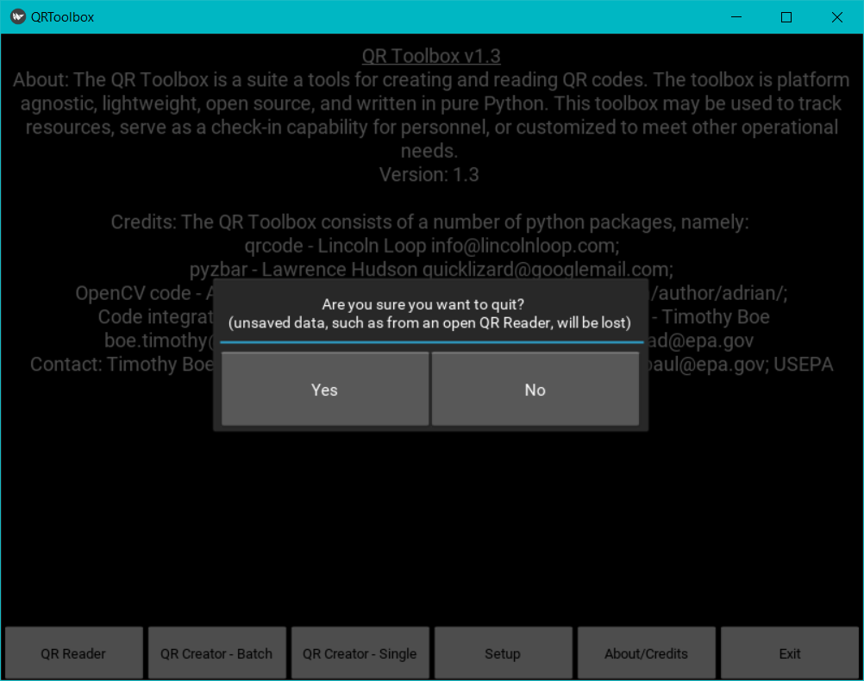
Figure 18. Exit Button

SETTINGS

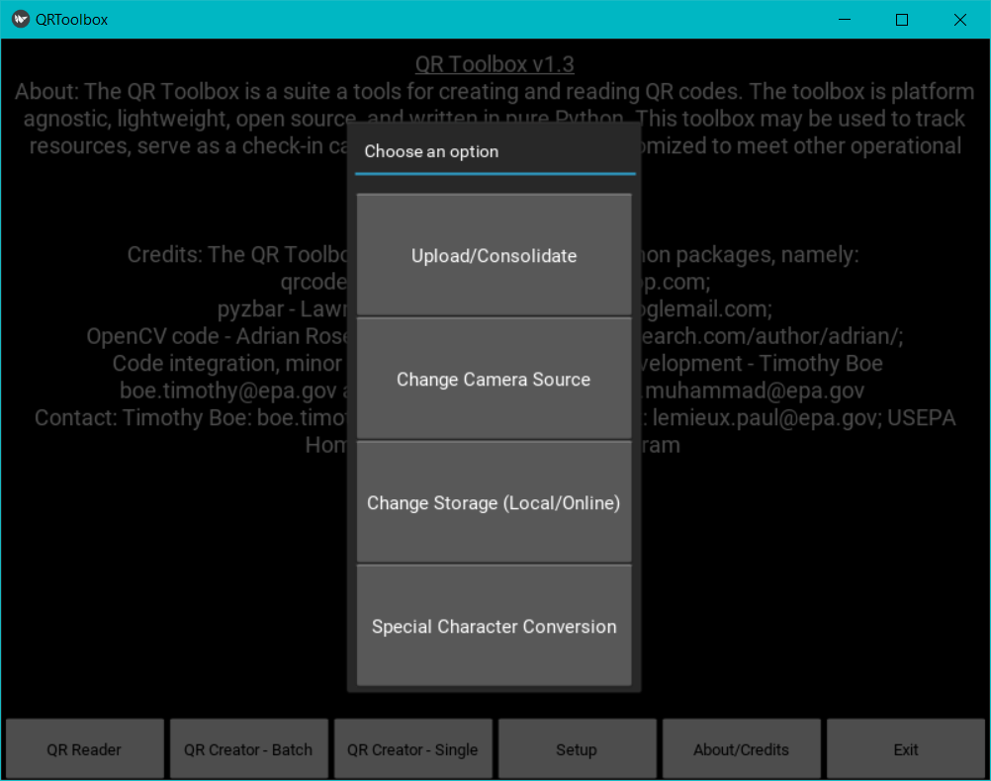
Figure 19. Setup Options

Change Camera Source

This setting allows you to select the camera that is used in the QR Reader from 3 options:

The built-in camera (if your computer has one)

An externally connected camera

A Raspberry Pi Camera/PiCamera – this functionality is experimental and likely will not work.

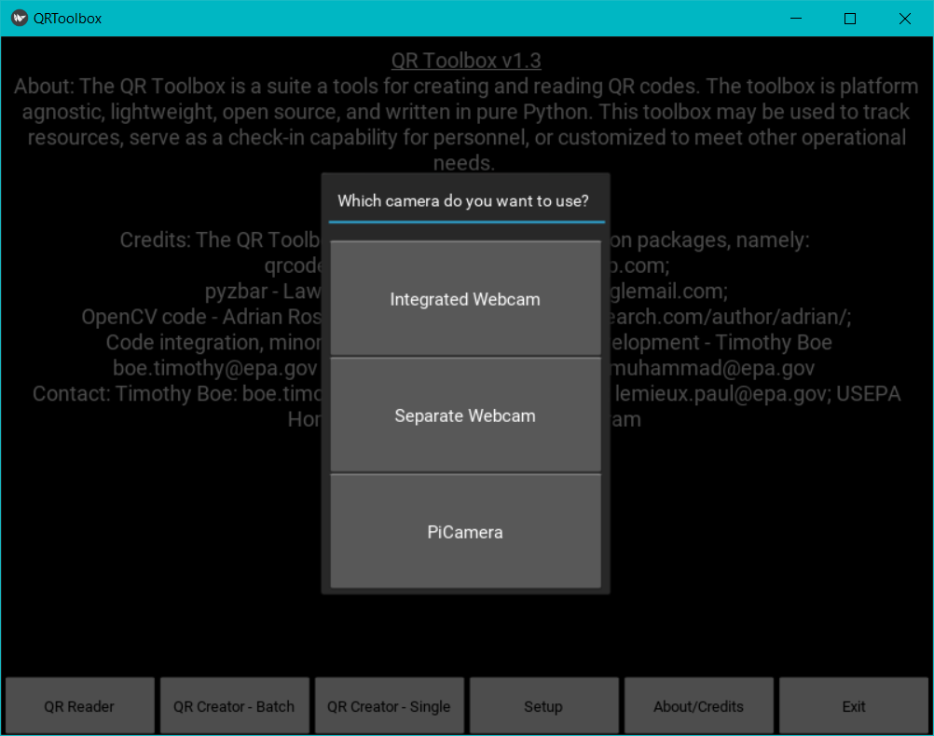
Figure 20. Change Camera Source Options

Change Storage Location

This setting allows you to change the storage location, either online (SharePoint) or local.

Note: Files are saved in the Archive folder (which is in the installation folder of the QR-Toolbox) regardless.

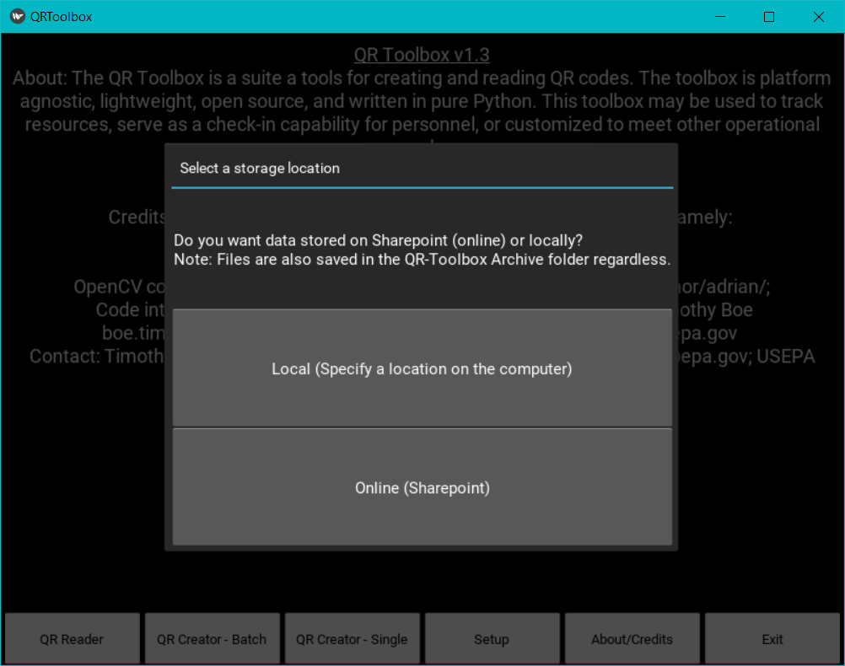
Figure 21. Change Storage Location

Special Character Conversion

This setting allows you to choose whether you want to allow special characters to be converted to regular characters or to skip them. Special characters are those that are similar to ‘é’ and the like. When storing online on SharePoint, and when converting into QR Codes, these characters don’t write properly. In order to work around this, they have to be converted into regular characters using a special code, then converted back when needed (but only for the QR Codes, the online special characters remain in their regular character forms). This setting allows you to choose whether you want to do this or not. If you choose not to allow this, the program will skip any data or code that has a special character in it.

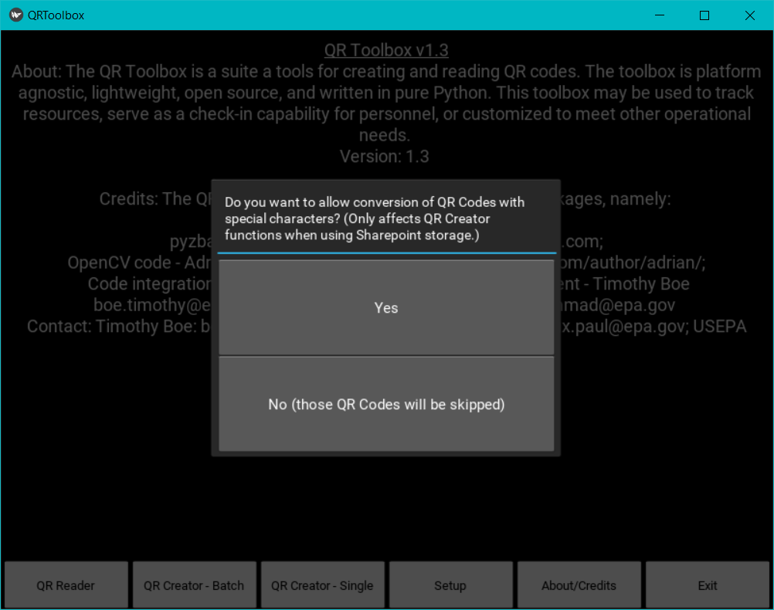
Figure 22. Special Character Conversion Options

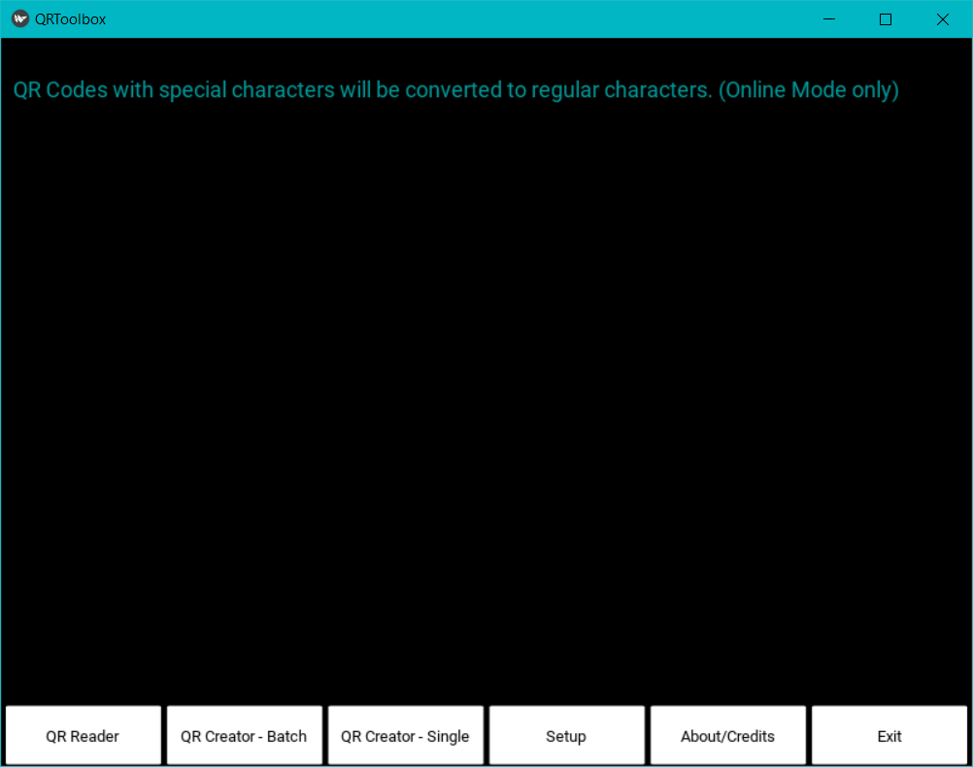
Figure 23. Special Character Conversion – Choosing Yes Example

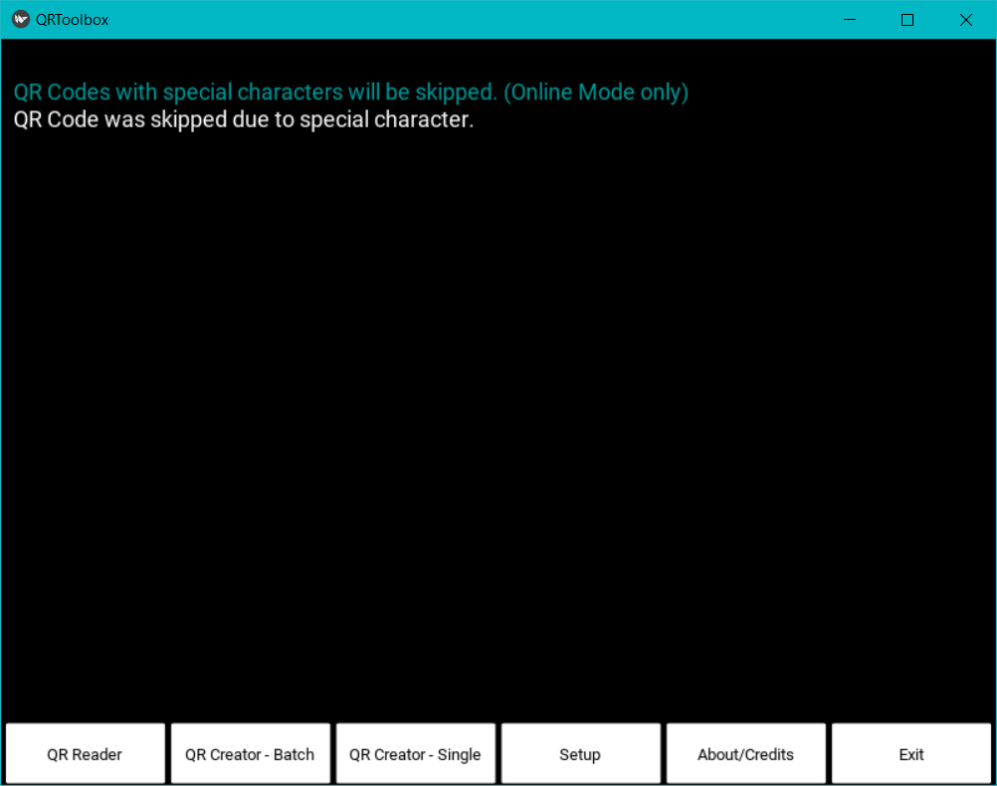
Figure 24. Special Character Conversion – Choosing No Example


Troubleshooting
5
CHAPTER
Read about issues and resolutions to common problems
This chapter provides solutions to commonly found problems that users may encounter when using QR-Toolbox.
Table 1. Troubleshooting Guide

Problem | Cause | Remedy
Program doesn’t run | If program doesn’t run right after installation, it’s likely due to a missing Microsoft Visual Code Redistributable. | In the installation folder of the QR-Toolbox there is a ‘Setup’ folder, and in that is two files, ‘vcredist_x64.exe’ and ‘vcredist_x86.exe’. To figure out which one of those to use, go to your Start Menu and search for ‘System Information’ and click that, and on the window that pops up locate the ‘System Info’ line. If the value for that has ‘x64’ in it, then run and install the ‘vcredist_x64.exe’, and if the value has ‘x32’ or ‘x86’ in it, then run and install the ‘vcredist_x86.exe’.
Online doesn’t work | If you have not setup SharePoint, or there could be an issue with your internet. If neither of these things are the issue, then there could be an issue with the code. | If it’s SharePoint, be sure ot follow the instructions above to set that up properly. If the issue is internet, contact your internet provider or technician for more help. If you think it might be the code/program itself, contact us via the Information in the Contact Us section in Chapter 1.
QR Reading fails or causes a crash | Likely due to trying to read a QR Code that was not generated by the QR-Toolbox or had characters that aren’t supported. Those kinds of QR Codes may or may not be compatible with the QR-Toolbox. | Generate the QR Code using the QR-Toolbox, and then use it with the QR Reader.
QR Creation fails | Not Latin or English characters. | Make sure you are using English and Latin characters only.
Built-in Camera doesn’t start | A common error on Windows computers | Logging out and back in usually fixes the problem, otherwise restarting should also solve the problem.
External Camera doesn’t work when you don’t have a built-in camera | This occurs because when you don’t have a built-in camera and you want to use an external webcam, so you select the external webcam option and then run it, it will try to read another camera source. | If you don’t have a built-in webcam, you should select the ‘Integrated Webcam’ option, as that is the default source for your computer.

This concludes the User’s Guide. If you have any questions, please email the point of contact listed in Chapter 1.

Appendix A – Quick Start Guide
Learn about how to quickly access and use the tool
To access the tool with minimal setup (which means you won’t be able to use online mode), simply run the program from either the desktop shortcut or the Start Menu shortcut and choose the ‘Local’ option when it starts up, and then choose where you want to store data. Then, you are able to use the QR-Toolbox however you want in local mode.

U.S. Environmental Protection Agency
Homeland Security Research Program
Research Triangle Park, NC 27711

