

Set-Everyone Group Script Deployment Guide



# EPA - Set Everyone Group

*Prepared for*

EPA

7-Aug-14

Version .1

*Prepared by*

**Sofiane ben** Sr. Consultant sofianeb@microsoft.com

Contributors

**David Weinstein**

Principal Consultant, daweins@microsoft.com

# Revision and Signoff Sheet

Change Record

|  |  |  |  |
| --- | --- | --- | --- |
| Date | Author | Version | Change Reference |
| 08/07/2014 | Sofiane Ben | .1 | Initial draft for internal review/discussion |

Reviewers

|  |  |  |  |  |
| --- | --- | --- | --- | --- |
| Name |  | Version Approved | Position | Date |

# 

Table of Contents

EPA - Set Everyone Group 1

Revision and Signoff Sheet 2

Table of Contents 3

1 Introduction 4

2 Requirements 5

3 Deployment & Configuration 6

3.1 Deploying the Script 6

3.2 Set up the Configuration File 6

3.3 Create Windows Scheduled Tasks 7

3.4 Test Check 8

4 Usage 10

4.1 Executing the Script 10

everyone 10

4.2 Configuring Logging 10

# Introduction

This document is aimed at providing guidance around the deployment and configuration of EPA’s O365 SPO Set Everyone Group script.

The function of the EPA’s O365 Set Everyone Group script is to audit the SharePoint Set Everyone Groups for the everyone group. The script implement a business logic to identify SharePoint groups that have the everyone group added to and replaces it with the UG-EPA-Employees group. This is done in order to ensure access to sites is limited to EPA employees only.

EPA’s O365 Set Everyone Group script is a console application written in .Net 4.5. The application leverages the APIs provided by Office 365 and SharePoint Online. The script communicate with EPA’s O365 tenant through SharePoint’s Client Side Object Model API (CSOM) and via https.

The document is organized as the following:

* Requirements:

Provide a listing of the requirements

* Deployment:

Detailed deployment steps of the script and configuration file

* Usage:

Detailed usage and logging configuration

# Requirements

The table below list the tool’s system requirement.

|  |  |  |
| --- | --- | --- |
| Requirement | Category | Comment |
| Windows Server OS | Platform | (any current version) |
| .Net 4.5 | Platform |  |
| Task scheduling solution | Platform | Preferably Windows Tasks Scheduler |
| Internet connectivity with port 443 enabled | Network | Communication with EPA  ‘s O365 is done via https |
| Microsoft.SharePoint.Client.dll | API | Included in package |
| Microsoft.SharePoint.Client.Runtime.dll | API | Included in package |
| Microsoft.SharePoint.Client.Search.dll | API | Included in package |
| Microsoft.SharePoint.Client.UserProfiles.dll | API | Included in package |
| Nlog.exe | API | Included in package |

***Note:*** The tool does not require additional technology such as an IIS/ASP.net sever or a SharePoint server.

# Deployment & Configuration

## Deploying the Script

Extract the content of EPA-SetEveryOne.zip into your directory of choice. The folder created will contain a script folder.

The script folder contains the tool’s executable and the supporting files

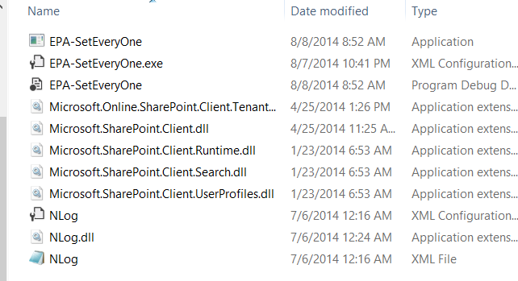

## Set up the Configuration File

The configuration file is used to store the account credentials used to access EPA’s O365 tenant as well as other configuration parameters used by the script.

The configuration file should be encrypted using the ASP.net registration tool (aspnet_regiis.exe) which ships with .Net 2.0.

In order to encrypt the configuration file:

* Rename EPA-SetEveryOne.exe.config to web.config

* Execute aspnet_regiis.exe

Execute the following command prompt: <Path-To-

Windows>\Microsoft.NET\Framework\v2.0.50727\aspnet_regiis.exe -pef connectionStrings

"<PathToFileDirectory>" -prov DataProtectionConfigurationProvider

* Rename web.config to EPA-SetEveryOne.exe.config

## Create Windows Scheduled Tasks

The script should be set up to execute at prescribed schedules and through Windows scheduled tasks. The scheduled tasks can be created with Windows’ GUI or using your command tool of choice.

Create 1 scheduled tasks:

|  |  |  |
| --- | --- | --- |
| **Name** | Schedule | Command |
| EPA-Set Everyone Group-Mismatch | Once per day (preferably after business hours) | EPA-SetEveryOne.exe everyone (See usage section ) |

## Test Check

An easy way to test deployment is execute the script without any option parameter.

After few seconds the script executes and simply logs the date and time stamp.

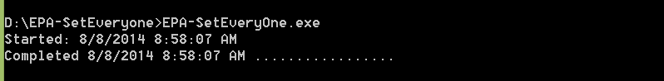

The script will create a log folder if it doesn’t already exist and appends few lines into the contained log file

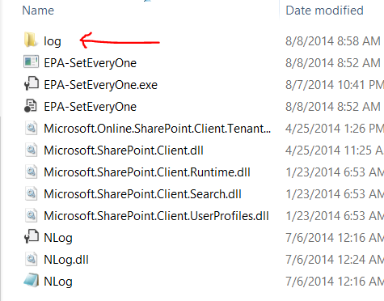

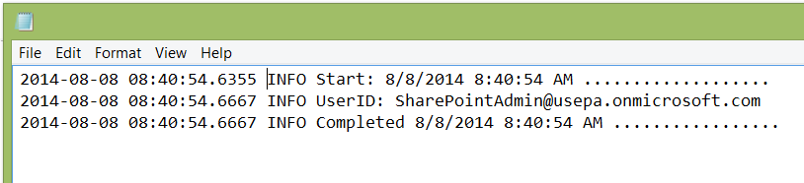

# Usage

## Executing the Script

The script should be executed through the command prompt. The script can be executed in 1 mode and uses command line argument:

### everyone

This option will instruct the script to process the team sites and will replace every occurrence of the everyone group with the UG-EPA-Employees group

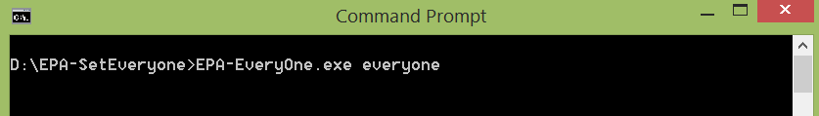

## Configuring Logging

The script uses nlog as its underlining logging framework. This enables the tool to have highly configurable logging capabilities including:

* Minimum level
* Logs directory
* Logs files maintained criteria

The nlog dll and configuration files are found within the script folder and referenced in the tool.

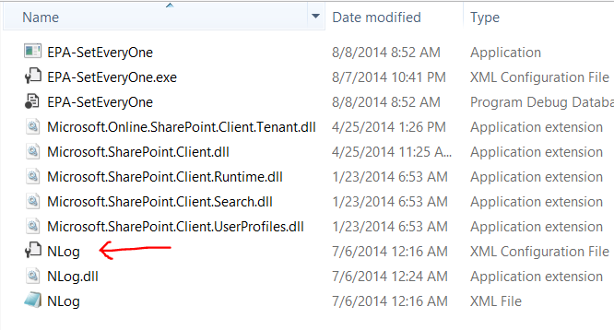

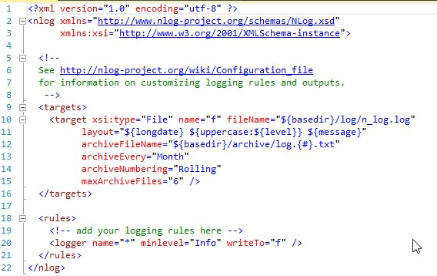

Detailed guide to nlog can be found @<https://github.com/nlog/nlog/wiki>