**Supplementary Information**

**Theoretical Equilibrium Lead (II) Solubility Revisited: Open Source Code and Practical Relationships**

David G. Wahman1, Matthew D. Pinelli2, Michael R. Schock1, and Darren A. Lytle1, *

1 United States Environmental Protection Agency, Office of Research & Development, Cincinnati, OH 45268

2 Oak Ridge Associated Universities (ORAU) Contractor to USEPA, Cincinnati, OH 45268

*Corresponding author, mailing address: USEPA, 26 W. Martin Luther King Dr., Cincinnati, OH 45268. Phone: (513) 569–7432. E–mail: [lytle.darren@epa.gov](mailto:lytle.darren@epa.gov)

**Table of Contents**

Derivation of Solubility Model Solution S-5

Inorganic Species S-5

Carbonate System S-5

Phosphate System S-6

Sulfate System S-7

Chloride System S-7

Solids S-8

Complexes S-8

Hydroxide S-8

Chloride S-9

Sulfate S-10

Carbonate S-10

Phosphate S-10

Instructions for Acquiring and Running TELSS R Code S-11

Graphical User Interface (GUI) Description S-14

Tabs for Selection. S-14

General Information Tab 1 S-15

Equilibrium Constants Selection Tab 2 S-16

Simulation Conditions Selection Tab 3 S-16

Solubility Diagram Tabs 4 through 14 S-24

Comparison of TELSS and LEADSOL Model Simulations S-27

Alternate Y–Axis Scale (Linear) for Figure 4 S-30

Alternate Y–Axis Scale (Linear) for Figure 5 S-31

Relevant Code Chunks for a Solid (Anglesite Example) S-32

Relevant Code Chunks for an Aqueous Complex (PbSO4 (aq) Example) S-37

**List of Figures**

Figure S1 Possible selection tabs S-15

Figure S2 General information tab S-17

Figure S3 Partial screenshot of equilibrium constants selection tab (Simulation A – Solids) S-18

Figure S4 Initial conditions selection (Simulation A – Type of Simulation) S-19

Figure S5 Initial conditions selection (Simulation A – pH range simulation selected) S-20

Figure S6 Initial conditions selection (Simulation A – solids to include in multiple solids analysis and function buttons) S-21

Figure S7 Example solubility diagrams (Simulation A – Pyromorphite)* S-25

Figure S8 Example solubility diagram (Simulation A – Multiple Solids)* S-26

Figure S9 Simulated total soluble lead(II) (TOTSOLPb) concentration comparison for TELSS and LEADSOL models with carbonate solids* S-27

Figure S10 Simulated lead(II) species concentration comparison for TELSS and LEADSOL models with carbonate solids* S-28

Figure S11 Simulated total soluble lead(II) (TOTSOLPb) concentration comparison for TELSS and LEADSOL models with phosphate and carbonate solids* S-29

Figure S12 Impact of dissolved inorganic carbon (DIC) and orthophosphate concentrations on simulated total soluble lead II (TOTSOLPb) concentrations for several pHs* S-30

Figure S13 Impact of pH and orthophosphate concentrations on simulated total soluble lead II (TOTSOLPb) concentrations for several dissolved inorganic carbon (DIC) concentations* S-31

**List of Tables**

Table S1 Summary of solutions for lead(II) ion concentration, [Pb2+], based on assumed controlling lead (II) solid S-8

Table S2 Summary of software and packages used to run TELSS R code locally S-14

Table S3 Summary of columns in downloaded simluation results file where each row represents a simulation condition S-22

# Derivation of Solubility Model Solution

In all Supplementary Information (SI) equations, indicates activity and indicates concentration (moles/L).

## Inorganic Species

Carbonate System**.** Dissolved inorganic carbon (DIC) concentration is provided as one of the assumed inputs to the model. Furthermore, it is assumed that the concentration of carbonate complexes is relatively small compared to the concentration of the three inorganic carbon species (SI Equation S1).

(S1)

Therefore, and because pH and ionic strength (μ) are also provided as inputs to the model, the concentrations of the inorganic carbon species (SI Equations S2 through S4) are calculated using the user–inputted DIC concentrations and α values derived from μ adjusted equilibrium constants (SI Equations S5 and S6).

(S2)

(S3)

(S4)

(S5)

(S6)

Phosphate System**.** Dissolved total inorganic phosphate (TOTPO4) concentration is provided as one of the assumed inputs to the model. Furthermore, it is assumed that the concentration of phosphate complexes is relatively small compared to the concentration of the four inorganic phosphate species (SI Equation S7).

(S7)

Therefore, and because pH and μ are also provided as inputs to the model, the concentrations of the inorganic phosphate species (SI Equations S8 through S11) are calculated using the user inputted TOTPO4 concentration and α values derived from μ adjusted equilibrium constants (SI Equations S12 through S14).

(S8)

(S9)

(S10)

(S11)

(S12)

(S13)

(S14)

Sulfate System**.** Dissolved total inorganic sulfate (TOTSO4) concentration is provided as one of the assumed inputs to the model. Furthermore, it is assumed that the concentration of sulfate complexes is relatively small compared to the concentration of the two inorganic sulfate species (SI Equation S15).

(S15)

Therefore, and because pH and μ are also provided as inputs to the model, the concentrations of the inorganic sulfate species (SI Equations S16 and S17) are calculated using the user–inputted TOTSO4 concentration and α values derived from μ adjusted equilibrium constant (SI Equations S18).

(S16)

(S17)

(S18)

Chloride System**.** Dissolved chloride concentration is provided as one of the assumed inputs to the model. Furthermore, it is assumed that the concentration of chloride complexes is relatively small compared to the concentration of chloride. Therefore, the inputed chloride concentration is used directly in the model.

## Solids

The solid equilibria were solved for the respective lead(II) (Pb(II)) ion concentration ([Pb2+], SI Table S1). The respective Pb2+ concentration is then determined using the user–inputed μ and pH, the respective solid equilibrium constant (Tables 1 and 2), and if required, the previously determined carbonate ion, phosphate ion, sulfate ion, or chloride ion concentration.

Table S1 Summary of solutions for lead(II) ion concentration, [Pb2+], based on assumed controlling lead (II) solid

|  |  |  |
| --- | --- | --- |
| **Controlling Lead(II) Solid** | **Equilibrium Equation** | **Lead(II) Ion Equilibrium Solution** |
| Lead Hydroxide  Pb(OH)2 (s) |  |  |
| Cerussite  PbCO3 (s) |  |  |
| Hydrocerussite  Pb3(CO3)2(OH)2 (s) |  |  |
| Hydroxypyromorphite  Pb5(PO4)3OH (s) |  |  |
| Pyromorphite  Pb5(PO4)3Cl (s) |  |  |
| Primary Lead Orthophosphate  Pb(H2PO4)2 (s) |  |  |
| Secondary Lead Orthophosphate  PbHPO4 (s) |  |  |
| Tertiary Lead Orthophosphate  Pb3(PO4)2 (s) |  |  |
| Anglesite  PbSO4 (s) |  |  |
| Laurionite  PbClOH (s) |  |  |

## Complexes

Hydroxide**.** Hydroxide complex equilibria are solved for the respective complex (SI Equations S19 through S26). The respective complex concentration is then determined using the user–inputted μ and pH, previously determined Pb2+ concentration, and the respective complex equilibrium constant (Table 1).

(S19)

(S20)

(S21)

(S22)

(S23)

(S24)

(S25)

(S26)

Chloride**.** Chloride complex equilibria are solved for the respective complex (SI Equations S27 through S30). The respective complex concentration is then determined using the user–inputted μ, previously determined chloride ion and Pb2+ concentrations, and the respective complex equilibrium constant (Table 1).

(S27)

(S28)

(S29)

(S30)

Sulfate**.** Sulfate complex equilibria are solved for the respective complex (SI Equations S31 and S32). The respective complex concentration is then determined using the user–inputted μ, previously determined sulfate ion and Pb2+ concentrations, and the respective complex equilibrium constant (Table 1).

(S31)

(S32)

Carbonate**.** Carbonate complex equilibria are solved for the respective complex (SI Equations S33 through S35). The respective complex concentration is then determined using the user–inputted μ and pH; previously determined carbonate ion and Pb2+ concentrations, and the respective complex equilibrium constant (Table 1).

(S33)

(S34)

(S35)

Phosphate**.** Phosphate complex equilibria are solved for the respective complex (SI Equations S36 and S37). The respective complex concentration is then determined using the user–inputted μ and pH; previously determined phosphate ion and Pb2+ concentrations, and the respective complex equilibrium constant (Table 1).

(S36)

(S37)

# Instructions for Acquiring and Running TELSS R Code

The following are the general steps to acquire and run the TELSS R code with Windows 10:

1. Download and install R: <https://cran.r-project.org/>

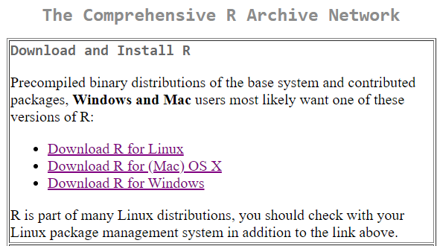

1. Download and install the free, open source edition of RStudio Desktop: <https://www.rstudio.com/products/RStudio/>

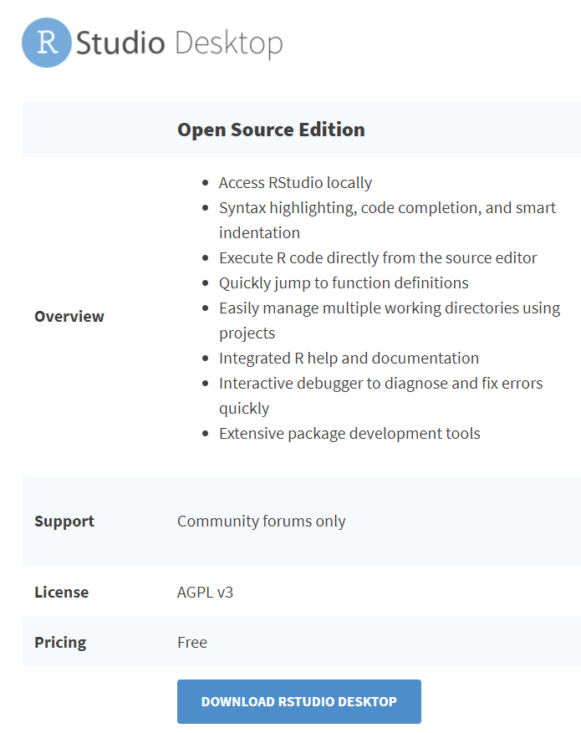

1. If not already installed, RStudio may prompt to install packages, or you may manually install the required packages as follows. Using RStudio Desktop, install the following seven packages (Tools → Install Packages):

gridExtra, reshape2, shiny, shinyBS, shinydashboard, shinythemes, tidyverse

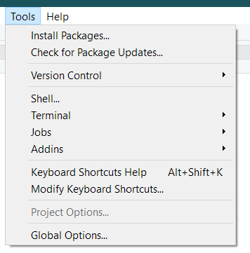

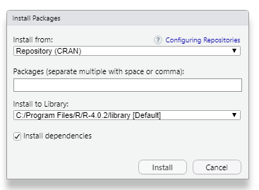

1. Download and save the TELSS R code file (app.R) located at GitHub on your local machine from <https://github.com/USEPA/TELSS>
2. Open the TELSS R code file (app.R) from within RStudio (File → Open File…)

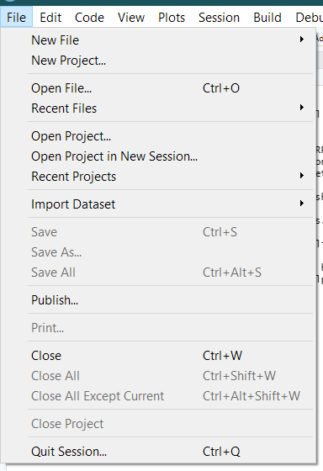

1. Once app.R loads, select the “Run App” button (see black box below) from within RStudio Desktop to run the TELSS R code which will open the graphical user interface

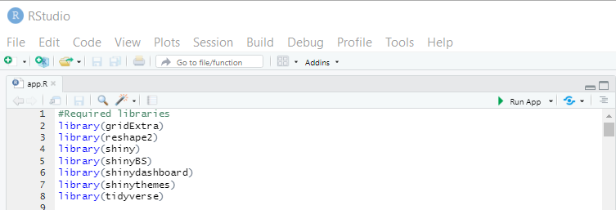

For reference, the version of R, RStudio, and associated R packages used in developing the TELSS R code are summarized in SI Table S2 along with relevant reference information.

Table S2 Summary of software and packages used to run TELSS R code locally

|  |  |  |  |
| --- | --- | --- | --- |
| **Item** | **Description** | **Version** | **Reference** |
| R | Free, open source language and environment for statistical computing and graphics | 4.0.2 | 1 |
| RStudio | Free, open source integrated development environment (IDE) for R | 1.3.1073 | 2 |
| gridExtra | R package, arrangement of multiple plots | 2.3 | 3 |
| reshape2 | R package, restructure and aggregates data | 1.4.4 | 4 |
| shiny | R package, allow creating of interactive web applications | 1.5.0 | 5 |
| shinyBS | R package, adds additional Twitter Bootstrap components to Shiny | 0.61 | 6 |
| shinydashboard | R package, allows dashboard creation with Shiny | 0.7.1 | 7 |
| shinythemes | R package, provides themes for use with Shiny | 1.1.2 | 8 |
| tidyverse | R package, a set of packages that share common data representations | 1.3.0 | 9 |
| 1R Core Team, 2020. R: A Language and Environment for Statistical Computing. R Foundation for Statistical Computing, Vienna, Austria. <https://cran.r-project.org/>  2 <https://rstudio.com/>  3 Auguie, B., 2017. *gridExtra: Miscellaneous Functions for "Grid" Graphics. R package version 2.3*. <https://CRAN.R-project.org/package=gridExtra>  4 Wickham, H., 2007. Reshaping Data with the reshape Package. *Journal of Statistical Software*, 21(12), 1-20. <http://www.jstatsoft.org/v21/i12/>  5 Chang, W., Cheng, J., Allaire, J., Xie, Y. & McPherson, J., 2020. *shiny: Web Application Framework for R. R package version 1.5.0*. <https://CRAN.R-project.org/package=shiny>  6 Bailey, E., 2015. *shinyBS: Twitter Bootstrap Components for Shiny. R package version 0.61*. <https://CRAN.R-project.org/package=shinyBS>  7 Chang, W. & Ribeiro, B., 2018. *shinydashboard: Create Dashboards with 'Shiny'. R package version 0.7.1*. <https://CRAN.R-project.org/package=shinydashboard>  8 Chang, W., 2018. *shinythemes: Themes for Shiny. R package version 1.1.2*. <https://CRAN.R-project.org/package=shinythemes>  9 Wickham et al., 2019. Welcome to the tidyverse. *Journal of Open Source Software*, 4(43), 1686. <https://doi.org/10.21105/joss.01686> | | | |

# Graphical User Interface (GUI) Description

Tabs for Selection. Running the TELSS R code provides an interactive Shiny application for the user to simulate theoretical equilibrium total soluble Pb(II) (TOTSOLPb) concentrations, including Pb2+ and Pb(II) complex concentrations. The GUI general layout is a dashboard with the left side containing 14 tabs available for selection (SI Figure S1) and the remainder displaying content for the selected tab. The application allows two simulations (A and B) to be run such that changes in a single parameter can be evaluated for comparison purposes.

Figure S1 Possible selection tabs

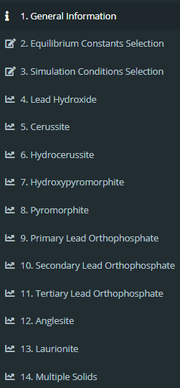

General Information Tab 1**.** SI Figure S2 displays the information provided when the general information tab is selected. The version of the TELSS R code and the last time the TELSS R code was updated is provided. General information about the contents of each possible tab selection is also provided to orient the user to the application. Finally, references and links (where available) are provided to the source literature for the equilibria and associated equilibrium constants selected for inclusion in the current model.

Equilibrium Constants Selection Tab 2**.** The equilibrium constants selection tab provides the user the ability to select which equilibrium constants are used in the solubility model, allowing direct comparison to be made to evaluate the impact of various combinations on TOTSOLPb solubility. SI Figure S3 displays the possible selections available for the solids contained in the model. For each solid, the equilibrium reaction is presented along with the log equilibrium constant value and the source for the equilibrium constant value. This tab also contains a button at the bottom of the page that allows the user to copy the current simulation’s equilibrium constants directly to the other simulation (*Copy Simulation A’s Equilibrium Constants to Simulation B’s Equilibrium Constants*).

Simulation Conditions Selection Tab 3**.** The simulation conditions selection tab allows the user to specify the desired conditions to solve the Pb solubility model. In addition, it provides for the selection of one of seven types of simulations to be run (SI Figure S4). For six of the simulations (pH range, ionic strength range, chloride range, total sulfate range, dissolved inorganic carbon range, or total phosphate range), selection will allow a range of values to be selected for the given parameter, and this parameter will become the abscissa on generated solubility diagrams. The seventh option is to simulate a single condition which will not generate a solubility diagram.

Figure S2 General information tab

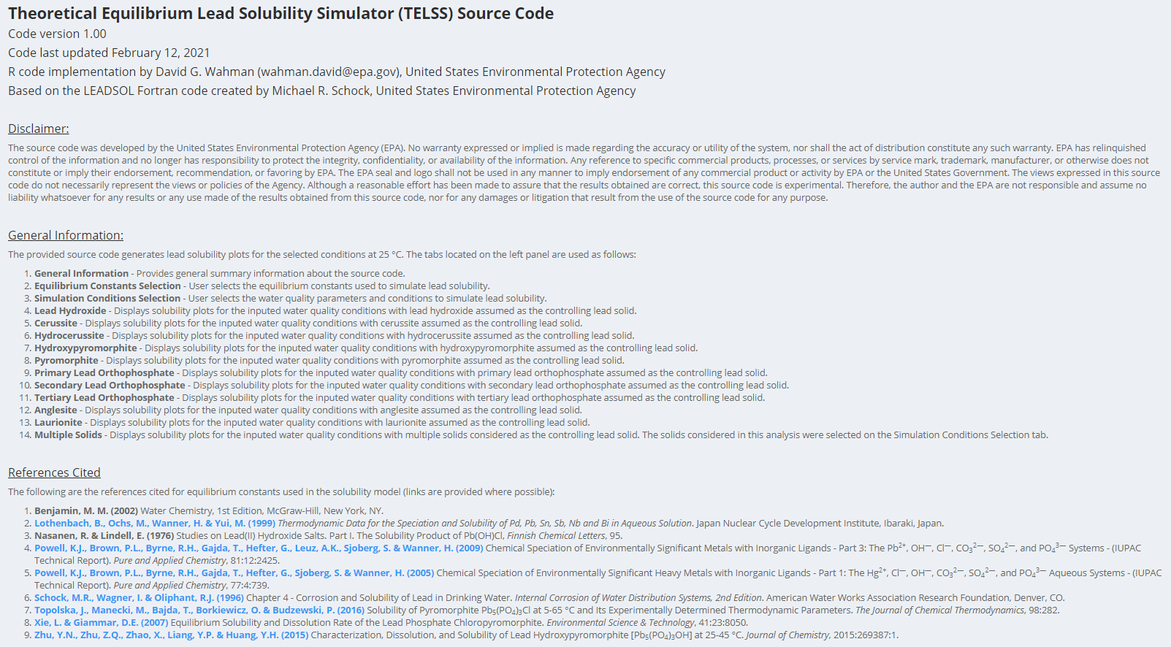

Figure S3 Partial screenshot of equilibrium constants selection tab (Simulation A – Solids)

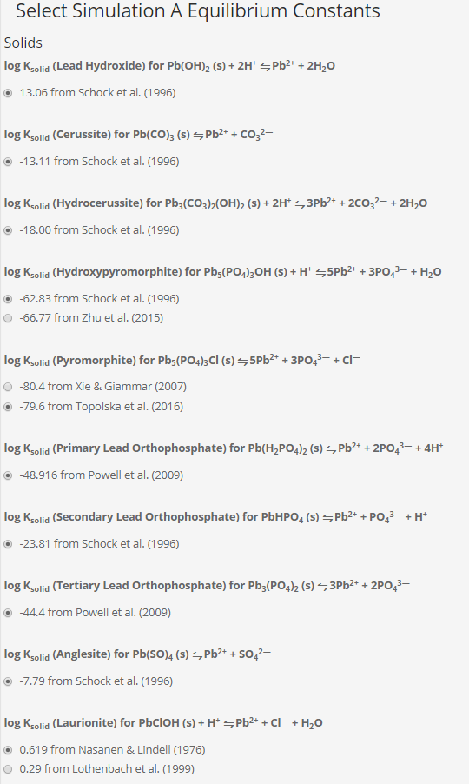

Figure S4 Initial conditions selection (Simulation A – Type of Simulation)

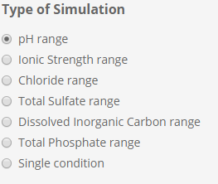

The type of simulation selected will define the other simulation conditions that are required. SI Figure S5 shows an example of the simulation conditions required when the pH range simulation type is selected. Sliders allows the selection of all required parameters.

The final area in this tab (SI Figure S6) specifies which solids will be considered when generating the multiple solids simulation and provides several buttons for the user to use. The application simulates each solid individually and then uses the individual simulations to generate a multiple solids solubility simulation. Only those solids selected will be used in the multiple solids simulation.

Figure S5 Initial conditions selection (Simulation A – pH range simulation selected)

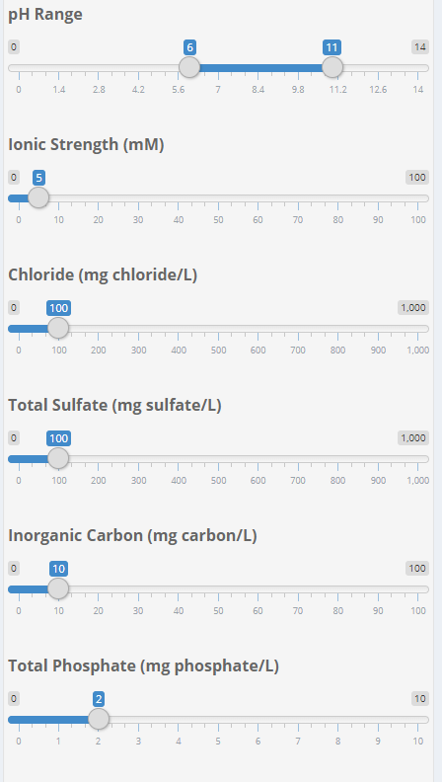

Figure S6 Initial conditions selection (Simulation A – solids to include in multiple solids analysis and function buttons)

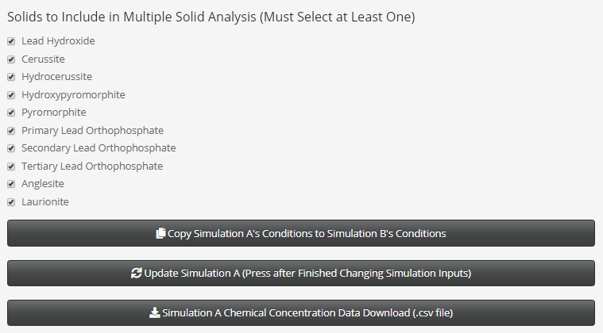

This tab also contains three buttons that allow the user to (1) copy the current simulation’s conditions directly to the other simulation (*Copy Simulation A’s Conditions to Simulation B’s Conditions*), (2) run the simulation with the provided conditions (*Update Simulation A [Press after Finishing Changing Simulation Inputs*]), and (3) export the simulation data to a comma-separated variable (.csv) file for use in external programs (*Simulation A Chemical Concentration Data Download (.csv file)*). The ability to download the concentration data allows comparison to collected experimental data and generation of additional solubility diagrams not provided with the TELSS R code. A summary of the downloaded data file is provided in SI Table S3.

Table S3 Summary of columns in downloaded simluation results file where each row represents a simulation condition

|  |  |
| --- | --- |
| **Column Header** | **Description** |
| pH | Simulation pH |
| DIC_mg_L | Simulated dissolved inorganic carbon concentration in mg/L of carbon |
| TOTP_mg_L | Simulated total phosphate concentration in mg/L of phosphate |
| TOTSO4_mg_L | Simulated total sulfate concentration in mg/L of sulfate |
| IS_mM | Simulated ionic strength in mM |
| Cl_minus_mg_L | Simulated chloride concentration in mg/L of chloride |
| lead_solid | Controlling lead(II) solid |
| analysis | Solids considered during simulation |
| Pb_2_plus | Molar concentration of chemical species |
| PbOH_plus | Molar concentration of chemical species |
| PbOH2 | Molar concentration of chemical species |
| PbOH3_minus | Molar concentration of chemical species |
| PbOH4_2_minus | Molar concentration of chemical species |
| Pb2OH_3_plus | Molar concentration of chemical species |
| Pb3OH4_2_plus | Molar concentration of chemical species |
| Pb4OH4_4_plus | Molar concentration of chemical species |
| Pb6OH8_4_plus | Molar concentration of chemical species |
| PbCl_plus | Molar concentration of chemical species |
| PbCl2 | Molar concentration of chemical species |
| PbCl3_minus | Molar concentration of chemical species |
| PbCl4_2_minus | Molar concentration of chemical species |
| PbSO4 | Molar concentration of chemical species |
| PbSO42_2_minus | Molar concentration of chemical species |
| PbHCO3_plus | Molar concentration of chemical species |
| PbCO3 | Molar concentration of chemical species |
| PbCO32_2_minus | Molar concentration of chemical species |
| PbHPO4 | Molar concentration of chemical species |
| PbH2PO4_plus | Molar concentration of chemical species |
| TOTSOLPb | Total soluble lead(II) molar concentration |
| action_level_mg_L | Lead action level in mg/L of lead |
| action_level | Lead action level in molar concentration |
| log_Pb_2_plus | Base 10 logarithm of molar concentration of chemical species |
| log_PbOH_plus | Base 10 logarithm of molar concentration of chemical species |
| log_PbOH2 | Base 10 logarithm of molar concentration of chemical species |
| log_PbOH3_minus | Base 10 logarithm of molar concentration of chemical species |
| log_PbOH4_2_minus | Base 10 logarithm of molar concentration of chemical species |
| log_Pb2OH_3_plus | Base 10 logarithm of molar concentration of chemical species |
| log_Pb3OH4_2_plus | Base 10 logarithm of molar concentration of chemical species |
| log_Pb4OH4_4_plus | Base 10 logarithm of molar concentration of chemical species |
| log_Pb6OH8_4_plus | Base 10 logarithm of molar concentration of chemical species |
| log_PbCl_plus | Base 10 logarithm of molar concentration of chemical species |
| log_PbCl2 | Base 10 logarithm of molar concentration of chemical species |
| log_PbCl3_minus | Base 10 logarithm of molar concentration of chemical species |
| log_PbCl4_2_minus | Base 10 logarithm of molar concentration of chemical species |
| log_PbSO4 | Base 10 logarithm of molar concentration of chemical species |
| log_PbSO42_2_minus | Base 10 logarithm of molar concentration of chemical species |
| log_PbCO3 | Base 10 logarithm of molar concentration of chemical species |
| log_PbHCO3_plus | Base 10 logarithm of molar concentration of chemical species |
| log_PbCO32_2_minus | Base 10 logarithm of molar concentration of chemical species |
| log_PbHPO4 | Base 10 logarithm of molar concentration of chemical species |
| log_PbH2PO4_plus | Base 10 logarithm of molar concentration of chemical species |
| log_TOTSOLPb | Base 10 logarithm of total soluble lead(II) molar concentration |
| log_action_level | Base 10 logarithm of lead action level in molar concentration |
| log_Pb_2_plus_mg_L | Base 10 logarithm of chemical species in mg/L of lead |
| log_PbOH_plus_mg_L | Base 10 logarithm of chemical species in mg/L of lead |
| log_PbOH2_mg_L | Base 10 logarithm of chemical species in mg/L of lead |
| log_PbOH3_minus_mg_L | Base 10 logarithm of chemical species in mg/L of lead |
| log_PbOH4_2_minus_mg_L | Base 10 logarithm of chemical species in mg/L of lead |
| log_Pb2OH_3_plus_mg_L | Base 10 logarithm of chemical species in mg/L of lead |
| log_Pb3OH4_2_plus_mg_L | Base 10 logarithm of chemical species in mg/L of lead |
| log_Pb4OH4_4_plus_mg_L | Base 10 logarithm of chemical species in mg/L of lead |
| log_Pb6OH8_4_plus_mg_L | Base 10 logarithm of chemical species in mg/L of lead |
| log_PbCl_plus_mg_L | Base 10 logarithm of chemical species in mg/L of lead |
| log_PbCl2_mg_L | Base 10 logarithm of chemical species in mg/L of lead |
| log_PbCl3_minus_mg_L | Base 10 logarithm of chemical species in mg/L of lead |
| log_PbCl4_2_minus_mg_L | Base 10 logarithm of chemical species in mg/L of lead |
| log_PbSO4_mg_L | Base 10 logarithm of chemical species in mg/L of lead |
| log_PbSO42_2_minus_mg_L | Base 10 logarithm of chemical species in mg/L of lead |
| log_PbHCO3_plus_mg_L | Base 10 logarithm of chemical species in mg/L of lead |
| log_PbCO3_mg_L | Base 10 logarithm of chemical species in mg/L of lead |
| log_PbCO32_2_minus_mg_L | Base 10 logarithm of chemical species in mg/L of lead |
| log_PbHPO4_mg_L | Base 10 logarithm of chemical species in mg/L of lead |
| log_PbH2PO4_plus_mg_L | Base 10 logarithm of chemical species in mg/L of lead |
| log_TOTSOLPb_mg_L | Base 10 logarithm of total soluble lead concentration in mg/L of lead |
| log_action_level_mg_L | Base 10 logarithm of lead action level concentration in mg/L of lead |

Solubility Diagram Tabs 4 through 14**.** Tab 4 (*Lead Hydroxide*) through 13 (*Laurionite*) are used to generate solubility diagrams for each of the possible control solids while tab 14 (*Multiple Solids)* considers multiple solids when generating the solubility diagrams. SI Figure S7 displays example application generated solubility diagrams when considering the controlling Pb(II) solid is pyromorphite. The upper graph’s ordinate is log molar concentration of chemical species shown in the legend while the lower graph’s ordinate is log mg/L as Pb concentration of the chemical species shown in the legend. In addition to individual chemical species, a line is provided showing the Pb action level (0.015 mg/L) and the TOTSOLPb concentration. The Pb action level is provided to provide context for the model simulations, and the simulated TOTSOLPb concentrations should not be expected to be found in practice because of the model limitations summarized in Table 3. SI Figure S7 is typical of the solubility diagrams generated on tabs 4 (*Lead Hydroxide*) through 13 (*Laurionite*). SI Figure S8 represents the typical solubility diagrams for tab 14 (*Multiple Solids)*. As with SI Figure S7, two solubility diagrams are generated on tab 14 (*Multiple Solids)* for molar and mg/L as Pb concentrations. An additional legend is presented at the bottom of the page designating which solid is controlling solubility.

Figure S7 Example solubility diagrams (Simulation A – Pyromorphite)*

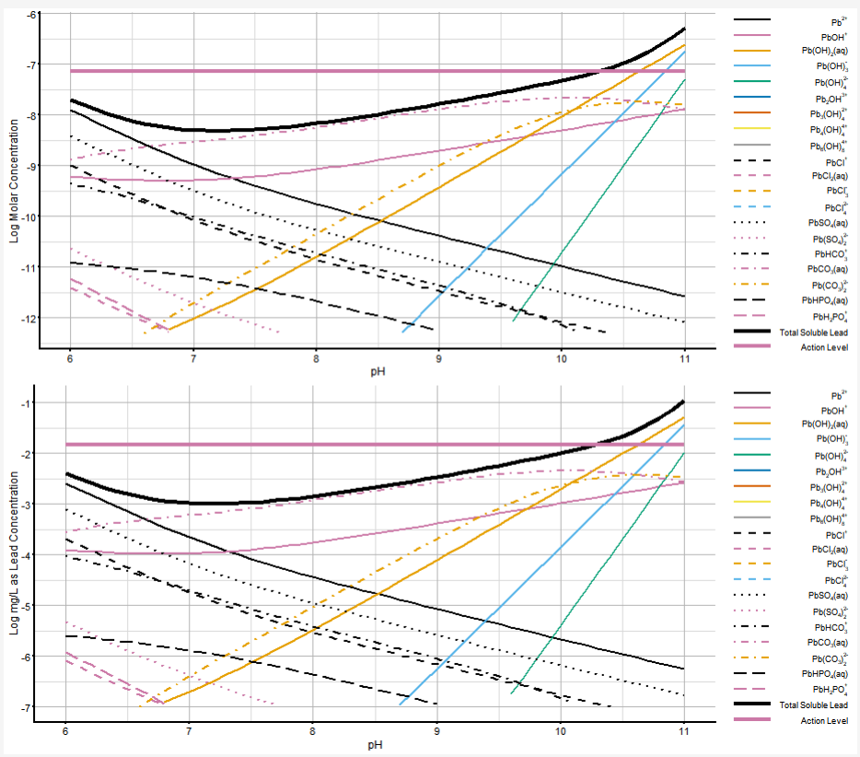

**\*Simulation conditions: 5 mM ionic strength, 100 mg Cl/L chloride, 100 mg SO4/L sulfate, 10 mg C/L dissolved inorganic carbon, 2 mg PO4/L orthophosphate, and pyromorphite as the lead(II) solid controlling solubility.**

Figure S8 Example solubility diagram (Simulation A – Multiple Solids)*

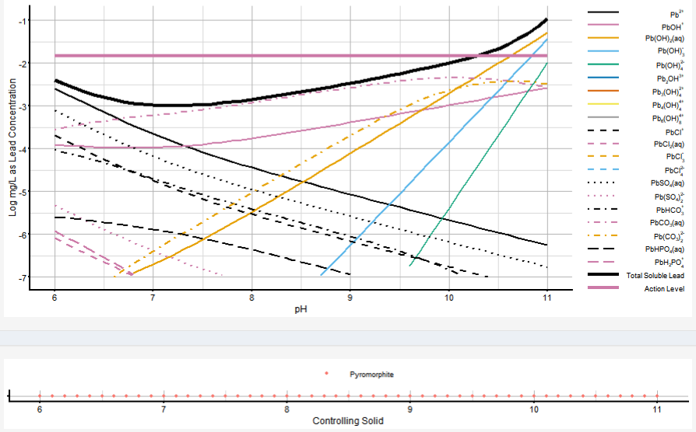

**\*Simulation conditions: 5 mM ionic strength, 100 mg Cl/L chloride, 100 mg SO4/L sulfate, 10 mg C/L dissolved inorganic carbon, 2 mg PO4/L orthophosphate, and all lead(II) solids considered for controlling solubility.**

# Comparison of TELSS and LEADSOL Model Simulations

Figure S9 Simulated total soluble lead(II) (TOTSOLPb) concentration comparison for TELSS and LEADSOL models with carbonate solids*



**\*Simulation conditions: 5 mM ionic strength, 0 mg Cl/L chloride, 0 mg SO4/L sulfate, 0 mg PO4/L orthophosphate, and cerussite and hydrocerussite solids considered for controlling solubility.**

Figure S10 Simulated lead(II) species concentration comparison for TELSS and LEADSOL models with carbonate solids*

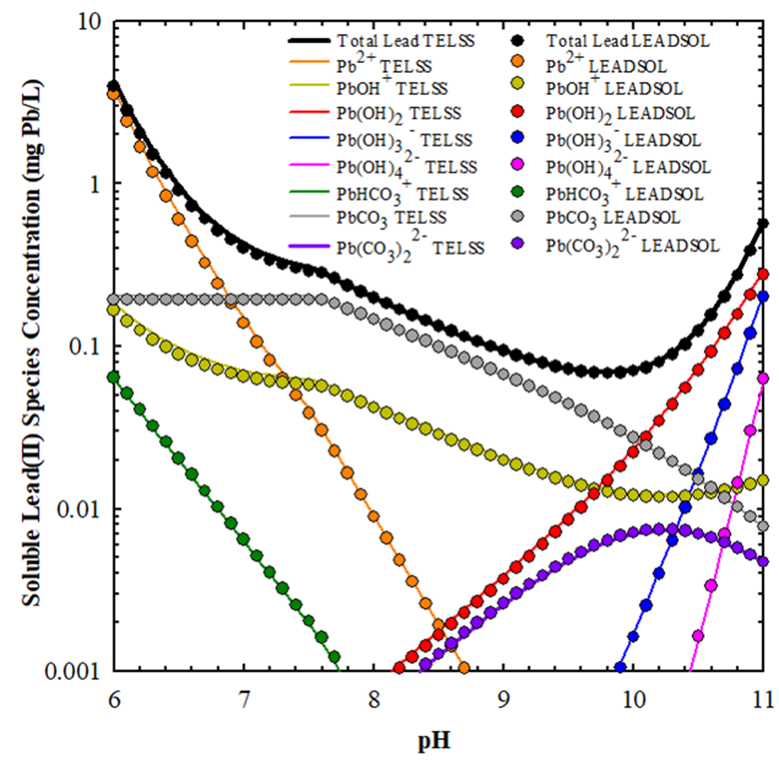

**\*Simulation conditions: 5 mM ionic strength, 0 mg Cl/L chloride, 0 mg SO4/L sulfate, 5 mg C/L dissolved inorganic carbon, 0 mg PO4/L orthophosphate, and cerussite and hydrocerussite solids considered for controlling solubility.**

Figure S11 Simulated total soluble lead(II) (TOTSOLPb) concentration comparison for TELSS and LEADSOL models with phosphate and carbonate solids*



**\*Simulation conditions: 10 mM ionic strength; 0 mg/L chloride; 0 mg/L sulfate; and cerussite, hydrocerussite, and hydroxypyromorphite solids considered for controlling solubility.**

# Alternate Y–Axis Scale (Linear) for Figure 4

Figure S12 Impact of dissolved inorganic carbon (DIC) and orthophosphate concentrations on simulated total soluble lead II (TOTSOLPb) concentrations for several pHs*

A

pH 7.0

pH 7.5

B



pH 8.5

pH 8.0

D

C



**\*5 mM ionic strength; cerussite, hydrocerussite, and hydroxypyromorphite solids considered for controlling solubility. TOTSOLPb is presented on a linear scale (see Figure 4 for a logarithmic scale version). Legend in panel A applies to all panels, and linetype denotes controlling lead(II) solid. For simulations with orthophosphate present and as DIC increases, these simulations proceed on the 0 mg PO4/L line once connected (i.e., as if orthophosphate had not been added).**

# Alternate Y–Axis Scale (Linear) for Figure 5

Figure S13 Impact of pH and orthophosphate concentrations on simulated total soluble lead II (TOTSOLPb) concentrations for several dissolved inorganic carbon (DIC) concentrations*

25 mg C/L DIC

10 mg C/L DIC

B

A



75 mg C/L DIC

50 mg C/L DIC

D

C



**\*5 mM ionic strength; cerussite, hydrocerussite, and hydroxypyromorphite solids considered for controlling solubility. TOTSOLPb is presented on a linear scale (see Figure 5 for a logarithmic scale version). Legend in panel C applies to all panels, and linetype denotes controlling lead(II) solid. For simulations with orthophosphate present and as pH increases, these simulations proceed on the 0 mg PO4/L line once connected (i.e., as if orthophosphate had not been added).**

# Relevant Code Chunks for a Solid (Anglesite Example)

The following code chunks are associated with anglesite in TELSS to provide an example of the code that is required for a solid in TELSS. The specific code for anglesite is highlighted in yellow in each code chunk. Approximate code line numbers are provided as they appeared in the authors’ RStudio session, but one would need to search the code for the specific locations of where these code chunks are located per their code editor.

**Code Lines 18-30**

# Set all parameter names for inputed conditions to pass to simulation function

sim_Names <- c("K_solid_lead_hydroxide", "K_solid_cerussite", "K_solid_hydrocerussite", "K_solid_hydroxypyromorphite",

"K_solid_pyromorphite", "K_solid_primary_lead_ortho", "K_solid_secondary_lead_ortho", "K_solid_tertiary_lead_ortho",

"K_solid_anglesite", "K_solid_laurionite",

"B_1_OH", "B_2_OH", "B_3_OH", "B_4_OH", "B_2_1_OH", "B_3_4_OH", "B_4_4_OH", "B_6_8_OH",

"K_1_Cl", "B_2_Cl", "B_3_Cl", "B_4_Cl",

"K_s", "K_1_SO4", "B_2_SO4",

"K_c_1", "K_c_2", "K_1_CO3", "K_2_CO3", "K_3_CO3",

"K_p_1", "K_p_2", "K_p_3", "K_1_PO4", "K_2_PO4",

"sim_type", "pH_single", "pH_range", "IS_mM_single", "IS_mM_range",

"Cl_minus_mg_L_single", "Cl_minus_mg_L_range",

"DIC_mg_L_single", "DIC_mg_L_range","TOTP_mg_L_single", "TOTP_mg_L_range",

"TOTSO4_mg_L_single", "TOTSO4_mg_L_range", "solids_include")

**Code Lines 190-200**

# Set list of solid names

solids <- c("Lead Hydroxide",

"Cerussite",

"Hydrocerussite",

"Hydroxypyromorphite",

"Pyromorphite",

"Primary Lead Orthophosphate",

"Secondary Lead Orthophosphate",

"Tertiary Lead Orthophosphate",

"Anglesite",

"Laurionite")

**Code Lines 256-269**

# Create function to copy simulation conditions from one simulation to another for equilibrium constants

update_IC_EQ <- function(session, from, to, input) {

# Update simulation condition for solid constants

updateRadioButtons(session, paste0(to, "_", "K_solid_lead_hydroxide"), selected = input[[paste0(from, "_", "K_solid_lead_hydroxide")]])

updateRadioButtons(session, paste0(to, "_", "K_solid_cerussite"), selected = input[[paste0(from, "_", "K_solid_cerussite")]])

updateRadioButtons(session, paste0(to, "_", "K_solid_hydrocerussite"), selected = input[[paste0(from, "_", "K_solid_hydrocerussite")]])

updateRadioButtons(session, paste0(to, "_", "K_solid_hydroxypyromorphite"), selected = input[[paste0(from, "_", "K_solid_hydroxypyromorphite")]])

updateRadioButtons(session, paste0(to, "_", "K_solid_pyromorphite"), selected = input[[paste0(from, "_", "K_solid_pyromorphite")]])

updateRadioButtons(session, paste0(to, "_", "K_solid_primary_lead_ortho"), selected = input[[paste0(from, "_", "K_solid_primary_lead_ortho")]])

updateRadioButtons(session, paste0(to, "_", "K_solid_secondary_lead_ortho"), selected = input[[paste0(from, "_", "K_solid_secondary_lead_ortho")]])

updateRadioButtons(session, paste0(to, "_", "K_solid_tertiary_lead_ortho"), selected = input[[paste0(from, "_", "K_solid_tertiary_lead_ortho")]])

updateRadioButtons(session, paste0(to, "_", "K_solid_anglesite"), selected = input[[paste0(from, "_", "K_solid_anglesite")]])

updateRadioButtons(session, paste0(to, "_", "K_solid_laurionite"), selected = input[[paste0(from, "_", "K_solid_laurionite")]])

**Code Lines 307-319**

# Define function to simulate lead solubility

simulate_solubility <- function(K_solid_lead_hydroxide, K_solid_cerussite, K_solid_hydrocerussite, K_solid_hydroxypyromorphite,

K_solid_pyromorphite, K_solid_primary_lead_ortho, K_solid_secondary_lead_ortho, K_solid_tertiary_lead_ortho,

K_solid_anglesite, K_solid_laurionite,

B_1_OH, B_2_OH, B_3_OH, B_4_OH, B_2_1_OH, B_3_4_OH, B_4_4_OH, B_6_8_OH,

K_1_Cl, B_2_Cl, B_3_Cl, B_4_Cl,

K_s, K_1_SO4, B_2_SO4,

K_c_1, K_c_2, K_1_CO3, K_2_CO3, K_3_CO3,

K_p_1, K_p_2, K_p_3, K_1_PO4, K_2_PO4,

sim_type, pH_single, pH_range, IS_mM_single, IS_mM_range,

Cl_minus_mg_L_single, Cl_minus_mg_L_range,

DIC_mg_L_single, DIC_mg_L_range, TOTP_mg_L_single, TOTP_mg_L_range,

TOTSO4_mg_L_single, TOTSO4_mg_L_range, solids_include) {

**Code Lines 485-486**

# Anglesite: PbSO4(s) --> Pb2+ + SO42-

Pb_2_plus_anglesite <- as.numeric(K_solid_anglesite) / (gamma_2^2 * SO4_2_minus)

**Code Lines 491-501**

#Create list of lead 2+ concentrations in formatted data frame for each controlling solid

Pb_2_plus <- c(Pb_2_plus_lead_hydroxide,

Pb_2_plus_cerussite,

Pb_2_plus_hydrocerussite,

Pb_2_plus_hydroxypyromorphite,

Pb_2_plus_pyromorphite,

Pb_2_plus_primary_lead_ortho,

Pb_2_plus_secondary_lead_ortho,

Pb_2_plus_tertiary_lead_ortho,

Pb_2_plus_anglesite,

Pb_2_plus_laurionite)

**Code Lines 1163-1178**

# Produce desired reactive plots

output$A_Anglesite <- renderPlot({

#Do not create a plot until an initial simulation has been conducted

if(input$simupdateA == 0) return(NULL)

#Isolate plot to update only on input$simupdate selection

plot_sim(simA(), "Anglesite")

})

output$B_Anglesite <- renderPlot({

#Do not create a plot until an initial simulation has been conducted

if(input$simupdateB == 0) return(NULL)

#Isolate plot to update only on input$simupdate selection

plot_sim(simB(), "Anglesite")

})

**Code Lines 1502-1524**

#Create input and tooltip to select which solids to include in minimization analysis

checkboxGroupInput(paste0(prefix, "_", "solids_include"),

label = h4("Solids to Include in Multiple Solid Analysis (Must Select at Least One)"),

choices = c("Lead Hydroxide",

"Cerussite",

"Hydrocerussite",

"Hydroxypyromorphite",

"Pyromorphite",

"Primary Lead Orthophosphate",

"Secondary Lead Orthophosphate",

"Tertiary Lead Orthophosphate",

"Anglesite",

"Laurionite"),

selected = c("Lead Hydroxide",

"Cerussite",

"Hydrocerussite",

"Hydroxypyromorphite",

"Pyromorphite",

"Primary Lead Orthophosphate",

"Secondary Lead Orthophosphate",

"Tertiary Lead Orthophosphate",

"Anglesite",

"Laurionite"),

**Code Lines 1666-1676**

radioButtons(paste0(prefix, "_", "K_solid_anglesite"),

label = p(HTML("log K<sub>solid</sub> (Anglesite) for Pb(SO)<sub>4</sub> (s) &#8651; Pb<sup>2+</sup> + SO<sub>4</sub><sup>2&#8212;</sup>"),

style = "font-size: 14px"),

c("-7.79 from Schock et al. (1996)" = 10^-7.79),

selected = 10^-7.79),

bsTooltip(id = paste0(prefix, "_", "K_solid_anglesite"),

"Set desired equilibrium constant for simulation",

"top",

options = list(container = "body")),

br(),

**Code Lines 2027-2042**

sidebarMenu(

menuItem("1. General Information", tabName = "Information", icon = icon("info")),

menuItem("2. Equilibrium Constants Selection", tabName = "Inputs_EQ", icon = icon("edit")),

menuItem("3. Simulation Conditions Selection", tabName = "Inputs", icon = icon("edit")),

menuItem("4. Lead Hydroxide", tabName = "Lead_Hydroxide", icon = icon("line-chart")),

menuItem("5. Cerussite", tabName = "Cerussite", icon = icon("line-chart")),

menuItem("6. Hydrocerussite", tabName = "Hydrocerussite", icon = icon("line-chart")),

menuItem("7. Hydroxypyromorphite", tabName = "Hydroxypyromorphite", icon = icon("line-chart")),

menuItem("8. Pyromorphite", tabName = "Pyromorphite", icon = icon("line-chart")),

menuItem("9. Primary Lead Orthophosphate", tabName = "Primary_Lead", icon = icon("line-chart")),

menuItem("10. Secondary Lead Orthophosphate", tabName = "Secondary_Lead", icon = icon("line-chart")),

menuItem("11. Tertiary Lead Orthophosphate", tabName = "Tertiary_Lead", icon = icon("line-chart")),

menuItem("12. Anglesite", tabName = "Anglesite", icon = icon("line-chart")),

menuItem("13. Laurionite", tabName = "Laurionite", icon = icon("line-chart")),

menuItem("14. Multiple Solids", tabName = "Multiple", icon = icon("line-chart"))

)

**Code Lines 2179-2181**

tags$li(tags$b("Anglesite"),

" - Displays solubility plots for the inputed water quality

conditions with anglesite assumed as the controlling lead solid."),

**Code Lines 2361-2370**

#Anglesite

tabItem(tabName = "Anglesite",

theme = shinytheme("spacelab"),

#Layout for simulation conditions and plots

fluidRow(

render_plot_outputs("A - Anglesite", "A_Anglesite"),

render_plot_outputs("B - Anglesite", "B_Anglesite"))

),

# Relevant Code Chunks for an Aqueous Complex (PbSO4 (aq) Example)

The following code chunks are associated with PbSO4 (aq) in TELSS to provide an example of the code that is required for an aqueous complex in TELSS. The specific code for PbSO4 (aq) is highlighted in yellow in each code chunk. Approximate code line numbers are provided as they appeared in the authors’ RStudio session, but one would need to search the code for the specific locations of where these code chunks are located per their code editor.

**Code Lines 18-30**

# Set all parameter names for inputed conditions to pass to simulation function

sim_Names <- c("K_solid_lead_hydroxide", "K_solid_cerussite", "K_solid_hydrocerussite", "K_solid_hydroxypyromorphite",

"K_solid_pyromorphite", "K_solid_primary_lead_ortho", "K_solid_secondary_lead_ortho", "K_solid_tertiary_lead_ortho",

"K_solid_anglesite", "K_solid_laurionite",

"B_1_OH", "B_2_OH", "B_3_OH", "B_4_OH", "B_2_1_OH", "B_3_4_OH", "B_4_4_OH", "B_6_8_OH",

"K_1_Cl", "B_2_Cl", "B_3_Cl", "B_4_Cl",

"K_s", "K_1_SO4", "B_2_SO4",

"K_c_1", "K_c_2", "K_1_CO3", "K_2_CO3", "K_3_CO3",

"K_p_1", "K_p_2", "K_p_3", "K_1_PO4", "K_2_PO4",

"sim_type", "pH_single", "pH_range", "IS_mM_single", "IS_mM_range",

"Cl_minus_mg_L_single", "Cl_minus_mg_L_range",

"DIC_mg_L_single", "DIC_mg_L_range","TOTP_mg_L_single", "TOTP_mg_L_range",

"TOTSO4_mg_L_single", "TOTSO4_mg_L_range", "solids_include")

**Code Lines 287-290**

# Update simulation condition for sulfate constants

updateRadioButtons(session, paste0(to, "_", "K_s"), selected = input[[paste0(from, "_", "K_s")]])

updateRadioButtons(session, paste0(to, "_", "K_1_SO4"), selected = input[[paste0(from, "_", "K_1_SO4")]])

updateRadioButtons(session, paste0(to, "_", "B_2_SO4"), selected = input[[paste0(from, "_", "B_2_SO4")]])

**Code Lines 307-319**

# Define function to simulate lead solubility

simulate_solubility <- function(K_solid_lead_hydroxide, K_solid_cerussite, K_solid_hydrocerussite, K_solid_hydroxypyromorphite,

K_solid_pyromorphite, K_solid_primary_lead_ortho, K_solid_secondary_lead_ortho, K_solid_tertiary_lead_ortho,

K_solid_anglesite, K_solid_laurionite,

B_1_OH, B_2_OH, B_3_OH, B_4_OH, B_2_1_OH, B_3_4_OH, B_4_4_OH, B_6_8_OH,

K_1_Cl, B_2_Cl, B_3_Cl, B_4_Cl,

K_s, K_1_SO4, B_2_SO4,

K_c_1, K_c_2, K_1_CO3, K_2_CO3, K_3_CO3,

K_p_1, K_p_2, K_p_3, K_1_PO4, K_2_PO4,

sim_type, pH_single, pH_range, IS_mM_single, IS_mM_range,

Cl_minus_mg_L_single, Cl_minus_mg_L_range,

DIC_mg_L_single, DIC_mg_L_range, TOTP_mg_L_single, TOTP_mg_L_range,

TOTSO4_mg_L_single, TOTSO4_mg_L_range, solids_include) {

**Code Lines 538-540**

# Calculate lead-sulfate complex concentrations

Pb_conc$PbSO4 <- as.numeric(K_1_SO4) * gamma_2^2 * Pb_conc$Pb_2_plus * SO4_2_minus

Pb_conc$PbSO42_2_minus <- as.numeric(B_2_SO4) * gamma_2^2 * Pb_conc$Pb_2_plus * SO4_2_minus^2

**Code Lines 551-558**

# Calculate total dissolved lead molar concentration

Pb_conc$TOTSOLPb <- Pb_conc$Pb_2_plus +

Pb_conc$PbOH_plus + Pb_conc$PbOH2 + Pb_conc$PbOH3_minus + Pb_conc$PbOH4_2_minus +

2 * Pb_conc$Pb2OH_3_plus + 3 * Pb_conc$Pb3OH4_2_plus + 4 * Pb_conc$Pb4OH4_4_plus + 6 * Pb_conc$Pb6OH8_4_plus +

Pb_conc$PbCl_plus + Pb_conc$PbCl2 + Pb_conc$PbCl3_minus + Pb_conc$PbCl4_2_minus +

Pb_conc$PbSO4 + Pb_conc$PbSO42_2_minus +

Pb_conc$PbHCO3_plus + Pb_conc$PbCO3 + Pb_conc$PbCO32_2_minus +

Pb_conc$PbHPO4 + Pb_conc$PbH2PO4_plus

**Code Lines 564-578**

# Calculate log molar concentrations

Pb_conc$log_Pb_2_plus <- log10(Pb_conc$Pb_2_plus)

Pb_conc$log_PbOH_plus <- log10(Pb_conc$PbOH_plus)

Pb_conc$log_PbOH2 <- log10(Pb_conc$PbOH2)

Pb_conc$log_PbOH3_minus <- log10(Pb_conc$PbOH3_minus)

Pb_conc$log_PbOH4_2_minus <- log10(Pb_conc$PbOH4_2_minus)

Pb_conc$log_Pb2OH_3_plus <- log10(Pb_conc$Pb2OH_3_plus)

Pb_conc$log_Pb3OH4_2_plus <- log10(Pb_conc$Pb3OH4_2_plus)

Pb_conc$log_Pb4OH4_4_plus <- log10(Pb_conc$Pb4OH4_4_plus)

Pb_conc$log_Pb6OH8_4_plus <- log10(Pb_conc$Pb6OH8_4_plus)

Pb_conc$log_PbCl_plus <- log10(Pb_conc$PbCl_plus)

Pb_conc$log_PbCl2 <- log10(Pb_conc$PbCl2)

Pb_conc$log_PbCl3_minus <- log10(Pb_conc$PbCl3_minus)

Pb_conc$log_PbCl4_2_minus <- log10(Pb_conc$PbCl4_2_minus)

Pb_conc$log_PbSO4 <- log10(Pb_conc$PbSO4)

**Code Lines 595-609**

# Calculate log mg lead/L concentrations

Pb_conc$log_Pb_2_plus_mg_L <- log10(Pb_conc$Pb_2_plus * 1000 * Pb_MW)

Pb_conc$log_PbOH_plus_mg_L <- log10(Pb_conc$PbOH_plus * 1000 * Pb_MW)

Pb_conc$log_PbOH2_mg_L <- log10(Pb_conc$PbOH2 * 1000 * Pb_MW)

Pb_conc$log_PbOH3_minus_mg_L <- log10(Pb_conc$PbOH3_minus * 1000 * Pb_MW)

Pb_conc$log_PbOH4_2_minus_mg_L <- log10(Pb_conc$PbOH4_2_minus * 1000 * Pb_MW)

Pb_conc$log_Pb2OH_3_plus_mg_L <- log10(Pb_conc$Pb2OH_3_plus * 1000 * Pb_MW * 2)

Pb_conc$log_Pb3OH4_2_plus_mg_L <- log10(Pb_conc$Pb3OH4_2_plus * 1000 * Pb_MW * 3)

Pb_conc$log_Pb4OH4_4_plus_mg_L <- log10(Pb_conc$Pb4OH4_4_plus * 1000 * Pb_MW * 4)

Pb_conc$log_Pb6OH8_4_plus_mg_L <- log10(Pb_conc$Pb6OH8_4_plus * 1000 * Pb_MW * 6)

Pb_conc$log_PbCl_plus_mg_L <- log10(Pb_conc$PbCl_plus * 1000 * Pb_MW)

Pb_conc$log_PbCl2_mg_L <- log10(Pb_conc$PbCl2 * 1000 * Pb_MW)

Pb_conc$log_PbCl3_minus_mg_L <- log10(Pb_conc$PbCl3_minus * 1000 * Pb_MW)

Pb_conc$log_PbCl4_2_minus_mg_L <- log10(Pb_conc$PbCl4_2_minus * 1000 * Pb_MW)

Pb_conc$log_PbSO4_mg_L <- log10(Pb_conc$PbSO4 * 1000 * Pb_MW)

**Code Lines 693-713**

Pb_DF_combo <- Pb %>%

select(pH,

DIC_mg_L,

TOTP_mg_L,

TOTSO4_mg_L,

IS_mM,

Cl_minus_mg_L,

log_Pb_2_plus,

log_PbOH_plus,

log_PbOH2,

log_PbOH3_minus,

log_PbOH4_2_minus,

log_Pb2OH_3_plus,

log_Pb3OH4_2_plus,

log_Pb4OH4_4_plus,

log_Pb6OH8_4_plus,

log_PbCl_plus,

log_PbCl2,

log_PbCl3_minus,

log_PbCl4_2_minus,

log_PbSO4,

**Code Lines 750-771**

# Assemble data frame of log mg lead/L concentrations versus pH

Pb_DF_mg_L_combo <- Pb %>%

select(pH,

DIC_mg_L,

TOTP_mg_L,

TOTSO4_mg_L,

IS_mM,

Cl_minus_mg_L,

log_Pb_2_plus_mg_L,

log_PbOH_plus_mg_L,

log_PbOH2_mg_L,

log_PbOH3_minus_mg_L,

log_PbOH4_2_minus_mg_L,

log_Pb2OH_3_plus_mg_L,

log_Pb3OH4_2_plus_mg_L,

log_Pb4OH4_4_plus_mg_L,

log_Pb6OH8_4_plus_mg_L,

log_PbCl_plus_mg_L,

log_PbCl2_mg_L,

log_PbCl3_minus_mg_L,

log_PbCl4_2_minus_mg_L,

log_PbSO4_mg_L,

**Code Lines 808-820**

# Rename column names in data frames

col_names <- c(type,

"Pb 2+",

"PbOH +", "Pb(OH)2", "Pb(OH)3 -", "Pb(OH)4 2-",

"Pb2OH 3+", "Pb3(OH)4 2+", "Pb4(OH)4 4+", "Pb6(OH)8 8+",

"PbCl +", "PbCl2", "PbCl3 -", "PbCl4 2-",

"PbSO4", "Pb(SO4)2 2-",

"PbHCO3 +", "PbCO3", "Pb(CO3)2 2-",

"PbHPO4", "PbH2PO4 +",

# "H2CO3", "HCO3 -", "CO3 2-",

# "H3PO4", "H2PO4 -", "HPO4 2-", "PO4 3-",

"TOTSOLPb",

"AL")

**Code Lines 1845-1854**

radioButtons(paste0(prefix, "_", "K_1_SO4"),

label = p(HTML("log K<sub>1,SO4</sub> for Pb<sup>2+</sup> + SO<sub>4</sub><sup>2&#8212;</sup> &#8651; PbSO<sub>4</sub> (aq)"),

style = "font-size: 14px"),

c("2.73 from Schock et al. (1996)" = 10^2.73),

selected = 10^2.73),

bsTooltip(id = paste0(prefix, "_", "K_1_SO4"),

"Set desired equilibrium constant for simulation",

"top",

options = list(container = "body")),

br(),