# Rao Scott Adjustment

**Report generated:** 2025-Mar-11 10:03 UTC

**BMDS Online Version:** 25.1a1 (pybmds 25.1a1; bmdscore 24.1)

# Summary

**Species:** Rat

|  |  |  |  |  |  |  |  |  |
| --- | --- | --- | --- | --- | --- | --- | --- | --- |
| Dose | N | Incidence | Fraction Affected | Design Effect (LS) | Design Effect (OR) | Design Effect (Average) | N (Rao Scott Adjusted) | Incidence (Rao Scott Adjusted) |
| 0 | 470 | 11 | 0.023 | 1.657 | 1.651 | 1.654 | 284.156 | 6.65 |
| 7 | 211 | 6 | 0.028 | 1.767 | 1.775 | 1.771 | 119.163 | 3.389 |
| 35 | 232 | 2 | 0.009 | 1.19 | 1.142 | 1.166 | 198.916 | 1.715 |
| 100 | 220 | 7 | 0.032 | 1.834 | 1.85 | 1.842 | 119.453 | 3.801 |
| 175 | 241 | 14 | 0.058 | 2.238 | 2.31 | 2.274 | 105.983 | 6.157 |
| 350 | 237 | 39 | 0.165 | 3.159 | 3.392 | 3.275 | 72.356 | 11.907 |
| 500 | 166 | 57 | 0.343 | 4.03 | 4.449 | 4.24 | 39.154 | 13.444 |

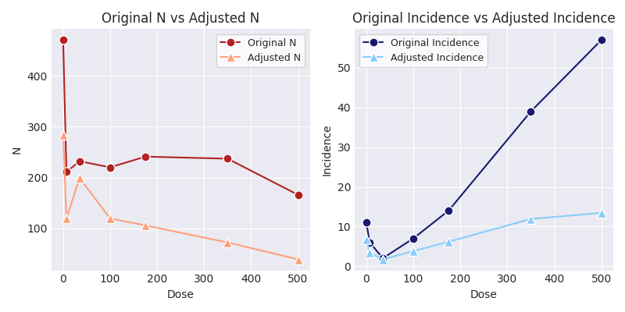

# Rao Scott Adjustment Parameters

|  |  |  |  |  |
| --- | --- | --- | --- | --- |
| Species | Regression Method | A | b | sigma |
| mouse | Least Squares | 1.594 | 0.287 | 0.208 |
| mouse | Orthogonal | 1.694 | 0.313 | 0.186 |
| rat | Least Squares | 1.685 | 0.331 | 0.125 |
| rat | Orthogonal | 1.833 | 0.369 | 0.109 |
| rabbit | Least Squares | 1.058 | 0.24 | 0.145 |
| rabbit | Orthogonal | 1.148 | 0.274 | 0.13 |

Fox JF, Hogan KA, Davis A. Dose-Response Modeling with Summary Data from Developmental Toxicity Studies. Risk Anal. 2017 May;37(5):905-917. PMID: 27567129. DOI: 10.1111/risa.12667.