**Mississippi River Basin leaching/runoff data preparation**

Alisa Keyser

3 March 2023

Data used to calculate indirect N2O emissions from leaching and runoff for the Mississippi River Basin (MSRB) are requested for year 2020 from National GHG Inventory. Data will be provided at 10km resolution.

**Methods:**

The Daycent variable that represents mineral nitrogen lost to leaching from the bottom of the soil profile into streamflow is provided. The data is in units of gN/m2/year.

Using a buffered MSRB boundary, I created a fishnet with cell size 10km. I then clipped this with the original MSRB boundary. Using the buffered shapefile to create the fishnet means that every cell that the MSRB boundary crosses will be a full 10km cell, regardless of how much boundary area it contains (See figure for examples). The geometry attributes were then added to the cell.

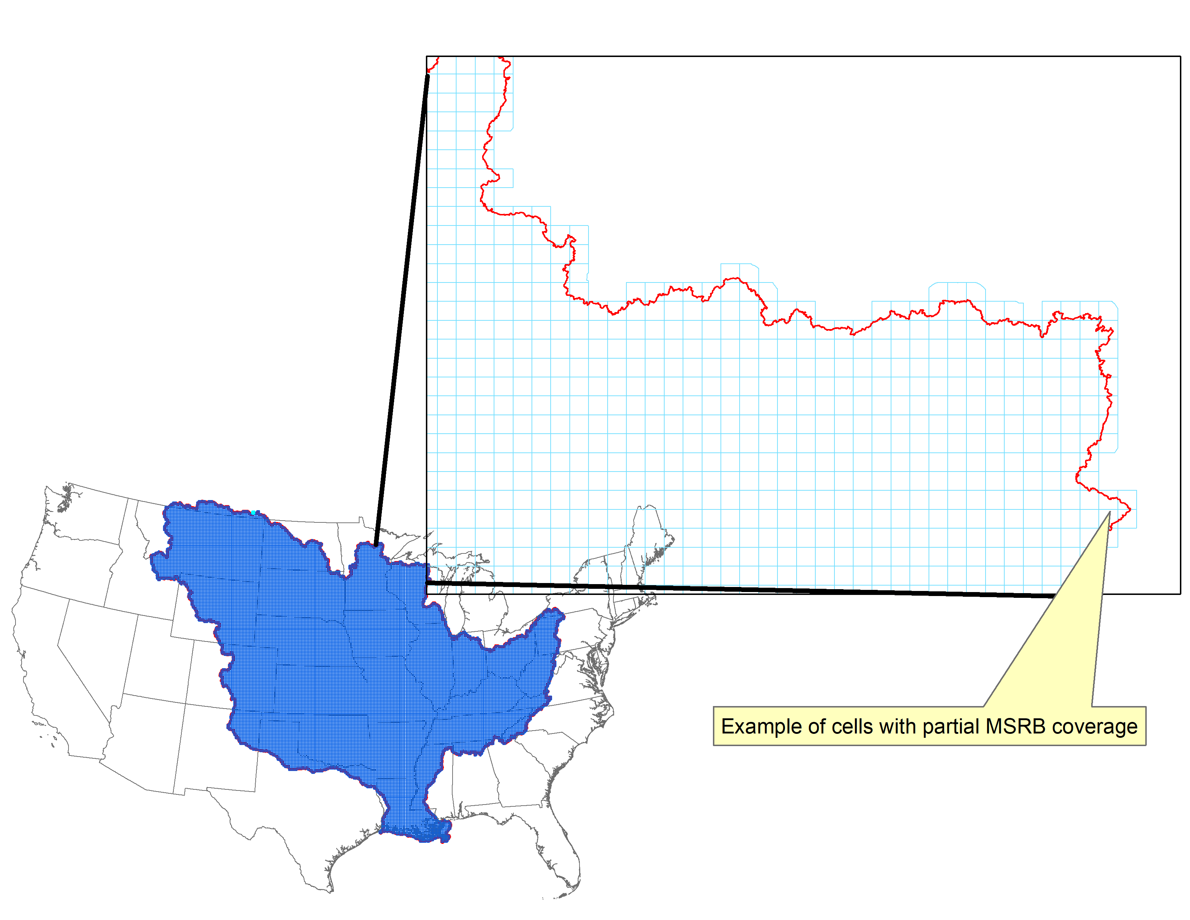

All NRI points that fell within the MRSB boundary were identified, assigned to the appropriate 10km cell, and used to aggregate the mineral N leached to streamflow output from Daycent. Some cells will not have any NRI points that are modeled with Daycent. These are retained in the output provided, but contain NAs.

To aggregate the Daycent output to 10km, I calculated the area weighted mean rate of leached N (gN/m2/yr). I also calculated the total area represented by modeled points and the area represented by all NRI grassland/cropland points in the cell to provide the percentage of grassland/cropland area that is simulated (Figure 1).

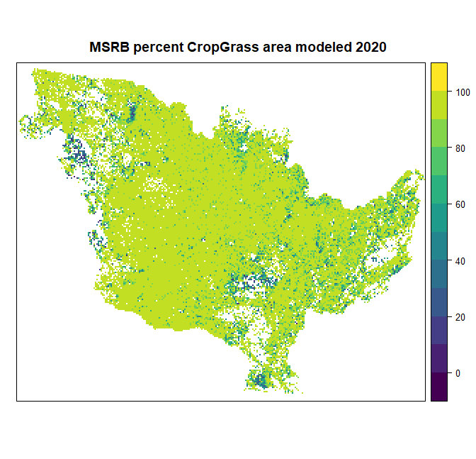

Figure . percent of crop/grass area simulated

Each of our NRI points is assigned to an IPCC climate zone. I provided this with the output data for each 10km cell. There are, of course, some cells that cross IPCC zone boundaries (343 cells). I assigned the zone that contained the largest representative simulated area. For example, if a cell contained three simulated points and 2 zones with areas: zone2-100ha, zone2-1000ha, zone3-10000ha, zone 3 would be assigned to that cell.

The creation of the 10km fishnet and identification of NRI points that fell within the 10km cells were executed in ArcMap. All other analysis was performed in R, importing the 10km grid as a polygon shapefile. The data provided contain the centroid X & Y values for the polygons from ArcMap. The simple feature geometry from R is also provided. A description of the data in the output is provided below.

**METADATA** for MSRBgrid_NO3_wIPCC_2023-03-03.csv:

**cellID_10km:** This is a unique ID generated for each 10km cell.

**CENTROID_X:** This is the X centroid of the 10km grid cell as output from ArcMap (grid was created as polygons)

**CENTROID_Y:** This is the Y centroid of the 10km grid cell as output from ArcMap (grid was created as polygons)

**Nitrogen_Leach_Rate_gN/m2/yr:** This is the mineral N leached from bottom of soil profile into stream flow. We calculated the area weighted mean of all modeled points that fell in the bounds of the 10km cell.

**ModeledPct_total_CropGrass_area:** This is the percent of total NRI cropland and grassland area in the grid cell that is simulated. (Total modeled area/total NRI area)*100

**IPCC_clim_zone:** This is the numeric code assigned to the modeled points in the grid cell. If the 10km grid cell crossed multiple IPCC zones, we assigned the zone that had the largest modeled area. There were 343 of these cells.

**IPCC_Zone_Name:** IPCC zone name that corresponds to numeric code.

**geometry:** This is output from R and is the simple feature geometry for each 10km cell, represented as a polygon)