Analysis of demographic and environmental conditions near selected facilities

2023-04-20

Abstract - Executive Order 14008 calls on EPA and other Agencies to make achieving environmental justice part of their missions, and EO 12989 directed EPA to make environmental justice part of their mission by identifying and addressing, as appropriate, disproportionately high and adverse human health or environmental effects of their programs, policies, and activities on minority populations and low-income populations in the United States. The United States Environmental Protection Agency (US EPA) analyzed baseline demographic and environmental conditions in communities living NA these sites. The analysis used EPA’s EJAM tool and EJScreen version 2.1 with demographic data based on the Census Bureau’s 2016-2020 American Community Survey (ACS). The analysis found that PLACEHOLDER EXAMPLE PLACEHOLDER EXAMPLE PLACEHOLDER EXAMPLE PLACEHOLDER EXAMPLE PLACEHOLDER EXAMPLE PLACEHOLDER EXAMPLE PLACEHOLDER EXAMPLE PLACEHOLDER EXAMPLE

Table of Contents

# 1 Executive Summary

Executive Order 14008 calls on EPA and other Agencies to make achieving environmental justice part of their missions, and EO 12989 directed EPA to make environmental justice part of their mission by identifying and addressing, as appropriate, disproportionately high and adverse human health or environmental effects of their programs, policies, and activities on minority populations and low-income populations in the United States.

EPA has conducted an analysis to characterize baseline environmental conditions faced by communities living near NA. The United States Environmental Protection Agency (US EPA) analyzed baseline demographic and environmental conditions in communities living NA. The analysis used EPA’s EJAM tool and EJScreen version 2.1 with demographic data based on the Census Bureau’s 2016-2020 American Community Survey (ACS).

## 1.1 Broad overview of findings

PLACEHOLDER EXAMPLE The environmental indicators – especially proximity scores – are more notable than the demographic indicators at these sites. Demographic indicators are moderately above average overall.

PLACEHOLDER EXAMPLE The environmental indicators – especially proximity scores – are more notable than the demographic indicators at these sites. Demographic indicators are moderately above average overall.

PLACEHOLDER EXAMPLE The environmental indicators – especially proximity scores – are more notable than the demographic indicators at these sites. Demographic indicators are moderately above average overall.

## 1.2 Summary of Findings

* PLACEHOLDER EXAMPLE Overall, % people of color, % limited English proficiency, and the Demographic Indicator are more than 1.5x the State rate, for the population within 1 mile.
* PLACEHOLDER EXAMPLE About a third of these sites are above the 80th percentile in State for the Demographic Indicator. The same is true for % low income and % with less than high school.
* PLACEHOLDER EXAMPLE About half of these 57 sites are in just 4 states: FL, NY, PA, or MA. Most of the people here live near just 8 sites (15% of sites). Most of the sites with the higher demographic indicators are owned by Covanta or Wheelabrator.
* PLACEHOLDER EXAMPLE Many of the sites with the highest demographic indicators also have proximity scores that are 5 to 10 times the State average.
  + PLACEHOLDER EXAMPLE The average person’s RMP score is more than 3x their State’s average.
  + PLACEHOLDER EXAMPLE The average person’s NPL and TSDF scores are about 2.5x State averages.
  + PLACEHOLDER EXAMPLE Most of these sites are >=80th in State for NATA. Same for RMP.
* PLACEHOLDER EXAMPLE
* PLACEHOLDER EXAMPLE
* PLACEHOLDER EXAMPLE

# 2 Introduction

Executive Order 12898 (59 FR 7629; February 16, 1994) established federal executive policy on environmental justice. Its main provision directed federal agencies, to the greatest extent practicable and permitted by law, to make environmental justice part of their mission by identifying and addressing, as appropriate, disproportionately high and adverse human health or environmental effects of their programs, policies, and activities on minority populations and low-income populations in the United States.

EPA defines environmental justice as the fair treatment and meaningful involvement of all people regardless of race, color, national origin, or income with respect to the development, implementation, and enforcement of environmental laws, regulations, and policies.

Executive Order 14008 (86 FR 7619; January 27, 2021) also calls on Agencies to make achieving environmental justice part of their missions “by developing programs, policies, and activities to address the disproportionately high and adverse human health, environmental, climate-related and other cumulative impacts on disadvantaged communities, as well as the accompanying economic challenges of such impacts.” It also declares a policy “to secure environmental justice and spur economic opportunity for disadvantaged communities that have been historically marginalized and overburdened by pollution and under-investment in housing, transportation, water and wastewater infrastructure and health care.”

EPA also released its “Technical Guidance for Assessing Environmental Justice in Regulatory Analysis” (U.S. EPA, 2016) to provide recommendations that encourage analysts to conduct the highest quality analysis feasible, recognizing that data limitations, time and resource constraints, and analytic challenges will vary by media and circumstance.

# 3 Methods

## 3.1 Selection of sites analyzed

This analysis focused on locations NA, which are the sites that may be affected by the proposal rule. The latitude and longitude of a point representing each site was obtained from NA. A total of NA sites had location information and were analyzed.

Figure shows a map of the sites analyzed.

## 3.2 Figure Map of Analyzed Sites

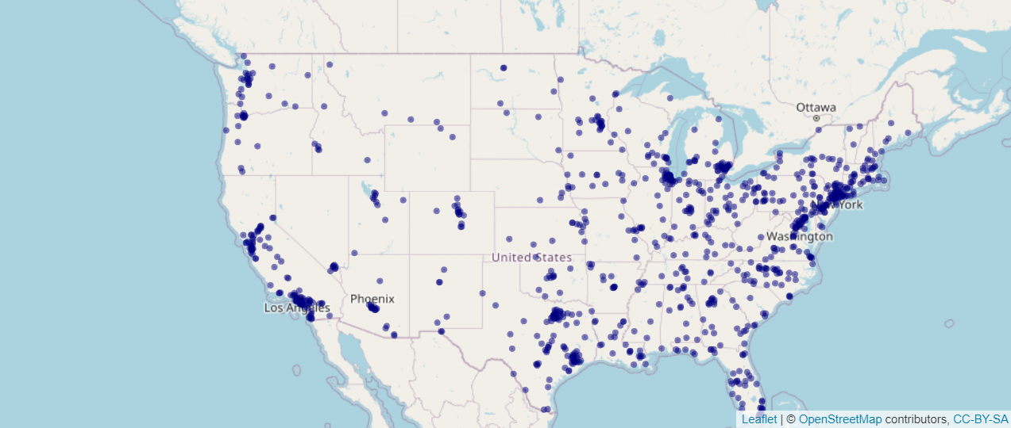

Map of Analyzed Sites

## 3.3 Estimating locations and population counts of residents

EPA’s EJAM (Environmental Justice Analysis Multisite) tool was used to develop this analysis. EPA’s [EJAM tool](https://rstudio-connect.dmap-stage.aws.epa.gov/content/dc3cda00-20a2-47ed-a753-0dcb89eb8f2a/) is a user-friendly web app that can summarize demographics and environmental conditions for any list of places in the nation.

### 3.3.1 Spatial resolution of data

The analysis used EPA’s EJAM tool and EJScreen version 2.1 with demographic data based on the Census Bureau’s 2016-2020 American Community Survey (ACS) 5-year summary file, and the corresponding version of Decennial Census information on geographic boundaries and FIPS codes for blocks, block groups, tracts, counties, and States. Demographic and environmental indicators were at block group resolution, while locations of residential populations was at block resolution (the highest resolution available from the Census Bureau) and then summarized by block group, then by location analyzed, and finally overall across the locations as a whole.

See EJScreen methodology for details.

### 3.3.2 Analytic method for buffering, and tools used to implement that method

The basic methodology and data used for this analysis are the same as those used in EPA’s EJScreen tool, with a few exceptions described below, and are described in detail in EJScreen’s documentation, at [EJScreen](https://epa.gov/ejscreen) and with more technical details available at [EJScreen technical documentation page](https://www.epa.gov/ejscreen/technical-information-about-ejscreen).

Like EJScreen, EJAM identifies residents near a given site by finding which Census block points are nearby, and counting the full block population as nearby if that point is nearby. The percent of each block group’s population that is estimated as inside a buffer is based on which Census block internal points are included in the buffer, and then using a block weight that is the Census 2020 block population as a fraction of the parent block group’s Census 2020 population (which is not quite the same as the ACS population count). That block weight is a fraction of the parent block group, and is used to estimate how many of the block groups residents are nearby or in the buffer.

The only notable differences between the EJScreen and EJAM calculations of proximity and indicators are the following:

* EJAM may include additional demographic or environmental indicators.
* For a proximity analysis (to characterize everyone living within a certain certain distance from a point such as a facility), EJAM identifies which residents live nearby using a slight variation on how the distance to each Census block is measured. While EJScreen uses ESRI’s ArcGIS calculations, EJAM calculates the distance using formulas implemented in the R language for statistical computing (R Core Team 2022). These measurements provide almost identical results for estimated distance from the average person in a block to a given site point. PLACEHOLDER MORE INFO
* EJAM aggregates indicator values within and across locations, converts them to percentiles, and does other summary calculations using the same formulas to the greatest extent possible, but in R rather than within EJScreen itself. There may be slight differences between raw scores and percentiles in EJScreen and EJAM in some cases.

## 3.4 Demographic and environmental indicators

PLACEHOLDER - The demographics included here are those in EJScreen and also race/ethnicity subgroups that comprise the total count of people of color. POC are defined as all other than those self-identifying in ACS survey data as white, single race, not Hispanic or Latino - i.e., non-hispanic white alone (NHWA). The subgroups include Hispanic or Latino (“hispanic”), several groups that are not hispanic but of only single race (e.g., Asian, or more specifically non-hispanic asian alone), non-hispanic other single race, and non-hispanic multiracial.

See EJScreen methodology for details.

# 4 Findings

## 4.1 Text on Findings

### 4.1.1 Results – Basic information about the locations analyzed and number of people nearby

• Explain whether the sites are to be analyzed as a whole or in some type of subgroups, such as 2 different source categories, or large vs small facilities, or some other categories we will use to compare all these stats?

• Count of locations

• Locations missing data There were several sites where EJScreen did not return any stats, typically (or always) because of low population density nearby (within 1 mile in this case). • Where are the sites (regions, states, cities?, urban/rural?)

• Clustering (are they near each other? How close? Which ones are in clusters, maybe?)

• Total population near any of the sites (count of unique residents) and some summary of site-specific Population sizes and population density nearby (what % of all people are at x% of the sites? Range and Interquartile range of pop counts nearby? etc.). Make clear to what extent some people in the overall summary stats are near more than a single one of these sites.

### 4.1.2 Demographics overall

Overall summary statement of some kind - e.g., a ” very large” number of all the (12?) envt (or D) indicators were ” very high” at a ” very large” share of the sites or preferably for a ” very large share of the people”? Or, how many of 12 indicators were “high” for the average person and/or site overall? Somehow put that in context ?? vs other rules, usA, other sites, etc.???

Table 1 shows key results for the analysis of demographics in these locations. The table shows each demographic group’s share of the residential population in these locations and conpares that to their shares of statewide and nationwide population.

## 4.2 Data Table 1. Demographic Indicators

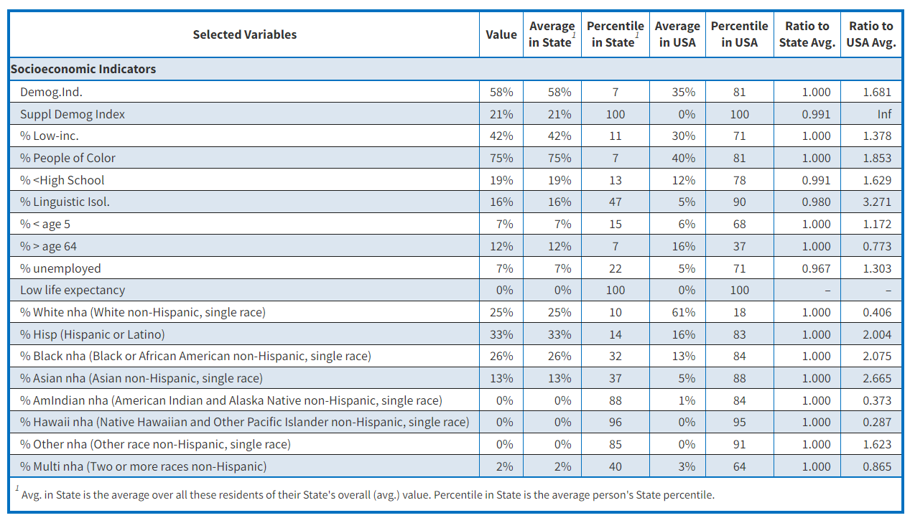

Almost all the EJ-relevant groups (low-income, people of color, etc.) are at least somewhat over-represented near these sites overall (at the collection of sites as a whole).

Most notably, % with limited English, % low income, and % with less than high school education near these sites are about 1.5 to 1.7 times the US overall rates.

The people living near these sites are 40% more likely to be in Limited-English Households than the average US resident.

The % with limited English is driven by high scores at only a few very highly population sites – it is high enough that the rate overall is in the top quintile nationally (83 percentile), but other demographics do not reach the top quintile for the entire population across all sites as a whole.

Near most of these 72 sites, % low income is at least 1.3x the rate in the US overall, and near 1 in 4 it is at least 1.5x the US rate.

discussion of plot goes here

discussion of plot goes here

discussion of plot goes here

discussion of plot goes here

## 4.3 Data Viz 2– Barplot

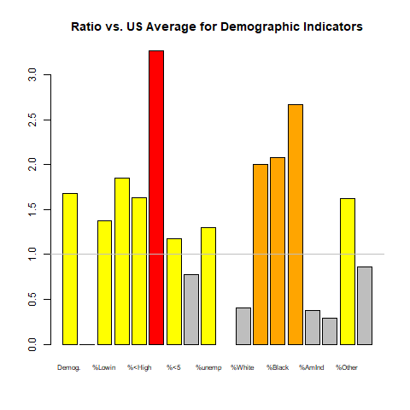

### 4.3.1 Key D group(s) based on policy or default / Key D group(s) based on observed magnitude of disparities here

Largest disparity in presence of any group – which group was most over-represented here?

* Relative disparity vs US: Which group(s) had the largest ratio of local % (for the overall set of sites) to US % overall?
* Absolute disparity vs US: which group(s) had

“Large” disparities: which groups were “very” over-represented here?

* Which indicator has max mean percentile? And how high is that?
* Which indicator has largest ratio to US? To state? And how large is that?

### 4.3.2 Demographics at key sites

Overall summary statement of some kind - e.g., a “___very large” number of all the (12?) envt (or D) indicators were “___very high” at a “___very large” share of the sites or preferably for a “___very large share of the people”? Or, how many of 12 indicators were “high” for the average person and/or site overall? Somehow put that in context ?? vs other rules, usA, other sites, etc.???

Demographic stats on the distribution across sites/people

• What % or count of people/sites have score > key cutoffs?

• What is mean or median or 95th pctile score of people/sites ?

• NOTABLE “WORST” SITES NAMES?

There are a handful of sites each with at least one very high demographic stat within 1 mile, however this may be within the normal range of what one would expect across the range of US residential areas -- there does not appear to be a pattern of an unusually large share of these 72 sites having any given demographic stat in the top 5%, for example.

Seven key sites have at least some demographic percentages more than 2x the US average: Crawford in Chicago IL (densely populated location), Bay Shore in Ohio, Watts Bar Fossil Plant in Spring City TN (but has almost no nearby residents), Arkwright in Macon GA, Venice in IL, Lake Shore in Cleveland, and Fair Station in Muscatine IA.

At two sites, percent people of color and percent low income are both more than twice the US averages (Venice and Lake Shore).

A few sites have over triple the US average unemployment rate (two of which are in the top 5% nationwide for their rate of unemployment, Bay Shore and Watts Bar).

## 4.4 Data Viz 3 – Boxplots

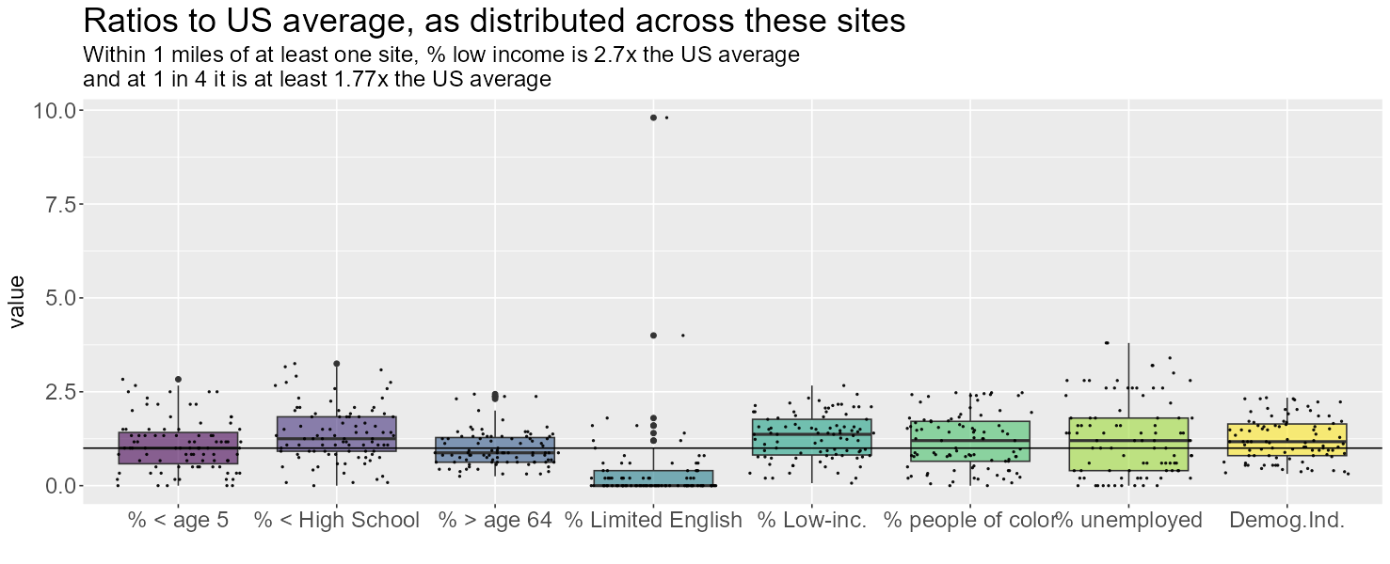

### 4.4.1 Environment overall

The people living nearby these sites as a whole are facing relatively high exposure to indicators of RMP proximity and possible lead paint due to older buildings. Overall the average person nearby has RMP proximity more than 3 times the US average. Lead paint and traffic are also notable, at more than 2x the US average. The average person near any of these sites lives in a blockgroup that is at the 80th percentile (worst quintile) of the US for RMP and lead paint – that is unusual because it is a pattern for these populations as a whole not just at one site. The same is almost true for traffic and UST – the average person nearby has those indicators in the worst quartile of the US. (Wastewater and Superfund also tend to be very high at an unusually large share of these sites but not necessarily at the ones in highly populated areas).

• Overall summary statement of some kind. e.g., a “___very large” number of all the (12?) envt (or D) indicators were “___very high” at a “___very large” share of the sites or preferably for a “___very large share of the people”? Or, how many of 12 indicators were “high” for the average person and/or site overall? Somehow put that in context ?? vs other rules, usA, other sites, etc.???

• Which indicator has max mean percentile? And how high is that?

• Which indicator has largest ratio to US? To state? And how large is that?

discussion of table here

discussion of table here

discussion of table here

discussion of table here

discussion of table here

## 4.5 Data Table 2. Environmental Indicators

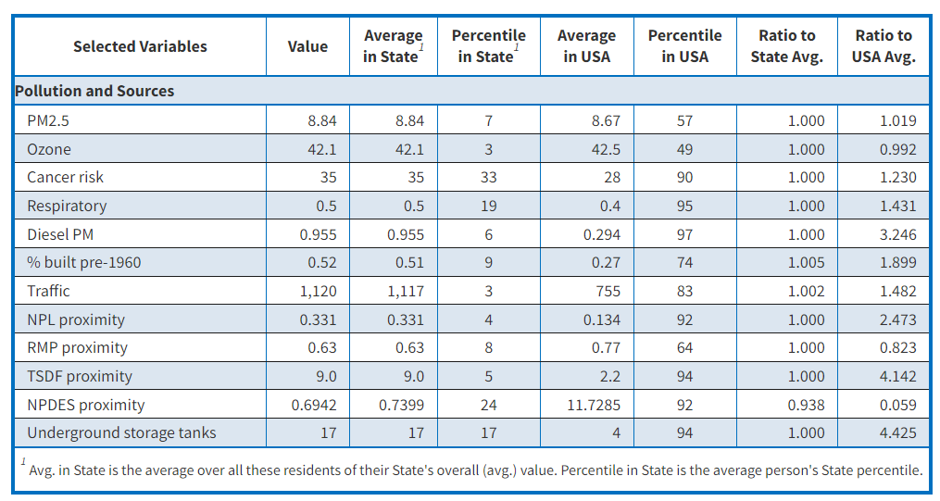

### 4.5.1 Environmental indicators distribution across the residents and sites

• What % or count of people/sites have score > key cutoffs?

• What is mean or median or 95th pctile score of people/sites ?

• NOTABLE “WORST” SITES NAMES?

### 4.5.2 Environment at key sites

There are an unusually large number of sites with very high environmental stats within 1 mile. Surprisingly, 27 of these 72 sites have at least one above the 95th percentile. One might expect 5% of these sites (i.e., 3.6 sites) to have a given score in the top 5% nationwide, but there are 8 sites (2x what one might expect) with RMP proximity scores in the top 5%, and the same is true for Superfund NPL proximity scores (there are 8 sites >=95th %ile instead of the expected 3.6). For the wastewater discharge indicator, there are 11 such sites, over 3x as many as one might expect. Most sites have at least one environmental indicator >80th percentile.

### 4.5.3 Cumulative impacts at key sites

Multiple environmental stressors are also an issue in some cases - At two of the sites, there are five environmental indicators that are all more than twice the US average (Valley and Crawford).

discussion of map

discussion of map

discussion of map

discussion of map

discussion of map

### 4.5.4 Combination of demographic and environmental conditions in these locations

Summary of Envt and Demog across all indicators? In other words, a single score like the combination of 12 EJ indexes as a threshold approach summary? e.g. the average person had 5 or more of the 12 EJ indexes at least at the 95th percentile nationwide?

• Individual EJ indicator of 12 that generally had highest overall percentiles? On average highest vs the one where at least a few sites had a very high number? Other?

• User specified EJ index(es)?

# 5 Appendices

### 5.0.1 Appendix 1 - Detailed tables of statistics for each site

e.g. how many of 12 are >x? does it have any high scores for any E? any D? etc.

### 5.0.2 Appendix 2 - Detailed tables of statistics for each indicator

#### 5.0.2.1 **What is Score of people/sites at key cutoffs: What is the X (useful) percentile

value, for this indicator (as %ile of people nearby or of sites)?**

* min
* min other than zero?
* mean
* 25th %ile of these sites or people (25% have lower than this, and 75% have higher than this – those are same if no ties with this value, but can differ if multiple places have this same exact indicator score)
* median (half of these sites or people have a score that is >= this, and half have <= this)
* 75th %ile of these sites or people (if a tied value, would want both >75 and <25%)
* max

#### 5.0.2.2 **How many people/sites have score > key cutoffs:  What % & what # of sites & people have this indicator score (raw or percentile) >= x (useful cutoff)?**

* **For percentiles**
  + % of sites w data where >=80
  + % of sites w data where >=90
  + % of sites w data where >=95
  + # of sites where >=95
* **For ratios to State or USA average overall % of sites w data where >1 not=1**
  + % of sites w data where ratio is >=2
  + % of sites w data where >=3
  + % of sites w data where >=5
  + % of sites w data where >=10
  + # of sites w data where >=10
* **for 12 EJ indexes, how many of the indexes are above a given threshold?**
  + # of sites w data where >=1
  + # of sites w data where >1 not =1
  + # of sites w data where >=4

### 5.0.3 Appendix 3 - notes on how to describe places generically/ in parameters

HOW TO REFER TO THE PLACES STUDIED (near these facilities vs more general language)

Note: this could be a “proximity analysis” in cases where it relies on circular buffers around facility points to define buffers that include residents within a fixed distance from one or more facilities/sites. But it more generally could be an EJ analysis that describes environmental and demographic conditions among residents in any specified places, such as all the places where air quality modeling suggests risk is currently above 1 in 1 million, for example. So the language should be flexible and refer to something like this:

FOR NON-PROXIMITY ANALYSIS, GENERALLY ANY KIND OF BUFFERS/PLACES ANALYZED:

The demographics of residents in …

The demographic / environmental indicators in …

Percent low income among residents in …

The environmental conditions in …

The environmental indicators for the average resident in …

The PM2.5 levels in …

Residents in …

… these locations

… these places

… these areas

… the analyzed locations

FOR PROXIMITY ANALYSIS SPECIFICALLY, EASIER TO SAY one of these:

Residents / conditions …

… within x miles of these sites…

… within x miles of any of these sites…

… nearby

… near these sites

… near any of these sites

## 5.1 Author contributions

The US EPA was responsible for planning this analysis and defining the locations to be analyzed. The US EPA was responsible for completing the manuscript. All authors evaluated the literature on previous relevant analyses. All authors contributed to the writing and reviewing of the manuscript and agree on its contents.

## 5.2 Acknowledgements

We thank ____ for helpful research assistance and ___ for suggesting useful background literature.

## 5.3 List of Abbreviations

* AAAS American Association for the Advancement of Science
* ACS American Community Survey, Census Bureau
* AFO Animal Feeding Operation
* AirToxScreen The Air Toxics Screening Assessment, EPA screening tool
* ANPR/ ANPRM Advance Notice of Proposed Rule/Rulemaking
* AO Office of the Administrator, USEPA
* API American Petroleum Institute
* API Application Programming Interface; or American Petroleum Institute
* AQI Air Quality Index
* ARP / ARPA American Rescue Plan Act
* BACT Best Available Control Technology
* Benmap (EPA criteria pollutants risk and benefit modeling tool)
* bg Census Block Group
* BR Biennial Report (under RCRA)
* CAA Clean Air Act
* CAFOs Concentrated Animal Feeding Operations
* CAMD Clean Air Markets Division, USEPA
* CARB California Air Resources Board
* CBG Census Block Group
* CDR Chemical Data Reporting (TSCA)
* CEQ Council on Environmental Quality, Executive Office of the President
* CERCLA Comprehensive Environmental Response, Compensation, and Liability Act / Superfund
* CFC Chlorofluorocarbon(s)
* CO Carbon Monoxide
* CPSC Consumer Product Safety Commission
* CRA Congressional Review Act
* CWA Clean Water Act
* DHS Department of Homeland Security
* DMR Discharge Monitoring Report (under CWA)
* DoD Department of Defense
* DOE Department of Energy
* DOT Department of Transportation
* dpm diesel particulate matter
* ECHO Enforcement and Compliance History Online, USEPA OECA
* EDGAR Electronic Data Gathering, Analysis, and Retrieval database (SEC)
* EGU electricity generating unit in a power plant
* EJ Environmental Justice
* EJAM The Environmental Justice Analysis Multi-site tool developed by USEPA
* EJScreen / EJSCREEN Environmental Justice Screening and mapping tool, USEPA
* ELG effluent limitation guideline
* EO Executive Order
* EP313 EPCRA Section 313 (established TRI)
* EPA United States Environmental Protection Agency
* EPCRA Emergency Planning and Community Right-to-Know Act
* ERNS Emergency Response Notification System
* ESA Endangered Species Act
* FAA Federal Aviation Administration
* FAQ Frequently Asked Questions
* FDA Food and Drug Administration
* FESOP Federally Enforceable State Operating Permit (CAA program)
* FIFRA Federal Insecticide, Fungicide, and Rodenticide Act
* FIP Federal Implementation Plan (CAA program)
* FIPS Codes Federal Information Processing Standards codes for geographic locations such as Census block groups
* FR, FRN Federal Register, FR Notice (but sometimes FR refers to a Final Rule)
* FRS Facility Registry Service
* GACT Generally Available Control Technology
* GAO Government Accountability Office
* GHG greenhouse gas
* HAP hazardous air pollutant (air toxic)
* HHS / DHHS Department of Health and Human Services
* HI Hazard Index, for HAPs
* HPV High Priority Violation (under CAA; also see SNC)
* ICIS Integrated Compliance Information System
* ICR information collection request
* ID Identifier or Identification Number
* IRA Inflation Reduction Act
* IRIS Integrated Risk Information System
* LOEL lowest observable effect level
* LQG Large Quantity Generator (RCRA Hazardous Waste)
* MACT Maximum Achievable Control Technology (CAA program)
* MIR maximum individual risk
* NAAQS National Ambient Air Quality Standards (for criteria air pollutants, CAA program)
* NAICS North American Industry Classification System
* NATA National Air Toxics Assessment, USEPA
* NCEE National Center for Environmental Economics, USEPA
* NDZ no discharge zone
* NEJAC EPA’s National Environmental Justice Advisory Council
* NESHAP National Emission Standards for Hazardous Air Pollutants (CAA program)
* NEXUS analytic tool, USEPA/OAR
* NGO nongovernmental organization
* NHTSA National Highway Traffic Safety Administration
* NOAA National Oceanic and Atmospheric Administration
* NOEL no observable effect level
* NOV Notice of Violation
* NOx Nitrogen Oxides
* NPDES National Pollutant Discharge Elimination System (CWA permit program)
* NPL National Priority List (related to Superfund)
* NRPM Notice of Proposed Rulemaking, or proposed rule or proposal
* NSPS New Source Performance Standards (CAA program)
* NSR New Source Review (CAA program)
* O3 ozone
* OA Office of the Administrator, USEPA
* OAR Office of Air and Radiation, USEPA
* OCHP Office of Children’s Health Protection, USEPA
* OCIR Office of Congressional and Intergovernmental Relations, USEPA
* OCSPP Office of Chemical Safety and Pollution Prevention, USEPA
* OECA Office of Enforcement and Compliance Assurance, USEPA
* OEI Office of Environmental Information, USEPA
* OEJ Office of Environmental Justice, USEPA
* OGC Office of General Counsel, USEPA
* OGWDW Office of Ground Water and Drinking Water, USEPA
* OIG / IG Office of Inspector General / Inspector General, USEPA
* OIRA Office of Information and Regulatory Affairs, OMB
* OITA Office of International and Tribal Affairs, USEPA
* OLEM Office of Land and Emergency Management, USEPA
* OMB Office of Management and Budget
* OMS Office of Mission Services, USEPA
* OMS Office of Mission Support, USEPA
* OP Office of Policy, or the Policy Office, USEPA
* ORD Office of Research and Development, USEPA
* ORPM Office of Regulatory Policy and Management, USEPA
* OSA Office of Science Advisor, USEPA
* OSHA Occupational Safety and Health Administration
* OTAQ Office of Transportation Air Quality, USEPA
* OW Office of Water, USEPA
* OWOW Office of Wetlands, Oceans and Watersheds, USEPA
* Pb lead
* PCE Partial Compliance Evaluation
* PEL Permissible Exposure Limits
* PFAS, e.g., PFOS, PFOA Per- and polyfloroalkyl substances (PFOS and PFOA are the 8-carbon PFAS)
* PM, PM2.5, PM10 Particulate Matter
* POC people of color
* POTWs Publicly Owned Treatment Works
* PRA Paperwork Reduction Act
* PSD Prevention of Significant Deterioration (CAA program)
* QNCR Quarterly Noncompliance Report (under CWA)
* RCRA Resource Conservation and Recovery Act
* RCRAInfo Resource Conservation and Recovery Act Information System
* RE Risk Evaluation
* REL Reference Exposure Level
* RFA reg. Flex analysis or request for applications
* RfC reference concentration (toxicology)
* RfD reference dose (toxicology)
* RFF Resources for the Future
* RFG reformulated gasoline
* RFS renewable fuel standards
* RMP Risk Management Plan
* RNC Reportable Noncompliance (under CWA)
* RSEI risk estimation tool based on TRI
* RTP Research Triangle Park, NC, USEPA
* SaRA analytic tool, USEPA/OAR
* SARA Superfund Amendments and Reauthorization Act
* SDWA Safe Drinking Water Act
* SDWIS Safe Drinking Water Information System
* SEC U.S. Securities and Exchange Commission
* SES socio-economic status
* SIC Standard Industrial Classification
* SIP State Implementation Plan (under CAA)
* SNC Significant Noncompliance (or Noncomplier) (also see HPV)
* SOx Sulfur Oxides
* SOx oxides of sulfur
* SQG Small Quantity Generator (RCRA Hazardous Waste)
* TOSHI Target-Organ-Specific Hazard Index, for HAPs
* TRC Technical Review Criteria (under CWA)
* TRI Toxic Release Inventory (EPCRA)
* TRIS Toxics Release Inventory System
* TSCA Toxic Substances Control Act
* TSD technical support document
* TSDF Treatment, Storage, and Disposal Facility (RCRA Hazardous Waste)
* UIC Underground Injection Control
* USCG United States Coast Guard
* USDA United States Department of Agriculture
* USEPA United States Environmental Protection Agency
* UST underground storage tank
* VOC Volatile Organic Compound
* VSQG Very Small Quantity Generator (RCRA Hazardous Waste)
* WHEJAC White House Environmental Justice Advisory Council
* WOTUS Waters of the United States

## References

R Core Team. 2022. *R: A Language and Environment for Statistical Computing*. Vienna, Austria: R Foundation for Statistical Computing. <https://www.R-project.org/>.