Control Strategy Tool (CoST) Training Manual and User’s Guide

Work Assignment: 2-01
Contract No: EP-D-07-102
OMB Clearance No: 2030-0005
Version: 4

Prepared for: David Misenheimer
U.S. Environmental Protection Agency
C439-02
Research Triangle Park, NC 27711

Prepared by: Alison M. Eyth
Institute for the Environment
The University of North Carolina at Chapel Hill
137 E. Franklin St., CB 6116
Chapel Hill, NC 27599-6116

Date due: September 17, 2009

Contents
Tables iv
Figures v
Acronyms vii
Acronyms vii
1 Introduction 1-1
2 Installing and Running CoST and the EMF 2-1
2.1 Background on the EMF Client-Server System 2-1
2.2 Installing Java 2-2
2.3 Installing the EMF Client for the First Time 2-3
2.4 Running the Installer to Update the Client 2-4
2.5 Logging in to the EMF 2-4
3 Control Measure Manager 3-1
3.1 The Upper Portion of the Control Measure Manager and Toolbar 3-2
3.2 Viewing Data for an Existing Control Measure 3-10
3.2.1 Viewing the Summary Tab for a Control Measure 3-11
3.2.2 Viewing the Efficiencies Tab for a Control Measure 3-13
3.2.3 Viewing the SCCs Tab for a Control Measure 3-17
3.2.4 Viewing the Equations Tab for a Control Measure 3-18
3.3 Copying a Control Measure 3-19
3.4 Editing Control Measure Data 3-20
3.4.1 Editing the Summary Tab for a Control Measure 3-20
3.4.2 Editing the Efficiencies Tab for a Control Measure 3-22
3.4.3 Editing the SCCs Tab for a Control Measure 3-25
3.4.4 Editing the Equations Tab for a Control Measure 3-27
3.5 Creating a New Control Measure 3-28
3.6 Finding Available Control Measures for Specific SCCs 3-29
3.7 The Pollutant Menu 3-30
3.8 The Cost Year Menu 3-30
3.9 Importing and Exporting Control Measure Data 3-31
4 Control Strategy Manager 4-1
4.1 Introduction to Control Strategies 4-1
4.1.1 Maximum Emissions Reduction Control Strategy 4-4
4.1.2 Apply Measures in Series Control Strategy 4-4
4.1.3 Least Cost Control Strategy 4-5
4.1.4 Least Cost Curve Control Strategy 4-6
4.1.5 Annotate Inventory Control Strategy 4-7
4.1.6 Project Future Year Inventory Control Strategy 4-9
4.2 Managing Control Strategies 4-9
4.2.1 Opening the Control Strategy Manager 4-10
4.2.2 Sorting and Filtering Control Strategies 4-11
4.2.3 Copying Control Strategies 4-12
4.2.4 Removing Control Strategies 4-12
4.2.5 Creating a New Control Strategy 4-13
4.2.6 Editing Control Strategies 4-13
4.3 Inputs to Control Strategies 4-15
4.3.1 Inputs on the Summary tab 4-15
4.3.2 Fields Automatically Set by CoST 4-16
4.3.3 Inputs on the Inventories Tab 4-17
4.3.4 Inputs on the Measures Tab 4-23
4.3.5 Input Constraints 4-27
4.3.6 Inputs on the Programs Tab 4-29
4.4 Running a Strategy and Accessing Its Outputs 4-30
4.4.1 Running a Strategy 4-30
4.4.2 Viewing and Editing Properties of the Strategy Outputs 4-33
4.4.3 Summarizing the Strategy Outputs 4-36
4.4.4 Exporting the Strategy Outputs 4-42
4.4.5 Analyzing the Strategy Outputs 4-42
4.4.6 Creating a Controlled Emissions Inventory 4-44
4.4.7 Creating Custom Strategy Outputs 4-45
4.5 Outputs of Control Strategies 4-45
4.5.1 Strategy Detailed Result 4-45
4.5.2 Strategy Measure Summary 4-50
4.5.3 Strategy County Summary 4-51
4.5.4 Controlled Emissions Inventory 4-52
4.5.5 Strategy Messages 4-53
4.6 Summaries of Strategy Inputs and Outputs 4-56
5 Control Program Manager 5-1
6 Advanced Training Exercises 6-2
6.1 Importing an Emissions Inventory (or County List File) 6-2
6.2 Running a Maximum Emissions Reduction Strategy 6-3
6.3 Running a Strategy with a Hypothetical Measure 6-3
6.4 Examining Cobenefits 6-4
7 References 7-5

Tables
Table 3-1. Columns on the Control Measure Manager 3-5
Table 3-2. Components on the Summary Tab of the View Control Measure Window 3-11
Table 3-3. Components on the Control Measure View Efficiency Record Window 3-15
Table 4-1. Summary of Strategy Algorithms 4-3
Table 4-2. Key Columns of the Control Strategy Manager 4-11
Table 4-3. Tabs of the Edit Control Strategy Window 4-14
Table 4-4. Fields on the Control Strategy Summary Tab Automatically Set by CoST 4-16
Table 4-5. Tabs of the Dataset Properties View and Edit Windows 4-19
Table 4-6. Examples of Row Filters (Data Viewer window) and Inventory Filters (Inventories tab of the Edit Control Strategy window) 4-22
Table 4-7. Constraints Common to Multiple Control Strategy Types 4-27
Table 4-8. Excerpt from the gdplev Table Used to Convert Data between Cost Years 4-46
Table 4-9. Columns in the Strategy Detailed Result 4-47
Table 4-10. Columns in the Strategy Measure Summary 4-51
Table 4-11. Columns in the Strategy County Summary 4-52
Table 4-12. Columns in the Strategy Messages Output 4-53
Table 4-13. Example of Strategy Messages Output 4-54
Table 4-14. Example of Strategy Measure Summary Data 4-55
Table 4-15. Example of Strategy County Summary Data 4-55

Figures
Figure 2-1. EMF Client-Server System 2-1
Figure 2-1. Login to the Emissions Modeling Framework Window 2-5
Figure 2-2. Register New User Window 2-5
Figure 2-3. EMF Main Window 2-6
Figure 3-1. Manage Menu of EMF Main Window 3-2
Figure 3-2. Control Measure Manager before Control Measures are Loaded 3-3
Figure 3-3. Control Measure Manager with Control Measures 3-4
Figure 3-4. Control Measure Manager showing Control Measure Details 3-4
Figure 3-5. Filter Rows Dialog 3-7
Figure 3-6. Control Measure Manager with Filter Applied 3-7
Figure 3-7. Show/Hide Columns Dialog 3-8
Figure 3-8. Format Columns Dialog 3-10
Figure 3-9. Summary Tab of View Control Measure Window 3-11
Figure 3-10. Efficiencies Tab of View Control Measure Window 3-13
Figure 3-11. View Efficiency Record Window 3-15
Figure 3-12. SCCs Tab of View Control Measure Window 3-18
Figure 3-13. Equations Tab of View Control Measure Window 3-19
Figure 3-14. Summary Tab of Edit Control Measure Window 3-21
Figure 3-15. Efficiencies Tab of Edit Control Measure Window 3-23
Figure 3-16. Edit Efficiency Record Window 3-24
Figure 3-17. SCCs Tab of Edit Control Measure Window 3-25
Figure 3-18. Select SCCs and Filter Rows Dialogs 3-26
Figure 3-19. Equations Tab of Edit Control Measure Window 3-27
Figure 3-20. Exporting Control Measures Dialog 3-31
Figure 3-21. Browser 3-32
Figure 3-22. Import Control Measures Dialog 3-33
Figure 4-1. Basic Steps for Running a Control Strategy 4-2
Figure 4-2. Manage Menu of EMF Main Window 4-10
Figure 4-3. Control Strategy Manager Window 4-10
Figure 4-4. Filter Rows to Show Only Strategies Targeting NO_{x} 4-12
Figure 4-5. Summary Tab of Edit Control Strategy Window 4-14
Figure 4-6. Inventories Tab of Edit Control Strategy Window 4-18
Figure 4-7. Selecting Inventory Datasets for a Control Strategy 4-18
Figure 4-8. Dataset Properties View Window for an Emissions Inventory 4-20
Figure 4-9. Data Viewer for an Emissions Inventory 4-21
Figure 4-10. Measures Tab of Edit Control Strategy Window 4-24
Figure 4-11. Dialog to Add Specific Control Measures to a Strategy 4-25
Figure 4-12. Measures Tab Showing Specific Measures to Include 4-26
Figure 4-13. Constraints Tab of Edit Control Strategy Window 4-29
Figure 4-14. Programs Tab of Edit Control Strategy Window 4-30
Figure 4-15. Outputs Tab of Edit Control Strategy Window for Least Cost Strategy 4-32
Figure 4-16. Outputs Tab for a Least Cost Curve Strategy 4-32
Figure 4-17. View Data for Strategy Detailed Result 4-33
Figure 4-18. Summary Tab of Dataset Properties Editor 4-34
Figure 4-19. Keywords Tab of Dataset Properties Editor 4-35
Figure 4-20. Summarizing a Strategy Detailed Result 4-37
Figure 4-21. Available QA Summaries for a Strategy Detailed Result 4-37
Figure 4-22. Edit QA Step Window to Create a Summary 4-38
Figure 4-23. View QA Step Results Window 4-39
Figure 4-24. KMZ File Generator 4-40
Figure 4-25. Exporting QA Step Results to CSV or Shapefiles 4-41
Figure 4-26. Analyze Control Strategy Window 4-43
Figure 4-27. Analyzing a Least Cost Curve Output 4-44
Figure 4-28. Control Technologies used within a Least Cost Analysis 4-58

Acronyms
AQM air quality model
CE Control Efficiency
CMAQ Community Multiscale Air Quality model
CMAS Community Modeling and Analysis System
CoST Control Strategy Tool
CPT Cost per Ton
CRF Capital Recovery Factor
CSV Comma-separated values
DBF D-base Format
EC Elemental Carbon
EMF Emissions Modeling Framework
EPA Environmental Protection Agency
ESRI Environmental Systems Research Institute (creators of ArcGIS software)
FGD Flue Gas Desulfurization
FGR Flue gas recirculation
FIPS Federal Information Processing Standards
GDP Gross Domestic Product
GIS Geographic information system
GUI graphical user interface
HEID Health and Environmental Impacts Division (of EPA)
IE Institute for the Environment (University of North Carolina)
LNB Low NOx Burner
NAICS North American Industry Classification System
NEI National Emissions Inventory
NSCR Non-Selective Catalytic Reduction
OC Organic Carbon
O&M Operating and Maintenance
ORL One record per line
PM10 Particulate matter with a diameter of 10 micrometers or less
PM2_5 Particulate matter with a diameter of 2.5 micrometers or less
PR Percent Reduction
RE Rule Effectiveness
RP Rule Penetration
SCC Source Classification Code
SCR Selective Catalytic Reduction
SIC Standard Industrial Classification
SNCR Selective Noncatalytic Reduction
SQL Structured Query Language
SMOKE Sparse Matrix Operator Kernel Emissions modeling system
tpy Tons per year
UNC University of North Carolina

Introduction
This document provides a training manual and user’s guide for the Control Strategy Tool (CoST) software developed by EPA’s Health and Environmental Impacts Division (HEID). CoST allows users to estimate the emission reductions and costs associated with future-year control scenarios, and then to generate emission inventories with the control scenarios applied [Misenheimer, 2007; Eyth, 2008]. CoST tracks information about control measures, their costs, and the types of emissions sources to which they apply. The purpose of CoST is to support national- and regional-scale multipollutant analyses. CoST helps to develop control strategies that match control measures to emission sources using algorithms such as “Maximum Emissions Reduction”, “Least Cost”, and “Apply Measures in Series”.
The result of a control strategy run contains information that specifies the estimated cost and emissions reduction achieved for each control measure-source combination. CoST is an engineering cost estimation tool for creating controlled inventories and is not currently intended to model emissions trading strategies, nor is it an economic impact tool. Control strategy results can be exported to comma-separated-values (CSV) files, Google Earth-compatible (.kmz) files, or Shapefiles. The results can also be viewed in a graphical table that supports sorting, filtering, and plotting. The Strategy Detailed Results from a strategy can also be merged with the original inventory to create controlled emissions inventories datasets that can be exported to files that can be input to the Sparse Matrix Operator Kernel Emissions (SMOKE) modeling system, which is used by EPA to prepare emissions inputs for air quality modeling.
CoST is a component of the Emissions Modeling Framework (EMF), which is currently being used by EPA to solve many of the long-standing complexities of emissions modeling [Houyoux, 2008]. Emissions modeling is the process by which emissions inventories and other related information is converted to hourly, gridded, chemically speciated emissions estimates suitable for input to an air quality model such as the Community Multiscale Air Quality (CMAQ) model. The EMF supports the management and quality assurance of emissions inventories and emissions modeling-related data, and also the running of SMOKE to develop CMAQ inputs. Providing CoST as a tool integrated within the EMF facilitates a level of collaboration between control strategy development and emissions inventory modeling that was not previously possible. The concepts that have been added to the EMF for CoST are “control measures”, “control strategies”, and “control programs”. Control measures store information about available control technologies and practices that reduce emissions, the source categories to which they apply, the expected control efficiencies, and their estimated costs. A control strategy is a set of control measures applied to emissions inventory sources (in addition to any controls that are already in place) to accomplish an emissions reduction goal. Control programs represent changes to emissions sources that are expected to occur between a base modeling year (e.g., 2005) and a future modeling year (e.g., 2020). These concepts are discussed in more detail later in this document.
CoST supports multipollutant analyses and data transparency, and provides a wide array of options for developing control strategies. CoST uses a Control Measures Database to develop control strategies, and provides a user interface to that database. CoST has been developed to replace the older AirControlNET software. It has been applied to develop strategies for criteria pollutants, but has not yet been used for hazardous air pollutants (HAPs) due to the limited availability of control measures data for toxics. CoST has been used in some very limited analyses for greenhouse gases (GHGs). The main limiting factors in performing GHG analyses is the availability of (1) GHG emissions inventories at an appropriate level of detail, and (2) control measures for GHGs.
CoST is an extensible software system that provides several types of algorithms for developing control strategies:
- “Maximum Emissions Reduction”
- “Least Cost”
- “Least Cost Curve”
- “Apply Measures in Series”
The first three algorithms are typically used for point and area sources; the last one is usually used for mobile sources, for which most control techniques are independent of one another. Because CoST is an extensible system, it was possible to develop additional algorithms to create altered emissions inventories that are not considered “control strategies” in the traditional sense. These specialized algorithms are called “Annotate Inventory” and “Project Future Year Inventory”. The “Annotate Inventory” algorithm examines the inventory to find sources with non-zero control efficiency fields that do not have control measure details specified. It will then attempt to find control measures in the database that can apply to the source and finds the measure with a control efficiency closest to the specialized efficiency and assigns that measure to the source. The “Project Future Year Inventory” strategy type uses the concept of control programs to project a base-year inventory to a future year. Control programs are sets of control measures and other adjustments (e.g., projection factors) that are used to estimate the effects of implementing a regulation that is “on the books” and is therefore considered when projecting a base-year emissions inventory to a future-year base emissions inventory. A future-year base inventory is what is typically used as an input to the traditional control strategy analyses that apply additional control measures to the emissions sources.
This document provides information on how to use CoST to view and edit control measures and how to develop control strategies. This includes how to specify the input parameters to control strategies, how to run the strategies, and how to analyze the outputs from the strategies. For additional information on other aspects of CoST, please see the following independent documents:
- Control Strategy Tool (CoST) Training Manual and User’s Guide: describes the algorithms implemented in the software
- Control Strategy Tool (CoST) Control Measures Database Documentation: describes the contents of the Control Measures Database
These documents, and additional information about CoST, can be found at: http://www.epa.gov/ ttn/ecas/cost.htm. A glossary of terms is included as an appendix to this document.

Installing and Running CoST and the EMF

Background on the EMF Client-Server System
Because CoST is fully integrated within the EMF, installing CoST is the same as installing the EMF. There are two parts of the EMF: a client and a server. For this guide, it is assumed that you need to install only the client and that you have access to an existing EMF server. The server installation instructions are much more complex and are not provided in this document. Prior to installing the EMF client, you need to verify that the version of Java is current enough to run the EMF client, as described in Section 2.2.
In a client-server system, there is a client portion of the system that runs on your desktop computer. The EMF client is a Java program that accesses software running on the EMF server. Because it is written in Java, it requires that a recent version of Java be installed on each user’s computer. The EMF server runs a PostgreSQL (http://www.postgresql.org) database that stores information related to emissions modeling, including emissions inventory datasets and a database of control measures. When a control strategy is developed, new datasets and summaries of them are created within the EMF, and controlled emissions inventories can optionally be generated. These emissions inventories can be exported from the EMF and then used as inputs to the SMOKE modeling system, which prepares emissions data for use in the CMAQ model. In addition to running control strategies, the EMF can be used to track SMOKE runs (these runs are typically performed on a separate compute server). A schematic of the EMF client-server system is shown in Figure 2-1.
Figure 2-1. EMF Client-Server System

Control
Strategy
Tool
Control
Measures
Database
Future
Base Case
Emission
Inventory
Control
Case
Emission
Inventory
Detailed
and
Summary
Reports
SMOKE
CMAQ
EMF Server
EMF Clients
Compute Server

Installing Java
The EMF requires Java Runtime Environment 6 (also known as JRE 1.6) or greater. Most computers already have a version of Java on them. You can verify the version of Java on your computer in the following way:
- Start a command prompt window. On some versions of Windows, this is done by activating the Start menu and then selecting All Programs->Accessories->Command Prompt.
- In the command prompt window, type “java –version”
- The command should return some text similar to the following:
java version "1.6.0_05"
Java(TM) SE Runtime Environment (build 1.6.0_05-b13)
Java HotSpot(TM) Client VM (build 10.0-b19, mixed mode, sharing)
- If the number in quotes after “java version” is 1.6 or later, you do not need to install a new version and can continue on to Section 2.3, “Installing the EMF Client for the First Time”.
- If your version of Java is less than 1.6, you should continue following the steps in this section to install a newer version of Java.
- Go to http://java.sun.com/javase/downloads/index.jsp and scroll down to the section labeled “Java SE Runtime Environment”. To download a product listed in this section (e.g., “JRE 6 Update 14”), click the Download button once.
- When you are prompted to select a Platform and Language for Download, choose the following:
Platform: Windows
Language: Multi-language
- You will need to check to box that indicates you agree to the license agreement and then click the Continue button.
- On the next page, you will see a list of available files. Note: we do not recommend that you use the Sun Download Manager to obtain the file you need. Instead, do the following: In the section labeled “Windows Offline Installation”, click on the link to the file listed in that section (e.g., jre-6u13-windows-i586-p.exe).
- You will be prompted by your web browser to save the file to your computer. Save the file to a known location on your computer. Remember where you saved the file.
- Double click on the file you saved (e.g., jre-6u13-windows-i586-p.exe) to run the installation executable. It may take a few sections to show you that it is installing, and you may have to answer a few Windows security questions prior to its running the installer.
- From the Java installer, accept the license agreement and follow the remaining instructions. When you reach the end, click “Finish”.
- To double check that you have updated Java, start a new command prompt window (e.g., by choosing “Start->All Programs->Accessories->Command Prompt”) and then type “java –version” again. You should now see that your java version is 1.6 or greater.
- You may delete the file you downloaded from the Sun site (e.g., jre-6u13-windows-i586-p.exe) once the installation is complete.

Installing the EMF Client for the First Time
The EMF client has its own installer program that is used initially to install the client, and later to update the client to the latest version. To install the installer and the EMF client, follow these steps:
- Download the EMF Installer Executable (emfinst.exe) from http://www.ie.unc.edu/cempd/projects/emf/install/emfinst.exe
- Double click on the installer file (emfinst.exe) to run it. First, the installer will expand the zipped compressed file onto your hard disk. The default location is C:\emfinst, but you may put it elsewhere if you like. The installer does not require much disk space, but you will want to keep it on your computer to use for future updates of the client.
- Once the installer expansion is complete, the installer program will start.
- In the EMF Client Installer window, fill in the fields as follows:
(make sure there are no trailing spaces)
  - EMF Download URL:http://www.ie.unc.edu/cempd/projects/emf/install
  - Server Import Directory: /oaqps
  - Server Export Directory: /oaqps
  - Java Home Directory: [this should be set for you by the system]
  - R Bin Directory: [if you have R installed on your computer, set to path of the executable; otherwise set to C:\Program Files\R\rw2011]
  - Client Home Directory: C:\Program Files\EMFClient
  - Local Temp Directory: C:\EMF_temp
  - Server Address: http://orchid.nesc.epa.gov:8080/emf/services
  - Output Preferences File: [this should be set for you by the system]
Note that the Server Import Directory, Server Export Directory, and Server Address settings are for the EPA installation only. You may select another location for the Client Home Directory or for the Local Temp directory if you like.
- Click Install.
- If you had previously installed the EMF client, you will be given an option to Update or Reinstall. Usually, choosing Update is sufficient, but if you feel like your installation is corrupted for some reason, choose Reinstall.
- The installer will provide feedback on the files it is downloading. When it is finished, click Done.
- The installer adds two items to your list of programs: EMF and EMF Client Installer. To run the EMF client, select EMF->EMF Client. To run the installer (e.g., to update your client version), select EMF Client Installer->Installer.
- If you would like to have a shortcut to the EMF client (not the installer) on your desktop that uses the EMF icon for its color scheme, you may add one by going to the EMF client from your Start menu, right clicking on it, and then choosing Create Shortcut. Once the additional shortcut appears on your menu, you may drag it onto your desktop.

Running the Installer to Update the Client
After you have installed the EMF client for the first time, you may use the installer program to update your client to a new version. If, when starting the EMF client, you get a warning message that says “An updated version of the EMF client exists (version). Would you like to stop logging in so that you can update your client using the Installer?”, this means that a new version is available. If you answer “Yes”, it will stop logging into the client. You should then perform the following steps:
- Run the installer by selecting EMF Client Installer->Installer from your programs menu.
- The installer window will appear with all settings preserved from the last time you ran it.
- Click Install.
- If it asks you to “Please make sure that the server import/export directory exists on the EMF server. Do you want to proceed with the installing the EMF client?”, select Yes.
- The next window will give you the option to Update or Reinstall. Normally, you should select Update. But, if you feel that your installation has been corrupted for some reason, you may select Reinstall. Once you have made your selection, click OK.
- It will provide you information on the files that need to be updated. If there are files to update, click Update and then click Done once the installation is complete.
- If there are no files to update, you will only be able to click Cancel and then should click Exit to close the installer.

Logging in to the EMF
Once you have installed the client, log in to the EMF by selecting the shortcut on your desktop or by choosing EMF->EMF Client from your programs menu. If the configuration was specified properly and the server is running, you should see a window like Figure 2-1.
Figure 2-1. Login to the Emissions Modeling Framework Window
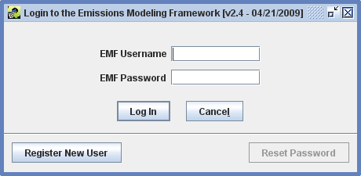
If you mistyped the server address during the installation, or if the server is not running, you may instead get a message about not being able to connect to the server. If you get this message, rerun the installer and make sure that you have typed the server address properly.
If you have never used the EMF before, click the Register New User button. You will then see a window that looks like Figure 2-2.
Figure 2-2. Register New User Window
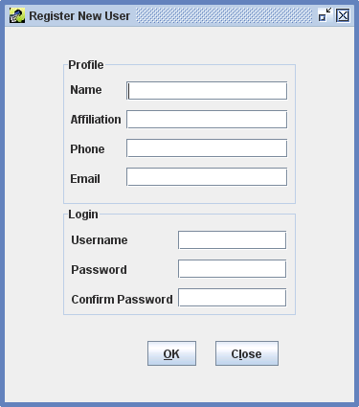

In the Register New User window, fill in your full name, affiliation, phone number, and email address. You may then select a username with at least three characters and enter a password with at least 8 characters and at least one digit and then click OK. Once your account has been created, the EMF main window should appear (Figure 2-3).
If instead you are an existing EMF user, enter your EMF username and password in the “Login to the Emissions Modeling Framework” window and click Log In. The EMF main window should appear (Figure 2-3).
Figure 2-3. EMF Main Window
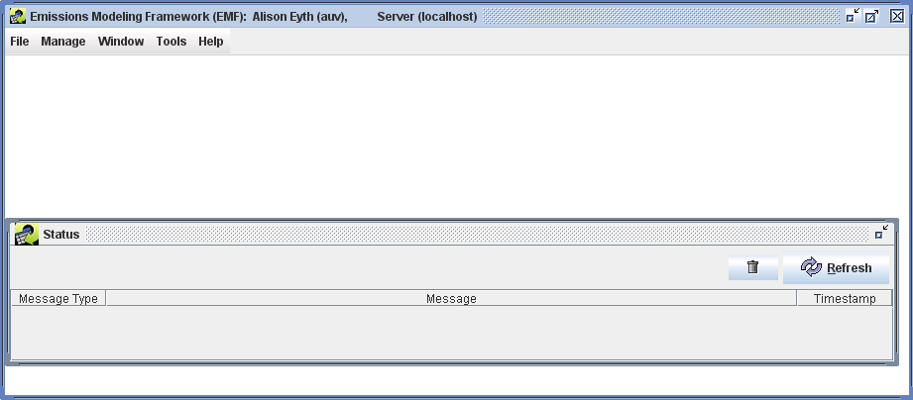

Control Measure Manager
This section demonstrates the features of the Control Measure Manager. The Control Measure Manager allows control measure data to be entered, viewed, and edited. The data that the Control Measure Manager is showing are stored in the Control Measures Database (CMDB). The CMDB is stored as a set of tables within the EMF database. Control measures can also be imported from files that are provided in a specific CSV format and exported to that same format. Control measures store information about control technologies and practices that are available to reduce emissions, the source categories to which they apply, the expected control efficiencies, and their estimated costs. In CoST, the control measures are stored separately from the emission inventory data and are matched with the emission sources using a list of Source Classification Codes (SCCs) that are specified for each control measure. The Control Measure Manager has the following major features:
- Facilitates storing and maintaining control measure data
- Shows minimum, maximum, and average control efficiency, cost per ton (based on year 2006 values), and average rule effectiveness and rule penetration
- Displays other control measure attributes (e.g., abbreviation, major pollutant, source group, equipment life, sectors, class)
- Allows import of control measure information into the system from CSV files
- Enables export of control measure to CSV files
In this section, you will learn how to:
- View, sort, and filter a list of control measures from the Control Measure Manager window
- Find control measure that apply to selected SCCs
- View the detailed data available for a control measure, including control efficiencies, SCCs, and cost equations
- Copy control measures
- Edit data for control measures
- Create new control measures
- Filter and display cost and control efficiency information for major and cobenefit pollutants of the measures
- See cost per ton information for different cost years
- Export control measures data

This section is presented as a series of steps so that it may be used as part of a training class or tutorial on how to use CoST. The steps to perform for the class are numbered.

The Upper Portion of the Control Measure Manager and Toolbar
We begin by opening the Control Measure Manager and exploring the buttons and menus in the upper portion of the window.
- To open the Control Measure Manager, choose Control Measures from the Manage menu on the EMF main window (Figure 2-3), as shown in Figure 3-1. The Control Measure Manager will appear (Figure 3-2). When the window first appears, it will be empty. Notice that the window appears within the EMF main window.
Figure 3-1. Manage Menu of EMF Main Window
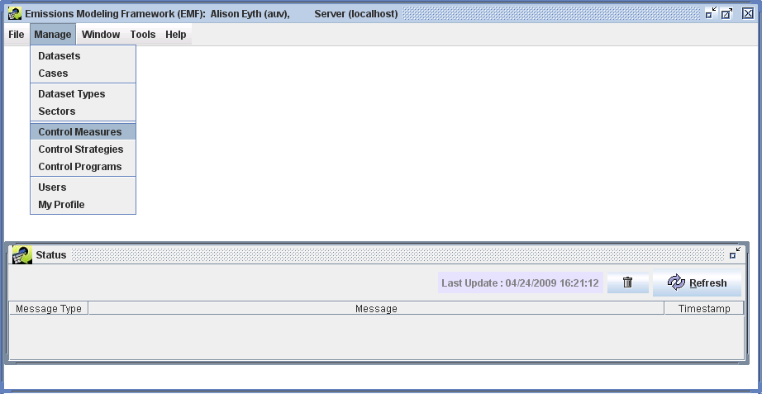

Notice the different parts of the Control Measure Manager. There is a Pollutant Filter at the top, along with a Show Details button and a Refresh button. Below those buttons is a toolbar full of buttons that operate on the data shown in the table below the toolbar, which is currently empty. There is also a distinct set of buttons and pull-down menus below the table. The functions of all of these buttons will be discussed in the coming sections.
Figure 3-2. Control Measure Manager before Control Measures are Loaded
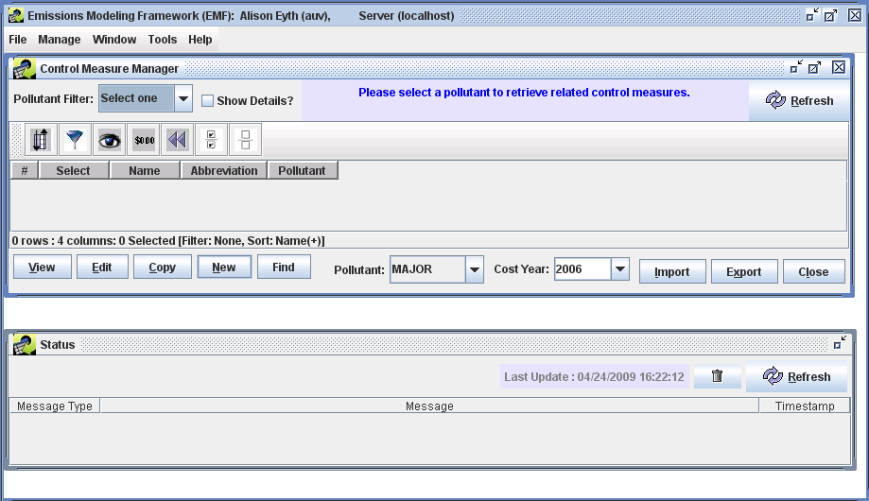

- To show some of the control measures from the database in the table, select a pollutant from the Pollutant Filter pull-down menu (for the training, select PM10). Information about any control measures that control the selected pollutant will appear in the window (Figure 3-3). At this point, only the control measure name, abbreviation, and pollutant are shown in the manager window. Note that name of each control measure must be unique within the database, and that the control measures appear in a table in which the data can be sorted and filtered.
The abbreviation is a set of characters that is a ‘short-hand’ for the control measure. Typically, the abbreviation should express the name of the control measure in an abbreviated form such that if someone is familiar with the abbreviation conventions, the person might be able to infer the name of the measure. Typically the first character of the measure denotes the ‘major pollutant’ (e.g., ‘P’ for PM controls, ‘N’ for NOx controls, ‘S’ for SO2 controls). The next few characters usually denote the control technology (e.g., ‘ESP’ for Electrostatic Precipitator, ‘FFM’ for fabric filter mechanical shaker). Abbreviations must be unique within the database (i.e., no two control measures can use the same abbreviation).
Figure 3-3. Control Measure Manager with Control Measures
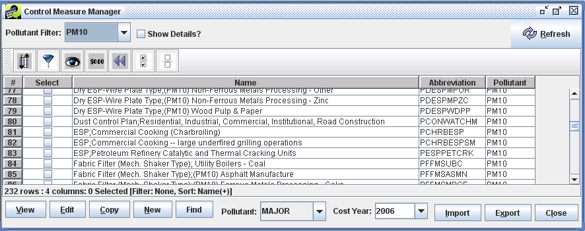
- To see more information about the measures, check the Show Details checkbox – additional columns will appear on the right of the table. An example is shown in Figure 3-4.
- To better see the additional columns, you can make the Name column narrower by positioning your mouse on the line between ‘Name’ and ‘Abbrevation’ on the table header – this will cause a special mouse pointer with arrows to appear and you can then drag your mouse to make the Name column narrower.
Figure 3-4. Control Measure Manager showing Control Measure Details
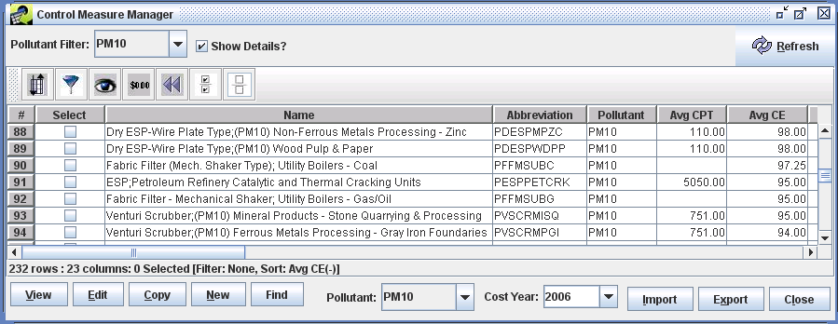
- Scroll to the right and examine the columns that are available in the Control Measure Manager for future reference. Note that you may move the columns around by grabbing the column’s header with your mouse and dragging them. You may also may change their widths as desired. You can resize the Control Measure Manager window within the EMF Main Window as desired, such as to make the entire window wider so that you can see more columns.
- After you scroll to the right a bit, hover your mouse over one of the columns other than ‘Name’, you will see that the name of the measure corresponding to the row you are on will appear briefly as a “tooltip”. This is so that you can tell what the name of the measure is even if has scrolled off the window.
The columns shown on the Control Measure Manager with brief descriptions are shown in Table 3-1. The table that shows the control measures allows the user to sort and filter the data. Tables of this same type are used many places throughout CoST and the EMF.

Table 3-1. Columns on the Control Measure Manager
Column Name | Description
Select | This column will allow the user to view, edit, or copy the measure by clicking the corresponding button at the bottom of the manager window. These features will be discussed later in the training.
Name | A unique name for the measure.
Abbreviation | A unique abbreviation for the measure.
Pollutant | A pollutant (e.g., NO_{x}, PM₁₀) that the measure might control. Note that any pollutant-specific information in the row is for this pollutant.
Max, Min, and Avg CE | Maximum, minimum, and average control efficiencies for the specified pollutant, aggregated across all locales, effective dates, and source sizes.
Max, Min, and Avg CPT | Maximum, minimum, and average cost per ton for the specified pollutant aggregated across all locales, effective dates, and source sizes.
Avg Rule Eff. | Average rule effectiveness aggregated across all efficiency records for the specified pollutant.
Avg Rule Pen. | Average rule penetration aggregated across all efficiency records for the specified pollutant.
Control Technology | The control technology that is used for the measure (e.g., Low NOx burner, Onroad Retrofit).
Source Group | The group of sources to which the measure applies (e.g., Fabricated Metal Products – Welding).
Equipment Life | Expected lifetime (in years) of the equipment used for the measure.
Sectors | An emission sector or set of EPA’s emission sectors to which the measure applies (e.g., ptipm, afdust, nonpoint).A sector represents a broad group of similar emissions sources.
Class | The class of the measure. Options are Known (i.e., already in use), Emerging (i.e., realistic, but in an experimental phase), Hypothetical (i.e., the specified data are hypothetical), and Obsolete (i.e., no longer in use).
Last Modified Time | The date and time on which the information about the measure was last modified in the editor or imported from a file.
Last Modified By | The last user to modify the measure.
Date Reviewed | The date on which the data for the measure were last reviewed.
Creator | The user that created the measure (either from the import process or by adding it via the “New” button).
Data Source | A description of the sources or references from which the values were derived. Temporarily, this is a list of numbers that correspond to references listed in the References Sheet from when the control measures were imported.
Description | A textual description of the applicability of the measure and any other relevant information.
- To sort based on data in one of the columns, click on the column header. For example, to sort based on the average control efficiency of the measure, first you may want to make the Name column narrower so that the column labeled “Avg CE” comes into view on the window, then click on the column header for the “Avg CE” column. The table will now be sorted by the values of “Avg CE” in descending order. Notice that information about the currently specified sort is reflected in the line just under the horizontal scrollbar for the table.
- If you click on the header of a column (e.g., Avg CE) a second time, the sort order will be reversed.
- To perform a multicolumn sort, click the sort button 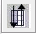 and then click Add to add an additional column to sort by (e.g., Name). Notice that you can control whether the sort is Ascending and whether it is Case Sensitive. Click OK once you have made your selection. The data should now be sort according to the column(s) you specified.
- To use a filter to limit the measures shown, click the button on the toolbar that looks like a filter: 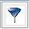. When you do this the “Filter Rows” dialog appears (Figure 3-5).
- Enter a criterion for the filter by clicking Add Criteria.
- Click in the cell under “Column Name” to make a pull-down menu appear, from which you may choose a column to filter on (e.g., ‘Name’).
- Click in the cell under “Operation” to see the available operations and, if desired, select an operation (‘contains’ is the default).
- Enter a value in the Value cell (e.g., ‘Scrubber’). Note that the filter values are case-sensitive (e.g., Measure names containing “scrubber” will not match a filter value of “Scrubber”).
Figure 3-5. Filter Rows Dialog
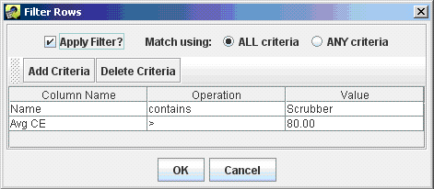
- To add a second criterion click Add Criteria again on the Filter Rows dialog (e.g., enter ‘Avg CE > 80’). Note that if Match using is set to ALL criteria then only rows that match all the specified criteria will be shown in the table after you click OK. If Match using is set to ANY criteria, then rows will be shown in the table if they meet any of the criteria that are listed.
- Click OK to close the Filter Rows dialog and to apply the selected filter. Figure 3-6 shows the table that results from the selections shown in Figure 3-5. Notice that the currently applied filter is reflected in the line under the horizontal scrollbar of the table.
Figure 3-6. Control Measure Manager with Filter Applied
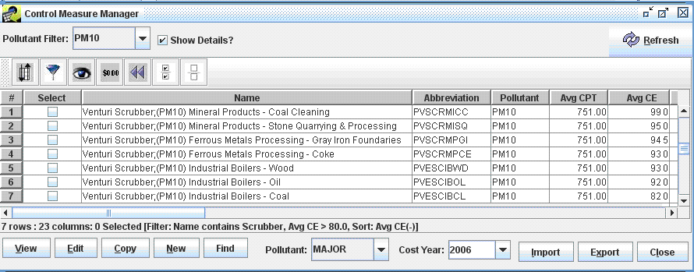
- Open the filter dialog again by clicking the Filter rows button. Set Match using to ANY CRITERIA and then click OK to see what effect it has on the measures shown. Hint: you should see more measures than when Match using is set to AND.
- Open the filter dialog again by clicking the Filter rows button. Remove one of criteria by clicking somewhere in one of the rows shown on the Filter Dialog and then clicking Delete Criteria. Now click OK to have the less stringent filter take effect.
- To select all of the control measures that meet your filter criteria, click the Select All button on the toolbar: . You will see that the checkboxes in the Select column are now all filled with checks. You may select or deselect individual measures by clicking their checkboxes in the Select column. In the next subsection, we will discuss operations that can be performed on selected measures, such as viewing them and exporting their data.
- To unselect all of the measures, click the Clear all the selections button: and you will see that all of the checks in the Select column are now removed.
- To hide some of the columns that are shown in the table, click the Show/Hide columns button: . On the Show/Hide Columns dialog that appears (similar to the one shown in Figure 3-7), uncheck some of the checkboxes in the “Show?” column and then click OK. The columns you unchecked will no longer be seen in the table.
Figure 3-7. Show/Hide Columns Dialog
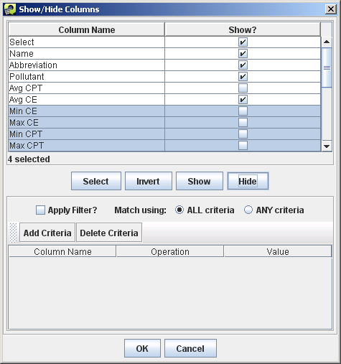
- Click the Show/Hide columns button again and scroll down through the list of columns at the top of the dialog to see others that are farther down the list. Select multiple columns to show or hide by clicking on the first column name of interest, then holding down the shift key, then clicking a second column name to select the intervening columns, and then clicking the Show button or the Hide button to either show or hide those columns.
If you want to select columns that are not next to each other, you can hold down the control key when you click your mouse, then when you are finished selecting click Show or Hide. The remaining buttons on the dialog are not used frequently: (a) Invert will invert the selection of highlighted columns. (b) The Filter section at the bottom can be used to locate columns when there are hundreds of column names, but there are no tables that large used in CoST.
- Click the Format columns button, , to open the Format columns dialog and examine the options for controlling how data in the table are shown. For example, check the checkboxes in the “Format?” column for one or more of the column names “Avg CE”, “Min CE”, and “Max CE” (note that you may first need to unhide the columns if you hid them in the previous step). Because these columns are all numeric, some controls used to format numbers will appear in the lower right corner.
Next, change the Font to Arial, the Style to Bold, the Size to 14, the Horizontal Alignment to Left, the Text Color to blue, the Column Width to 60, and the number of Decimal Places to 0. Once you have made all of your selections, your dialog should look similar to the one in Figure 3-8; if so, click OK. The columns that you had selected for formatting will have the attributes you specified on the Format Columns dialog. In practice, this dialog is not used very often, but it can be particularly helpful to format numeric data by changing the number of decimal places or the number of significant digits shown.
Figure 3-8. Format Columns Dialog
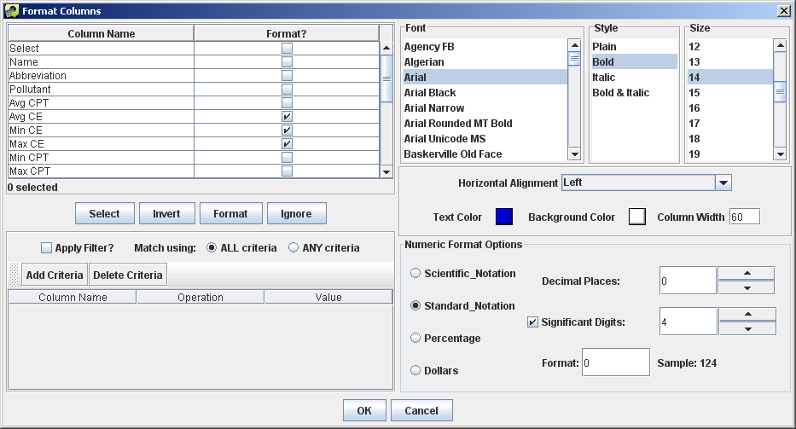
- To remove the specified sort, the row and column filters, and the formatting, click the Reset button:  .
- If you are unsure of what a button does when using CoST, place your cursor over the button and wait; in many cases, a small piece of text called a “tooltip” will appear. For example, place your cursor over one of the buttons on the toolbar and hold it still. You will see a tooltip describing what the button does. Many of the buttons and fields used in CoST have tooltips to clarify what they do or what type of data should be entered.
- If you wish to retrieve an updated set of control measures data from the server, click the Refresh button at the upper right portion of the Control Measure Manager. Note that this will also reset any special formatting that you have specified, but any sort and filter settings will be preserved.

Viewing Data for an Existing Control Measure
In this section you will learn about viewing the detailed data for a control measure.
- Before you can open a measure to view its data, you must select a measure of interest. For example, on the Control Measure Manager, make sure the Pollutant Filter is set to PM10, and then in the table locate the control measure named “Dry ESP-Wire Plate Type;(PM10) Commercial Institutional Boilers – Coal”.
Hint: Using a filter on the name field to show measures with names that include “Wire” may make it easier to find.
- Click the checkbox in the Select column next to the measure you want to examine and click the View button. The View Control Measure window will appear (Figure 3-9). There are several tabs available on the window; the Summary tab will be shown by default.
Figure 3-9. Summary Tab of View Control Measure Window
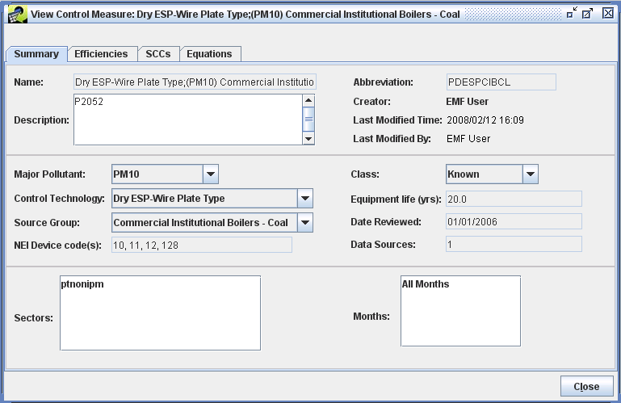

Viewing the Summary Tab for a Control Measure
The Summary tab of the View Control Measure window contains high-level summary information about the measure. Table 3-2 shows brief descriptions of the fields on this tab.

Table 3-2. Components on the Summary Tab of the View Control Measure Window
Component | Description
Name | A unique name that typically includes both the control technology used and the group of sources to which the measure applies.
Description | A description of the applicability of the measure and any other relevant information.
Abbreviation | A 10-character unique abbreviation that is used to assign the control measure to sources in the inventory. Ideally, the abbreviation should be somewhat readable so that the user has some idea of what type of measure it is from reading the abbreviation (e.g., the DESP in PDESPIBCL is short for ‘Dry Electrostatic Precipitator, the IB is short for ‘Industrial Boiler’, and the CL is short for ‘Coal’).
Creator | The name of the user who imported or created the measure.
Last Modified Time | The date and time on which the information about the measure was last modified in the editor or imported from a file.
Last Modified By | The last user to modify the measure.
Major Pollutant | The pollutant most controlled by the measure. This is used to group the measures only, and has no impact on how the measure is assigned to sources.
Control Technology | The control technology that is used for the measure (e.g., Low NOx burner). You can type a new entry into this field and then choose it from the pull-down menu in the future.
Source Group | The group of sources to which the measure applies (e.g., Fabricated Metal Products – Welding). You can type a new entry into this field and then choose it from the pull-down menu in the future.
NEI Device Code | The numeric code used in the NEI to indicate that the measure has been applied to a source.A cross-reference table to match the control measure abbreviations and NEI Device Codes to one another may be created.
Sectors | An emissions modeling sector or set of emissions modeling sectors to which the measure applies. A sector represents a broad group of similar emissions sources.
Class | The class of the measure. Options are Known (i.e., already in use), Emerging (i.e., realistic, but in an experimental phase), Hypothetical (i.e., the specified data are hypothetical), and Obsolete (i.e., no longer in use).
Equipment Life | The expected life of the control measure equipment, in years.
Date Reviewed | The date on which the data for the measure were last reviewed.
Date Sources | A description of the sources or references from which the values were derived. Temporarily, this is a list of numbers that correspond to references listed in the References Sheet from when the control measures were imported.
Months | The month(s) of the year to which the control measure is applicable. This is either “All Months” or a list of individual months (e.g., March, April, May for measures applicable only in spring months).
- When viewing a control measure (as opposed to editing a control measure), you cannot make changes to any of the selections. However, you can review the available selections for some fields. Click the arrows next to the fields Major Pollutant, Control Technology, Source Group, and Class to see the available options for each of these fields. Note that if you make a selection that differs from the original value on one of these menus, the new value will not be saved when you close the window because you are only viewing the measure data.

Viewing the Efficiencies Tab for a Control Measure
- Click on the Efficiencies tab to see the data that are available from this tab. You will see a table with many columns. Each row in the table corresponds to a different “efficiency record” in the database. An efficiency record contains cost and control efficiency information about the control measure. In the example shown in Figure 3-10, notice that the control efficiency and cost data (CPT) vary by pollutant. Scroll to the right to see some of the other columns in the table that are not immediately visible.
If the cost or control efficiency varies over region or time, it is possible to specify different records in the table for each Locale (i.e., state or county) or for each Effective Date if the measure will be “phased in” over time. Different efficiency records can also be entered to account for different source sizes using the Min Emis and Max Emis columns.
Figure 3-10. Efficiencies Tab of View Control Measure Window
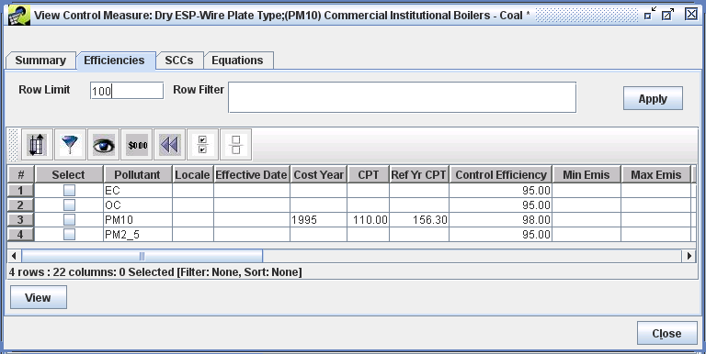
The Row Limit and Row Filter fields are helpful when there are hundreds or thousands of efficiency records (e.g., some data may be county specific and available for multiple pollutants). The Row Limit is the maximum number of records that will be displayed on the page. For example, if there were thousands of records, it could take a long time to transfer all of those data from the server, so by default only 100 records will be transferred if the Row Limit is set to 100.
- To see how the Row Filter works, enter Pollutant=’PM10’ into the text field and then click Apply. You will see only the record for PM10. These filters follow the syntax that can be used in a Structured Query Language (SQL) ‘WHERE’ clause. Note that the filter may not seem necessary in this particular example that only has a few records, but if this measure had entries for every county and pollutant as some mobile measure may have, then the filter can be very helpful to wade through all the records. If desired, you may try some other filters with this measure, such as:
“Pollutant like ‘PM%’”, “Pollutant=’EC’ or Pollutant=’OC’”, or
“Control Efficiency > 95”.
Here are some examples of other types of filters that you may find useful that illustrate other aspects of the syntax, although they may not all be applicable to this particular measure:
  - Pollutant <> 'PM10'
  - Locale LIKE ‘37%’
  - Pollutant IN ('EXH__CO', 'EXH__VOC', 'EXH__PM10')
- To see the data for an efficiency record in their own window: In the Select column,
check the checkbox for the PM10 efficiency record and click View. A View Efficiency Record window will appear (Figure 3-11). The fields of the efficiency record are shown in Table 3-3.
Notice that most of the fields in Figure 3-11 are set using text fields. The ‘Ref Yr Cost Per Ton Reduced’ is shown with a label because this value is automatically computed for the reference year (currently 2006) according to the cost year and the specified ‘Cost Per Ton Reduced’. Note that the cost per ton reduced should take into account the specified rule effectiveness and rule penetration, which ‘dilute’ the effectiveness of the control measure, but are not taken into account when the Ref Yr Cost Per Ton Reduced is computed. Other fields that are labels are Last Modified By and Last Modified Time. These fields are automatically updated and tracked by CoST when someone edits the efficiency record, although editing is done from the ‘Edit Efficiency Record’ window instead of the View Efficiency Record window.
Note: The efficiency records must be unique according to the contents of the following fields: Pollutant, Locale, Effective Date, Minimum Emissions, Maximum Emissions, and Existing Measure Abbreviation. This means that two records cannot have the same values for all of these fields.
- When you are done examining the information on the View Efficiency Record Window, click Close.
Figure 3-11. View Efficiency Record Window
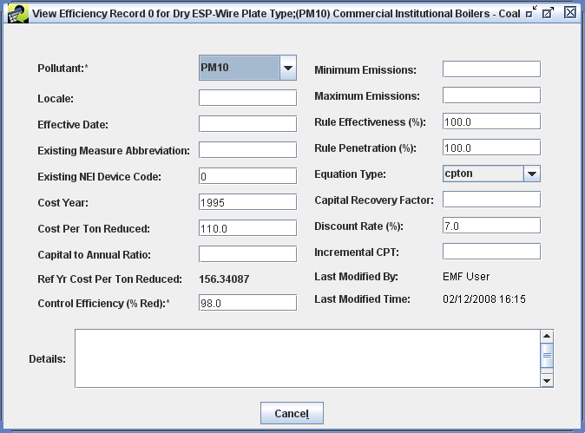

Table 3-3. Components on the Control Measure View Efficiency Record Window
Component | Description
Pollutant | The pollutant for which this record applies (emissions are either decreased or increased). An asterisk appears beside this field because a value for it must be specified.
Locale | A two-digit FIPS state code, or a five-digit FIPS county code, to denote that the information on the row is relevant only for a particular state or county. If left blank, it is assumed to apply to all states and counties.
Effective Date | The month, day, and year on which the record becomes effective. The system will find the record with the closest effective date that is less than or equal to the date of the analysis. If this is left blank, the record is assumed to apply to any date.
Existing Measure Abbreviation | This field should be populated when the data on the row are provided, assuming that a control measure has already been applied to the source. The contents of the field should be the control measure abbreviation that corresponds to the existing measure. The reason for this field is that the efficiency of and cost of applying the measure may vary when there is already a control measure installed on a source.
Existing NEI Device Code | This is used in conjunction with Existing Measure and should specify the device code used in the NEI that corresponds to the currently installed device.
Cost Year | The year for which the cost data are provided.
Cost per Ton Reduced | The cost to reduce each ton of the specified pollutant.
Capital to Annual Ratio | The ratio of capital costs to annual costs. Applicable only for equation-based annualized costs.
Ref Yr Cost per Ton Reduced | The cost per ton to reduce the pollutant in 2006 dollars.
Control Efficiency | The [median] control efficiency (in units of percent reduction) that is achieved when the measure is applied to the source, exclusive of rule effectiveness and rule penetration. An asterisk is shown next to the field because a value for the field is required, whereas other fields are optional. Eventually, statistical distributions for percent reduction may be provided to facilitate uncertainty analysis. Note that there are sometimes disbenefits for certain pollutants as a result of the control device, so control efficiency can be negative to indicate that the amount of a pollutant actually increased.
Minimum Emissions | The lower limit of emissions from the inventory required for the control measure to be applied.
Maximum Emissions | The upper limit of emissions from the inventory for the control measure to be applied.
Rule Effectiveness | The ability of a regulatory program to achieve all the emissions reductions that could have been achieved by full compliance with the applicable regulations at all sources at all times. A rule effectiveness of 100% means that all sources are fully complying at all times. Rule effectiveness can sometimes vary by locale.
Rule Penetration | The percent of sources that are required to implement the control measure. Rule penetration might vary over time as a new rule is “phased in” gradually, and can sometimes vary by locale.
Equation Type | The type of cost equation to use.
Capital Recovery Factor | The capital recovery factor to use. Applicable only for equation-based annualized costs.
Discount Rate | The discount rate used to compute the capital recovery factor. Applicable only for equation-based annualized costs.
Incremental CPT | The cost to reduce a ton of the specified pollutant, when applied on top of an existing measure at an emissions source.
Last Modified By | The last user to modify the efficiency record.
Last Modified Time | The last date and time a user modified the efficiency record.
Details | Text that specifies information about the source of data for this row or reason they were changed.

Viewing the SCCs Tab for a Control Measure
The inventory sources to which the control measure could be applied are those for which their SCC appears on the SCCs tab for the control measure. Note that while multiple SCCs can be specified for a measure, if the control efficiency or cost data differs for any of the SCCs, then a separate measure must be created to contain that data.
- Click on the SCCs tab to see the SCCs associated with the measure. An example of this tab is shown in Figure 3-12. The control measure will be considered for application only to sources with SCCs listed on this tab.
Note that no expanding of SCC codes ending in zeros is performed by CoST; therefore each applicable SCC must be explicitly listed on this tab. You may sort and filter the SCCs in the table to get a better idea of what SCCs are associated with the measure.
Figure 3-12. SCCs Tab of View Control Measure Window
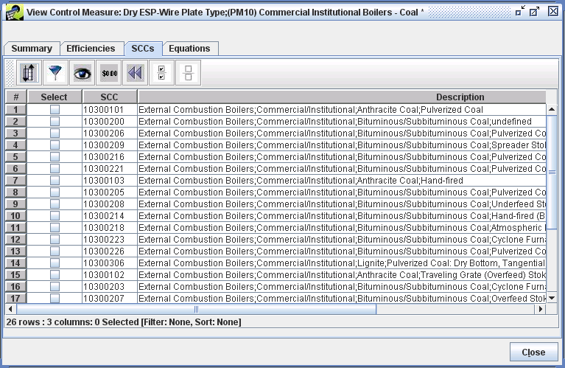
- When you are finished examining the SCCs the measure can apply to, click Close.

Viewing the Equations Tab for a Control Measure
As an alternative to using a simple ‘cost per ton of pollutant reduced’ value to compute the cost of a control measure, a cost equation can be specified. The cost equation will then be used to associate costs with a particular pollutant. The equation must be selected from a list of prespecified equation types. The value of the equation will be computed as specified by the form of the equation using the values of variables specified on the equations tab and values specified to the source that are given in the inventory (e.g., stack flow rate). Currently, only a single equation can be specified for any given measure.
- Click on the Equations tab to see any information associated with cost equations for the measure. An example of this tab is shown in Figure 3-13. If the measure does not use a cost equation, this tab will be blank. The table on the Equations tab shows the Equation Type (the same type is repeated in every row), in addition to the variable name and value for that variable.
Each type of equation uses a different set of variables. CoST supports at least eight different types of cost equations. Equation types 1 through 8 were also supported in AirControlNET. Additional types of equations may be added in the future. For more information on the Equations and their input variables, see the document “Documentation of Cost Equations in EPA’s Control Strategy Tool (CoST)” (available at http://www.epa.gov/ttn/ecas/cost.htm). The appropriate form of the equation will be used in conjunction with the specified values to compute the total cost of applying the measure to the source for the specified pollutant and cost year.
- Once you are finished viewing the information about the control measure, click the Close button to close the View Control Measure window.
Figure 3-13. Equations Tab of View Control Measure Window
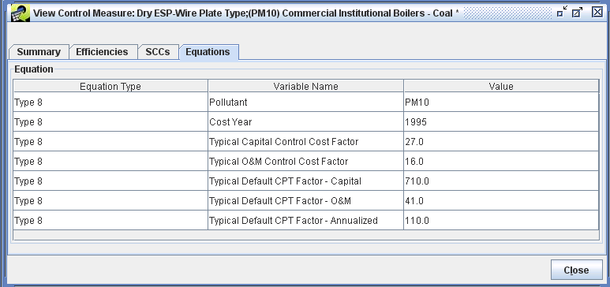

Copying a Control Measure
In addition to viewing existing control measure data, it is possible to create new control measures in CoST. One way to create a new measure is to copy an existing control measure and then edit its data.
- To copy a measure, we first need to find a measure that we want to copy. Start by clicking the Reset button ( ) on the toolbar of the Control Measure Manager to remove any previously specified filters.
- Next, uncheck the Show Details button at the top of the Control Measure Manager (to speed the data transfer) and set the Pollutant Filter at the top of the Control Measure Manager to the pollutant of interest (e.g., for the training pick NOX). For training purposes, find the measure named “SNCR; ICI Boilers - Natural Gas”. Hint: You may want to apply a filter to the manager to make it easier to find this specific measure.
- Once you have found the measure you wish to copy, check the corresponding checkbox in the Select column and then click the Copy button. CoST will create a new control measure called ‘Copy of the starting measure name your name unique #’. A unique abbreviation was also automatically generated for the measure.
- To see your new control measure in the Control Measure Manager, Scroll to the top of the window. If you do not see the measure, click the Refresh button at the top right of the manager - this causes the manager to obtain updated data from the server. Note: if you still do not see the measure named ‘Copy of SNCR; ICI Boilers…’ you may have a filter applied that is preventing this from showing up. If that is the case, you would need to remove the filter to see your newly copied measure.
- If you wish, you may view the contents of your new measure at this time by selecting it and clicking the View button, but we will edit the data for the new measure in the next section, so you may not need to view it now.

Editing Control Measure Data
CoST allows you to edit the data on each of the tabs for a control measure that you created, but not for measures that you did not create, unless you are an Administrator.
- Find a measure that you want to edit. First, click the Clear all the selections button to unselect any measures you may have worked with previously: For training purposes, find the new measure you just created using the copy button (Section 3.3) in the Control Measure Manager and check the corresponding button in the Select column. Now, click Edit to edit the data for the control measure. The Edit Control Measure window will appear (Figure 3-14).

Editing the Summary Tab for a Control Measure
Like the View Control Measure window, the Edit Control Measure window has four tabs, and the Summary tab is shown by default. The main difference between the View and Edit windows is that you can actually change things from the Edit window, rather then just viewing the information.
Notice that most of the fields have white backgrounds, which usually indicates that the field is editable; fields that are not contained within boxes are set by the software and cannot be changed by the user. In addition, there are Add and Remove buttons for the lists of Sectors and Months.
Figure 3-14. Summary Tab of Edit Control Measure Window
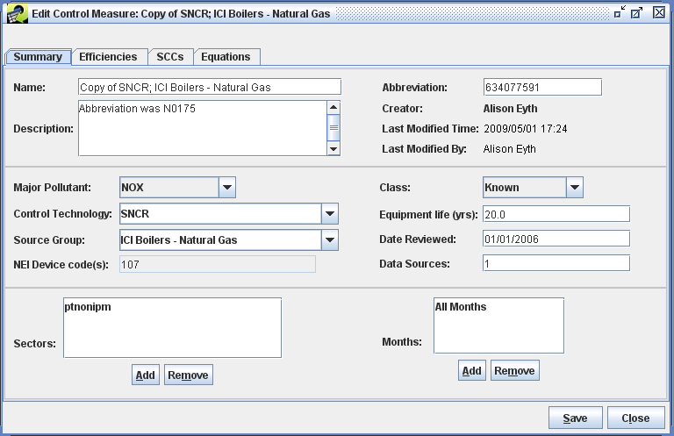
- Change the Name of the newly created measure to reflect the name of the new measure you intended to create (e.g., you might change the part of the name that deals with the affected sources, such as SNCR; ICI Boilers – Natural Gas and Oil). Recall that measure names must be unique.
- When the measure was copied, the abbreviation is set to a number that is known to be unique so that it could be saved in the database. At this point, you should replace the automatically generated Abbreviation for the new measure with one that has some meaning to you (e.g., NSNCRMINE). Try to follow a similar naming convention as the other measures, but your new abbreviation must be unique in the database.
- Edit the fields of the measure as desired. For training purposes, change the Equipment Life to 10, and the Date Reviewed to today’s date, set the Class to Emerging, and make any other changes you wish, such as entering a more detailed Description.
- Next click the Add button under the Sectors list to add another sector for the measure. For example, from the Select Sectors dialog, choose ptipm (i.e., point sources handled by the Integrated Planning Model) and click OK. You will then see the new sector added to the list of applicable sectors. Note that the sectors listed here are informational only; they do not affect the use of the measure in control strategies in any way.
- To remove a sector, click on the sector in the list and click Remove and it will no longer appear on the list.
- Adding and removing Months works similarly to adding and removing sectors. For training purposes, specify some specific months to which the measure should apply (e.g., March, April, and May).
Note: the feature of setting specific months for which a measure applies is effective when you are applying measures to monthly emission inventories. Specifying months in this way is not effective when you are applying measures to annual emission inventories.
- To set the months back to All Months, select all of the months in the Months list by clicking on the first month and then going to the last month and doing shift-click with your mouse. Then click Remove.
- Option to discard your changes: Now that you have changed information for the measure, notice that an asterisk (*) appears after the measure name in the title for the window. This means that CoST is aware that you have made changes. If you try to Close a window on which you have made changes to the data without saving it, CoST will ask you “Would you like to discard the changes and close the current window?” If you want to discard (i.e., undo) ALL of the changes made since you started editing the measure, click Yes. If you prefer to not to close the window so that your changes stay in-tact, click No. For training purposes, click No.

Editing the Efficiencies Tab for a Control Measure
- Go to the Efficiencies tab of the Edit Control Measure Window (Figure 3-15). The buttons on the Efficiencies tab of the Edit window are different from those on the View window. The available buttons are Add, Edit, and Remove. Notice the efficiency records for the measure shown in Figure 3-15 are for only one pollutant, but their values differ in the Min Emis and Max Emis columns because different costs apply for small versus large sources.
Figure 3-15. Efficiencies Tab of Edit Control Measure Window
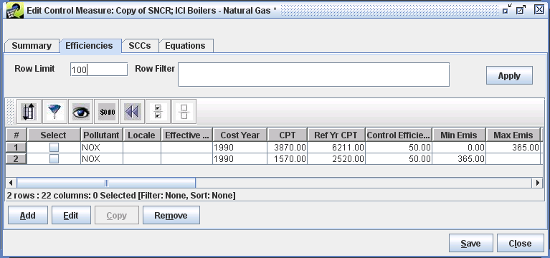
- Scroll to the right to examine additional fields on the window. Note that more of the fields are filled in than we saw for the PM measure that we examined in Section 3.2. The additional data allow CoST to compute the capital and operating and maintenance (O&M) costs in addition to overall annualized costs when this measure is used in a control strategy.
- To edit an efficiency record (for training purposes, choose the second record), check the corresponding checkbox in the Select column and then click Edit. The Edit Efficiency Record window will appear (Figure 3-16). Notice that the capital to annual ratio and capital recovery factor are filled in for this specific record, as is the incremental CPT. The incremental CPT would be used if this measure is added to a source with an existing control measure already applied.
Figure 3-16. Edit Efficiency Record Window
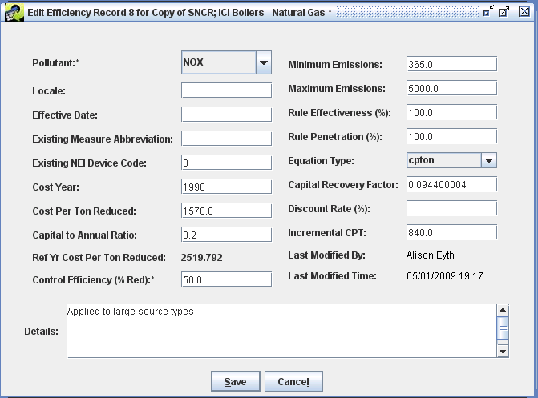
- You can edit the values for the efficiency record as needed to reflect your new control measure. For training purposes, enter 5000 as the value for Maximum Emissions, then click Save. Notice that this value has been updated in the table in the Edit Control Measure window. This means that the record will apply only to sources that emit between 365 and 5000 tons of NO_{x} each year.
- To add a new efficiency record, click Add. You will need to fill in the appropriate values in the Add Efficiency Record window that appears. For training purposes, select CO2 as the pollutant. Specify 06 as the Locale, 1/1/2015 as the Effective Date, and 10 as the control efficiency. When you are finished, click Save. A new row should appear in the table in the Edit Control Measure window. The effect of adding this record is to note that there is a 10% reduction to CO₂ when this control measure is applied, but only in California (FIPS=06) starting on 1/1/2015.
- To remove one or more efficiency records, click the corresponding checkboxes and then click Remove to remove those records. For training purposes, click the checkbox in the Select column for the record for CO₂ that you just added. Next, click Remove to remove that record. When ask to confirm if you are sure you want to remove the selected record, click Yes. The record should disappear from the table.
When costs are specified for multiple efficiency records: If you have cost per ton values specified for multiple efficiency records, they are additive when they are used in a control strategy. For example, if a CPT is specified for both NO_{x} and VOC for a measure, the total cost of applying the measure is the sum of (1) the cost per ton for NO_{x} times the NO_{x} emissions reduced and (2) the cost per ton for VOC times the VOC emissions reduced.

Editing the SCCs Tab for a Control Measure
- Click on the SCCs tab on the Edit Control Measure window to show the SCCs for inventory sources to which the edited measure can be applied. An example of this tab is shown in Figure 3-17. From this tab, you may add or remove SCCs from the list applicable to this measure.
Figure 3-17. SCCs Tab of Edit Control Measure Window
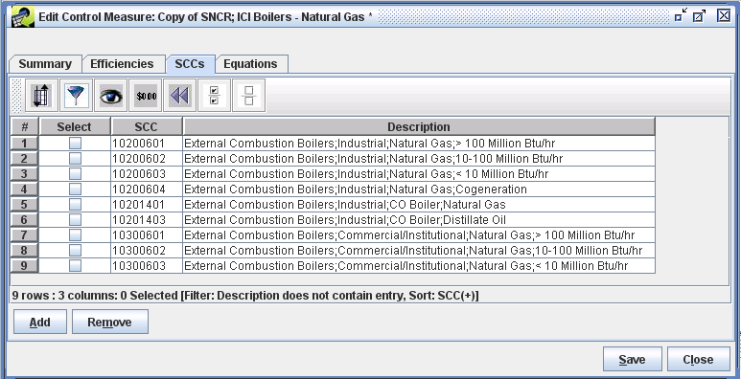
- To add some new SCCs, click the Add button. A Select SCCs dialog similar to the one shown in the background of Figure 3-18 will appear. Note that prior to filtering down the list of SCCs (which we will do starting in the next step), there are over 11,000 possible SCCs.
- To filter the SCCs on the Select SCCs dialog down to the more relevant ones, click the Filter Rows button on the toolbar. For training purposes, in the Filter Rows dialog that appears, click Add Criteria three times, enter the following criteria, then click OK:
- Description contains Natural Gas
- Description contains Boiler
- SCC starts with 1
Figure 3-18. Select SCCs and Filter Rows Dialogs
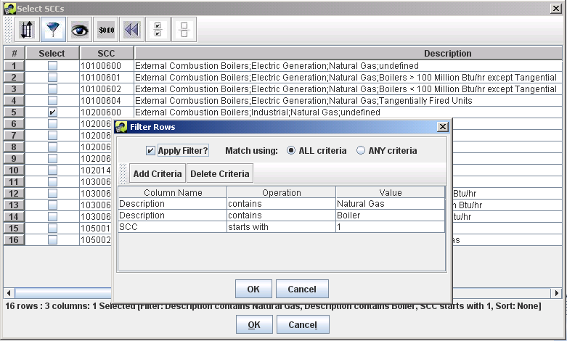

- At this point, in the Select SCCs window you should see only the SCCs that met your criteria, such as the 16 SCCs shown in Figure 3-18. Many of these SCCs are already associated with the measure (i.e., they are already shown on the SCCs tab of the Edit Control Measure window), but apparently 10200600 may also be relevant for this measure.
Click the checkbox in the Select column for the SCCs you wish to add to the measure (e.g., for training purposes 10200600) and then click OK. Now you will see that the SCC is added to the list of applicable SCCs for the measure in the Edit Control Measure window. If you had selected multiple SCCs, they all would have been added to the Edit Control Measure window (if they were not already there). Note: If you select an SCC to add that was already on the SCCs tab, it will not cause any problems and it will not add the SCC for a second time.
Hints for adding groups of SCCs: If you need to add a lot of SCCs and are able to specify a filter on the Select SCCs dialog that results in only the SCCs that are appropriate for the control measure being shown, you could enter the filter and then click the Select All button on the toolbar to select all of those SCCs at once. Then, when you clicked OK, all of the SCCs would be added to the SCCs tab for the measure. This keeps you from having to click all of the individual Select checkboxes. Alternatively, if most but not all of the SCCs were appropriate, you could select all of them and then click on a few checkboxes to deselect the ones that were not needed and then click OK to add only the ones that remained selected.

Editing the Equations Tab for a Control Measure
- Go to the Equations tab of the Edit Control Measure window (Figure 3-19). Notice the Add and Remove buttons that were not there on the View Control Measure window. Double click your mouse in the Value column next to the variable named Cost Year. For training purposes, change the value to 1995 and then press the Enter key on your keyboard. You will see that the new cost year is set to 1995. Note that the values for other fields could be changed in a similar way.
Figure 3-19. Equations Tab of Edit Control Measure Window
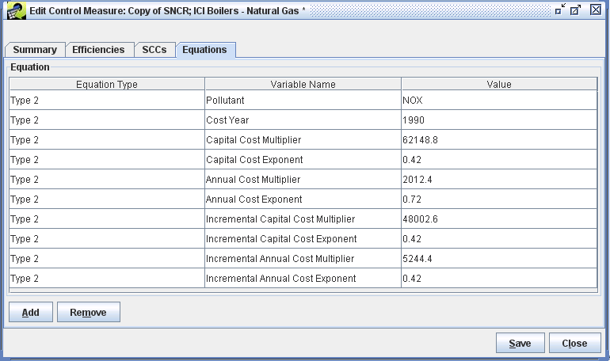
- To remove equation information, click the Remove button. You will see a dialog that says “Are you sure you want to remove the equation information”? So that you can see how removing and resetting equation information works using the copied version of the measure, click “Yes”. You will then see all of the equation information removed from the Equations tab.
- To add equation information to the measure, click the Add button on the Equations tab. You will see a Select Equation Type dialog. Click the pull-down menu to see the available types of equations—there are at least eight different types and select the desired equation type. For training purposes, select Type 1 – EGU. You will see that there are eight variables for this equation type. Note that the variables differ somewhat from the variables for the Type 2 equation shown in Figure 3-19, and that the Type 1 equation is for NO_{x} controls.
Details on the types of cost equations and their variables are given in the “Documentation of Cost Equations in EPA’s Control Strategy Tool (CoST)” document referenced earlier.
- For training purposes, click the Remove button again to remove the equation information, and click Yes in the confirmation dialog. Then click the Add button, and this time select Type 2 – NonEGU NOx. Next, fill in the values for the variables as they are shown in Figure 3-19 by double clicking on the field corresponding to each Value and then entering the appropriate information.
Note: You can enter cost equations in terms of only one pollutant, even if the measure reduces emissions for multiple pollutants.
- Click Save at the bottom of the Edit Control Measure window to save the changes you made to the control measure and to close the window. To see your revised name and abbreviation you entered for the measure in section 3.4.1, click the Refresh button at the upper right of the Control Measure Manager to load the updated data from the server.

Creating a New Control Measure
New control measures can be created in CoST.
- To create a brand new control measure, click New on the Control Measure Manager. A New Control Measure window will appear that looks like the Edit Control Measure window shown in Figure 3-14, except that it has no information filled in.
- Before you can save the control measure into the CMDB, enter a unique name and a unique abbreviation for the control measure. You must also specify a major pollutant and a class for the measure before the measure can be saved into the database. For more information on the other fields on the Summary tab, such as the Major Pollutant, Class, and Months, see Sections 3.2 and 3.4.
- Go to the Efficiencies tab and add at least one Efficiency Record for the measure; otherwise it will have no effect on any emissions sources. The Efficiencies tab should look similar to Figure 3-15, except there will be no rows available initially. For more information on the data needed for efficiency records, see Sections 3.2 and 3.4. You may add as many efficiency records as you need to describe the control efficiency and cost of the measure.
- Go to the SCCs tab, which should look like the one shown in Figure 3-17, except that no SCCs are listed initially. Add at least one SCC for the measure; otherwise it will have no effect on any emissions sources. Note that the same control efficiency and cost information must apply to all sources with SCCs listed on this tab, otherwise the information must be stored in a separate measure for the other SCCs. For more information on the data needed for SCCs, see Sections 3.2 and 3.4.
- If you need to associate a cost equation with the measure, go to the Equations tab and add an equation. The tab should look similar to the one shown in Figure 3-19. Cost equations are optional. Ideally, if you do not have a cost equation, you will have entered cost per ton information on one or more of the efficiency records so that the cost of applying the measure can be computed when it is use in a control strategy.
- Once you have entered all of the relevant information for the measure, click Save at the bottom of the New Control Measure window. Hint: set your Pollutant Filter on the Control Measure Manager to a pollutant that you specified an efficiency record for, so that you can see the measure on the Manager, otherwise your new measure will not be visible.
- Set the Pollutant Filter to a pollutant you specified for one of your new measure’s efficiency records, and you should see the new measure listed. If you do not see it, try clicking the Refresh button to reload the measures from the server.

Finding Available Control Measures for Specific SCCs
There are many situations in which you may be interested in what control measures might be available for emissions sources of certain types. If you know what SCCs are used for the source, the Find button on the Control Measure Manager (e.g., see Figure 3-4) can show you what control measures are available for sources with those SCCs.
- Before using the Find feature, set the Pollutant Filter (in the top left corner of the Control Measure Manager) to Select one, and click the Reset button on the toolbar, so that no pollutant or other filters will be applied prior to performing the next step.
- Now, click the Find button. You will see the Select SCCs dialog, similar to the one shown in Figure 3-18, except that all 11,000+ SCCs will be shown.
- Use the Filter Rows button on the toolbar of the Select SCCs dialog to enter a filter that will help identify SCCs for which you would like to see available control measures. For training purposes, try entering the filter SCC starts with 103 and then click OK. Hint: the ‘starts with’ operation is above the ‘contains’ operation in the list of operations. You should see about 60 SCCs that meet this criterion.
- Click the checkbox in the Select column for a few of the SCCs that interest you (e.g., select at least 10300101) and then click OK. If there are measures available for your selected SCC(s), they will be shown in the table. If you happened to select an SCC for which there are no measures available, none will be shown.
- Click Find again and this time, enter a filter on the Select SCCs dialog based on the SCC description instead of the SCC itself. For example, use the Filter Rows button on the toolbar to enter the filter Description contains Cement, then click on the checkbox in the Select column for a few of these SCCs (e.g., 30500606) and click OK. If there are measures in the database for the selected SCCs, they will be shown in the Control Measure Manager table. However, note that there may be some SCCs for which there are no measures available in the database. In that case, no measures would be shown in the table after you apply your filter. For the measures that are returned, notice whether they all have the same value for Pollutant (e.g., measures for SCC 30500606 target NO_{x}, PM₁₀, and SO₂).

The Pollutant Menu
The Pollutant pull-down menu near the bottom of the Control Measure Manager selects the pollutant for which the cost per ton, control efficiency, rule effectiveness, and rule penetration data are shown in the Control Measure Manager when Show Details is checked. Recall that each control measure can have efficiency records for multiple pollutants, so the Pollutant pull-down menu allows you browse the data for different pollutants. Note: The Pollutant menu at the bottom of the window performs a different function than the Pollutant Filter at the top of the window. By setting the Pollutant Filter at the top of the window, any measures that control the selected pollutant will be shown in the table.
- To see the effect of the Pollutant pull-down menu, first click the Reset button on the Control Measure Manager toolbar to remove any previously specified filters. Then set the Pollutant Filter to PM2_5, make sure that Show Details? is checked, and set the Pollutant menu at the bottom to MAJOR. If desired, make the Name column narrower so you can see more columns.
Examine the values in the Avg CPT, Min CPT, Max CPT, Avg CE, Min CE, and Max CE columns for some of the measures. Notice that for some of the measures, PM2_5 is not the pollutant listed in the pollutant column (e.g., sort on the Pollutant column by clicking on it once or twice to find other pollutants). These measures are shown in the manager because they affect PM2_5, even if PM2_5 is not the major pollutant for the measure. In this case, the CPT and CE values are shown for the major pollutant specified for the measure, not necessarily for PM2_5.
- Now change the value of the Pollutant menu to something other than MAJOR (e.g., PM10). You will see that all entries in the Pollutant column are now set to the pollutant you specified, and the cost per ton (CPT) and control efficiency (CE) values are specific to the selected pollutant instead of being for the major pollutant specified for the measure. Note that CPT values may not be filled in for some measures. For PM measures, the cost information is typically associated with PM10, as opposed to PM2_5. Therefore, if you now set the Pollutant menu to PM2_5, you will not see CPT values for many of the measures that do show CPT values for PM10.
- Next, set the Pollutant menu to some other pollutant that interests you. The control efficiency and cost information for the measures will be shown for the selected pollutant.

The Cost Year Menu
The Cost Year menu near the bottom of the Control Measure Manager controls the cost year for which the cost data are shown in the manager. The default cost year is 2006. The cost data are converted between cost years using the Gross Domestic Product (GDP): Implicit Price Deflator, issued by the U.S. Department of Commerce, Bureau of Economic Analysis. Details of the computation used are given in the “Control Strategy Tool (CoST) Development Document”.
- Change the cost year in the Cost Year menu from 2006 to an earlier year (e.g., 2000). You will see that the CPT information decreases. If you then change the cost year to a later year than the current setting (e.g., 2005), the CPT information increases.
Note that due to the method used to convert the costs between years, it is not possible to show costs for a future year (e.g., 2025); costs can be shown only for years prior to the current year. Also note that there is a 1- to 2-year lag between the current year and the latest available cost year data, so you cannot specify the current year in this field.
Note that if an equation is specified for a measure, and there are no default CPT data available for that measure, the CPT will not be shown in the Control Measure Manager because it must be applied to an emissions source for the cost to be computed.

Importing and Exporting Control Measure Data
It is possible to export control measure data to a set of CSV files. To do this, you first need to identify a set of control measures for which you wish to export data.
- For example, to export some measures that control PM10, set the Pollutant Filter on the Control Measure Manager to PM10. Next, use the Filter Rows button the toolbar and enter the following criterion: Name contains Fabric Filter. You should see about 51 measures in the manager.
- Click the Select all button on the Control Measure Manager toolbar, and then click the Export button. The Exporting Control Measures dialog (Figure 3-20) will appear.
To specify the folder (i.e., directory) in which to write the CSV files, type the folder name into the Folder text field (or paste it in using Control-V). Alternatively, you may use the Browse button to bring up the file and directory browser shown in Figure 3-21.
Figure 3-20. Exporting Control Measures Dialog
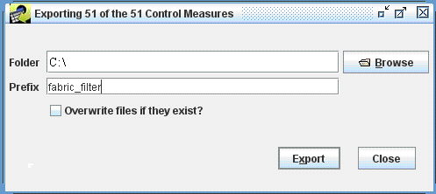

- To use the browser (Figure 3-21) to select the export folder, you may enter a starting folder (e.g., C:\) by typing it into the Folder field and hitting the Enter key. To browse into subfolders of the Folder, use the mouse or your arrow keys to find the folder you wish to drill down into and either double click or press the Enter key on your keyboard. If you want to create a new subfolder, enter the name in the New Subfolder field and click the Create button. Once you have the desired folder, click OK.
Figure 3-21. Browser
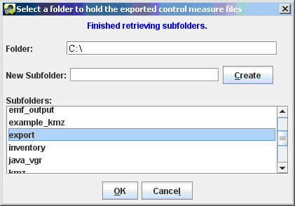

- Type a string into the Prefix field of the export dialog (e.g., fabric_filter). This string will precede the names of the files that will be written to help you identify the types of measures that are included once they have been exported into files.
- Once you have specified the desired Folder and the Prefix on the Exporting Control Measures dialog, click the Export button. The message at the top of the dialog will notify you that the export has started and that you should monitor the Status window to track your export request.
The Status window is near the bottom of the EMF main window (Figure 2-3). It will show a message when the export starts and when it is finished. You can see updates to the status on demand by clicking the Refresh button at the top of the Status window.
- After the export is finished, close the Exporting Control Measures dialog by clicking Close and then use your computer’s file browser to look in the folder that you selected for the export. In the example shown above, the files created in the selected folder are: fabric_filter_summary.csv, fabric_filter_efficiencies.csv, fabric_filter_SCCs.csv, and fabric_filter_equations.csv. These files may be opened with standard spreadsheet software. For a complete description of the fields in the files, see “Control Strategy Tool (CoST) Control Measures Database (CMDB) Documentation”.
Files in the exported format can also be imported into the CMDB. To import control measures from files, you must be an Administrator for the EMF. If you are an Administrator, you can click the Import button on the Control Measure Manager to start importing measure. [Note that if you are taking a training class, you will not be an Administrator and therefore will not be able to import control measure data, but you can review the concepts for importing described in the following section.]
In the Importing Control Measures window that appears (Figure 3-22), you may type or paste the name of the Folder into the field. You may also use the Browse button to browse to a folder containing the files to be imported (see the instructions for Figure 3-21) and select the files directly from the browser. Alternatively, you may enter the folder name then type in a pattern to specify the files, and then click Apply Pattern. When using a pattern, a * will be expanded to the available file names.
Once you have selected the files to import, click the Import button. Information about the status of the import will be shown in the Status section of the window. To see updates to the status of the import, click the Refresh Import Status button. Once the imports are complete, click the Done button. If the measures you import already exist in the database, the new data will replace the existing data. Note that you are not warned before the data is replaced, so use the import feature with caution.
Figure 3-22. Import Control Measures Dialog
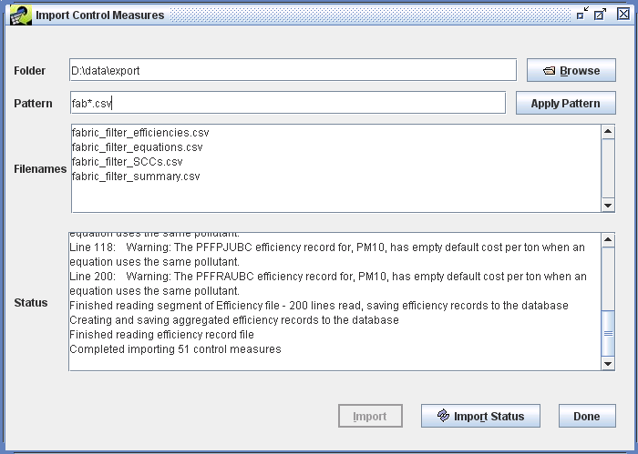

Control Strategy Manager
This section demonstrates the features of the Control Strategy Manager. The Control Strategy Manager allows control strategies to be created, edited, copied, and removed. A control strategy is a set of control measures applied to emissions inventory sources (in addition to any controls that are already in place) to accomplish an emissions reduction goal. Such goals are usually set to improve air quality and/or to reduce risks to human health. In this section, you will learn how to:
- View, sort, and filter a list of control strategies from the Control Strategy Manager window
- Create control strategies
- Edit control strategies to specify their inputs and parameters
- Run control strategies
- Copy control strategies
- Remove control strategies
- Analyze and summarize outputs from control strategies
This section is presented as a series of steps so that it may be used as part of a training class or as a tutorial on how to use CoST. The numbered steps are the ones you are expected to perform, while other material is provided for documentation purposes.

Introduction to Control Strategies
CoST automates the key steps for preparing control strategies. The purpose of developing control strategies is to answer questions about which sources can be controlled and how much the application of those controls might cost. For example, suppose you have a goal to reduce NO_{x} emissions for the Southeast in 2030 by 100,000 tons per year. CoST can help answer questions related to this goal, such as:
- What is the maximum emissions reduction achievable for NO_{x} (i.e., is my reduction goal less than the maximum possible reduction?), and what set of controls will achieve this reduction?
- What set of controls can achieve the goal at the least cost?
- What does the cost curve look like for other levels of reduction?
- What emissions reductions for the target pollutant would be achieved?
- What are the emission reductions or increases for other pollutants of interest?
- What are the engineering costs of applying the controls for a specific strategy?
- What control measures are available for specific source categories and pollutants, how much reduction does each one provide, and for what cost?
A future goal for CoST is to be able to answer this question: What is the optimum method for achieving simultaneous targeted reductions for multiple pollutants?
CoST can help answer the above questions when users set up and run one or more control strategies. A diagram of the basic steps for running a control strategy is shown in Figure 4-1. As illustrated in that figure, the inputs to a control strategy consist of:
- a set of parameters that control how the strategy is run
- one or more emissions inventory datasets (that have already been loaded into the EMF)
- filters to limit the sources included from those datasets
- filters to limit which control measures are to be included in the strategy analysis
- constraints that limit the application of measures to specific sources based on the resulting costs or emissions reduction achieved
Figure 4-1. Basic Steps for Running a Control Strategy
1) Input Basic Parameters (e.g.):
Type of Analysis
Cost Year
Target Pollutant
6) Run Strategy
Query
Outputs:
Detailed Pairing of Measures to Sources
Various Summary Files
Control Case Emissions Inventory
2) Select Strategy Algorithm (e.g.):
Maximum Emissions Reduction
Least Cost
Least Cost Curve
3) Select Inventory Dataset(s):
Sectors (EGUs, point, area, mobile)
Projection year (2020, 2030)
Filters for specific SCCs,
geographic areas, etc.
4) Select Control Measures:
Default is to include known measures
Can select certain technologies
5) Select Constraints (e.g.):
Max cost/ton controls (e.g., $20K/ton)
Min emissions size (e.g., 10 tpy)

Once the inputs have been defined, the strategy can be run on the EMF server. The method by which the measures are associated with the strategies depends on the algorithm that has been selected for the strategy. At this time, six algorithms are available to determine how measures are assigned to sources:
- Annotate Inventory: assigns control measures to the inventory based on the control efficiency specified for each source, and can be used to fill in control measure information for inventory sources that are missing these details but have a control efficiency assigned.
- Apply Measures in Series: assigns all control measures that can be used for a source to the source in the specified order; this is often used for mobile sources, for which the control measures are typically independent of one another.
- Least Cost: each source can be assigned only a single measure to achieve a specified percent or absolute reduction for the sources included in the strategy run, with the minimum possible annualized cost.
- Least Cost Curve: performs least-cost runs iteratively at multiple percent reductions so that a cost curve can be developed that shows how the annualized cost increases as the level of desired reduction increases.
- Maximum Emissions Reduction: assigns to each source the single measure (if a measure is available for the source) that provides the maximum reduction to the target pollutant, regardless of cost.
- Project Future Year Inventory: applies control programs and growth factors to sources, as would be needed to project a base-year inventory to a future-year inventory.
Some of the key aspects of each of the strategy types are summarized in Table 4-1, and some additional information on each strategy type is provided in the following subsections.

Table 4-1. Summary of Strategy Algorithms
Strategy Type | Multiple Inventories | Typical Sectors | Measure Assignment | Outputs
Maximum Emissions Reduction | Processed independently | Area, nonpoint | One per source | Standard
Apply Measures in Series | Processed independently | Mobile: Onroad, nonroad | Multiple per source | Standard
Least Cost | Can be merged | Area, nonpoint | One per source | Standard, Least Cost Control Measure Worksheet
Least Cost Curve | Can be merged | Area, nonpoint | One per source | Standard, Least Cost Control Measure Worksheet, Least Cost Curve Summary
Annotate Inventory | Processed independently | Area, nonpoint | One per source | Standard
Project Future Year Inventory | Processed independently | Any | One per source | Standard
After the strategy run is complete, several outputs are associated with the strategy. The main CoST output for each control strategy is a table called the “Strategy Detailed Result”. This table consists of emission source-control measure pairings, each of which contains information about the cost and emission reduction that would be achieved if the measure were to be applied to the source. If multiple inventories were processed by the strategy, then there will be one Strategy Result for each input inventory, unless the inventories were merged for a least cost run (as indicated in the ‘Multiple Inventories’ column Table 4-1). Also, there will be at least one Strategy Detailed for each of the least cost iterations performed as part of a Least Cost Curve run. In addition to the Strategy Detailed Result, two other outputs are produced for each strategy run: the Strategy County Summary (which includes uncontrolled and controlled emissions), and the Strategy Measure Summary (which summarizes how control measures were applied for each sector-county-SCC-Pollutant combination). These three outputs are referred to in Table 4-1 as the ‘Standard’ outputs.
The Strategy Detailed Result table itself can be summarized on-demand in many ways using predefined summary queries (e.g., by state, by county, by control technology). Users familiar with SQL can also define their own custom queries. The Strategy Detailed Result table can also be merged with the original input inventory, in an automated manner, to produce a controlled emissions inventory that reflects implementation of the strategy. The controlled emissions inventory includes information about the measures that have been applied to the controlled sources and can be directly input to the SMOKE modeling system to prepare air quality model-ready emissions data. Comments are placed at the top of the inventory file to indicate the strategy that produced it and the settings of the high-level parameters that were used to run the strategy.
Detailed information on specifying control strategy input parameters is given in Section 4.3.1. Section 4.3.2 discusses fields automatically set by CoST. Section 4.3.3 addresses inventories and inventory filtering. Section 4.3.4 discusses control measure filtering and custom overrides. Constraints are discussed in Section 4.3.5. Running a strategy and developing summaries of strategy inputs and outputs are discussed in Section 4.4. Documentation for the various types of strategy outputs is given in Section 4.5, and information about summaries of strategy inputs and outputs is given in Section 4.6.

Maximum Emissions Reduction Control Strategy
The Maximum Emissions Reduction control strategy is the simplest of the strategy algorithms. It assigns to each source the single control measure that provides the maximum reduction to the target pollutant, regardless of cost. The strategy produces the three standard types of strategy outputs, including a Strategy Detailed Result for each input inventory.

Apply Measures in Series Control Strategy
The Apply Measures in Series control strategy applies all relevant controls to a source, as opposed to the Maximum Emission Reduction strategy, where only the most relevant measure (with the best possible reduction for lowest cost) is applied to the source. The Apply Measures in Series strategy is typically used for mobile sources, for which the input inventories are often average day inventories specific to a given month, and for which there are often multiple independent controls available for each source. Therefore, the measures are applied to the source in series, one after the other. The order of application is based on the user-specified “apply order,” but the system also considers the lowest cost and greatest control efficiency. Thus, the cost factor in terms of dollars per ton of pollutant reduced is used to calculate the annualized cost of the control measure when applied to a specific source.
The three standard types of outputs are generated after a successful strategy run: a Strategy Detailed Result for each input inventory, a single Strategy Measure Summary, and a single Strategy County Summary. Note that when input inventories contain average-day emissions data for a month, the corresponding Strategy Detailed Result datasets will specify total monthly emissions as opposed to average day emissions for each source; otherwise they will specify annual emissions. The total monthly emissions are calculated by multiplying the average day emissions by the number of days in the month. Regarding the two types of summary outputs, if the input datasets have data for each of the 12 months, the summaries will provide annual emissions.

Least Cost Control Strategy
The Least Cost strategy type assigns measures to emissions sources to achieve a specified percent reduction or absolute reduction of a target pollutant for sources in a specified geographic region while incurring the minimum possible annualized cost. This algorithm is similar to the maximum emissions reduction strategy in that only a single measure is applied to each source. For example, one measure might be selected for a source when trying to reduce the target pollutant by 20%. However, if you were trying to obtain a 40% reduction of the target pollutant, another more expensive measure that achieves a higher level of control might be selected for the same source to meet the targeted level of reduction. If multiple inventories are specified as inputs to a Least Cost strategy, they are automatically merged into one EMF dataset as an ORL Merged dataset type. This allows the multiple inventory sectors to be considered simultaneously during a single Least Cost run. Note that the merged inventory dataset will be truncated and repopulated at the start of each strategy run, to ensure that the most up to date inventory data is included in the run.
The Least Cost strategy automatically creates the same three standard output datasets, but it also creates an additional output dataset called the Least Cost Control Measure Worksheet. This output is a table of all possible emission source-control measure pairings (for sources and measures that meet the respective filters specified for the strategy), each of which contains information about the cost and emission reduction achieved if the measure was to be applied to the source. Examples of these tables are given in Section 5.4. This dataset will be used to help generate a single Strategy Detailed Result (no matter how many input inventories were processed) once the optimization process has been performed to achieve the desired reduction. This dataset has the all of the same columns as the Strategy Detailed Result (see Table 4-4), in addition to the following columns:
- marginal: This column stores the marginal cost (dollars are given based on the specified cost year) for the source-measure record. This is calculated according to the following equation:
marginal cost = annual cost (for specified cost year) / emission reduction (tons)
Note that cost equations are used to compute the annual cost, when applicable and all required input data is available. For target pollutant source-control pair records, the annual cost will be the total of the annual costs for the target pollutant and any costs associated with cobenefit pollutants.
- status: This column contains a flag that helps determine which source-control records should be actively considered during the strategy run.
- cum_annual_cost: This column contains the cumulative annual cost for the source and all preceding sources that have been included in the strategy (i.e., for which status is null). This is only specified for target pollutant sources, but it also includes costs associated with cobenefit pollutants.
- cum_emis_reduction: This column contains the cumulative emission reduction for the source and all preceding sources that have been included in the strategy (i.e., for which status is null). This is only calculated for target pollutant sources. The emission reduction is cumulated by following the apply_order in an ascending order.
If multiple input inventories are used for the least cost strategy run and the user requests to create controlled inventories, there will be one controlled inventory created for each of the input inventories.

Least Cost Curve Control Strategy
The purpose of the Least Cost Curve strategy type is to iteratively run Least Cost strategies so that a cost curve of can be generated. Typically, a cost curve will show has the total cost of emissions reduction and the cost per ton of emissions reduction increases as the desired level of reduction increases. The input inventories are treated in the same way as the least cost run in that the data from the inventories will be put together into an ORL Merged inventory prior to performing any of the runs. The inventory filters and measure filters work in the same way as they do for the other strategy types, as do the constraints that apply to all strategy types. The main difference between the Least Cost and Least Cost Curve strategy types is in the specification of constraints. Instead of specifying a single percent reduction or absolute emissions reduction, three new constraints are used to control the run:

- Domain-wide Percent Reduction Start (%): Specifies a percent reduction to be used for the first Least Cost strategy to be run.
- Domain-wide Percent Reduction End (%): Specifies a percent reduction to be used for the last Least Cost strategy to be run.
- Domain-wide Percent Reduction Increment (%): Specifies an increment on percentages to use between the first and last runs (e.g., if 25% is specified, runs will be performed for 25, 50, 75, and 100% reduction).

Additional runs can be added to a least cost curve strategy if you do not delete the previous results when you rerun the strategy. Suppose that you generate a coarse cost curve (default increment is 25%) and you find an area of interest that bears further examination. You can then go back and specify different start, end, and increment to obtain more information (e.g., start=80%, end=90%, increment=2%) about that portion of the curve.

The types of outputs for a Least Cost Curve strategy are the following:
- Strategy Detailed Result datasets for each targeted percent reduction. Note that several results could have the same actual percent reduction if the targeted reduction exceeds the maximum available reduction. As with a Least Cost strategy, the actual percent reduction may not exactly match the targeted reduction due to the discrete nature of applying specific controls to specific sources. CoST will ensure that each actual reduction is equal to or greater than the corresponding targeted reduction.
- Least Cost Control Measure Worksheet: this output is the same as the worksheet produced for a regular Least Cost strategy run. Note that the same worksheet is used for all targeted percent reductions and only the status column is updated to specify would measure-source combinations are included in the current strategy.
- Least Cost Curve Summary: this output dataset contains a row with cost and emissions reduction information for each of the runs that was performed for the strategy. Rows are added to this output if additional strategy runs are performed (e.g., to examine different sections of the curve). The columns of this summary are: Poll, Uncontroll_Emis (tons), Total_Emis_Reduction (tons), Target_Percent_Reduction, Actual_Percent_Reduction, Total_Annual_Cost, Average_Ann_Cost_per_Ton, Total_Annual_Oper_Maint_Cost, Total_Annualized_Capital_Cost, Total_Capital_Cost. Here, the Uncontroll_Emis column contains the emissions from the original input inventory with all existing controls backed out so that it represents the uncontrolled emissions. The columns starting with Total are computed by summing all of the values of the corresponding column in the Strategy Detailed Result for the pollutant specified in the Poll column. Examples of Least Cost Curve Summaries are given in Figure 10 and Table 19.
- Controlled Inventories: these output datasets may optionally be created based on any of the Strategy Detailed Results that are available for the strategy. Thus, results corresponding to any of the targeted reductions may be processed by SMOKE and the resulting data used as an input to an air quality model. Note that for each targeted reduction, individual controlled inventories will be created for each of the input inventories.

Annotate Inventory Control Strategy
The purpose of the Annotate Inventory strategy type is to specify what measures are likely to have been used to achieve specified percent reductions in input inventories. The input inventories are treated in the same way as the Maximum Emissions Reduction runs in that each inventory is processed separately and separate results are created for each one. The inventory filters and measure filters work in the same way as they do for the other strategy types. Note that the selected target pollutant is important because only records for that pollutant will be annotated, but CoST may be changed in the future to consider all inventory pollutants. Constraints are applicable in that if the controlled source does not satisfy the specified constraints, it will not be included in the result and another measure that does satisfy the constraints will be sought.
The outputs from the Annotate Inventory strategy type are an Annotated Inventory for each of the input inventories. The annotated inventories have the same dataset types as the input inventories. All of the source records for the specified target pollutant with nonzero control efficiencies in the input inventory will appear in the annotated inventory and the control measures column will be filled in for sources for which a matching measure has been found. Note that the originally specified control efficiency fields and the emissions in the inventory are not changed, even if the inventory efficiency differed from the efficiency specified for the control measure. Once an annotated inventory has been created, a controlled inventory can be created from the annotated inventory. Unlike the annotated inventory, the controlled inventory will have all records found in the input inventory and can therefore be used as an input to SMOKE.
One of the goals for CoST that has not yet been met is for the tool to be able to intelligently make use of control measures that can be applied in addition to other controls (also known as ‘add-on’ controls). In order for the software to meet this goal, it is important for it to first be able to determine whether there are any existing control measures on the emissions source and the type of control device(s) used by the existing measures. Currently, a data gap exists in this area for both the base year emissions inventories and the future year emissions inventories which may be used as inputs to a control strategy run. The NEI contains data fields to store this information, and there is a limited amount of existing control efficiency and control device code data in the base year NEI. However, these fields are not very well populated in the base year inventory for sectors other than the EGU point sources, and the fields are even less well populated in the future year modeling inventories. Generally, the control efficiency field is much better populated than the control device fields. In addition, the control device codes that are stored in the NEI are a lot less specific than the control measure abbreviations that CoST uses. Therefore, even if the control device codes were well populated, these codes would need to be translated into the CoST control measure abbreviations for CoST to really have the information it needs to properly apply add-on controls.
To address the issue of unspecified control measures in inventories that can be input to CoST, several steps have been taken. First, when CoST creates a controlled inventory, in addition to filling in the information in the CEFF, REFF, and RPEN columns, CoST populates the Control Measures, Pct Reduction, Current Cost, and Total Cost columns in the ORL inventory to specify information about measures that it has applied. In this way, the controlled inventories created by CoST always specify the relevant information about the measures that have been applied as a result of a CoST control strategy. The Annotate Inventory strategy type is a second step that has been taken to provide more information about existing control measures.
When an Annotate Inventory strategy is run, CoST looks at the percent reduction specified by the CEFF, REFF, and RPEN columns and uses the available control measures in the database to try to determine what control measure has the closest percent reduction to the one specified in the inventory. It then fills in the control measures column with the measure that was found. Note that the originally specified control efficiency fields and the emissions in the inventory are not changed, even if the inventory efficiency differed from the efficiency specified for the control measure. If no measure was found, it leaves the control measure field blank. Once the strategy has been run, a summary report can be generated with using the "Compare CoST to NEI measures" query that shows the sources with non-zero CEFF values and the difference between the inventory specified percent reduction and the percent reduction that the control measure that CoST “guessed” had been applied to the source. It is important for the user to then examine the results of this report to find cases where the specified control efficiency matches were not even close and those for which no match was found. Both of these situations can indicate that there is missing or incorrect data in the control measures database, or that the information in the inventory was erroneous. The eventual goal of the Annotate Inventory strategy is to develop a base year inventory with more complete existing control measure information. The specific algorithm is follows, and an illustration of the algorithm is shown in Figure 12:

Project Future Year Inventory Control Strategy
In order for the future year base inventories to have information on existing control measures, it will be helpful if the inventory projection process (that takes the base year inventory and projects it to a future year inventory) can specify what control measures have been applied to the sources. This can be accomplished in a similar way to how the Annotate Inventory strategy analysis works. It can also be accomplished by incorporating the concept of control programs into CoST and the EMF. The process of projecting inventories is currently done using a series of SAS programs that take as input data tables collected from various sources. For several years, EPA has wanted to make the process of applying the control programs more explicit and documentable. By incorporating the control programs into CoST and having CoST apply the projection and control factors to create the projected inventory, it will be possible to annotate the inventories as the projection takes place.
To accomplish the application of control programs and projection factors to an inventory, the control programs concept is being incorporated into CoST. For each control program it will be possible to specify the type of program, the start date, and one or more accompanying datasets that identify the sources that will be affected by the program (e.g., a list of plants that will close). The types of control programs are expected to include, but not be limited to, the following:

- Plant closures
- Planned reductions at specific plants
- Planned growth at specific plants and estimated growth for specific sectors
- Caps on emissions at existing plants

In situations where the desired control measures or technologies for the control program are known, these can be specified as part of the control program. If the control measures are not known, CoST can search for a measure with the desired control efficiency and provide that as the best guess for the applied measure. The Strategy Detailed Result for the Project Future Year Inventory strategy shows any control efficiencies and growth factors that were applied and a probable control measure for each projected source. This strategy type can generate a complete inventory for use as input to SMOKE. It is important to note that there is another important data need to collect planned control program data (e.g., from SIPs) from states so that future EPA control strategy modeling can incorporate these programs and thereby produce more realistic results than if the planned state-specific programs are ignored.

Managing Control Strategies
The control strategies currently available within CoST are shown in the Control Strategy Manager. The Control Strategy Manager allows you to see information about control strategies, to create new control strategies, and also to edit, remove, and copy control strategies.

Opening the Control Strategy Manager
- To open the Control Strategy Manager, choose Control Strategies from the Manage menu on the EMF main window (Figure 4-2) and the Control Strategy Manager will appear (Figure 4-3). You will not see the same strategies shown in Figure 4-3.
Figure 4-2. Manage Menu of EMF Main Window
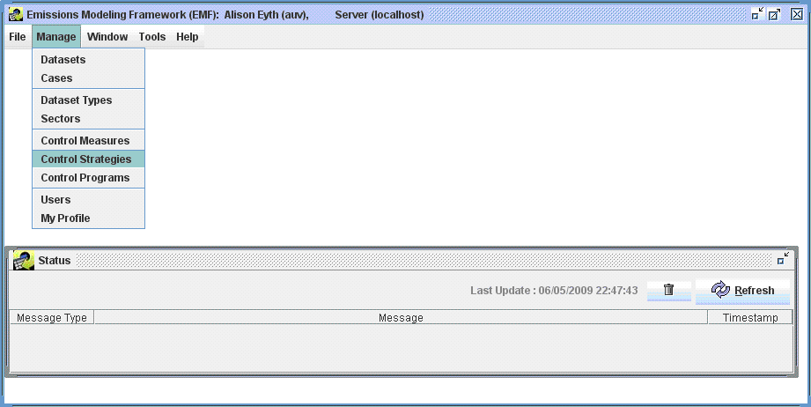
Figure 4-3. Control Strategy Manager Window
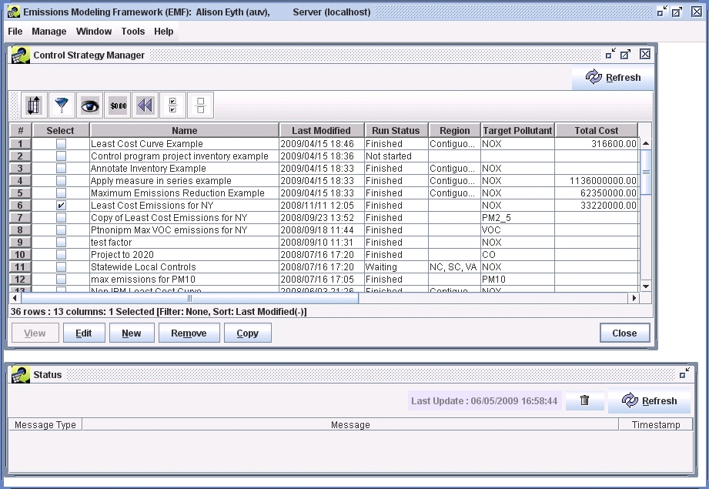
The Control Strategy Manager shows all of the control strategies currently available within the EMF/CoST system in a sortable, filterable window. The columns shown in the window are Select, Name, Last Modified, Run Status, Region, Target Pollutant, Total Cost, Reduction (tons), Project, Strategy Type, Cost Year, Inv[entory] Year, and Creator. Descriptions of some of the columns are given in Table 4-2. The remaining fields are described in detail in Section 4.3.

Table 4-2. Key Columns of the Control Strategy Manager
Column | Description
Name | shows the name of the control strategy.
Last Modified | shows the date and time on which the strategy was last changed.
Run Status | gives information about the strategy run. Possible options are:  Not started – the strategy run has never been started;  Waiting – a run has been requested, but it is waiting because other strategies are running;  Running – the strategy is currently running;  Finished – the strategy run completed successfully;  Failed – the strategy run started, but failed due to a problem.
Inv Year | shows the year of the emissions inventory that the strategy will process.

Sorting and Filtering Control Strategies
By default, the strategies are shown using a descending sort on the last modified date and time, so that the most recently modified strategies appear at the top of the list.
- To sort the control strategies on the total cost of the strategy, click on the words ‘Total Cost’ in the Total Cost column and the rows will re-sort so that the most expensive strategies will be shown at the top. Click on the Total Cost column header again to reverse the sort.
- To see only strategies that were run with a specific target pollutant, click the button on the toolbar that looks like a filter: . When you do this the “Filter Rows” dialog appears. Try entering a criterion for the filter by clicking Add Criteria. Click in the cell under “Column Name” to make a pull-down menu appear; choose “Target Pollutant”. You can change the operation used by clicking in the cell under “Operation”, but for our purposes “contains” is the desired selection. Next, enter the pollutant of interest (e.g., ‘NOX’) in the Value cell.
Note that the filter values are case-sensitive (e.g., “NOx” will not match a filter value of “NOX”). When you are finished, the Filter Rows dialog should look like the one shown in Figure 4-4. After you click OK, the Control Strategy Manager will show only strategies that targeted NO_{x}.
Figure 4-4. Filter Rows to Show Only Strategies Targeting NO_{x}
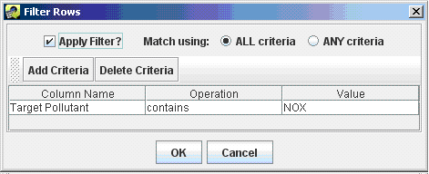
- Once you have reviewed the information available on the Control Strategy Manager,
click the Reset button to remove the filter and sort that you had specified.
For more information on performing sorting, filtering, formatting, and other operations on the table that shows the control strategies used for the Control Strategy Manager, refer to Section 3.1.

Copying Control Strategies
Control strategies can be copied to create new control strategies, regardless of whether they have been run. If you copy a strategy and then edit the newly created strategy, you will not be changing any settings for the original strategy, so this is a safe way to start working with your own strategies. When a strategy is copied, is retains all of the settings from the original strategy except for the information on the Outputs tab, and the output summary information that is shown on the Summary tab.
- Click the Select checkbox next to one of the strategies (e.g., “Least Cost Emissions Example”) and then click Copy. You will see that a new strategy has been added to the Control Strategy Manager with the name “Copy of original strategy name”.
Note that if you had selected more than one strategy prior to clicking Copy, each of the selected strategies would have been copied.

Removing Control Strategies
If you created a control strategy, or you are an EMF Administrator, you can remove the control strategy from CoST. Strategies should be removed with caution, because there is no ‘undo’ for this operation.
- To remove a control strategy, click the Select checkbox that corresponds to the strategy and then clicking Remove. For training purposes, select the strategy you just copied in the previous subsection. When you are prompted to confirm whether you would like to remove the control strategy, click Yes. You will see that the selected strategy has been removed from the table on the Control Strategy Manager.
Note that if you had selected more than one control strategy before clicking Remove, all of the selected strategies would have been removed.

Creating a New Control Strategy
- To create a new control strategy, click the New button. A dialog will appear that asks you to name the strategy. Enter a name that is different from any of the existing control strategies (e.g., Least Cost 2020 NOx for Training) and then click OK.
An Edit Control Strategy window for your newly created strategy will appear. The window has five tabs: Summary, Inventories, Measures, Constraints, and Outputs. This window and how to fill in the information on these tabs is discussed in more detail in Section 4.3.
- Click Save to save your newly created strategy. You will be prompted to give values for the following fields prior to saving.
- For Target Year, enter the year of the emissions inventory you plan to use (e.g., 2020). - Select a Type of Analysis based on the goal of your strategy (e.g., Least Cost for training purposes).
- Select a Target Pollutant for your strategy (e.g., NOX for training purposes).
- Close your newly created control strategy by clicking the Close button in the Edit Control Strategy window.
If you do not see your newly created strategy in the Control Strategy Manager, click the Reset button on the toolbar to remove any filters that you may have applied previously that may not apply previously.
If you still do not see your new strategy, click the Refresh button at the top right of the Control Strategy Manager to obtain new data from the server.
After taking these steps, you can also try clicking on the top of the Last Modified column and scroll to the top to find the most recently modified strategies.

Editing Control Strategies
Click the select checkbox next to a strategy that you created (e.g., one from the previous subsection), and then click Edit. If you have permission to edit the strategy (i.e., you are its creator or an Administrator), the Edit Control Strategy window will appear with the Summary tab visible (Figure 4-5). Note that if you had selected multiple control strategies before clicking Edit, they each would have opened in their own window. The tabs on the Edit Control Strategy window are listed in Table 4-3. The contents of these tabs are described in detail in Section 4.3.

Table 4-3. Tabs of the Edit Control Strategy Window
Tab | Description
Summary | Shows you high-level information about the strategy, such as its Name and the Target Pollutant.
Inventories | From which you can specify the emission inventories to use as input to the strategy and filters for those inventories.
Measures | Allows you to specify the classes of measures to include in the strategy, or select specific measures to include.
Constraints | Allows you to specify constraints for the strategy, such as a maximum cost per ton.
Outputs | Shows the results from the strategy after it has been run.
Figure 4-5. Summary Tab of Edit Control Strategy Window
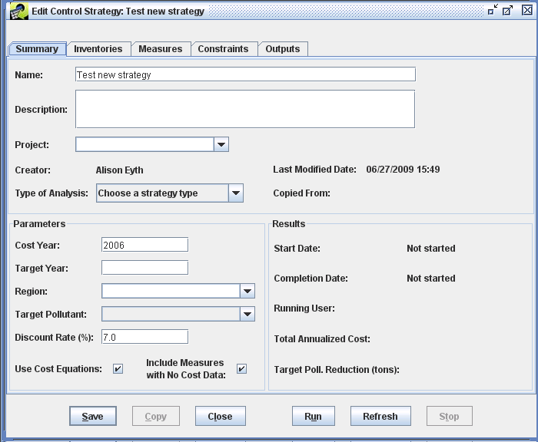

Inputs to Control Strategies
Control strategies have fields that can be specified by the user prior to running the strategy. These fields are described in this section.

Inputs on the Summary tab
To specify the inputs for the strategy on the Summary tab (see Figure 4-5, above), follow the steps below. Note that the fields on the Summary tab missing from this list are automatically set by CoST, and are discussed in Section 4.3.2. Fields that have white backgrounds or that are pull-down menus usually allow you to enter your own data; while fields that are not contained within boxes are set by the software and cannot be changed by the user.
- If one has not already been specified, enter a unique and meaningful Name for the control strategy (e.g., Least CoST NOx).
- Optionally, enter a Description of the purpose for the control strategy, and any other information deemed relevant and useful to describe the strategy.
- Optionally, enter the name of the Project for which this strategy run was performed (e.g., Initial Ozone NAAQS). The project is used as a means of grouping related strategies that were performed in support of a common goal.
- Select a Type of Analysis to specify the type of algorithm used to match the control measures with sources (e.g., Maximum Emissions Reduction, Least Cost). For purposes of training, select Least Cost, otherwise specify the type of strategy algorithm you are interested in running.
- Specify a Cost Year to use for presenting the costs for the results of this strategy. For training purposes, enter 2006. All cost data specified for the control measures will be converted to this year using the Gross Domestic Product (GDP): Implicit Price Deflator, issued by the U.S. Department of Commerce, Bureau of Economic Analysis, as described in Section 3.8. Note that there is a 1- to 2-year lag between the current year and the latest available data, so you cannot specify the current year in this field.
- Specify a Target Year for the strategy run. For training purposes, enter 2020. Typically, this is the year represented by the input inventory or inventories (e.g., 2020, 2030). For control measure efficiency records to be considered for a strategy, the specified effective date for the record must be equal to or earlier than the target year. Note that any control measure efficiency records that come into effect after the target year will not be considered for use in the strategy. Also, for the “Project Future Year Inventory” analysis type, the target year represents the future year to which you are projecting the inventory.
- Optionally specify the name of the geographic Region to which the strategy is to be applied. For training purposes, select any region, because this setting is for user information only and does not impact the strategy results. Region is different from the concept of “locale” used in the control measure efficiency records (see Section 3.2.2) to indicate the state or county code to which the record applies.
- Select a Target Pollutant for the strategy (e.g., for training purposes pick ‘NOX’). The target pollutant is the pollutant of primary interest for emissions reduction for this control strategy. The Least Cost and Maximum Emissions Reduction algorithms will consider reductions of this pollutant when performing their computations.
Note that reductions of pollutants other than the selected target pollutant (e.g., PM₁₀, PM_{2.5}, elemental carbon [EC], organic carbon [OC]) will be included in strategy results if those pollutants both appear in the inventories input to the strategy and they are affected by measures applied as part of the strategy. These pollutants are sometimes referred to as “coimpact pollutants”, because the impact on the emissions could be either a reduction (i.e., a benefit) or an increase (i.e., a disbenefit).
- Specify a Discount Rate (i.e., interest rate) to use when computing the annualized capital cost for control measures when appropriate data are available. For training purposes, enter 7. Note that discount rate typically does not affect strategies for area or mobile sources.
- Specify whether to Use Cost Equations for the strategy run. When the checkbox is checked, cost equations will be included in the run, otherwise only CPT related cost estimates will be used. For training purposes, leave this checked. When it is not checked, they will not be used; only the default cost per ton values will be used.
- Specify whether to Include Measures with No Cost Data. When the checkbox is checked, measures with control efficiencies but without cost data (e.g., measures with no cost data specified or measures that use a cost equation to compute cost, but for which there is not enough data for the source in the inventory to fill in the equations variables), are included in the strategy run; otherwise they are not included. For training purposes, leave this checked.

Fields Automatically Set by CoST
Some fields of a control strategy that appear on the Summary tab are set automatically by the CoST software and are not specified by the user. Note that some of these summarize the results of the strategy analysis, so information for them is not available until after the strategy has been run. The automatically set fields are described in Table 4-4.

Table 4-4. Fields on the Control Strategy Summary Tab Automatically Set by CoST
Field | Description
Creator | The name of the person who created the strategy.
Last Modified Date | The date and time when the strategy was last modified.
Copied From | The name of the strategy that this strategy was copied from, if any.
Start Date | The date and time on which the strategy run was most recently started, or “Not started” if the strategy has never been run.
Completion Date | The date and time on which the strategy run was most recently completed. If the run has not completed, this field shows the run status of either “Not started”, “Running”, “Waiting”, “Completed”, or “Failed”.
Running User | The name of the user who most recently ran the strategy.
Total Annualized Cost | The total annualized cost of applying the strategy.
Target Poll. Reduction (tons) | The absolute emissions reduction achieved for the target pollutant, in tons.

Inputs on the Inventories Tab
To specify the inputs for the strategy on the Inventories tab (Figure 4-6), follow the steps in this section. The Inventories to Process table near the top of the tab lists the emissions inventories for which the control strategy will be run. A control strategy can have one or more emissions inventories as input. Before inventories can be selected for use in the strategy, they must already have been imported into the EMF via the Import button on the File menu of the EMF Main Window. The inventories must also have one of the following EMF dataset types: ORL point, ORL nonpoint, ORL nonroad, or ORL onroad. “ORL” stands for “one record per line”, meaning that each line of the file has information for a single source-pollutant combination. Point inventories have information about emissions sources with specific locations, which are specified using latitude and longitude. Nonpoint, nonroad, and onroad inventories contain data aggregated to the county level. Note that IDA inventories are not supported by CoST and need to be converted to ORL prior to use with CoST. The EMF database stores the data for the emissions inventories along with metadata about the inventories in its PostgreSQL (http://www.postgresql.org) database.
- To add one or more inventories to the Inventories to Process table for the control strategy, click the Add button on the Inventories tab. A Select Inventory Datasets dialog will appear (Figure 4-7).
- From the Select Inventory Datasets dialog, select the type of inventory that you wish to show (e.g., ORL Point) from the pull-down menu near the top of the dialog. The browser will then show you the inventories of the specified type. If there are many inventories and you wish to narrow down the list (e.g., to find inventories for 2020), you can then enter a string in the Dataset name contains field and press the Enter key on your keyboard. This will limit the list to those inventories for which their name contains the specified string.
- To select an inventory to use for the strategy from the dialog, click on the name of the inventory with your mouse. To select additional inventories, hold down the control key while clicking the additional inventories. For training purposes, select ptnonipm_2020cc and ptinv_ptnonipm_xportfrac_cap2002nei and then click OK. When you return to the Inventories tab, you will see the inventories you selected in the list of inventories to process.
Figure 4-6. Inventories Tab of Edit Control Strategy Window
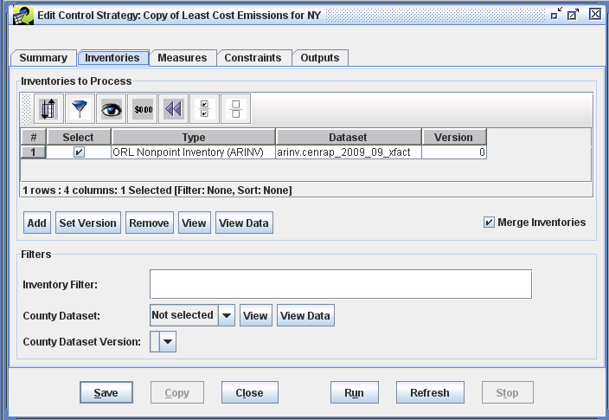
Figure 4-7. Selecting Inventory Datasets for a Control Strategy
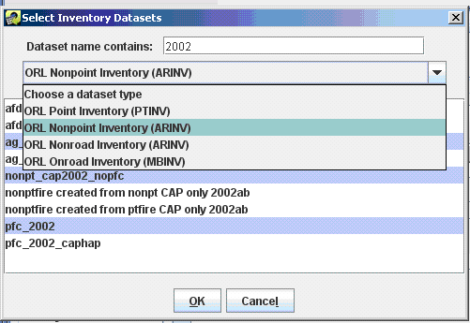
- If you wish to remove inventories from the list of inventories to process, click the Select checkboxes that correspond to those inventories, click the Remove button (Figure 4-6), and then click Yes when you are asked to confirm deleting of the inventories. For training purposes, remove the ptinv_ptnonipm_xportfrac_cap2002nei inventory so that only the ptnonipm_2020cc inventory remains in the list. When asked if you really want to remove the selected inventories, select Yes.
- Note that multiple versions of the inventories may be available within the EMF. The EMF supports the storing of multiple versions of a dataset to facilitate reproducibility of historical runs. To specify which version of the inventory to use, check the Select checkbox next to a single inventory and then click the Set Version button. A dialog will appear that lists the versions available for the selected inventory. Choose the desired version from the menu and then click the OK button. You will then see the number of the version you specified in the Version column of the Inventories to Process table. Note that the initial version of a dataset is always version number 0.
- To see the properties (i.e., metadata) for an inventory you selected, click the corresponding checkbox in the Select column and then click View. The Dataset Properties View window will appear (Figure 4-8). The Dataset Properties View window provides information about the selected inventory dataset and has multiple tabs as described in Table 4-5.

Table 4-5. Tabs of the Dataset Properties View and Edit Windows
There are also buttons at the bottom of the window. The Edit Properties button will bring up the Dataset Properties Editor that will allow you to change (as opposed to just look at) the properties of the Dataset. The Edit Data button will bring up the Dataset Versions Editor that allows you to edit the actual data of the dataset by adding new versions. The Refresh button will update the data on the Dataset Properties View window with the latest information available from the server.
Tab | Description
Summary | Shows high-level properties of the dataset
Data | Provides access to the actual inventory data so that you can view the data that will be used in the control strategy
Keywords | Shows additional types of metadata not found on the Summary tab
Notes | Shows comments that users have made about the dataset and questions they may have
Revisions | Shows the revisions that have been made to the dataset
History | Shows how the dataset has been used in the past
Sources | Shows where the data came from and where it is stored in the database, if applicable
QA | Shows QA summaries that have been made of the dataset (e.g., state summaries, county summaries)
Figure 4-8. Dataset Properties View Window for an Emissions Inventory
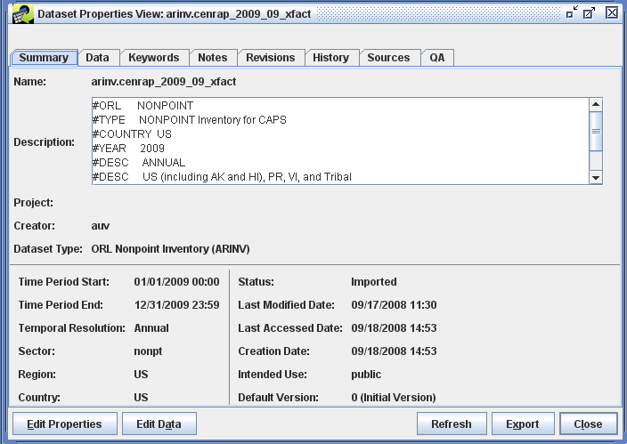
- When you are finished examining the properties of the inventory dataset as shown on the various tabs, click Close.
- To view the inventory data itself (as opposed to just the metadata), check the select checkbox for an inventory from the Inventories to Process table in the Edit Control Strategy window and click the View Data button. This may take a minute or two, but the Data Viewer window that shows the actual rows of data for the selected inventory will appear (Figure 4-9). This is different from the metadata that was shown in the Dataset Properties View window. Note that the View Data button is a shortcut. The Data Viewer can also be brought up from the Data tab of the Dataset Properties Viewer.
Figure 4-9. Data Viewer for an Emissions Inventory
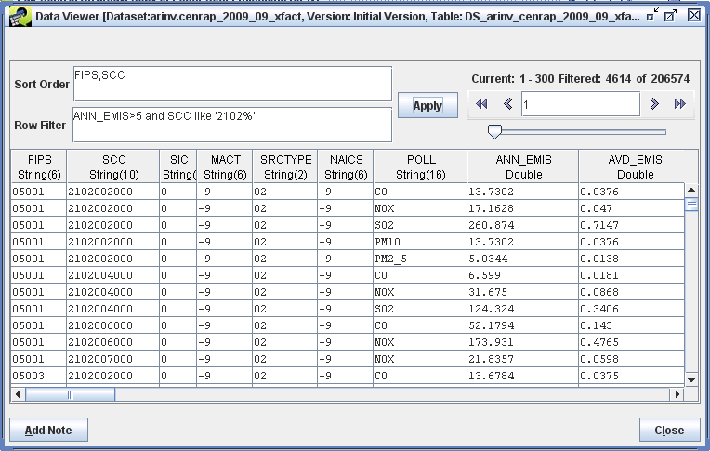
- Inventories can have a lot of data—up to millions of rows. The fields in the upper right corner of the window in the area labeled “Current:” provide information about how many rows the inventory has, and which rows are currently visible. The Data Viewer transfers only a small amount of data (300 rows) from the server to your desktop client to keep the transfer time reasonable. It works similarly to a web search engine that shows the results in pages, and the pagination arrows near the upper right corner of the window facilitate moving between pages of data. Try using some of the pagination arrows in the upper right corner to see how they work: go to first record, go to previous page, give a specific record, go to next page, and go to last record.
- You can control how the data are sorted by entering a comma-separated list of columns in the Sort Order field and then clicking Apply. For training purposes, if you are using a UNC laptop, do not specify a sort order because this function is very slow on these laptops. It should be much faster on a true EMF server. Note that a descending sort can be specified by following the column name with “desc” (e.g., “ANN_EMIS desc, FIPS” will sort by decreasing annual emissions and then by county).
- If you enter a Row Filter, and then click Apply, the Data Viewer will find rows that meet the criteria you specified. Examples of the syntax for row filters are given in Table 4-6 (this table is discussed further in paragraph 32 below). For training purposes, if you are using a UNC laptop, do not specify a row filter because this function is very slow, otherwise you may try some of the filters.

Table 4-6. Examples of Row Filters (Data Viewer window) and
Inventory Filters (Inventories tab of the Edit Control Strategy window)
Filter Purpose | SQL Where Clause
Filter on a particular set of SCCs | scc like '101%' or scc like ‘102%’
Filter on a particular set of pollutants | poll in ('PM10', 'PM2_5')  or  POLL = 'PM10' or POLL = 'PM2_5'
Filter sources only in NC (State FIPS = 37), SC (45), and VA (51); note that FIPS column format is State + County FIPS code (e.g., 37001) | substring(FIPS,1,2) in ('37', '45', '51')
Filter sources only in CA and include only NO_{x} and VOC pollutants | substring(fips,1,2) = '06' and poll in ('NOX', 'VOC')  or  fips like '06%' and (poll = 'NOX' or poll = 'VOC')
- When you are finished examining the Data Viewer, click Close to close the window.
The next few paragraphs provide information on how the options at the lower portion of the Inventories tab work, there are no training steps in them. The training exercises start again with the first numbered bullet on the next page.
Some control strategy algorithms (e.g., Apply Measures in Series) are designed to process the inventories iteratively and produce results for each inventory. However, the “Least Cost” and “Least Cost Curve” strategy types can merge the input inventories from multiple sectors together prior to processing them, thereby facilitating cross-sector analyses. The Merge Inventories checkbox is shown in the lower right corner of the Inventories to Process section, when multiple inventories will be merged together prior to applying the strategy algorithm, such as for Least Cost or Least Cost Curve runs. Otherwise, each inventory will be processed independently to create separate, independent results.
The fields in the Filters section of the Inventories tab of the Edit Control Strategy window let you control whether the entire inventory is processed in the strategy or just a portion of it. The Inventory Filter field allows you to specify a general filter that can be entered using the same syntax as a Structured Query Language (SQL) “where clause”. Any of the columns in the inventory can be used in the expression. Examples include: “SCC like ‘212%’ ” to limit the analysis to apply only to inventory records for which the SCC code starts with 212, and “FIPS like ‘06%’ or FIPS like ‘07%’ ” to limit the strategy analysis to apply only to inventory records with Federal Information Processing Standards (FIPS) numeric state-county codes starting with 06 or 07. Additional examples of filters are shown in Table 4-6. Note that within the inventory filter, you may use either upper or lower case to refer to the column names and for the SQL keywords; the specified values within single quotes, however, are case sensitive (e.g., ‘NOx’ is different from ‘NOX’). Entering an inventory filter will not have an effect until the strategy is run.
Note that if you enter an inventory filter to include only specific pollutants, then pollutants not specified by the filter will not be considered for the computation of coimpacts. In addition, pollutants like EC and OC that are not traditionally included in input inventories will not be included in the results unless the inventory has been preprocessed to include EC and OC.
The County Dataset field allows another way to filter the inventory. With this field you can specify an EMF dataset containing a list of counties within which to consider applying control measures during the strategy run. If the user selects a county dataset filter when creating a control strategy, control measures will be applied only to counties that are included in this list. The County Dataset pull-down will show as options the names of the available datasets in the EMF that have the dataset type ‘List of Counties (CSV)’. Note that CSV files from which these county datasets are created must have at least two columns of data. Also, the first row of the file must be the column names, and one of the columns must have a name that starts with “FIPS”. CoST will assume that this column has the list of FIPS codes that should be controlled. Make sure that leading zeros are present for FIPS codes less than 10000.
Note that only the records of the input inventories that pass both the inventory and county filters will be considered for control measure application.
- For training purposes, on the Inventories tab, specify the following Inventory Filter:
FIPS in (‘42001’, ‘42009’, ‘42011’). Note that specifying a list of counties using the Inventory Filter is an alternative to specifying a county dataset that has a list of counties to consider controlling in the strategy (as show in the next bullet). If you just wanted to control a few counties, you might use the Inventory Filter, but if you want to control more than a few counties, the county dataset method is recommended. In addition, many types of Inventory Filters can be specified using other fields of the inventory depending on the needs of your analysis (e.g., ‘SCC like 231%’, or ‘ANN_EMIS>5’).
- Examine the available county datasets by pulling down the menu and select one of the datasets. After you have selected a county dataset, examine its properties and the data themselves by clicking the View and View Data buttons.
- If a county dataset is specified, a version of the dataset to use must be selected using the County Dataset Version field, which shows the available versions of the selected dataset. This selection is required because the EMF can store multiple versions of each dataset. Examine the list of versions available for the dataset in the menu.
- If you selected a county dataset as part of understanding how this feature works only for training purposes, as opposed to performing a strategy run in support of your work, set the pull-down menu back to Not selected before proceeding.

Inputs on the Measures Tab
The Measures tab appears on the Edit Control Strategy window for all types of strategies except “Project Future Year Inventory”, which instead shows the Programs tab. The Programs tab is discussed in more detail in Section 4.3.6. The purpose of the measures tab is to allow you to select a subset of all available control measures for use in your strategy run. There are two mutually exclusive ways to select control measures for inclusion in the control strategy run. The default way is to include measures according to their class (see the top half of Figure 4-10). Currently available classes are Known (i.e., already in use), Emerging (i.e., realistic, but in an experimental phase), Hypothetical (i.e., the specified data are hypothetical), and Obsolete (i.e., no longer in use). By default, only Known measures will be included in the strategy run. The second way to specify measures for inclusion in a strategy run is to select a list of specific measures to consider using for the run. The use of these two methods is described in this section.
- To select additional classes of measures other than the default ‘Known’, hold down the Ctrl key while clicking the desired classes of measures. To start over with selecting classes, just click on a single class of measure without holding down the Ctrl key. Note that only the measures with the classes selected by the user will be included in the strategy run.
Figure 4-10. Measures Tab of Edit Control Strategy Window
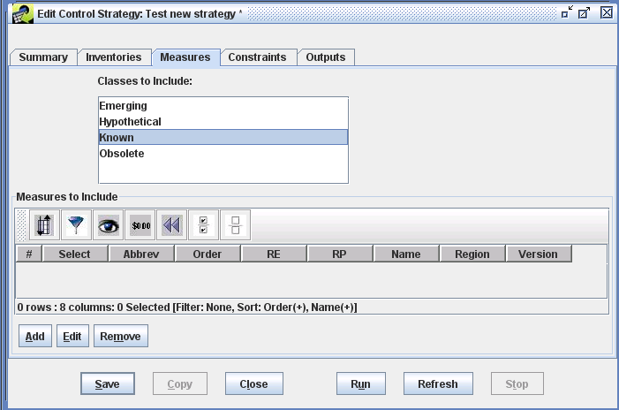
- To select specific measures for inclusion in the strategy, click the Add button to show the Select Control Measures dialog (Figure 4-11). On this dialog, specify a filter to find all measures with the same control technology (e.g., Abbrev contains SNCR). You need to check the Select checkboxes corresponding to any of the measures that you want to include in your strategy run. If you want to select all or most of the measures that matched the filter in your strategy, click the Select All button in the toolbar to select all of the measures. If you do not want to include all of the measures, you can uncheck the Select checkbox for the measures you do not want included. For training purposes, Select All of the measures that matched your filter.
Figure 4-11. Dialog to Add Specific Control Measures to a Strategy
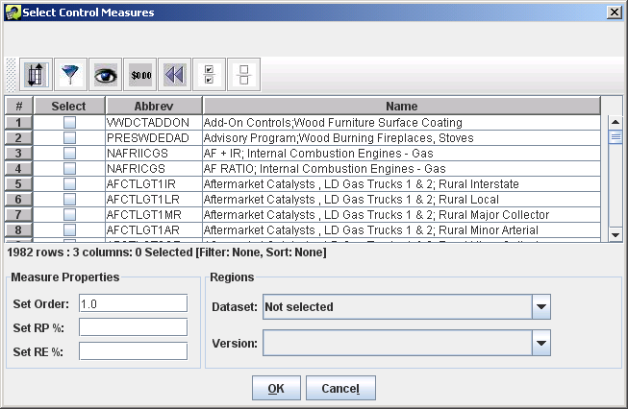
- Prior to selecting OK on the Select Control Measures dialog, you may want to make some optional settings for the group of measures in support of your analysis. (For training purposes, you may make whatever selections interest you, because these selections will be removed later in the process and will not impact your results.)
- Specify an Order to control the order in which this group of measures is applied as compared to other groups of measures you have selected. This order of application is particularly relevant to the “Apply Measures in Series” strategy type. When running this type of strategy, since multiple measures can be applied to the sources, they will be applied in increasing numerical order (i.e., measures with order set to 1 will be applied before those with order set to 2).
- Override the values of Rule Effectiveness or Rule Penetration that are specified in the measure efficiency records using the Set RE % and Set RP % fields. This can be helpful if you want to assess the level of emissions reductions achieved assuming different levels of penetration for the measures. For example, setting the rule penetration to 75% assumes that 75% of the sources are applying the measure and would therefore result in 75% of the emissions reductions it would if it was 100%.
- Specify a Region of applicability for the group of measures by selecting a county dataset from the Dataset pull-down menu and a version of that dataset from the Version menu. If you select a Region, the selected measures will not be applied in any counties that are not listed in the dataset.
- Once you have selected some the specific measures using the Select Control Measures dialog and specified any desired overrides for those measures, click OK and the selected measures will appear on the Measures tab. The tab will now look similar to that shown in Figure 4-12. Note that only the table of specific measures and their properties is shown, and the Classes to Include list is no longer shown. If desired, you may repeat the process of selecting specific measures to add new sets of measures to the list of measures to be used for the strategy. Each new group of measures selected can have different settings for the order, RE, RP, and Region.
Figure 4-12. Measures Tab Showing Specific Measures to Include
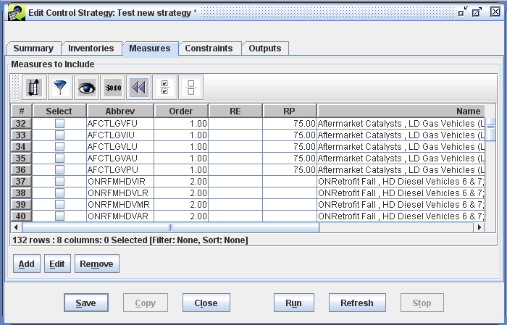
- After you have selected specific measures, if you wish to change their order, RE, RP, or Region properties, select the measures you wish to adjust and click the Edit button on the Measures tab. An Editing measures dialog will appear and you can make changes to their properties when they are used in the strategy.
- To remove specific measures from the list of measures to be included in the strategy run, check the corresponding Select checkboxes and then click Remove. When you are prompted to confirm the removal, click Yes.
- For training purposes, remove all of the individually selected measures by clicking the Select All button on the toolbar and then clicking Remove followed by clicking Yes when prompted. Make sure that Known is selected in the Classes to Include list. Now the Measures tab should look like Figure 4-10 again.

Input Constraints
The Constraints tab (Figure 4-13) can be used to specify constraints for a control strategy to limit how control measures are assigned during the strategy run. For example, the strategy could be set up to not use any measures that cost more than $5,000 per ton (in 2006 dollars) for the target pollutant. Alternatively, the user could specify that measures not be assigned to sources if the measures do not reduce at least 1 ton of the target pollutant for the source. CoST evaluates the constraints while the source is being matched with the control measures. For example, the emission reduction achieved by applying a measure to a source is not known until the measure and its control efficiency have been selected. Thus, constraint calculations are dependent on both the inventory source and the measure being considered for application to the source. Note that the term “source” here refers to a single row of the emissions inventory, which for point sources is uniquely determined by FIPS, plant, point, stack, segment, and SCC, and for nonpoint sources is uniquely determined by FIPS and SCC. Sources should not be confused with “plants”, each of which can contain many sources.
Some settings for the strategy described in Table 4-7 are known as “constraints”. If the constraint values are not satisfied for a particular control measure and source combination, the measure under consideration will not be applied to the source, and CoST will look for another measure that satisfies all of the constraints.

Table 4-7. Constraints Common to Multiple Control Strategy Types
Minimum Emissions Reduction (tons) | If specified, requires each control measure to reduce the target pollutant by at least the specified minimum tonnage for a particular source (down to the plant+point+stack+segment level of specification); if the minimum tonnage reduction is not attainable, the measure will not be applied.
Minimum Control Efficiency (%) | If specified, requires each control measure used in the strategy to have a control efficiency greater than or equal to the specified control efficiency for a particular source and target pollutant.
Maximum Cost per Ton ($/ton) | If specified, each control measure must have an annualized cost per ton less than or equal to the specified maximum annualized cost per ton for the target pollutant for each source. This cost is based on 2006 dollars.
Maximum Annualized Cost ($/yr) | If specified, each control measure must have an annualized cost less than or equal to the specified annualized cost for each source and target pollutant. This cost is based on 2006 dollars.
Minimum Percent Reduction Difference for Replacement Control (%) | If specified, each control measure must have a percent reduction in emissions with the new measure that is greater than or equal to the specified difference in order for the old control measure to be “replaced by” the new control measure. Incremental controls that add an additional device onto a previously controlled source are not yet supported by CoST except for the Apply Measures in Series strategy type, for which all controls are assumed to be independently applicable. In the event that a combination of two control devices is listed as a control measure (e.g., LNB+FGR) and the combined control efficiency provides an ample increase in the control efficiency over the original efficiency, that combination of the devices can still serve as a replacement control if the source already has a measure applied (e.g., LNB). In the future, instead of requiring an increase in the percent reduction, it may be more useful to specify a minimum additional percent reduction in remaining emissions (e.g., such as one might see when going from a 99% control measure to a 99.5% control measure).
The constraints in Table 4-7 are available on the Constraints tab for all types of strategies. The lower portion of the Constraints tab is used to specify constraints that are specific to particular strategies. These constraints vary based on the type of algorithm selected. Figure 4-13 shows the constraints specific to the Least Cost strategy algorithm. For the Least Cost algorithm, you can specify either the Domain Wide Emissions Reduction [for the target pollutant] in tons, or you can specify the Domain Wide Percent Reduction [in emissions of the target pollutant]. When the strategy is run, CoST will attempt to satisfy the reduction you specified using controls selected with the minimum cost. Note that after the strategy run is complete, CoST will fill in the value for the least cost constraint that was not originally specified.
- For training purposes, enter a percent reduction of 50 for the Domain Wide Percent Reduction (%).
- Click Save to save all of the changes you made to the strategy. Note that if you were to click Close without saving the changes, you will be prompted as to whether you wish to close the window without saving the changes.
Figure 4-13. Constraints Tab of Edit Control Strategy Window
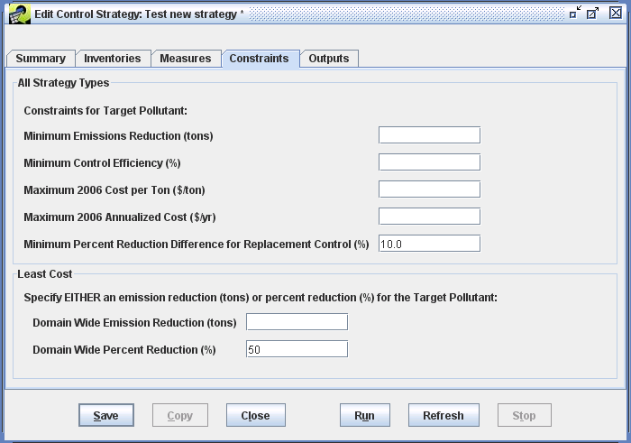
The other strategy type with special constraints is the Least Cost Curve. This algorithm allows you to specify three special constraints: Domain-wide Percent Reduction Increment (%), Domain-wide Percent Reduction Start (%), and Domain-wide Percent Reduction End (%). The Least Cost Curve strategy will iteratively run Least Cost strategies. First it will run the least cost strategy with the percent reduction specified as the value of Domain-wide Percent Reduction Start (%), it will then add the Domain-wide Percent Reduction Increment (%) to the starting percent value and will run the least cost strategy at that value (i.e., starting value + increment). It will continue running strategies for each increment until it reaches the value of Domain-wide Percent Reduction End. Note that it may not be possible to achieve some of the selected percent reductions, in which case CoST will generate the same result for that increment as the Maximum Emissions Reduction would generate.

Inputs on the Programs Tab
The Programs tab is only available on the Edit Control Strategy window when the Strategy Type is set to “Project Future Year Inventory”. An example of the Programs tab is shown in Figure 4-14. The Select Control Programs dialog in the foreground of Figure 4-14 appears when you click the Add button on the Programs tab. To add programs to the tab, you would check the Select checkbox that corresponds to the program(s) you want to use. Then when you click OK, those programs will be added to the tab. Programs are removed using the Remove button, and you can click the View button to bring up the Edit Control Program Window described in Section 5. We are not going to review features related to control programs any more as part of the training tutorial in this section.
Figure 4-14. Programs Tab of Edit Control Strategy Window
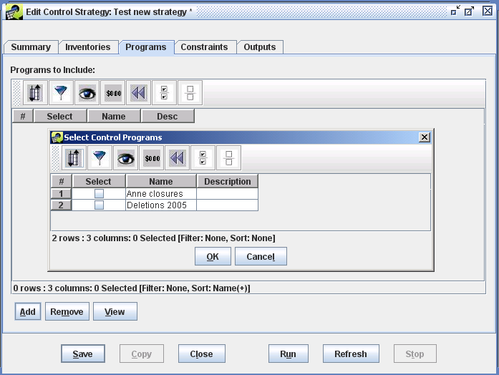

Running a Strategy and Accessing Its Outputs

Running a Strategy
- Once you have finished specifying all of the inputs to the strategy, as described in Section 4.3, click the Run button to start running the strategy. If you have not saved the strategy before clicking Run, your changes will automatically be saved to the database. On the training laptops, the run will take several minutes to complete.
- While the strategy is running, please review the rest of this subsection, including Figures 4-15 and 4-16), to see what will happen during the run and the types of outputs that will be created by the strategy.
- Once the run has started, monitor the Status window near the bottom of the EMF graphical user interface (GUI). If all inputs have been properly specified, you should see a status message like “Started running control strategy: your strategy name”. You can click the Refresh button on the Status window to see immediate status updates, or the Status window will update every 1-2 minutes automatically.
- If the strategy runs successfully, you will see multiple messages in your status window. You will get one message as the processing for each inventory completes, such as “Completed processing control strategy input dataset: dataset_name”. When the entire run has finished, you will see a message like “Completed running control strategy: your strategy name” in the Status window. Otherwise, you will see a message stating that the strategy failed and some information as to why it failed.
- Once the strategy run has completed, click on the Outputs tab in the Edit Control Strategy window and then click Refresh at the bottom of the window to see the newly created outputs listed in the Output Datasets table (Figures 4-15 and 4-16).
CoST automatically generates three main outputs as EMF datasets after each successful strategy run: Strategy Detailed Result, Strategy Measure Summary, and Strategy County Summary. Some types of strategies also generate a Strategy Messages output. Least cost and least cost curve strategies generate a Least Cost Control Measure Worksheet that lists all of the available control measure options for each source in the inventories.
For all types of strategies, it is possible to generate Controlled Inventory on-demand for any of the Strategy Detailed Result datasets. The types of outputs are discussed in more detail in Section 4.5. Note that the output datasets are given unique names that include a timestamp indicating when the strategy was run, including the year, month, day, hour, and minute of the run. You can rename the output datasets as described in the following section if you wish them to have more meaningful names.
For additional details on the algorithms that are applied to assign measures to sources as part of a strategy run (other than the descriptions in Section 4.1), please see the “Control Strategy Tool (CoST) Development Document”.
Figure 4-15. Outputs Tab of Edit Control Strategy Window for Least Cost Strategy
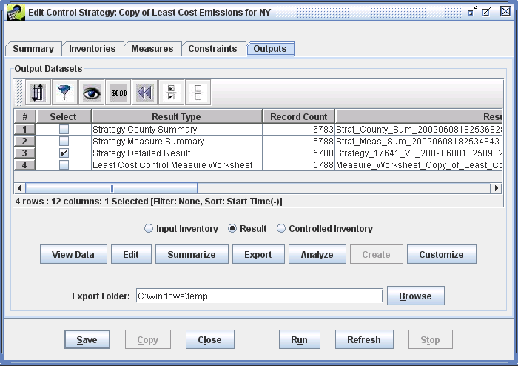
Figure 4-16. Outputs Tab for a Least Cost Curve Strategy
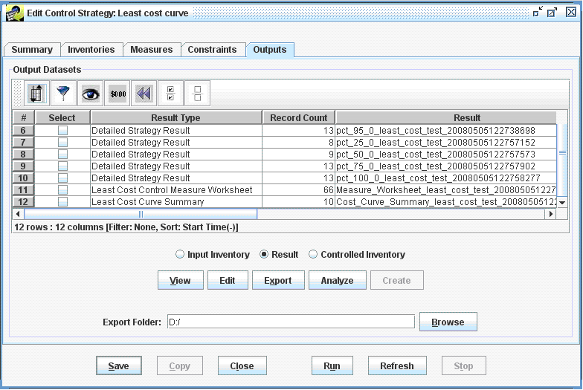

Viewing and Editing Properties of the Strategy Outputs
It is possible to perform a number of operations on the strategy outputs. These operations are described in this and the following subsections.
- The most basic operation is to view the data of the output dataset using the Data Viewer. To do this, select one of the outputs, such as the Strategy Detailed Result, and then click View Data. (Note that the Strategy Detailed Result is the main output on which the Strategy County Summary and Strategy Measure Summary are based.) This will bring up the Data Viewer showing the contents of the Strategy Detailed Result (Figure 4-17).
- The Strategy Detailed Result shows the abbreviation of the measure matched to each of the sources for all of the controlled sources, along with columns that identify each controlled source, information about the cost of applying the measures to the sources and the emissions reductions that resulted. The information computed includes the cost of application and the emissions reduced as a result. Enter a sort order (e.g., annual_cost desc) and/or a row filter (e.g., emis_reduction>2) to subselect different rows of the result and have them sorted in a particular way.
Figure 4-17. View Data for Strategy Detailed Result
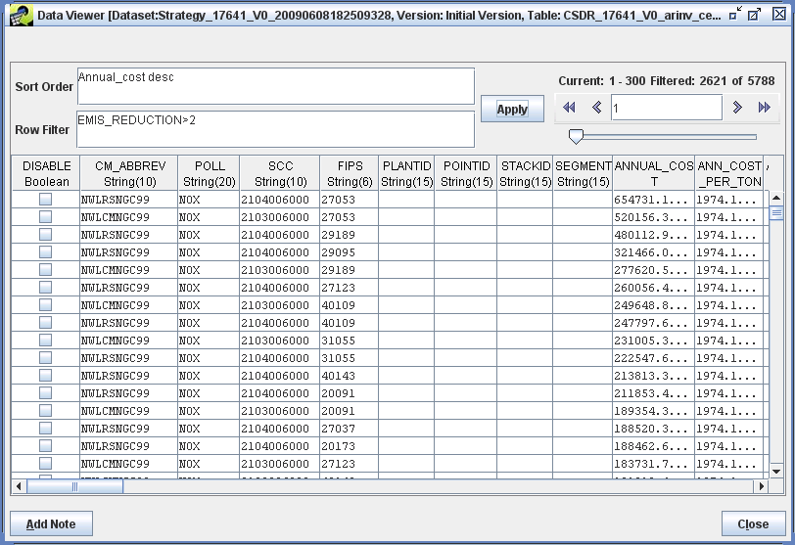
- If you clear the entries in the Sort Order and Row Filter fields on the Data Viewer and click Apply, all of the data records will be presented in the order in which they appear in the database. More information about the columns included in the detailed result is given in Table 4-9, which is discussed later in Section 4.5.1.
- Close the Data Viewer when you are finished reviewing the Strategy Detailed Result.
- From the Outputs tab, you can also access the properties (metadata) of an output dataset (as opposed to the actual data contained in the output), and you can edit these properties. To edit the output dataset properties, select an output (for training purposes, select the Strategy Detailed Result) on the Outputs tab of the Edit Control Strategy window and click the Edit button. This will bring up the Dataset Properties Editor for the output dataset (Figure 4-18).
Figure 4-18. Summary Tab of Dataset Properties Editor
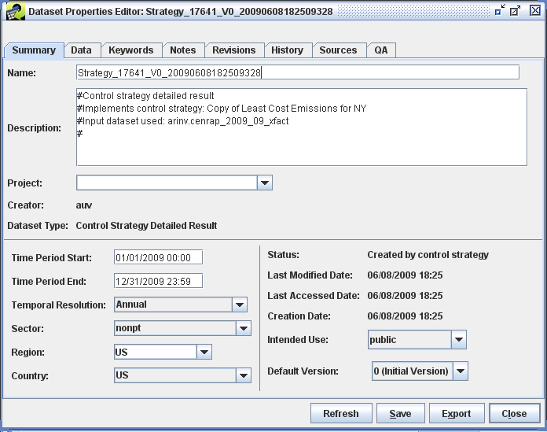
- Notice that the tabs on the Dataset Properties Editor are the same as those on the Dataset Properties Viewer shown in Figure 4-8, but with the editor you can actually change many of the fields, whereas they could not be changed directly from the Dataset Properties Viewer. For example, you can change the name of the output by replacing the automatically generated name with a more meaningful one (e.g., Least Cost NOx for Training Result) and then clicking Save. Notice that when you change the name, an asterisk is added to the title bar of the window to indicate that something has been changed but not yet saved. Throughout CoST and the EMF, if you change something on a window and then try to close the window without saving the changes, you will be prompted to confirm that you want to close without saving..
- Examine the other tabs of the Dataset Properties Editor for the Strategy Detailed Result output, in particular the Keywords tab, an example of which is shown in Figure 4-18. For the Strategy Detailed Result, there are a number of keywords set in the Keywords Specific to Dataset section (in the lower part of window). These keywords correspond to the major parameters of the control strategy, such as the COST_YEAR and the STRATEGY_TYPE (these specific keywords are available in the list of keywords but have scrolled off of the portion of the window shown in Figure 4-19). There are also keywords for the UNCONTROLLED_EMISSIONS, the TOTAL_EMISSION_REDUCTION, and the ACTUAL_PERCENT_REDUCTION.
Figure 4-19. Keywords Tab of Dataset Properties Editor
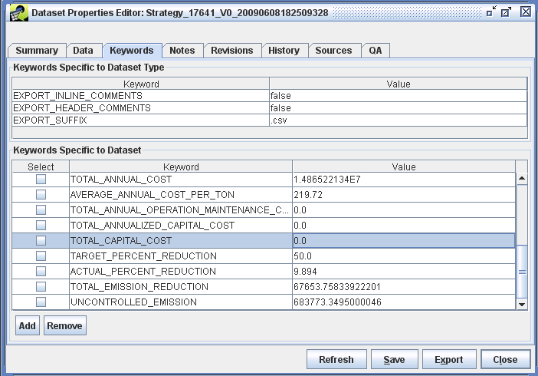

The keywords in the Keywords Specific to Dataset Type section (the upper part of window in Figure 4-19) typically contain directives on how to export the data or other data values that are the same for all datasets of the same type. Typically ORL inventories will have some of these keywords.
- Note that when you have the Dataset Properties Editor open for a dataset, no other users can edit that dataset. Similarly, if you have a control strategy or control measure open for editing, no other users can edit those items; users are able to view them, however, if a view option is available.
When you are finished examining the other tabs, close the Dataset Properties Editor by clicking Save if you wish to save the changes, or Close to close without saving changes. If you are in the training class, click Close.

Summarizing the Strategy Outputs
Strategy outputs, particularly Strategy Detailed Results, but also the input emissions inventories, can be summarized in many different ways. The ability to prepare summaries is helpful because in many cases there could be thousands of records in a single Strategy Detailed Result or emissions inventory. Thus, when the results of a strategy are analyzed or presented to others, it is useful to show the impact of the strategy in a summarized fashion. Frequently, it is helpful to summarize a strategy for each county, state, SCC, and/or control technology. The summaries are prepared using the EMF subsystem that was originally designed to support quality assurance (QA) of emissions inventories and related datasets, for which summaries are also needed. Thus, each summary is stored as the result of a “QA Step” that is created by having CoST run a SQL query. There are many predefined queries stored in the EMF as ‘templates’, so you do not need to know SQL to create a summary. Summaries can be added from the QA tab of the Dataset Properties Editor, although there is a shortcut available on the Outputs tab. Summaries are discussed in more detail in Section 4.6.
- Select the Strategy Detailed Result on the Outputs tab of the Edit Control Strategy window and then click Summarize to create a summary of the result. This will cause the Dataset Properties Editor for the detailed result to appear, but with the QA tab brought to the front.
- To add a new summary from the list of predefined summary templates, click the Add from Template button and the Add QA Steps dialog will appear (Figure 4-20). To create summaries of interest, click the mouse button on the summaries you wish to create (e.g., select Summarize by Control Technology and Pollutant, Summarize by Plant and Pollutant). To select multiple summaries (as is illustrated in the figure), hold down the Ctrl key while clicking your mouse on the ones you wish to select, then click OK. The selected templates will be added to the table on the QA tab (Figure 4-21).
Figure 4-20. Summarizing a Strategy Detailed Result
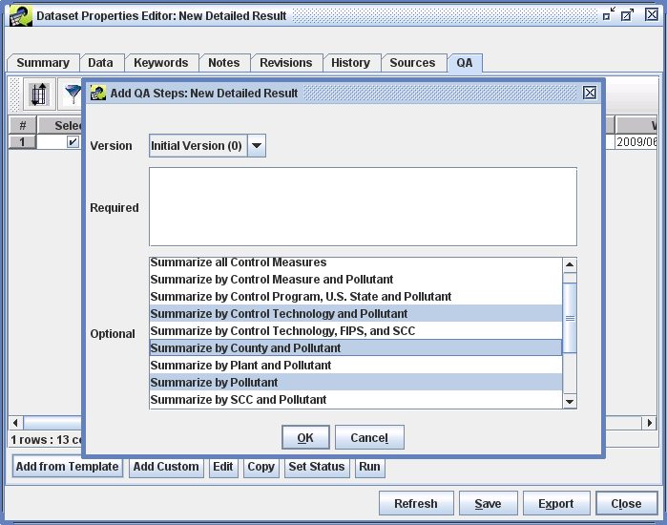
Figure 4-21. Available QA Summaries for a Strategy Detailed Result
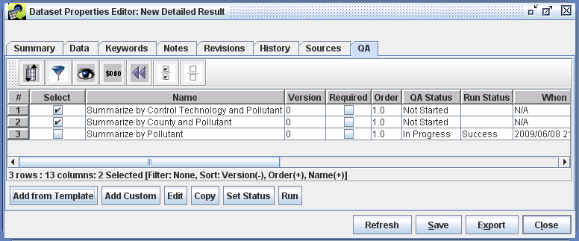
- To run the summaries that are listed on the QA tab, first select the summaries of interest and then click Edit. The Edit QA Step window will appear (Figure 4-22). You do not actually need to edit anything in this window, just click Run to start the QA summary processing.
Monitor the progress of the QA step in the Status window at the bottom of the EMF main window. Once the run is complete, click the Refresh button to populate the Output Name, Run Status, and Run Date fields in the Edit QA Step window. Note: as an alternative to clicking Run on several different windows, you can instead select a few summaries and click Run on the QA tab. However, at this time, you still need to open the QA summaries using the Edit button when you want to view their results.
Figure 4-22. Edit QA Step Window to Create a Summary
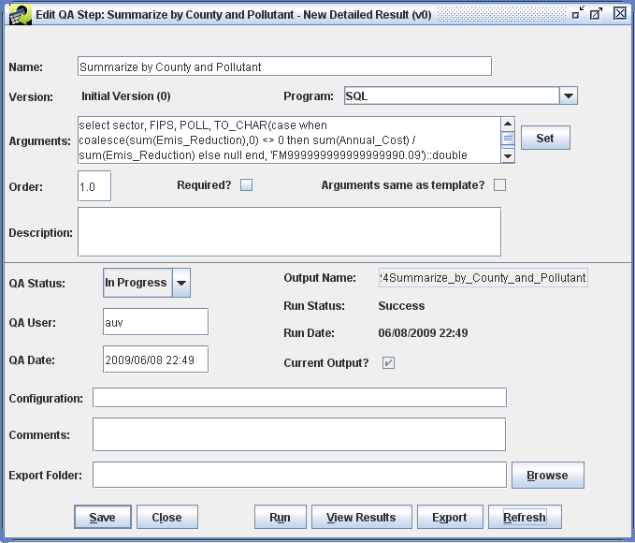
- To see the summarized output, click the View Results button to bring up the View QA Step Results window (Figure 4-23). From this window, you can sort and filter the results in the same way you can on the Control Measure Manager and Control Strategy Manager. For example, click on the avg_cost_per_ton column header to sort on the cost per ton. You can also show the Top N or Bottom N rows using the second and third toolbar buttons from the left. The toolbar buttons on the right support computing statistics, creating plots (if you have the R software package installed on your client machine), and saving the table and plot configurations.
Figure 4-23. View QA Step Results Window
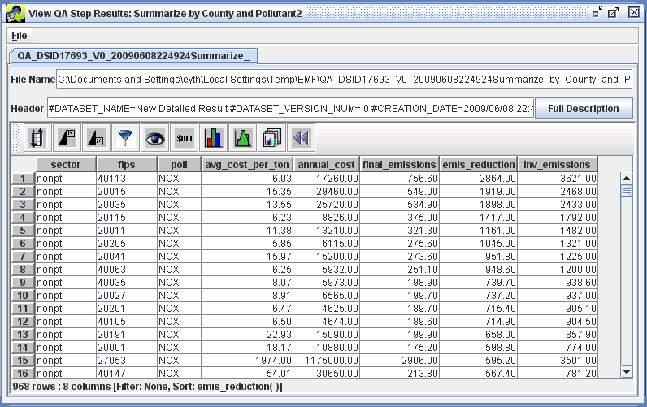
- If the summary you generated has the columns longitude and latitude (e.g., a plant, state, or county summary), you can access an interface to create Google Earth-compatible Keyhole Markup Language Zipped (.kmz) files by choosing Google Earth from the File menu of the View QA Step Results window. The interface to create these files is shown in Figure 4-24. Note that the following detailed result summaries have longitude and latitude:
- Summarize by U.S. County and Pollutant
- Summarize by U.S. State and Pollutant
- Summarize by Plant and Pollutant

Figure 4-24. KMZ File Generator
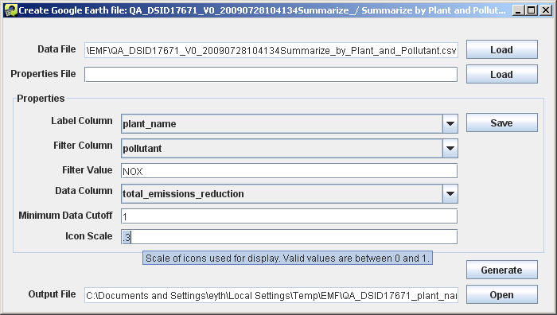
- In the Create Google Earth file window, select a Label Column that will be used to label the points in the .kmz file. This label will appear when you mouse over a point. For a plant summary this would typically be plant_name, for a county summary this would be county_name, for a state summary, this would be state_name.
- If your file has data for multiple pollutants, you will often want to specify a filter so that data for only one pollutant is included in the KMZ file. To do this, specify a Filter Column (e.g., pollutant), and then specify a Filter Value (e.g., NOX).
- Select a Data Column to specify the column to use to obtain the value when you mouse over a point (e.g., total_emissions_reduction, total_annual_cost, or avg_cost_per_ton). The mouse over information will have the form:
value from Label column : value from Data Column.
- If you wish to limit the points shown in the file to include only those that reach a certain size threshold (e.g., you do not want to show small sources or sources with a small amount of reduction), you can specify a Minimum Data Cutoff. Points will only be created for rows in the summary for which the value in the data column exceeds the value given in minimum data cutoff. For example, if you selected total_emissions_reduction as the Data Column, you might enter 1 as the minimum data cutoff to show only plants with at least 1 ton of reduction.
- If you wish to control the size of the points, you may adjust the value of the Icon Scale setting to a number between 0 and 1. If this is your first time using the processor, we recommend leaving it at the default setting of 0.3. Giving a value smaller than 0.3 will result in smaller circles than the default and larger than 0.3 will result in larger circles.
- If you are unsure of what some of the settings mean, place your mouse in the appropriate field and a tooltip will appear that gives you some information about the field. Once you have specified the settings (aside from the Properties file) click Generate and it will create the .kmz file using default file name. The name and location of the created file can be found on the Output File field.
If your computer has Google Earth installed (note that it is not installed on the training laptops), you may open the created file in Google Earth by clicking Open.
If you find that you need to repeatedly create similar .kmz files, you may choose to click Save to save the settings of the properties to a file. Once you have a file saved, you can click Load the next time you enter the Create Google Earth file window so that you do not have to type in all the properties again.
- When you are done with the Create Google Earth file window, close the window by clicking the X at the top right corner.
- Back on the Edit QA Step window (Figure 4-22), you can export CSV files of the QA step result to the EMF server, and you can create Shapefiles for QA summaries at the state, county, or point level. First, select a folder to export your results to by typing one into the Export Folder field, or by clicking the Browse button. If desired, you can put the files into your EMF temp directory, which is set to C:\EMF_temp on the training laptops.
- Next, click the Export button, the Export QA Step Results dialog that appears is shown in Figure 4-25.
Figure 4-25. Exporting QA Step Results to CSV or Shapefiles
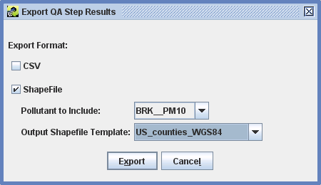
- If you click the checkbox next to CSV, a CSV file containing the data in the summary will be exported to the EMF server computer. It will be placed into the Export Folder specified on the Edit QA Step window after you click the Export button.
- If you check the checkbox next to Shapefile, you should select a Pollutant to Include in the Shapefile entries. You should also select an Output Shapefile Template. The template will specify the level of resolution for the Shapefile that is produced – e.g., counties, states, or points. You should select a template that has a similar level of detail to your summary. The name of the Shapefile gives an indication of which one you should select. After making the selection, click the Export button and the files that comprise the Shapefile will be placed into the Export Folder specified on the Edit QA Step window.

Exporting the Strategy Outputs
We now return to the Outputs tab of the Edit Control Strategy window (Figure 4-14).
- To export the strategy output datasets to the EMF server, enter a folder/directory name into the Export folder field on the Outputs tab, and click Export. The files will be written as ASCII files to that folder. The resulting files can then easily be imported as a CSV file into spreadsheet or database software.

Analyzing the Strategy Outputs
From the Outputs tab, it is possible to analyze the strategy results in a sortable, filterable table, similar to the table used by the View QA Step Results window (Figure 4-23).
- Select an output from the strategy and click Analyze to show the Analyze Control Strategy window for that output. An example of analyzing a Strategy County Summary is shown in Figure 4-26. From this window, you can apply a sort or filter. You can also generate statistics and plots. An example of a Least Cost Curve Summary is shown in Figure 4-27. This window has the same features as the window used to show the QA summary results in Figure 4-23, only the data shown is different.
Figure 4-26. Analyze Control Strategy Window
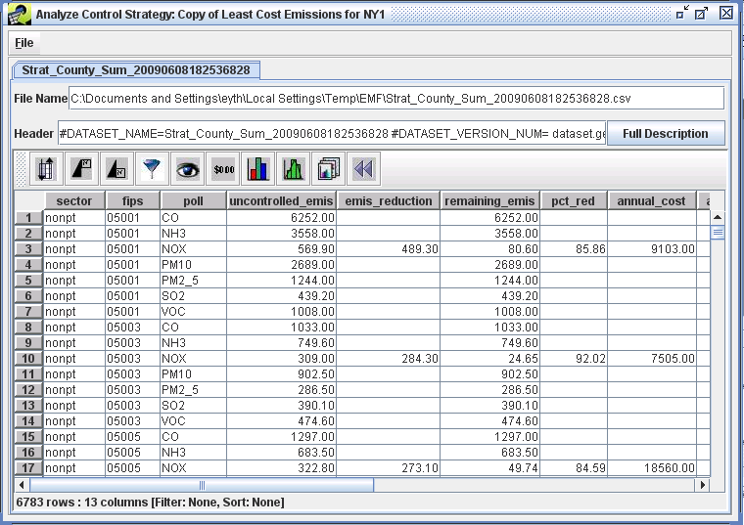
Figure 4-27. Analyzing a Least Cost Curve Output
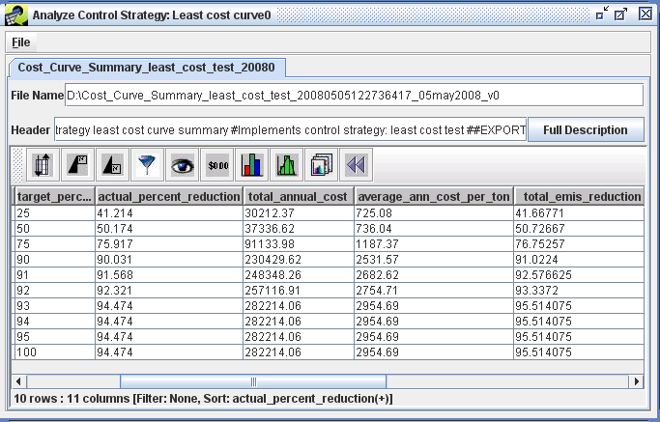

Creating a Controlled Emissions Inventory
CoST can create a controlled emissions inventory that reflects the effects of the strategy by merging the detailed result with the original emissions inventory. Controlled inventories are discussed further in Section 4.5.4.
- To create a controlled inventory, click the Controlled Inventory radio button on the Outputs tab to enable the Create button, and select the Strategy Detailed Result for which you want to create the controlled inventory. Now click Create. The status of the inventory creation will be shown in the Status window. Once the controlled inventory has been successfully created, you will see the name of the dataset at the far right of the Output Datasets table on the row corresponding to the Strategy Detailed Result.
- To view the data for the controlled inventory, make sure the Controlled Inventory radio button is still selected, and if you are not running on a training laptop click the View Data button. The data for the controlled inventory dataset will appear in the Data Viewer. Scroll to the right to see that values are filled in for
- To view the data for the input inventory that was merged with the Strategy Detailed Result to create the controlled inventory, select the Input Inventory radio button and if you are not running on a training laptop, click View Data.
- THIS CONCLUDES THE TRAINING EXERCISES IN SECTION 4. The remainder of the section provides reference documentation on the outputs of strategies and summaries that can be created. Advanced Exercises are available in Section 6.

Creating Custom Strategy Outputs
The Customize button on the Outputs window is not frequently used, but can generate special types of outputs related to analyses with the Response Surface Model (RSM). These custom outputs are not discussed here.

Outputs of Control Strategies
This section provides details on the columns available for each type of output. No training exercises are available in this subsection.

Strategy Detailed Result
As noted earlier, the Strategy Detailed Result is the primary output from running a control strategy. It is a table of emission source-control measure pairings, each of which contains information about the costs and emission reduction achieved for measures after they are applied to the sources. The contents of this table are described later in this subsection. When generating the Strategy Detailed Result table, some data are needed for CoST to calculate the values of some columns related to costs, such as:

- Stack Flow Rate (cfs) – from the emissions inventory
- Capital Annual Ratio – from the control measure efficiency record
- Discount Rate (%) – from the control measure efficiency record
- Equipment Life (yrs) – from the control measure efficiency record
- Boiler Capacity (MW) – from the design capacity column of the inventory; units are obtained from the design_capacity_unit_numerator and design_capacity_unit_denominator columns from the inventory. Note that boiler capacity is often blank in inventories, so special steps may need to be taken to fill in this information.

The stack flow rate provides information on the volume of effluent that requires treatment by the control device. The capital annual ratio is used to calculate the capital costs of a control device from an available O&M cost estimate for that device. The capital costs are the one-time costs to purchase and install the device, while the operating and maintenance (O&M) costs are those required to operate and maintain the device for each year. The discount rate and equipment life are used to compute the annualized capital costs for the device. The discount rate can be considered an annual interest rate used to calculate the cost of borrowing money to purchase and install the control device. The annualized capital cost is computed based on the discount rate, and the costs are spread over the life of the equipment. The algorithms to compute these cost breakdowns vary based on whether the input data required to utilize a cost equation are available. This topic is described in further detail in Table 4-9, which is given after an introductory discussion of cost concepts, below. The columns of the Strategy Detailed Result are also given in Table 4-9.

When cost data are provided for the control measures, the resulting costs are also specified in terms of a particular year. To compute the cost results for a control strategy, it is necessary to escalate or de-escalate the costs to the same year in order to adjust for inflation and to allow for consistency in comparing control strategy results. This is done with the following formula:

Cost ($) for a year of interest = Cost for original cost year × Chained GDP for year of interest
Chained GDP for original cost year

where the chained GDP is the chained Gross Domestic Product available from the United States Department of Commerce Bureau of Economic Analysis spreadsheet at http://www.bea.gov/national/xls/gdplev.xls. The current version used is dated January 30, 2009. An excerpt of this version is shown in Table 4-8.

Table 4-8. Excerpt from the gdplev Table
Used to Convert Data between Cost Years
Year | Current_GDP | Chained_GDP
1996 | 7816.9 | 8328.9
1997 | 8304.3 | 8703.5
1998 | 8747 | 9066.9
1999 | 9268.4 | 9470.3
2000 | 9817 | 9817.0
2001 | 10128 | 9890.7
2002 | 10469.6 | 10048.8
2003 | 10960.8 | 10301.0
2004 | 11712.5 | 10675.8
2005 | 12455.8 | 10989.5
2006 | 13246.6 | 11294.8
2007 | 13807.5 | 11523.9
2008 | 14280.7 | 11671.3
To facilitate the comparison of the costs of control measures with one another, a normalized version of the control measure cost per ton is stored within the control measures database. These costs have all been converted to a consistent “reference year” using the above formula, so that the cost of any measure can be compared with any other even if their cost years differ. Currently, the reference year is 2006. In addition, during the course of the strategy run, the costs are converted (using the above formula) from the reference year to the cost year that was specified as an input to the strategy. The results of the strategy are therefore presented in terms of the specified cost year.

Table 4-9. Columns in the Strategy Detailed Result
Column | Description
DISABLE | A true-false value that determines whether to disable the control represented on this line during the creation of a controlled inventory.
CM_ABBREV | The abbreviation for the control measure that was applied to the source.
POLL | The pollutant for the source, found in the inventory.
SCC | The SCC for the source, found in the inventory.
FIPS | The state and county FIPS code for the source, found in the inventory.
PLANTID | For point sources, the plant ID for the source from the inventory.
POINTID | For point sources, the point ID for the source from the inventory.
STACKID | For point sources, the stack ID for the source from the inventory.
SEGMENT | For point sources, the segment for the source from the inventory.
Annual_Cost ($) | The total annual cost (including both capital and O&M) required to keep the measure on the source for a year.  a. Default Approach (used when there is no cost equation, or when inputs to cost equation are not available):  Annual Cost = Emission Reduction (tons) x Reference Yr Cost Per Ton ($/tons in 2006 Dollars) x Cost Yr Chained GDP / Reference Yr Chained GDP  b. Approach when Using Type 8 Cost Equation:  If Stack Flow Rate >= 5.0 cfm Then  Annual Cost = (Annualized Capital Cost + 0.04 x Capital Cost  + O&M Cost)  Else  Annual Cost = Default Annualized Cost Per Ton Factor x Emission Reduction (tons) x Cost Yr Chained GDP / Reference Yr Chained GDP
Ann_Cost_Per_  Ton ($/ton) | The annual cost (both capital and O&M) to reduce one ton of the pollutant.  Ann_Cost_Per_Ton = Annual Cost ($) / Emis Reduction (tons)
Annual_Oper_  Maint_Cost ($) | The annual cost to operate and maintain the measure once it has been installed on the source.  a. Default Approach (used when there is no cost equation, or inputs to cost equation are not available):  = (Annual Cost – Annualized Capital Cost)  Note: if the capital recovery factor was not specified for the measure, it would not be possible to compute Annualized Capital Cost or Annual O&M Costs  b. Approach when Using Type 8 Cost Equation:  If Stack Flow Rate >= 5.0 cfm Then  = O&M Control Cost Factor x Stack Flow Rate (cfm) x Cost Yr Chained GDP / Reference Yr Chained GDP  Else  = Default O&M Cost Per Ton Factor x Emission Reduction (tons) x Cost Yr Chained GDP / Reference Yr Chained GDP
Annualized_  Capital_Cost ($) | The annualized cost of installing the measure on the source assuming a particular discount rate and equipment life.  Annualized_Capital_Cost = Total Capital Cost x Capital Recovery Factor (CRF)  Note: if the CRF is not available for the measure, it is not possible to compute the ACC or the breakdown of costs between capital and O&M costs.  CRF = (Discount Rate x (1 + Discount Rate)^Equipment Life) / ((Discount Rate + 1) ^Equipment Life - 1)
Total_Capital_  Cost ($) | The total cost to install a measure on a source.  a. Default Approach (used when there is no cost equation or cost equation inputs are not available):  TCC = Emission Reduction (tons) x Reference Yr Cost Per Ton ($/tons in 2006 Dollars) x Capital Annualized Ratio x Cost Yr Chained GDP / Reference Yr Chained GDP  b. Approach when Using Type 8 Cost Equation:  If Stack Flow Rate >= 5.0 cfm Then  TCC = Capital Control Cost Factor x Stack Flow Rate (cfm) x Cost Yr Chained GDP / Reference Yr Chained GDP  Else  TCC = Default Capital Cost Per Ton Factor x Emission Reduction (tons) x Cost Yr Chained GDP / Reference Yr Chained GDP
Control_Eff (%) | The control efficiency of the measure being applied, stored in the measure efficiency record.
Rule_Pen (%) | The rule penetration of the measure being applied, stored in the measure efficiency record, but could be overridden as a strategy setting (see Section 4.3.4).
Rule_Eff (%) | The rule effectiveness of the measure being applied, stored in the measure efficiency record, but could be overridden as a strategy setting (see Section 4.3.4).
Percent_  Reduction (%) | The percent by which the emissions from the source are reduced after the control measure has been applied.  Percent reduction = Control Efficiency (%) x Rule Penetration (%) / 100 x Rule Effectiveness (%) / 100
Adj_Factor | The factor that was applied by a control program to adjust the emissions to the target year.
Inv_Ctrl_Eff (%) | The control efficiency for the existing measure on the source, found in the inventory.
Inv_Rule_Pen (%) | The rule penetration for the existing measure on the source, found in the inventory.
Inv_Rule_Eff (%) | The rule effectiveness for the existing measure on the source, found in the inventory.
Final_Emissions  (tons) | The final emission that results from the source being controlled.  = Annual Emission (tons) - Emission Reduction (tons)
Emis_Reduction  (tons) | The emissions reduced (in tons) as a result of applying the control measure to the source.  Emissions reduction = Annual Emission (tons) x Percent Reduction (%) / 100
Inv_Emissions  (tons) | The annual emissions, found in the inventory. Note that if the starting inventory had average-day emissions, the average-day value is annualized and the resulting value is shown here. This is necessary to properly compute the costs of the measure.
Apply_Order | If multiple measures are applied to the same source, this is a numeric value noting the order of application for this specific control measure. The first control to be applied will have a value of 1 for this field, the second will have a value of 2, and so on.
Input_emis (tons) | The emissions that still exist for the source after prior control measures have been applied. Usually this is the same as INV_EMISSIONS (see above), but for the “Apply Measures In Series” strategy type, in which multiple measures are applied to the same source, this is the emissions that are still available for the source after all prior control measures have been applied.
Output_emis  (tons) | The emissions that still exist for the source after the current and all prior control measures have been applied. Usually this is the same as Final_Emissions (see above), but for the “Apply Measures In Series” strategy type, in which multiple measures are applied to the same source, this is the emissions that are still available for the source after the current and all prior control measures have been applied.
FIPSST | The two-digit FIPS state code.
FIPSCTY | The three-digit FIPS county code.
SIC | The SIC code for the source from the inventory.
NAICS | The NAICS code for the source from the inventory.
Source_Id | The record number from the input inventory for this source.
Input_DS_Id | The numeric ID of the input inventory dataset (for bookkeeping purposes). If multiple inventories were merged to create the inventory (as can be done for Least Cost strategies), this ID is that of the merged inventory.
CS_Id | The numeric ID of the control strategy.
CM_Id | The numeric ID of the control measure.
Equation Type | The control measure equation that was used during the cost calculations.
Original_  Dataset_Id | The numeric ID of the original input inventory dataset, even if a merged inventory was used for the computation of the strategy, as can be done for Least Cost strategies.
Sector | The emissions sector specified for the input inventory (text, not an ID number; e.g., ptnonipm for the point non-IPM sector)
Control_  Program | The control program that was applied to produce this record.
Xloc | The longitude for the source, found in the inventory for point sources; for nonpoint inventories the county centroid is used. This is useful for mapping purposes.
Yloc | The latitude for the source, found in the inventory for point sources; for nonpoint inventories the county centroid is used. This is useful for mapping purposes.
Plant | The plant name from the inventory (or county name for nonpoint sources).
Comment | Information about this record and how it was produced; this information is either created automatically by the system or entered by the user.

Strategy Measure Summary
The Strategy Measure Summary output dataset is a table of emission reduction and cost values aggregated by the emissions sector (i.e., an EMF Sector), state/county FIPS code, SCC, pollutant, and control measure. This table contains information only for sources that were controlled during the strategy run. It is generated by running a SQL statement that aggregates the data from the Strategy Detailed Result according to the five categories just listed. The annual cost and emission reduction are calculated by summing all costs and emission reductions for the specified grouping (sector, FIPS, SCC, pollutant, and control measure). The average annual cost per ton is calculated by dividing the total annual costs by the total emission reduction for each measure. The columns contained in this summary and the formulas used to compute their values are shown in Table 4-10. An example Strategy Measure Summary is shown in Table 4-14 (located at the end of Section 4.5).

Table 4-10. Columns in the Strategy Measure Summary
Column | Description
Sector | The sector for the source (e.g., ptnonipm for the point non-IPM sector)
Fips | The state and county FIPS code for the source
Scc | The SCC for the source
Poll | The pollutant for the source
control_measure_  abbrev | The control measure abbreviation
Control_measure | The control measure name
Control_technology | The control technology that is used for the measure (e.g., Low NOx burner, Onroad Retrofit).
Source_group | The group of sources to which the measure applies (e.g., Fabricated Metal Products – Welding).
Annual_cost | The total annual cost for the measure. This is calculated by summing the annual costs for the measure  = sum(annual_cost)
Avg_ann_  cost_per_ton | The average annual cost per ton ($/ton). This is calculated by dividing the total annual cost by the total emission reduction.  = sum(annual_cost) / sum(emis_reduction)
Emis_reduction | The total reduction in emission in tons for the control measure

Strategy County Summary
The Strategy County Summary output dataset is a table of emission reduction and cost values aggregated by emissions sector, county, and pollutant. This dataset includes all of the inventory sources regardless of whether they were controlled. If there is more than one inventory included in the strategy inputs, then all inventories and their associated Strategy Detailed Results are merged and aggregated in this summary. The columns that compose this summary are shown in Table 4-10. An example Strategy County Summary is shown in Table 4-15 (located at the end of Section 4.5).

Table 4-11. Columns in the Strategy County Summary
Column | Description
Sector | The emissions sector for the source (i.e., ptnonipm for the point non-IPM emissions sector)
FIPS | The state and county FIPS code for the source
Poll | The pollutant for the source
Uncontrolled_emis | The original inventory emission for the county (in tons)
Emis_reduction | The total emission reduction for the county (in tons)
Remaining_emis | The remaining emissions after being controlled (in tons)
Pct_red | The percent reduction for the pollutant
Annual_cost | The total annual cost for the county. This is calculated by summing the annual costs for the county  = sum(annual_cost)
Annual_oper_  maint_cost | The total annual O&M costs for the county. This is calculated by summing the annual O&M costs for the county  = sum(annual_oper_maint_cost)
Annualized_  capital_cost | The total annualized capital costs for the county. This is calculated by summing the annualized capital costs for the county  = sum(annualized_capital_cost)
Total_capital_  cost | The total capital costs for the county. This is calculated by summing the total capital costs for the county  = sum(total_capital_cost)
Avg_ann_  cost_per_ton | The average annual cost per ton ($/ton). This is calculated by dividing the total annual cost by the total emission reduction for the county.  = sum(annual_cost) / sum(emis_reduction)

Controlled Emissions Inventory
Another output that can be created is a controlled emissions inventory (introduced earlier in Section 4.4.6). This dataset is not automatically created during a strategy run; instead, a user can choose to create it after the strategy run has completed successfully. When CoST creates a controlled inventory, comments are placed at the top of the inventory file that indicate the strategy that produced it and the high-level settings for that strategy. For the sources that were controlled, CoST fills in the CEFF (control efficiency), REFF (rule effectiveness), and RPEN (rule penetration) columns based on the control measures applied to the sources. It also populates several additional columns toward the end of the ORL inventory rows that specify information about measures that it has applied. These columns are:

- CONTROL MEASURES: An ampersand (&)-separated list of control measure abbreviations that correspond to the control measures that have been applied to the given source.
- PCT REDUCTION: An ampersand-separated list of percent reductions that have been applied to the source, where percent reduction = CEFF × REFF × RPEN.
- CURRENT COST: The annualized cost for that source for the most recent control strategy that was applied to the source.
- TOTAL COST: The total cost for the source across all measures that have been applied to the source.

In this way, the controlled inventories created by CoST always specify the relevant information about the measures that have been applied as a result of a CoST control strategy.

Strategy Messages
The Strategy Messages output provides information gathered while the strategy is running that is helpful to the user. The Strategy Messages output is currently created by the following strategy types:
- Project Future Year Inventory
- Max Emission Reduction
- Least Cost (but not Least Cost Curve)

The columns of the Strategy Messages output are described in Table 4-12. An example Strategy Messages output is shown in Table 4-13.

Table 4-12. Columns in the Strategy Messages Output
Column | Description
FIPS | The state and county FIPS code for the source, found in the inventory
SCC | The SCC code for the source, found in the inventory
PLANTID | For point sources, the plant ID for the source from the inventory.
POINTID | For point sources, the point ID for the source from the inventory.
STACKID | For point sources, the stack ID for the source from the inventory.
SEGMENT | For point sources, the segment for the source from the inventory.
POLL | The pollutant for the source, found in the inventory
STATUS | The status type of the message. The possible values:  Warning – a possible issue has been detected, but processing did not stop.  Error – a problem occurred that caused the processing to stop.  Informational – it was desirable to communicate information to the user.
CONTROL_  PROGRAM | The control program for the strategy run; this is populated only when using the “Project Future Year Inventory” strategy type.
MESSAGE | Text describing the strategy issue.

Table 4-13. Example of Strategy Messages Output
fips | scc | plantid | pointid | stackid | segment | poll | status | control_ program | message
42049 | 30900201 | 420490009 | 942 | S942 | 1 | PM2_5 | Warning |  | Emission reduction is negative, -1693.9.

Table 4-14. Example of Strategy Measure Summary Data
Sector | fips | scc | poll | control_  measure_  abbrev | control_ measure | control_ technology | source_ group | annual_ cost | avg_ ann_ cost_ per_ ton | emis_ reduction
ptnonipm | 37001 | 10200906 | PM10 | PFFPJIBWD | Fabric Filter (Pulse Jet Type);(PM10) Industrial Boilers - Wood | Fabric Filter (Pulse Jet Type) | Industrial Boilers - Wood | $419,294 | $12,862 | 32.6007
ptnonipm | 37001 | 10200906 | PM2_5 | PFFPJIBWD | Fabric Filter (Pulse Jet Type);(PM10) Industrial Boilers - Wood | Fabric Filter (Pulse Jet Type) | Industrial Boilers - Wood |  |  | 19.5426
ptnonipm | 37001 | 30500311 | PM10 | PFFPJMIOR | Fabric Filter (Pulse Jet Type);(PM10) Mineral Products - Other | Fabric Filter (Pulse Jet Type) | Mineral Products - Other | $446,026 | $83,379 | 5.3494
ptnonipm | 37001 | 30500311 | PM2_5 | PFFPJMIOR | Fabric Filter (Pulse Jet Type);(PM10) Mineral Products - Other | Fabric Filter (Pulse Jet Type) | Mineral Products - Other |  |  | 2.0939
ptnonipm | 37001 | 30501110 | PM10 | PFFPJMIOR | Fabric Filter (Pulse Jet Type);(PM10) Mineral Products - Other | Fabric Filter (Pulse Jet Type) | Mineral Products - Other | $110 | $147 | 0.7498
ptnonipm | 37001 | 30501110 | PM2_5 | PFFPJMIOR | Fabric Filter (Pulse Jet Type);(PM10) Mineral Products - Other | Fabric Filter (Pulse Jet Type) | Mineral Products - Other |  |  | 0.2605

Table 4-15. Example of Strategy County Summary Data
SECTOR | FIPS | POLL | UNCONTROLLED_ EMIS | EMIS_ REDUCTION | REMAINING_ EMIS | PCT_ RED | ANNUAL_ COST | ANNUAL_ OPER_ MAINT_COST | ANNUALIZED_CAPITAL_ COST | TOTAL_ CAPITAL_ COST | AVG_ ANN_ COST_ PER_TON
ptnonipm | 37001 | VOC | 313.8724 |  | 313.8724
ptnonipm | 37001 | PM2_5 | 33.4717 | 33.2505 | 0.2212 | 99.3391
ptnonipm | 37001 | NH3 | 6.9128 |  | 6.9128
ptnonipm | 37001 | NOX | 146.2904 |  | 146.2904
ptnonipm | 37001 | PM10 | 51.0928 | 50.7019 | 0.3909 | 99.2349 | $865,430 | $746,831 | $83,300 | $882,489 | $22,363
ptnonipm | 37001 | SO2 | 54.3864 |  | 54.3864

Summaries of Strategy Inputs and Outputs
The EMF/CoST system can prepare summaries of the datasets that are loaded into the system, including both the emissions inventory datasets and the Strategy Detailed Result outputs. The ability to prepare summaries is helpful because in many cases there could be thousands of records in a single Strategy Detailed Result. Thus, when the results of a strategy are analyzed or presented to others, it is useful to show the impact of the strategy in a summarized fashion. Frequently, it is helpful to summarize a strategy for each county, state, SCC, or control technology. The power of the PostgreSQL relational database that contains the system data is used to develop these summaries. Currently, they are prepared using the EMF subsystem that was designed to support quality assurance (QA) of emissions inventories and related datasets. Recall that the creation of summaries for strategy outputs was discussed in Section 4.4.3.
Each summary is stored as the result of a “QA Step” that is created by asking CoST to run a SQL query. Summaries can be added to inventory or Strategy Detailed Result datasets by editing the dataset properties, going to the QA tab, and using the available buttons to add and edit QA steps. For more details on how to create summaries, see Section 4.4.3. Examples of the types of summary templates available for ORL Point Inventories (the type with the most templates due to the larger number of columns in that inventory type) are:
- "Summarize by Pollutant with Descriptions"
- "Summarize by Pollutant"
- "Summarize by SCC and Pollutant with Descriptions"
- "Summarize by SCC and Pollutant"
- "Summarize by U.S. State and Pollutant with Descriptions"
- "Summarize by U.S. State and Pollutant"
- "Summarize by U.S. County and Pollutant with Descriptions"
- "Summarize by MACT Code, U.S. State and Pollutant with Descriptions"
- "Summarize by Data Source Code, U.S. State and Pollutant with Descriptions"
- "Summarize by U.S. State, SCC and Pollutant with Descriptions"
- "Compare CoST to NEI measures"
- "Roll Up CoST and NEI measures"
- "Summarize by Plant and Pollutant"
Note that the summaries “with Descriptions” have more information than the ones without. For example, the “Summarize by SCC and Pollutant with Descriptions” summary includes the SCC description in addition to the pollutant description. The disadvantage to include the descriptions is that they are a bit slower to generate because information has to be brought in from additional tables than the table being summarized.
Each of the summaries is created using a customized SQL syntax that is very similar to standard SQL, except that it includes some EMF-specific concepts that allow the queries to be defined generally and then applied to specific datasets as needed. An example of the customized syntax for the "Summarize by SCC and Pollutant" query is:
"select SCC, POLL, sum(ann_emis) as ann_emis from $TABLE[1] e group by SCC, POLL order by SCC, POLL"
Notice that the only difference between this and standard SQL is the use of the $TABLE[1] syntax. When this query is run, the $TABLE[1] portion of the query is replaced with the table name used to contain the data in the EMF. Note that most datasets have their own tables in the EMF schema, so you do not normally need to worry about selecting only the records for the specific dataset of interest. The customized syntax also has extensions to refer to another dataset and to refer to specific versions of other datasets using tokens other than $TABLE. For the purposes of this discussion, it is sufficient to note that these other extensions exist.
Some of the summaries are constructed using more complex queries that join information from other tables, such as the SCC descriptions, the pollutant descriptions (which are particularly useful for HAPs), and to account for any missing descriptions. For example, the syntax for the "Summarize by SCC and Pollutant with Descriptions" query is:
"select e.SCC, coalesce(s.scc_description,'AN UNSPECIFIED DESCRIPTION')::character varying(248) as scc_description, e.POLL, coalesce(p.descrptn,'AN UNSPECIFIED DESCRIPTION')::character varying(11) as pollutant_code_desc, coalesce(p.name,'AN UNSPECIFIED SMOKE NAME')::character varying(11) as smoke_name,p.factor, p.voctog, p.species, coalesce(sum(ann_emis), 0) as ann_emis, coalesce(sum(avd_emis), 0) as avd_emis from $TABLE[1] e left outer join reference.invtable p on e.POLL=p.cas left outer join reference.scc s on e.SCC=s.scc group by e.SCC,e.POLL,p.descrptn,s.scc_description, p.name, p.factor,p.voctog, p.species order by e.SCC, p.name”
This query is quite a bit more complex, but is still supported by the EMF QA step processing system. In addition to summaries of the inventories, there are many summaries available for the Strategy Detailed Results output by control strategy runs and for some of the other CoST-related dataset types. Some of the summaries available for Strategy Detailed Results are as follows:
- "Summarize by Pollutant"
- "Summarize by County and Pollutant"
- "Summarize by SCC and Pollutant"
- "Summarize by Control Technology and Pollutant"
- "Summarize by Control Measure and Pollutant"
- "Summarize by Source Group and Pollutant"
- "Summarize by U.S. State and Pollutant"
- "Summarize by State, SCC, and Control Technology"
- "Summarize by Control Technology, FIPS, and SCC"
- "Summarize by Control Program, U.S. State and Pollutant"
- "Summarize by Plant and Pollutant"
- "Summarize all Control Measures"
- "Summarize by Sector and Pollutant with Descriptions"
- "Summarize by Sector, U.S. State, and Pollutant"
- "Summarize by U.S. State and SMOKE Pollutant Name"
- "Cost Curve"
A plot created based the output of a Summarize by Control Technology and Pollutant summary is shown in Figure 4-28.
Figure 4-28. Control Technologies used within a Least Cost Analysis
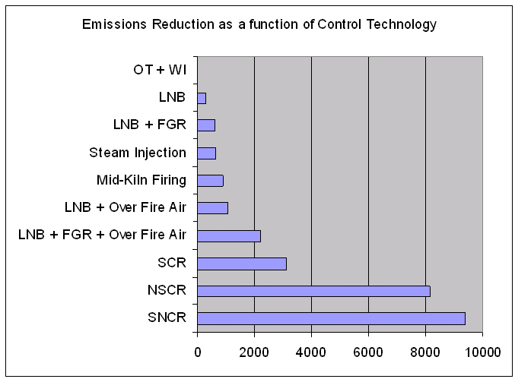
When multiple datasets need to be considered in a summary (e.g., to compare two inventories), the EMF “QA Program” mechanism is used. The QA programs each have customized user interfaces that allow users to select the datasets to be used in the query. Some of the following QA programs may prove useful to CoST users:
- "Multi-inventory sum": takes multiple inventories as input and reports the sum of emissions from all inventories
- "Multi-inventory column report": takes multiple inventories as input and shows the emissions from each inventory in separate columns
- "Multi-inventory difference report": takes two sets of inventories as input, sums each inventory, and then computes the difference between the two sums
- "Compare Control Strategies": compares the data available in the Strategy Detailed Result datasets output from two control strategies
Summaries can be mapped with geographic information systems (GIS), mapping tools, and Google Earth. To facilitate this mapping, many of the summaries that have “with Descriptions” in their names include latitude and longitude information. For plant-level summaries, the latitude and longitude provided are the average of all the values given for the specific combination of FIPS and PLANT_ID. For county- and state-level summaries, the latitude and longitude are the centroid values specified in the “fips” table of the EMF reference schema.
It is useful to note that after the summaries have been created, they can be exported to CSV files and also to Shapefiles. By clicking ‘View Results’, the summary results can be viewed in a table called the Analysis Engine that does sorting, filtering, and plotting. From the File menu of the Analysis Engine window, a compressed .kmz file can be created and subsequently loaded into Google Earth. Note that each KMZ file is currently provided with a single latitude and longitude coordinate representing its centroid, even for geographic shapes like counties. Shapefiles, on the other hand, may represent regions. When exporting the QA summary, the user selects the appropriate Shapefile to use as a template (e.g., U.S. States, U.S. Counties) during the export process, and the attribute data are attached to the shapes in a copy of the selected Shapefile.
Recall that in addition to the datasets output for control strategies, many types of summaries of these datasets can be created in CoST (see Section 2.7). Figure 11 shows a plot that can be created by summarizing a Least Cost Strategy Detailed Result using the "Summarize by Control Technology and Pollutant" query. Some of the technologies used in this run were Low NOx burners (LNB), Low NOx burners with Flue Gas Recovery (LNB + FGD), Non-Selective Catalytic Reduction (NSCR), and Selective Non-catalytic Reduction (SNCR). Note that Figure 11 was generated by plotting data output from CoST with spreadsheet software, and not by CoST itself. CoST does have some plotting capabilities, but they are not discussed in this document.

Control Program Manager
The Control Program Manager manages Control Programs within the EMF. Control Programs describe changes to emissions that occur in the years in between the base modeling year (e.g., 2005) and a future modeling year (e.g., 2020).
Additional info will be added later in 2009.

Advanced Training Exercises
This section has some advanced training exercises for you to work through after you have worked through the basic exercises above.

Importing an Emissions Inventory (or County List File)
In many cases, it will be necessary to import an emissions inventory into the EMF for use with CoST. Before it can be imported, the inventory must be in one of these ORL formats: ORL Point, ORL Onroad, ORL Nonroad, or ORL Nonpoint. For more information on these formats, see http://www.smoke-model.org/version2.5/html/ch08s02.html#d0e38904. Try importing an inventory using the following steps:
- Choose Datasets from the Manage menu of the EMF main window.
- Set the Show Datasets of Type menu to the type that represents your inventory (e.g., ORL Nonpoint Inventory).
- Click the Import button to show the Import Datasets window.
- Click the Browse button and browse to the location of your inventory on the EMF server computer (e.g., C:\EMF_temp\inventories\nonpoint).
- Select the checkbox that corresponds to your inventory (e.g., arinv_nonpt_2020cc_31may2007_v0_orl_txt) and then click OK.
- Specify a meaningful name for the new dataset in the Dataset Name type-in field that does not duplicate one of the existing dataset names.
- Click the Import button. Monitor the Status window for the status of your import. If the inventory file was new, you may have data formatting issues to deal with.
- Click Done on the Import Datasets window.
- After you see a message that the Status window that indicates that the import has completed, click Refresh on the Dataset Manager and you should see the newly imported inventory dataset. The dataset could now be used as an input to a control strategy.
- To import a list of counties to limit the counties used for a strategy analysis, set the Show Datasets of Type menu to List of Counties and then import the file following steps 3 through 9 above. Be sure that your list of counties file has at least two columns, with one of them labeled ‘FIPS’.
From the Dataset Manager, you can:
- use the View button to open the Dataset Properties Viewer,
- use the Edit button to open the Dataset Properties Editor,
- use the Edit Data button to create new versions of the dataset,
- use the Export button to export the data to a file on the EMF server.

Running a Maximum Emissions Reduction Strategy
For this exercise, we will modify the least cost strategy you created in Section 4 and run it as a maximum emissions reductions strategy.
- Copy the least cost strategy you created in Section 4 to a new strategy.
- Edit the strategy and set the Strategy Type to Max Emissions Reduction.
- Run the new strategy.
- Did the maximum emissions reduction strategy run slower or faster than the least cost?
- How much more reduction did you get over the 50% level of reduction you specified in Section 4?
- How does the Average Cost per Ton and Total Cost differ between the 50% reduction strategy you ran earlier and the maximum emissions reduction available?
Hint: use the columns of the Control Strategy Manager to answer this question.
Least Cost Strategy Total Cost: Average CPT:
Max. Emissions Red Total Cost: Average CPT:
- What are some of the SCCs for sources that had control measures applied in the result, but had a control efficiency of less than 90%? [It is important to note these because they may provide opportunities for controls…] Hint: Examine the Strategy Detailed Result and apply a filter for CONTROL_EFF<90 to find the applicable rows.
SCCs with CE < 90%:

Running a Strategy with a Hypothetical Measure
For this exercise, we will create a new control measure and then see what impact it has on the strategy results.
- Create a new control measure. Set the Major Pollutant to NOX. Set the Class to Hypothetical.
- On your new measure, enter an Efficiency record for NOX with a control efficiency of 95%, a cost per ton of 3000, and a cost year of 2006.
- For your new measure, add all SCCs starting with 102 (there should be about 83 of these). Hint: you do not have to click 83 checkboxes to do this - remember to filter and Select All.
- Copy your maximum emissions reduction strategy from the previous exercise to a new strategy.
- Set your new strategy to include Hypothetical measures in addition to Known.
- Run your new strategy.
- Based on the results of this strategy, how much additional emissions reduction could you get over the previous maximum reduction result if there was a control measure with a 95% CE available for sources with SCCs starting with 102, such as the one you created?

Examining Cobenefits
For this exercise, we will run a control strategy that will result in some control measures being applied that result in co-benefits.
- Set up a new control strategy.
- Set the Target year to 2020 and the Strategy Type to Max Emissions Reduction.
- Set the inventory to use to be the nonpoint inventory you imported in Section 6.1.
- Set the inventory filter to: FIPS like ‘42%’.
- Set the Target Pollutant to PM10, then Run the strategy.
- Once the run completes, summarize the Strategy Detailed result by Control Technology and Pollutant.
- Once the summary has completed running, view the Detailed Result.
Do you see data for more than one pollutant?
What is the typical cost per ton for the strategy?
- Try setting a Maximum Cost per Ton constraint less than the typical cost per ton in the result you just generated and rerun the strategy.
How does the constraint impact the results?

References
Eyth, A.M., D. Del Vecchio, D. Yang, D. Misenheimer, D. Weatherhead, L. Sorrels, “Recent Applications of the Control Strategy Tool (CoST) within the Emissions Modeling Framework”, 17th Annual Emissions inventory Conference, Portland, OR, 2008.
Houyoux, M.R., M. Strum, R. Mason, A. Eyth, A. Zubrow, C. Allen, “Using SMOKE from the Emissions Modeling Framework”, 17th Annual Emissions inventory Conference, Portland, OR, 2008.

Misenheimer, D.C., “A New Tool for Integrated Emissions and Controls Strategies Analysis”, 16th Annual Emissions inventory Conference, Raleigh, NC, 2007.

