EMF Server Communication

System Requirements

Python:
The SMOKEServer must have a minimum of Python v2.3.

tcsh:
The SMOKEServer must have tcsh installed.

Java
Ideally the EMFServer and SMOKEServer should have common Java versions and locations.

Home Directory
The ‘emf’ (Linux) user must have a home directory on the EMFServer.

Shared Disks
Any shared (mounted) disks that are to be used by the EMF should have the same root on both the EMFServer and SMOKEServer. If the EMFServer local disk is called /data_emf, for example, then the disk mounted on the SMOKEServer should also be call /data_emf. In the Installation and Configuration instructions, review the Directory Permissions section.

SMOKEServer to EMFServer Communication

Setup
- From the emf_installation_beta.tar.gz file (previously downloaded and untarred), place EMFClient directory and contents on a shared disk, as mentioned above (We refer to this location as <emf_client_dir> and the URL of your EMF server as <emf_server_host_name>)

- Edit the EmfCmdClientEnv.csh script as follows:
setenv EMF_HOME <emf_client_dir>
setenv TOMCAT_SERVER http://<emf_server_host_name>:8080

- Edit EmfTaskStatusClient.csh script as follows:
setenv EMF_HOME <emf_client_dir>
setenv TOMCAT_SERVER http:// <emf_server_host_name>:8080

- Edit EmfRestoreClient.csh script as follows:
setenv EMF_HOME <emf_client_dir>
setenv TOMCAT_SERVER http://localhost:8080

Test
Run EmfTaskStatusClient.csh script from the SMOKEServer
$ <emf_client_dir>/EmfTaskStatusClient.csh
A successful test means that the program has connected to the EMFServer and prints information on any tasks running on the EMFServer, for example:
Starting EMF Task Manager Status Client

=======================================
Status of the CaseJobTaskManager

Tasks in the Wait Table
JobId,JobName,CaseId,CaseName,UserId,Ready?
There are no tasks in the CaseJobTaskManager WaitTable
=======================================
Tasks in the CaseJobTaskManager RunTable
JobId,JobName,CaseId,CaseName,UserId
There are no tasks in the CaseJobTaskManager RunTable
=======================================

=======================================
Status of the ExportTaskManager

Tasks in the Wait Table
UserId,DatasetNamevVersion
There are no tasks in the ExportTaskManager WaitTable
=======================================
Tasks in the ExportTaskManager RunTable
UserId,DatasetName,Version
There are no tasks in the ExportTaskManager RunTable
=======================================

=======================================
Status of the ImportTaskManager

Tasks in the Wait Table
UserId, Dataset Name
There are no tasks in the ImportTaskManager WaitTable
=======================================
Tasks in the ImportTaskManager RunTable
UserId, Dataset Name
There are no tasks in the ImportTaskManager RunTable
=======================================

EMFServer to SMOKEServer Communication
For the EMFServer to communicate properly with the SMOKEServer, the EMF will need to be able to ssh from the EMFServer to the SMOKEServer without being prompted for password authentication. This is achieved through the generation and ‘deployment’ of ssh keys. Once the keys has been generated (steps 1-4 below), the public key will need to be ‘deployed’ (as outlined below) to the SMOKEServer for each EMF user (steps 5-9). That is to say, if you have two EMF users, ‘userA’ and ‘userB’, steps 1-4 will only need to be performed once, while steps 5-9 will need to be performed twice. If a particular user is going to run SMOKE (or other model from the EMF), their EMF username must be the same as their username on the SMOKEServer.
If your EMFServer and your SMOKEServer are the same machine, we will use the same mechanism as above to run SMOKE. The emf user will use ssh to log onto the EMFServer/SMOKEServer via its public address.
Complete the following steps:
- On the EMFServer, change to the ‘emf’ user:
$ su emf

- Look at the contents of the .ssh directory in the ‘emf’ user’s home directory:
$ ls ~/.ssh

If you see a file named id_rsa.pub, then the ‘emf’ user already has a public key, and you can skip to step 5 below.

- Make sure the .ssh directory is only ‘rwx’ (‘read/write/execute’) by the ‘emf’ user:
$ chmod 700 ~/.ssh

- To generate the ssh keys, execute:
$ ssh-keygen -t rsa

  - You will be prompted to “Enter file in which to save the key”. Hit enter to accept the default.
  - You will then be prompted to “Enter passphrase”. Hit enter for no passphrase.
  - You will finally be prompted to “Enter same passphrase again”. Hit enter for no passphrase.
  - You will be given a message that looks something like:
Your public key has been saved in /home/emf/.ssh/id_rsa.pub. The key fingerprint is …

You should now see two new files in the .ssh directory:
id_rsa (private key)
id_rsa.pub (public key)

- Copy the public key (id_rsa.pub) from your EMFServer to the SMOKEServer, as the EMF user (the login name of the user who will be running EMF jobs). For example:
$ scp id_rsa.pub azubrow@anubis.cep.unc.edu:/home/azubrow/.ssh

- On the SMOKEServer, as the EMF client user, append the id_rsa.pub file to the authorized_keys file in .ssh. For example:
$ ssh azubrow@anubis.cep.unc.edu
$ cat id_rsa.pub >> authorized_keys

Note: If the authorized_keys file doesn’t exist, this will create it.

- Change the permissions on the .ssh dir and the authorized_keys file:
$ chmod 700 ~/.ssh
$ chmod 640 authorized_keys

- Delete the id_rsa.pub file

- Test the connection from the EMFServer to the SMOKEServer:

  - On the EMFServer, as the ‘emf’ user, ssh to the SMOKEServer. For example:
$ ssh azubrow@anubis.cep.unc.edu

  - You should NOT be prompted for a password.

EMF Test Case

Configuring the Case
- Download test_EMF.tar.gz and untar the file.

- If there is not a process queue on the SMOKEServer (e.g., PBS or LSF), copy our fake queue script to a central location. For example, as root:
# cp test_EMF/qsub_emf /usr/local/bin
# chmod a+rx /usr/local/bin/qsub_emf

- Move or copy the test_EMF/test_scripts directory and contents to your shared disk (so that they can be accessed by both the EMFServer and SMOKEServer). Make sure the scripts are 'rx' for the emiss group. An example directory for these scripts is:
/data4/test_EMF/scripts/test_scripts

- Move or copy the test_EMF/test_case_setup to your import directory on the EMFServer. An example directory for the case imports is:
/data3/imports/cases/test_case_setup

- Modify test_case_setup/inputs/emf_jobheader_generic to match your system:
source <emf_client_dir>/EmfCmdClientEnv.csh
setenv EMF_CLIENT <emf_client_dir>/EmfCmdClient.py

- Using the EMF client, import the test_case_setup/inputs/emf_jobheader_generic dataset:

  - From the EMF client, launch the Dataset Manager (Manage > Datasets from the main menu)

  - From the Dataset Manage window, select ‘EMF Job Header’ from the Show Datasets of Type pull-down. This should be empty.

  - Click the Import button

  - Browse to and select the newly modified emf_jobheader_generic file from step 3 above and click the OK button

  - Click the Import button

  - From the Status window, click the Refresh button periodically until you see a message stating the import completed (It should actually only require one click, as the import should be fast for such a small file)

  - From the Import Dataset window, click the Done button

  - From the Dataset Manage window, verify that your newly imported dataset is there (clicking the Refresh button if necessary)

  - Close the Dataset Manage window

- Import the test Case:
  - From the EMF client, launch the Case Manager (Manage > Cases from the main menu)

  - Click the Import button

  - Browse to the test_case_setup directory and select the following files:
test_EMF_setup_test_setup_Inputs.csv
test_EMF_setup_test_setup_Jobs.csv
test_EMF_setup_test_setup_Summary_Parameters.csv

  - Click the Import button

  - Verify that the message ’Successfully imported the case.’ appears at the top of the window

  - Click the Done button

  - From the Case Manage window, select ‘Demo’ from the Show Cases of Category pull-down and verify that your newly imported case (‘test EMF setup’) is there

- You will now need to modify the imported case to match your system

- Select the new case and click the Edit button

- From the Jobs tab, edit the Output Job Scripts Folder field. An example directory is:
/data4/test_EMF/scripts/cases/$CASE

The EMF server will replace the variable $CASE by the case abbreviation. It will create this subdirectory when the first job is run. Make sure that the rest of the directory tree has been created and has the proper permissions (see Directory Permissions).

- Select both jobs and click the Edit button (this will open two Edit Case Job windows)

- For each job, modify:

  - the Executable field to match the location of the test_scripts directory

  - the Host field to match the SMOKEServer host name. This is the URL or IP address of your SMOKEServer. The first time you do this, you will need to type into the field. Subsequent times, you can select the host from the pull-down. If your EMFServer and SMOKEServer are the same machine, set the host to the public address of the machine, not localhost.

  - the Queue Options field. If you are using a process queue on your SMOKEServer, you will provide the queue command and additional options here. An example using a PBS queue:
qsub -o $EMF_JOBLOG $EMF_QUEUE_OPTIONS

If you are not using a process queue, then you should use the fake queue script provided:
qsub_emf $EMF_JOBLOG

The variable $EMF_JOBLOG is automatically filled in by the EMF. This is the file that captures stdout and stderr of the job. The variable $EMF_QUEUE_OPTIONS is defined in the parameters tab.

  - click the Save button

- From the Inputs tab, modify the Input Folder field. An example directory is:
/data4/test_EMF/inputs/$CASE

The EMF server will replace the variable $CASE by the case abbreviation. It will create this subdirectory when the first Job is run. Make sure that the rest of the directory tree has been created and has the proper permissions (see Directory Permissions).

- Make sure that the ‘emf job header’ input is selected and click the Edit button

- From the Edit Case Input window, click the Select button (next to the Dataset field)

- From the Select EMF Job Header window, select the dataset ‘emf_jobheader_generic’ and click the OK button

- From the Edit Case Input window, verify that the Dataset field has been correctly updated and click the Save button

- If you are using a real process queue, go to the Parameters tab, select the ‘EMF queue options’ parameter and click the Edit button. If you are using the fake queue, the value of the 'EMF queue options' does not matter.

- From the Edit queue options window, edit the Value field. If you are using a process queue, this is where you would place additional options such as user permissions, estimated time of run, etc. After editing the value, click Save.

Running a Job
Once the Case (Jobs, Inputs, and Parameters) have been properly configured, to run a Job, simply return to the Jobs tab, select the Job you wish to run and click the Run button. Once the Run button has been clicked a confirmation dialog will appear; click the OK button.

Job Status and Files
The EMF will generally not update a Job’s state or status messages, so the user will be required to click the Refresh button from time to time. A successful run will go through the following progression:
- Not Started - before a Job has been run
- Exporting - EMF is exporting all the Inputs necessary for that specific Job
- Waiting - Job is sitting in the EMF internal queue waiting for all exports to complete and/or and Job dependencies
- Submitted - Job has been submitted to the SMOKEServer's process queue
- Running - Job has started on the SMOKEServer
- Completed - Job has completed its run on the SMOKEServer
If there is an error that occurs in the Exporting, Waiting, or Running stages, the status will be set to Failed. If you have previously run a Job and do not change any Inputs in the interim, a second run of a Job will skip the Exporting stage.
The EMFServer will create a Job wrapper script that sets up the necessary environment for the Job. This wrapper script is a csh script that includes EMF related environment variables and environment variables from the Summary, Jobs, Inputs, and Parameters tabs. As the Job wrapper script runs on the SMOKEServer, stdout and stderr are redirected to the Job specific log file. Both of these files are tagged with job name, an ID, and a datestamp. If a Job is rerun, a new Job wrapper script and log is created. Based on the above directory structure, the Job wrapper scripts and log files would be located in:
/data4/test_EMF/scripts/cases/test_setup
/data4/test_EMF/scripts/cases/test_setup/logs

Expected Messages
More detailed information concerning a Job can be seen in the History tab. The underlying scripts (the executable) have been developed to send back information on the progression of the program, status changes, and some error messages if they do occur.
Once the History tab has been selected, select the Job in which you are interested from the Job pull-down (selecting ‘All’ will display all messages). Clicking the Refresh button from time to time will display any new messages if the Job has not yet completed the run.
Below is a screenshot of the expected messages from a successful run of the "test messages 1" Job:
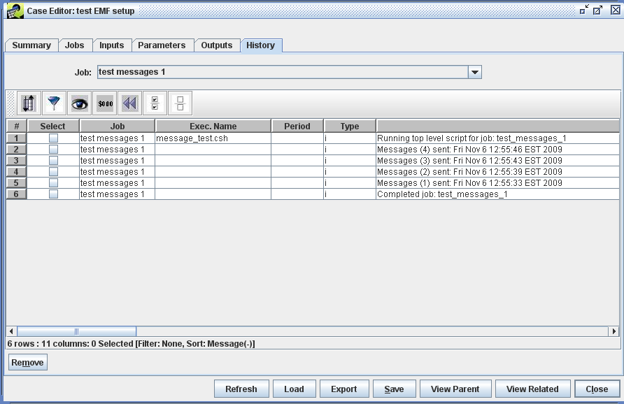
Below is a screenshot of the expected messages from a successful run of the "test outputs 1" Job:
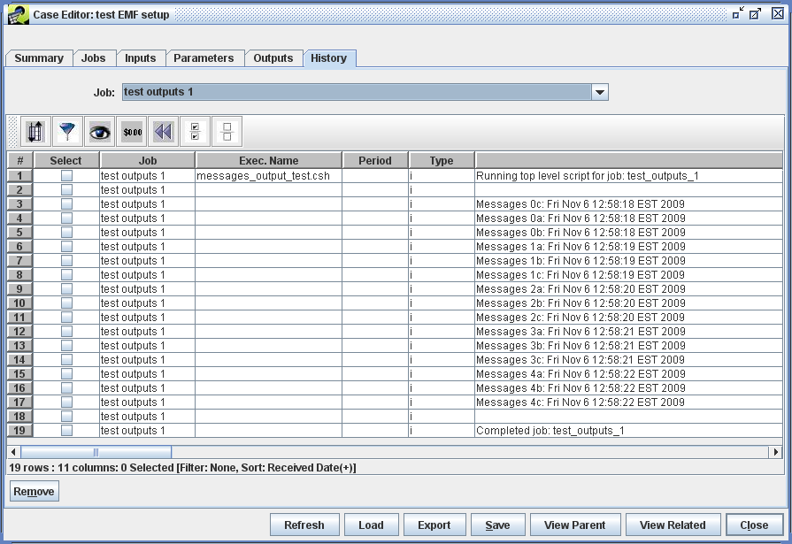

Expected Outputs
In addition to messages, a Job can import new datasets into the EMF. These new datasets are associated with Case outputs (similar to how a dataset is associated to an Input).
Once the Output tab has been selected, select the Job in which you are interested from the Job pull-down (selecting ‘All’ will display all outputs). Clicking the Refresh button from time to time will display any new outputs if the Job has not yet completed the run.
The "test messages 1" Job does not produce any outputs.
Below is a screenshot of the expected outputs from a successful run of the "test outputs 1" Job:
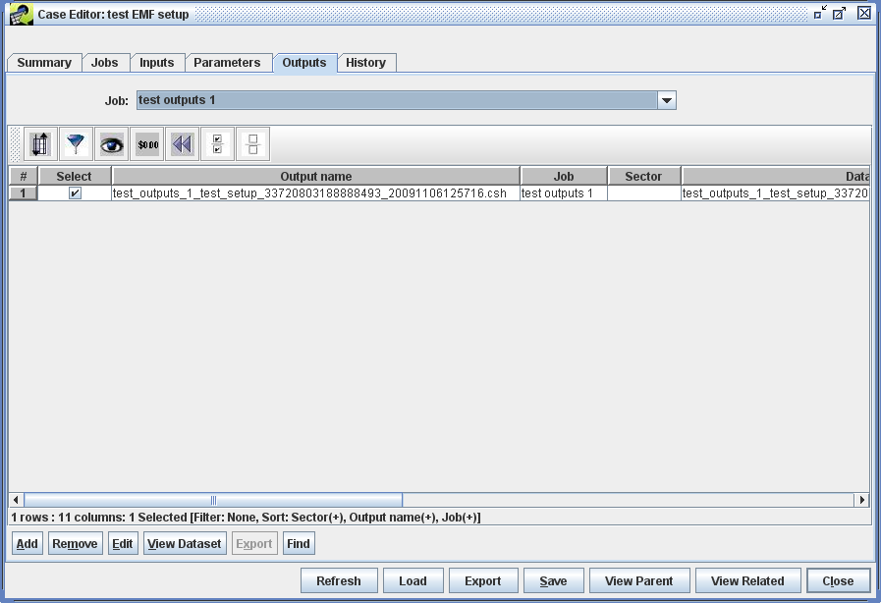

Troubleshooting
The most common source of errors is a problem with user permissions. Both the emf user on the EMFServer and the user who is actually running the Job wrapper script on the SMOKEServer need permission to read, write, and execute in the common directories and files.
Another possible problem is that the ssh-keys have not been properly setup. Make sure for each new user who plans to run on the SMOKEServer that the emf user can login via ssh without a password.
Other areas to search for the cause of an error:
- The History tab. For known errors, the underlying scripts will attempt to send back error information.
- The EMF status window. This will generally indicate errors in exporting the Inputs.
- The Job wrapper log file.
- Other log files created. For example, SMOKE intermediary log files.
If none of these sources help identify the cause of an error, consult the apache-tomcat log, /usr/local/apache-tomcat-6.0.20/logs/catalina.out

