Emissions Modeling Framework Sensitivity Tool User Instructions

Work Assignment: 2-02
Contract No: EP-D-07-102
OMB Clearance No: 2030-0006

Prepared for: Marc Houyoux
U.S. Environmental Protection Agency
C339-02
Research Triangle Park, NC 27711

Prepared by: Alexis Zubrow and Alison M. Eyth
Institute for the Environment
The University of North Carolina at Chapel Hill
137 E. Franklin St., CB 6116
Chapel Hill, NC 27599-6116

June 3, 2009

Contents

1 Background and Design 3
2 Using the EMF Sensitivity Tool 5
2.1 Model-ready adjustment sensitivities 5
2.1.1 Preparation for a sensitivity run 5
2.1.2 Selecting the parent case 6
2.1.3 Creating the sensitivity case 7
2.1.4 Running Model-ready Sensitivity jobs 10
2.1.5 Reviewing results and logs 12
2.2 Source-level adjustment sensitivities 13
2.2.1 Preparation for a sensitivity run 13
2.2.2 Selecting the parent case 14
2.2.3 Creating the sensitivity case 14
2.2.4 Running Source-level Sensitivity jobs 18
2.2.5 Reviewing results and logs 19
2.3 Running jobs from the EMF 22

Background and Design
The sensitivity tool provides a simplified entry into running SMOKE from the EMF. Air quality modelers can define and run emissions control strategies or other emissions adjustments, called ”sensitivities”, to existing EMF SMOKE cases.
EMF supports two main types of sensitivities:
- Adjustment of model-ready emissions: This type of sensitivity adjusts model-ready, gridded sector-specific emissions output from SMOKE by a factor that can either increase or decrease the emissions. You make adjustments to model-ready emissions that had previously been created by a SMOKE case, which is called the “parent” case. A new case performs the adjustments; we call this new case the “sensitivity” case. You can only adjust emissions for sectors that have already been run through SMOKE (either in the parent case or through another case). Here are some examples of what you can do with this type of sensitivity case:
  - Reduce NOx by 50% for all sectors (“across the board” cut)
  - Double PM_{2.5} for the dust sector
  - Zero out all emissions from the EGU sector
  - Reduce VOC by 10% from all sectors other than the fires sector and the biogenics sector
  - Any combination of the above
The model-ready adjustment case is the easiest case to use currently, because there are fewer steps to run and quality assure. Also, the input file that defines the adjustments has a simpler format than the adjustment file used in the source-level sensitivities. Limitations of this type of sensitivity include
    - Does not allow geographic sensitivities (e.g., zero-out of a county or state); users can only adjust the entire grid by sector and pollutant
    - Does not allow changing emissions for parts of a sector, such as reducing emissions from particular groups of sources (e.g., petroleum refineries).
    - Supports only 3-d air quality model inputs (rather than CMAQ’s “inline” approach)
To run the sensitivity, the EMF and SMOKE scripts integrate data from the parent and sensitivity cases. The Job uses the sector-specific, model-ready emissions output from SMOKE by the parent case as a starting point to the Job. These emissions will be adjusted based on the Inputs from the sensitivity Case. The key input is the user-supplied set of adjustment factors, which you provide on the Inputs tab of the sensitivity case. These factors define the adjustment factors by sector and model species. The sensitivity case’s Job (called “Sector merge”) runs a script that calls the SMOKE program Mrggrid. Mrggrid applies the adjustment factors to the specified sectors and model species and creates the final model-ready emissions and reports. The sensitivity's model-ready emissions have been adjusted by the factors and are ready to be run in an air quality model.
- Adjustment of source-level emissions: This type of sensitivity adjusts emissions by State/County/SCC or MACT or NAICS or Facility and/or Sector. Some examples of what you can do with this type of sensitivity are:
  - Zero out emissions of anthropogenic NOx for New York (exact state’s emissions, not by grid cell)
  - Reduce PM_{2.5} emissions from residential wood SCCs by 20% in Oregon
  - Reduce VOC emissions from a MACT category by 80%
  - Reduce all PM nonattainment counties’ PM_{2.5} emissions by 20%
  - Double emissions of ABC Steel, in Detroit, Michigan
  - Any combination of the above
For the source-level adjustment case, the user provides more information to set up the sensitivity and runs more jobs than when adjusting model-ready emissions with the first type of sensitivity. First, you will need to run jobs to create the adjusted, sector-specific, model ready emissions for each sector that needs adjusting. Second, you need to run a Job to combine the model-ready emissions across all sectors to produce the model-ready emissions for AQ modeling.
To perform this sensitivity, the EMF and SMOKE scripts do the following. Sector-specific Jobs are run only for any sector that needs to be adjusted. For these sector-specific Jobs, the scripts use the SMOKE intermediate files from the parent case as a starting point and run the SMOKE programs Cntlmat and Smkmerge. These jobs create the adjusted sector-specific, model ready emissions. A final Job calls a SMOKE script that runs the SMOKE program Mrggrid to create the final model-ready emissions. The Mrggrid program merges the emissions from the adjusted sector-specific Jobs with the emissions from any unadjusted sectors directly from the parent case.
The EMF sensitivity wizard assists the user in creating sensitivity cases and relies on sensitivity case templates, as shown in Figure 1. Instructions are provided in the next section. A template is an EMF case that contains Jobs, Inputs, and Parameters that are needed in the final sensitivity case. The template is not complete until the EMF merges it with a parent case, filling in the values for the Inputs and Parameters that are left unspecified in the template. Some Inputs and Parameters in a template may have default values and some may be unset. They are unspecified because they will vary depending on the parent case you select. Once the EMF merges the template with a parent case, the sensitivity case is created. While the sensitivity case is being created, any required, unspecified Inputs and Parameters from the template that are not set by the Parent case (such as the adjustment factors file) can be filled in using the wizard or by manually editing the sensitivity case after it has been created.
Figure 1. Relationship between Base/Starting Case, Template Case, and Sensitivity Case
Parent case (an existing SMOKE case)
Template Case
(with jobs, inputs, params needed for all sensitivity cases)
Sensitivity Case
(has jobs, inputs, params from template added to it, plus some settings and values from base/starting case and some from a wizard)

Using the EMF Sensitivity Tool
Both types of sensitivities have five major steps: (1) preparing directories and inputs for the run, (2) selecting a parent case on which the sensitivity will be built, (3) creating the sensitivity case, (4) running one or more jobs in the new sensitivity case to apply the adjustments and create new model ready emissions files, and (5) reviewing the outputs. The following sections will explicitly describe these steps for the two types of sensitivities.

Model-ready adjustment sensitivities

Preparation for a sensitivity run
- Create on amber (or the machine you will actually run the job on, e.g., garnet) the path for the model ready files. Use the following convention for this path. Before creating it, check if it already exists. Our (OAQPS) naming convention is:
/orchid/oaqps/<project>/smoke_out_<platform>
Where <platform> is “v31” or “v4” depending upon the parent case (e.g., /orchid/oaqps/noxsox_naaqs/smoke_out_v31) and <project> should be based on the project for which the sensitivity case is being run, and consistent with the “Project” level name in the ASM directory structure. The EMF Jobs will create a case- specific directory (corresponding to your sensitivity CASE abbreviation) under this path for the model ready files.
- Make your model ready adjustment file; put it on /orchid (recommended directory is below), and import it into the EMF (unless someone has done this for you). Directions on importing this file are in (c) below.
The adjustment file is a CSV formatted file and has the following columns:
name of model species (maximum width 16)
name of sector (maximum width 32)
adjustment factor (ratio, not percentage)
Examples are in the directory
/orchid/share/em_v4/inputs/model_adjustments
If you are interested in reducing PM_{2.5}, you need to supply a record for each model species (POC, PEC, PSO4, PNO3, and PMFINE). The same is true for VOC species. For NOx, some sectors (if they contain any mobile sources) are speciated into NO, NOX and HONO so you need to specify all 3 model species for these sectors.
We recommend that you put your model ready adjustment file into the same directory that contains the examples shown above (or the corresponding directory for platform "em_v31"). Note that the EMF cannot import from your amber home directory (the import location must be mounted on the EMF server, tulip.nesc.epa.gov).
- To import the adjustment file to the EMF:
Click on File menu of the main EMF interface and select Import. In the Import Datasets window, set the Dataset type to “Sensitivity Adjustment Factors (CSV)”. Choose the proper Folder (subdirectory where you put the file) on the EMF server to import this file by clicking Browse and navigating to the folder. Click on the appropriate file. Do not put anything in Pattern. Check the Filename. Keep the Dataset name the same as the filename minus any extension (automatically shows up in the window). Click Import.
Import as many files as you need for your sensitivity cases (typically 1 file per case).
- For advanced users, check that the sector-specific model ready files from the parent case are in the proper location. The proper location is indicated by the parent case’s SECTORLIST dataset(s). While most parent cases have just one SECTORLIST, some will have multiple SECTORLIST datasets (for example, a different SECTORLIST for a different GRID). Note: if the model ready files are not in their proper location, they will need to be copied to their original location from mass storage.

Selecting the parent case
- Click on the Manage menu and select Cases. In the Case Manager window, set the Show Cases of Category to the category of your parent case (e.g., “Run SMOKE model performance" or “Run SMOKE future year”)
- Click the box in the select column of the parent case (i.e., the case that you will apply the sensitivity to) and make sure you get a check mark.

Creating the sensitivity case
- After selecting your parent case as described in 2.1.2 (b), click the Sensitivity button on the bottom of the Case Manager window. A new window will appear, labeled Add Sensitivity for Case: <parent>.
- Here, you define the new sensitivity case. Select "Create new case" (i.e., create a new sensitivity case). Fill in the sensitivity case Name and Abbreviation (you can use the same for both).
For EPA users, the convention for case abbreviations is:
<Parent case abbreviation , except met tag>_<sensitivity tag>_<met tag>.
Here are some examples:
Parent case abbreviation Sensitivity Tag Sensitivity case abbreviation
2005ai_tox_05b 50nox 2005ai_tox_50nox_05b
2005ak_05b GAzero 2005ak_GAzero_05b
- Select the Case Category. Typically, we keep the Case Category as “Sensitivity”, but this can be reset if desired. For the Sensitivity Type, choose “Adjust AQ model ready emissions”. Note: there may be multiple "Adjust AQ model ready emissions" templates based on different production cases. Pick the template that is consistent with your parent case.
At this point, the Information field will be filled in with specific details on the type of sensitivity you chose. We typically keep the Job Group blank. It could be used to add an additional label for your output files and reports.
- Under Grid Filter, you determine which grid resolutions to apply your sensitivity. You can apply sensitivities to one or more grids from the parent case. Select the grid(s) of interest (see Figure 2). The Sector Filter should be ignored for this type of sensitivity; it is applicable to the “Source-level adjustment” sensitivities.
Figure 2. Creating a model-ready adjustment sensitivity
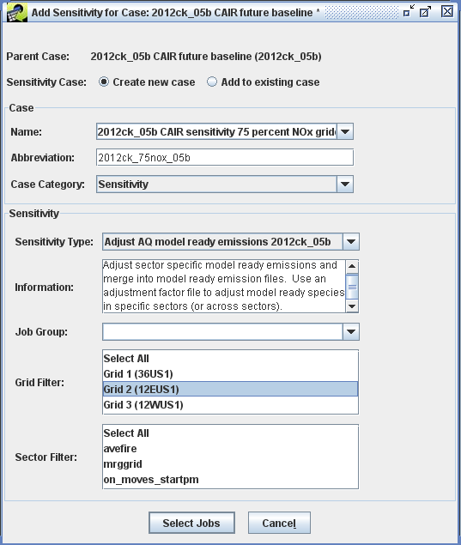
- Click on the Select Jobs button and you will see a window labeled Select jobs for (Add Sensitivity for Case: <parent>). Highlight the job(s) for your grid(s) (e.g., "Sector merge sensitivity GRID2").
- Click the Wizard button. This will open a new window, labeled Sensitivity Wizard: <sensitivity case>. The wizard is designed to guide the user through setting the inputs and parameters needed for the sensitivity. The first window determines the input folder and job script folder. Check that the Input Folder is using the same platform in its path that you are using (e.g., "em_v31" versus "em_v4"). You will likely not change the Output Job Scripts Folder unless you do not have write permission on the folder listed from the parent case (for example, if an ORD user is creating a sensitivity case from an OAQPS parent case). You may want to add/modify text for the Sens. Case Description, which is summary metadata for the case. The default text from the wizard is just “Sensitivity on” prepended to the parent case's description.
At any point during use of the Wizard, you can click the Edit Case button to go directly to the new sensitivity case. Most users will continue to click Next until all of the user inputs and parameters have been completed.
The following steps describe each of the steps of the Sensitivity Wizard in more detail.
- After clicking Next, you will select the SECTORLIST input. The SECTORLIST provides the names and case abbreviations (from which the file locations can be determined) of the sector-specific model ready emissions that will be merged. You should use the same SECTORLIST as is used in the parent case. The wizard should have found a default for this input based on the parent case. The reason you have to choose the SECTORLIST is that sometimes, a parent case will have more than one SECTORLIST (i.e., a different list for different grids.)
The View button may be used to confirm that the selected dataset has the desired contents.
Here are some recommendations on how to choose the appropriate sector list:
- The SECTORLIST dataset should typically be named with the parent case abbreviation and may have a grid extension.
- Choose the dataset that has the name of your parent, and the grid you are running.
- If the SECTORLIST dataset from your parent case does not have a grid extension, then choose the SETORLIST used by the parent case.
- You should not need to create a new SECTORLIST file for your sensitivity case.
- If the wizard selected the wrong input, for example the wrong grid, you can select another SECTORLIST using the Select button.
- After clicking Next, you will select the Species Adjustment Factors input, which determines the adjustment factors by sector and model species. Use the Select button to pick your dataset. Note: this dataset must have been previously imported into the EMF (see section 2.1.1).
- Once all of the inputs are set, the wizard will show the parameters that need to be set. The user can type the value of the parameter into the Value field and click Next to go to the next parameter:
  - For the OUT_ROOT parameter, set the full path for where you want the AQM-ready files (see section 2.1.1), making sure that your UNIX account has write permission on the location selected.
  - For the EMF_QUEUE_OPTIONS parameter, put in the value of the queue options, paying particular attention to the accounting code.
  - For the RUN_MONTHS parameter (Figure 3), set a list of months to run (e.g., entering ‘3 4’ will run the months March and April).

Figure 3. Sensitivity wizard, setting the parameter RUN_MONTHS
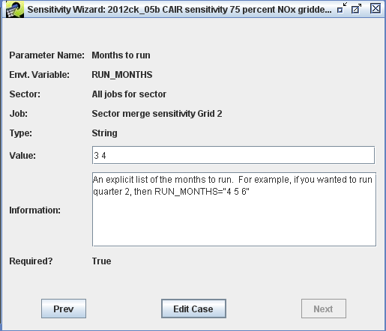
  - Once all parameters have been set, the Next button will no longer be available and the user will select Edit Case to open the sensitivity case.

Running Model-ready Sensitivity jobs
- After clicking Edit Case from the wizard, a new window will appear, labeled Case Editor: <sensitivity case> (Figure 4). From the Case Editor, the user can review all the settings on the Summary. Jobs, Inputs, and Parameters Tabs, and actually run the sensitivity jobs. From this point on, the case will behave as any other case. It will also appear in the list of cases in the Case Manager under the case category that was specified in the Add Sensitivity for Case window (typically “Sensitivity”).
Figure 4. Case editor, model-ready adjustment sensitivity case
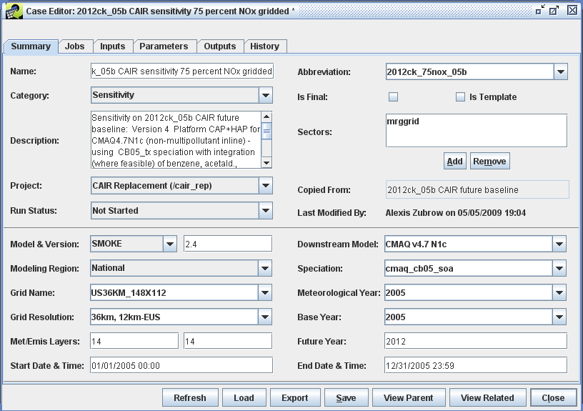
- We recommend that you review the case before running any jobs. In the Summary tab, you can see the description that you provided. If you selected the default (and uninformative) description, you can edit it now. In addition, you may want to change the “Project” listed, if the project for the Sensitivity Case is not the same as the Project for the Parent Case.
In the Jobs tab, you may want to change the host on which the jobs are run. The host will be set to the same host on which the Parent Case was run. You can see the selected host for each Job by scrolling to the right in the main table on the Jobs tab. If you want to change the host to another computer, you must select the Jobs to change, click the Edit button, and edit/save each of the Jobs to specify a new host.
In the Inputs tab, you will see the SECTORLIST and ADJ_FACS inputs that you have previously selected. In the Parameters tab, you can see the various parameters that you have filled in. If you want to see either the inputs or parameters that came directly from the parent case without user input, select the Show All field.
- After reviewing your settings, go to the Jobs tab. Select the job that you want to run using the checkbox in the leftmost column (e.g., "Sector merge sensitivity GRID 2") and click the Run button at the bottom of the window. A new window will appear, labeled Confirm Running Jobs. This window will identify any inputs which may have later versions (typically, later versions are not a problem because you are applying the sensitivity to a parent case that was run in the past with particular versions of the inputs). Click Yes. This will return you to the Case Editor window.
As the job progresses, it will go through a series of "Run Status’". You may need to click on the Refresh button to see the progress. The first status is "Exporting", in which the EMF exports the inputs to the inputs folder. The second status is "Waiting", in which the job sits in an internal EMF queue waiting for any dependencies to be fulfilled prior to job submission. The third status is "Submitted", which means that the job has been added to the PBS queue on the "Host". Note the first time you run a job on a particular host (e.g., garnet or amber) you may need to setup the EMF to run jobs on your account (see section 2.3).
- At this point, the jobs are running as a script on the host and therefore are outside the EMF's direct control. The EMF can cancel a running job (by selecting the job and clicking the Cancel button), or the users can log on to the host and stop a job using the commands “qstat” (to find the queue ID) and “qdel <queue ID>” to stop the job. When the job’s script is started by the PBS queue, the status in the EMF will change to "Running". You may need to click the Refresh button to see these status changes. If the job finishes without error, the final status will be "Completed", otherwise, you will get a "Failed" status.

Reviewing results and logs
- As the job actually runs on the host, it sends back messages and outputs to the EMF. You can review the progress of the run through the History tab. To see the history of a Job, select a Job using the Job pull-down menu at the center top of the tab. You may periodically need to click Refresh to see the latest messages. Each message is marked as information or error. The History tab is a good place to start tracking the cause of a "Failed" status.
- In the Outputs tab, you will also need to select the job of interest using the pull-down menu at the center top of the tab. Here, the job will register specific logs, reports, and AQM model ready files that it produces. Again, you will need to click Refresh to see the latest outputs. Some of these outputs are internal: the data is stored in the EMF database and you can view their content directly through the EMF. Other outputs are external: the EMF records only their location on the host, so you can see where it is and go find it for review outside of the EMF.
Two reports that are particularly useful for the Model-ready Adjustment Sensitivity Cases are (1) the Smkreport adjustment sectors and (2) the Smkreport adjustment summary. The first report records the emissions before and after adjustment for each day for only those sector/model species combinations that were adjusted. The second report sums emissions by day before and after adjustment for those model species that were adjusted across all sectors.
- If you want to track down individual files on the host, such as when debugging a failed job, the following paths may help you.
Standard out/error from the job's run (note the job scripts and logs are tagged with a date stamp):
/orchid/share/em_<platform>/subsys/smoke24/scripts/cases/<case>/logs
If you have made previous runs of this job, older stdout/stderr will be under:
/orchid/share/em_<platform>/subsys/smoke24/scripts/cases/<case>/old_logs/mrggrid
AQM model ready files are under the path (see section 2.1.1):
<project_path>/<case>/<grid>/<mechanism>
The logs for the SMOKE mrggrid program can be found under:
<intermediate_root>/<case>/mrggrid/logs
where <intermediate root> is set by the IMD_ROOT parameter on the Parameters tab
Additional mrggrid reports are under that path:
/orchid/share/em_<platform>/reports/<case>/mrggrid/<grid>/<mechanism>

Source-level adjustment sensitivities

Preparation for a sensitivity run
- On the host where you will run, such as amber, create the path for the model ready files. Use the following convention for this path. Check if it exists first, you may not have to create it if it already exists. For example, the OAQPS naming convention is:
/orchid/oaqps/<project>/smoke_out_<platform>
Where <platform> is “v31” or “v4” depending upon the parent case (e.g., /orchid/oaqps/noxsox_naaqs/smoke_out_v4). Note the SMOKE run scripts called by the Jobs will create a case-specific directory (corresponding to your sensitivity CASE abbreviation) under this path for the model ready files.
- Make your Sensitivity Projection Packet file and import it into the EMF as described in step (c). This file will be used by the Jobs to reduce or increase the emissions of selected emissions sources. The file is a SMOKE input file and its format is described in the SMOKE documentation (e.g., for SMOKE version 2.5, go to
http://www.smoke-model.org/version2.5/html/ch08s06.html#sect_input_gcntl_projection).
Examples of the Sensitivity Projection Packet file are in the directory
/orchid/share/em_v4/inputs/emf/source_level_sens
We recommend that OAQPS users put the Sensitivity Projection Packet file in the same directory that contains the examples shown above (or the corresponding directory for platform "em_v31"). Note that the EMF cannot import files from your home directory due to permissions issues.
It is a good idea to give the Sensitivity Projection Packet file a name that is informative about its contents, which may include the Case abbreviation and the Sector name (for files that are sector-specific).
Note: the Sensitivity Projection Packet must use the SMOKE inventory pollutant name (not the model species name) such as VOC and PM2_5. Valid names are available from the Inventory Table input on the Inputs tab. Note that for PM10, you need to specify PM2_5 and PMC.
- To import the adjustment file to the EMF:
Click on File menu and select Import. In the Import Datasets window, set the Dataset type to "Sensitivity Projection Packet". Click Browse to access the file to import. Select the proper file with the browser window, and click OK. Do not put anything in the Pattern field. Check the Filename. Keep the Dataset name the same as the filename (automatically shows up in the window). Click Import.
Import as many files as you need for your sensitivity case(s).
- For advanced users, check that both 1) the intermediate files for the sectors you plan to adjust, and 2) sector-specific model ready files for sectors you do not plan to adjust, are in the proper locations.. The intermediate and sector-specific model ready files can be found under:
<intermediate_root>/<case>/<sector>
where <intermediate root> is set by the IMD_ROOT parameter on the Parameters tab and the <case> refers to the column "sectorcase" in the SECTORLIST.

Selecting the parent case
- From the main EMF window, click on the Manage menu and select Cases. In the Case Manager window, set the Show Cases of Category pull-down menu to the category of your parent case (e.g., “Run SMOKE model performance" or “Run SMOKE future year”).
- Click the box in the Select column of the parent case (i.e., the case that you will apply the sensitivity to) and make sure you get a check mark. Confirm that only one case is selected.

Creating the sensitivity case
- After selecting your parent case (see 2.2.2 (b)), click the Sensitivity button on the bottom of the Case Manager window. A new window will appear, labeled Add Sensitivity for Case: <parent>.
- Here, you define the new sensitivity case. Select "Create new case" (i.e., create a new sensitivity case). Fill in the sensitivity case Name and Abbreviation (you can use the same for both). Note that the abbreviation should include: year, parent case version (e.g., “af”), met (e.g., 05a) and a unique set of characters for sensitivity (e.g., "NYzeroNOx").
See Section 2.1.3 for examples of the OAQPS naming convention for Case abbreviations.
- Select the Case Category. Typically, we keep the Case Category as “Sensitivity”, but this can be reset if desired. For the Sensitivity Type, choose “Adjust Source Level Emissions”. Note: there may be multiple "Adjust Source Level emissions" templates based on different production cases. Pick the template that is consistent with your parent case.
At this point, the Information field will be filled in with specific details on the type of sensitivity you chose. We typically keep the Job Group blank. It could be used to add an additional label to your output files and reports.
- Under Grid Filter, you determine which grid resolutions to apply your sensitivity. You can apply sensitivities to one or more grids from the parent case. Select the grid(s) of interest.
- For the source-level sensitivity, you need to run sector-specific jobs for each of the sectors that are getting adjusted and run the mrggrid sector to create model-ready files. Under Sector Filter, you can further filter the jobs that you will potentially select in the next step by highlighting specific sectors (see Figure 5). If you do not highlight anything, you will have the opportunity to determine which sectors to apply source level adjustments to in the next step.

Figure 5. Creating a source-level adjustment sensitivity
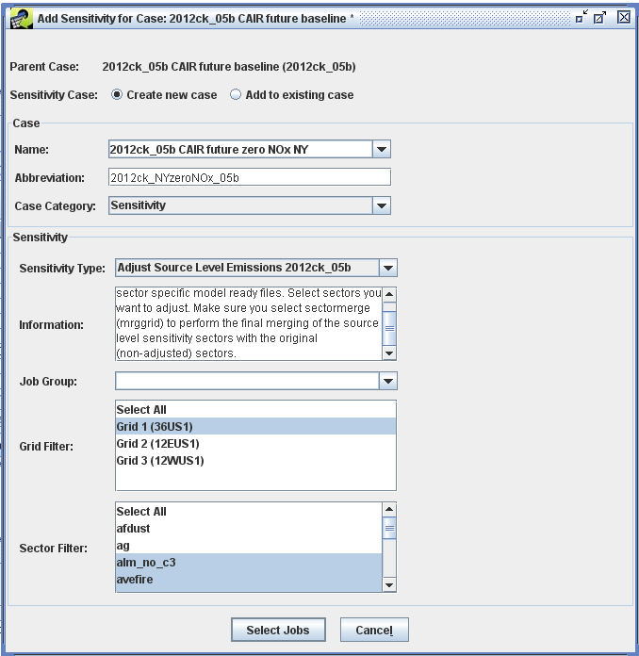
- Click on the Select Jobs button, and you will see a window labeled Select jobs for (Add Sensitivity for Case: <parent>). Highlight the job(s) for your sector and grid(s). Make sure that you select at least two jobs: a job for one sector and a job for one sector merge (e.g., "Annual avefire source level projection GRID 1" and "Sector merge GRID 1").
- Click the Wizard button. This will open a new window, labeled Sensitivity Wizard: <sensitivity case>. The wizard is designed to guide the user through setting the inputs and parameters needed for the sensitivity. The first window determines the input folder and job script folder. Check that the Input Folder is using the same platform in its path that you are using (e.g., "em_v31" versus "em_v4"). You will likely not change the Output Job Scripts Folder unless you do nor have write permission on the folder listed from the parent case (for example, if an ORD user is creating a sensitivity case from an OAQPS parent case). You may want to add/modify text for the Sens. Case Description, which is summary metadata for the case. The default text from the wizard is just “Sensitivity on” prepended to the parent case's description.
At any point during use of the Wizard, you can click the Edit Case button to go directly to the new sensitivity case. Most users will continue to click Next until all of the user inputs and parameters have been completed.
The following steps describe each of the steps of the Sensitivity Wizard in more detail.
- After clicking Next, you will select the GCNTL (Sensitivity Projection Packet) input. Use the Select button to pick your dataset. Note: this dataset must have been previously imported into the EMF (see section 2.2.1). The View button may be used to confirm that the selected dataset has the desired contents.
- After clicking Next, you will select the SECTORLIST input. The SECTORLIST provides the names and case abbreviations (from which the file locations can be determined) of the sector-specific model ready emissions and intermediate files. You should use the same SECTORLIST as is used in the parent case. The wizard should have found a default for this input based on the parent case. The reason you have to choose the SECTORLIST is that sometimes a parent case will have more than one SECTORLIST (e.g., a different list for different grids.). Note: if your parent case has a single SECTORLIST for all grids, then you can run the sensitivity case for all three grids. If it has grid specific SECTORLISTs, then you need to have a separate sensitivity case for each grid. The View button may be used to confirm that the selected dataset has the desired contents.
Here are some recommendations on how to choose the appropriate sector list:
- The SECTORLIST dataset should typically be named with the parent case abbreviation and may have a grid extension.
- Choose the dataset that has the name of your parent, and the grid you are running.
- If the SECTORLIST dataset from your parent case does not have a grid extension, then choose it.
- You should not need to create a new SECTORLIST file for your sensitivity case.
- If the wizard selected the wrong input, for example the wrong grid, you can select another SECTORLIST by using the Select button.
- Once all of the inputs are set, the wizard will show the parameters that need to be set. The user can type the value of the parameter into the Value field and click Next to go to the next parameter:
  - For the OUT_ROOT parameter, set the full path for where you want the AQM-ready files (see section 2.2.1), making sure that your UNIX account has write permission on the location selected.
  - For the EMF_QUEUE_OPTIONS parameter, put in the value of the queue options, paying particular attention to the accounting code.
  - For the RUN_MONTHS parameter (Figure 6), set a list of months to run (e.g., entering ‘1 2 3’ will run the months January, February, and March).

Figure 6. Sensitivity wizard, setting parameter RUN_MONTHS
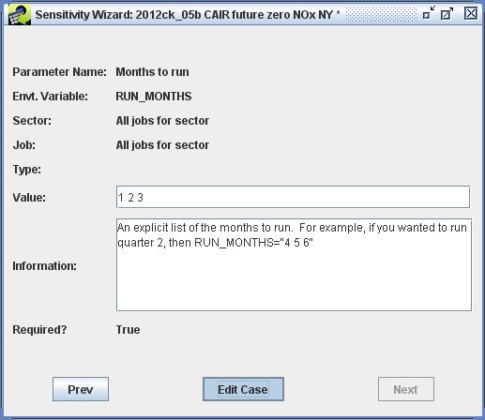
  - Once all parameters have been set, the Next button will no longer be available and the user will select Edit Case to open the sensitivity case.

Running Source-level Sensitivity jobs
- After clicking Edit Case from the wizard, a new window will appear, labeled Case Editor: <sensitivity case> (Figure 7). From the Case Editor, the user can review all the settings on the Summary, Jobs, Inputs, and Parameters Tabs, and actually run the sensitivity jobs. From this point on, the case will behave as any other case. It will also appear in the list of cases in the Case Manager under the case category that was specified in the Add Sensitivity for Case window (typically “Sensitivity”).
Figure 7. Case editor, source-level adjustment sensitivity case
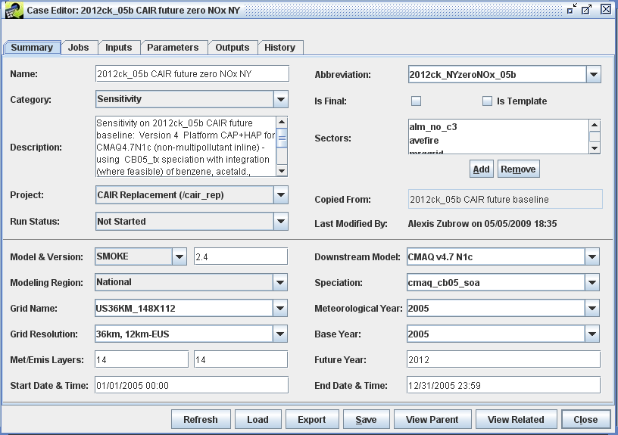
- We recommend that you review the case before running any jobs. In the Summary tab, you can see the description that you provided. If you selected the default (and uninformative) description, you can edit it now. In addition, you may want to change the “Project” listed, if the project for the Sensitivity Case is not the same as the Project for the Parent Case.
In the Jobs tab, you may want to change the host on which the jobs are run. The host will be set to the same host as the sensitivity template. You can see the selected host for each Job by scrolling to the right in the main table on the Jobs tab. If you want to change the host to another computer, you must select the Jobs to change, click the Edit button, and edit/save each of the Jobs to specify a new host.
In the Inputs tab, you will see the SECTORLIST and GCNTL inputs that you have previously selected. In the Parameters tab, you can see the various parameters that you have filled in. If you wan to see either the inputs or parameters that came directly from the parent case without user input, select the Show All field.
A common warning when opening the new sensitivity case is a missing non-local input, MRGDATE_FILES. This input is needed by the case to run, but sometimes it is not in parent cases. To rectify the problem, go to the Inputs tab, select the Show All field. After selecting the MRGDATE_FILES (Smkmerge representative dates files) with the checkbox at left, click Edit. In the new Edit Case Input window, select a dataset that corresponds to your modeling year and click Save.
- After reviewing your settings, go to the Jobs tab. Select the sector specific job that you want to run using the checkbox in the leftmost column (e.g., "Annual alm_no_c3 source level projections GRID 1") and click the Run button at the bottom of the window. A new window will appear, labeled Confirm Running Jobs. This window will identify any inputs which may have later versions (typically, later versions are not a problem because you are applying the sensitivity to a parent case that was run in the past with particular versions of the inputs). Click Yes. This will return you to the Case Editor window.
As the job progresses, it will go through a series of "Run Status". First status is "Exporting" in which the EMF exports the inputs to the inputs folder. Second status is "Waiting" in which the job sits in an internal EMF queue. Third status is "Submitted", which means that the job has been added to the PBS queue on the "Host". Note the first time you run a job on a particular host (e.g., garnet or amber) you may need to setup the EMF to run jobs on your account (see section 2.3).
- At this point, the jobs are running as a script on the host and therefore are outside the EMF's direct control. The EMF can cancel a running job (by selecting the job and clicking the Cancel button), or the users can log on to the host and stop a job using the commands “qstat” (to find the queue ID) and “qdel <queue ID>” to stop the job. When the job’s script is started by the PBS queue, the status in the EMF will change to "Running". You may need to click the Refresh button to see these status changes. If the job finishes without error, the final status will be "Completed", otherwise, you will get a "Failed" status.
- After successfully running the individual jobs for each sector that you want to control, you will run the sector merge job for that grid. You can optionally first check the reports from the sector jobs to make sure that the emissions changes were applied as expected (see Section 2.2.5, next). Running the merge step will combine the controlled sectors from the sensitivity case with the non-controlled sectors (from the parent case via your SECTORLIST file) and create a new set of AQM model ready files.

Reviewing results and logs
- As the job actually runs on the host, it will send back messages and outputs to the EMF. You can review the progress of the run through the History tab. To see the history of a Job, select a Job using the Job pull-down menu at the center top of the tab. You may periodically wish to click Refresh to see the latest messages. Each message is marked as information or error.
Hint: The History tab is a good place to start tracking down the cause of a "Failed" status.
- In the Outputs tab, you will also need to select the job of interest using the pull-down menu at the center top of the tab. Here, the job will register specific logs, reports, and AQM model ready files that it produces. Again, you will need to click Refresh to see the latest outputs. Some of these outputs are internal: the data is stored in the EMF database and you can view their content directly through the EMF. Other outputs are external: the EMF records only their location on the host so that you can easily find it for review outside of the EMF.
Of particular interest may be the control projection reports (the specific sources that were controlled by your Sensitivity Projection Packet) and the state totals reports. The state total reports (annual or sub-annual) are the sums of their respective smkmerge reports (daily totals by state and model species). For example, if you ran a job to zero NOx for NY for the ptipm sector, then NY would have zero emissions for the appropriate model species.
- If you want to track down individual files on the host, the following paths may help you. This may be needed if you are debugging a failed job.
Standard out/error from the job's run (note the job scripts and logs are tagged with a date stamp):
/orchid/share/em_<platform>/subsys/smoke24/scripts/cases/<case>/logs
If you have made previous runs of this job, older stdout/stderr will be under (for the sectormerge job itself, other jobs will be under their own sector specific subfolder):
/orchid/share/em_<platform>/subsys/smoke24/scripts/cases/<case>/old_logs/mrggrid
AQM model ready files are under the path (see section 2.2.1):
<project_path>/<case>/<grid>/<mechanism>
The sector specific model-ready files are under:
<intermediate_root>/<case>/<sector>
where <intermediate root> is set by the IMD_ROOT parameter on the Parameters tab
The logs for the SMOKE cntlmat program and smkmerge can be found under:
<intermediate_root>/<case>/<sector>/logs
Sector specific smkmerge reports are under:
/orchid/share/em_<platform>/reports/<case>/smkmerge/<sector>
Sector specific cntlmat reports are under:
/orchid/share/em_<platform>/reports/<case>/programs
Additional mrggrid reports are under:
/orchid/share/em_<platform>/reports/<case>/mrggrid/<grid>/<mechanism>
- Additional considerations and typical problems:
  - Applying source-level changes to onroad and nonroad mobile sources requires particular care. For some pollutants and some cases, the pollutant may have a mode (e.g., a leading "EXH__" or "EVP__"), while other pollutants may not.
  - If you are applying controls to coarse PM, use "PMC" not "PM10" in your Sensitivity Projection Packet, because the post-speciation intermediate files that the scripts are relying on already have PMC and no longer have PM10.
  - If you apply source-level changes to a sector and your Sensitivity Projection Packet does not match any records in the sector's emissions inventory, the job will fail. For example, if your apply a sensitivity to the ag sector and you are not controlling NH3, you will get an error. To solve this problem, do not include that sector in the list of Jobs to run for application of emissions changes. See also the next item in the list for another related step needed for correcting this problem.
  - If you successfully ran a sensitivity on a particular sector and later decided to not merge the sensitivity results into your final model ready file (i.e., through sector merge), then you need to remove the sector name from the source sector override file. You can find this file under:
<intermediate_root>/<case>/mrggrid/
  - If you are adjusting a particular sector but do not want it merged into the final model-ready emissions files (e.g., seca_c3), check to see that this sector is in your SECTORLIST file and that the mrgapproach column is set to 'N'. The sector needs to be in the SECTORLIST file for the source-level adjustment script to run correctly. The mrgapproach column controls whether or not the sector is merged via the sector merge script.
  - If you are adjusting the on_moves sectors, here are some additional considerations:
- The Sensitivity Projection Packet should control one or more of the pre-speciated pollutants: PEC_72, PMFINE_72, POC_72, PNO3, PSO4, or OTHER
- For each on_moves sector, select a job for the source-level adjustment and a job for the temperature adjustment during your creation of the sensitivity case.
- Run the source-level adjustment before running the temperature adjustment for each on_moves sector.
- The SECTORLIST should include both the on_moves sector (e.g., 'on_moves_runpm') and the temperature adjusted on_moves sector (e.g., 'on_moves_runpm_adj'). The on_moves sector should have a 'N' in the mrgapproach column of the SECTORLIST so that only the temperature adjusted on_moves sector is merged into the final model-ready emissions.
- After running the temperature adjustment, you manually need to link these files into the appropriate directory for the final sector merge. For example, if your sector is 'on_moves_runpm', you will need to link the output of the temperature adjustment job into the directory:
<intermediate_root>/<case>/on_moves_runpm_adj
  - If your sensitivity case's OUT_ROOT is not the same as the PARENT_CASE's OUT_ROOT and the sector you are adjusting uses STACK_GROUP files, you will need to manually copy these files to your OUT_ROOT. You will likely need to recreate the path of your PARENT_CASE's output under your OUT_ROOT.
  - If your sensitivity on a sector fails, the likely causes are:
- Missing intermediate files for this sector. Often the temporal intermediate files are removed from the parent case to save disk space.
- A change in naming convention of the intermediate files. Older parent cases may name the intermediate files with a different convention.
- Compressed, gzipped, intermediate files. Currently, the scripts will test for gzipped PLAY files (in the point sectors). Other gzipped intermediate files will cause an error. If there is another common situation where intermediate files are gzipped, this could be added to the source sensitivity scripts.
- No matching Sensitivity Projection Packet records for the specific sector.
- Incorrect merge approach in the SECTORLIST file. This column defines the representative days (e.g., "aveday", "all", "mwdss", etc.) and whether or not to run holidays.
- Missing sector in the SECTORLIST.

Running jobs from the EMF
To be able to use the "Run" button from the EMF Cases, you will need to do some special setup for the UNIX account of your host server (e.g., amber or garnet). If you want to run on another host, you will need to repeat these steps on that server:
- If you do not already have a ".ssh "directory in your home directory on amber, create one. Note to see this directory, use the command "ls -a".
- Make sure that the permissions on this directory are user read, write, exec ONLY. All group and other permissions need to be eliminated (e.g., using the command: chmod go-rwx)
- Copy the file /orchid/share/EMFClient/authorized_keys to your ".ssh" directory.

As of the writing of this document, the following accounting codes are available to OAQPS: naaqs_ss, naaqs_di, fedrules, multipol, sectors, climate, plat_eval
SMOKE2.5 is latest version available at the time of this document.
As of the writing of this document, the following accounting codes are available to OAQPS: naaqs_ss, naaqs_di, fedrules, multipol, sectors, climate, plat_eval

