Styling your content using the master style sheet for Template 4

Using Styles included in the master style sheet
The master style sheet contains many useful styles. You should not need to create your own local styles very often, if ever. If you have something you think should be included in the master style sheet so everyone can take advantage of it, contact Michael Hessling.

Note: The following styles are only for use in the <div id="content"> section.

- Abbreviations and acronyms
- Boxes (that don't use tables)
  - Multipurpose box – box with more than one link
  - Links to National Information from Regional Pages
  - Simple or Temporary Information
  - Emergency Alert Boxes
  - Pull Quote
  - PDF disclaimer
  - Quick Finder
  - Photos/images with captions
  - Highlight Boxes
- Data tables or contact lists
- Double breadcrumbs for topic sites
- Exit disclaimer
- Floats
- Lists
- Text
  - smaller text (epaltsans & epaltsansbold)
    - Note: the style sheet has both epaltsans and epaLtSans.
  - Caption text
  - PDF file info in smaller text
  - Emergency text
  - Code
  - Highlight
- Clear (<br clear=”right”> equivalent)
- Text Alignment (left, center, right)
- Top of page links
- No borders around linked images

All styles, with the exception of epaLtSans are lowercase.

1. Abbreviations and Acronyms
Description: The <abbr> and <acronym> elements highlight abbreviations and acronyms and offer the fully spelled out word or phrase in a small popup when reader’s mouse hovers over the term. Browsers indicate <abbr> and <acronym> with dotted (or dashed) underlines.

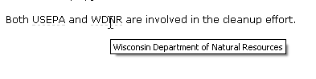

How To: Spell out the acronym or abbreviation in the title attribute.

<acronym title="Assistant Administrator/Regional Administrator">AA/RA</acronym>
<abbr title="picocurie">pCi</abbr>

Note: Mark up only the first occurrence of any particular abbreviation or acronym on a page. <abbr> does not work in Internet Explorer for Windows versions 6 and under.

2. Boxes (that don’t use tables)
Description: The master style sheet offers several styles of boxes that do not use tables, all of which have been engineered to work across browsers. You can use these for navigation, pullout quotes, fact lists, related articles, press info, definitions of terms,...

See the box standard: http://yosemite.epa.gov/OEI/webguide.nsf/standards-guidance/boxes

2A. Multipurpose box
Description: This is basically the EPA default right aligned box. When in doubt use it. This box is a fixed width box (218px), with borders, floated right. Title appears in white against a soft green background. Default background of box itself is gray.
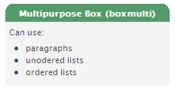
How To:
- Make a <div> and give it a class of "boxmulti". All the code for this box must be within that <div>.
- Use <h5> for the title.
- After closing the title tag, fill with your content. Use paragraphs <p>, unordered lists <ul>, and ordered lists <ol>.
- The rounded corners are automatic.

Example:
<div class="boxmulti">
<h5>Your Title here</h5>
<p>Your content here</p>
</div>

2B. Links to National Information from Regional Pages
Description: National and/or regional EPA links that supplement the topic, always located at the right side of the page. The blue header color would unify this specific purpose box. The only difference between this and the Mulit-purpose box above is the header color and narrower rules for its use.
This box is a fixed width box (218px), with borders, floated right. Title appears in white against a soft blue background. Default background of box itself is gray.

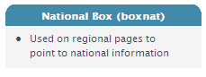
How To:
- Make a <div> and give it a class of "boxnat". All the code for this box must be within that <div>.
- Use <h5> for the title. The title is always “National Information.”
- After closing the title tag, fill with your content. Use paragraphs <p>, unordered lists <ul>, and ordered lists <ol>.
- The rounded corners are automatic.

Example:
<div class="boxnat">
<h5>National Information</h5>
<p>Your content </p>
<ul>
<li>here</li>
<li>and here</li>
</ul>
</div>

2C. Simple or Temporary Information
Description: For highlighting occasional things like reminders of individual upcoming events, call for papers, focus special features, etc. If a bulleted list is needed, use the multi-purpose box. It is set to use 15% of the page width and will expand vertically to contain all text. It has gray borders, floated right.
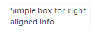
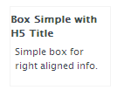
How To:

- Make a <div> and give it a class of "boxsimple". All the code for this box must be within that <div>.
- Use <h5> for the (optional) title.
- Use paragraphs.

Example:
<div class="boxsimple">
<h5>Your Title here</h5>
<p>Your content here</p>
</div>

2D. Emergency Alert Box
Description: Used only for emergency information such as the Hurricane Katrina response information. Content will typically be issued by OPA. A fixed width box (218 px) in emergency red. Default background of box itself is gray.
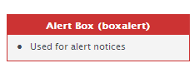
How To:
- Make a <div> and give it a class of "boxalert". All the code for this box must be within that <div>.
- Use <h5> for the title.
- After closing the title tag, fill with your content. Use paragraphs <p>, unordered lists <ul>, and ordered lists <ol>.

Example:
<div class="boxalert">
<h5>Your Title here</h5>
<p>Your content </p>
<ul>
<li>here</li>
<li>and here</li>
</ul>
</div>

2E. Pull Quote
Description: Very similar to the Simple style, but with larger font size and wider box width. Also includes a style for the author's name, if needed.
How To:
- Make a <p> and give it a class of "pullquote". All the code must be within that <p>.
- Use <span class="author"> for the author, if needed.
Example:
<p class="pullquote">This is a fabulous quote pulled from the surrounding content. <span class=”author”>– The Fabulous Author</span></p>

2F. PDF Disclaimer / Non-HTML file information

Description: Adds a border around disclaimer notices and makes the text smaller than regular content text. It is available as a right aligned box or as a box centered on the page.

The box is not a requirement for the PDF disclaimer, but is frequently used. Disclaimers should only appear once per page.

Note: You can use this style for disclaimers when you link to other file formats, such as PowerPoint, Word, Excel, etc.

Right Aligned Disclaimer Box:
The box width is 20% of the screen. Use this box for non-HTML files, like PDF, or offsite links disclaimers. The smaller font-size (90%) is standard.

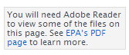
How to:
Use class="disclaimer" in a <p> element.

Example:
<p class="disclaimer">You will need Adobe Acrobat Reader to view some of the files on this page. See <a href="http://epa.gov/epahome/pdf.html">EPA's PDF page</a> to learn more. </p>

Centered Disclaimer Box:
The box is centered with margins of 10% on the left and right.
How to:
Use class="disclaimer-wide" in a <p> element.

Example:
<p class="disclaimer-wide">You will need Adobe Acrobat Reader to view some of the files on this page. See <a href="http://epa.gov/epahome/pdf.html">EPA's PDF page</a> to learn more. </p>

Warning:
This style will go underneath the right aligned boxes, if they’ve been used.

2G. Quick Finder

Description: Each AA and RA home page should have a Quick Finder. To learn more, see http://www.epa.gov/epafiles/s/qf.html

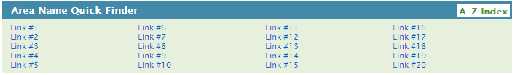

How to:
Example at http://www.epa.gov/epafiles/v4/tropo.html
Other examples at:
http://www.epa.gov/epafiles/v4/index.html#tropo

Use this table for the quickfinder in template 4. Do not invent your own.
<table class="qfinder">
<thead>
<tr>
<th colspan="3">Area Name Quick Finder</th>
<th colspan="1"><a href="#">A-Z Index</a></th>
</tr>
</thead>
<tbody>
<tr>
<td width="25%">
<a href="#">Link #1</a>
<a href="#">Link #2</a>
<a href="#">Link #3</a>
<a href="#">Link #4</a>
<a href="#">Link #5</a>
</td>
<td width="25%">
<a href="#">Link #6</a>
<a href="#">Link #7</a>
<a href="#">Link #8</a>
<a href="#">Link #9</a>
<a href="#">Link #10</a>
</td>
<td width="25%">
<a href="#">Link #11</a>
<a href="#">Link #12</a>
<a href="#">Link #13</a>
<a href="#">Link #14</a>
<a href="#">Link #15</a>
</td>
<td width="25%">
<a href="#">Link #16</a>
<a href="#">Link #17</a>
<a href="#">Link #18</a>
<a href="#">Link #19</a>
<a href="#">Link #20</a>
</td>
</tr>
</tbody>
</table>

2H. Image with Caption
Description: This box contains both the image and the image caption. An image with a caption in a frame that floats right (or left). The width depends on the width of your image. You can use the same <div> to put a gray border around any image.
How it looks:
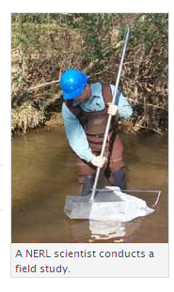

How to:
- Make a <div> and give it a class of "imgcontainer-l" (or "imgcontainer-r"). All the code for this image/caption must be within that <div>.
- Add an inline style to account for the width of your image. In this case, the image is 209px wide.
- Insert your image code
- Add a paragraph and give it a class of "caption"

Examples:

Image floated right
<div class="imgcontainer-r" style="width: 167px;">
<img src="http://www.epa.gov/nerl/images/sampling1.jpg" width="167" height="245" alt="scientist sampling" />
<p class="caption">A NERL scientist conducts a field study.</p>
</div>
Image floated left
<div class="imgcontainer-l" style="width: 167px;">
<img src="http://www.epa.gov/nerl/images/front/playset.jpg" width="167" height="245" alt="playground" />
<p class="caption">A NERL scientist conducts a field study.</p>
</div>

2I. Highlight Boxes

Description: This box is the default box. It is the base of all the highlight boxes whether it's centered, a different width, or the header is a different color (green or blue). The default is a box of 50% width, gray borders, and aligned left. Title text is black on a light gray background. The elements allowed are: lists, paragraphs, images. Classes available in the style sheet to modify the box as needed for individual pages:

- centered—centers the box
- righted—aligns the box right
- color1—creates a green box
- color 2—creates a blue box

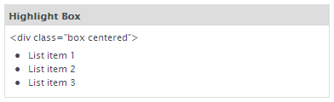

How-To:
- Make a <div> and give it a class of "box". All the code for this box must be within that <div>.
- To center this box, add a second class of "centered" (note the tense).
- If you would rather right-align this box, add a second class of "righted" (er, note the tense).
- For color, add yet another class:
  - "color1" for soft green; #559b6a
  - "color2" for blue; #4289aa
- To override the default width, use a local style or add in an inline style. style="width: 123px;". Use whatever value (or percentage) fits your page layout best.
- Use <h5> for the optional title. Title text can be anything, but should be descriptive.
- You can use paragraphs, ordered/unordered lists and images in the highlight box.

Example:
<div class="box centered/righted color1/color2">
<h5>Highlight Box</h5>
<ul>
<li>Unordered list</li>
<li>Blue/green bullets</li>
</ul>
<ol>
<li>Ordered list</li>
<li>Numbers present</li>
</ol>
</div>

Variations on the Default

The following are examples of how to modify the basic box to meet your needs and the EPA boxes standard.

Plain Highlight Box, Centered

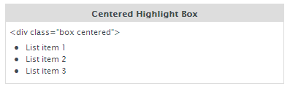

How-To:
- Make a <div> and give it a class of "box". All the code for this box must be within that <div>.
- To center this box, add a second class of "centered" (note the tense).
- Use <h5> for the optional title. Title text can be anything, but should be descriptive.
- You can use paragraphs, ordered/unordered lists and images in the highlight box.

Example:
<div class="box centered ">
<h5>Plain Centered</h5>
<ul>
<li>Unordered list</li>
</ul>
<ol>
<li>Ordered list</li>
<li>Numbers present</li>
</ol>

Green Highlight Box, Righted (Right Aligned)

Green boxes are outlined in green.

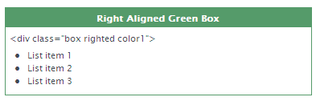

How-To:
- Make a <div> and give it a class of "box". All the code for this box must be within that <div>.
- To right align this box, add a second class of "righted" (note the tense).
- To make this box green, add a third class of "color1"
- Use <h5> for the optional title. Title text can be anything, but should be descriptive.
- You can use paragraphs, ordered/unordered lists and images in the highlight box.

Example:
<div class="box righted color1">
<h5>Green "Righted"</h5>
<ul>
<li>Unordered list</li>
<li>Blue/green bullets</li>
</ul>
<ol>
<li>Ordered list</li>
<li>Numbers present</li>
</ol>

Blue Highlight Box, Different size

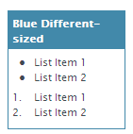

How-To:
- Make a <div> and give it a class of "box". All the code for this box must be within that <div>.
- Add a style that sets the box width to the <div>.
- Use <h5> for the optional title. Title text can be anything, but should be descriptive.
- You can use paragraphs, ordered/unordered lists and images in the highlight box.

Example:
<div class="box color2" style="width: 123px;">
<h5>Blue Different-sized</h5>
<ul>
<li>Unordered list</li>
<li>Blue/green bullets</li>
</ul>
<ol>
<li>Ordered list</li>
<li>Numbers present</li>
</ol>
</div>

Plain Highlight Box, No Title

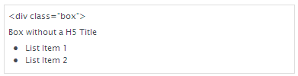

How-To:
- Make a <div> and give it a class of "box". All the code for this box must be within that <div>.
- You can use paragraphs, ordered/unordered lists and images in the highlight box.

Example:
<div class="box">
<ul>
<li>Unordered list</li>
<li>Blue/green bullets</li>
</ul>
<ol>
<li>Ordered list</li>
<li>Numbers present</li>
</ol>

3. Data Tables or contact lists
Description: Tables with rows in alternating background colors for improved legibility. This is done automatically instead of manually coding in background colors for cells.

Classes Available for tables are:
Table – creates a borderless table
Tablebord – creates a table with borders
Zebra – adds alternate row shading
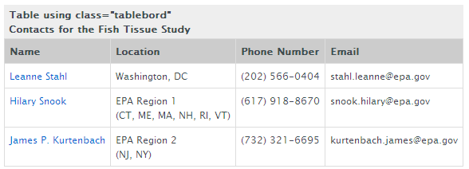
Example: Table using class=”tablebord”

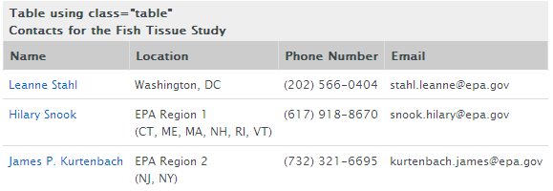
Example: Table using class=”table”

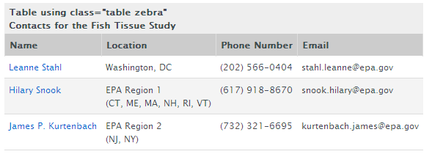
Example: Table using class=”table zebra”

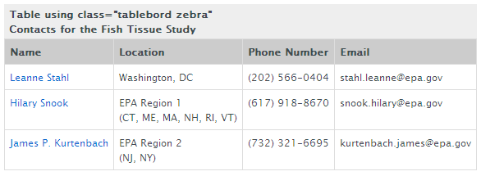
Example: Table using class=”tablebord zebra”

How to:
Tables, if given classes of "table” and “zebra", will be formatted with dark gray table headers and alternating colored rows (<table class="table zebra">).
If you just want alternating colored rows, simply give your table a class of "zebra" (<table class="zebra">).
Note: If you have more complicated tables, you may wish to experiment before using the zebra stripes code.
Example: Note that this is also a good example on how to code a 508 compliant data table. Other examples exist.

<table class="table zebra" summary="Headquarters and Regional Contacts for the National Lake Fish Tissue Study">
<caption>Contacts for the Fish Tissue Study</caption>
<thead>
<tr>
<th id="name">Name</th>
<th id="location">Location</th>
<th id="phone">Phone Number</th>
<th id="email">Email</th>
</tr>
</thead>
<tbody>
<tr>
<td headers="name"><a href="mailto:stahl.leanne@epa.gov">Leanne Stahl</a></td>
<td headers="location">Washington, DC</td>
<td headers="phone">(202) 566-0404</td>
<td headers="email">stahl.leanne@epa.gov</td>
</tr>
<tr>
<td headers="name"><a href="mailto:snook.hilary@epa.gov">Hilary Snook</a></td>
<td headers="location">EPA Region 1<br />
(CT, ME, MA, NH, RI, VT)</td>
<td headers="phone">(617) 918-8670</td>
<td headers="email">snook.hilary@epa.gov</td>
</tr>
<tr>
<td headers="name"><a href="mailto:kurtenbach.james@epa.gov">James P. Kurtenbach</a></td>
<td headers="location">EPA Region 2<br />
(NJ, NY)</td>
<td headers="phone">(732) 321-6695</td>
<td headers="email">kurtenbach.james@epa.gov</td>
</tr>
</tbody>
</table>

4. Double breadcrumbs for topic sites
Description: This is no longer used at EPA.

5. Exit Disclaimer
Description: Image for the exit disclaimer. Do not create a local copy. Directions and code available.
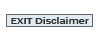

How to: See: http://www.epa.gov/epafiles/exit.html

6. Floats
Description: If you want to float an image to the right or the left and cause the text to wrap around, use the float classes:

class=”right” will make your element float to the right
class=”left” will make your element float to the left

How to: For example, to make an image float to the right, instead of using align=”right” you can float it. Floating takes the element out of the “flow” of the page and pushes it all the way to the side (either left or right). The text will wrap around.

Example: From: http://www.epa.gov/waterscience/guide/airport/
<img src="i/aircraft_deicing.jpg" alt="Deicing operations at O'Hare Airport" title="Deicing a plane" width="250" height="174" class="right"></a>
<p>The <a href="http://www.faa.gov/">Federal Aviation Administration</a> requires airlines and airports that operate during icy conditions to perform deicing and anti-icing of aircraft and airfield pavement. This ensures the safety of passengers and cargo operations. However, when performed without discharge controls in place, these deicing operations can result in environmental impacts.</p>

7. Lists
Description: Unordered list.

How to: Use the defaults when creating unordered lists. No special coding required.

8. Text
There are a few styles available for text.

8A. Smaller text (epaltsans & epaltsansbold)
Description: Smaller fonts to be used when needed.

“epaltsans” is a little smaller than “epaltsansbold”.

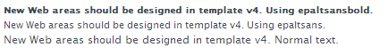

How to: Apply class of "epaltsans" in a tag such as <p> or <span>. For bold text, apply a class of "epaltsansbold".

Examples:
<p class="epaltsans">This image still looks great.</p>
<a href="arsenic.html" class="epaltsansbold">Arsenic</a>

Note: See the image caption information for more details.

8B. File (e.g., PDF) file info in smaller text
Description: EPA's PDF linking standards require us to add (Pages, File size, Sometimes an About PDF link) immediately after the document title. This style makes that information smaller and a little lighter than standard content text.

How to:
Use a class=fileinfo in a <span> tag
Example:
<span class="fileinfo">(45 pages, 256 K)</span>
<span class="fileinfo">(114 pages, 611 K, about PDF) </span>

8C. Warning Font
Description: Used for emergency announcements - Red text in bold using a larger size font.
How to: Use the class “warning” in a paragraph or span tag.

Example:
<p class="warning">Warning or emergency announcement</p>

8D. Code
Description: Used for text that needs to appear as computer code.

How to: Use the tag <code> normally.

Example: <code>&#60;a href="http://www.epa.gov/epahome/exitepa.htm" title="EPA's External Link Disclaimer"&#62;</code>

8E. Highlight
Description: Used for text that you would like to make appear as if it has been highlighted by a yellow highlighter.
How to: Use the class “highlight” in a paragraph or span tag

Example: <p class="highlight">Highlighted Text</p>

9. Clear

Description: This style was added to the style sheet to serve the same purpose <br clear="right"> served in HTML. Using this class will "clear" any element following a floated element. Normally, an element (usually text set in paragraphs) following a floated element (like boxes or images) will wrap. If, for some reason, you don't want wrapping, set this class on the element.

How to: For HTML elements following a floated element, give it a class of "clear".

Example:
<p class="clear">Text will not wrap around a floated box.</p>

Note: This can be used to make sure right aligned boxes are stacked correctly but be cautious because using it this way can create reading order problems.

10. Alignment

10A. Text Alignment

Description: Aligning text left, right, or center.

How to: Use classes “left”, “right”, and “center”.

Example:
<p class=”right”>This text is aligned right.</p>
<p class="center">This text is centered.</p>

10B. Image Alignment (Outside a box)

Description: Aligning DIVs and IMGs. The right and left alignments are floated which means text will wrap around the images. See the boxes section for box alignment.

How to: To align an image right, center or left. Classes available include right, center, and left. To center you have to give a <div> a class of center and put the image in the DIV. Right and left can be used as a class within the img src code.

Example:
To center:
<div class="center">
<img src="http://www.epa.gov/nerl/news/forum2006/SF06stamp2a.jpg" height="135" width="136" alt="NERL Science Forum" />
</div>

To align right (float):
<img src=”http://www.epa.gov/nerl/news/forum2006/SF06stamp2a.jpg”
height="135" width="136" class="righted" alt="NERL Science Forum" />

To align left (float):
<img src="http://www.epa.gov/nerl/news/forum2006/SF06stamp2a.jpg" height="135" width="136" class="left" alt="NERL Science Forum" />

11. Top of Page Links

Description: If you have Top of Page links (e.g. on lengthy pages), it is to the left. The link will take users to the beginning of the content section.

How to: Give a paragraph the class of "pagetop"

Example:
<p class="pagetop"><a href="#content">Top of page</a></p>

Note: In this example, the link points to #content which is just above the Page Name, but you can make it point to any anchor you create (e.g., #tableofcontents).

12. No borders around linked images
Description: By default linked images are surrounded in blue/purple. There is a style in the master style sheet that removes borders from all linked images.

How To: You don't need to do anything. The master style sheet eliminates borders around all linked images. This option doesn’t require any special coding. The border attribute is deprecated so border="0" is no longer recommended in HTML code.

Example:
<a href="/nerl/index.html"><img src="/nerl/newimages/ecoresch.gif" width="80" height="80" alt="link to National Exposure Research Laboratory home" /></a>

Are these the only styles I can use?
Not necessarily. It’s possible to create your own local styles. However, you must extensively test your pages prior to uploading any local styles.

The content (white space) is the only area where you may use a local style sheet or inline style declarations. If you use any local styles, you must preface them with #content in the code. For example, your local style sheet would look like:

#content .yourclass { }
#content #yourid { }
#content ul li { }

In the page code, write:

<div id="content">
<!-- This is the page's content container -->

...

<h5>Your heading text</h5>
<div class="yourclass"> text text text </div>
<ul>
<li> text </li>
</ul>

...

</div>

Writing your local styles this way will help ensure that your local styles only content within the white space of the web page. The header, the area navigation, and the footer will be unaffected.

If you plan to use a local style sheet, import it before the link to the master style sheet.

Example
<style type="text/css" media="screen">@import 'link/to/yourstylesheet.css';</style>
<style type="text/css" media="screen">@import 'http://www.epa.gov/epafiles/s/epa.css';</style>

Importing the style sheet this way shields the advanced code from older browsers.

