Assessing landscape N removal in coastal New England catchments using the N-Sink approach with a new R package, nsink

Kellogg, D. Q. *1*, Hollister. J. W. * *2*, Arnold, C.*3*, Gold, A.*1*, Wilson, E. H.*3*, Chadwick, C.*3*, Dickson, D.\**3*, Forshay, K. J.*4*

*1* University of Rhode Island, Department of Natural Resources Science, Kingston, RI 02881

*2* US Environmental Protection Agency, Office Of Research and Development, Atlantic Coastal Environmental Sciences Division, Narragansett, RI 02882

*3* University of Connecticut, Center for Land Use Education and Research, Haddam, CT 06438

*4* US Environmental Protection Agency, Office Of Research and Development, Groundwater Characterization and Remediation Division, Ada, OK 74820

* *corresponding author: [qkellogg@uri.edu*](mailto:qkellogg@uri.edu*)

Excessive nitrogen (N) loading to coastal ecosystems impairs estuarine water quality. Land management decisions made within estuarine watersheds have a direct impact on downstream N delivery. Natural features within watersheds can act as landscape sinks for N – wetlands, streams and ponds – transforming dissolved N into gaseous N, effectively removing it from the aquatic system. Identifying and evaluating these landscape sinks and their spatial relationship to N sources can assist managers to understand the effects of their decisions on downstream resources. N-Sink is an approach that uses widely available GIS data to identify landscape sinks within HUC-12 (or larger) catchments, estimate their N removal potential and map the effect of those sinks on N movement through the catchment. A series of static maps are produced to visualize N removal efficiency, transport and delivery, the latter in the form of an index. To facilitate data acquisition, processing and visualization, an R package nsink was developed and has been used to produce static maps for all HUC-12 catchments in southern New England. The R package can be used to develop N delivery maps for a HUC-12 of interest, or users can visit the University of Connecticut website to explore the already mapped areas. Users can also investigate specific flowpaths interactively by clicking on any location within the catchment. A flowpath is generated, along with a table describing N removal along each segment.

# Introduction

Excess nitrogen (N) delivery via surface water to coastal estuaries contributes to impaired water quality evidenced by excess algal blooms and hypoxia (Ryther and Dunstan 1971, Nixon 1995, Howarth and Marino 2006). Hydrologic connections and flowpaths are influential in the delivery of nutrients to estuaries (Mengistu et al. 2020). Identifying landscape N sinks along hydrologic flowpaths – areas where dissolved N is transformed to gaseous N and effectively removed from the aquatic system – and their effect on N delivery at the watershed scale is helpful to watershed managers, land use planners and conservation organizations. The intent of N-Sink, and its associated R package nsink, is as a screening tool to identify source areas where downgradient N sinks are able to process and remove excess N, versus areas where downgradient N sinks are less prevalent or effective at removing N. The latter argues for more aggressive N management at the source, while the former argues for protecting and/or restoring downgradient N sinks that are helping to reduce N delivery to estuaries.

N-Sink was developed as a web-based tool to visualize and explore landscape N sinks at the HUC-12 scale (HUC = Hydrologic Unit Code; (Berelson et al. 2004)), and makes extensive use of widely available GIS data. The theoretical underpinnings are outlined in Kellogg et al. (2010) and build on peer-reviewed meta-analyses and reviews (Seitzinger et al. 2006, Alexander et al. 2007, Mayer et al. 2007) to estimate N removal within landscape N sinks – wetlands, streams and ponds. Residence time in these landscape features is the primary driver of N retention and transformation (e.g., Klocker et al. 2009).

The nsink R package was written to simplify the acquisition and management of the spatial data necessary to estimate N removal within each identified landscape sink, estimate cumulative N removal along a specified flowpath, and create a set of static watershed maps (Hollister et al. 2022) . Datasets used by nsink are the National Hydrography Dataset Plus (NHDPlus), Soil Survey Geographic Database (SSURGO), the National Land Cover Dataset (NLCD) land cover and the National Land Cover Dataset (NLCD) impervious surface (Soil Survey Staff 2017, Jin et al. 2019, Moore et al. 2019). The static maps include 1) N Removal Efficiency, a color-coded map of the estimated N removal efficiency of the different landscape sinks; 2) N Transport Index, a heat map with the cumulative N removal along flowpaths originating from sources represented by a grid of points across a watershed. This heat map highlights “leaky” source areas with less downstream N retention versus those with higher downstream retention; and c) N Delivery Index, combining maps (1) and (2) along with source loading based on NLCD categories and expressed as an index ranging from 0 to 1, resulting in a map showing potential N delivery from different sources, taking into account the potential N removal as water moves downstream.

# Methods

## Development of the R package nsink

The package nsink implements the approach detailed in Kellogg et al. (2010) to estimate relative nitrogen (N) removal along a flowpath. The nsink package follows from an initial version of N-Sink written in ArcGIS using ModelBuilder. That version required time-consuming data manipulation by hand due to limitations of earlier NHDPlus datasets as well as the limitations of working in a GIS environment requiring a user license. With the increasingly more versatile GIS packages now available in R, the previously time-consuming spatial data acquisition and management of N-Sink was automated and applied to other HUC-12 catchments, leading to the development of the nsink package. Specifically, nsink relies on packages sf and raster. The nsink package is available from <https://github.com/usepa/nsink> and is fully described in (Hollister et al. 2022).

## Using the nsink package

The nsink package provides several functions (Table 1) to set up and run an N-Sink analysis for a specified 12-digit HUC. By using the package all required data are downloaded, prepared for the analysis, HUC-wide N removal calculated, and flowpaths summarized. Additionally, a convenience function, nsink_build(), is included that will run all of the required functions for a specified HUC. The workflow follows a simple series of steps to create a set of static maps: N Removal Efficiency, N Transport Efficiency, and N Delivery Index.

Table 1: Functions in the R package nsink

| Function | Description |
| --- | --- |
| nsink_get_huc_id | Takes Hydrologic Unit Code (HUC) Name and returns HUC12 IDs |
| nsink_get_data | Downloads local copies of datasets for specified HUC |
| nsink_prep_data | Standardizes projections, clips all datasets to HUC boundary |
| nsink_calc_removal | Calculates percentage of nitrogen (N) removal within the various landscape N sinks |
| nsink_generate_flowpath | Generates a flowpath from XY starting point for use in N removal analysis |
| nsink_summarize_flowpath | Estimates N removal along flowpath and lists removal by type of N sink encountered |
| nsink_generate_static_maps | Generates static maps for a given HUC |
| nsink_plot | Creates simple plot with pre-selected palettes from a list of static maps created by nsink_generate_static_maps() |
| nsink_build | Wrapper function that runs all required functions to build the full dataset and static maps for a specified HUC12 |

## Download the data

The first step for an N-Sink analysis with the nsink package is to download the required datasets. The only required information to download the data is a HUC identifier. The nsink package was developed using 12-digit HUC IDs, but larger HUCs (e.g. 8-digit) may also be used. There are two functions provided for downloading the data.

nsink_get_huc_id() - search 12-digit HUC IDs using a known location name.

nsink_get_data() - download and save, in a specified folder, hydrography, soils, and land cover data for the specified 12-digit HUC. These data cover the HUC, but have not been pared down to those data exclusive to the specified HUC. The nsink package utilizes widely available data from several U.S. Federal Government sources and as of 2023-04-27 no authentication is required to access these sources. The HUC ID is required and users may specify a path for storing the data as well as indicate whether or not to download the data again if they already exist in the data directory.

## Prepare the data

Once the data are downloaded there are several additional data processing steps that are required to subset the data to the HUC and set all data to a common coordinate reference system (CRS).

These include:

* filter out the HUC boundary
* mask all other data sets to the HUC boundary
* convert all column names to lower case
* create new columns
* harmonize raster extents
* set all data to common CRS

The nsink_prep_data() function will complete all of these processing steps. It requires a HUC ID, a specified CRS, and a path to a data directory. It returns a “list” (a specific data format in R) with all required data for subsequent N-Sink analyses.

## Calculate N removal

The next step in the N-Sink workflow is to calculate potential nitrogen removal within each landscape sink, expressed as percent of incoming N. Details on how the nitrogen removal estimates are calculated are available in Kellogg et al. (2010), and make use of peer-reviewed literature. Since the publication of that article, changes have been implemented to make better use of the most recently available geospatial data. Those changes are described below. The nsink_calc_removal() function takes the prepared data as an input and returns a “list” with three items:

* raster_method: Contains a raster-based approach to calculating removal. Used for the static maps showing potential N removal within landscape sinks.
* land_removal: Represents land-based nitrogen removal within vegetated hydric soils (i.e., with impervious surface/developed areas removed).
* network_removal: Contains removal along the NHD Plus flow network. Removal is calculated separately for streams and waterbodies (i.e., lakes and reservoirs).

## Generate and summarize flowpaths

A useful part of the N-Sink approach is not just the calculation of potential N removal for individual components of the landscape, it is the ability to summarize cumulative removal along the length of a specified flowpath. Starting from any specified location the flowpath on land is generated from a flow direction grid. Once that flowpath intersects the surface water network, flow is determined by flow along the NHD Plus surface water network. With a flowpath generated, the cumulative N removal along that flowpath can be calculated with the nsink_summarize_flowpath() function, taking the flowpath and removal as input. A data frame is returned with each segment identified by type of sink, if present (i.e., “Hydric”, “Stream”, “Lake/Pond”, or “No Removal”), the percent removal associated with that segment, and cumulative removal. Total cumulative removal is 100 - the minimum of the n_out column. That is, n_out keeps track of the percent of N leaving each subsequent downstream segment (Table 2).

Table 2: Summary of N removal along specified flowpath A (See Figure 4)

| segment_type | length_meters | percent_removal | n_in | n_out |
| --- | --- | --- | --- | --- |
| Hydric | 287 | 4.390 | 100.0 | 95.6 |
| No Removal | 276 | 0.000 | 95.6 | 95.6 |
| Lake/Pond | 84 | 41.400 | 95.6 | 56.0 |
| Stream | 61 | 0.005 | 56.0 | 56.0 |
| Lake/Pond | 2170 | 56.300 | 56.0 | 24.5 |
| Stream | 316 | 0.022 | 24.5 | 24.5 |
| Stream | 2480 | 0.076 | 24.5 | 24.4 |
| Lake/Pond | 167 | 0.000 | 24.4 | 24.4 |
| Stream | 816 | 0.022 | 24.4 | 24.4 |
| Stream | 1056 | 0.022 | 24.4 | 24.4 |
| Lake/Pond | 338 | 0.000 | 24.4 | 24.4 |
| Stream | 59 | 0.000 | 24.4 | 24.4 |
| Lake/Pond | 5894 | 0.000 | 24.4 | 24.4 |

## Static maps

Individual flowpaths are useful for specific areas of interest, but it is also useful to look at removal patterns across the landscape. The nsink_generate_static_maps() function produces a set of HUC-wide raster maps. Required inputs are the prepped data, removal raster, and sampling density, for which a default is provided. The function returns four separate rasters.

* removal_effic: HUC-wide estimate of potential nitrogen removal from different landscape sinks as a percentage.
* loading_idx: A normalized index of nitrogen loads by land cover class derived from published sources, ranging from 0 to 1.
* transport_idx: N transport for a sample of all possible flowpaths in a given HUC. This is an expensive computational task, so nsink generates a removal hotspot map based on a sample of flowpaths and the final hotspot map is interpolated from these samples and referred to as the nitrogen transport index. The samp_density argument controls the number of sample flowpaths generated and is roughly the distance between points in a uniform grid. Each of these starting points is assigned the value of N delivery (%) based on cumulative N removal along the flowpath from that starting point. The points are then interpolated with an inverse distance weighted interpolation to a roughly 30 meter resolution. A sampling density of 300 was used to create the static maps in the web application.
* delivery_idx: The delivery index is the combination of the loading index and the transport index. It highlights areas of the landscape that are delivering the most nitrogen to the outflow of the watershed based on NLCD land cover data and transport efficiency.

These static maps can be quickly plotted with nsink_plot() using the map argument to identify map type.

nsink_plot(niantic_static_maps, map = "removal")

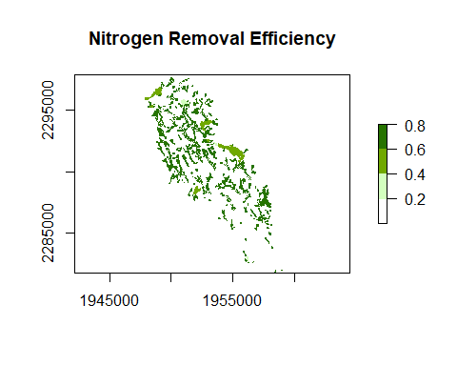

Figure 1: Nitrogen Removal Efficiency (range 0 to 1) for the Niantic River HUC-12, showing the estimated percentage of N removed within three types of landscape N sinks - wetlands, streams, lakes/ponds/reservoirs.

nsink_plot(niantic_static_maps, map = "transport")

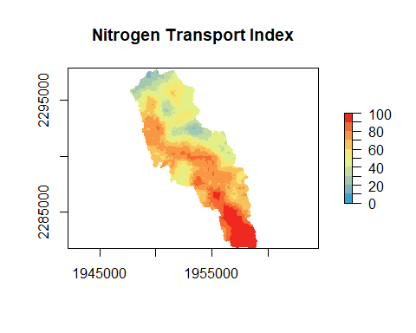

Figure 2: Nitrogen Transport Index (range 0 to 100%) for the Niantic River HUC-12, showing the estimated percentage of N originating at a given location within a watershed that is expected to reach downstream receiving waters, such as a coastal embayment.

nsink_plot(niantic_static_maps, map = "delivery")

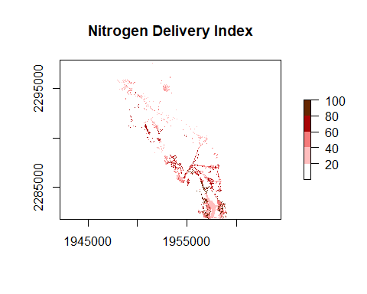

Figure 3: Nitrogen Delivery Index (range 0 to 100%) for the Niantic River HUC-12, showing a relative measure of the estimated N being transported from a location within a mapped watershed to receiving waters. N loading estimates are based on land cover classes, making use of peer-reviewed published data, and normalized, with a range of 0 to 1. These N loading factors are then multiplied by the N Transport Efficiency (range 0 to 100) from a given location within a watershed, to arrive at the NDI.

## Convenience function to build it all

The workflow described above includes all the basic functionality. Some users may wish to use nsink to calculate the base layers for an N-Sink analysis and then build an application outside of R. A convenience function that downloads all data, prepares, calculates removal, and generates static maps has been included to facilitate this type of analysis. The nsink_build() function requires a HUC ID, coordinate reference system, and sampling density. An output folder is also needed but has a default location. There is an optional argument for forcing a new download. All prepped data shape files and .tif files are written to the output folder for use in other applications.

N-Sink maps are now available for HUC-12 catchments in coastal CT, RI and southern MA as a web application [interactive tool](https://uconnclear.maps.arcgis.com/apps/MapSeries/index.html?appid=e96b01502f5b4aeda64aacf0cb5234c7&folderid=dde199a7cf674845a83b43a3011b1d31). This app can be used to examine and better understand N movement through these HUC-12 catchments.

## Changes to underlying methodology

Several improvements have been made to the underlying N-Sink methodology used in Kellogg et al. (2010) that have allowed nsink to make use of more recently available spatial data. In estimating N removal in streams, we originally had to estimated stream depth and velocity based on other available geospatial data to arrive at a travel time along a given stream reach. With the updated and expanded NHD Plus V2 we use the estimates provided in that dataset, making use of USGS expertise that went into these estimates.

In estimating N removal occurring in the terrestrial portion of the flowpath, we originally focused on riparian wetlands, using SSURGO mapped hydric soils to identify this landscape sink. With the latest version of SSURGO we include all hydric soils in the catchment, except those identified as “subaqueous”. Each soil mapping unit (SMU) that has a positive hydric status also has an estimate of %hydric for that SMU. We then estimate N removal within that SMU as 80% of the %hydric. Each raster has one SMU associated with it and raster cell size is 30m X 30m. A 30-m wide wetland is estimated by Mayer et al. (2007) as having 80% N removal. In the current version, N removal is cumulative as a flowpath intercepts hydric soils in any cell before encountering surface water.

## Off-network hydrology

In the NHD Plus dataset there are situations where a water body or stream segment is “off-network”, i.e., it is not linked to the larger surface flow network. These may be features such as groundwater fed kettle ponds, or canals or ditches where connecting hydrology may not be captured in the NHD Plus dataset. These off-network features tend to have less NHD data (e.g. time of travel) associated with them, making direct N removal estimates impossible. In these cases, we must estimate removal based on other in-network surface water features. For the vast majority of HUC-12 catchments off-network features are rare and spatially small compared to the overall system. We examined seven HUC-12s within southern New England, with a range of land cover and soils, for the extent of off-network hydrology. None had off network stream or canal segments, while six of the seven had off-network waterbodies. These off-network waterbodies represented from 2 to 14% (mean of 7%) of total lake area. We estimated removal from off-network stream segments to be equal to the median removal of all first order streams in the same catchment. In this case we are assuming these first order segments behave similarly to other first order stream reaches. A subset of these off-network stream segments are identified by the NHD dataset as ditches and canals. These are expected to provide little N removal due to their designed intent to move water efficiently, reducing residence time (Buchanan et al. 2013), and therefore N-Sink assigns removal as the lower quartile of removal from the highest order streams in the same catchment. Finally, off-network lakes and ponds are assigned N removal at the 3rd quartile of removal from all lakes and ponds in the same catchment due to the level of uncertainty regarding residence time in these groundwater-fed lakes and ponds (Hampton et al. 2019).

## Caveats

N-Sink was designed for catchments where surface and groundwater flow paths are not highly manipulated. In settings where substantial storm water conveyance networks or extensive subsurface agricultural drainage bypasses the processes within wetland ecosystems, the removal of N in riparian zones is likely to be overstated. The variation in loading associated with different agricultural practices, density of unsewered development and inputs from wastewater treatment plants are not encompassed in the default loading index. Thus the numeric outputs of the tool focus on metrics suitable for planning purposes, such as percent removal of N from source to receiving water and relative intensity of loading from different locations. It is not intended to replace high-resolution models that rely on long term weather records and incorporate detailed spatial data on N loading, within-field transport or variable source hydrology (e.g., Easton (2008)). Instead, N-Sink combines widely available datasets for waterway networks, soils and land cover with nitrogen dynamics developed for these datasets to highlight major sources and sinks of nitrogen within a watershed context.

SHOULD WE ADD SOMETHING ABOUT AREAS WHERE GROUNDWATER FLOW DOMINATES (E.G. CAPE COD)?

# Use Examples

## Example 1: Comparison of N delivery from two adjacent locations

Users can use the following to interactively identify a starting point for a flowpath of interest.

# EPSG for CONUS Albers Equal Area  
aea <- 5072  
# Select location on map for starting point using cursor and click  
pt <- unlist(locator(n = 1))  
# Convert to sf POINT  
start_loc <- st_sf(st_sfc(st_point(pt), crs = aea))  
# Generate the flowpath  
niantic_fp <- nsink_generate_flowpath(start_loc, niantic_data)  
# Summarize N removal along the flowpath  
niantic_removal <- nsink_calc_removal(niantic_data)  
# table of removal within flowpath segments  
niantic_fp_removal <- nsink_summarize_flowpath(niantic_fp, niantic_removal)

Using this approach, we can compare the N delivery from two locations that are separated by approximately 900 meters. This example illustrates the importance of location with respect to landscape N sinks. Approximately 56% of the N that originates at point A is transported to the estuary vs. approximately 25% of the N that originates at point B (Figure 4). The difference is due to the different N sinks encountered along the way to the estuary. Most of the removal that occurs along flowpath A is due to flow through hydric (wetland) soils, with little removal occurring during flow along the downgradient stream network (Table 2). Flowpath B encounters a large pond along the way, significantly increasing residence time and N transformation (Table 3). These two currently undeveloped locations demonstrate the importance of understanding the landscape position and its role in the movement of N from source to outlet. If development were proposed in the western portion of this area (flowpath A), source controls could be advised, while the less “leaky”eastern region (flowpath B) underlines the importance of wetlands and slow moving water ways, such as ponds, that protect downstream waters by slowing flow and increasing opportunities for N transformation.

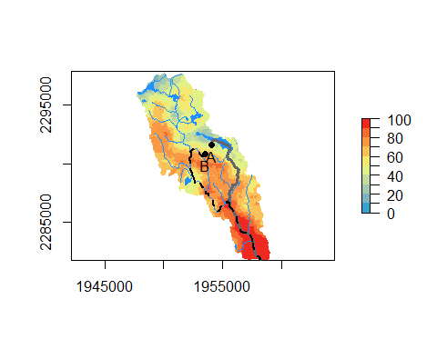

Figure 4: Flowpaths originating from two nearby locations within the Niantic River HUC-12 with differing N removal estimates. Hydrofeatures are pictured on the Nitrogen Transport Index map.

Table 3: Summary of N removal along specified flowpath B

| segment_type | length_meters | percent_removal | n_in | n_out |
| --- | --- | --- | --- | --- |
| Hydric | 336 | 44.000 | 100.0 | 56.0 |
| Stream | 1518 | 0.120 | 56.0 | 55.9 |
| Stream | 462 | 0.007 | 55.9 | 55.9 |
| Stream | 1202 | 0.016 | 55.9 | 55.9 |
| Stream | 653 | 0.007 | 55.9 | 55.9 |
| Stream | 77 | 0.002 | 55.9 | 55.9 |
| Stream | 2164 | 0.041 | 55.9 | 55.9 |
| Stream | 2246 | 0.024 | 55.9 | 55.9 |
| Lake/Pond | 130 | 0.000 | 55.9 | 55.9 |
| Stream | 1088 | 0.010 | 55.9 | 55.9 |
| Lake/Pond | 462 | 0.000 | 55.9 | 55.9 |
| Stream | 59 | 0.000 | 55.9 | 55.9 |
| Lake/Pond | 5894 | 0.000 | 55.9 | 55.9 |

## Example 2: Source controls and sink protection or restoration

The maps produced by N-Sink can be helpful in prioritizing source controls, sink protection and/or restoration. For example, many wetlands are considered “protected” by federal, state or local laws and regulations; but as occurs with many types of protected areas (Neal et al. 2018) they are frequently altered through variances granted by local commissions or committees charged with zoning decisions. By better understanding the important role that N sinks play in the protection of estuaries, local agencies have a better chance of achieving protection of downstream receiving waters. Variances granted on a case-by-case basis can quickly undermine local water quality goals. Land conservancies and other NGOs interested in identifying parcels of high value for protecting downstream waters from N loading can also use these maps to prioritize land acquisition or wetland restoration projects.

Similarly, sources of N that are contributing relatively more N due to their location within the catchment can be highlighted using the nsink static maps. The N Delivery Index map combines N sources with N transport to highlight developed areas that are located on “leakier parts” of a catchment. Figure 5A displays a high resolution image of land cover in the same watershed as Example 1, with two developed areas circled. Figure 5B shows the N Delivery Index from these two developed areas. Note that the northern area is less densely developed than the southern area but the N Delivery Index is higher in the northern area as compared to the southern area, suggesting that N source controls within the northern development might be considered.

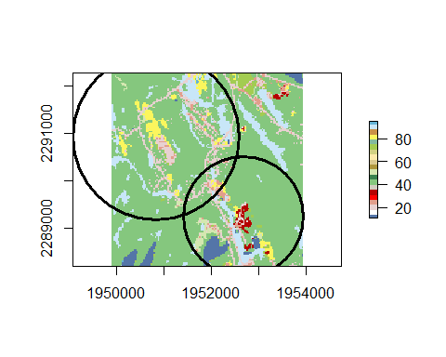 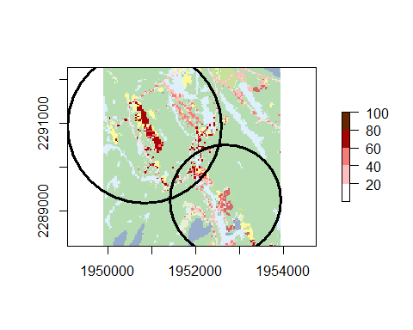

Other examples using N-Sink to examine the N loading implications of past land use decisions are also available as [bonus maps](https://uconnclear.maps.arcgis.com/apps/MapSeries/index.html?appid=e96b01502f5b4aeda64aacf0cb5234c7&folderid=dde199a7cf674845a83b43a3011b1d31) on the N-Sink website.

# Conclusions

N-Sink as implemented in the nsink R package allows users to easily download all necessary spatial data (hydrography, land cover and soils), create static maps (N Removal Efficiency, N Transport Efficiency and N Delivery Index), and interactively investigate N removal along flowpaths within any specified catchment. Currently, the default catchment definition uses HUC-12 designations, though it is also possible to use larger catchments. Larger catchments would require longer download and processing times. For investigators who do not work in R, we have created a web application that covers HUC-12 catchments in coastal CT, RI and southern MA using an [interactive tool](https://uconnclear.maps.arcgis.com/apps/MapSeries/index.html?appid=e96b01502f5b4aeda64aacf0cb5234c7&folderid=dde199a7cf674845a83b43a3011b1d31).

N-Sink is a decision support tool and was created to be a useful, easy way for local land use managers to explore the relationship between land use and nitrogen pollution in their waters. Local decision-makers that have prioritized nitrogen mitigation in their long-term planning efforts can use this tool to help them better understand the potential impact of proposed development projects and zoning variances. Similarly, land trusts and other NGOs interested in N mitigation can use this tool to identify high priority areas for acquisition or restoration.

# Bibliography

Alexander, R. B., E. W. Boyer, R. A. Smith, G. E. Schwarz, and R. B. Moore. 2007. The role of headwater streams in downstream water quality 1. JAWRA Journal of the American Water Resources Association 43:41–59.

Berelson, W. L., P. A. Caffrey, and J. D. Hamerlinck. 2004. Mapping hydrologic units for the national watershed boundary dataset 1. JAWRA Journal of the American Water Resources Association 40:1231–1246.

Buchanan, B., K. Falbo, R. Schneider, Z. Easton, and M. Walter. 2013. Hydrological impact of roadside ditches in an agricultural watershed in central new york: Implications for non-point source pollutant transport. Hydrological processes 27:2422–2437.

Easton, Z. M., D. R. Fuka, M. T. Walter, D. M. Cowan, E. M. Schneiderman, and T. S. Steenhuis. 2008. Re-conceptualizing the soil and water assessment tool (SWAT) model to predict runoff from variable source areas. Journal of hydrology 348:279–291.

Hampton, T. B., J. P. Zarnetske, M. A. Briggs, K. Singha, J. W. Harvey, F. D. Day-Lewis, F. MahmoodPoor Dehkordy, and J. W. Lane. 2019. Residence time controls on the fate of nitrogen in flow-through lakebed sediments. Journal of Geophysical Research: Biogeosciences 124:689–707.

Hollister, J. W., D. Q. Kellogg, Q. Lei-Parent, E. Wilson, C. Chadwick, D. Dickson, A. Gold, and C. Arnold. 2022. Nsink: An r package for flow path nitrogen removal estimation. Journal of Open Source Software 7:4039.

Howarth, R. W., and R. Marino. 2006. Nitrogen as the limiting nutrient for eutrophication in coastal marine ecosystems: Evolving views over three decades. Limnology and Oceanography 51:364–376.

Jin, S., C. Homer, L. Yang, P. Danielson, J. Dewitz, C. Li, Z. Zhu, G. Xian, and D. Howard. 2019. Overall methodology design for the united states national land cover database 2016 products. Remote Sensing 11:2971.

Kellogg, D., A. J. Gold, S. Cox, K. Addy, and P. V. August. 2010. A geospatial approach for assessing denitrification sinks within lower-order catchments. Ecological Engineering 36:1596–1606.

Klocker, C. A., S. S. Kaushal, P. M. Groffman, P. M. Mayer, and R. P. Morgan. 2009. Nitrogen uptake and denitrification in restored and unrestored streams in urban maryland, USA. Aquatic Sciences 71:411–424.

Mayer, P. M., S. K. Reynolds Jr, M. D. McCutchen, and T. J. Canfield. 2007. Meta-analysis of nitrogen removal in riparian buffers. Journal of environmental quality 36:1172–1180.

Mengistu, S. G., H. E. Golden, C. R. Lane, J. R. Christensen, M. L. Wine, E. D’Amico, A. Prues, S. G. Leibowitz, J. E. Compton, M. H. Weber, and others. 2020. Wetland flowpaths mediate nitrogen and phosphorus concentrations across the upper mississippi river basin. JAWRA Journal of the American Water Resources Association.

Moore, R. B., L. D. McKay, A. H. Rea, T. R. Bondelid, C. V. Price, T. G. Dewald, and C. M. Johnston. 2019. User’s guide for the national hydrography dataset plus (NHDPlus) high resolution. US Geological Survey.

Neal, W. J., O. H. Pilkey, J. A. G. Cooper, and N. J. Longo. 2018. Why coastal regulations fail. Ocean & coastal management 156:21–34.

Nixon, S. W. 1995. Coastal marine eutrophication: A definition, social causes, and future concerns. Ophelia 41:199–219.

Ryther, J. H., and W. M. Dunstan. 1971. Nitrogen, phosphorus, and eutrophication in the coastal marine environment. Science 171:1008–1013.

Seitzinger, S., J. A. Harrison, J. Böhlke, A. Bouwman, R. Lowrance, B. Peterson, C. Tobias, and G. V. Drecht. 2006. Denitrification across landscapes and waterscapes: A synthesis. Ecological applications 16:2064–2090.

Soil Survey Staff, U. 2017. Web soil survey.