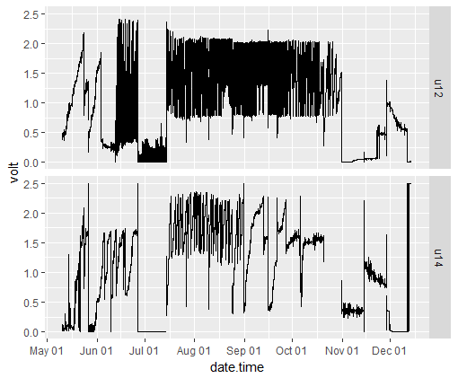

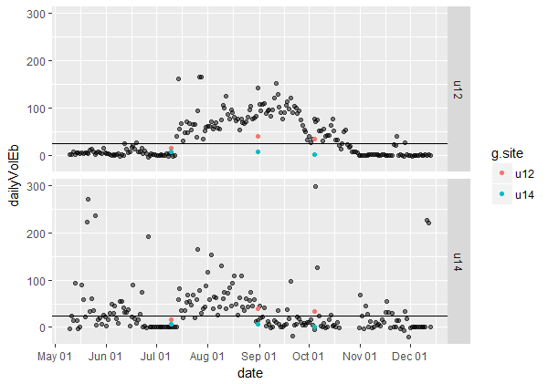

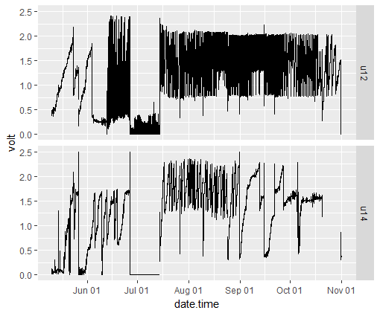

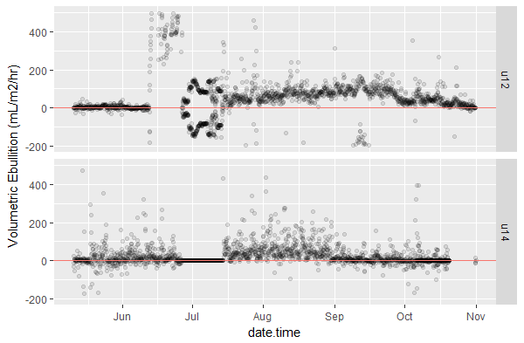

Two-hour timestep

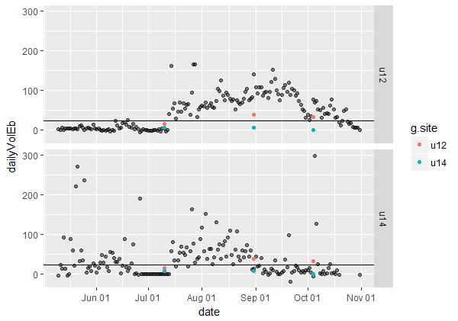

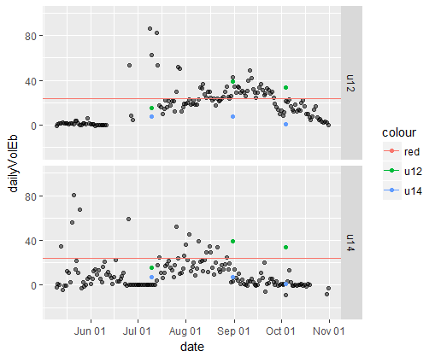

Fixed it. Top plot wasn’t using pi in the equation for funnel cross-sectional area, so over-estimated volumetric ebullition by a factor of 3.

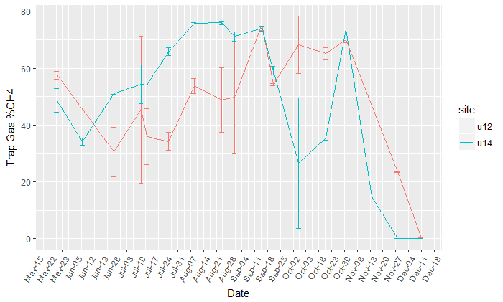

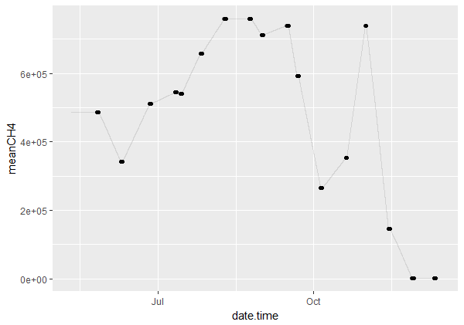

Linear interpolation results for U14 CH4

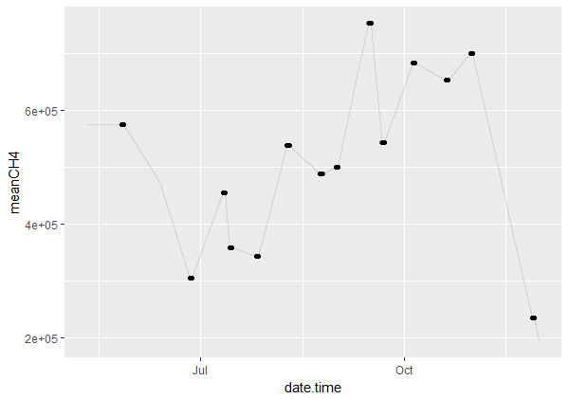

Linear interpolation results for U12 CH4.

GRTS Ebullition rates (mg CH4/m2/hr)

|  |  |  |
| --- | --- | --- |
| Date | U12 | U14 |
| July 10 | 5.907 | 2.56 |
| Aug 31 | 9.0 | 2.54 |
| Oct 4 | 16.13 | 0.41 |

