DCFnet: Few-Shot Industrial Anomaly Localization via a Dual-Encoder Calibrated Fusion Network

Abstract
Industrial inspection often begins with few defect-free images and limited knowledge of possible defects. A single pretrained representation may miss local cues, while heterogeneous features differ in spatial grids and magnitudes. We propose DCFnet, a Dual-Encoder Calibrated Fusion Network for normal-only few-shot industrial anomaly localization. It combines frozen patch descriptors from DINOv2, a self-supervised visual foundation model, and the image encoder of Contrastive Language–Image Pre-training (CLIP), a model pretrained on image–text pairs. Grid alignment and branch-wise normalization enable fixed equal-weight concatenation and joint normalization. Normal support descriptors form a memory for nearest-neighbor anomaly scoring, without target-domain parameter optimization or text-based inference. Experiments on four industrial benchmarks show improved mean pixel-level localization over a matched DINOv2-only baseline, with category-specific losses and additional computational cost. Code is available at https://github.com/USEU117/sci_project.
Keywords: industrial anomaly localization; few-shot learning; visual foundation models; calibrated fusion; normal memory bank

1 Introduction
Visual quality inspection must identify defects whose appearance and location cannot be fully specified before deployment. Small surface flaws, missing components, and contamination can resemble acceptable changes in material, pose, or illumination. Supervised inspection requires representative defect examples and annotations that may be unavailable for a new product or failure mode. Industrial anomaly detection instead models normal appearance and identifies deviations at test time, motivating recent one-class inspection methods [1]. In practice, an image-level alarm also needs a localized explanation that an inspector can examine.
The constraint becomes more severe when normal examples are also scarce. During production-line start-up or a product change, collecting a large category-specific reference set may delay deployment, motivating few-shot inspection [2]. Here, the detector receives $K$ verified normal images and must identify previously unseen abnormalities without abnormal target-domain training samples. Comparing local query descriptors with normal reference descriptors can already be effective with frozen visual features [3]. This makes the representation, rather than additional target-category training alone, a central design choice.
Industrial defects involve different visual cues: a thin scratch changes local texture, whereas a missing or displaced part can require structural context. Recent work combines global and multiscale local information and calibrates its scores to address this variation [4]. Heterogeneous foundation features have also been combined in adapted anomaly detectors [5]. However, those complete systems do not establish whether a second frozen visual descriptor helps when the normal references and nearest-neighbor scorer remain fixed. We study this controlled question.
Three design requirements follow from this question. First, the chosen encoders use different preprocessing resolutions, so their patch grids must be aligned before descriptors can be concatenated by position. Second, unequal branch magnitudes can unbalance the joint distance, motivating explicit normalization; the resulting distance relationship is derived in Section 3.4. Third, a dataset average cannot establish robustness to reference selection or rule out category-specific losses and extra cost. We therefore keep references and scoring fixed across encoder controls and report reference variability, adverse cases, and resource use. These requirements define the present design and evaluation; they are not claims that all earlier methods omit such controls.
DCFnet addresses the first two issues through spatial calibration and magnitude calibration before fixed feature fusion. It aligns CLIP-derived patches to the DINOv2 grid, normalizes each branch, concatenates equal-scaled descriptors, and normalizes the result. The term calibrated refers to these deterministic operations; it does not denote probability calibration or a learned gate. Normal support descriptors form a category memory, and query patches are scored by exact nearest-neighbor search. The evaluation addresses the third issue by preserving reference identities and the scoring pipeline across controls, then examining localization gains, adverse cases, and resource use.
The contributions are as follows:
- Novel framework. We formulate DCFnet as a dual-visual-encoder localization framework in which normal supports and queries share a fixed feature transformation. The support path constructs a category memory, and the query path reads it without updating it or optimizing target-domain parameters.
- XXX Module . We specify a deterministic calibration and fusion procedure that resolves grid incompatibility and controls branch magnitude before concatenation. Its distance decomposition explains how both descriptors evaluate the same candidate support patch. The contribution is this explicit integration and analysis, rather than a new interpolation or concatenation operator.
- Module…dyt layer. We evaluate the complete procedure with matched encoder controls and multiple normal-reference configurations, reporting both localization improvements and failure boundaries. Complete image- and pixel-level metrics, category analyses, and resource measurements establish the scope and cost of the observed benefit. R OI pixels-based patch strategy
- First-proposed 。。。evaluation。 Existing focus on …,,It is first work…this work

2 Related Work
Industrial anomaly detection can be organized into reconstruction and one-class learning, pretrained feature embeddings with normal memories, and foundation-model or hybrid approaches. The boundaries overlap: foundation features can also be used inside a memory detector. This organization highlights what each method learns, which data it uses, and how it produces an anomaly score.
Reconstruction and one-class methods learn inspection-specific representations or decision rules from normal data. Their advantage is the ability to shape features toward the detection task. The following examples achieve this through different forms of supervision and augmentation, which must be considered when comparing them with a detector whose target-category encoders remain frozen.
SLSG combines generative pretraining, simulated anomalies, and self-attentive graph convolution to learn normal embeddings and their spatial relationships [1]. RealNet uses diffusion-based anomaly synthesis, anomaly-aware feature selection, and reconstruction-residual selection to reduce feature redundancy and expose defect-sensitive residuals [6]. These mechanisms provide task-specific supervision, but their effectiveness depends in part on how well synthesized abnormalities represent useful departures from normality. Dual-path Frequency Discriminators exploit spatial and frequency views with pseudo-anomaly supervision to make subtle defects more distinguishable [7]. DMMGNet separates augmented training features from stored memory features and uses discrimination mapping and memory-bank mean guidance to support few-shot learning [2]. The latter two methods illustrate how representation learning can address sparse normal data, while retaining a model-fitting stage. DCFnet avoids this target-category optimization by fixing its encoders and feature transformation; the corresponding limitation is that it cannot learn a category-specific correction when the transferred descriptors are inadequate.
Pretrained feature embedding and normal-memory methods measure deviations directly in a transferred feature space. PaDiM represents normal patch embeddings with multivariate Gaussian distributions [8]. This provides a compact statistical description, but estimating a high-dimensional covariance from very few examples is challenging. PatchCore stores a coreset of normal local descriptors and applies nearest-neighbor scoring [9]. Retaining observed descriptors avoids prescribing a single Gaussian distribution, although retrieval cost and reference coverage become important. Both approaches avoid learning named defect classes. DCFnet follows the descriptor-memory approach and retains all available support patches, trading greater reference retention for memory and search cost. With few references, neither a statistical model nor a descriptor memory can be assumed to cover every acceptable appearance variation.
Few-shot work has consequently focused on expanding normal coverage or improving representation quality. Hu et al. transform support features conditionally and construct multi-frequency descriptors to compensate for sparse normal patterns in FEAD [10]. Wei et al. formulate K-NG for few-shot online detection and update a Neural Gas representation from an unlabeled stream while attempting to avoid contamination by anomalies [11]. Zhou et al. combine global invariant and multiscale local features and explicitly calibrate differently distributed anomaly scores in PGAD [4]. Li et al. refine normal prototypes at test time in FastRef and use optimal transport to reduce the risk of absorbing anomalous query features [12]. Feature transformation and multiscale modeling enrich the evidence available from sparse supports, whereas online updating and test-time refinement can accommodate appearance changes. Updating from unlabeled queries also requires safeguards against incorporating anomalies into the normal representation. DCFnet instead keeps the normal memory fixed and asks whether a second frozen representation provides a reproducible gain without query-conditioned adaptation.
Foundation-model and hybrid approaches build on transferable pretrained representations. Self-supervised visual foundation models have substantially changed the quality of transferable local descriptors. AnomalyDINO applies frozen DINOv2 patches to few-shot anomaly detection and shows that straightforward patch comparison is already highly competitive [3]. UniVAD develops a training-free unified model that reasons over reference images across industrial, logical, and medical anomalies [13]. SubspaceAD fits a principal subspace to frozen DINOv2 patches and scores reconstruction residuals, providing a strong training-free alternative to direct nearest-neighbor memories [14]. DCP-SFR argues that deep structural representations may suppress shallow defect cues and refines them to preserve subtle anomalies [15]. Collectively, these studies show that feature selection, normal-space modeling, and cue preservation can be as important as the downstream anomaly scorer. They also establish a demanding visual-only baseline against which fusion must be assessed.
Vision-language pretraining offers another route to transfer. WinCLIP uses prompt ensembles, window-level visual features, and optional normal references for zero- and few-shot anomaly classification and segmentation [16]. AnomalyCLIP replaces object-specific descriptions with object-agnostic prompts learned for normality and abnormality [17], whereas PromptAD learns prompts using only normal target samples [18]. InCTRL performs in-context residual learning with few-shot sample prompts [19]. AA-CLIP introduces anomaly-aware text anchors and patch-level visual alignment [20], and FAPrompt decomposes coarse abnormality descriptions into fine-grained prompt components [21]. Language prompts provide transferable descriptions of normality and abnormality, which is useful when visual references are scarce. Their scores can also depend on prompt design or learned prompt parameters; target-normal prompt tuning introduces an additional adaptation stage. These dependencies differ across the cited methods and should not be equated with target-defect supervision. DCFnet uses only the frozen CLIP image encoder with the diagonally prominent attention map (DPAM) modification from AnomalyCLIP [17] at inference; it is therefore a dual-visual-encoder method rather than a vision-text inference system.
Hybrid approaches are the closest context for DCFnet. Ma et al. combine retrieval-enhanced references and multimodal prompt fusion in ReMP-AD [22]. Xu et al. study cooperative refinement of multimodal features for few-shot detection [23]. Guo et al. use DINOv2-guided patch matching and a learned decoder in Sea-CLIP [5]. PAPL introduces particle-based adaptive prompt learning for zero-shot inspection [24], while Jiang et al. combine CLIP and DINOv2 with multimodal fusion and stabilized attention pooling [25]. These designs can couple complementary representations through retrieval, prompting, or learned fusion, but the resulting system gains do not isolate the effect of fixed visual-feature concatenation. Pairing CLIP and DINOv2 is therefore not itself a novel contribution. DCFnet makes the distance contribution of each frozen branch explicit and preserves a fixed reference memory, at the expense of a second backbone and without the flexibility of a learned fusion rule.
The three groups make different trade-offs. Reconstruction and one-class learning can adapt discrimination to a target setting, but their fitted components are difficult to estimate from very few normal examples. Feature-memory methods avoid this optimization while depending on reference coverage and descriptor quality. Foundation-model and hybrid methods broaden the available cues, often introducing adaptation, prompting, or additional computation. DCFnet combines frozen visual representations with a fixed normal memory to examine fusion under matched conditions. The unresolved issue is whether the resulting localization benefit survives reference variation and compensates for category losses and cost; Sections 3 and 4 specify and evaluate that trade-off.

3 Detailed DCFnet

3.1 Problem Statement
Let $c$ denote a product category and let the support set contain $K$ verified normal images. A query image $x$ can be normal or anomalous. DCFnet returns a pixel-level anomaly map and an image-level score; it does not predict named defect classes. The normal support set is
$R_{c}={{\left\{{x^{c}}_{i}\right\}}^{K}}_{i=1}$ (1)
Here ${x^{c}}_{i}$ is the ith normal support image of category $c$, $i$ = 1, …, $K$, and $K$ ∈ {1, 2, 4}. Support selection requires verified normality and product-category identity. Query ground-truth labels and pixel masks are used for evaluation, not for feature extraction, memory construction, query scoring, or parameter selection on the external-validation datasets. Development-set labels inform method selection as described in Section 4.1.1. All target-category model parameters remain fixed. Building a memory from normal images is a data-dependent preparation step, even though it performs no gradient optimization.

3.2 Overview Structure
Figure 1 separates support-memory construction from query inference. Both paths share frozen dual-encoder extraction, CLIP-to-DINO grid alignment, branch-wise normalization, equal-scaled concatenation, and joint normalization. Support descriptors are stored once for each category and reference configuration. Query descriptors are compared with this fixed memory, then patch scores are resized and smoothed. The query is never added to the normal memory. The encoder and control details are expanded in Supplementary Figures S₁ and S₂. Figure 2 describes the core
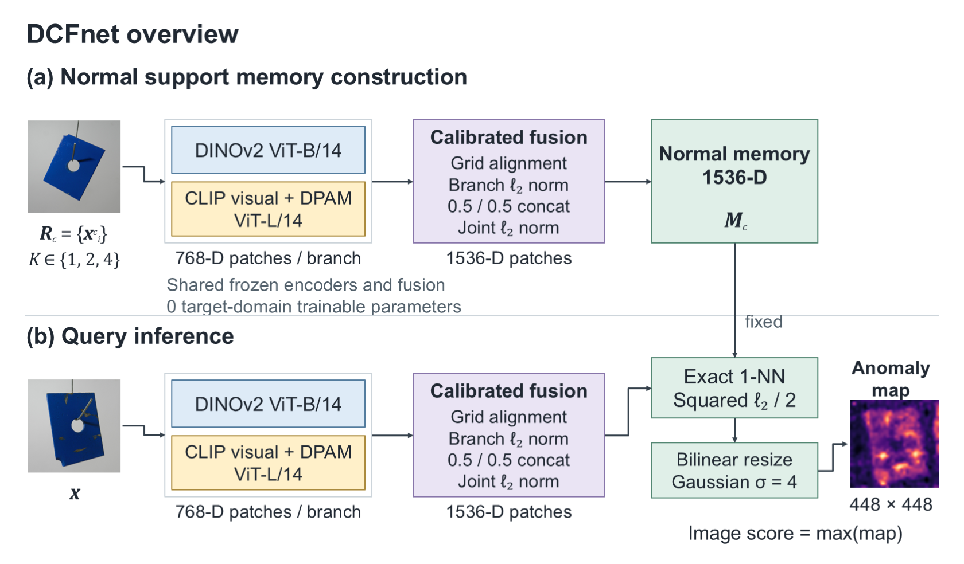
变量同意，字体，斜体，输出两种
Figure 1. DCFnet overview. Normal supports build a category memory; the query uses the same frozen encoders and fusion path, then reads the fixed memory. Squared ℓ2 / 2 denotes half the squared Euclidean distance. Example images are from MPDD; the heatmap is an inference example, not a ground-truth label.

3.3 Frozen Dual-Encoder Visual Representation
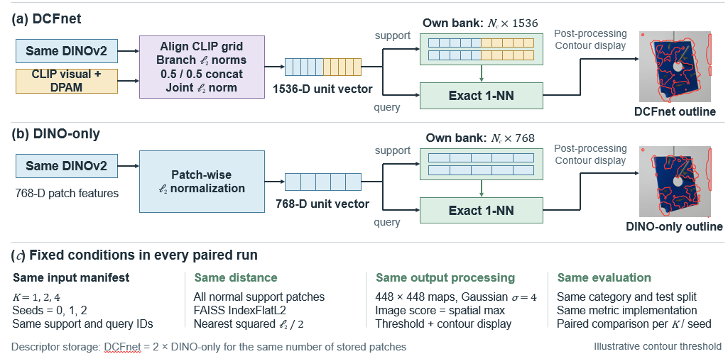
The first branch is a frozen DINOv2 ViT-B/14 encoder [26]. An input is resized according to the fixed pipeline with a target short-side resolution of 448 pixels and cropped so that each spatial dimension is divisible by the patch size of 14. The resulting grid is denoted by $h_{D}$ × $w_{D}$; its shorter dimension is 32 patches, and each patch descriptor has dimension $d_{D}$ = 768. DINOv2 is selected because its self-supervised objective produces transferable dense visual descriptors and because DINO-based patch comparison is a strong few-shot baseline [3]. The branch is not fine-tuned on any of the four target datasets.
The second branch uses a frozen CLIP visual encoder with a ViT-L/14 backbone pretrained at a nominal image resolution of 336 × 336 pixels [27]. Its attention path follows the diagonally prominent attention map (DPAM) modification in AnomalyCLIP [17]. It receives a 518 × 518 input and produces a 37 × 37 grid of 768-dimensional local descriptors. The extractor requests the outputs of visual layers 6, 12, 18, and 24 with DPAM_layer set to 20 and retains the final returned patch tensor, corresponding to layer 24. Only image features are retained. No text prompt, text-encoder output, normal-versus-abnormal language similarity, or dynamic vision-language routing is computed during DCFnet inference. The branch is used to test whether CLIP-pretrained local descriptors processed by a fixed DPAM attention path provide information complementary to self-supervised DINOv2 descriptors. This motivation does not assume that complementarity holds for every category; that question is evaluated rather than built into the method.
Both backbones use 14-pixel patches. Their grid mismatch is caused by the different preprocessing resolutions and aspect-ratio handling, not different patch sizes. The CLIP transformer has hidden width 1024; its final local features are projected to 768 dimensions. The class token is excluded from the memory descriptors. The export script loads the AnomalyCLIP prompt checkpoint for its inherited setup, but the retained feature path calls only the image encoder and does not consume the loaded prompts.

3.4 Spatial Calibration and Fixed Feature Fusion
Let $F_{D}$ and $F_{C}$ be the DINOv2 and CLIP patch tensors. As shown in Figure 2, a bilinear operator R maps $F_{C}$ onto the $h_{D}$ × $w_{D}$ reference lattice with align_corners = false:
$F_{C→D}=R(F_{C})∈R^{h_{D}×w_{D}×768}$ (2)
This operation matches grid dimensions; it does not guarantee exact receptive-field or object-part correspondence. Let $f_{D,p}$ and $f_{C→D,p}$ denote the branch descriptors at aligned position $p$. For descriptors with positive $l_{2}$ norm, branch normalization is
$g_{D,p}=\frac{f_{D,p}}{{\left\|f_{D,p}\right\|}_{2}},g_{C,p}=\frac{f_{C→D,p}}{{\left\|f_{C→D,p}\right\|}_{2}}$ (3)
The calibrated vectors are concatenated using the frozen coefficient $α$ = 0.5 and jointly normalized to form a 1536-dimensional descriptor. Norm denotes division by the $l_{2}$ norm of the concatenated vector:
$f_{A,p}=Norm(\left[αg_{D,p};(1-α)g_{C,p}\right]),α=0.5$ (4)
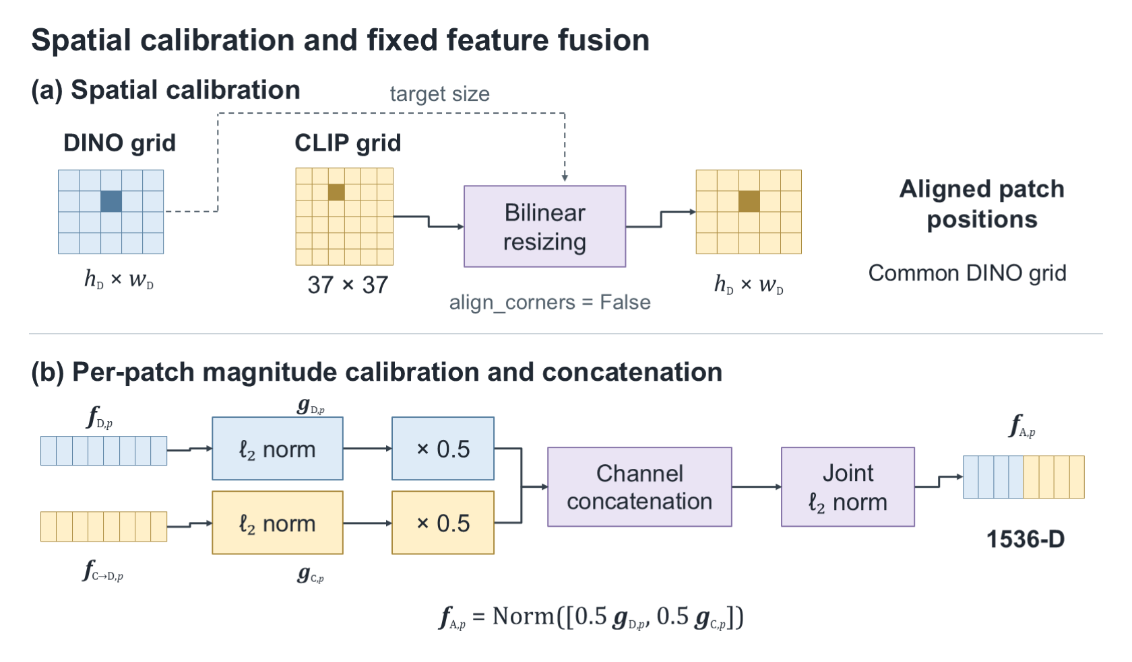
Figure 2. Deterministic grid and magnitude calibration. The CLIP grid is resized to the DINO lattice before branch-wise normalization, equal scaling, concatenation, and joint normalization. Grid correspondence is not learned semantic matching.
For nonzero branch descriptors, equal scaling implies $f_{A,p}$ = [$g_{D,p}$; $g_{C,p}$]/√2. Consequently, the distance between a query patch $p$ and a support patch $q$ decomposes as
$\frac{1}{2}{\left\|f_{A,p}-f_{A,q}\right\|}_{2}^{2}=\frac{1}{4}\left({\left\|g_{D,p}-g_{D,q}\right\|}_{2}^{2} + {\left\|g_{C,p}-g_{C,q}\right\|}_{2}^{2}\right)$ (5)
Thus, fusion averages two branch distances for the same candidate support patch before the nearest neighbor is selected. It is generally different from averaging two anomaly maps whose nearest neighbors were selected independently. A support patch that matches only one branch can become less competitive under the joint metric. This explains a possible benefit of joint evidence, while also exposing a failure mode: an unhelpful second descriptor can worsen the ranking. Equation (5) describes the implemented geometry, not proof that the two branches encode complementary defect causes.
Equations (3)–(5) describe positive-norm descriptors. The complete-metric evaluator divides directly by the measured branch norms, and FAISS performs joint normalization. Degenerate zero-norm inputs are outside this derivation and require explicit handling before the implementation is used in settings where such inputs may occur.

3.5 Normal Reference Memory and Anomaly Scoring
For category $c$, all fused descriptors from its $K$ normal references form the memory $M_{c}$ (Figure 3). We retain all reference patches without a coreset or principal-component projection:
$M_{c}=\bigcup_{i=1}^{K}{\{}f_{A,q}({x^{c}}_{i}):q∈G_{D}({x^{c}}_{i})\}$ (6)
Here $G_{D}$(${x^{c}}_{i}$) denotes the DINO patch lattice of the category-c support image ${x^{c}}_{i}$, and $q$ indexes a patch on that lattice. Descriptors are stored in a FAISS IndexFlatL2 index [28]. For query patch $p$, the raw anomaly score is one half of the minimum squared Euclidean distance:
$a_{p}(x)=\frac{1}{2}\min_{m∈M_{c}}{\left\|f_{A,p}(x)-m\right\|}_{2}^{2}$ (7)
FAISS returns squared distances. For unit descriptors, one half of squared Euclidean distance equals cosine distance. We arrange patch scores on the DINO grid as a score matrix $a$, bilinearly resize to 448 × 448, and apply Gaussian smoothing with $σ$ = 4 pixels at that output resolution. The image score is the maximum response:
$S_{448}(x)=G_{σ=4}({Resize}_{448}(a)),s_{img}(x)=\max_{u}S_{448,u}(x)$ (8)
In Equation (8), the Gaussian operator with $σ$ = 4 denotes Gaussian filtering, Resize denotes bilinear resizing to 448 × 448, and $u$ ranges over all pixels of the output map. Thus, $a_{p}$, $S_{448,u}$, and $s_{img}$ are scores at the patch, output-pixel, and image levels, respectively.
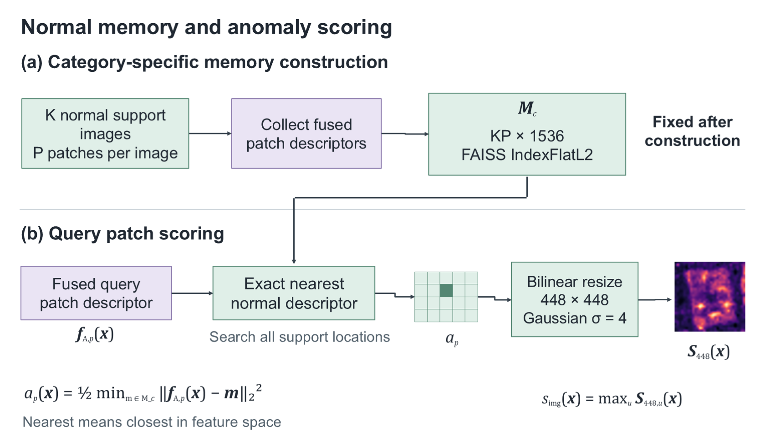
Figure 3. Normal-memory construction and exact nearest-neighbor scoring. All normal support patches are retained. A query does not update the memory; its scores are bilinearly resized and Gaussian-smoothed.

3.6 Matched Controls and Computational Complexity
The matched DINO-only control removes the DPAM-modified CLIP branch and the concatenation step but retains the identical DINOv2 descriptors, support-image identities, $K$ values, random seeds, exact one-nearest-neighbor search, distance convention, upsampling, Gaussian smoothing, and evaluation resolution. This design is essential: comparing DCFnet only with published numbers from methods using different checkpoints, data roles, or post-processing would not isolate the effect of feature fusion. The matched control instead changes a single factor: whether the calibrated second visual representation is present.
The CLIP-image-only control likewise uses its visual descriptors without text, with matched reference identities and the same downstream metric convention. If a category has $N_{c}$ stored patches and a query contains $P$ patches, memory storage is O($N_{c}$ $d$) and exact retrieval costs O($P$ $N_{c}$ $d$), where $d$ is 1536 for DCFnet and 768 for a single branch. For a common grid, $N_{c}$ = $KP$. The fused descriptor doubles bank storage relative to matched DINO-only, and an additional encoder must execute. No optimization cost does not imply negligible inference cost.

3.7 Model Configuration
Table 1 specifies the configuration used throughout the study. The spatial-alignment, normalization, concatenation, and nearest-neighbor stages have no trainable weights. Both visual backbones remain fixed; learning rate, optimizer, training epochs, and target-category training batch size are therefore not applicable. Support-memory construction is repeated when category, seed, or $K$ changes.
The connections are explicit: each preprocessed image feeds both visual branches; the retained CLIP local tensor feeds spatial alignment; aligned CLIP and DINO descriptors feed branch normalization, weighted concatenation, and joint normalization in order. Support outputs feed the category index, whereas query outputs feed index search, map resizing, smoothing, and maximum pooling. Table 1 lists the tensor sizes for these connections; Figures 1–3 illustrate the same order.
Table 1. Frozen model configuration
Component | Configuration | Output / trainable parameters
DINOv2 | ViT-B/14; 12 blocks; width 768; 12 heads; short side 448 | $h_{D}$ × $w_{D}$ × 768; 0
CLIP visual | ViT-L/14; 24 blocks; width 1024; 16 heads; input 518 × 518 | 37 × 37 × 768 after projection; 0
DPAM / layer output | DPAM_layer = 20; request 6/12/18/24; retain layer 24, exclude CLS | Frozen attention path; 0
Grid calibration | Bilinear CLIP-to-DINO resize; align_corners = false | $h_{D}$ × $w_{D}$ × 768; 0
Fusion | Per-patch branch $l_{2}$; $α$ = 0.5; concat; joint $l_{2}$ | $h_{D}$ × $w_{D}$ × 1536; 0
Normal memory | $K$ = 1/2/4; seeds 0/1/2; all normal patches; no PCA/whitening | $N_{c}$ × 1536; 0
Scoring | FAISS IndexFlatL2; 1-NN; squared Euclidean distance / 2 | $h_{D}$ × $w_{D}$ scores; 0
Post-processing | Bilinear resize, then Gaussian $σ$ = 4; image maximum | 448 × 448 map and scalar; 0
Target optimization | Optimizer, learning rate, epochs, training batch: not applicable | 0 trainable parameters

The DINOv2 checkpoint contains 86,580,480 parameter elements. The CLIP visual architecture contains 304,293,888 parameters at its native 336-pixel position lattice; DPAM replacement preserves this count. The implementation interpolates the CLIP positional embedding from 24 × 24 to 37 × 37 at a 518-pixel input, increasing its stored position values by 812,032 without learning new weights. These counts exclude the unused text tower and prompt learner. All target-domain trainable-parameter counts are zero.

4 Experimental Evaluations

4.1 Experimental Design

4.1.1 Datasets and Reference Protocol
We evaluate four image datasets with normal/abnormal image labels and pixel-level defect masks: the Metal Parts Defect Detection dataset (MPDD) [29], the beanTech Anomaly Detection dataset (BTAD) [30], MVTec Anomaly Detection (MVTec AD) [31], and Visual Anomaly (VisA) [32]. MPDD covers metal parts, BTAD covers three industrial products, MVTec AD combines object and texture categories, and VisA includes circuit boards and single- or multiple-object scenes. Table 2 gives the actual category and test-image counts in the archived project splits. Every category uses $K$ ∈ {1, 2, 4} normal references sampled with seeds 0, 1, and 2. Reference identities are shared by DCFnet and its matched controls, giving nine configurations per dataset and 36 dataset-level comparisons.
Table 2. Evaluated datasets and their roles
Dataset | Categories | Test images | Role
MPDD | 6 | 458 | Development
BTAD | 3 | 741 | External frozen validation
VisA | 12 | 2162 | In-domain frozen validation
MVTec AD | 15 | 1725 | External frozen validation
Every category uses 1, 2, or 4 normal references and seeds 0, 1, and 2. Counts describe the archived project splits.
MPDD is the development dataset. Fusion and post-processing decisions are frozen before BTAD and MVTec AD evaluation. VisA is reported conservatively as in-domain frozen validation because the inherited AnomalyCLIP setup uses a VisA-trained prompt checkpoint, even though the retained visual path does not consume those prompts. This role assignment avoids presenting VisA as independently established external-transfer evidence. Test labels are used for metric computation and subsequent analysis, not for fitting the validation detector. Development-set comparisons informed the decision to retain a symmetric fusion coefficient; they must not be described as label-free method selection.

4.1.2 Baselines and Ablation Scope
The primary comparison is DCFnet against matched DINO-only. Additional CLIP-image-only results cover all nine configurations on BTAD and MVTec AD. We also report local evaluations of PatchCore [9], WinCLIP+ [16], AnomalyDINO [3], and PromptAD [18], with supplementary context from zero-shot AnomalyCLIP [17] and source-trained ReMP-AD [22]. These external methods differ in backbone, adaptation, and sometimes shot coverage; their numbers provide context rather than an isolated estimate of fusion effectiveness. Recent methods discussed in Section 2, including Sea-CLIP and SubspaceAD, are literature comparisons where a verified common-protocol numerical run is unavailable.
The validated ablations concern encoder presence, reference count, and reference sampling. Matched component studies of alternative spatial alignment, branch normalization, DPAM, and feature fusion versus separately searched score fusion remain incomplete. Accordingly, the study establishes the effect of the complete fusion path, not a separately measured gain for every calibration operation. Under the positive-norm, equal-weight assumptions of Section 3.4, the concatenated branch-unit descriptors have constant norm. Joint normalization therefore fixes the distance scale; it is not expected to improve ranking-based metrics independently in exact arithmetic.

4.1.3 Evaluation Metrics and Uncertainty
Image-level metrics are the area under the receiver operating characteristic curve (I-AUROC), average precision (I-AP), and maximum F1 over evaluation thresholds (I-F1max). Pixel-level metrics are P-AUROC, P-AP, and the normalized area under the per-region overlap curve up to a false-positive rate of 0.30 (P-AUPRO). All values are reported on the 0–1 scale. I-F1max is an evaluation summary selected with ground-truth labels; it is not a deployment threshold obtained from normal references.
For pixel metrics, the frozen evaluator samples each 448 × 448 prediction and mask at stride 8. Test pixels are pooled within each category before its metric is computed, and category metrics are then averaged with equal weight. The nine-configuration mean and sample standard deviation describe sensitivity to reference selection and shot count. These configurations share the same test set; they are not nine independent datasets. Full-resolution scores with a different pixel-sampling rule are not directly interchangeable with these results.
Archived uncertainty analyses use 2,000 bootstrap resamples and percentile 95% intervals, with base random seed 20260827. The category bootstrap resamples paired category-level P-AP differences and corresponds to the macro-average statistic. A separate image bootstrap resamples paired per-image P-AP differences only for images retaining at least one positive mask pixel after stride sampling; it is not category-stratified and does not estimate the same statistic as the main table. We therefore emphasize category intervals when interpreting macro-average gains. Replay comparisons were checked against the archived configuration results within a tolerance of 5 × 10⁻⁴.

4.1.4 Implementation and Computing Environment
Feature extraction uses PyTorch with frozen pretrained backbones; exact nearest-neighbor retrieval uses FAISS on the CPU. The archived environment records Windows, Python 3.10.11, PyTorch 2.0.0 with CUDA 11.8 for the CLIP branch, and an NVIDIA GeForce RTX 3060 Laptop GPU with 6,144 MiB VRAM. The workstation inventory checked during manuscript preparation identifies an Intel Core i9-12900H CPU and approximately 16 GB installed RAM (15.8 GiB reported as physical memory). CPU/RAM inventory was completed retrospectively, whereas GPU and software details are present in the experiment archive.
The audited CLIP exporter and stage benchmark process one image per encoder call. This inference batch size of one is distinct from the number $K$ of support images and from the patch chunks used by the memory evaluator. There is no target-domain training batch size.
Efficiency measurements use the MVTec bottle category, seed 0, and one normal reference, with three warm-up passes and 30 timed repetitions per stage. The two extraction stages execute on the GPU in separate processes; alignment, concatenation, and retrieval are measured on the CPU from cached features. The reported aggregate is the sum of stage means and excludes one-time model loading. It should not be interpreted as a separately instrumented application-wide latency including interprocess orchestration, image acquisition, or all transfer costs.

4.2 Results and Analysis

4.2.1 Main Results against the Matched Control
Table 3 reports all six metrics for the matched comparison. Mean P-AP increases from 0.3304 to 0.3562 on MPDD, from 0.6206 to 0.6455 on BTAD, from 0.3201 to 0.3725 on VisA, and from 0.5226 to 0.5546 on MVTec AD. The mean gains computed from the unrounded paired records are 0.0258, 0.0249, 0.0524, and 0.0320. All three pixel-level metric means increase on each dataset. The strongest supported conclusion is a localization benefit relative to the same DINO-only pipeline.
Table 3. Complete matched results across four datasets
Dataset | Method | I-AUROC | I-AP | I-F1max | P-AUROC | P-AP | P-AUPRO
MPDD | DINO-only | 0.7460  ± 0.0538 | 0.7656  ± 0.0474 | 0.8213  ± 0.0205 | 0.9547  ± 0.0076 | 0.3304  ± 0.0345 | 0.8805  ± 0.0232
MPDD | DCFnet | 0.7750  ± 0.0519 | 0.7948  ± 0.0490 | 0.8280  ± 0.0167 | 0.9646  ± 0.0065 | 0.3562  ± 0.0350 | 0.9001  ± 0.0208
BTAD | DINO-only | 0.9214  ± 0.0175 | 0.9316  ± 0.0268 | 0.8943  ± 0.0189 | 0.9708  ± 0.0015 | 0.6206  ± 0.0183 | 0.7574  ± 0.0092
BTAD | DCFnet | 0.9254  ± 0.0120 | 0.9185  ± 0.0212 | 0.8706  ± 0.0131 | 0.9735  ± 0.0012 | 0.6455  ± 0.0124 | 0.7608  ± 0.0102
VisA | DINO-only | 0.8730  ± 0.0303 | 0.8779  ± 0.0303 | 0.8512  ± 0.0149 | 0.9662  ± 0.0070 | 0.3201  ± 0.0278 | 0.8933  ± 0.0167
VisA | DCFnet | 0.9046  ± 0.0196 | 0.9103  ± 0.0190 | 0.8710  ± 0.0138 | 0.9757  ± 0.0046 | 0.3725  ± 0.0246 | 0.9125  ± 0.0117
MVTec AD | DINO-only | 0.9465  ± 0.0172 | 0.9703  ± 0.0092 | 0.9548  ± 0.0098 | 0.9548  ± 0.0057 | 0.5226  ± 0.0184 | 0.9065  ± 0.0097
MVTec AD | DCFnet | 0.9583  ± 0.0141 | 0.9777  ± 0.0069 | 0.9638  ± 0.0078 | 0.9663  ± 0.0043 | 0.5546  ± 0.0196 | 0.9199  ± 0.0082
Mean ± sample standard deviation across nine shared-test reference configurations; metrics range from 0 to 1. A1 in archived figures denotes DCFnet.
Image-level improvements are less uniform. On BTAD, I-AP decreases from 0.9316 to 0.9185 and I-F1max from 0.8943 to 0.8706, despite improved pixel localization. Maximum pooling compresses the map to one score, so improved pixel ranking need not improve the ordering of entire images. The results do not establish all-metric superiority and should be interpreted in relation to the intended localization task.

4.2.2 Encoder Controls and Reference Stability
Table 4 completes the three-way P-AP comparison on BTAD and MVTec AD. CLIP-image-only is weaker than matched DINO-only, but its fusion with DINOv2 improves the mean beyond both single branches. DCFnet exceeds CLIP-image-only in all 18 configurations across the two datasets. This excludes the simple explanation that fusion merely substitutes a stronger standalone CLIP branch, and is consistent with complementary information under the joint metric. It does not identify the particular features responsible for the gain.
Table 4. Matched three-way P-AP comparison
Dataset | DINO-only | CLIP-image-only | DCFnet
BTAD | 0.6206 ± 0.0183 | 0.4006 ± 0.0277 | 0.6455 ± 0.0124
MVTec AD | 0.5226 ± 0.0184 | 0.4654 ± 0.0180 | 0.5546 ± 0.0196
Nine reference configurations per dataset; no text is used in the CLIP-image-only control.
Every dataset-level seed/shot configuration has a positive P-AP difference against matched DINO-only (Figure 4). Table 5 groups those differences by shot count. MPDD benefits somewhat more at two and four shots than at one shot, while the VisA and MVTec AD margins narrow as $K$ increases. BTAD has similar mean margins across the three shot settings. These are descriptive patterns within the evaluated references, not evidence of a universal monotonic relation between $K$ and fusion gain.
Table 5. P-AP gain grouped by normal-reference count
Dataset | 1 shot | 2 shots | 4 shots
MPDD | 0.0210 ± 0.0122 | 0.0277 ± 0.0024 | 0.0288 ± 0.0025
BTAD | 0.0258 ± 0.0092 | 0.0239 ± 0.0091 | 0.0250 ± 0.0073
VisA | 0.0558 ± 0.0063 | 0.0523 ± 0.0033 | 0.0490 ± 0.0019
MVTec AD | 0.0348 ± 0.0056 | 0.0311 ± 0.0054 | 0.0300 ± 0.0051
DCFnet minus matched DINO-only; mean ± sample standard deviation across three seeds at each $K$.
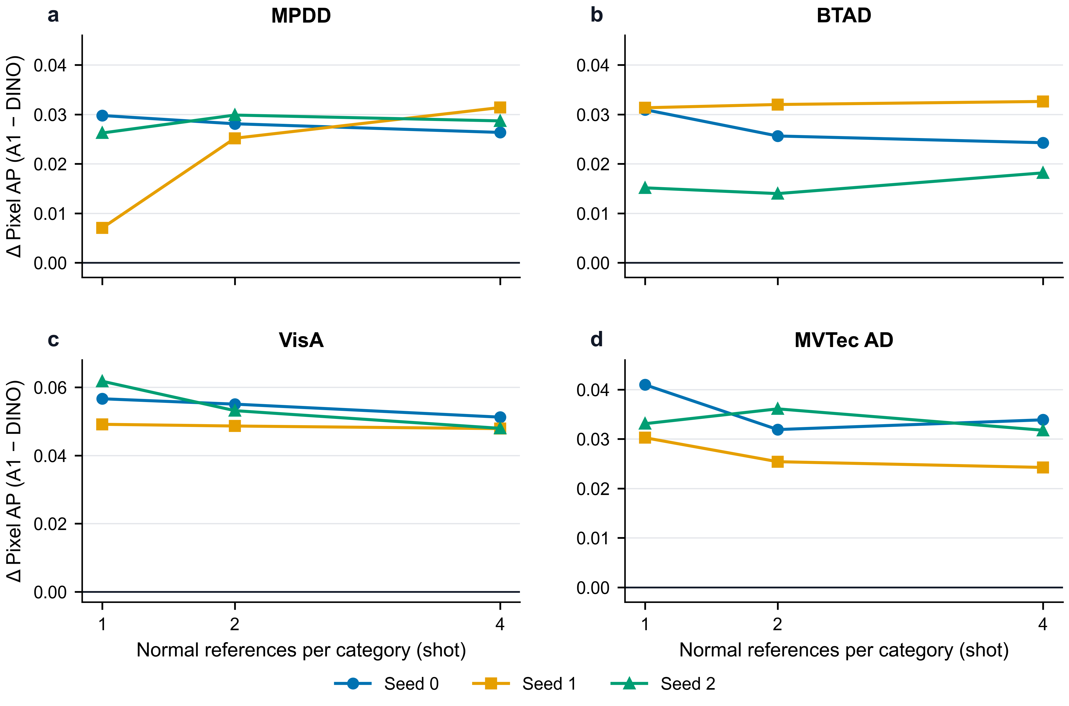
Figure 4. P-AP differences between DCFnet (A1) and matched DINO-only for every seed/shot configuration. All 36 dataset-level point estimates are positive. The panels use different vertical ranges; connecting lines aid reading and do not establish a fitted trend.
Positive point estimates do not mean that every confidence interval excludes zero. For MPDD at seed 1 and one shot, the category-bootstrap interval is [−0.0374, 0.0450] around a point gain of approximately 0.0070. For BTAD at seed 2 and two shots, it is [−0.0085, 0.0320] around 0.0140. The archived category intervals are above zero for all nine configurations of VisA and MVTec AD, but MPDD and BTAD contain intervals spanning zero. In particular, category resampling from only three BTAD categories has limited resolution. No independent-sample significance claim is based on the 36 shared-test configurations.

4.2.3 Comparison with Broader Baselines
Table 6 places DCFnet alongside verified local baseline results. DCFnet exceeds the reported PatchCore, WinCLIP+, and PromptAD means on both MVTec AD and VisA, but remains below the project AnomalyDINO run: 0.5546 versus 0.5710 on MVTec AD and 0.3725 versus 0.4117 on VisA. That AnomalyDINO run uses ViT-S/14 and its own pipeline; it is distinct from the matched ViT-B/14 DINO-only control. A gain against the matched control therefore cannot be rewritten as a gain against AnomalyDINO.
Table 6. Broader local baseline context in P-AP
Method | Protocol / backbone | MVTec AD | VisA
PatchCore | Frozen WRN-50; normal coreset | 0.3944 ± 0.0378 | 0.2553 ± 0.0305
WinCLIP+ | Frozen OpenCLIP ViT-B/16+; text and references | 0.2892 ± 0.0071 | 0.1080 ± 0.0040
AnomalyDINO | Frozen DINOv2 ViT-S/14; own pipeline | 0.5710 ± 0.0096 | 0.4117 ± 0.0192
PromptAD | CLIP ViT-L/14; target-normal prompt tuning | 0.5202 ± 0.0153 | 0.3002 ± 0.0184
DCFnet | Frozen DINOv2-B + CLIP-L; no target optimization | 0.5546 ± 0.0196 | 0.3725 ± 0.0246
Nine reference configurations for each reported method/dataset. Different pipelines prevent interpretation as a matched ablation.
On MVTec AD, the archived zero-shot AnomalyCLIP result is 0.4454 P-AP for one run, while source-trained ReMP-AD reaches 0.5790 ± 0.0296 across its three shot evaluations. These protocols have different sample counts and adaptation assumptions from the nine-configuration DCFnet study and are not pooled with its stability estimate. Together with the stronger AnomalyDINO result, they preclude a state-of-the-art claim. Wider evaluation on larger, multi-view benchmarks such as Real-IAD [33] would also be needed to establish broader industrial coverage.

4.2.4 Category Boundaries and Qualitative Results
Dataset averages conceal persistent negative transfer. Table 7 includes both high-gain and adverse categories. MVTec leather, VisA chewinggum, MVTec hazelnut, VisA candle, and MPDD bracket_brown all lose P-AP in every reference configuration. Across the four datasets, ten dataset–category pairs have at least one negative configuration, accounting for 65 negative category/configuration occurrences. These counts distinguish occasional losses from persistent category-level deterioration.
Table 7. Selected category-level gains and losses
Dataset | Category | Mean ΔP-AP | Negative configs / 9
VisA | pcb1 | +0.1148 | 0
VisA | cashew | +0.1145 | 0
MVTec AD | toothbrush | +0.1080 | 0
MPDD | metal_plate | +0.0917 | 0
MVTec AD | leather | −0.0428 | 9
VisA | chewinggum | −0.0386 | 9
MVTec AD | hazelnut | −0.0297 | 9
VisA | candle | −0.0198 | 9
MPDD | bracket_brown | −0.0051 | 9
Category-pooled P-AP differences averaged across nine reference configurations; selected extremes, not the complete category list.
Figures 5 and 6 show fixed one-shot, seed-0 success and failure cases. Ground-truth defect boundaries are marked in cyan, and each case uses a shared color scale for the two anomaly maps. The displayed P-AP is the per-image stride-sampled metric, not the category-pooled value in Table 3. Successes were selected for the largest per-image gain within the specified category; the displayed failures are category extremes recorded in the fixed case manifest. They illustrate behavior and are not an unbiased random sample of test images.
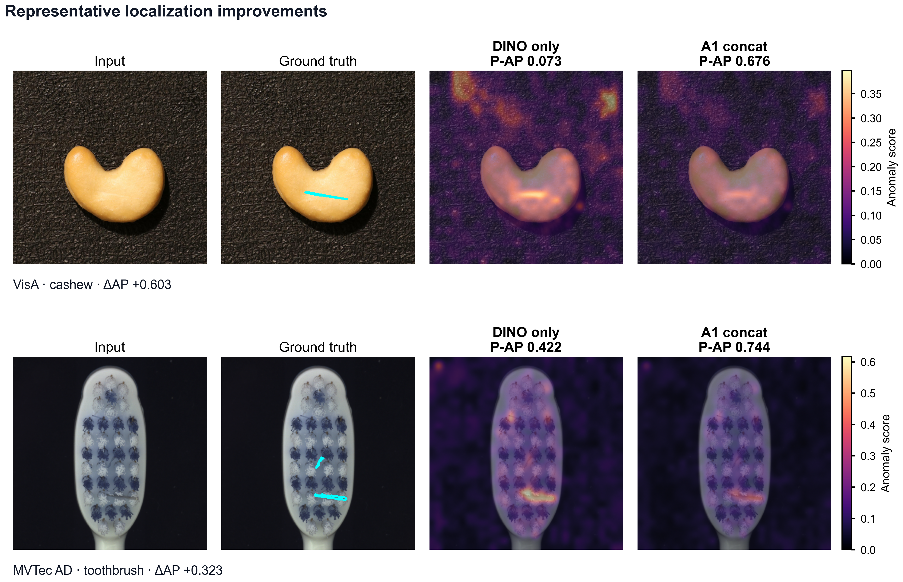
Figure 5. Selected success cases at seed 0 and one shot: VisA cashew 085 and MVTec toothbrush 004. A1 denotes DCFnet. Cyan marks ground-truth boundaries; scores share a color scale within each row. P-AP is per image. Cases maximize the recorded per-image gain in their respective categories and are illustrative extremes. 轮廓。
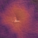
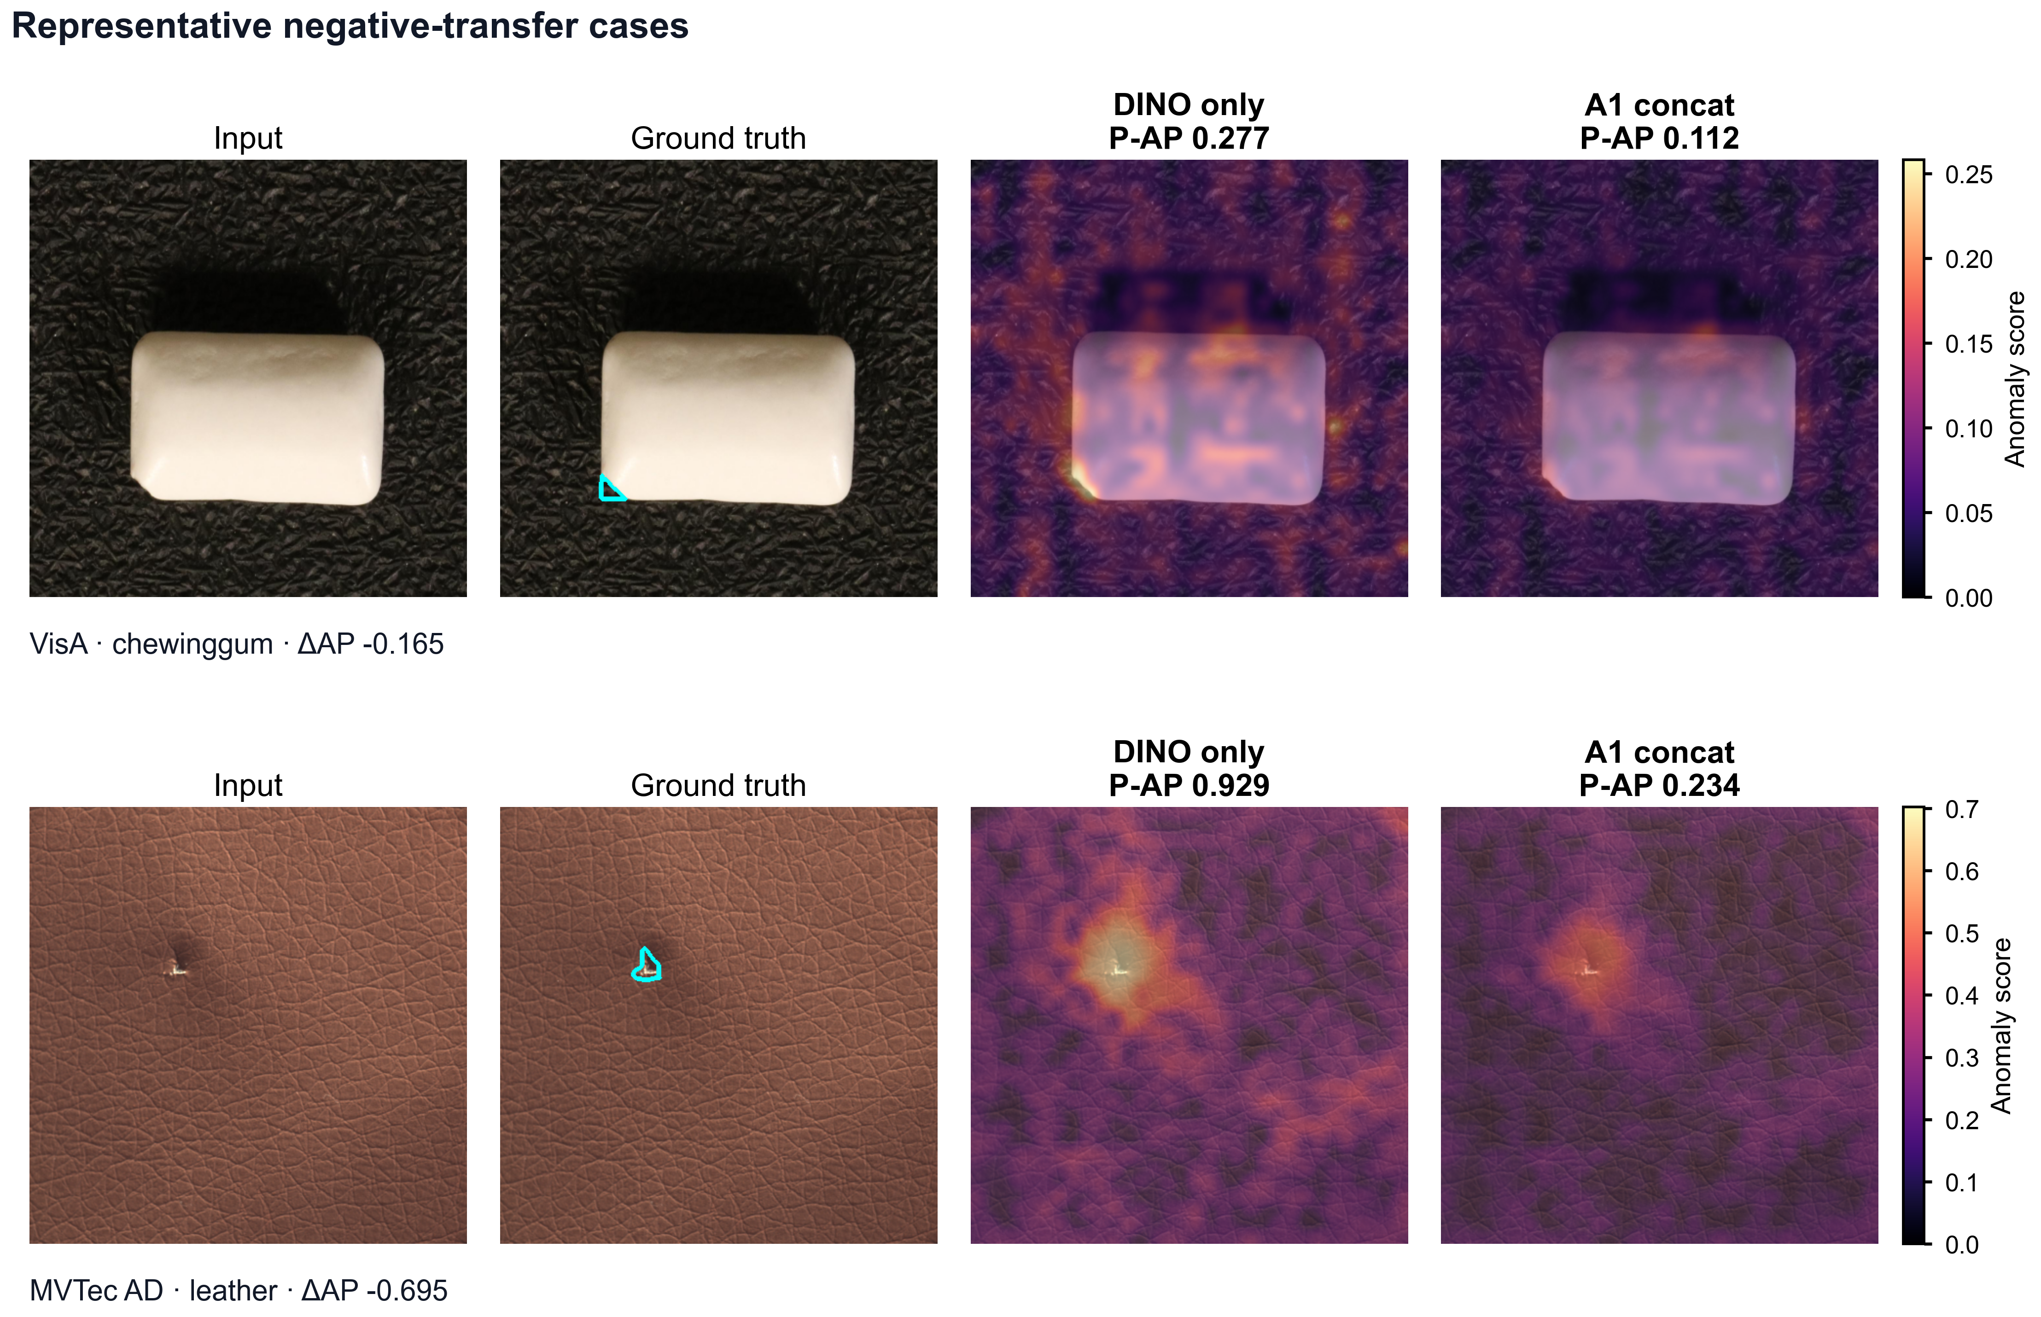
Figure 6. Selected negative-transfer cases at seed 0 and one shot: VisA chewinggum 037 and MVTec leather poke 016. A1 denotes DCFnet. These category-extreme failures show stronger DINO-only localization being degraded by fusion; they do not establish the cause of the degradation.
The cashew and toothbrush examples show improved ranking of defect regions relative to background responses. Conversely, chewinggum and leather show that a stronger DINO-only localization can be diluted by the second branch. Texture sensitivity, receptive-field differences, and imperfect grid correspondence are plausible explanations, but the present controls do not separate them causally. A dedicated intervention study would be required before attributing the losses to a specific semantic or texture mechanism.
- 5个本文方法的检测图例子（细节放大版）

图：所有对比方法针对样品1的检测结果，样品2，样品3
Method1

所有对比方法loss 随着epoch的变化曲线。问我要。

VRAM 消耗（所有对比方法）vs 推理速度。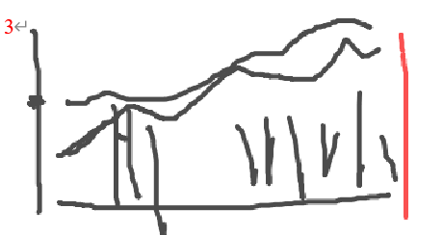
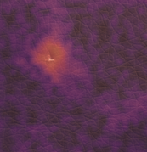


4.2.5 Efficiency and Memory Cost
Table 8 reports the measured stage costs. CLIP extraction dominates the stage-summed mean of 0.4146 seconds per image; its reciprocal is approximately 2.412 images per second under the stated setup. This is an aggregate estimate from separate stage measurements, not an independently measured production throughput. The experiment establishes that zero target-domain training does not remove the runtime cost of the additional backbone.
Table 8. Stage timing for the one-shot bottle benchmark
Stage | Device | Mean seconds | Std seconds
DINOv2 extraction | GPU | 0.0626 | 0.0010
CLIP extraction | GPU | 0.3049 | 0.0010
Alignment + fusion + retrieval | CPU | 0.0471 | 0.0012
Sum of stage means | Mixed | 0.4146 | Not estimated
Three warm-ups and 30 repetitions per stage; one-time loading excluded. Reciprocal aggregate ≈ 2.412 images/s.
Archived extraction measurements report peak allocated GPU memory of 374.58 MB for DINOv2 and 2,072.81 MB for CLIP. The maximum recorded working set across the separate benchmark processes is 3,980.9 MB. These are stage/process maxima; they do not establish the peak of an implementation holding both models and all cached features simultaneously. Dataset-level bank totals in Table 9 show the exact dimension-driven storage increase. They sum the category banks at each $K$ and exclude model parameters, query caches, and allocator overhead.
Table 9. Aggregate normal-memory storage in float32 MB
Dataset | Method | 1 shot | 2 shots | 4 shots
MPDD | DINO-only | 18.87 | 37.75 | 75.50
MPDD | DCFnet | 37.75 | 75.50 | 150.99
BTAD | DINO-only | 10.42 | 20.84 | 41.68
BTAD | DCFnet | 20.84 | 41.68 | 83.36
VisA | DINO-only | 49.94 | 99.88 | 199.75
VisA | DCFnet | 99.88 | 199.75 | 399.51
MVTec AD | DINO-only | 47.19 | 94.37 | 188.74
MVTec AD | DCFnet | 94.37 | 188.74 | 377.49
Sum over category banks; decimal MB. Descriptor storage only, without model weights or query caches.

4.2.6 Reproducibility and Remaining Limitations
The accompanying repository records the frozen configuration, reference identities, split and checkpoint hashes, per-configuration metrics, and a CPU replay path. The compact prediction package contains 324 category/configuration files with float16 patch-score arrays, occupying approximately 186.8 MB; each file can contain multiple test images. Dataset images and third-party weights are obtained separately. Replaying quantized maps verifies the archived evaluation within its stated tolerance, whereas a full reproduction also requires the recorded checkpoints, preprocessing, and legally obtained datasets.
Several limitations remain. The study validates the complete fusion path but not the isolated contribution of each calibration operation. Deterministic grid resizing is not semantic correspondence. Category-specific losses show that equal fusion is not universally suitable. The pixel evaluator uses stride sampling, so tiny defects can be missed by the evaluation lattice. VisA retains a conservative in-domain role, the tested benchmarks do not cover all industrial settings, and the stage-based runtime audit is narrower than a deployed application benchmark. These limitations bound the present claim and define concrete targets for further experiments.

5 Conclusion
We presented DCFnet, a normal-only few-shot anomaly-localization pipeline that combines frozen DINOv2 and DPAM-configured CLIP visual descriptors through deterministic spatial and magnitude calibration. Its joint normal-memory distance uses both representations without learning a fusion network or invoking text at inference. Matched experiments across four datasets, three reference seeds, and three shot levels show positive dataset-level P-AP gains in all 36 configurations. Additional single-branch controls on BTAD and MVTec AD support a benefit beyond either isolated visual branch under that protocol.
The benefit is qualified by persistent category losses, lower BTAD image-level AP and maximum F1, stronger results from some broader baselines, and a material inference-cost increase. DCFnet is therefore a transparent fixed-fusion reference rather than a universal best-performing detector. Future work should isolate calibration components, test controlled alternatives to grid interpolation, validate any selective fusion rule without external-test tuning, and measure an integrated application pipeline. Such studies are necessary before assigning a causal mechanism to the observed complementarity or claiming wider deployment suitability.

Data and Code Availability
The implementation and reproducibility materials are available at https://github.com/USEU117/sci_project. Within the repository, docs/submission_reproducibility_20260826/README.md is the reproduction entry point, and submission_repro_20260827 contains the archived evidence package. Its SOURCE_COMMIT and checksum manifests identify the experiment archive; they do not identify later manuscript edits. The evaluated data are MPDD [29], BTAD [30], MVTec AD [31], and VisA [32], distributed by their respective providers. The repository records the required dataset layout and checkpoint identifiers without redistributing the original images or third-party model weights.

References
[1] M. Yang, J. Liu, Z. Yang, and Z. Wu, 'SLSG: Industrial image anomaly detection with improved feature embeddings and one-class classification,' Pattern Recognit., vol. 156, Art. no. 110862, 2024. https://doi.org/10.1016/j.patcog.2024.110862.
[2] A. Luo, G. Wen, Y. Cheng, S. Mei, H. Dong, and X. Liu, 'DMMGNet: A discrimination mapping and memory bank mean guidance-based network for high-performance few-shot industrial anomaly detection,' Neurocomputing, vol. 610, Art. no. 128622, 2024. https://doi.org/10.1016/j.neucom.2024.128622.
[3] S. Damm, M. Laszkiewicz, J. Lederer, and A. Fischer, 'AnomalyDINO: Boosting patch-based few-shot anomaly detection with DINOv2,' in Proc. IEEE/CVF Winter Conf. Appl. Comput. Vis. (WACV), 2025, pp. 1319-1329. Available: https://openaccess.thecvf.com/content/WACV2025/html/Damm_AnomalyDINO_Boosting_Patch-Based_Few-Shot_Anomaly_Detection_with_DINOv2_WACV_2025_paper.html
[4] J. Zhou, W. Wong, and F. Liao, 'One-shot unsupervised industrial anomaly detection: Enhanced performance under extreme data scarcity,' Pattern Recognit., vol. 173, Art. no. 112759, 2026. https://doi.org/10.1016/j.patcog.2025.112759.
[5] X. Guo, Z. Chen, C. D. Castillo, H. Wang, and X. Liu, 'Sea-CLIP: Mining semantic-aware representations for few-shot anomaly detection with CLIP,' in Proc. IEEE/CVF Winter Conf. Appl. Comput. Vis. (WACV), 2026, pp. 3689-3699. Available: https://openaccess.thecvf.com/content/WACV2026/html/Guo_Sea-CLIP_Mining_Semantic-Aware_Representations_for_Few-Shot_Anomaly_Detection_with_CLIP_WACV_2026_paper.html
[6] X. Zhang, M. Xu, and X. Zhou, 'RealNet: A feature selection network with realistic synthetic anomaly for anomaly detection,' in Proc. IEEE/CVF Conf. Comput. Vis. Pattern Recognit. (CVPR), 2024, pp. 16699-16708. https://doi.org/10.1109/cvpr52733.2024.01580.
[7] Y. Bai, J. Zhang, Z. Chen, Y. Dong, Y. Cao, and G. Tian, 'Dual-path frequency discriminators for few-shot anomaly detection,' Knowl.-Based Syst., vol. 302, Art. no. 112397, 2024. https://doi.org/10.1016/j.knosys.2024.112397.
[8] T. Defard, A. Setkov, A. Loesch, and R. Audigier, 'PaDiM: A patch distribution modeling framework for anomaly detection and localization,' in Pattern Recognition. ICPR International Workshops and Challenges, 2021, pp. 475-489. https://doi.org/10.1007/978-3-030-68799-1_35.
[9] K. Roth, L. Pemula, J. Zepeda, B. Schölkopf, T. Brox, and P. Gehler, 'Towards total recall in industrial anomaly detection,' in Proc. IEEE/CVF Conf. Comput. Vis. Pattern Recognit. (CVPR), 2022, pp. 14318-14328. https://doi.org/10.1109/cvpr52688.2022.01392.
[10] Z. Hu, X. Zeng, Y. Li, Z. Yin, E. Meng, L. Zhu, and X. Kong, 'Few-shot anomaly detection with adaptive feature transformation and descriptor construction,' Chin. J. Aeronaut., vol. 38, no. 3, Art. no. 103098, 2025. https://doi.org/10.1016/j.cja.2024.06.007.
[11] S. Wei, X. Wei, Z. Ma, S. Dong, S. Zhang, and Y. Gong, 'Few-shot online anomaly detection and segmentation,' Knowl.-Based Syst., vol. 300, Art. no. 112168, 2024. https://doi.org/10.1016/j.knosys.2024.112168.
[12] Y. Li, L. Tian, Y. Dai, W. Chen, L. Bao, and X. Liu, 'FastRef: Fast prototype refinement for few-shot industrial anomaly detection,' in Proc. IEEE/CVF Conf. Comput. Vis. Pattern Recognit. (CVPR), 2026, pp. 43040-43049. Available: https://openaccess.thecvf.com/content/CVPR2026/html/Li_FastRef_Fast_Prototype_Refinement_for_Few-shot_Industrial_Anomaly_Detection_CVPR_2026_paper.html
[13] Z. Gu, B. Zhu, G. Zhu, Y. Chen, M. Tang, and J. Wang, 'UniVAD: A training-free unified model for few-shot visual anomaly detection,' in Proc. IEEE/CVF Conf. Comput. Vis. Pattern Recognit. (CVPR), 2025, pp. 15194-15203. Available: https://openaccess.thecvf.com/content/CVPR2025/html/Gu_UniVAD_A_Training-free_Unified_Model_for_Few-shot_Visual_Anomaly_Detection_CVPR_2025_paper.html
[14] C. Lendering, E. Akdag, and E. Bondarev, 'SubspaceAD: Training-free few-shot anomaly detection via subspace modeling,' in Proc. IEEE/CVF Conf. Comput. Vis. Pattern Recognit. (CVPR), 2026, pp. 28557-28566. Available: https://openaccess.thecvf.com/content/CVPR2026/html/Lendering_SubspaceAD_Training-Free_Few-Shot_Anomaly_Detection_via_Subspace_Modeling_CVPR_2026_paper.html
[15] L. Jiang, Y. Huang, Z. Xu, Y. Xu, H.-S. Wong, and S. Wu, 'Defect cue-preserved structural feature refinement for few-shot anomaly detection,' in Proc. IEEE/CVF Conf. Comput. Vis. Pattern Recognit. (CVPR), 2026, pp. 35607-35616. Available: https://openaccess.thecvf.com/content/CVPR2026/html/Jiang_Defect_Cue-Preserved_Structural_Feature_Refinement_for_Few-Shot_Anomaly_Detection_CVPR_2026_paper.html
[16] J. Jeong, Y. Zou, T. Kim, D. Zhang, A. Ravichandran, and O. Dabeer, 'WinCLIP: Zero-/few-shot anomaly classification and segmentation,' in Proc. IEEE/CVF Conf. Comput. Vis. Pattern Recognit. (CVPR), 2023, pp. 19606-19616. https://doi.org/10.1109/cvpr52729.2023.01878.
[17] Q. Zhou, G. Pang, Y. Tian, S. He, and J. Chen, 'AnomalyCLIP: Object-agnostic prompt learning for zero-shot anomaly detection,' in Proc. Int. Conf. Learn. Represent. (ICLR), 2024. Available: https://proceedings.iclr.cc/paper_files/paper/2024/hash/d7b50b8ac2c781a12f26155f48310d8d-Abstract-Conference.html
[18] X. Li, Z. Zhang, X. Tan, C. Chen, Y. Qu, Y. Xie, and L. Ma, 'PromptAD: Learning prompts with only normal samples for few-shot anomaly detection,' in Proc. IEEE/CVF Conf. Comput. Vis. Pattern Recognit. (CVPR), 2024, pp. 16838-16848. Available: https://openaccess.thecvf.com/content/CVPR2024/html/Li_PromptAD_Learning_Prompts_with_only_Normal_Samples_for_Few-Shot_Anomaly_CVPR_2024_paper.html
[19] J. Zhu and G. Pang, 'Toward generalist anomaly detection via in-context residual learning with few-shot sample prompts,' in Proc. IEEE/CVF Conf. Comput. Vis. Pattern Recognit. (CVPR), 2024, pp. 17826-17836. https://doi.org/10.1109/cvpr52733.2024.01688.
[20] W. Ma et al., 'AA-CLIP: Enhancing zero-shot anomaly detection via anomaly-aware CLIP,' in Proc. IEEE/CVF Conf. Comput. Vis. Pattern Recognit. (CVPR), 2025, pp. 4744-4754. https://doi.org/10.1109/cvpr52734.2025.00447.
[21] J. Zhu, Y.-S. Ong, C. Shen, and G. Pang, 'Fine-grained abnormality prompt learning for zero-shot anomaly detection,' in Proc. IEEE/CVF Int. Conf. Comput. Vis. (ICCV), 2025, pp. 22241-22251. https://doi.org/10.1109/iccv51701.2025.02065.
[22] H. Ma, G. Yang, D. Zhao, Y. Ji, and W. Zuo, 'ReMP-AD: Retrieval-enhanced multi-modal prompt fusion for few-shot industrial visual anomaly detection,' in Proc. IEEE/CVF Int. Conf. Comput. Vis. (ICCV), 2025, pp. 20425-20434. https://doi.org/10.1109/iccv51701.2025.01899.
[23] L. Xu, D. Han, G. Li, M. Zhou, J. Wan, and M. Li, 'Multimodal feature cooperative refinement for few-shot anomaly detection,' Adv. Eng. Inform., vol. 68, pt. C, Art. no. 103792, 2025. https://doi.org/10.1016/j.aei.2025.103792.
[24] R. Ma, C. Li, J. Chen, Y. Feng, and J. Xie, 'PAPL: Particle-based adaptive prompt learning for zero-shot industrial anomaly detection,' Pattern Recognit., vol. 178, Art. no. 113489, 2026. https://doi.org/10.1016/j.patcog.2026.113489.
[25] J. Jiang, Z. He, A. Wan, K. AL-Bukhaiti, and K. Wang, 'Zero-shot industrial anomaly detection via CLIP-DINOv2 multimodal fusion and stabilized attention pooling,' Electronics, vol. 14, no. 24, Art. no. 4785, 2025. https://doi.org/10.3390/electronics14244785.
[26] M. Oquab et al., 'DINOv2: Learning robust visual features without supervision,' Trans. Mach. Learn. Res., 2024. Available: https://openreview.net/forum?id=a68SUt6zFt
[27] A. Radford et al., 'Learning transferable visual models from natural language supervision,' in Proc. 38th Int. Conf. Mach. Learn., vol. 139, 2021, pp. 8748-8763. Available: https://proceedings.mlr.press/v139/radford21a.html
[28] J. Johnson, M. Douze, and H. Jegou, 'Billion-scale similarity search with GPUs,' IEEE Trans. Big Data, vol. 7, no. 3, pp. 535-547, 2021. https://doi.org/10.1109/tbdata.2019.2921572.
[29] S. Jezek, M. Jonak, R. Burget, P. Dvorak, and M. Skotak, 'Deep learning-based defect detection of metal parts: Evaluating current methods in complex conditions,' in Proc. 13th Int. Congr. Ultra Modern Telecommun. Control Syst. Workshops, 2021, pp. 66-71. https://doi.org/10.1109/icumt54235.2021.9631567.
[30] P. Mishra, R. Verk, D. Fornasier, C. Piciarelli, and G. L. Foresti, 'VT-ADL: A vision transformer network for image anomaly detection and localization,' in Proc. IEEE 30th Int. Symp. Ind. Electron., 2021, pp. 1-6. https://doi.org/10.1109/isie45552.2021.9576231.
[31] P. Bergmann, M. Fauser, D. Sattlegger, and C. Steger, 'MVTec AD - A comprehensive real-world dataset for unsupervised anomaly detection,' in Proc. IEEE/CVF Conf. Comput. Vis. Pattern Recognit. (CVPR), 2019, pp. 9592-9600. https://doi.org/10.1109/cvpr.2019.00982.
[32] Y. Zou, J. Jeong, L. Pemula, D. Zhang, and O. Dabeer, 'SPot-the-Difference self-supervised pre-training for anomaly detection and segmentation,' in Proc. Eur. Conf. Comput. Vis. (ECCV), 2022, pp. 392-408. https://doi.org/10.1007/978-3-031-20056-4_23.
[33] C. Wang et al., 'Real-IAD: A real-world multi-view dataset for benchmarking versatile industrial anomaly detection,' in Proc. IEEE/CVF Conf. Comput. Vis. Pattern Recognit. (CVPR), 2024, pp. 22883-22892. https://doi.org/10.1109/cvpr52733.2024.02159.

Supplementary Method Figures
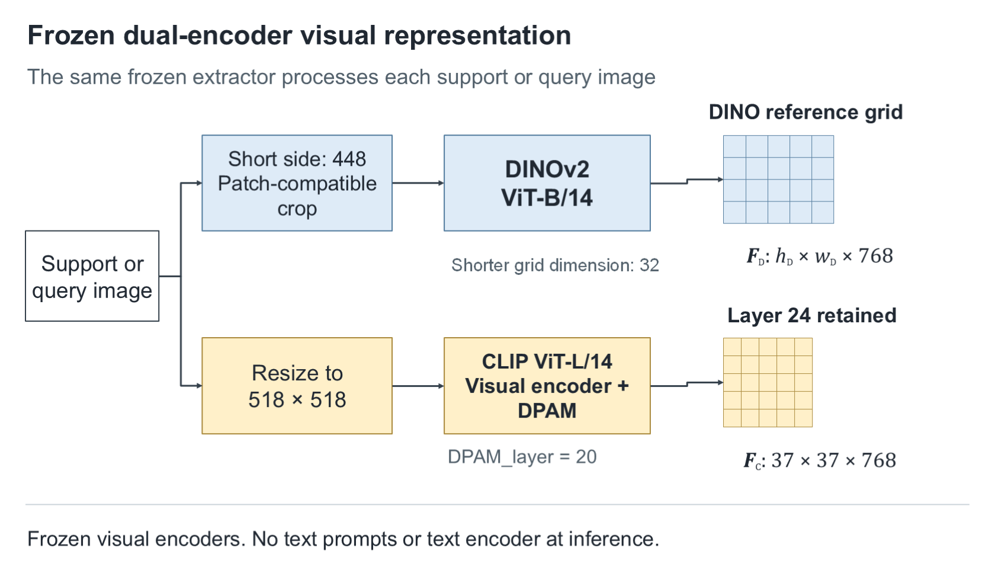
Figure S1. Frozen visual encoders and native patch grids. Both patch sizes are 14 pixels; the grid difference arises from preprocessing. CLIP hidden features are projected to 768 dimensions, and only the final requested local tensor is retained.
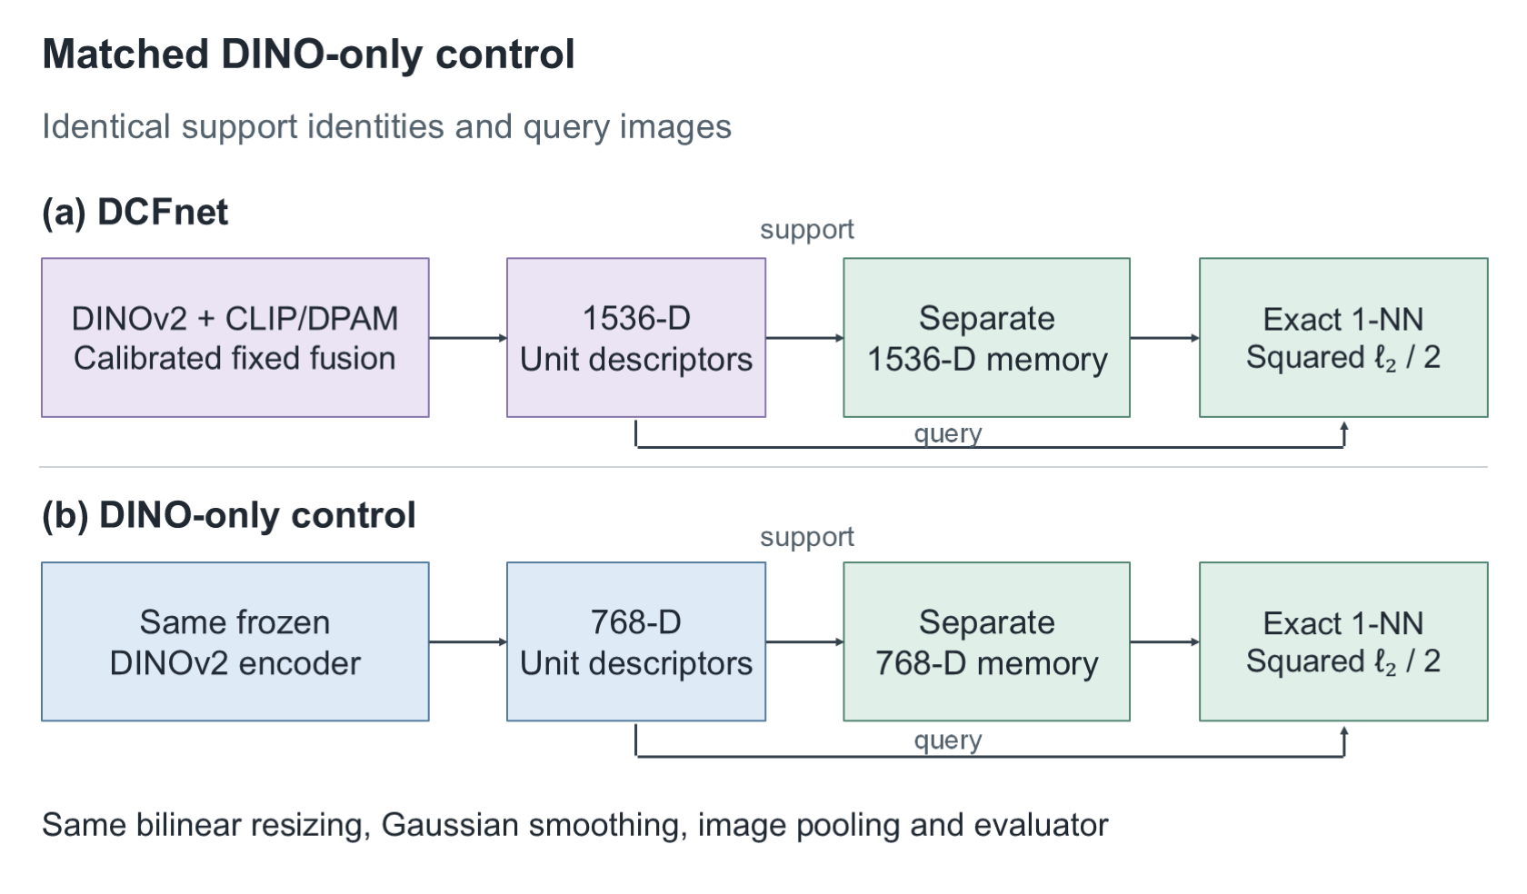
Figure S2. Matched ablation design. DINO-only and DCFnet share reference identities and downstream scoring, while each builds a memory in its own descriptor space. The CLIP-image-only control is additionally evaluated on BTAD and MVTec AD.

