Using the NCS to Control Application Execution

June 2005

Introduction

Purpose
This document explains how to run applications using the NISGS Control System (NCS).
The NCS is part of the National Polar-orbiting Operational Environmental Satellite System (NPOESS) Preparatory Project (NPP) In-Situ Ground System (NISGS), now under development by NASA’s Goddard Space Flight Center (GSFC) Direct Readout Laboratory (DRL), Code 606.3. .

NCS design and function

Overview
The NISDS Control System (NCS) is a subsystem of the NISGS (see figure 1). Other NISGS subsystems acquire spacecraft Direct Broadcast telemetry during a satellite pass, remove transmission artifacts and store the resulting packet data in computer-accessible files.
The NCS schedules and executes science processing algorithms to generate data products.
The NCS acquires the input resources required by the science algorithm before running the application. Resources may be packet files, products previously generated by other algorithms, or ancillary files.
The NCS requests these resources from the Data Storage Manager (DSM) and the DSM locates the resource in a Data Repository. The DSM returns the resource location to the NCS. The NCS executes the program and registers the resultant output products with the DSM.
The NCS sends status and event messages to the NISGS Status/Event Logging System (NSLS).
.
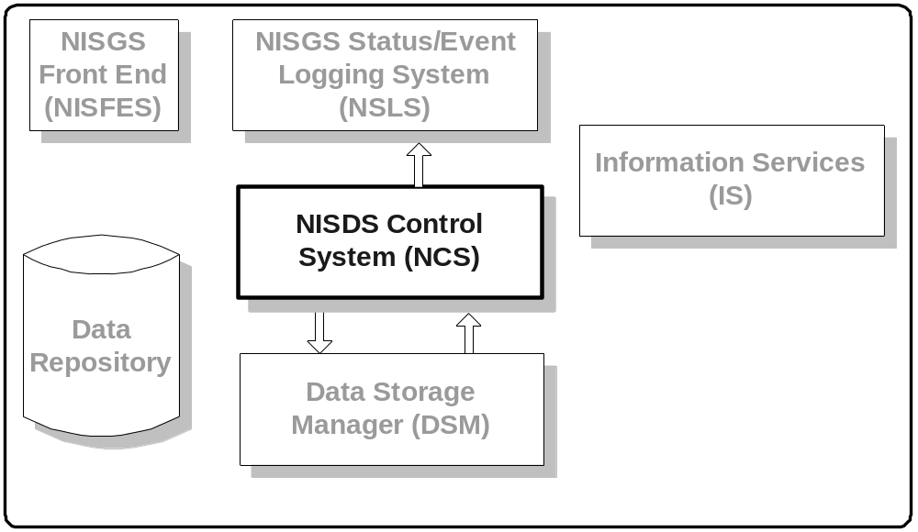
Figure 1: NCS is a Subsystem of NISGS

The NCS architecture is decentralized and based on the notion of a station. There may be any number of stations in the NCS, and the stations may reside on multiple computers (see figure 2).
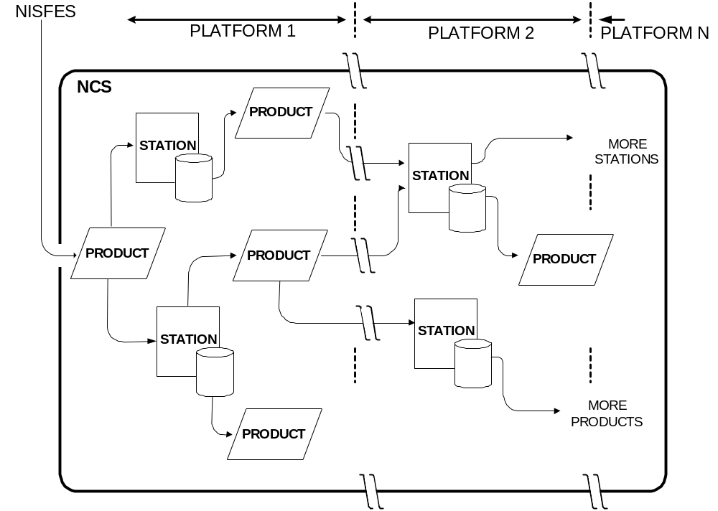
Figure 2: NCS Decentralized Architecture
Each NCS Station is independent of other stations; it communicates only with the DSM and the NSLS and therefore stations can be added or removed without modifying the remaining stations. Stations may be added to accommodate new science algorithms or to better distribute computing and storage loads within existing or added hardware resources.
An NCS Station generally controls the execution of a single science algorithm or other application, but a station can consecutively run multiple programs as when an application requires a preprocessor. Where useful for dividing loads among several platforms or multi-threaded processors, multiple stations can run separate instances of the same application.
NCS Stations are data-driven; there is no central planner or scheduler. An NCS Station requests the input resources from the DSM and waits for the DSM to respond before executing the algorithm.
Each NCS station is an executing control program and a subdirectory. The control program instances are identical for all stations. The subdirectory contains a configuration file and several other requisite station files and may contain files required by the science algorithm. (See figure 3.) The configuration file defines the characteristics of the NCS Station. To easily manage NCS operation, station Subdirectories are generally made subdirectories of a “stations” subdirectory.

Bob has figure 3
Figure 3. NCS Station Subdirectory

The basic operation of an NCS Station is presented in Figure 4. The arrows indicate data flow. When started, the NCS Control Program reads a configuration file to determine the input resources required by the science processing algorithm.
The control program requests these resources from the DSM and waits for the DSM to respond. The DSM returns the locations of the requested resources.
The station then builds the execution environment required by the algorithm. The environment includes subdirectories, environment variables, and auxiliary files or links.
The station next assembles a program command line and executes the program. If execution is successful, the station registers the resulting products with the DSM, and deletes the program environment. If execution fails, the environment is preserved for later analysis. The NCS Control Program then requests the next set of input resources from the DSM.

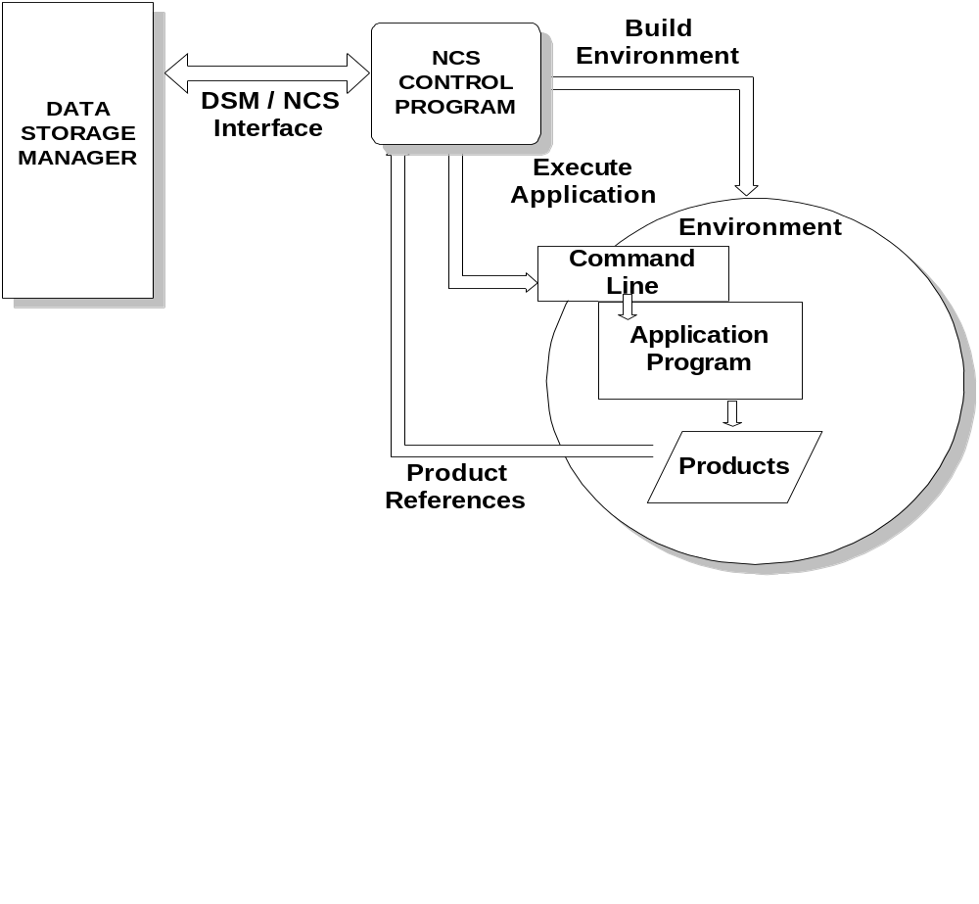Figure 4 NCS Station Operation

Creating an NCS Station
NCS Stations are created by making a new station subdirectory and populating it with the requisite files. Generally, NCS Stations are easier to control if the station subdirectories reside within a single parent directory. Usually, a good way to create a new NCS station subdirectory is to simply copy and modify an existing subdirectory or template.
An NCS Station directory must initially contain a command file and a configuration file. The command file must be named “station.cmdfile” and it must contain the text “cmd=run”. The configuration file is an XML file defining the NCS Station’s behavior. The default configuration file name is station.cfgfile.
The NCS program always creates a lock file and a RUN directory in the station subdirectory. The lock file is a mechanism to prevent multiple program executions in the same subdirectory. A current RUN Directory is created for each application program before it executes. If the program successfully completes, the RUN Directory and its contents are deleted. If the program fails, the RUN directory is renamed FAIL and is retained for analysis.
The NCS program optionally creates an NSLS Log File, and an NSLS Log Directory. The NSLS Log File is a text file containing event messages forwarded to the NSLS Server. The directory saves messages for later transmission if the NSLS client is unable to connect to the server.
The station subdirectory may also contain files required or generated by the application program. However, data products are generally stored in a central data subdirectory external to the NCS.

Station Configuration
NCS Station behavior is defined by assigning values to parameters and specifying NCS program commands. Parameter values may be optionally set on the program command or by commands in the configuration file. NCS program commands are specified in the configuration file.

Parameters
NCS Parameters store information required by the NCS Program in a name/value table. Parameter names are always text strings, but values may be text strings, or objects defined by the Data Storage Manager.

Parameter Initialization
Parameters may assigned values by the program, set on the program command line as parameter name/value pairs, or set by commands in the configuration file.

Parameters assigned by the NCS Program
Parameter names prefixed with “cfg_” have predefined meaning to the NCS station program and therefore, although not enforced, these names should not be used in other contexts. Most predefined parameters have default values that need not be changed. However, the following parameters usually should be manually set.

Cfg_stationName
This name should uniquely identify the NCS Station on a computer. The name identifies the station to the Data Storage Manager and identifies the source of events sent to the NSLS .

Cfg_groupTag
NCS Stations executing the same algorithm should specify the same groupTag to prevent multiple stations from processing the same input products.

Cfg_logServerURL
This is the host name of the NSLS Server.

Cfg_logPort
This is the port number of the NSLS Server.

Cfg_stationLog
This is the name of a local file where NSLS text messages are written.

The following parameters are useful for debugging the configuration file. Their default values are set to “false”.

Cfg_keepDirectory
When set “true”, the local RUN directory is unconditionally retained after program execution.

Cfg_printDSM
When set “true”, the DSM initialization values are printed.

Cfg_printNsls
When set “true”, the NSLS initialization values are printed.

Cfg_printCommands
When set “true”, NCS configuration file commands are printed as they are executed.

Cfg_printXML
When set “true”, the NCS configuration file is printed as parsed by the XML interpreter.

Parameters set on the command line
Parameters may be defined and initialized on the command line as parameter name/value pairs. The format is: -name value -name value . . .

The nisgs_home parameter is set to the NCS absolute directory path using the java –D system property mechanism.

Parameters set by NCS Commands
Parameters may explicitly defined and initialized using the Ncs_set command or returned as the result of an NCS command. The Ncs_read command reads a list of parameter name/value pairs from a file.

Configuration File
Each NCS Station contains a configuration file. The configuration file specifies the NCS Station behavior, the required input resources, execution environment and how to execute the application through NCS Commands. The configuration file contains text in XML format. The NCS Confguration File XML structure is:

<CONFIGURE>
<SETUP>
Commands executed once when the NCS Station is started.
</SETUP>

<EXECUTE>
commands executed each time a product is generated.
</EXECUTE>
</CONFIGURE>

Commands in the SETUP section are executed once when the NCS program starts. Parameters established in the SETUP section are restored to their original values before each execution of a science application.
Commands in the EXECUTE section are invoked each time the science application runs. All parameters and other artifacts created in the this section are deleted when the application completes.

Configuration File Command Format
Commands add or modify NCS parameters or use parameter values to perform some function and they are executed sequentially as they appear in the configuration file. Most NCS Commands have the following format:
<Command attribute=”value” attribute=”value”…../>
By example:
<Ncs_set name=”cfg_stationName” value=”FireIndex” debug=”true” />
is an “Ncs_set” command setting a parameter named “cfg_stationName” to the value “FireIndex”. Some attributes may be mandatory or optional depending on the command. It is not an error to include an undefined attribute in a command.
Most commands include two optional boolean attributes: “runFlag” and “debug”. If “runFlag” is not “false” the command executes. If “debug” is “true”, the command prints internal diagnostic information to the standard output.
Parameters prefixed with “cfg_”, as in the previous example, have special meaning
A simple substitution mechanism allows the construction of new parameter values from existing parameters. Text delimited by a left brace “{“ and right brace “}” is interpreted as a parameter and is replaced by the parameter value. For example, the commands:
<Ncs_set name=”prefix” value=”new” />
<Ncs_set name=”suffix” value=”group3” />
<Ncs_set name=”testit” value=”{prefix}-test-{suffix}” />
will result in three parameters named “prefix”, “suffix”, and “testit”. “testit” will have a value of “new-test-group3”. As in this example, multiple substitutions may be made within a single value and substitutions can be directly nested. Where braces “{“, “}”, must be interpreted as ordinary characters, they may be escaped by prefixing a “\” .
Text may be continued on succeeding lines, but the carriage return cannot be escaped with a “\” and will be replaced with a blank. That is:
<Ncs_set name="testa" value="this is a test line1
line2" />
will give the parameter “testa” a value of: “this is a test line1 line2”.

Special NCS Commands
DSM Command
The DSM Command is a special NCS Command to communicate with the Data Storage Manager.
The command format is:

<Dsm_command result=”resultname” class=”dsmclass” method=”dsmmethod” >
<methodargumenttype value=”argumentvalue” />
<methodargumenttype value=”argumentvalue />
. . .
</Dsm_command>

DSM classes and methods are described in the Data Storage Manager Javadoc. Methodargumenttypes may be String, Object, or any of the Java numeric wrappers (e.g. Float, Double, Integer, etc). The following example retrieves a file name from the aqua.gbad.eph.OBJ object.

<Dsm_command result=”ephemerisfile”
class=”aqua.gbad.eph.OBJ” method=”getResource”>
<String value=”DATA” />
</Dsm_command>

Direct Readout Laboratory Science Processing Algorithm Wrapper Commands.
Direct Readout Laboratory Science Processing Algorithm Wrapper (SPA) Wrappers present a common model for initialization and execution of science algorithm applications. The NCS wrapper commands interface directly with the wrappers. SPA wrappers are described in TBD.

InitAlgorithm Command
The InitAlgorithm Command creates and initializes a Direct Readout Laboratory Science Processing Algorithm Wrapper object. This command is usually placed in the SETUP section of the NCS Configuration File. The format is:

<InitAlgorithm result=”spawrapperobject” file=”xmlinstallationfile” />

RunAlgorithm Command
The RunAlgorithm Command runs an SPA Wrapper Object and is placed int the EXECUTE section of the NCS Configuration File. The format is:
<RunAlgorithm algorithm=”spawrapperobject” />

. . .

Appendix ?? Configuration File Commands

Command: Dsm_command

Purpose:
Invoke Data Storage Manager (DSM) Commands by specifying class type, and method arguments. See the DSM javadoc for classes and methods. Not all classes and methods are supported.

Command Format:
<Dsm_command attributes>
<argtype value=”value” />
<argtype value=”value” />
. . .
</Dsm_command>

Example:
From the DSM Javadoc, a reserveProduct method of the DSM class is:

Product reserveProduct( java.lang.String productType,
java.lang.Integer sleepSeconds);

An example NCS Configuration File Command calling this method would be;

<Dsm_command
blockflag="true"
result="aqua.gbad.pds"
class="DSM"
method="reserveProduct">
<String value="aqua.gbad.pds" />
<Integer value="{dsmsleep}"/>
</Dsm_command>

Where the key="value" attributes are:

class - Required name of the DSM object. See DSM Javadoc for DSM classes. Not all DSM classes are supported.

method – Required method name to be invoked. If method is "new", an object of class type is created.

result - Optional result of invoking the method.

blockflag- Optional true/false flag, defaults to "false". Flag warns NCS that this DSM command can block.

waitflag- Optional true/false flag, defaults to "false". If "true", station waits for DSM command to return non-null value.

runFlag- Optional true/false flag, defaults to "true". If "true", command is executed.

debug- Optional true/false flag, defaults to "false". If "true", debug information is sent to the standard output.

DSM method arguments "argType", are one of the data types: String, Object, or any of the Java numeric wrappers (e.g. Float, Double, Integer, Long, Short).

Description:

The NCS Dsm_command gives the configuration file access to the Data Storage Manager. Requests for requisite input products and registration of output products are implemented through this command. The DSM javadoc describes the DSM classes and methods.

New Data Storage Manager objects may be created by specifying method=”new” in the command. The DSM object itself is created implicitly by the NCS and should not be created using the configuration file.

The blockflag informs the NCS that execution of this command may be safely stopped to effect an orderly shutdown of this station. An orderly shutdown means that any product currently being generated will be registered with the DSM before the station terminates.

Generally, the blockflag should be set “true” for DSM method which can block if the method is called before the creation of a product. Otherwise, the NCS Station may wait indefinitely for the product to complete. Methods called to register a product after its creation should exclude the blockflag or set its value to “false” so that the method will complete and the product will be registered before the station stops.

Some Data Storage Manager methods return a “null” a requested product or resource is not available. If the waitflag is set “true”, then the NCS will wait for the DSM to return a non-null result. The blockflag is implicitly set when the waitflag is set.
Command: Ncs_checkFile

Purpose:
Verify existance of a file or directory and optionally get file attributes.

Command Format:
<Ncs_checkFile attributes />

Example:

<Ncs_checkFile debug="false" file="pdsfile" s ize="pdssize" />

Where the key="value" attributes are:

file- Required name of file to be verified. May be absolute or relative to current directory.

result- Optional flag set to "true" if file exists. Otherwise, is set to false. If not specified, throws FileNotFoundException if file not found.

length- Optional name of java.lang.Long object to hold file length in bytes. See the Java api.

date- Optional name of java.util.Date object to hold file modification date. See the Java api.

runFlag- Optional true/false flag, defaults to "true". If "true", command is executed.

debug- Optional true/false flag, defaults to "false". If "true", debug information is sent to the standard output.

Description:
This command verifies existance of a file or directory and optionally gets file attributes.

Command: Ncs_compare

Purpose:
Perform logical comparisons of numeric, date or string values.

Command Format:
<Ncs_compare attributes />

Example:

<Ncs_compare valueA=”123” valueB=”456” type=”Numeric”
A_gt_B=”result” />

Where the key="value" attributes are:

valueA - Required name of Parameter A.

valueB - Required name of Parameter B.

type – Required comparison type. "Numeric" if values are to compared numerically. "String" if string comparison.

A_gt_B - Optional name of result. If A is greater than B, then result is "true", otherwise, "false".

A_eq_B - Optional name of result. If A equals B, then result is "true", otherwise, "false".

A_ne_B - Optional name of result. If A is not equal to B, then result is "true", otherwise, "false".

runFlag- Optional true/false flag, defaults to "true". If "true", command is executed.

debug- Optional true/false flag, defaults to "false". If "true", debug information is sent to the standard output.

Command: Ncs_date

Purpose:
Create a java.util.Date object or get the string value of an existing date.

Command Format:
<Ncs_date attributes />

Example:

<Ncs_date name="startDate" setValue="now" getValue="start" />

Where the key="value" attributes are:

name – Required name of date object.

pattern – Optional parse pattern for date. Defaults to "yyDDDHHmmss". See java.test.SimpleDateFormat Class javadoc.

getValue – Optional name where parsed value string from an existing date will be stored.

setValue – Optional date value to set date. if value is “now”, date will be set to current date.

offset – Optional starting position in Date/time string to begin parsing setvalue. Defaults to zero.

runFlag- Optional true/false flag, defaults to "true". If "true", command is executed.

debug- Optional true/false flag, defaults to "false". If "true", debug information is sent to the standard output.

Discription
Ncs_date creates a java.util.Date object or gets the string value from an existing Date object.

If setValue is specified, it must be a date/time string in the pattern format and a new Date will be created and entered into the pool. The current date may used by specifying setValue="now".

If getValue is specifed, it is the name in the pool where the date/time string parsed from an existing date will be stored. The Date object must exist, but may be created by also specifying a setValue.

If neither setValue nor getValue is specified, the named Date object will be created using the current date and entered into the pool.

Command: Ncs_deleteFile

Purpose:
Delete a file or directory.

Command Format:
<Ncs_delete attributes />

Example:

<Ncs_delete name="/home/charlile/tempfile" />

Where the key="value" attributes are:

file – Required path/file of file or directory to be deleted.

runFlag- Optional true/false flag, defaults to "true". If "true", command is executed.

debug- Optional true/false flag, defaults to "false". If "true", debug information is sent to the standard output.

Command: Ncs_editValue

Purpose:
Edit a value in the parameter table using a regular expression.

Command Format:
<Ncs_editValue attributes />

Example:

<Ncs_editValue result="ephfile"
name="P0420064AAAAAAAAAAAAAA05056160116001.PDS" replacement="1.eph"
pattern="1\.PDS" />

Where the key="value" attributes are:

name – Required value (not parameter name) to be modified.

result – Required new name for result in parameter table.

pattern – Required regular expression to be applied to value.

replacement – Required replacement text used by the regular expression.

runFlag- Optional true/false flag, defaults to "true". If "true", command is executed.

debug- Optional true/false flag, defaults to "false". If "true", debug information is sent to the standard output.

Description:
Replace the first part of the text in “name” matching the regular expression in “pattern” with the text in “replacement”. See java.lang.String replaceFirst() method javadoc.

See java.util.regex.Pattern for a summary of regular expressions. For a more detailed description, see “Mastering Regular Expressions”, Jeffrey E. F. Friedl, O'Reilly and Associates, 1997.

Command: Ncs_getFileNames

Purpose:
Get a list of files in a directory.

Command Format:
<Ncs_getFileNames attributes />

Example:
<!-- Get relative subdirectory with yyyy_mm_dd_hhmmss format-->
<Ncs_getFileNames
directory="{cfg_runDirectory}"
listName="mod1Dir"
pattern="^[0-9]\{4\}(_[0-9]\{2\})\{2\}_[0-9]\{6\}"
/>

Where the key="value" attributes are:

directory – Required path to directory containing files to be listed.

pattern - Optional regular expression for selecting files to be listed. If omitted, all files will be selected.

listName – Required parameter name for returned filename list. Filenames are delimited by blanks.

runFlag- Optional true/false flag, defaults to "true". If "true", command is executed.

debug- Optional true/false flag, defaults to "false". If "true", debug information is sent to the standard output.

Description:

See java.util.regex.Pattern for a summary of regular expressions. For a more detailed description, see “Mastering Regular Expressions”, Jeffrey E. F. Friedl, O'Reilly and Associates, 1997.

Command: Ncs_get

Purpose:
Put the text string value of a java.lang.Number object in the parameter table.
This allows retrieval of the value of Number objects returned by some Data Storage manager methods.

Command Format:
<Ncs_get attributes />

Example:
<Ncs_get name=”SleepSeconds” value=”time” />

Where the key="value" attributes are:

name - Required name of Number object (e.g. Float, Double, Integer, Long, Short) to be added or modified.

value – Required name of parameter to hold returned text value.

runFlag- Optional true/false flag, defaults to "true". If "true", command is executed.

debug- Optional true/false flag, defaults to "false". If "true", debug information is sent to the standard output.

Command: Ncs_getMatch

Purpose:
Extract part of a value matching a regular expression.

Command Format:
<Ncs_getMatch attributes />

Example:

<Ncs_getMatch name=
"/home/charlie/demo/P0420064AAAAAAAAAAAAAA05056160116001.PDS"
result="gbadpds" pattern="P.......AAAAAAAAAAAAAA0.............\.PDS"
/>

In this example, result will contain only the file name.

Where the key="value" attributes are:

name – Required value to be modified.

result – Required name of parameter containing result.

pattern – Required regular expression to be applied to “name”.

runFlag- Optional true/false flag, defaults to "true". If "true", command is executed.

debug- Optional true/false flag, defaults to "false". If "true", debug information is sent to the standard output.

Description:
See java.util.regex.Pattern for a summary of regular expressions. For a more detailed description, see “Mastering Regular Expressions”, Jeffrey E. F. Friedl, O'Reilly and Associates, 1997.

Command: Ncs_log

Purpose:
Set default NISGS Status/Event Logging System (NSLS) default parameters and write a log message.

Command Format:
<Ncs_log attributes />

Example:

<Ncs_log level=”INFO” pass=”aquapass” text=”this is a night pass” />

Where the key="value" attributes are:

text - Optional message text. If not present, any specified default NSLS parameters are set, but a log message is not generated.

level - Optional severity level is one of: INFO, WARN, ERROR. If not specified, default is INFO.

pass - Optional name DSM pass object. If specified, default NSLS.PassParameters are initialized from the pass object.

Pass Id - unique pass number assigned by DSM.
Spacecraft - name of spacecraft
Station Name - name of receiving station
AOS - time of acquisition of signal
LOS - time of loss of signal

product - Optional name DSM product object. If specified, default NSLS.ProductParameters are initialized from the product.

Product Id - unique product number assigned by DSM.
Product Type - name of product
Pass Id - unique pass number assignd by DSM.

granule - Optional granule (String). A granule is a segment of a spacecraft pass. Value is copied to NSLS.GranuleParameters.

runFlag- Optional true/false flag, defaults to "true". If "true", command is executed.

debug- Optional true/false flag, defaults to "false". If "true", debug information is sent to the standard output.

Description:
Ncs_log sets default NISGS Status/Event Logging System (NSLS) default parameters and writes a log message. See the DSM and NSLS javadocs.
Command: Ncs_loop

Purpose:
Loop through one or more lists. In each iteration, the next name is selected from each list and substituted for any corresponding {listname} in the loop body. Loops may be nested.

Command Format:
<Ncs_loop attributes >
<ncs command 1 />
<ncs command 2 />
. . .
</Ncs_loop>

Example:
<Ncs_set name=”list_1” value=”abc def ghij” />
<Ncs_set name=”list_2” value=”123 45 678” />

<Ncs_loop lists=”list_1 list_2” >
<Ncs_print text=” list 1 = {list_1} and list 2 = {list_2}” />
</Ncs_loop>

The above example would print:
list 1 = abc and list 2 = 123
list 1 = def and list 2 = 45
list 1 = ghij and list 2 = 678

Where the key="value" attributes are:

lists - List of lists separated by whitespace. All lists must be same length. Lists are names separated by blanks.

runFlag- Optional true/false flag, defaults to "true". If "true", command is executed.

debug- Optional true/false flag, defaults to "false". If "true", debug information is sent to the standard output.

Command: Ncs_parseFile

Purpose:
Substitute text in a file. Parameter names delimited by braces ({}) are replace by the corresponding values in the parameter table.

Command Format:
<Ncs_parseFile attributes />

Example:

<Ncs_parseFile sourceFile=”pcsTemplate” targetFile=”pcsFile” />

Where the key="value" attributes are:

sourceFile – Required name of file to be read. May be absolute or relative to current directory.

targetFile – Required name of file to be read. May be absolute or relative to current directory.

runFlag- Optional true/false flag, defaults to "true". If "true", command is executed.

debug- Optional true/false flag, defaults to "false". If "true", debug information is sent to the standard output.
Command: Ncs_print

Purpose:
Print text to a file or to the Standard Output. This command is primarily a debugging tool.

Command Format:
<Ncs_print attributes />

Example:

<Ncs_print text=”value of cfg_sleepSeconds is: {cfg_sleepSeconds}” />

Where the key="value" attributes are:

text - Optional text to be printed.

table - Optional true/false flag, defaults to "false". It true, print contents of parameter pool.

file - Optional file to receive printed values. if not present, print to Standard output.

runFlag- Optional true/false flag, defaults to "true". If "true", command is executed.

debug- Optional true/false flag, defaults to "false". If "true", debug information is sent to the standard output.

Description:
Ncs_print prints text to a file or to the Standard Output. This command is primarily a debugging tool for printing table values and text. If both “text” and “table” attributes are specified, the text precedes the table listing.

Command: Ncs_readFile

Purpose:
Read parameters and values from a file into the parameter tablel. The file contents are assumed to be lines each containing a parameter=value pair.

Command Format:
<Ncs_print attributes />

Example:

<Ncs_readFile file=”newvaluefile” />

Where the key="value" attributes are:

file – Required name of file to be read. May be absolute or relative to current directory.

runFlag- Optional true/false flag, defaults to "true". If "true", command is executed.

debug- Optional true/false flag, defaults to "false". If "true", debug information is sent to the standard output.

Command: Ncs_run

Purpose:
Execute a science application or other program.

Command Format:
<Ncs_run attributes >
<env name=”variable_name” value=”value” />
<env name=”variable_name” value=”value” />
. . .
</Ncs_run/>

Example:

<Ncs_run
standardFile="stdfile"
errorFile="errfile"
directory="{SDSVIEWER_DIR}"

cmd="{sdsviewer} -mode NDVI -exit yes -show no -tiff yes -reverse yes -hdffile {ndvifilelnk} -hkmfile {hkmfilelnk}">

<env name="SDSVIEWER_DIR" value="{SDSVIEWER_DIR}" />
<env name="DISPLAY" value=":0.0" />
</Ncs_run>

Where the key="value" attributes are:

cmd – Required command line specifying program and arguments. The format is: “program arg1 arg2 ...”.

directory – Optional local directory for program execution. Default is "."

standardFile – Optional file where program standard output is written. Output is lost if not specified.

errorFile - Optional file where program error output is written. Output is lost if not specified.

goodReturn - Optional return value expected if program execution is successful. Default is 0 (zero).

runFlag- Optional true/false flag, defaults to "true". If "true", command is executed.

debug- Optional true/false flag, defaults to "false". If "true", debug information is sent to the standard output.

Command: Ncs_set

Purpose:
Add or modify the value of a parameter in the parameter table.

Command Format:
<Ncs_set attributes />

Example:
<Ncs_set name=”waitflag” value=”true” />

Where the key="value" attributes are:

name – Required name of parameter value to be added or modified.

value – Required new value of parameter

type- Optional parameter type. Type may be: Byte, Double, Float, Integer, Long, Short or String. If this option is specified, the command wraps the value in one of these classes. Otherwise, the value is a string.

runFlag- Optional true/false flag, defaults to "true". If "true", command is executed.

debug- Optional true/false flag, defaults to "false". If "true", debug information is sent to the standard output.

Command: Ncs_set

Purpose:
Add or modify the value of a parameter in the parameter table.

Command Format:
<Ncs_set attributes />

Example:
<Ncs_set name=”waitflag” value=”true” />

Where the key="value" attributes are:

name – Required name of parameter value to be added or modified.

value – Required new value of parameter

type- Optional parameter type. Type may be: Byte, Double, Float, Integer, Long, Short or String. If this option is specified, the command wraps the value in one of these classes. Otherwise, the value is a string.

runFlag- Optional true/false flag, defaults to "true". If "true", command is executed.

debug- Optional true/false flag, defaults to "false". If "true", debug information is sent to the standard output.

Command: Ncs_sleep

Purpose:
Delay execution for a specified number of seconds.

Command Format:
<Ncs_sleep attributes />

Example:
<Ncs_sleep value=”60” />

Where the key="value" attributes are:

value – Optional delay time in seconds. If not specified, default is 10 seconds.

runFlag- Optional true/false flag, defaults to "true". If "true", command is executed.

debug- Optional true/false flag, defaults to "false". If "true", debug information is sent to the standard output.

Command: Ncs_stop

Purpose:
Terminate execution of a job. The NCS Station continues to run.

Command Format:
<Ncs_stop attributes />

Example:
<Ncs_stop level=”INFO” message=”Night Pass. No product expected” />

Where the key="value" attributes are:

message – Optional message written to the NISGS Status/Event Logging System. Default is “300 Ncs_stop command”.

runFlag- Optional true/false flag, defaults to "true". If "true", command is executed.

debug- Optional true/false flag, defaults to "false". If "true", debug information is sent to the standard output.

Command: Ncs_test

Purpose:
Return result of searching for a pattern in a text string.

Command Format:
<Ncs_test attributes />

Example:
</Ncs_test
name=”/demo/P1540957AAAAAAAAAAAAAA04229183716001.PDS”
pattern=”P.......AAAAAAAAAAAAAA0.............\.PDS”
result=”PDSfile”
/>

In this example, result would be “true”.

Where the key="value" attributes are:

name – Required name of parameter value to be modified.

result – Optional name for boolean result in parameter pool.

pattern – Required regular expression to be applied to value

runFlag- Optional true/false flag, defaults to "true". If "true", command is executed.

debug- Optional true/false flag, defaults to "false". If "true", debug information is sent to the standard output.

Description:
See java.util.regex.Pattern for a summary of regular expressions. For a more detailed description, see “Mastering Regular Expressions”, Jeffrey E. F. Friedl, O'Reilly and Associates, 1997.

Command: Ncs_write

Purpose:
Write text lines to a file.

Command Format:

<Ncs_write attributes >
<line> text </line>
<line> text </line>
. . .
</Ncs_write>

Example:

<Ncs_write file=”output”>
<line> text including {substitution} </line>
<line> text in next line </line>
</Ncs_write>

Where the key="value" attributes are:

file – Required name of file to be written.

runFlag- Optional true/false flag, defaults to "true". If "true", command is executed.

debug- Optional true/false flag, defaults to "false". If "true", debug information is sent to the standard output.

Default Parameters.xls

