**Author:** Joshua Ibrahim

**Site:** Kattis

**Date:** 9/29/2019

**Problem:** Hissing Microphone

**Difficulty:** 1.2

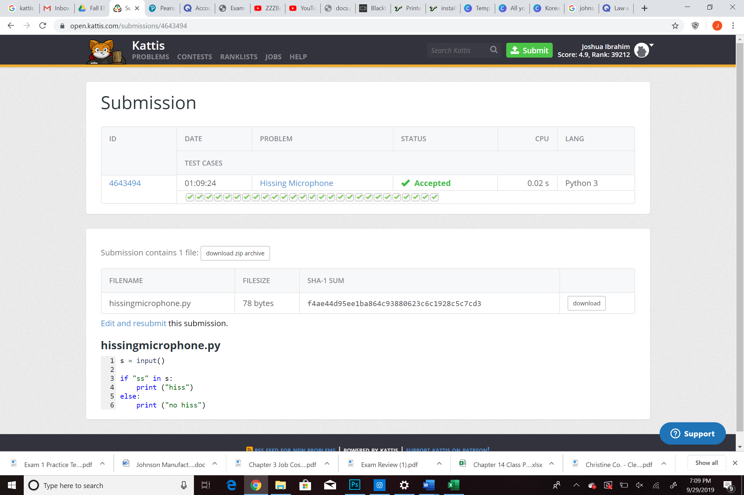

s = input()

if "ss" in s:

print ("hiss")

else:

print ("no hiss")

<https://github.com/josh195/muma-analytics/blob/master/hissingmicrophone.py>

