# 6. Core Analysis

## Overview

Core Analysis is the last FIA BioSum module and depends upon the successful completion of all the preceding modules. The purpose of the extensive data manipulation and analysis performed in the previous segments of FIA BioSum is to enable exploration of “case study scenarios”— referred to in this user’s guide as scenarios. A scenario represents a set of assumptions about the land base to be considered, which potential processing sites will be assumed to exist, what constitutes an effective treatment, and so on.

## Module Components

The button that activates the Core Analysis module can be found in the module-selector on the left-side of the FIA BioSum Manager desktop (it is labeled “Core Analysis”). Selecting it opens a 2-button panel that accesses two tasks: (1) **Define Calculated Variables** and (2) **Case Study Scenario**. Unless Calculated Variables are used, the current version of Core Analysis supports analysis for cycle 1 only.

## Define Calculated Variables

There are two categories of calculated variables (weighted FVS and weighted economic). Weighted FVS variables are derived from values in the PRE/POST tables that are generated by the FVS module. These tables are located in the /fvs/data/<variant> folder.

Weighted FVS variables can be used in a case study scenario when defining the elements of an effective treatment, as the optimization variable, or as the first tie-breaker variable. Weighted economic variables can be used in a case study scenario as the optimization variable or as the first tie-breaker variable. In addition, weighted economic variables derived from net revenue or onsite treatment costs can be used to filter packages in the optimization settings.

1. Click the <**Define Calculated Variables**> button to review the list of calculated variables. This screen lists all of the calculated variables available for use along with their descriptions and category/type.

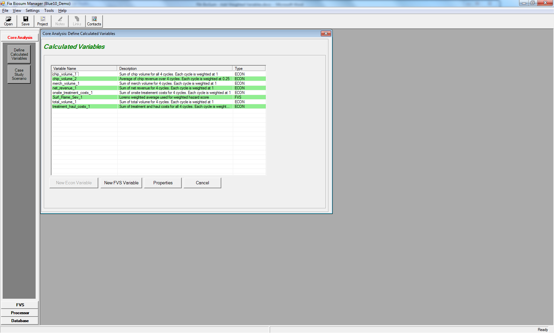

Figure 6.1: List of calculated variables

1. From this window, you have the option of (1) configuring a **New Econ Variable**, (2) configuring a **New FVS Variable**, (3) viewing the **Properties** of a variable, or (4) selecting **Cancel** to close the window. Note that configuring a new economic variable is currently disabled but will be included with a future release.

## Configuring a New FVS Variable

1. Click the **<New FVS Variable>** button to configure a new weighted FVS variable.

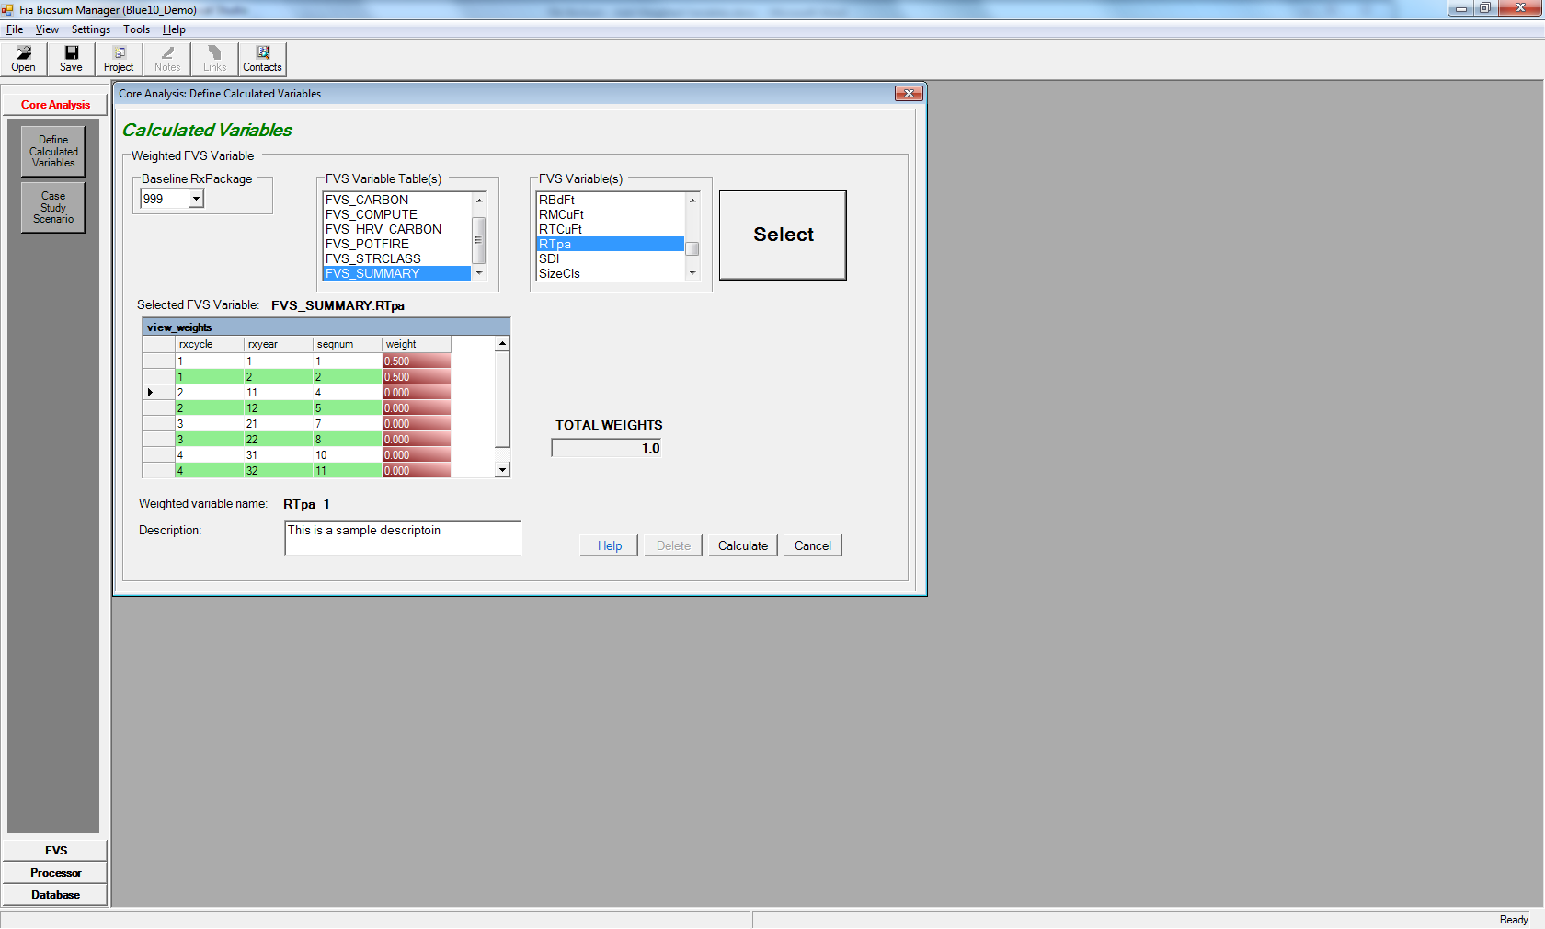

Figure 6.2: New weighted FVS variable properties screen

1. The fields on the weighted FVS variable properties screen are:
   1. **Baseline RxPackage**: Without weighted variables, the effectiveness of case study scenarios is based on the concept of comparing pre and post values for stand attributes for cycle 1; that is, comparing the values before and after treatment. With weighted variables, because you will be comparing summary values across multiple cycles/treatments, the first step is to choose a baseline RxPackage. Core Analysis will compare the metrics for each RxPackage to the results from the Baseline package. A common scenario is to compare active treatment packages with a grow-only package to isolate the effects of the treatments. Biosum grow-only packages are customarily assigned the RxPackage number 999, but this is configurable.
   2. **FVS Variable Table**: This is a list of all the FVS Pre/Post tables that are available to be used as the basis for an FVS weighted variable. If you do not see a table or field that you expect, check your FVS configuration. These tables are generated by the FVS module.
   3. **FVS Variable**: When you select an FVS Variable Table, this box will populate with a list of fields from that table. After you have selected your desired variable, click the **<Select>** button.
   4. **Selected FVS Variable:** This read-only field will populate with the table and name of the FVS variable you select from the dropdown lists. This field must be populated before clicking the **<Calculate>** button.
   5. **view_weights:** This table lists the rxcycle, rxyear, and sequence number associated with each analysis point. The rxyear and sequence number should be used only as a point of reference as they could vary across variants in the project. Each weight is linked to a cycle, Pre or Post. For example: cycle 1 Pre and cycle 1 Post. Enter the appropriate values in the editable (red) column for each analysis point. Below are two possible weighted variable configurations:

Table 6.1: Sample weights for an FVS variable summed over 4 cycles

|  |  |
| --- | --- |
| Cycle | Weight |
| 1 (Pre) | 1 |
| 1 (Post) | 1 |
| 2 (Pre) | 1 |
| 2 (Post) | 1 |
| 3 (Pre) | 1 |
| 3 (Post) | 1 |
| 4 (Pre) | 1 |
| 4 (Post) | 1 |

Table 6.2: Sample weights for an FVS variable averaged over 4 cycles

|  |  |
| --- | --- |
| Cycle | Weight |
| 1 (Pre) | 0.125 |
| 1 (Post) | 0.125 |
| 2 (Pre) | 0.125 |
| 2 (Post) | 0.125 |
| 3 (Pre) | 0.125 |
| 3 (Post) | 0.125 |
| 4 (Pre) | 0.125 |
| 4 (Post) | 0.125 |

* 1. **TOTAL WEIGHTS**: This read-only field will automatically add the weight values together as you enter weights into the view_weights grid. This is a running total.
  2. **Weighted Variable Name:** This read-only field contains the name of the weighted variable that displays on the Core Analysis scenario screens. FIA Biosum generates the Weighted Variable Name by appending a suffix to the selected FVS variable name. For example: the first weighted variable associated with Surf_Flame_Sev is Surf_Flame_Sev_1, the second Surf_Flame_Sev_2 and so on.
  3. **Description:** This is an optional, free form text field where you can type a description of the weighted FVS variable. This description appears on the main Calculated Variables screen and some Core Analysis scenario configuration screens.

1. There are three enabled buttons in the lower right-hand corner of the new weighted FVS variable screen. They are:
   1. **<Help>**: As on other FIA Biosum screens, clicking on this button opens a new window that displays help text and instructions associated with this screen.
   2. **<Calculate>**: The **<Calculate>** button saves the settings for the calculated variable to the project database. This button also calculates the weighted values for each stand + rxPackage + rxCycle and saves them to the PRE_<FVS_TABLE_NAME>_WEIGHTED and POST_<FVS_TABLE_NAME>_WEIGHTED tables where FVS_TABLE_NAME is the name of the source FVS output table. For example, if the source variable is from the FVS_POTFIRE table, the name of the PRE_<FVS_TABLE_NAME>_WEIGHTED table will be PRE_FVS_POTFIRE_WEIGHTED. These tables may be found in the /core/db/ prepost_fvs_weighted.accdb.

Because the values are calculated when the FVS weighted variable is created, they can be shared across multiple case study scenarios and will not be re-calculated when a scenario is run, shortening processing time.

* 1. **<Cancel>**: Closes the FVS variable properties screen without saving the contents and returns to the main Calculated Variables screen. This action will not save changes and cannot be undone.

## Viewing the Properties of an existing FVS Variable

1. Select the variable you want to review in the main Calculated Variables screen and click the <**Properties**> button. FVS variables can be identified by the ‘FVS’ value in the **Type** column.

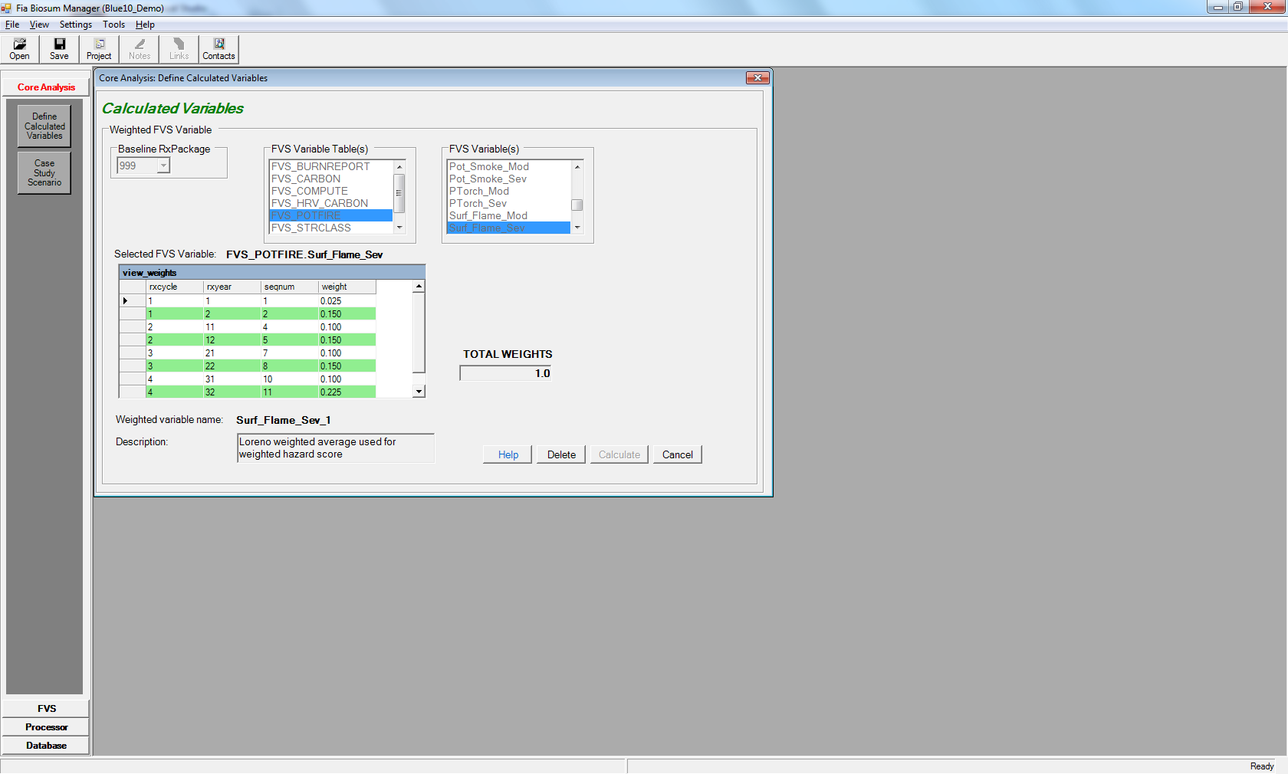

Figure 6.3: Existing weighted FVS variable properties screen

1. The screen for viewing the properties for an existing FVS variable is almost identical to the screen for creating a new weighted FVS variable. See the section immediately above for detailed descriptions of each field.

The weighted FVS variable properties screen is read-only. As weighted FVS variables can be shared across scenarios, it could lead to data corruption if a weighted FVS variable were re-configured and recalculated if it had been previously used in a case study scenario.

1. There are three enabled buttons in the lower right-hand corner of the new weighted FVS variable screen. They are:
   1. **<Help>**: As on other FIA Biosum screens, clicking on this button opens a new window that displays help text and instructions associated with this screen.
   2. **<Delete>**: The **<Delete>** button deletes the weighted FVS variable configurations from the project databases and the weighted value columns from the PRE_<FVS_TABLE_NAME>_WEIGHTED and POST_<FVS_TABLE_NAME>_WEIGHTED tables

Weighted FVS variables can only be deleted if they are not associated with any case study scenarios. FIA Biosum will prevent you from deleting an FVS variable if it is in use by a case study scenario**.**

* 1. **<Cancel>**: Closes the FVS variable properties screen without saving the contents and returns to the main Calculated Variables screen.

## Configuring a New Economic Variable

This function is not yet available but is slated for a future release

## Viewing the Properties of an Existing Economic Variable

1. Select the variable you want to review in the main Calculated Variables screen and click the <**Properties**> button. FVS variables can be identified by the ‘ECON’ value in the **Type** column.

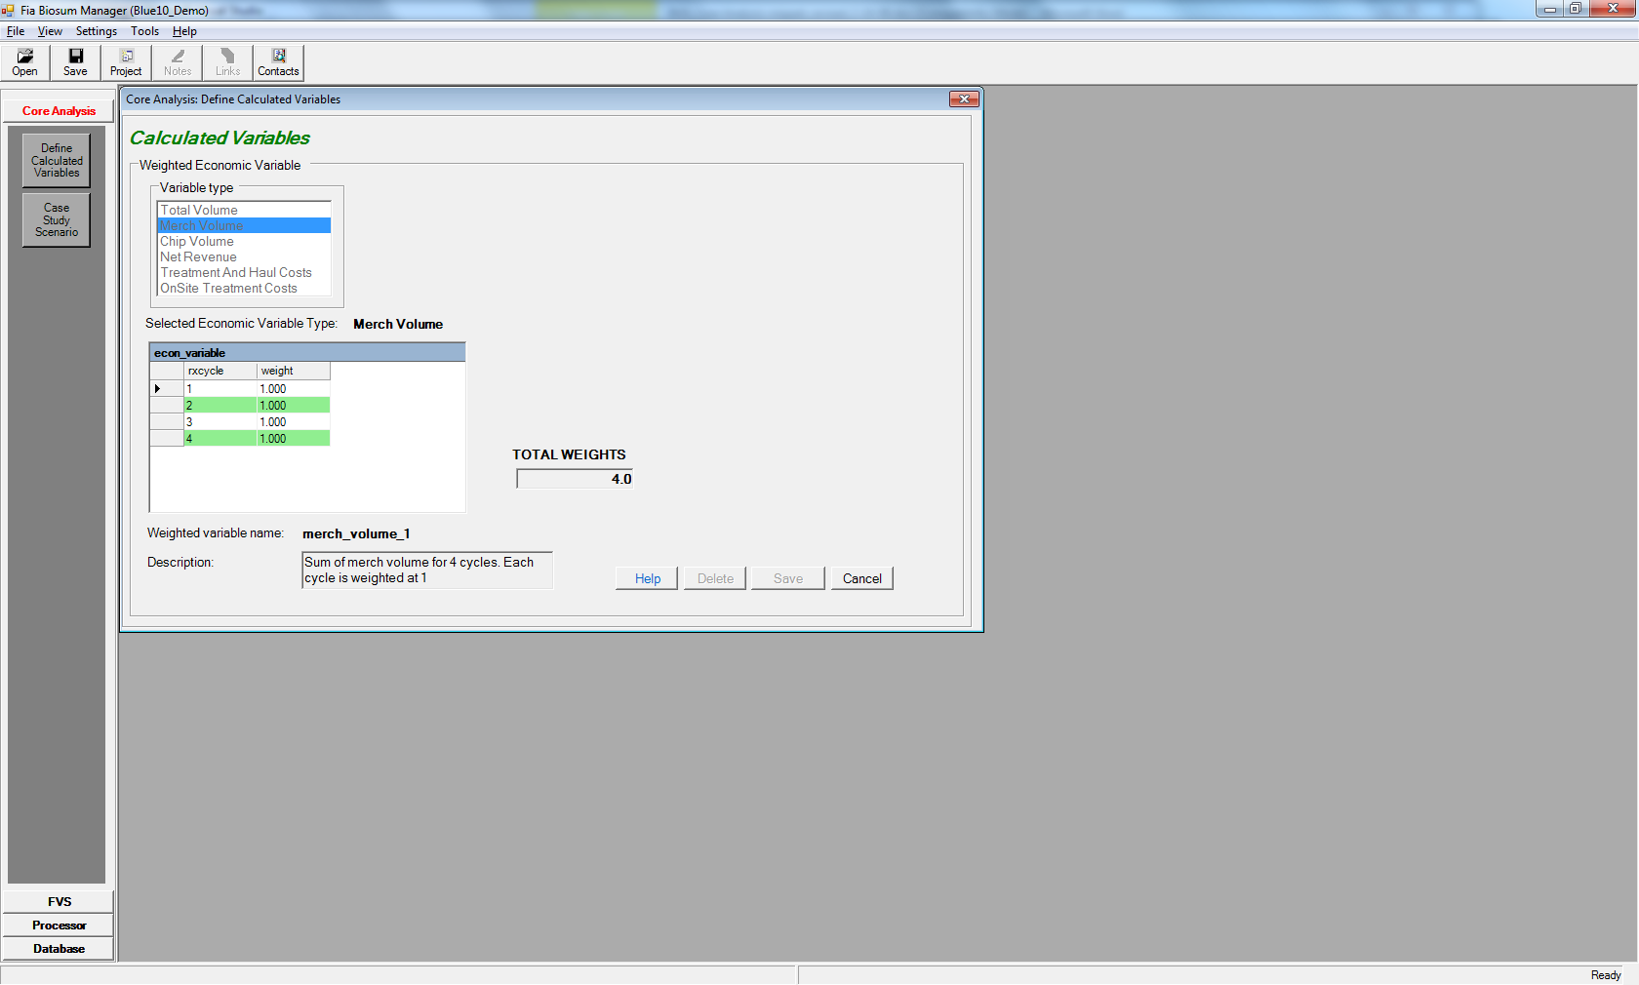

Figure 6.4: Weighted Economic variable properties window

1. The fields on the weighted Economic variable properties screen are:
   1. **Variable type**: The list of available weighted economic variable types; Economic variables must be based on one of the following six variable types:

Table 6.3: Six economic variable types available in FIA Biosum

|  |  |
| --- | --- |
| Type | Description |
| Chip Volume | Chip volume generated from the condition/package |
| Merch Volume | Merchantable volume generated from the condition/package |
| Total Volume | Sum of chip and merch volume |
| Net Revenue | Revenue generated from the condition/package less the treatment and haul costs |
| Treatment and Haul Costs | Sum of harvest treatment costs and haul costs |
| Onsite Treatment Costs | Harvest treatment costs |

* 1. **Selected economic variable type**: This read-only field shows the selected economic variable type
  2. **econ_variable**: This table displays the weight applied to each rxCycle. Below are two possible weighted variable configurations:

Table 6.4: Sample weights for an economic variable summed over 4 cycles

|  |  |
| --- | --- |
| Cycle | Weight |
| 1 | 1 |
| 2 | 1 |
| 3 | 1 |
| 4 | 1 |

Table 6.5: Sample weights for an economic variable averaged over 4 cycles

|  |  |
| --- | --- |
| Cycle | Weight |
| 1 | 0.25 |
| 2 | 0.25 |
| 3 | 0.25 |
| 4 | 0.25 |

* 1. **TOTAL WEIGHTS**: Sum of weights over 4 cycles
  2. **Weighted variable name**: This read-only field contains the name of the weighted variable that is displayed on the Core Analysis scenario screens. FIA Biosum generates the weighted variable name by appending a suffix to the selected economic variable type. For example: the first weighted variable associated with Merch Volume is merch_volume_1, the second merch_volume_2 and so on.
  3. **Description**: This is an optional, free form text field where there may be a description of the weighed economic variable. This description appears on the initial weighted variables screen and some Core Analysis scenario configuration screens.

1. There are three enabled buttons in the lower right-hand corner of the weighted economic variable properties screen. They are:
   1. **<Help>**: As on other FIA Biosum screens, clicking on this button opens a new window that displays help text and instructions associated with this screen.
   2. **<Delete>**: The **<Delete>** button deletes the weighted economic variable configurations from the project databases. Weighted economic variables can only be deleted if they are not associated with any existing Core Analysis scenarios. FIA Biosum will prevent you from deleting an economic variable if it is in use by a case study scenario**.** You are also prevented from deleting built-in weighted economic variables (described below).
   3. **<Cancel>**: Closes the economic variables property screen and returns to the main Calculated Variables screen.

## Built-in Weighted Economic Variables

FIA Biosum provides a set of default weighted economic variables for your use. These weighted variables assign a weight of 1 to each cycle resulting in the sum of the selected economic variable over all 4 cycles. For example, **net_revenue_1** is the net revenue for all 4 cycles combined. These built-in variables cannot be deleted.

# Case Study Scenario

When you click the <**Case Study Scenario**> button, the Open Scenario screen will appear:

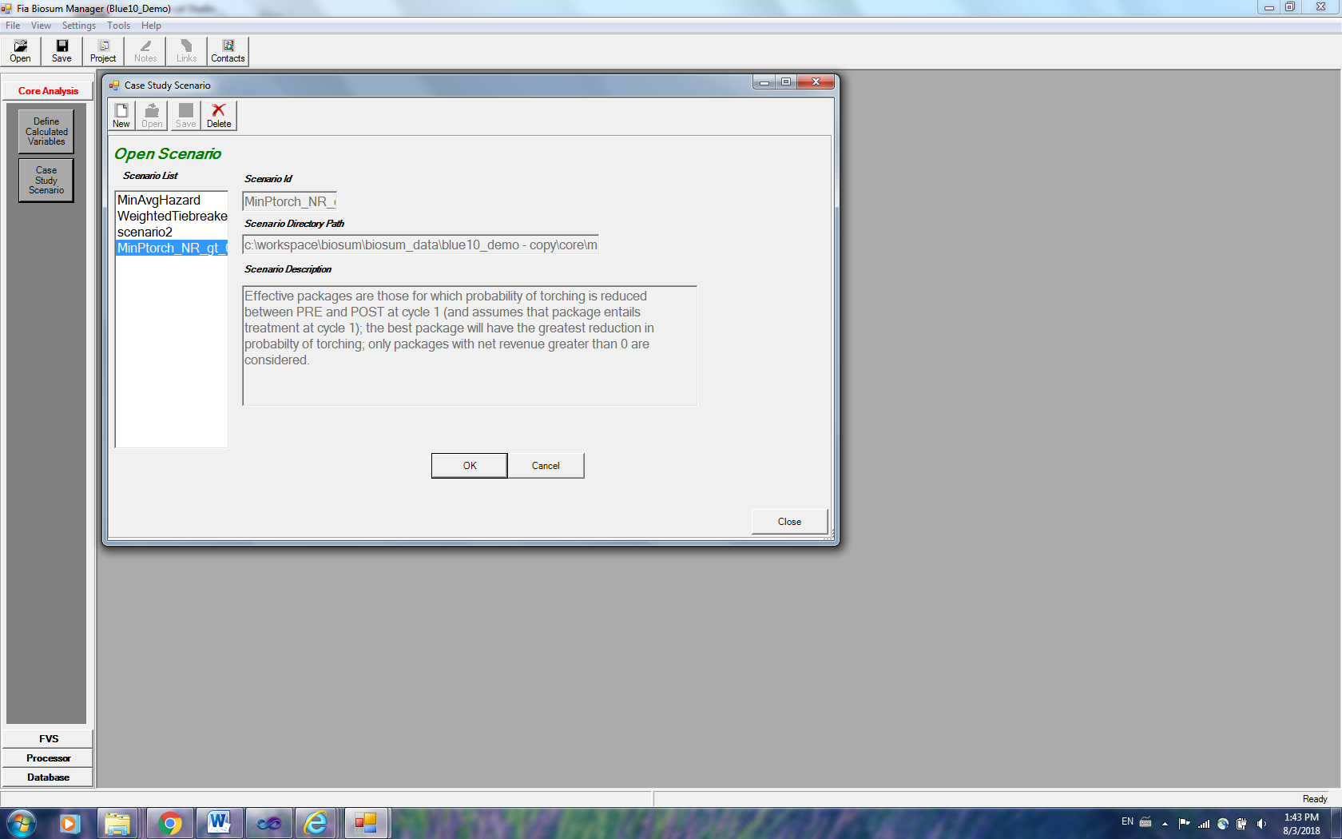

Figure 6.5: Open Scenario window

The Open Scenario form has the following fields:

1. **Scenario List**: This is the list of all the case study scenarios available in the project. When you click on a scenario in this list, the other fields on the screen will update to match your choice.
2. **Scenario Id**: The case study scenario id currently selected from the list
3. **Scenario Directory Path**: The computer file system path to the scenario currently selected from the list
4. **Scenario Description**: An optional free form description of the scenario currently selected from the list

There are two buttons enabled on the toolbar in the upper right-hand corner of this window. They are:

1. **<New>**: Use this button to create a new case study scenario. The **New Scenario** window that will open has places for you to enter the **Scenario Id** and **Description**. The scenario id is required but the description is optional. Although the suggested scenario id will start with scenario…, it is recommended to use a more descriptive scenario id so that it can be used to assist in identifying the scenario in the future.
2. **<Delete>**: Use this button to delete the selected scenario. All configuration settings and databases associated with the selected scenario will be deleted. Be careful, as this action cannot be undone.

There are two buttons at the base of this window. They are:

1. **<OK>**: This button opens the selected case study scenario and displays the configuration settings associated with it
2. **<Cancel>**: Closes the Open Scenario window

## Core Analysis Case Study Scenario properties

After clicking the <**OK**> button to open a case study scenario, you can review and update the scenario properties using a combination of buttons and tabs that are available on this form.

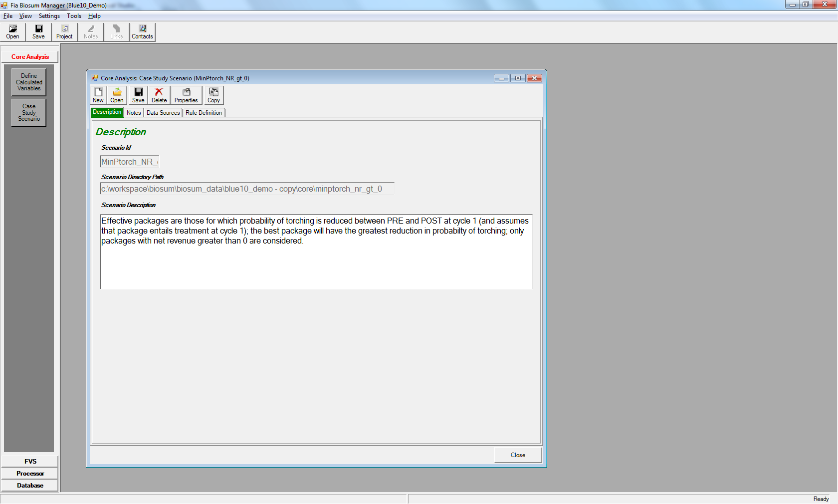

Figure 6.6: First page (Description tab) of case study scenario properties

The toolbar in the upper right-hand corner of this form has 6 buttons that are enabled. They are:

1. **<New>**: Opens the new scenario screen to create a new case study scenario
2. **<Open>**: Allows you to select and open an additional scenario. Having multiple case study scenarios open at the same time can be confusing and is not advised.
3. **<Save>**: Saves the configuration settings for the case study scenario that is open. This button saves all of the settings regardless of which tab is selected
4. **<Delete>**: Deletes the scenario that is open and returns to the Open Scenario screen. All configuration settings and databases associated with the deleted scenario will be removed. Be careful as this action cannot be undone
5. **<Properties>**: Displays the configuration settings for the current scenario in text format, allowing for the review of all configuration settings on a single page. This button is also useful when calibrating your case study scenario, as you can copy and paste the settings into an external text document that can be saved and used as a log or audit trail.
6. **<Copy>**: Copies the settings from a selected scenario to the current scenario. Be careful as copying a scenario overwrites any existing scenario settings and this action cannot be undone.

The Scenario Description can be updated on this form. The **<Close>** button closes the case study scenario properties window. FIA Biosum will prompt you to save any unsaved changes when closing.

There are three tabs, in addition to the **<Description>** tab, that are used to refine a case study scenario definition. They are (1) **Notes** (2) **Data Sources** and (3) **Rule Definitions**.

1. **Notes**: The **Notes** tab has copious space to accommodate detailed notes about a scenario. Use this tab if the Description field is not large enough to accommodate your descriptive text.
2. **Data Sources**: This tab displays pointers (file paths, file names, table names, status, records counts, etc.) to all types of source data used in the case study scenario. Any of these data sources can be copied to another table or database and the pointer updated to point to the copy instead of the original data source. These copies can then be updated or customized to allow consideration of different scenarios.

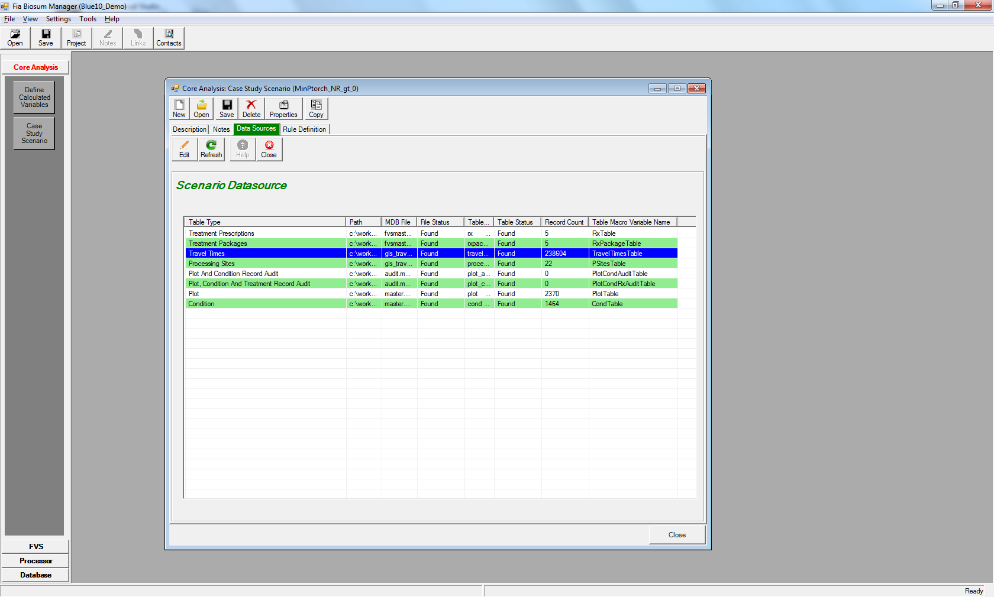

Figure 6.7: The Data Sources tab lists all of the case study scenario data sources

To edit the pointer to the data source, and to make copies of data sources, select a table type and click **<Edit>**. The **Edit Data Source** window will appear. Here you can move, copy, or rename existing Access DB files and tables, and reset links for any table type.

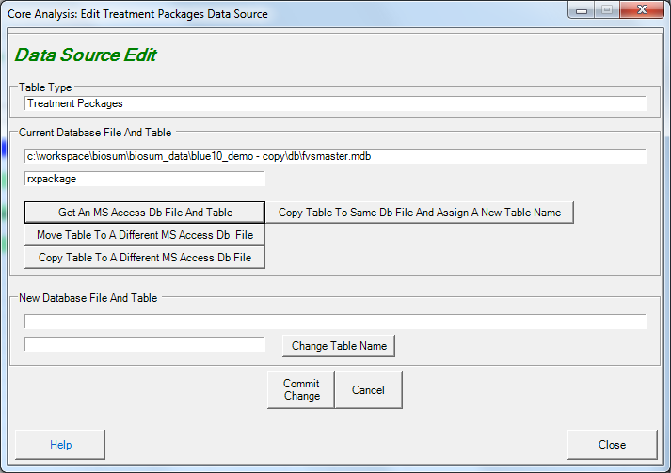

Figure 6.8: The Edit Data Source window

**Caution**: Making changes to data sources is an advanced capability, not to be undertaken lightly or by FIA Biosum beginners, and has the potential to be confusing or produce unintended consequences.

## Rule Definitions

Most of the properties related to a case scenario are configured from the Rule Definitions tab. This tab has 7 child tabs. They are: They are (1) **Land Ownership Groups** (2) **Cost and Revenue** (3) **Wood Processing Sites** (4) **Filter Plot Records** (5) **Filter Condition Records** (6) **FVS Variables** and(7) **Run**.

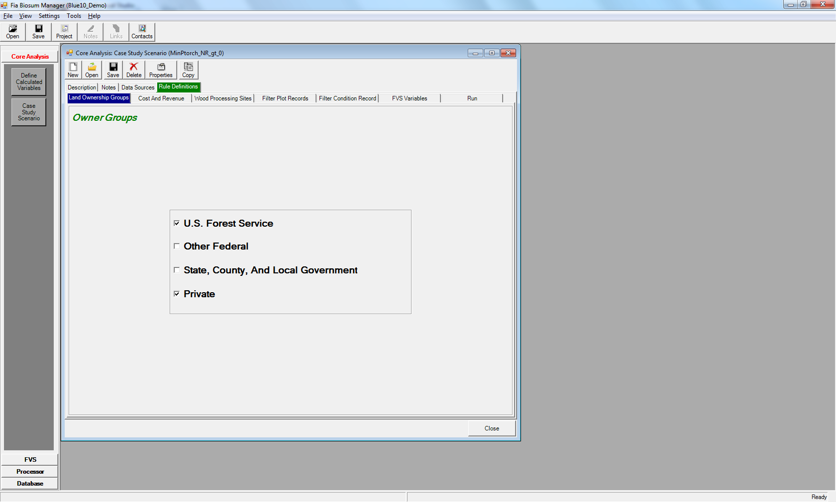

Figure 6.9: The first child tab on the Rule Definitions tab is Land Ownership Groups

1. **Land Ownership Groups**: Allows you to filter your scenario input plots according to landowner group (for example, USFS, private). Checking a checkbox, tells FIA Biosum to include the analysis forested conditions from the corresponding land owner group. One, some, or all owner group boxes can be checked depending on which ownerships are assumed to be managing with fuel treatment as the principal objective.

It is possible to query final outputs to determine how much of the area treated falls within each type of owner group, and how much woody biomass, by size class, was generated by each owner group, but these kinds of answers are inextricably linked to the land base considered at the time of the analysis. For example, a bioenergy facility at a given site may only be economically feasible (in terms of longevity of feedstock supply) if all treatable lands are treated. By applying the landownership constraints prior to running the analysis, it is easy to determine scenarios that will make it more obvious when there is not enough supply to warrant a bioenergy facility (e.g., if only Private was checked).

1. **Cost and Revenue**: This tab has 2 child tabs. They are: (1) **Haul Costs** and (2) **Processor Scenario**. The fields on the **Haul Costs** tab relate to costs of hauling woody material from the forest to processing sites. They are:
   1. **Round Trip Truck and Driver Haul Cost per Green Ton Hour:** should be entered in dollars and is used, in combination with the program-calculated round-trip travel times between plots and processing sites, to calculate the costs of hauling woody material (chips or logs) to processing sites via the road network.
   2. **Rail Haul Cost per Green Ton Mile**: should contain the per-mile cost, in dollars, of moving one ton of material one mile along a rail network once it is already on the rail network.
   3. **Truck to Rail Transfer Load Cost (Merch) $/gt**: specifies the costs of inter-modal transition from truck to rail for merchantable wood. If no rail is specified in the scenario, this field can be set to 0.
   4. **Truck to Rail Transfer Load Cost (Chip) $/gt**: specifies the costs of inter-modal transition from truck to rail for chip wood. If no rail is specified in the scenario, this field can be set to 0.

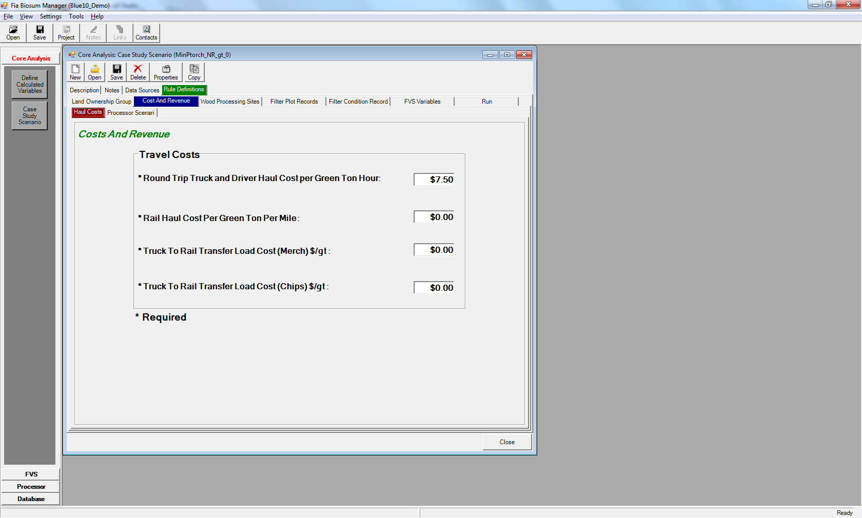

Figure 6.10: Haul Costs child tab on the Costs and Revenue tab

* 1. Each case study scenario MUST be associated with a processor scenario. Use the **Processor Scenario** tab to select the processor scenario that should be used as the source for harvested wood volumes, weights, and onsite harvest costs.

1. **Wood Processing Sites**: Displays details about the processing sites (psites) that are available for inclusion in the current case study scenario. Use the checkbox in the left-hand column to include/exclude a psite from the scenario.

The **Biomass Processing Type** column on the right-hand side of the table allows you to specify if the psite can process: (1) **Merchantable – Logs Only** (2) **Chips – Chips Only** or (3) **Both – Logs and Chips**.

There are 4 buttons below the **Wood Processing Sites** table that may be used to manipulate data on the table. They are:

* 1. <**Select All**>: Checks the boxes for all the psites on the current table for inclusion in the current scenario
  2. <**Unselect All**>: Unchecks the boxes for all the psites on the current table to exclude them from the current scenario
  3. <**Use Default Values**>: There is a master psite configuration table called ‘processing_site’ associated with each FIA Biosum project. This table is located in \gis\db\gis_travel_times.mdb. Use this button if you have made changes to the **Biomass Processing Type** column for the current scenario but wish to revert to the default psite settings from the project master psite table.
  4. <**Update PSite Table With Checked Items**>: Use this button to update the **Biomass Processing Type** field on the project master psite table from the current Wood Processing sites table.

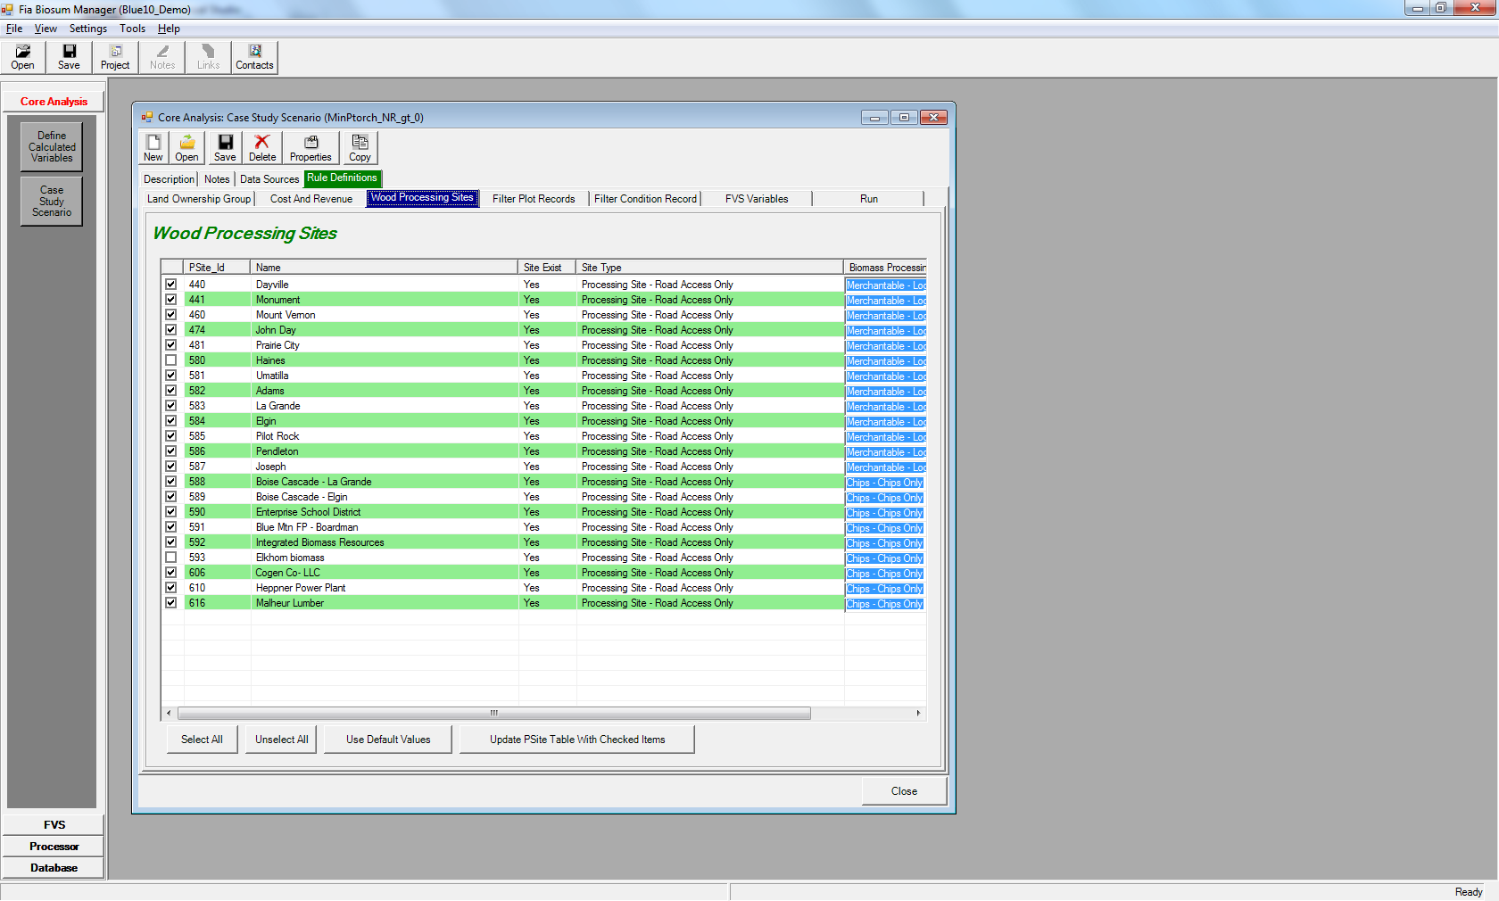

Figure 6.11: The Wood Processing Sites tab displays details of the psites in a scenario

1. **Filter Plot Records**: Allows you to build a SQL filter to include/exclude plots from the case study analysis. The plot table structure includes the fields *gis_roadless_yn* and *gis_protected_area_yn*. The values in these two fields are obtained during the GIS process. If it is determined that the plot is in a roadless area then the flag *gis_roadless_yn* is set to ‘Y’. Likewise, if a plot is in a protected area then the variable *gis_protected_area_yn* is set to ‘Y’. When a case study scenario is calculated, the field *plot_accessible_yn* value is set by evaluating the values in *gis_roadless_yn* and *gis_protected_area_yn* fields. By default a case study scenario includes an attribute filter to only include plots where *plot_accessible_yn* = ‘Y’.

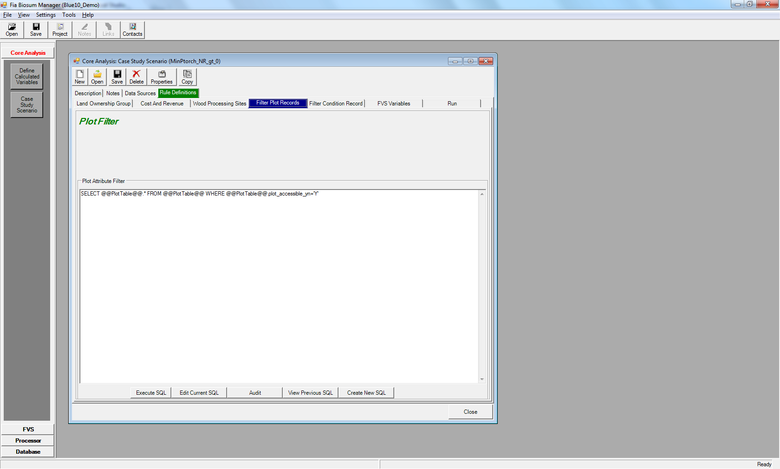

Figure 6.12: Plot attribute filter tab

The **Filter Plot Records** tab has 4 buttons beneath the **Plot Attribute Filter**. They are:

* 1. **<Execute SQL>**: Click this button to view records selected by the SQL currently in the Plot Attribute filter.
  2. **<Edit Current SQL>**: Opens the interactive SQL Builder

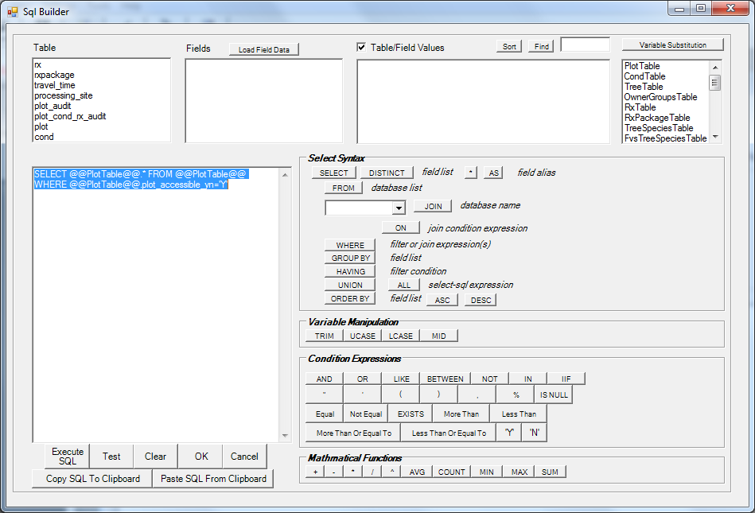

Figure 6.13: SQL Builder window for the Plot Attribute Filter

* 1. **<Audit>**: Tests the plot filter SQL to ensure that it is valid
  2. **<View Previous SQL>**: Lists the previous Plot SQL statements by scenario. The current scenario SQL has a current_yn field value of ‘Y.’ To select the plot SQL, highlight the row and click the **<Select>** button. To delete the item, highlight the row and click the **<Delete>** button. Deleted records are only marked for deletion and can be recalled by pressing the **<Recall>** button. Using a plot filter from a previous scenario is often a good starting point for novice FIA Biosum users.
  3. **<Create New SQL>**: Begins creation of a new plot SQL statement by asking you to select the tables that should be included in the filter and adding them to the SQL Builder window that subsequently opens.

1. **Filter Condition Records**: Allows you to build a SQL filter to include/exclude conditions from the case study analysis. See the section above on filtering plot records for details on building/updating a condition filter. The interfaces are almost identical.

In addition, the Filter Condition Records window provides two fields that specify the **Maximum Yarding Distance Allowed (Feet)**. Conditions exceeding these maximum yarding distances are excluded from case study scenario processing. There are separate boxes for **Low Slope** and **Steep Slope** conditions. The slope degrees value that determines whether a slope is steep is configured in the processor scenario associated with the current case study scenario.

Use the **<Default Values>** to set the **Maximum Yarding Distance Allowed (Feet)** values to the FIA Biosum default. Currently these default values are 2500 feet for both slope categories.

## FVS Variables - Overview

The FVS Variables tab is used to select a set of parameters that determines the best RxPackage for each condition. The FVS Variables tab has 3 child tabs. They are (1) **Effective** (2) **Optimization** and (3) **Tie Breaker**. **Effective** settings support the configuration of up to 4 stand attributes to determine whether or not an RxPackage is effective.

Only effective RxPackages are passed through to the **Optimization** analysis step. If no RxPackages are found to be effective in a condition, that condition will be dropped from further core analysis. **Optimization Settings** allow you to select one stand attribute of interest to determine the best RxPackage, if more than one RxPackage is deemed effective. This window optionally allows you to filter on a weighted economic attribute, for example: net revenue > 0.

If multiple RxPackages for a condition have the same optimization attribute value and optionally, pass the weighted economic attribute filter, the **Tie Breaker** attribute will be used. This attribute can be an FVS stand attribute or a weighted economic attribute. If multiple RxPackages are still under consideration after the **Tie Breaker** attribute is applied, the tie will be broken by the **Last Tie-Break Rank** value. This required numeric value is assigned by you and is unique for each RxPackage. The lowest **Last Tie-Break Rank** value wins the tie and is anointed best RxPackage for that condition.

The output of a Core Analysis scenario run is written to \core\scenario1\db\ scenario_results.mdb. There is also a runlog.txt file in the \core\scenario1\db\ that may be helpful when troubleshooting Core Analysis issues.

## FVS Variables – Effective Settings

The Effective tab allows you to choose up to 4 FVS output stand attributes. A minimum of one selected FVS output stand attributes must be defined for improvement, disimprovement, and effectiveness, but a selected FVS output variable does not need to be defined for improvement, disimprovement, and effectiveness if the above requirement has been met.

Unless the selected FVS variable table name ends in “_WEIGHTED”, only the FVS output for cycle 1 will be included in the analysis. It is not recommended to combine cycle 1 and weighted variables in the same analysis.

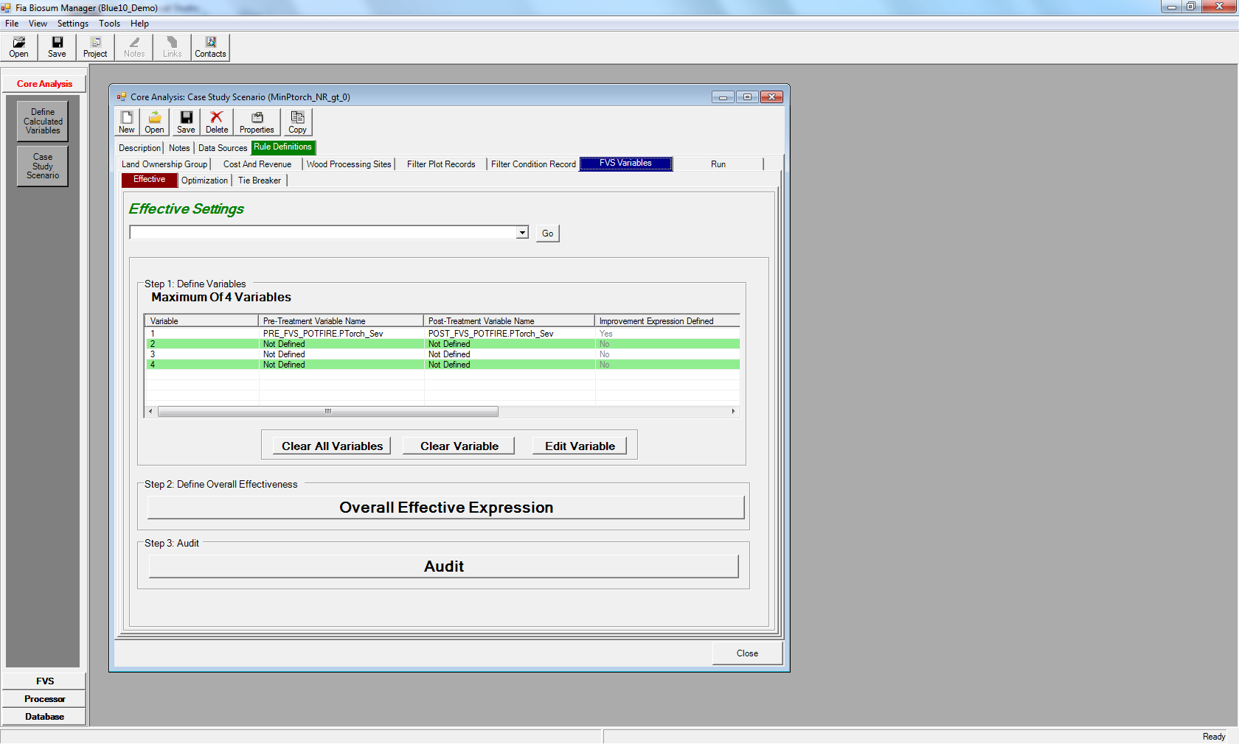

Figure 6.14: The Effective Settings main menu

The collection of Effective Settings variables is summarized on a table on the Effective Settings main menu. The columns are:

1. **Variable**: The id of the variable. Each value is unique and ranges between 1 and 4. FIA Biosum supports a maximum of 4 FVS output stand attributes.
2. **Pre-Treatment Variable Name**: The table and field name containing the source pre-treatment FVS output stand attribute separated by a period ‘.’. Tables that don’t have the suffix “_WEIGHTED” may be found in the FVS output directory: /fvs/db. Tables that do have the suffix “_WEIGHTED” may be found in the /core/db/prepost_fvs_weighted.accdb.
3. **Post-Treatment Variable Name**: The table and field name containing the source post-treatement FVS output stand attribute separated by a period ‘.’. See the definition of Pre-Treatment variable name for the table locations.
4. **Improvement Expression Defined**: Indicates if an improvement expression is defined for this variable
5. **Disimprovement Expression Defined**: Indicates if an disimprovement expression is defined for this variable
6. **Effective Expression Defined**: Indicates if an effective expression is defined for this variable

Note: At least one improvement, one disimprovement, and one effective expression must be defined between the 4 variables for a case study scenario.

The initial page of the Effective Settings screen has 6 buttons:

1. **<Go>**: Use this button with the dropdown list on the left to gain immediate access to any wizard prompt location
2. **<Clear All Variables>**: Clears configuration for all variables displayed in the **Step 1: Define Variables** table
3. **<Clear Variable>**: Clears configuration for the variable selected in the **Step 1: Define Variables** table
4. **<Edit Variable>**: Opens the first page of the configuration wizard for the variable selected in the **Step 1: Define Variables** table
5. **<Overall Effective Expression>**: Opens the overall effective expression builder which determines if the RxPackage was effective for the condition.
6. **<Audit>**: Runs a series of validation checks to ensure that the Effective Settings can be used by a case study scenario run.

Defining or editing an effectiveness variable is a 4 step process:

1. Select the source table and field for the stand attribute or variable
2. Define a SQL expression for what constitutes variable post-treatment improvement (better)
3. Define a SQL expression for what constitutes variable post-treatment disimprovement (worse)
4. Define a SQL expression for what constitutes variable effective treatment. This SQL expression can utilize the outcome of the better/worse expressions from steps 2 and 3.

**Selecting an FVS Stand Attribute**

To select a new FVS stand attribute (Step 1) choose **Select Variable X…** from the dropdown list at the top of the screen and click the **<Go>** button. To edit an existing FVS stand attribute, select row containing the attribute from the table on the **Effective Settings** main menu and click the <**Edit Variable**> button.

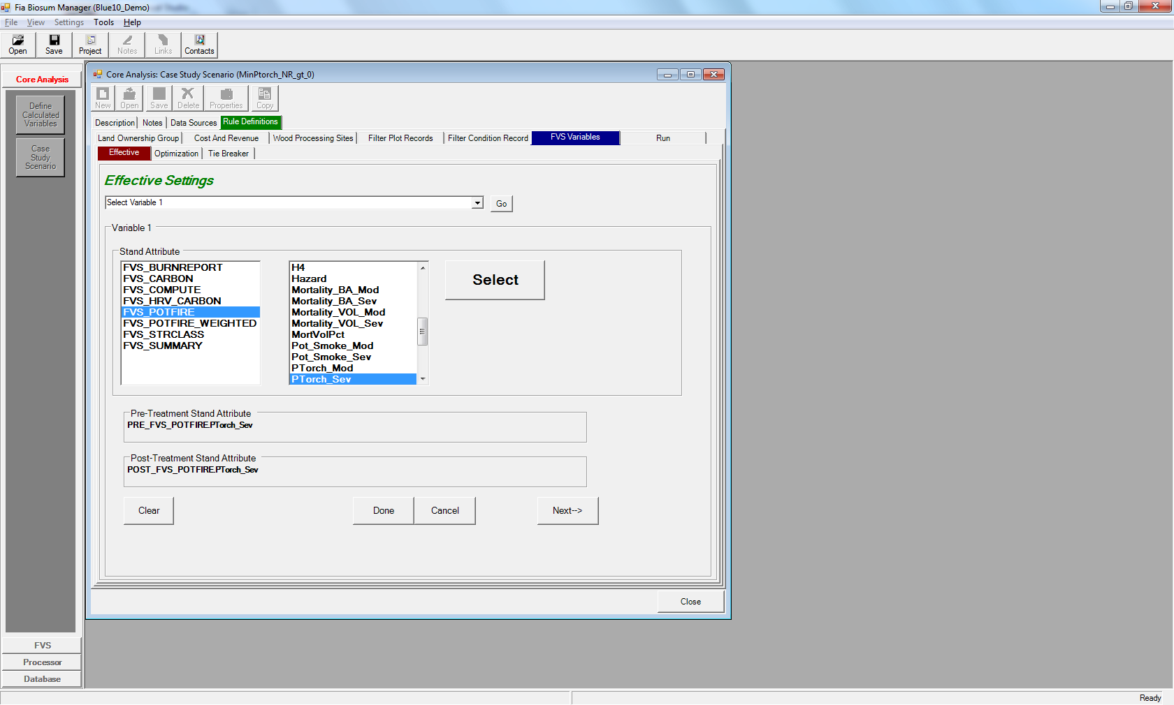

Figure 6.15: Selecting an FVS Stand Attribute

When you select an FVS output table from the left-hand list, the right-hand list will automatically populate with the names of the columns available in that table. Choose a stand attribute from the right-hand list and then click the <**Select**> button to select it. The **Pre** and **Post Treatment Stand Attribute** fields will display the name of the selected element. Click the <**Next->**> button to configure the expression for the Effectiveness Variable you just selected (step 2).

Note that the window and method for selecting an FVS Stand Attribute are identical on the Effectiveness, Optimization, and Tie Breaker stand attribute tabs.

**Effectiveness Variable Expression Builder**

The expression builder is used in steps 2, 3, and 4 of editing an effectiveness variable and also when defining the overall effectiveness expression. It contains the following elements:

1. **<Go>**: Use this button with the dropdown list on the left to gain immediate access to any wizard prompt location
2. **Available Variable(s)**: List the variables that can be used to generate your expression. Use the buttons next to the list to add operators and qualifiers to your expression.
3. **Define expression for what constitutes** …: Contains the expression that will be used during a Core Analysis run. The text can either be built using the buttons above or manipulated directly by typing in the box.
4. **<Test>**: Use this button to test your expression and make sure it is valid
5. **<Default Expression>**: Generates a sample expression in the **Define expression for what constitutes** … box. This should be used as example syntax for composing your own expressions but is not recommended for actual use in most scenarios.
6. **<Previous Expression**>: Lists the previous expression SQL statements by scenario. Current expressions are indicated with a ‘Y’ in the current_YN field. Using an expression from a previous scenario is often a good starting point for novice FIA Biosum users.
7. **<Clear Expression>**: Clears the **Define expression for what constitutes** … box.
8. **<Done>**: Saves your expression to memory and closes the expression builder. Use the **<Save>** button in the toolbar after clicking **<Done**> to save your configuration changes to your computer. Your changes are also automatically saved before a case study scenario is run.
9. **<Cancel>**: Closes the expression builder without saving your changes. Note that when you are in edit mode the **Optimization** and **Tie Breaker** settings will be read-only until you use the **<Done>** or **<Save>** buttons to exit the expression builder.

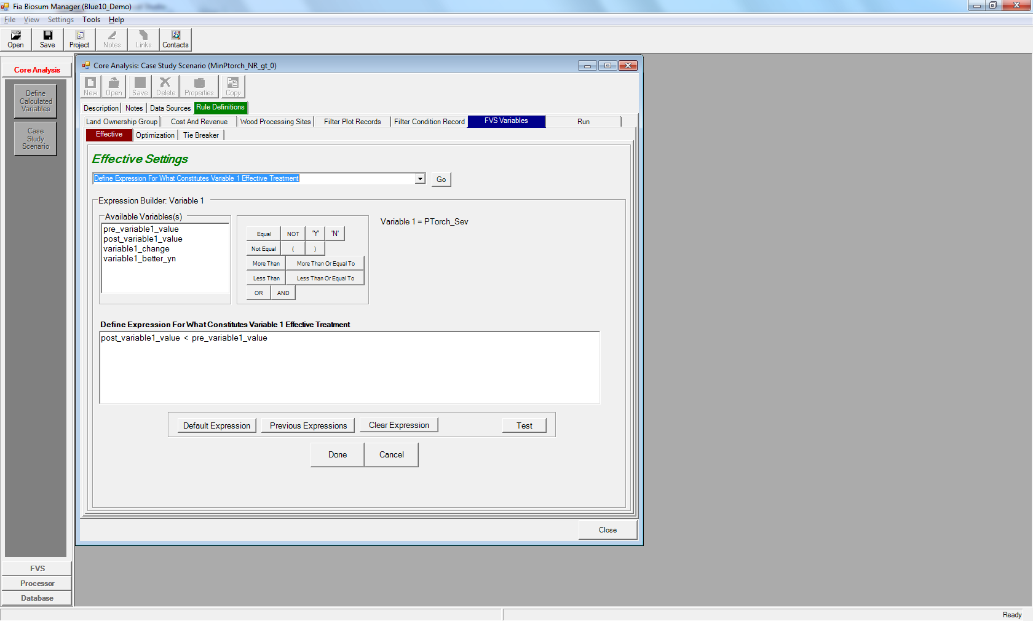

Figure 6.16: Defining variable 1 effective treatment expression using the expression builder

**Audit for Effective Variables**

The Effective Variables configuration must pass the following tests to be valid:

1. Ensure the user-defined FVS variable tables exist
2. Ensure the user-defined FVS columns exist
3. Ensure overall expression exists
4. Ensure no FVS variables are defined more than once
5. Ensure effective expressions all have valid variable references. Example of an invalid variable reference: you delete FVS variable #4 but forget to remove FVS variable #4 from the effective expression.

**Effective Variables output**

The output from Effective Variables processing is written to the cycle1_effective table in the scenario_results.mdb. The following columns may benefit from a brief description:

1. **nr_dpa**: net revenue for cycle 1
2. If a Net Revenue filter was configured in the **Optimization Settings**, the name of the filter, for example **net_revenue_1**, and the weighted values will be in this table
3. **overall_effective_yn**: indicates if the rxPackage was deemed effective according to your criteria. Only conditions with a value of ‘Y’ will be included in downstream analysis

## FVS Variables – Optimization Settings

The **Optimization Settings** require you to select a single optimization variable of interest. The variable can be an FVS stand attribute, an economic stand attribute, revenue, or merchantable volume. The FVS stand attribute, revenue, and merchantable volume options apply only to cycle 1. The FVS stand attribute may apply to all 4 cycles if a WEIGHTED stand attribute is selected. The economic stand attribute is always WEIGHTED and applies to 4 cycles.

The optimization variable configuration includes options for favoring Maximum or Minimum aggregate values and, optionally, excluding conditions that do not meet a defined Net Revenue threshold filter.

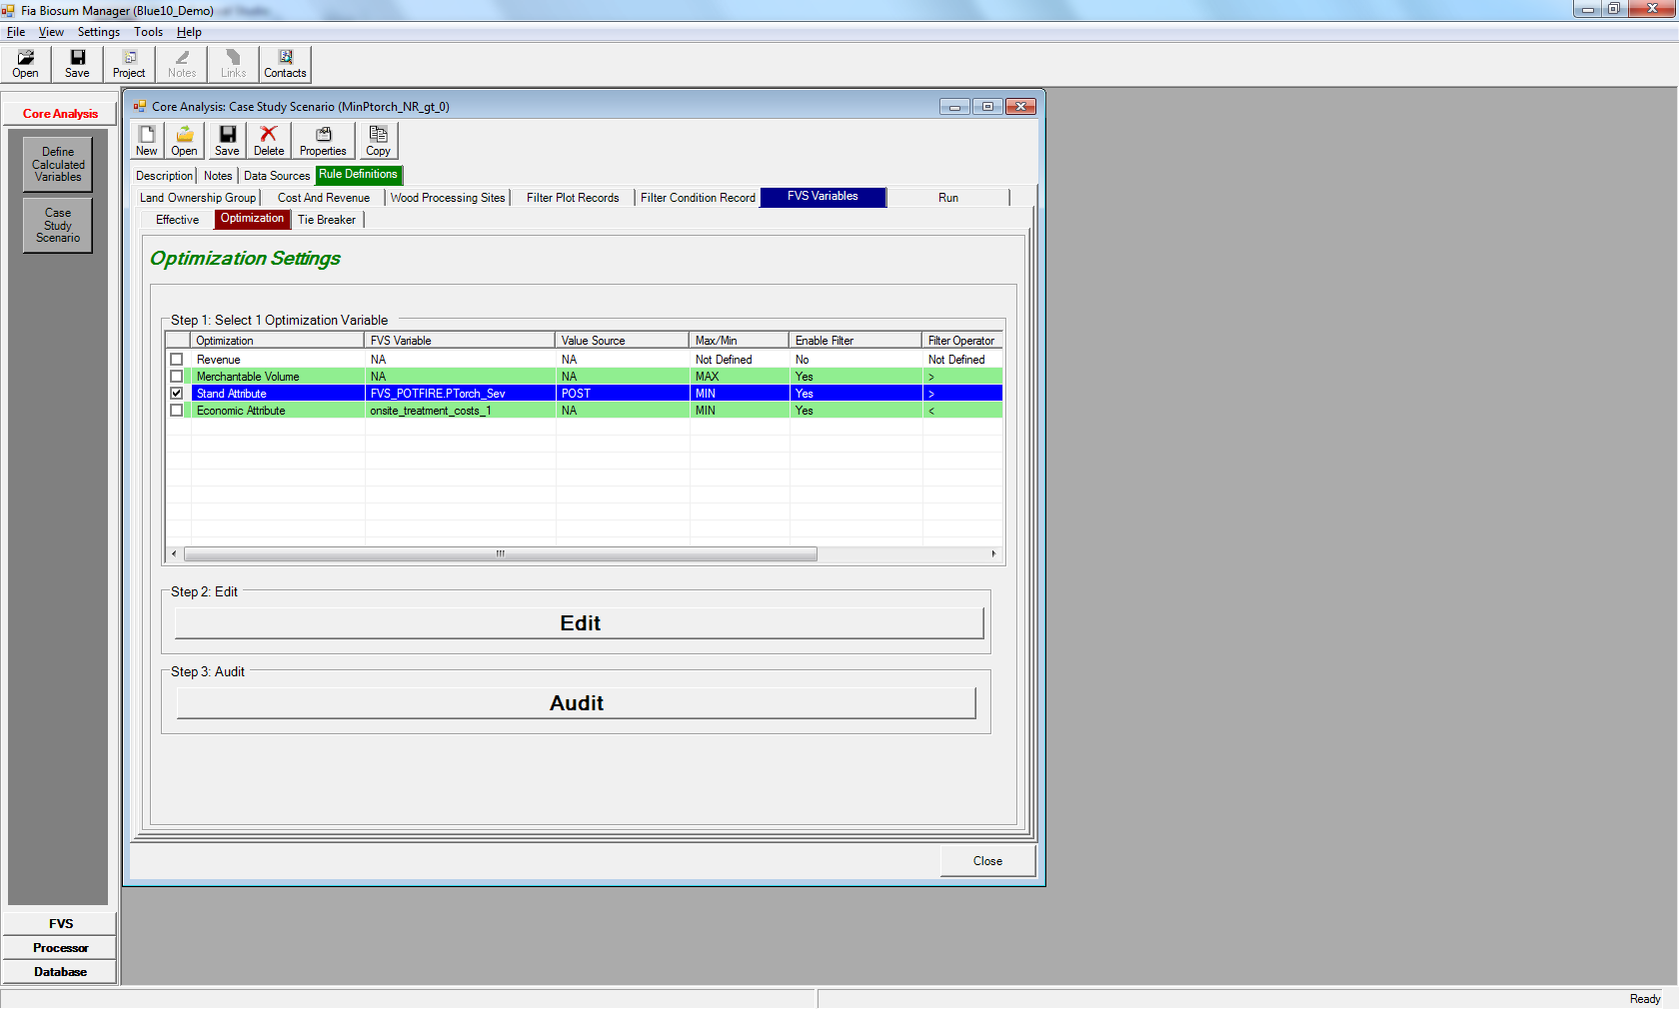

Figure 6.17: Optimization Settings main menu

The Optimization settings are summarized in a table on the Optimization settings main menu. The columns are:

1. The first unlabeled column is a checkbox column. Only one optimization attribute per case study scenario can be selected.
2. **Optimization**: Lists the optimization attribute type; the options are Revenue, Merchantable Volume, Stand Attribute, and Economic Attribute
3. **FVS Variable**: For stand attributes and economic attributes, the name of the selected variable appears. Stand attributes include the FVS table and field name, concatenated by a period ‘.’. Economic attributes show the name of the weighted economic variable. ‘NA’ appears in this column for Revenue and Merchantable volume variables.
4. **Value Source**: Only populated for stand attributes. The values will be either POST (treatment value) or POST-PRE (treatment change value). ‘NA’ appears in this column for all other optimization attribute types.
5. **Max/Min**: Should the maximum or minimum value of the attribute be considered optimal?
6. **Enable Filter**: Has a net revenue filter been configured?
7. **Filter Operator**: The operator for the net revenue filter
8. **Filter Value**: The threshold value set for the net revenue filter. If the filter is not enabled, this value will be ignored

The Optimization Settings main menu has 2 buttons:

1. **<Edit>**: Opens the configuration page(s) for the attribute selected in the Optimization Variable table
2. **<Audit>**: Runs a series of checks to ensure that the Optimization attribute and, optionally net revenue filter, are configured correctly

**Editing the Optimization Attribute**

If you select a Stand Attribute as an optimization attribute, the first step is to select the table and column for the attribute. The follow-on configuration window allows you to specify additional details. The configuration screens for Economic Attribute, Revenue, and Merchantable Volume are similar to the follow-on configuration window although they may not contain all of the fields as not all fields are relevant to all variable types.

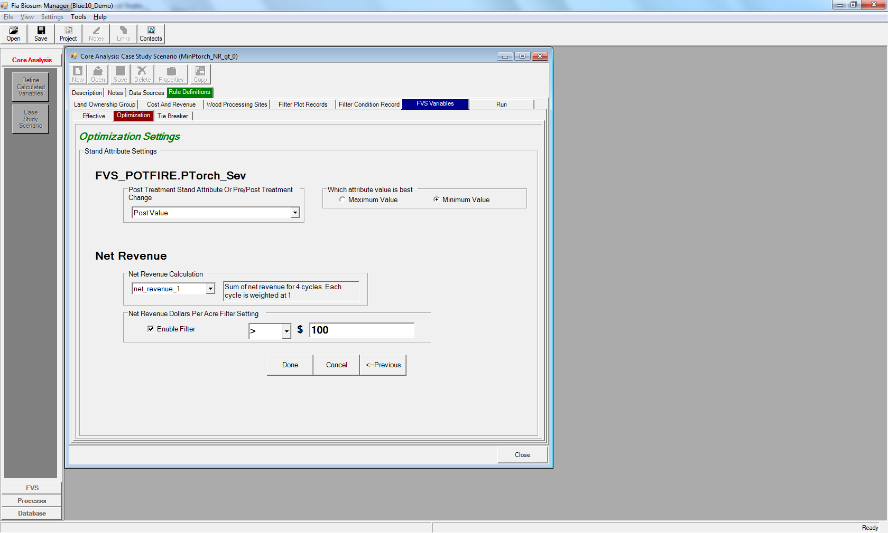

Figure 6.18: Follow-on stand attribute settings configuration window

The name of the selected Optimization variable of interest appears near the top of the configuration window. It will be either the FVS variable table and field name, the economic attribute name, Merchantable Volume, or Revenue. The other fields on this screen are:

1. **Post Treatment Stand Attribute Or Pre/Post Treatment Change**: Choose between the post-treatment stand attribute value or the difference between the post and pre-treatment values. The pre-treatment value is subtracted from the post-treatment value.
2. **Which Attribute Value is Best**: Select minimum or maximum value for the stand attribute, economic attribute, revenue, or merchantable volume
3. The following 4 fields work together to configure the optional Net Revenue threshold filter. If a condition and RxPackage combination fails to meet the threshold, it will be excluded from downstream processing.
   1. **Net Revenue Calculation**: This is a select list containing all available net revenue and onsite treatment cost calculations. When you select an item from the list, the calculation description appears next to the select list. Currently net_revenue_1 and onsite_treatment_costs_1 are the only calculations available. These are the sum of net revenue or onsite treatment costs across all 4 cycles. In a future release, you will be able to configure custom calculations using the FIA Biosum calculated variable functionality.
   2. **Net Revenue Dollars Per Acre Filter Setting**: Checking this checkbox enables the Net Revenue threshold. There is a select list containing a choice of operators ( >, <, >=, <=, <>). Select the appropriate operator from this list. The last field is a freeform numeric field that allows you to enter the threshold value. Negative numbers are permitted.

Below are 3 Optimization attribute configuration examples:

* **Optimization**: Stand Attribute
* **FVS Variable**: FVS_POTFIRE_WEIGHTED.Torch Index
* **Pre/Post Treatment Change**
* **Which Attribute Value is Best**: Minimum
* **Net Revenue Filter:** enabled where net_revenue_1 > 100
* **Synopsis:** Find the treatment for each condition where the weighted torch index decreased the most after treatment. Only consider plots where the sum of net revenue over 4 cycles is greater than 100.
* **Optimization**: Merchantable Volume
* **FVS Variable**: N/A
* **Which Attribute Value is Best**: Minimum
* **Net Revenue Filter:** disabled
* **Synopsis:** Find the treatment for each condition that cuts the least amount of merchantable volume for cycle 1. *Note that merchantable volume and revenue optimizations apply to cycle 1 only.*
* **Optimization**: onsite_treatment_costs_1
* **FVS Variable**: N/A
* **Which Attribute Value is Best**: Minimum
* **Net Revenue Filter:** enabled where net_revenue_1 > 0
* **Synopsis:** Find the treatment for each condition that has the lowest onsite treatment costs where net revenue is greater than 0. These are both built-in economic variables so they include the sum of all 4 cycles in their calculation.

**Audit for Optimization Attribute**

The Optimization attribute must pass the following tests to be valid:

1. One optimization attribute of interest must be checked
2. If the optimization is the FVS Post variable then ensure the post column exists
3. If the optimization is the FVS Post-Pre change than ensure both the PRE and POST columns exist
4. The optimization variable has an aggregate definition of MAX or MIN
5. If enabled, ensure the filter operator is valid

**Optimization Attribute output**

The output from Optimization processing is written to the cycle1_optimization table in the scenario_results.mdb. All condition RxPackage combinations deemed to be effective are included on this table along with their optimization attribute values.

The **affordable_yn** column indicates if a condition RxPackage met the Net Revenue filter threshold. If a Net Revenue filter isn’t configured, this field will always be set to ‘Y’. If a Net Revenue filter is configured, there will be a column with the name of the selected Net Revenue economic attribute, for example: net_revenue_1. This column will be populated with the values of the economic attribute.

## FVS Variables – Tie Breaker Settings

One and only one RxPackage per condition can be selected as “best” during a Core Analysis scenario run. It is highly probable that multiple RxPackages for a condition may meet the Effectiveness criteria, exceed the Net Revenue threshold, and have the same Optimization attribute value. In these cases, the **Tie Breaker** settings are used to break any ties.

Tie breaking can be a two-step process. Optionally, you can select an FVS Stand Attribute or Economic Attribute to break any ties. This attribute cannot be the same data element as the Optimization attribute.

If multiple RxPackages are still tied or a Tie Breaker attribute is not selected, the required Last Tie-Break Rank value will be used to select the “best” RxPackage. On the Tie-Break Rank screen, a unique value is assigned to each RxPackage. The RxPackage with the lowest Tie-Break Rank value will be selected.

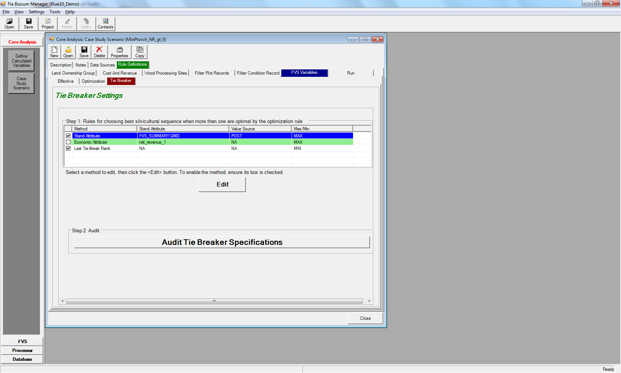

Figure 6.19: Tie Breaker settings main menu

The centerpiece of the Tie Breaker settings main menu screen is a table that lists the potential Tie Breaker attributes of interest. They are Stand Attribute, Economic Attribute, and Last Tie-Break Rank. The only required attribute is Last Tie-Break Rank. The columns on this table are:

1. The first unlabeled column is a checkbox column. If the checkbox is checked, it means the attribute is selected as a Tie Breaker. In addition to Last Tie-Break Rank, you can select a stand attribute OR and economic attribute but not both.
2. **Method**: Lists the Tie Breaker attribute type; the choices are Stand Attribute, Economic Attribute, and Last Tie-Break Rank.
3. **Stand Attribute**: For stand attributes and economic attributes, the name of the selected variable appears. Stand attributes include the FVS table and field name, concatenated by a period ‘.’. Economic attributes show the name of the weighted economic variable. ‘NA’ appears in this column for Last Tie-Break Rank.
4. **Value Source**: Only populated for stand attributes. The values will be either POST (treatment value) or POST-PRE (treatment change value). ‘NA’ appears in this column for all other Tie Breaker attribute types.
5. **Max/Min**: Should the maximum or minimum value of the attribute be considered best? For Last Tie-Break Rank, this will always be set to minimum.

**Editing an Economic or Stand Attribute Tie Breaker**

If you wish to use an Economic Attribute as Tie Breaker attribute, the first step is to select the weighted economic attribute. When you select an attribute from the list, a textual description automatically appears in the **Description** box. After you use the **<Select>** button to finalize your choice, the name of the attribute will appear as the **Currently Active Tie Breaker**. After selecting the attribute, you will also need to specify whether the **Minimum** or **Maximum Value** is best.

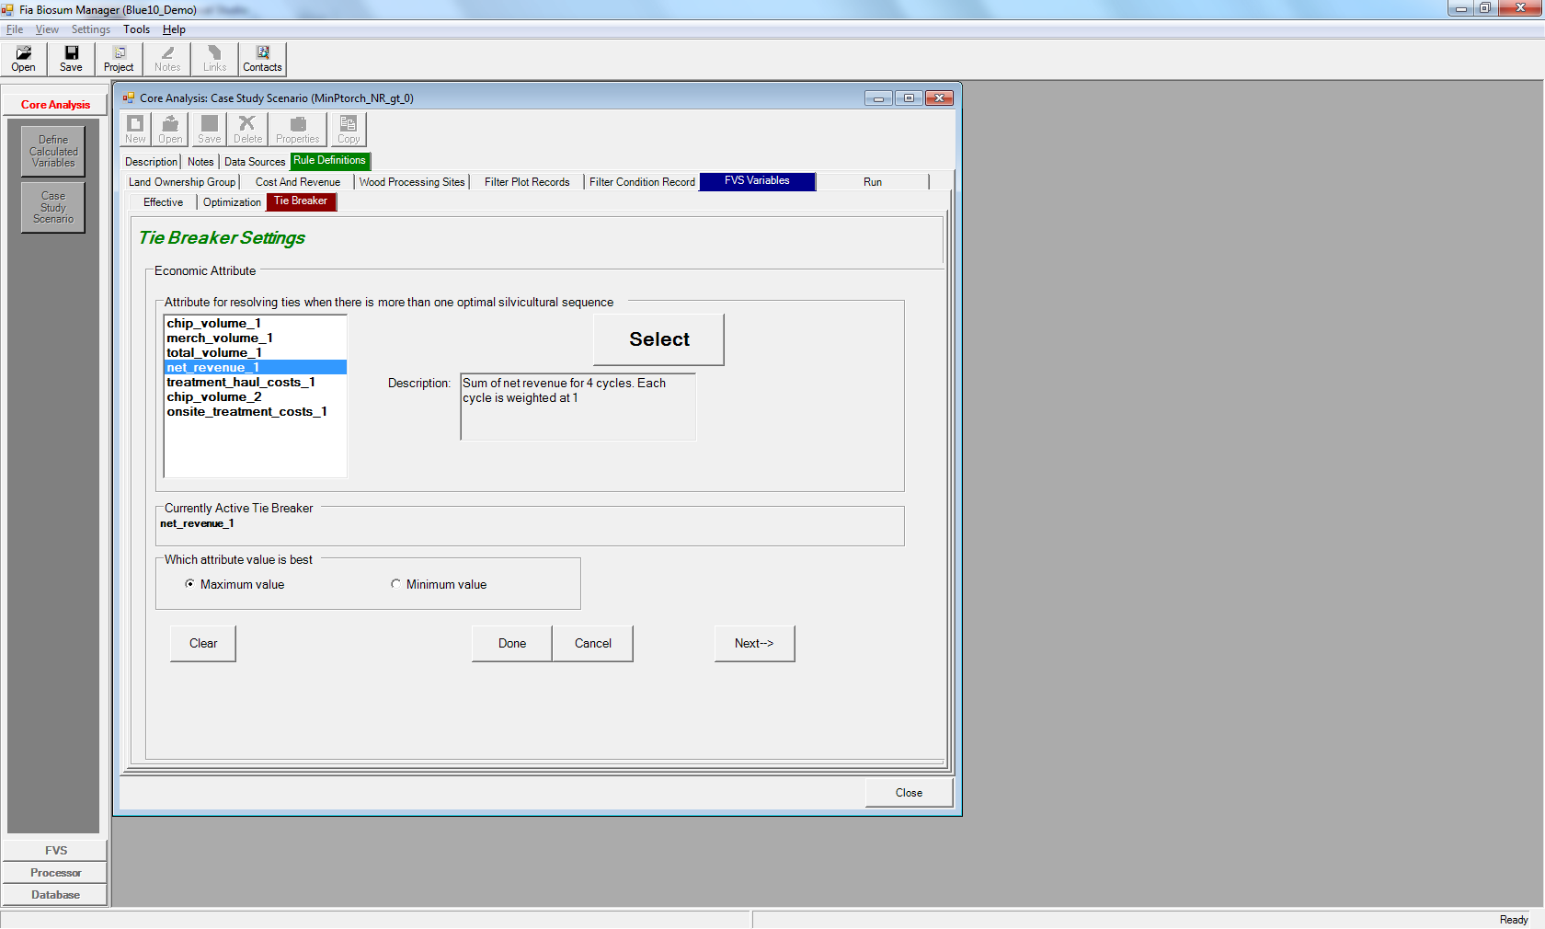

Figure 6.20: Editing an Economic Tie Breaker attribute

The Stand Attribute Tie Breaker screen is similar but also requires you to select **Post Treatment Stand Attribute Or Pre/Post Treatment Change**: Choose between the post-treatment stand attribute value or the difference between the post and pre-treatment values. The pre-treatment value is subtracted from the post-treatment value.

There are four buttons at the base of the Tie Breaker **Stand** or **Economic** attribute screen. They are:

1. <**Clear**>: Clears your selections from the screen
2. **<Done>**: Saves your selections to the computer’s memory and returns to the Tie Breaker settings main menu. You must use the **<Save>** button to persist your configurations after FIA Biosum is closed.
3. **<Cancel>**: Discards your changes and returns to the Tie Breaker settings main menu.
4. **<Next->**>: Saves your selections to the computer’s memory and proceeds to the Last Tie-Break Rank window. You must use the **<Save>** button to persist your configurations after FIA Biosum is closed.

The **Last Tie-Break Rank** tab requires you to assign a unique rank to each rxPackage in the red column. Following FIA Biosum convention, only the red column is editable. The **last_tiebreak_rank** value is the ultimate tiebreaker if more than one rxPackage in a condition has the same **Optimization** and **Tie Breaker** attribute values. The lowest **last_tiebreak_rank** value wins a tie.

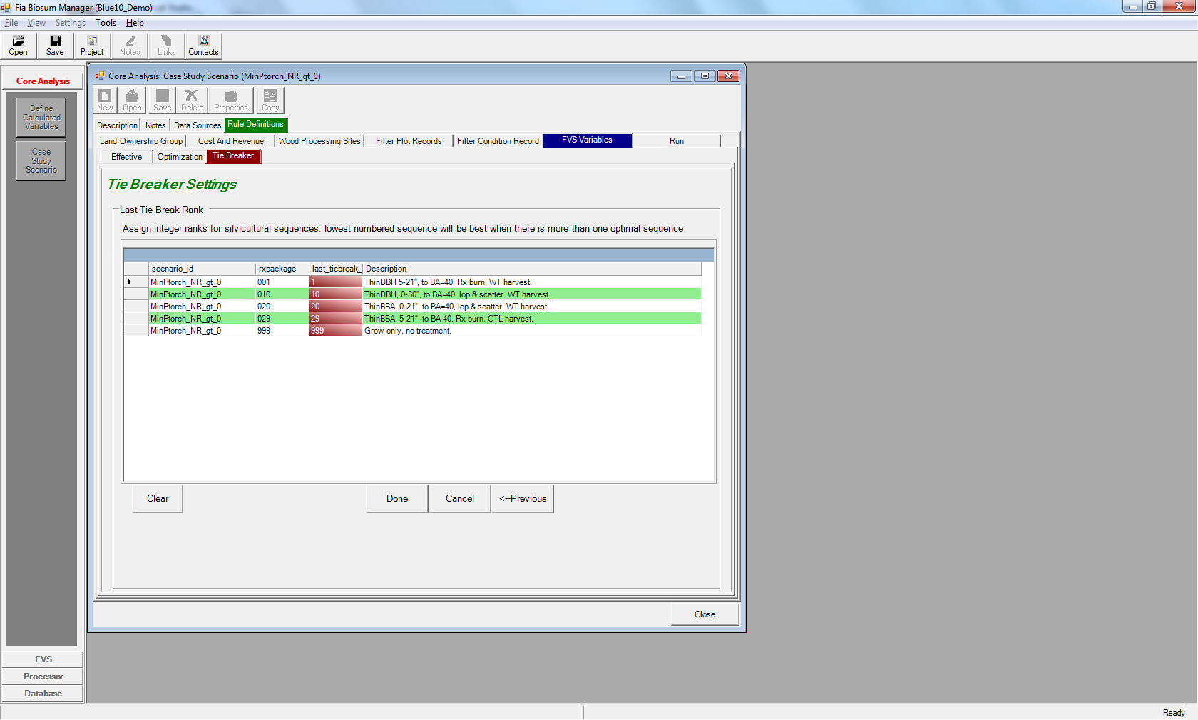

Figure 6.21: The Last Tie-Break Rank window

There are four buttons at the base of the **Last Tie-Break Rank** screen. They are:

1. <**Clear**>: Clears your selections from the screen
2. **<Done>**: Saves your selections to the computer’s memory and returns to the Tie Breaker settings main menu. You must use the **<Save>** button to persist your configurations after FIA Biosum is closed.
3. **<Cancel>**: Discards your changes and returns to the Tie Breaker settings main menu.
4. **<<-Previous**>: Saves your selections to the computer’s memory and returns to either the Stand or Economic attribute window (depending on which was previously selected). You must use the **<Save>** button to persist your configurations after FIA Biosum is closed.

The <**Audit Tie Breaker Specifications**> button runs an audit on the Tie Breaker settings to ensure that the following requirements are met:

1. Each rxPackage must have an last tie-break rank value
2. Last tie-break rank must be unique.
3. The stand or economic attribute must be defined if it is checked
4. If enabled, the Tie Breaker attribute cannot be the same as the Optimization attribute

**Tie Breaker output**

The output from Tie Breaker processing is written to the cycle1_best_rx_summary_before_tiebreaks, cycle1_best_rx_summary, and cycle1_best_rx_summary_air_dest tables in the scenario_results.mdb. The cycle1_best_rx_summary_before_tiebreaks table includes all condition RxPackage combinations that passed the Optimization attribute and revenue filter threshold tests. It appends the tiebreaker_value (if configured) and last_tiebreak_rank value to each of the condition RxPackage table rows.

The cycle1_best_rx_summary table applies the Tie Breaker settings and only includes rows with the ‘best’ RxPackage for each condition. The cycle1_best_rx_summary_air_dest does the same for air curtain destruction plots.

## Run

The Run tab executes the case study scenario that you have configured and writes out the results to a set of tables in the \core\scenario1\db\scenario_results.mdb. Before commencing the scenario calculations, a series of audits is run to ensure that the case study configuration is valid. At the base of the run screen are two file size monitors that report the current size of the temporary databases used when calculating a case study scenario. The maximum size of an MS Access database is 2 gigabytes.

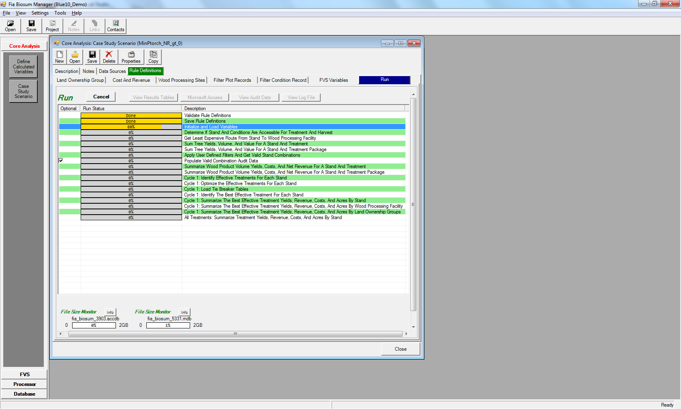

Figure 6.22: The Run scenario window

There are 5 buttons above the table on the **Run** screen. They are:

1. **<Start>**: Clicking this button begins a case study scenario analysis run. While the scenario is running, the label of this button changes to <**Cancel**>. Click the <**Cancel**> button if you need to interrupt the case study scenario run for any reason.
2. **<View Results Tables>**: This button is enabled if the scenario_results.mdb exists for the current scenario. Click this button to view the output tables from within FIA Biosum. If you can’t see all of the tables in the viewer, click and drag the lower right-hand corner to enlarge the window.

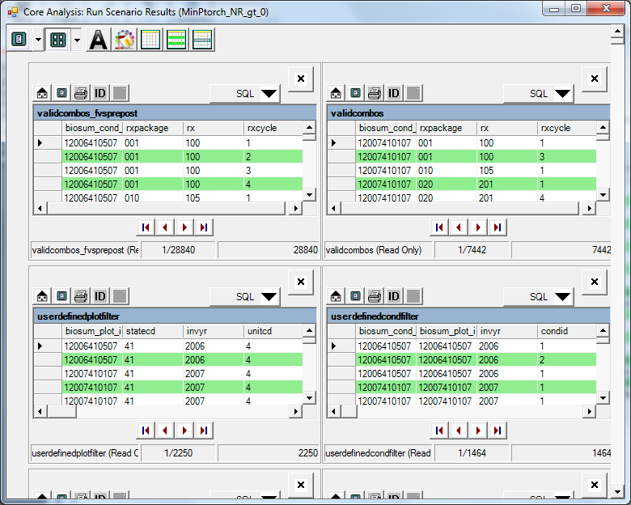

Figure 6.23: The Results Tables viewer

1. <**Microsoft Access**>: Launches Microsoft Access on your computer and opens the scenario_results.mdb.
2. <**View Audit Data**>: Review the MS Access Core Analysis audit tables from within FIA Biosum
3. <**View Log File**>: Opens a viewer containing the case study scenario log file (runlog.txt). This log is the place to start if you experience failures while running a case study scenario.