

FIA Biosum

Setup Instructions

Version Date: 9 June 2016

Introduction

The FIA_BIOSUM_SETUP.exe file is a self-extracting WINZIP file that extracts to the c:\fia_biosum\setup folder. These are the 5 main steps when installing the BIOSUM application:

- Install Oracle 11g Express Edition (XE)
- Install FIADB Oracle Schema.
- Install R
- Install RODBC
- Install FIA Biosum Manager.

If Oracle 11g XE (11.2.0) is already installed according to the Biosum setup instructions then a reinstallation of the Oracle 11g software is not required. For further Oracle 11g documentation, reference the document c:\ fia_biosum\setup\oracle11g_xe\oracle_11g_setup_instructions.pdf.

Software Requirements

- Microsoft Windows XP Professional. Microsoft Windows 7 Professional, Enterprise, or Ultimate editions.
- Microsoft Office 2010 32bit Version with Access and Excel.
- Microsoft .NET Framework 4.0.
- ARCGIS 9.2-10.0 (Separate Installation)
- FVS Suppose v.2.02 or later (Separate Installation) http://www.fs.fed.us/fmsc/fvs/software/complete.php

Setup Overview
The current version of the setup instructions guides the user through the steps required to get BIOSUM up and running. BIOSUM now relies on ORACLE “packages” (code libraries), even in the initial stages of workflow when FIADB inventory data get imported into a BIOSUM project, so ORACLE XE must be installed—the BIOSUM MANAGER software (the overarching workflow management environment) will not function properly without it. Once ORACLE is installed, it is necessary to install the FIADB ORACLE “schema” that connects BIOSUM to the ORACLE packages; this process must be conducted with admin status on the computer. Unless FIA BIOSUM will be used only to create FVS files for purposes other than BIOSUM, the R software and RODBC driver must be installed as the OPCOST software that estimates costs of harvest operations is coded in R. Finally, the FIA BIOSUM MANAGER must be installed. If any of ORACLE XE, R or RODBC are already installed on the computer, they do not need to be reinstalled. The self-extracting zip file fia_biosum_setup.exe generally contains all the files needed for a full install. It is best to unzip this to the root directory of the C drive (specify C:\ as the location to install).

Upgrade Overview
Most BioSum upgrades can be installed by simply installing the MSI file provided (in this case, fia_biosum_setup_vBeta572.msi). This will install a new BioSum version, and that version will appear as a new menu entry under FIA BioSum in the Windows Start Menu. Old versions can be deleted later, if desired (via Control panel). However, some upgrades, including 5.7.2 are so substantial that they also include changes to the FIADB ORACLE schema, so a new schema must also be loaded. To install version 5.7.2 as an upgrade, follow the instructions for step 10 in the setup instructions making sure that you have admin privileges. It is ESSENTIAL that all of the following files be in the Import_FCS directory BEFORE running the Import_FCS.bat file (as admin):
1. FCS_EXPDP.DMP (dated 5/12/2016 at 1:24PM)
2. FCS_impdp.DAT
3. Import_FCS.bat
4. SetNoPasswordExpiration.SQL
5. TryDropUserCmd.SQL

THEN, you will need to create or verify the ODBC connection (Step 26). This must be done using an admin account (at least on a FS imaged computer—other environments have been less tested).
It may be necessary to repeat Step 27, entering the fcs password in the registry. Admin privileges are required for this step also.

ADMINISTRATOR PRIVILEGES OVERVIEW
To install and uninstall the software (.MSI) requires administrative privileges. If the computer has an FS imaged operating system and the user installing the software does not have admin privileges then there are 2 options:
1. Right-click the install file and select <Install Elevated>
2. Shell a command prompt by selecting <Start> button <All Programs><Accessories> and then right-clicking <Command Prompt>menu option and selecting <Run Elevated>. From the elevated command prompt navigate to the folder location of the BIOSUM install files and run each of them from the elevated command prompt. This is the PREFERRED and only FULLY TESTED approach.

NOTE: The instructions included with the full BIOSUM setup have not been updated to include FS computers that now only allow admin privileges using the Powerbroker software. <Install Elevated> and <Run Elevated> are Powerbroker options.
All other elements of the installation process are also most reliably executed as an admin level user, especially the Install_FCS.bat, regedit, and odbcad32.exe steps.
If there is a possibility that different user accounts on the computer will run BioSum, it is strongly advised to define the ODBC entries as SYSTEM DSN and not USER DSN settings.
Actually running the BioSum software, once it has been successfully installed, does not require administrative privileges. By default, the BIOSUM software is installed for all user accounts.
If you intend to open and edit BIOSUM MS Access files, make sure that the directory location of the file is set as a trusted location in the Access software settings (under options, trust center settings).
The best way to make sure that installation components are installed under the admin privileges is to open a command window as admin and type the commands out in that command window. For example:
For step 10 but follow these steps:
1. Start a command prompt with admin privileges.
2. In the command prompt type these commands:

2a. cd c:\ fia_biosum\setup\Import_FCS <enter key>
2b. Import_FCS.bat <enter key>
When defining the ODBC entries make sure ODBCAD32.EXE is started from the c:\windows\SYSWOW64 folder, as an admin user.

Setup Instructions

- Login to your computer as an administrator.
- If not running Windows 7 skip to step 3. If running Windows 7, it is recommended that User Account Control (UAC) settings are turned off. Follow these steps to turn off UAC:

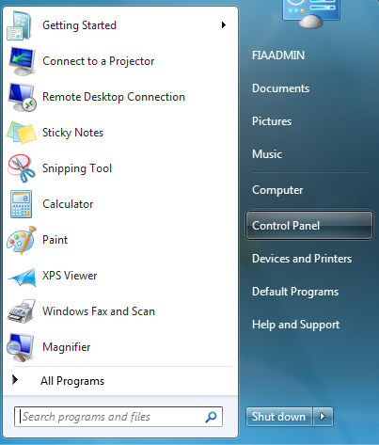

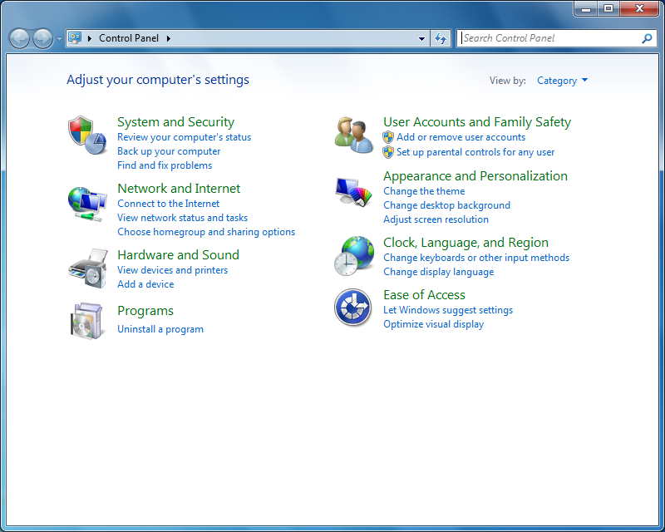

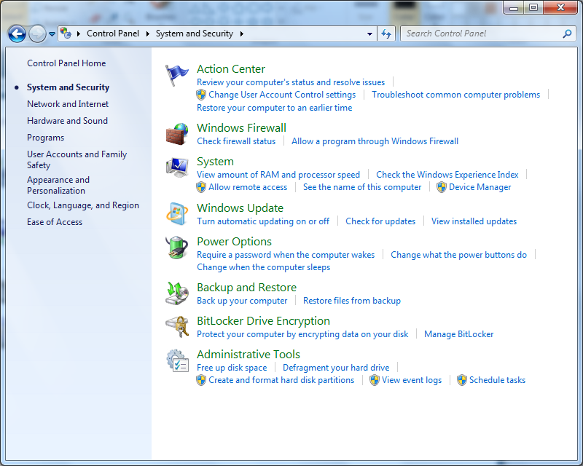

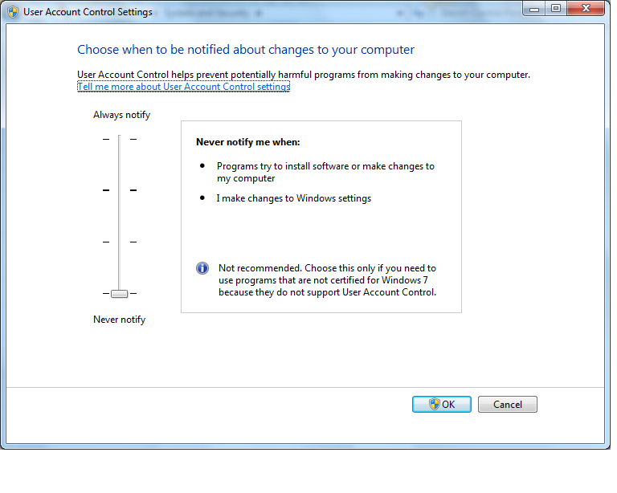
NOTE: Even though the position of the slider may be located at the lowest level, it needs to be slid up and returned back to the lowest level in order to reinitialize the UAC settings. A reboot is required after changing UAC settings.

- INSTALL Oracle 11g XE: If Oracle 11g XE is already installed then skip to item 10. Open the file c:\ fia_biosum\setup\oracle11g_xe\DISK1\setup.exe and click <Next>.

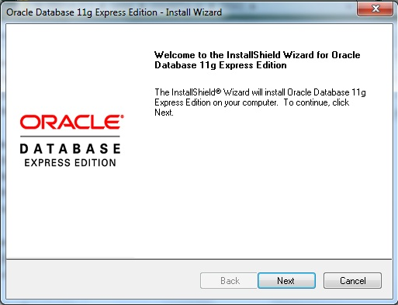

- Accept the terms and <Next>.

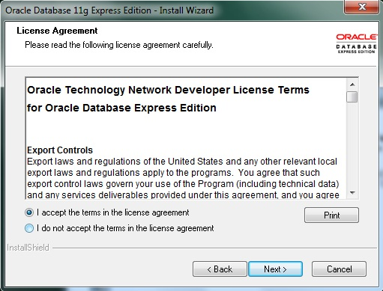

- Accept the default destination folder and click <Next>.

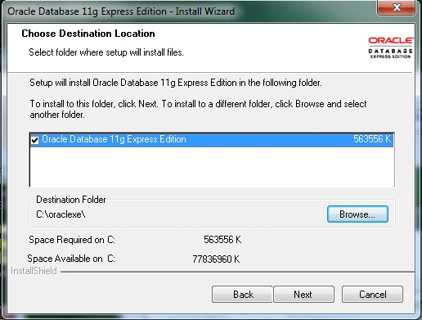

- Set the System Administrators password. Type the password admin and select <Next>.

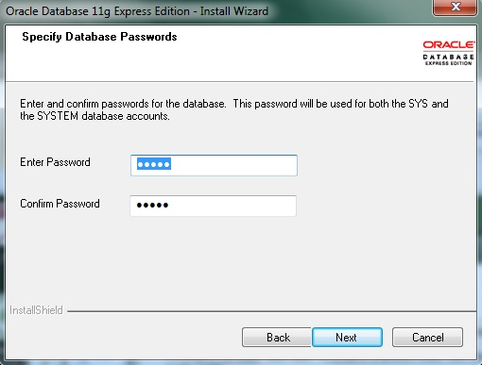

- Check the settings and proceed with the installation by selecting <Next>. NOTE: Port settings should read as follows: Oracle Database Listener – 1521; Oracle Services for Transaction Server – 2030; Oracle HTTP Listener – 8080.

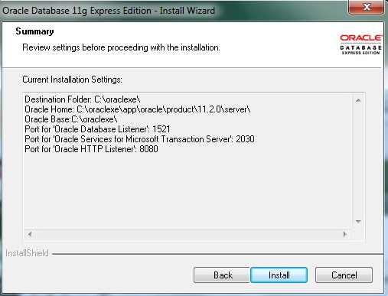

- If receiving these messages click <OK> and proceed with installation.

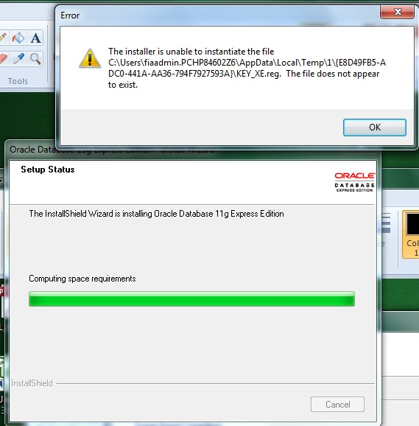
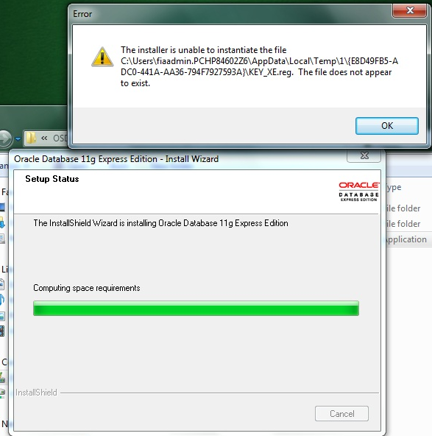

- Click <Finish>

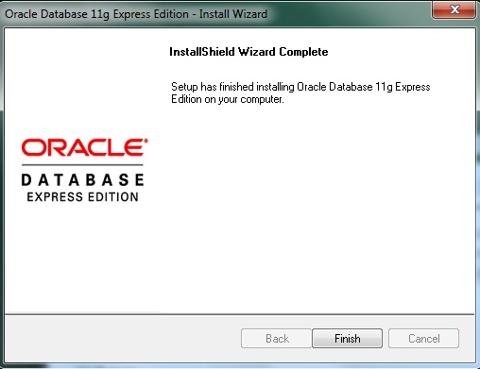

- Install FIADB Oracle Schema: Start the command prompt by clicking the <Start> button on the task bar, clicking the <All Programs>, <Accessories>, right-click <Command Prompt> menu option and select <Run as administrator> or <Run Elevated>. At the command prompt type cd c:\ fia_biosum\setup\Import_FCS and the <enter key>. At the c:\fia_biosum\setup\Import_FCS> command prompt type Import_FCS.bat and the <enter key>.

Note
It is ESSENTIAL that all of the following files be in the Import_FCS directory BEFORE running the Import_FCS.bat file (as admin):
1. FCS_EXPDP.DMP (dated 5/12/2016 at 1:24PM)
2. FCS_impdp.DAT
3. Import_FCS.bat
4. SetNoPasswordExpiration.SQL
5. TryDropUserCmd.SQL

When prompted for the password type in fcs and press <enter>. (IMPORTANT - the text will not appear and the cursor will not move. Don't type in any extraneous characters). See Figure 1.

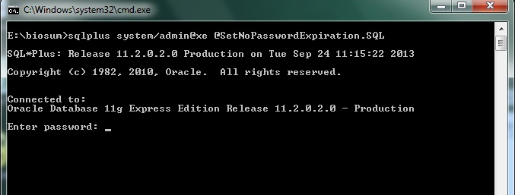
Figure 1

Oracle FCS Schema Troubleshooting Tips
If a previous FCS schema is already installed or if the setup of the FVS schema failed then follow these steps:

- Navigate to the C:\oraclexe\app\oracle\admin\XE\dpdump folder
- Delete all files
- Perform step 10

If the FIA BIOSUM MANAGER application is failing to connect to the Oracle FCS services then follow these steps:

1. Start a command prompt with <Run As Administrator>.
2. Open the sqlnet.ora file in a text editor (notepad). It is located in the folder below:
C:\oraclexe\app\oracle\product\11.2.0\server\network\ADMIN
3. Make the edits below and save

FROM
SQLNET.AUTHENTICATION_SERVICES = (NTS)
TO
SQLNET.AUTHENTICATION_SERVICES = (NONE)
4. Save the file.
5. Logout FIAADMIN and login with your FS userid and test

- Install R: Navigate to the c:\fia_biosum\setup\R folder and open the file R-3.1.2-win.exe and click <OK>. NOTE: If R is already installed then skip to step#20.

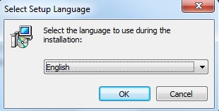

- Click <Next>.

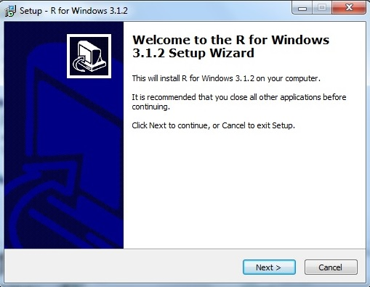

- Click <Next>.

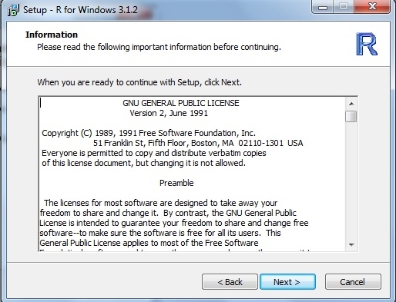

- Choose the location to install the R software and click the <Next> button. By default, R will install the software in the <Program Files> folder. If you wish to install the R software in a different folder then click the <Browse> button and navigate to a folder. In the example below, R is being installed in the c:\R folder.

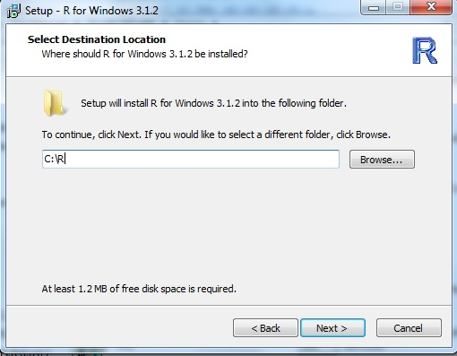

- Accept the defaults and click <Next>.

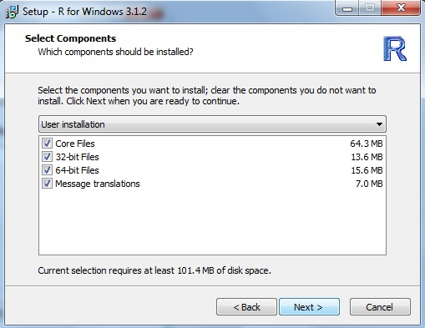

- Accept the defaults and click <Next>.

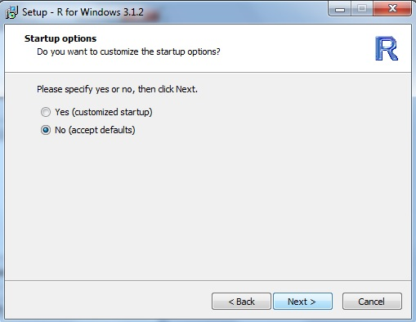

- Accept the defaults and click <Next>.

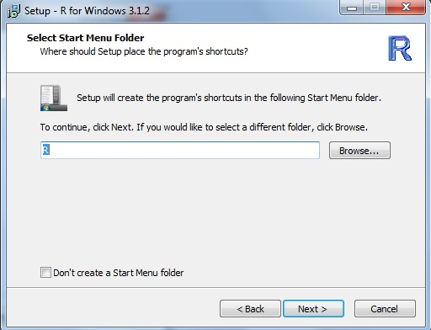

- Accept the defaults and click <Next>.

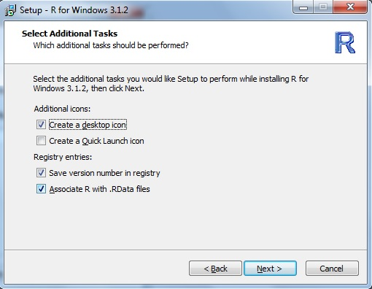

- Click <Finish>.

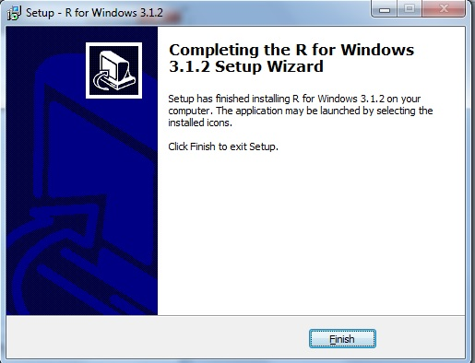

- Install RODBC: If RODBC is already installed then skip to item #25. RODBC enables R to connect to MS Access tables using ODBC. Navigate to the folder containing the R i386 program called RGui.exe and open it. NOTE: An internet connection is required for the RODBC install.

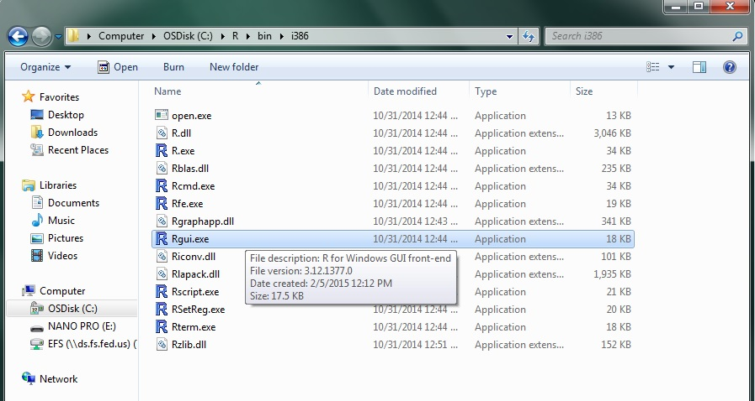

- Click on <Packages><Install Packages>.

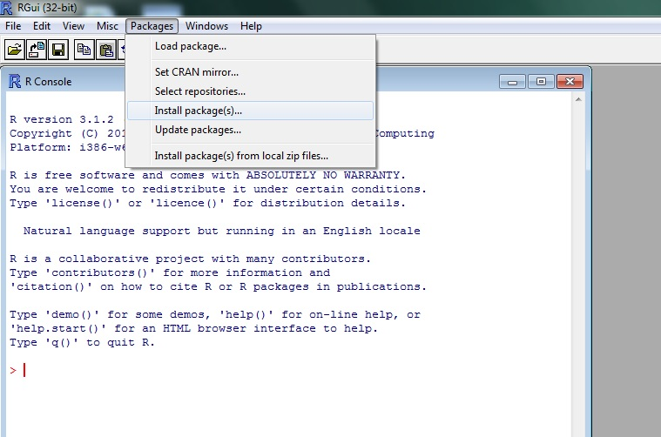

- Select the server location to download the file and click <OK>.

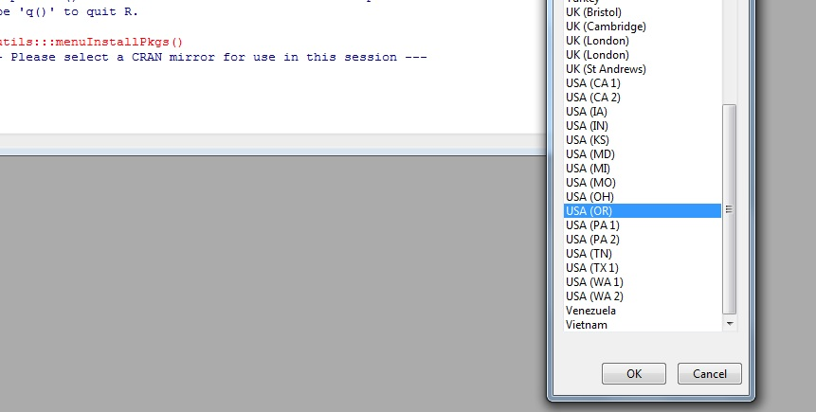

- Select the <RODBC> package to download and install. Click <OK>.

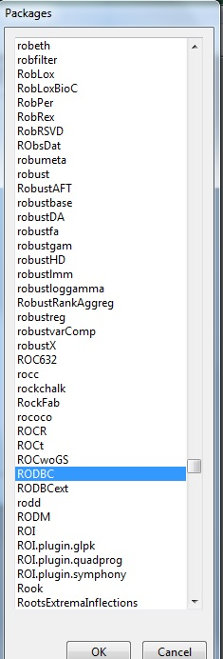

- Check to see if successfully installed.

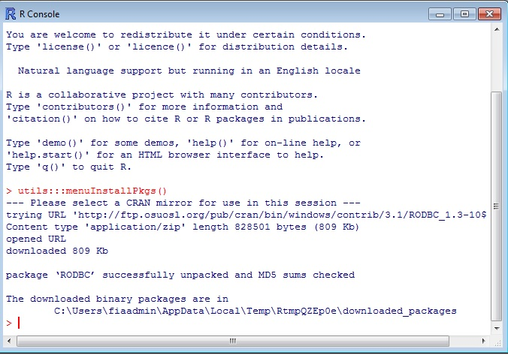

- Install FIA Biosum Manager: Navigate to the c:\ fia_biosum\setup\FIA Biosum Manager folder. and open the file ‘fia_biosum_setup_versionnumber.msi. Click on <Next>.

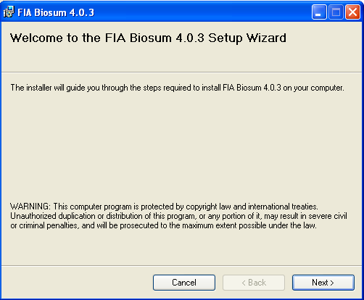

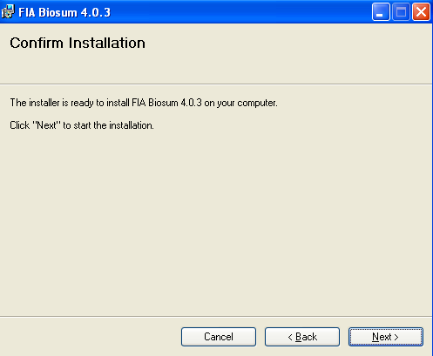

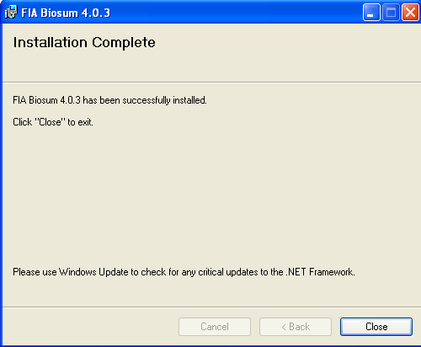

- Create ODBC connection : If Windows XP machine then select <Start><Control
Panel><Administrative Tools> and <Data Sources (ODBC)>. If Windows 7 then navigate to the
c:\windows\sysWOW64 folder and open the file odbcad32.exe. Select <Add> and enter the connection information as displayed in figure 4. After entering the information select <Test Connection> .

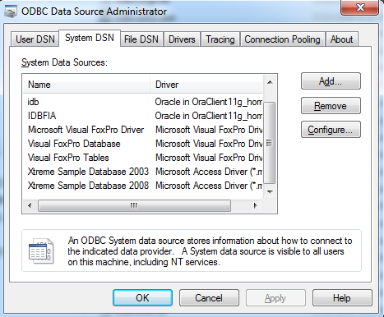
Figure 2.

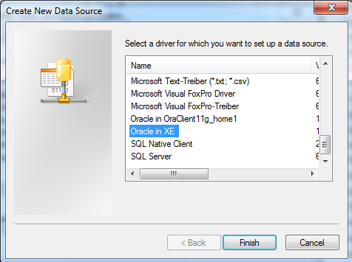
Figure 3.

Follow these instructions for entering the ODBC information:
1. Enter Data Source Name:
FIA Biosum Oracle Services
2. Enter TNS Service Name:
XE
3. Enter User ID:
fcs
4. Click <Test Connection>

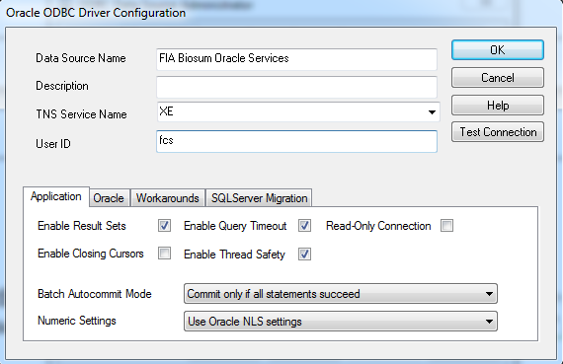
Figure 4.

Enter the following information if prompted
for the password (See Figure 5):

- Enter Service Name:
XE
- Enter User Name:
fcs
- Enter Password:
fcs
- Click <OK> button

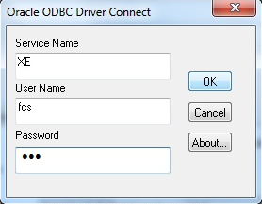
Figure 5.

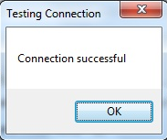
Figure 6.

If the test connection failed then check to see if the Oracle XE services are running. In the task bar on the desktop, select <Start> right click <My Computer> and select <Manage>. On the computer management form select <Services and Applications><Services> and check to see if <OracleServiceXE> is started and <OracleXETNSListener> is started. To start either of the Oracle XE services, right-click on the service and select <Start>. Test the ODBC connection again. If the connection fails a second time then contact FIA BIOSUM support person.

- ODBC Registry Edit: Add the ODBC Oracle fcs password. Adding the fcs password to the registry will prevent the user from being prompted for the password each time BIOSUM requests access to the fcs->BIOSUM_VOLUME table.

In the task bar on the desktop, select <Start>. If Windows XP select <Run> and type in the text box ‘regedit’ and select <OK>. If Windows 7 type in the text box ‘regedit’ and press the <enter> key.

In the registry editor form, select <Edit><Find> and enter the search information displayed in Figure 3 and select <Find Next>.

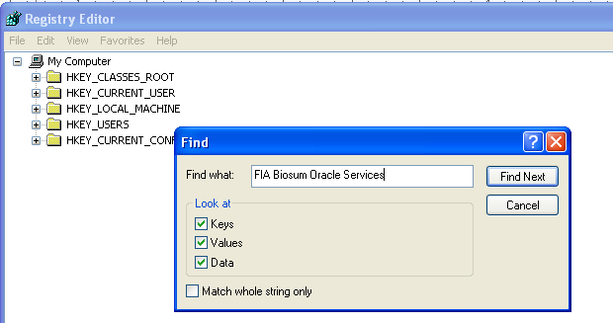
Figure 7.

When the search finds the ODBC DSN string then double click on the <Password> value and in the text box type ‘fcs’ and <OK>. See Figure 4. Exit registry editor form.

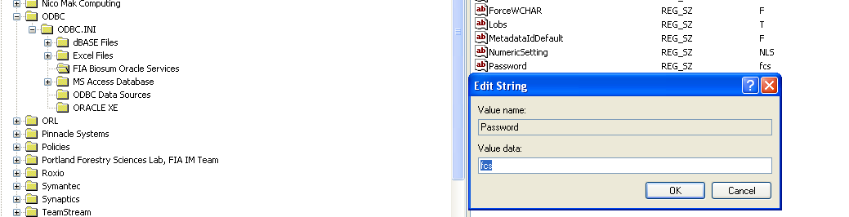
Figure 8.

- Additional ODBC connection test: Open any MDB or ACCDB file and select <External Data>

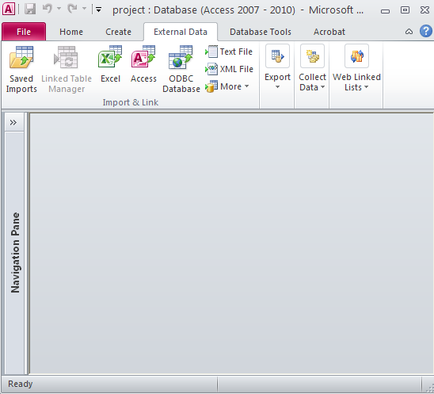
Figure 9.

- Select <ODBC Database>.

Figure 10.

- Select <Link to the data source by creating a linked table> and then click <OK>.

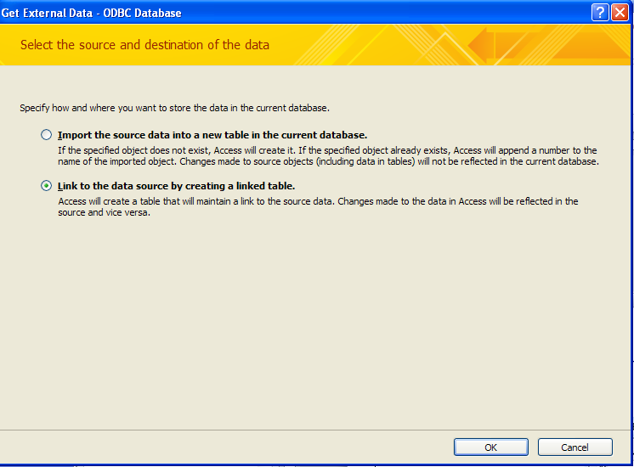
Figure 11.

- Select <Machine Data Source> tab, <FIA Biosum Oracle Services> and <OK>.

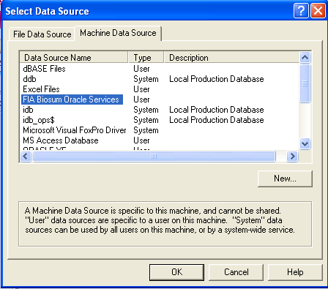
Figure 12.

- If ODBC is successful then the FCS oracle schema should be listed in the tables list below. If there is an ODBC connection problem please contact a Biosum support person for assistance.

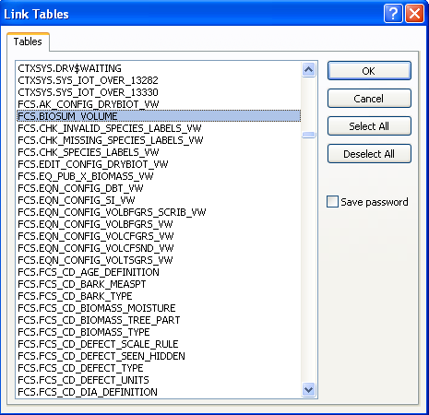
Figure 13.

