

**FIA Biosum**

**Bioregional Inventory Originated**

**Simulation Under Management**

**Installation Guide**

**For Version 5.8.9, released on 16 October 2020**

**Introduction**

This guide details the 34 steps required to install the FIA BioSum software on your Windows computer for the first time—what we call a “full installation”. Instructions for upgrading from a previous version of BioSum are provided in an Appendix at the end of this guide. Review of the aforementioned appendix is particularly important for upgrading to BioSum 5.8.9 as BioSum is transitioning to 64-bit architecture with this release.

BioSum should be installed from an account with administrative privileges. Some components, such as ORACLE Express Edition, must be installed from an administrative account. One benefit of installing all components from an “admin” account is that all components are then available to be run from any user account on the computer. It is also essential that BioSum “projects”, the datasets assembled and analyzed during the BioSum workflow, be in “trusted locations” as defined in the MS Access configuration to eliminate disk write failures in a project’s database.

If installing on a Forest Service computer, full administrative account access is not available. The components can be installed using the <Run Elevated> option on the right click menu, paying strict attention to the instructions herein. Users with computers on the Forest Service network should refer to Appendix 2 for installing additional components that allow BioSum to function without installing ORACLE XE. Forest Service users should skip steps 2-8 and NOT try to install and configure ORACLE XE or the FIADB Oracle Schema.

The full installation can be initiated from FIA_BIOSUM_SETUP.ZIP. Use your favorite archive program (e.g., 7-zip, WinZip) to extract this archive to C:\ -- this will create the folder C:\FIA_BioSum and subfolders such as C:\FIA_BioSum\Setup. After archive extraction, five critical installation tasks must be performed:

1. Install Oracle 11g Express Edition (XE), if not already installed (unless the computer is on the USFS network; If a USFS computer, refer to Appendix 2)
2. Install FIADB Oracle Schema, if not already installed (unless the computer is on the USFS network)
3. Install R, if not already installed on the computer (version 3.4 or better)
4. Install RODBC, if not already installed
5. Install FIA Biosum Manager—the analyst-friendly software that manages workflow associated with the many data manipulation and analysis procedures in a BioSum project.

If Oracle 11g XE (11.2.0) 64-bit has already been installed via procedures consistent with those specified in this guide, there is no need to reinstall this component. Oracle 11g documentation is available in c:\ fia_biosum\setup\oracle11g_xe\oracle_11g_setup_instructions.pdf after self-extraction of FIA_BIOSUM_SETUP, but if the installation is successful, it is typically not needed. User permissions on the USFS network prohibit the installation of Oracle 11g XE.

**Software Requirements for Computers Running BioSum**

For BioSum to install and function at all, requirements 1-2 must already be met. Requirement 3 can be met following installation.

1. Microsoft Windows 7 Professional, Enterprise, or Ultimate editions, or Windows 10.
2. Microsoft Office 2013 or greater (through Office 365), which BioSum uses for data storage, but **must be** 64-bit Version and include MS Access. IMPORTANT: If running Office 2016 or later the MS Office 2013 64-bit runtime library Access_runtime_**x64**_en-us.exe) must also be installed (download via <https://www.microsoft.com/en-us/download/details.aspx?id=39358>), then install as admin or via Run Elevated (USFS users).
3. FVS Suppose v.2.02 or later (Separate Installation) <http://www.fs.fed.us/fmsc/fvs/software/complete.php>

**Setup Overview**

|  |
| --- |
| Faithfully (and patiently) following these instructions will get you up and running with BioSum soon. Because BioSum relies on ORACLE “packages” (code libraries) throughout the workflow, both ORACLE XE and the FIADB ORACLE “schema” that connects BioSum to the ORACLE packages **must** be installed for the software to function correctly. These installations require admin status on the computer. Because the Forest Service network prohibits admin status, Forest Service users should refer to Appendix 2 for the alternative to ORACLE XE.  Unless BioSum will be used only to create FVS files for purposes unrelated to BIOSUM analysis, the R software and RODBC driver must also be installed to enable OPCOST to estimate costs of forest operations. Install the FIA BIOSUM MANAGER last.  If ORACLE XE, R (64 bit, a.k.a. x64, version 3.4 or better) or RODBC are already installed on your computer, they do not need to be reinstalled. The fia_biosum_setup.zip archive file contains all the files needed for a full install. It is best to unzip this to the root directory of the C drive (specify C:\ as the location to install—the installed will then create folder named C:\fia_biosum, with a setup folder, these installation instructions, and release notes). |

**RUN ELEVATED PRIVILEGES OVERVIEW (Forest Service users)**

|  |
| --- |
| To install or uninstall the software (via the .MSI file) requires administrative privileges. Forest Service users will typically be operating with a Forest Service computer with a standardized “imaged” operating system that does not grant the user admin privileges. For installation steps requiring administrative privileges there are 2 alternatives:   1. Right-click the install file (e.g., the msi) or command (e.g., odbcad32.exe) and select <Install Elevated> or <Run Elevated>, or 2. Shell to a command prompt by selecting locating (in File Explorer) and right-clicking on the file C:\Windows\SysWOW64\cmd.exe, then selecting <Run Elevated>. From the elevated command prompt, navigate to the folder location of the BIOSUM install files and run each of them from the elevated command prompt. This is the PREFERRED and only FULLY TESTED approach.   **<Install Elevated>** and **<Run Elevated>** are the Forest Service Powerbroker options that should be used for elements of the installation process requiring execution as an admin level user.  Running the BioSum software, once it has been successfully installed, does not require administrative privileges. By default, the BIOSUM software is installed for all user accounts.  If you intend to open and edit BIOSUM MS Access files, make sure that the directory location that houses a BioSum project (which consists of a great many Access database files) of the file is set as a trusted location in the Access software settings (under options, trust center settings).  The best way to make sure that installation components are installed under the admin privileges (non-Forest Service users) is to open a command window as admin and type the commands out in that command window. For example:  For step 9, you would follow these steps:  1. Start a command prompt with admin privileges.  2. In the command prompt type these commands:  2a. cd c:\ fia_biosum\setup\Import_FCS <enter key>  2b. Import_FCS.bat <enter key>  When defining the ODBC entries make sure ODBCAD32.EXE is started from the c:\windows\System32 folder, as a user with admin privileges. Note that the System32 folder contains the 64-bit ODBC Data Source Administrator. |

**Setup Instructions**

1. Login to your computer as an administrator
2. **INSTALL Oracle 11g XE:** If your computer is on the Forest Service network, execute the steps in Appendix 2 before skipping to step 10. If Oracle 11g XE is already installed then skip to item 9. As an administrator, execute the file

c:\fia_biosum\setup\oracle11g_xe\DISK1\setup.exe.

|  |  |
| --- | --- |
| 1. Click <Next> | 1. Check “Accept terms”,click <Next>. |
|  |  |
| 1. Accept the default destination folder and click <Next>. | 1. Set the System Administrators password. Type the password admin and select <Next>. |
|  |  |

|  |  |  |
| --- | --- | --- |
| 1. Check the settings and proceed with the installation by selecting <Next>. | NOTE: Port settings should read as follows: Oracle Database Listener – 1521; Oracle Services for Transaction Server – 2030; Oracle HTTP Listener – 8080. | |
|  | | |
| 1. If receiving these messages click <OK> and proceed with installation. If one or more error messages such as the one displayed below appear, clear them by clicking OK to ignore them. Then click <Finish> to complete the installation. | | |
|  | |  |

1. **Install** **FIADB Oracle Schema:**
   1. Start the command prompt with administrative privileges
   2. At the command prompt type **cd c:\ fia_biosum\setup\Import_FCS_BioSum** and the <enter> key (case does not matter when typing these commands at the command line prompt).
   3. At the c:\fia_biosum\setup\Import_FCS> command prompt type **.\FCS_BioSum_Import.bat** and the <enter>.

**Note**

It is ESSENTIAL that all of the following files be in the Import_FCS_BioSum directory BEFORE running the FCS_BioSum_Import.bat file (as admin):

1. FCS_BIOSUM.DMP (dated 5/25/2018)

2. FCS_BIOSUM_impdp.DAT

3. FCS_BIOSUM_Import.bat

4. FCS_BIOSUM_SetNoPasswordExpiration.SQL

5. FCS_BIOSUM_TryDropUserCmd.SQL

If prompted for the password type in **fcs** (for this purpose, **case matters**—these are lower case letters) and press <enter>. (**IMPORTANT!** - the text will not appear as you type, nor will the cursor move. Don't type in any extraneous characters). See below.

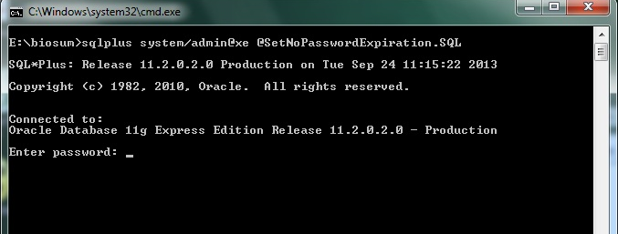

Many lines of processing will scroll up the screen; when finished, you may see a “3”. Press <enter>, then “quit” to exit the ORACLEXE environment.

**Tips for troubleshooting the Oracle FCS Schema**

|  |
| --- |
| If a previous FCS schema is already installed on your computer or if the setup of the schema failed, follow these steps:   1. Navigate to the C:\oraclexe\app\oracle\admin\XE\dpdump folder 2. Delete all files 3. Repeat step 9   If the FIA BIOSUM MANAGER application fails to connect to the Oracle FCS services, follow these steps:   1. Start a command prompt with <Run Elevated>. 2. Open the **sqlnet.ora** file in a text editor (such as notepad). It is located in the folder: C:\oraclexe\app\oracle\product\11.2.0\server\network\ADMIN 3. Edit this file so that it reads as below   FROM  SQLNET.AUTHENTICATION_SERVICES = (NTS)  TO  SQLNET.AUTHENTICATION_SERVICES = (NONE)   1. Save the file. 2. Logout of the admin account on your computer, login with your regular userid and test |

**Install R:** If R is already installed then skip to step 19; otherwise, navigate to the c:\fia_biosum\setup\R folder and run the file R-3.4.0-win.exe, with admin privileges.

|  |  |
| --- | --- |
| 1. Click <OK>. | 1. Click <Next>. |
|  |  |
| 1. Click <Next>. | 1. By default, R will install in the <Program Files> folder. Click <Browse> to navigate elsewhere, if desired (e.g., C:\R, as shown). |
|  |  |
| 1. Accept the defaults and click <Next>. | 1. Accept the defaults and click <Next>. |
|  |  |

|  |  |
| --- | --- |
| 1. Accept the defaults and click <Next>. | 1. Accept the defaults and click <Next>. |
|  |  |
| 1. Click <Finish>. | |
|  | |

1. **Install RODBC:** If RODBC is already installed then skip to step #24. RODBC enables R to connect to MS Access tables using ODBC. Navigate to the folder containing the R i386 program called RGui.exe and open it. NOTE: An internet connection is required for the RODBC install.

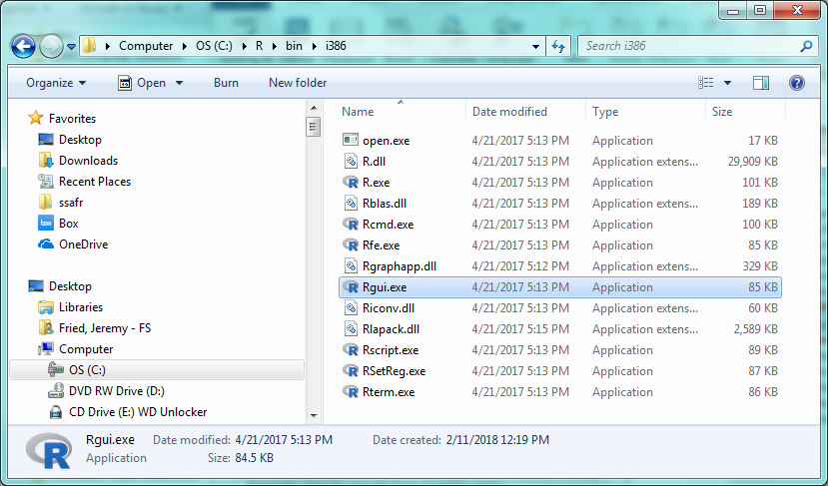

1. Click on <Packages> <Set CRAN mirror>, and choose a mirror location near you.

|  |  |
| --- | --- |
|  |  |

1. Then, click again on <Packages> but this time select <Install Packages>.

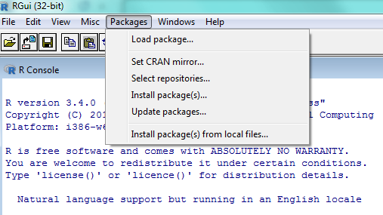

1. Select the <RODBC> package to download and install. Click <OK>.

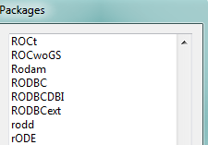

1. Check to see if successfully installed.

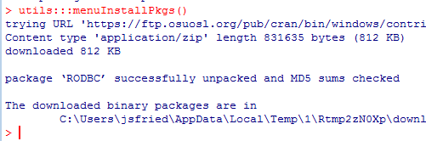

|  |  |
| --- | --- |
| 1. **Install FIA Biosum Manager:** Navigate to the c:\ fia_biosum\setup\FIA Biosum Manager folder. Open the file ‘fia_biosum_setup_versionnumber.msi via right click, Install. Click on <Next>. | |
|  |  |
| 1. **Create ODBC connection**: If your computer is on the Forest Service network, consult Appendix 2 for alternate instructions on creating an ODBC connection to an internal Forest Service database. Otherwise, navigate to the c:\windows\system32 folder and run odbcad32.exe as an administrator. Click System DSN tab, and select <Add> to add data source | |
| * 1. Choose the System DSN tab, and select <Add> to initiate adding a data source | * 1. Select ORACLE in XE as the data source driver |
|  |  |
| * 1. Enter the connection information exactly as it appears below | * 1. Then click <Test Connection> to ensure that the service works as intended, **THEN** <OK> |
|  |  |

|  |  |
| --- | --- |
| * 1. Enter TNS Service name: XE, User ID: fcs_biosum and password: fcs, then click <OK>. | * 1. A “Connection Successful” result is validation of a working ORACLE connection. |
|  |  |
| If the test connection fails, check to see if the Oracle XE services are running. In the task bar on the desktop, select <Start> right click <My Computer> and select <Manage>. On the computer management form select <Services and Applications><Services> and check to see if <OracleServiceXE> is started and <OracleXETNSListener> is started. To start either of the Oracle XE services, right-click on the service and select <Start>. Test the ODBC connection again. If the connection fails a second time then contact FIA BIOSUM support staff for assistance. | |

1. **ODBC Registry Edit:** Add the ODBC Oracle fcs password. Adding the fcs password to the registry will prevent the user from being prompted for the password each time BIOSUM requests access to the fcs->BIOSUM_VOLUME table.

In the task bar on the desktop, select <Start>. Type in the text box ‘regedit’ and press <enter>.

In the registry editor form, select <Edit><Find> and enter the search information displayed below and select <Find Next>.

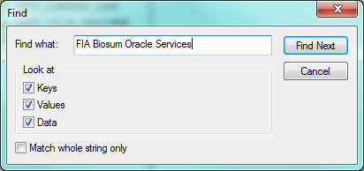

When the search finds the ODBC DSN string, double click on the <Password> value and in the text box type ‘fcs’, then click <OK>.

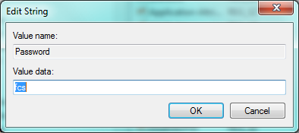

1. If running Access 2016, Office 365 or any other version later than 2013, you will need to install the **MS Office 2013 64-bit runtime library** Access_runtime_x64_en-us.exe. This can be downloaded via https://www.microsoft.com/en-us/download/details.aspx?id=39358, and must be installed with elevated or admin privileges. Forest service users should be able to find this component in the Software Center.
2. Path Statement modification (essential if there are other versions of ORACLE installed). Forest service users can skip this step because they are not using ORACLE.

Setting the PATH variable in the command prompt only exists for the life of the command prompt. To permanently set the PATH variable follow these steps:

* 1. Run a command prompt (CMD.EXE) with admin access
  2. Type sysdm.cpl <Enter>
  3. Click the <Advanced> tab
  4. Click the button <Environment Variables>
  5. Find the PATH variable in the bottom ‘System’ list
  6. If the ORACLEXE path isn’t in first position, move it there as shown below

|  |  |
| --- | --- |
|  |  |
|  | |

1. **Additional (optional) ODBC connection test for non-Forest Service users:**
2. Open any MDB or ACCDB file, select the <External Data> tab and choose <ODBC Database>.

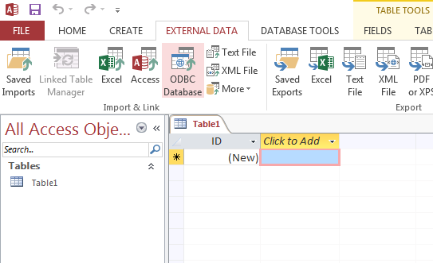

1. Select <Link to the data source by creating a linked table> and then click <OK>.

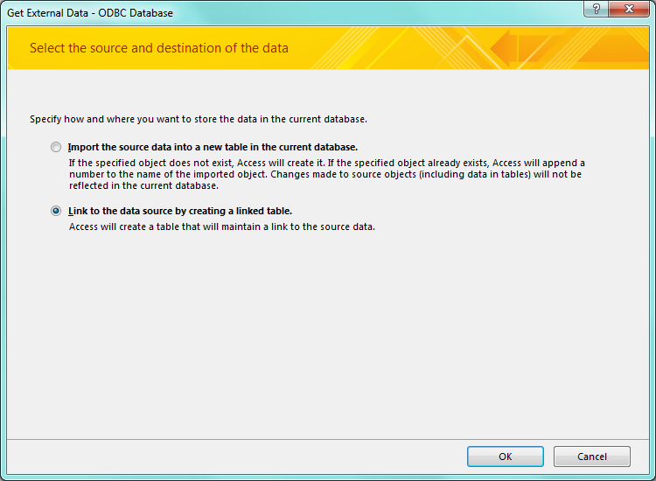

1. Select <Machine Data Source> tab, <FIA Biosum Oracle Services> and <OK>  
     
   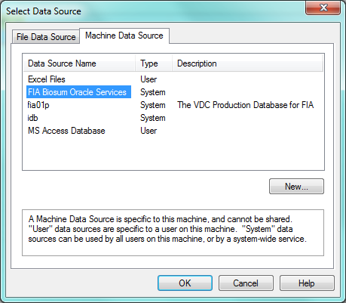
2. If ODBC is successful, then the tables in the FCS oracle schema will be listed, as below. If there is an ODBC connection problem, Biosum support staff can assist.   
     
   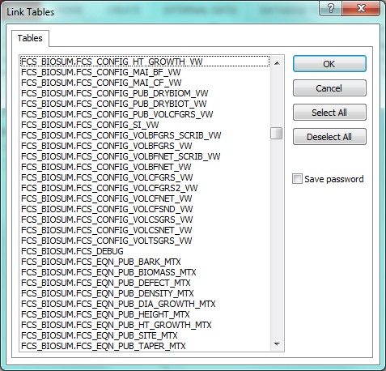

**Setting up BioSum Manager**, and **testing the ODBC connection** from BioSum

|  |
| --- |
| 1. Start BioSum Manager and select the Settings menu |
|  |
| 1. Navigate to the directory containing Rscript.exe on your computer. Be sure to select the 64 bit version of Rscript, which is stored in the x64 folder within your R version bin folder. Also navigate to and select the OpCost script file (10_1_5.R as of this version of BioSum); it can be found in the C:\Program Files\FIA PNW Portland Forestry Sciences Lab\FIA Biosum 5.8.9\opcost\ folder. Then click <Save> to save these choices, then <OK> to close the Settings window. |
|  |

|  |
| --- |
| 1. Start the BioSum Troubleshooter tool |
| 1. Click the <Calculate Volume and Biomass> button |
|  |
| 1. If numbers show up in the results table, typically after 10 to 20 seconds, all is well with the ODBC connection. The tool can be closed by clicking the close (x) button in the upper right corner of the dialog. If errors or no results, the ODBC connection issue needs resolution before BioSum can operate correctly. |
|  |

# Appendix 1: Upgrading the BioSum software from an earlier version

**Upgrade Overview**

|  |
| --- |
| BioSum 5.8.9 is a major BioSum upgrade as it transitions the BioSum platform from 32 to 64 bit architecture. Support for projects created under previous BioSum versions is limited to versions 5.8.6 and later. If you have existing projects, the BioSum version is listed in the application.version file in the main folder of the project and can be read using notepad or another text editor. If you need to maintain compatibility for projects created under an earlier version than v5.8.6, please contact BioSum support prior to upgrading BioSum or any of its accompanying components.  BioSum stores most of its data in Microsoft Access databases and version 5.8.9 requires that a 64-bit version of Access be installed. Microsoft does not support multiple versions of Microsoft Office (Access) on a single computer, so you will likely need to uninstall any 32-bit versions of Microsoft Office and/or the 32-bit Microsoft Access 2013 runtime if they were previously installed. BioSum is compatible with most 64-bit versions of Microsoft Access 2013 or later. If using Microsoft Access 2016 or later, the 64-bit Microsoft Access 2013 Runtime is required (see item #2 in the software requirements section). Microsoft Office software management/configuration is beyond the scope of this document so when upgrading Microsoft Office/Access, it is recommended that you consult with your organization’s I/T department if available.  Non-forest service users will also need to upgrade Oracle XE from 32 to 64-bit. To do this, use the Windows Add or Remove programs menu to uninstall Oracle XE 32-bit. Then follow the instructions starting with step #2 to install Oracle XE 64-bit and to import the FIADB Oracle schema. The ODBC Oracle FCS data source also needs to be (re)created using the 64-bit Data Sources Manager (step 25).  After insuring that the required pre-requisites are in place, launch the BioSum .msi installer per the instructions in step 24. BioSum versions can usually exist side-by-side, but because of the platform change, once you upgrade Microsoft Office/Access and Oracle XE to 64-bit, BioSum versions prior to 5.8.9 will no longer work and should be uninstalled. Use the Windows Add or Remove programs menu to remove these older versions.  The R installation includes both the 32 and 64-bit versions of the software, but following the installation of 5.8.9, BioSum should be re-configured to use the 64-bit version:   1. After launching BioSum, click on the Settings menu 2. Set the directory path for R to point to the 64-bit version. This is usually C:\Program Files\R\R-3.4.0\bin\x64\RScript.exe 3. While on this screen, verify that the path to OpCost is correct. This may have changed because the BioSum installation directory has changed with 5.8.9. The default location for OpCost is now C:\Program Files\FIA PNW Portland Forestry Sciences Lab\FIA Biosum 5.8.9\opcost\ Opcost_10_1_5.R. 4. Use the Save button on the Settings form when your changes are complete. |

# Appendix 2: Additional steps when installing BioSum on Forest Service computers

Users with computers on the Forest Service network should execute the following steps to allow BioSum to connect with an internal, central Oracle database hosting the ANL_PNW_FIA_FCS schema:

1. Permissions for the ANL_PNW_FIA_FCS schema must be granted before you can connect to it. Request access from <insert contact info here>.
2. If it is not already installed, install the 64-bit Oracle 12c client from the Software Center. Accept the default values as you click through the installation dialog.
3. Navigate to the c:\windows\system32 folder and run odbcad32.exe.
   * Click the User DSN tab, and select <Add> to add a data source.
   * Select ‘Oracle in OraClient’ as the data source driver
   * Enter the connection information exactly as it appears below:
     + DSN=FIADB01P
     + TNS Service Name=FIADB01P
     + User name=user name associated with the permissions granted in step 1
   * Then click <Test Connection> to ensure that the service works as intended. Use the user name and password provided to you during step 1. The test connection will not work if step 1 has not been completed.
   * Click <OK> to finish creating the datasource
4. Copy the following 3 files from C:\Program Files\FIA PNW Portland Forestry Sciences Lab\FIA Biosum 5.8.9\fcs to your Windows AppData folder. If you don’t know the location of the AppData folder, launch BioSum and click on the <Settings> menu. The path to the AppData folder appears on this screen.
   * BioSumComps.jar
   * fcs_tree.db
   * fcs_tree_calc.bat
5. If multiple users share a computer, steps 3 and 4 will need to be completed by each user.