- BOTH Need to revisit the informed prior for annual visibility corrections, and all the EE priors YES
- Add 2021 YKD counts? And 2020/21 ice measurements? YES -see Dunham 2019
  - Put 2015 and 2021 counts in (and look to see if detection probability and/or breeding propensity explains those counts sufficiently)
  - CAT Need to ask Nate or Dan to provide the 2019 and 2020 ice measurements
    - Dan reanalyzed the entire time series, so the years before 2019 are slightly different from Dave Douglas data. Suggest that we replace the complete time series while adding the additional years.
    - 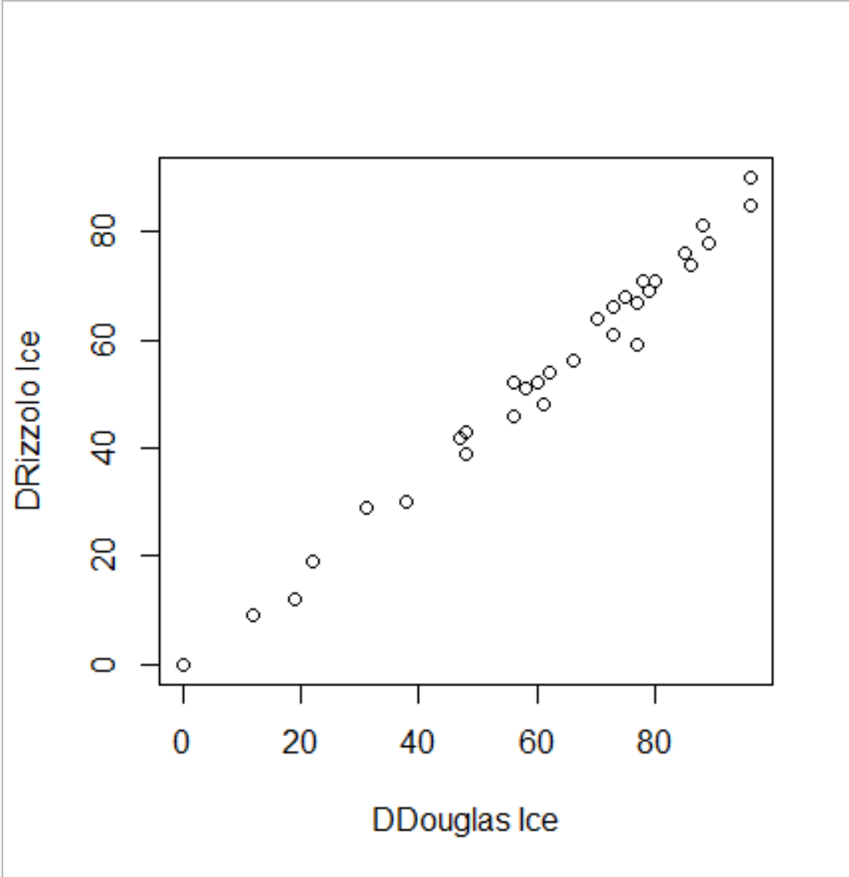
- CAT Fit the regression for ice over time within the IPM to develop the NB parameters used to draw ice projections. YES or change the inputs to priors.
  - The idea behind this is that annual realized ice observations can be thought of as a draw from an NB distribution with mean == to model predicted ice. Using the regression of obs ~ model-pred from 1980 – 2018 to estimate the appropriate value of the size (overdispersion) parameter.
  - Then using that estimated size parameter and model predicted ice values in the future to draw possible realizations for annual ice values in the future. The intent is to appropriately reflect the uncertainty in the model predicted ice values, and particularly, that observed data 1980- 2018 is much noisier than the model predicted values. Note that the predicted ice day values are a weighted mean from an ensemble of climate models (8 specifically) where weights reflected the fit of individual model estimates to the observed data from 1950 - current, as described in Christie et al. 2018. So, not super surprising that they are not very noisy.
  - Here we’re moving from a point estimate for the size parameter given as data in the jags.data() call to the model to asserting additional uncertainty in that parameter by giving a prior for the size parameter using the estimate and its s.e. from the regression.
  - Below, blue points are the observed data, 1980 – 2018. Red points are the RCP4.5 model predictions for those data (ala Christie et al. 2018). Violin plots show draws (N = 1,000 for each year) from an NB distribution with the size parameter varying at each draw from a Normal (2.768, 0.452). Annual draws are a little noisier than when pulling from a NB with constant size, but you have to plot the variances to see it.

  - 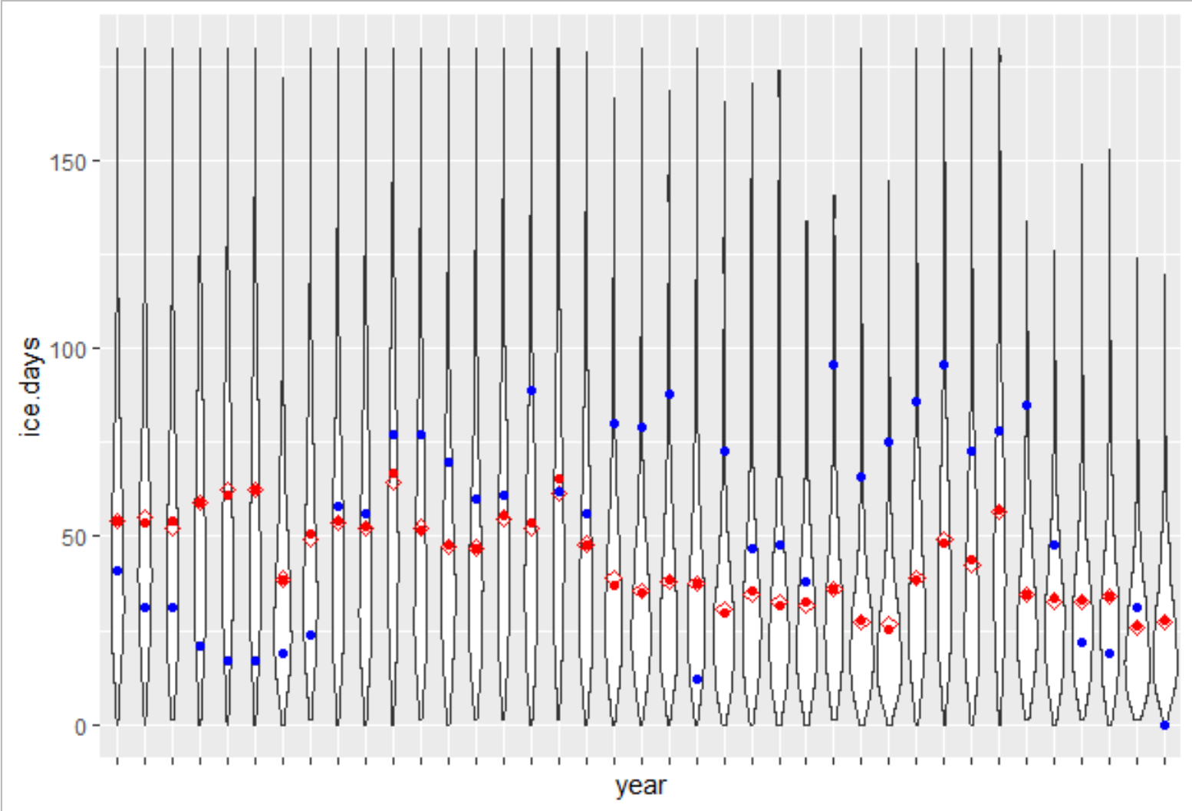
  - Below, predictions for BB with (blue) and without (red) varying size parameter in the model, under constant lead, RCP4.5 scenario. It looks purple, because the result is very, very similar. Predictions in 2060 are 8,972 (794 – 36,948) for constant NB size, 8.763 (821 – 37,319) for vary NB size. Guessing that compared to other sources of variance, this is a small contribution.
  - 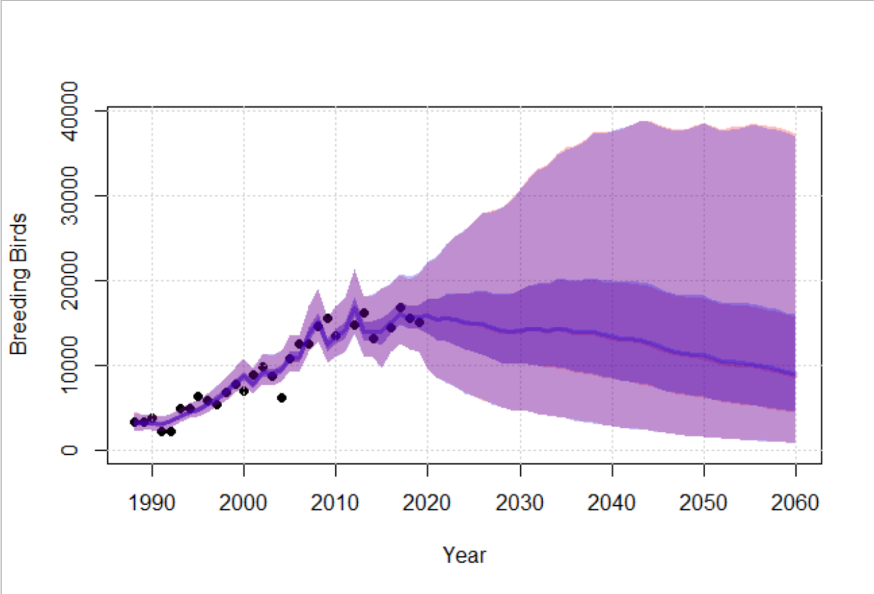
- What the relative contribution of DD vs Ice in the long-term resilience? MAYBE
- Result: show correlation between lambda and demographic parameter estimates (some use asymptotic growth rates instead of Nt+1/Nt in this comparison… Nichols et al. 2011 notes that this can lead to different conclusions in non-stationary systems) NEED TO READ NICHOLS AND DECIDE
- Results: several look at transient life table response experiments (Koons et al. 2016, Eacker et al. 2017, Fay et al. 2019) to estimate contribution of demographic variability to growth rate variability. Koons et al. 2017 MAYBE STUDY MORE
- ERIK New Idea: adding an inclusion parameter (Abadi et al. 2017) to the linear models with covariates (i.e. ice and ice^2 covariates) to measure the importance of the covariate (Royle 2008; O’Hara and Sillanpaa 2009) ERIK’S GONNA THINK ABOUT GAMS
  - Setting the beta parameters in the ice as a MVN prior as an alternative??? : Look at the Stan user manual
- Big caution in recent IPM papers that would need to be reiterated here: Systemic biases in measured vital rates or errors in model structure can be absorbed by the estimates of any latent variables. Most (all) latent variables in our model are initiated by EE priors, which may have some ameliorating effect…VERY IMPORTANT FOR DISCUSSION, ALL DATA COME FOR KIGIGAK AND KASHUNIK—ALL LEAD IS SPATIAL OR SAMPLING VARIANCE BETWEEN SITES IN SURVIVAL; IMP BENEFIT IS ESTIMATE FOR LATENT PARAMETERS, THESE ARE A HYPOTHESIS AS MIGHT BE DO TO BIASES OR MODEL STRUCUTRE. RESULTS REPRESENT A COHERENT HYPOTHESIS RELATIVE TO LIKELIHOOD.
- CAT Setting phi1 = phi2 = phiA and only allowing phi0 to be different SIMPLE WAIC COMPARISON?
  - N/A. This is the current model. p0 and pA are fitting different covariates to ice. p2 = pA, without the lead effect (i.e., beta parameters are ==), and p1 = p2.
- Priors vs posterior distributions for the LH parameters (or fitting components of the IPM vs the full IPM) MAYBE IN RESPONSE TO REVIEW OR INTEREST
- Doing the whole projection using ONLY the prior predictive simulations. CAT: Look at the priors v posteriors first to get a sense of likelihood contribution, look at the correlation matrix of the beta coefficients
- CAT: Explore if fecundity could be modeled as proportional to phiA
- Exploring naïve priors and looking at EE contribution vs likelihood contribution. SEEMS INTERESTING, THINK MORE
- Intro, YKD is increasing , ACP is stable (looking at Dunham paper). We’re focusing on the YKD.
- Dropping lead decreasing in 2008 scenario? Comment made during the decision meeting is that we know lead shot use continued after 2008... Change the rate of decline in that scenario? What would inform that rate? We’re using simple exponential decline in 2008/2026 scenarios.
####################################################################################
DROPPING COMPLETED ITEMS or ITEMS that we decided not to pursue down here
- YKD only (think we already decided yes to this) YES
- Reconsider the time frames? Current points in time for assessment were 2060 (40 years) and 2100 (80 years). Most PVAs now don’t go out nearly that far… See Oppel et al. 2014 - predictions greater than a couple generations are rarely meaningful given considerable uncertainty due to error propagation [and uncertainty in realized covariate values] KEEP TO 2060 UNLESS WE IDENTIFY SOMETHING TO EXPLORE

- Different scenarios with the overall Russian population? NO, BUT MAYBE DISCUSS
- Looking at something like: how big would the [lack of] ice effect need to be to generate an XX% chance in QE, given the model NO
- New Idea: Including counts of geese on the YKD/ACP as a covariate to productivity (Saunders et al. 2018; Diller et al. 2016) NO
- Consider correlated random effects between LH parameters ala Koons et al. 2017?? NO - WE DO THIS DETERMINISTICALLY USING THE COVARIATES
- Need a DAG or other figure to illustrate model structure or is the life cycle figure and leslie matrix enough? NO
- Model fit assessment? Many IPMs use posterior predictive p-values or graphical checks for component models. Here, CJS and SS count model. Alternatives and/or necessity (some don’t report it. I think Conn et al. 2018 basically said these aren’t very sensitive to lack of fit)? WE SHOULD DO SOMETHING - LOO ON YETI??? NO FOR NOW—TRY TO AVOID LOO

