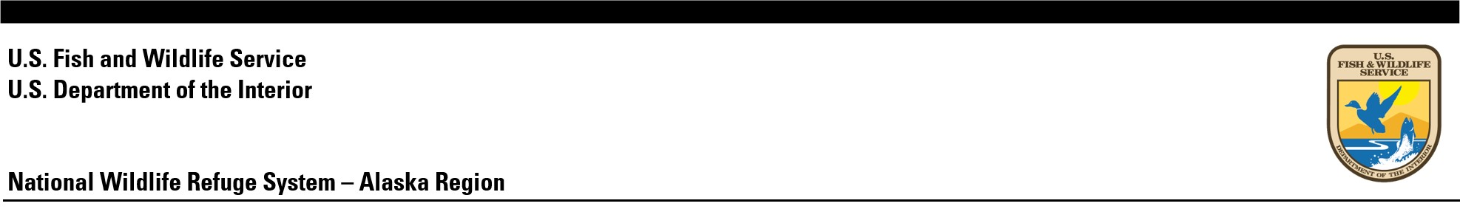

Alaska Refuge Report 2024-REPORT # 1

Tetlin Witch Report

Jane Biologist, Tetlin National Wildlife Refuge

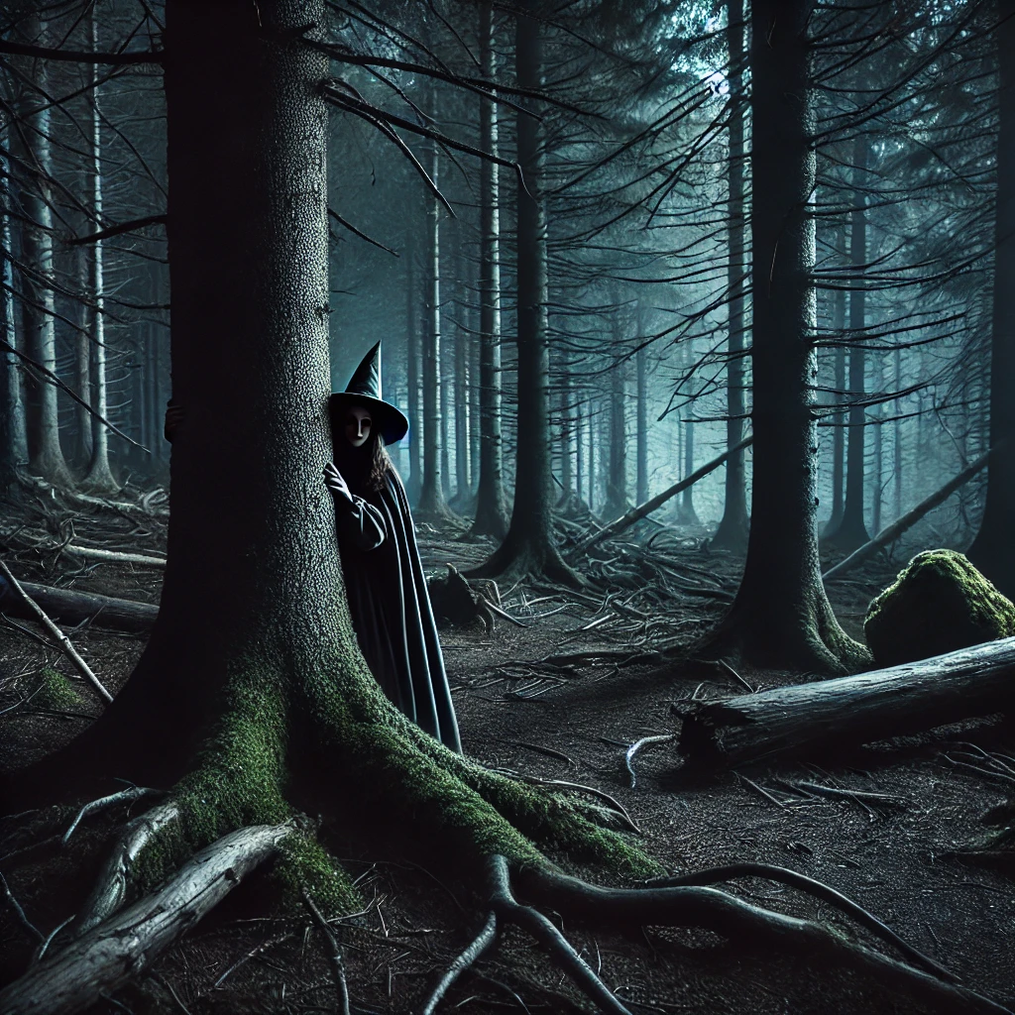

Photo Caption/FWS

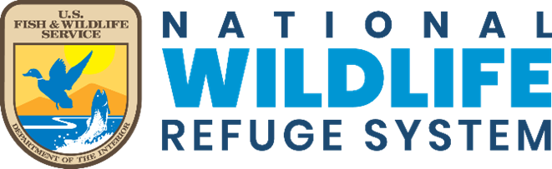

The Alaska Refuge Report Series is used to disseminate information and analysis about natural resources and related topics concerning lands managed by the National Wildlife Refuge System in Alaska. The series supports the advancement of science and informed decision-making by publishing scientific findings that may be ongoing or too limited for journal publication but provide valuable information or interpretations to the field of study.

Manuscripts in the series receive an appropriate level of peer review to ensure that the information is scientifically credible, technically accurate, appropriately written for the intended audience, and designed and published in a professional manner.

Disclaimer: The use of trade names of commercial products in this report does not constitute endorsement or recommendation for use by the federal government.

How to cite this report: Biologist, J. 2024. Tetlin Witch Report. Alaska Refuge Report 2024-01. https://doi.org/{UNIQUEDOI}.

ON THE COVER  
Image caption goes here  
Image credit goes here

## Abstract

Invasive witches have become a management concern at Tetlin National Wildlife Refuge. As such, there is a need to estimate witch occurrence within the Refuge.

## Keywords

Halloween, occupancy, Witches

# Study Area

We surveyed for witches at Tetlin National Wildlife Refuge, Alaska. blah blah

# Methods

### Data Collection

We visited a sample randomly distributed sites across Tetlin Refuge. At each site, we spent one hour looking and listening for witches. We revisited each site eight times.

### Model

We estimated witch occupancy and detection using a single-season occupancy model. We used the unmarked R package. [blah, blah, blah]

# Results

## Results

We surveyed a total of 100 sites. The average distance to water at our sites was 1137.03 m. The average distance to forest at our sites was 59.41 m.

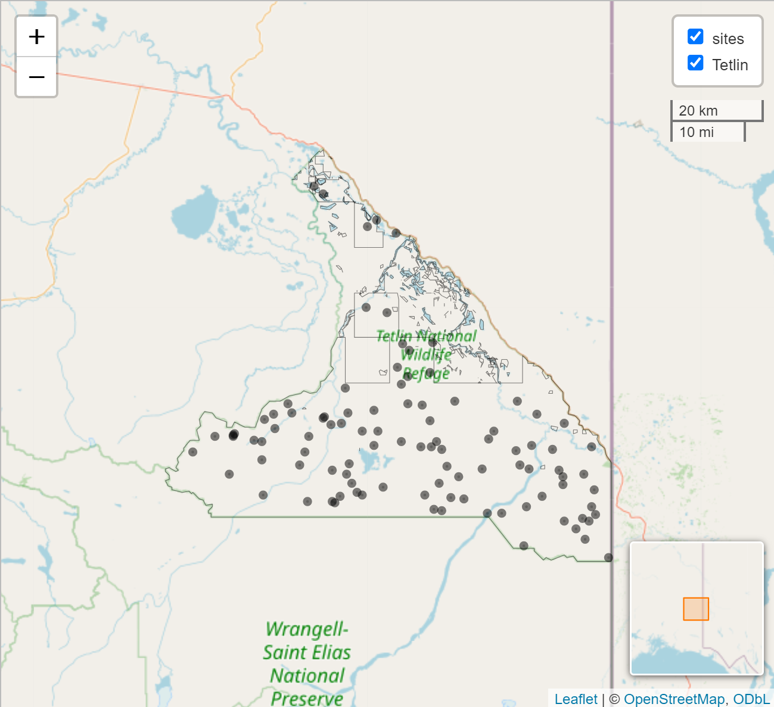

We observed witches on 193 of 800 site visits, for a naive occupancy of 0.24.

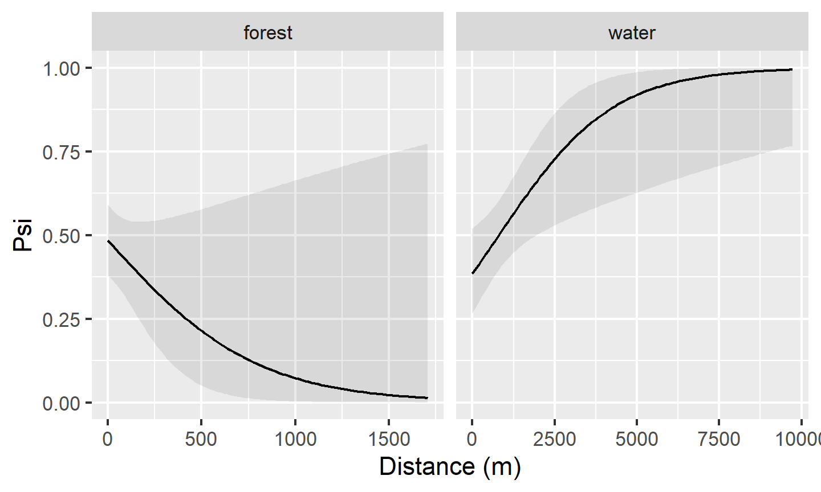

Occupancy of witches at Tetlin National Wildlife Refuge, Alaska, 2024.

# Discussion

## Adding citations and bibliography

Link a .bib document via the YAML header, and the bibliogaphy will be printed at the very end (as usual). The default bibliography style is provided in the the-journal-of-wildlife-management.csl file, which adopts the [Journal of Wildlife Management](https://www.nacwg.org/JWMguidelines2011.pdf) reference style.

References can be cited directly within the document using the R Markdown equivalent of the LaTeX citation system [@key], where key is the citation key in the first line of the entry in the .bib file. Example: [@fws2001]. To cite multiple entries, separate the keys by semicolons (e.g., (Buckland et al. 1997, Paul 2009)).

If you are using the reference manager [Zotero](https://www.zotero.org/) (**highly recommended**), then Rstudio can [access your reference library directly](https://bookdown.org/pdr_higgins/rmrwr/adding-citations-to-your-rmarkdown.html). Zotero is available through FWS Apps-2-Go. There is also the package [citr](https://github.com/crsh/citr). *citr* provides functions and an RStudio add-in to search a BibTeX-file to create and insert formatted Markdown citations into the current document.

# Acknowledgements

Include your appreciation of logistical support, funding sources, field technicians, managers, and others who contributed to the work.

# Data availability

All the raw data used in your report should be publicly-accessible, unless legally exempt (e.g., [FOIA-exempt](https://www.fws.gov/program/fws-freedom-information-act-foia)) Recommended boilerplate language for this section could read “The data presented in this report are available at {your data’s ServCat URL}”.

# References

Buckland, S. T., K. P. Burnham, and N. H. Augustin. 1997. Model selection: An integral part of inference. Biometrics 53:603–618. <<://A1997XE96500017>>.

Paul, T. W. 2009. Game transplants in alaska, 2nd edition. Alaska department of fish and game, divison of wildlife conservation. Alaska Department of Fish; Game, Divison of Wildlife Conservation, Juneau, AK.