**Preliminary Results of a Population Viability Analysis Applied to Lake Erie Cisco**

# INTRODUCTION

The Coregonine Restoration Framework provides an adaptive management structure to guide restoration of this suite of species in the Great Lakes Region of the U.S. One part of the framework is the implementation of population viability analysis (PVA) to support development of decision support tools that managers can use to determine optimal restoration strategies for coregonines. This report summarizes a PVA applied to Cisco (*Coregonus artedi*) occurring in Lake Erie.

On October 16th and October 30th of 2024, a panel of experts met to explore the available data for Lake Erie Cisco and review the PVA modeling efforts to date. Panelists were asked to work with the modeling team to make decisions on input parameters and modeling strategies. The PVA model was tweaked based on suggestions from the expert panelists and the initial results are presented here.

# METHODS

## Matrix Projection Model

Custom simulation models were used to assess the recovery potential of Cisco in Lake Erie under various scenarios. All models were based on a stochastic Leslie matrix modeling framework (Leslie 1945; Caswell 2001). The Leslie matrix models were age-structured, female-only, and assumed an annual time step. All model coding was performed in R (v4.4.2; R Core Team 2024).

Population dynamics from year *y* to *y* + 1 are governed by:

$$N_{y+1}=AN_{y}$$

where *N* represents a vector of numbers at age at time *y* and **A** is the Leslie matrix that takes the form:

$$A=\left[\begin{matrix}f_{1} & f_{2} & f_{3} & ⋯ & f_{t-1} & f_{t+} \\ S_{1} & 0 & 0 & ⋯ & 0 & 0 \\ 0 & S_{2} & 0 & ⋯ & 0 & 0 \\ 0 & 0 & S_{3} & ⋯ & 0 & 0 \\ ⋮ & ⋮ & ⋮ & ⋱ & ⋮ & ⋮ \\ 0 & 0 & 0 & ⋯ & S_{t-1} & S_{t+}\end{matrix}\right]$$

where *ft* and *St* are the fertility and survival for age class *t*, respectively. Here, the maximum age is 15 and is assumed to represent a plus-group, which accumulates all older individuals.

## Survival

The sub-diagonal cells of the Leslie matrix show the probability of an individual surviving from one age class to the next. In the absence of survival estimates for Lake Erie Cisco, we opted to derive estimates from life history relationships. Specifically, we estimated survival at age based on the assumed relationship between natural mortality and weight (Lorenzen 1996). This required parameter values characterizing both the age-length and weight-length relationships in order to derive weight at age (alternatively, an age-weight relationship could be applied). The relationship between age and total length was described by the von Bertalanffy age-length function:

$$L_{t}=L_{∞}\left[1-e^{-K\left(t-t_{0}\right)}\right]$$

where *Lt* is total length (mm) at age *t*, *L*∞ is the theoretical asymptotic average total length (if *K* > 0), *K* is growth rate at which the asymptote is approached, and *t*0 is the hypothetical age at which length is zero. The age-length parameters were used to compute length at each age and each length was then converted to weight using a weight-length relationship. An allometric function was used to relate weight to total length and requires two parameters, *a* and *b*:

$$W_{t}=aL_{t}^{b}$$

where *Wt* is weight (g) at age *t*, *Lt* is total length (mm) at age *t*, and *a* and *b* are parameters of the weight-length relationship.

The estimated weights (at age) derived above were used to compute natural mortality based on the Lorenzen (1996) relationship between natural mortality and weight:

$$M_{t}=3{W_{t}}^{-0.288}$$

where *Mt* is the instantaneous rate of natural mortality at age *t* and *Wt* is weight at age *t*. This gives estimates of age-specific *M*, which were then converted to survival rates (finite) at age:

$$S_{t}=e^{-M_{t}}$$

where *St* is the finite rate of survival at age *t* and *Mt* is the instantaneous rate of natural mortality at age *t*.

Data characterizing the life history of Cisco in Lake Erie are limited and were collected during a period of high commercial fishery exploitation (Clemens 1922) and when lake conditions were likely much different from what they are today. For this reason, we borrowed life history parameters from Cisco occurring in the other Great Lakes for the development of survival estimates (Tables 1 and 2; Figures 1 and 2). During each simulation, the model selects one set of age-length parameters and one set of weight-length parameters to derive survival at age.

In order to add additional realism to the models, the vector of age-specific natural mortality rates were varied within each year of each simulation. This was accomplished by randomly selecting an error (+/- 30% for age-1 fish; +/-10% for fish age-2 and older) and adding that value to the entire vector of natural mortality at age for the given year before converting to survival. This process effectively results in the inclusion of both process error (uncertainty in the expected natural mortality) as well as environmental uncertainty (some random noise on an expected value).

## Reproduction

The top row of the Leslie matrix contains age-specific fertility rates (*ft*) defined as the average number of offspring produced from an age class. These rates are calculated using data on sex ratios, maturity, fecundity, and early life stage survival:

$$f_{t}=P_{t}m_{t}F_{t}E$$

where *Pt* is the proportion of females at age *t*, *mt* is the proportion of mature females at age *t*, *Ft* is the fecundity at age *t*, and *E* is the early life stage survival (finite). For the Cisco Leslie matrix model, a 1:1 sex ratio was assumed for all ages. Estimates of female maturity at age were borrowed from the Green Bay model of Cisco published in Rook et al. (2024)—18% at age 2, 99% at age 3, and 100% at age 4–15 (Smith 1956). Historical conditions in Green Bay were likely more similar to what would be expected in Lake Erie under contemporary conditions, rather than contemporary conditions in other areas of the Great Lakes (highly oligotrophic; Scott 1951; Hile et al. 1953; Epstein et al. 1974; Gregor and Rast 1979; Barbiero et al. 2012, 2018; Qualls et al. 2013; Sgro 2018; Hecky and DePinto 2020). Maturity at age 1 was assumed to be 0.

A review of the primary literature yielded both historical (before 1970) and modern predictive equations to estimate fecundity based on weight or length (Stone 1938, estimated in Yule et al. 2020; Scott 1951; Smith 1956, estimated in Yule et al. 2020; Dryer and Beil 1964, estimated in Yule et al. 2020; Yule et al. 2006a, 2006b; Yule et al. 2020). We opted to incorporate the four modern fecundity equations into the model—two based on relationships with weight and two based on relationships with length. The fecundity-weight relationships were based on data collected from the Wisconsin waters of Lake Superior (Yule et al. 2006a):

$$F_{t}=-86.5+46.5W_{t}$$

and the Ontario waters of Lake Superior (Yule et al. 2006b):

$$F_{t}=-440.35+44.48W_{t}$$

where *Ft* is fecundity (number of eggs) at age *t* and *Wt* is weight (g) at age *t*.

The fecundity-length relationships were derived from data collected from Lake Superior (Yule et al. 2020):

$$\log_{10}\left(F_{t}\right)=2.919+0.037L_{t}$$

and Michigan-Huron combined (Yule et al. 2020):

$$\log_{10}\left(F_{t}\right)=2.978+0.037L_{t}$$

where *Ft* is fecundity (number of eggs) at age *t* and *Lt* is total length (cm; note that all other lengths are in mm) at age *t*. The model randomly selected one of these four parameter sets in each simulation to estimate fecundity. Weight and length at age were computed using the parameters and relationships described in section 2.2.

Early life stage survival was the product of egg, fry, and age-0 survival. In each simulation, the values for egg, fry, and age-0 survival were drawn from beta distributions characterized by a mean and variance. The mean and variance for egg survival were taken from a Cisco egg survival study in Lake Ontario that evaluated egg survival at different depths for both control and experimental (exp.; enhanced substrate) habitat types. In our base model, we calculated the mean and variance of egg survival in the control habitat type based on a suggestion from the lead scientist for that study (B. Weidel, USGS, personal communication; Table 1). For fry and age-0 survival, the mean and variance values used in Fielder and McDonnell (2024) were applied.

## Stocking

Stocking was used to initialize the numbers at age for the population projections and occurred in the first 10 years of each simulation. Based on the maximum potential production of the Lamar (S. Davis, USFWS, personal communication) and Allegheny (B. Layton, USFWS, personal communication) National Fish Hatcheries, the model assumed stocking of 1,025,000 age-0 Cisco in the fall and 600,000 age-1 Cisco in the spring. To account for variation in the hatchery rearing and stocking process, the number of stocked individuals was varied by +/- 25% in each year of stocking for each simulation. Also, because this model is female-only, the number of stocked fish was divided in half assuming an equal sex ratio.

When stocked fish first enter the model, an age-invariant immediate stocking survival rate (finite) was applied; this rate was randomly selected (currently, 0.12 to 0.50 based on Paulic et al., in press) and varied within each year of each simulation. Following immediate stocking survival, and for the remainder of the modeled year, stocked individuals were subject to age-specific survival rates that were one half the rates simulated for wild fish. Survival rates were age-specific and varied among years and simulations. Stocked individuals could not produce offspring in their first year in the model, even if considered mature. After the first year, hatchery fish were assumed to behave like wild fish in that the survival and reproductive rates assumed for wild fish were applied to hatchery fish. The offspring of stocked fish are considered wild. The model tracked hatchery and wild fish separately.

## Population Growth Rate

The dominant eigenvalue, l, of the projection matrix **A** defines the rate of growth of the population. Population growth is stationary when l is 1 (exactly replaces itself from one time step to the next); the population is decreasing when l is less than 1 and increasing when l is greater than 1. We applied an alternative computation for the population growth rate:

where l*wild*,*y* represents the population growth rate for wild fish at time *y*. The post-stocking l was computed as the geometric mean over post-stocking (*ps*) years and represented by l*wild*,*ps*. Although calculatingl*wild*,*y* in this manner is somewhat biased as compared to calculating l*wild*,*y* directly from the Leslie matrix because of the persistence of hatchery fish for some years after stocking ends, it still represents a rate of population change given simulated management (i.e., stocking).

## Simulations and Summary Statistics

Each model was projected forward for 50 years and a total of 10,000 simulations were run for each model scenario. Stocking occurred in the first 10 years of each simulation (see section 2.4). We computed the extinction probability for each model scenario as the number of simulations with less than one fish in the terminal year divided by the total number of simulations (10,000). We also computed summary statistics for the mature portion of the population over all simulations for each year of each model scenario.

## Alternative Model Scenarios

### Variation in Year-Class Strength

Ciscoes occurring in the Great Lakes are known to exhibit highly variable recruitment (Rudstam et al. 1993; Yule et al. 2006, 2008; Ebener et al. 2008; Stockwell et al. 2009; CWTG 2017; Fisch et al. 2019; Fisch and Bence 2020; McKenna et al. 2020; Brown et al. 2024; Fielder and McDonnell 2024). Most of the data characterizing the frequency of large, or ‘boom’, recruitment years comes from Lake Superior. Vinson et al. (2023) observed boom recruitment events in 16 years of a 46-year time series. Fisch et al. (2019) considered 4- and 7-year frequencies of boom years in their modeling of Cisco in Thunder Bay, Ontario in Lake Superior. Stockwell et al. (2009) reported four abundant year classes in a 16-year period while Yule et al. (2008) found boom recruitment occurred in four of 17 years. In their analysis of Lake Huron Cisco, Fielder and McDonnell (2024) considered periodicities between one and ten years. Here, we considered 2-, 4-, 6-, 8-, and 10-year frequencies of boom recruitment years (models boom2, boom4, boom6, etc.). The occurrence of a boom year was determined randomly and the probability of any year being defined as a boom year was the mean number of years between recruitment events (e.g., a 4-year periodicity corresponded to a 0.25 probability for a given year).

Research indicates that year-class strength in Cisco is believed to be established before age 1 (McCormick et al. 1971; Kinnunen 1997; Stockwell et al. 2009; Myers et al. 2015; CWTG 2017, McKenna et al. 2020). We applied a multiplier to early life stage survival (section 2.3) to simulate recruitment booms. The size of the recruitment booms ranged from a 6- to 600-fold increase in early life stage survival and followed a truncated log-normal distribution to mimic the distribution of recruitment boom magnitudes observed by Vinson et al. (2023).

### Maximum Growth & Fecundity

Given the expected high prey resources in Lake Erie (relative to other Great Lakes), we explored a scenario in which growth and fecundity were maximized (maxGF model). In this scenario, we used data only from Lake Michigan as those data indicated that both growth (length at age) and fecundity have been higher in Lake Michigan than the other lakes from which data were available.

### Egg Survival

The impact of egg survival on predicted population growth was evaluated by considering an alternative estimate for the assumed value of egg survival in the calculation of fertility. The base model derived egg survival values from the control habitat in an experiment in Lake Ontario (see section 2.3; Table 1). An alternative model scenario assumed egg survival values derived from the experimental habitat in that study (expHabitat model).

### Commercial Fishing

If the base, expHabitat, and/or maxGF model produced a population with a post-stocking lambda greater than or equal to 1.0, we explored the addition of fishing mortality, *F*. Specifically, we investigated the degree of fishing mortality the population could sustain before the calculated lambda, l*wild*,*ps*, dropped below 1.0. Assuming selectivity by the fishery was knife-edge with full selectivity at ages 3 and older, fishing mortality was added starting with *F* = 0.05 and increasing by increments of 0.05 until l*wild*,*ps* fell below 1.0.

# RESULTS

A summary of all model scenarios with the computed lambda values and probabilities of extinction can be found in Table 2.

## Base Run

The base run of the model resulted in a declining population and a 60% probability of extinction (Table 2). The median l*wild*,*ps* was 0.77 and few (7.2%) of the simulations produced a l*wild*,*ps* value greater than or equal to 1.0 (Table 2; Figure 3). The median number of wild-origin mature females in the population peaked at just over 3,000 fish in year 14 (Figure 4). The number of hatchery-origin mature female fish peaked in year 10, the year stocking ended, and quickly declined to 0.

## Alternative Model Scenarios

### Variation in Year-Class Strength

The addition of intermittent boom recruitment years to the base model failed to produce a persisting population (Table 2; Figure 5). All model scenarios assuming recruitment booms yielded lambda values less than 1.0.

### Maximum Growth & Fecundity

The median l*wild*,*ps* for the maxGF model scenario was 0.86 (Table 2). The probability of extinction for this scenario (0.28) was less than that estimated for the base run (0.60). Assuming maximum growth and fecundity resulted in higher population sizes than in the base run but ultimate declined to 0 as in the base run (Figure 4).

### Egg Survival

Increasing the assumed value for egg survival to the value derived from the experimental habitat in the Weidel study (see section 2.3; expHabitat model) produced a l*wild*,*ps* value that exceeded 1.0 (1.04), suggesting a population that would continue to increase following the ending of the 10-year stocking period (Table 2). The median number of wild-origin mature females in the population showed a substantial increase over the projection time period (Figure 4).

### Commercial Fishing

Fishing mortality was added to the expHabitat model scenario to determine how much fishing pressure the population could sustain without declining. The results show that at an assumed *F* of 0.10, the population begins to decline (Table 2; Figure 6).

# SUMMARY

The results suggest that, under the baseline assumptions, the population will not persist once stocking ends. Given the results of the alternative model scenarios, this is due to the low value assumed for egg survival in the base run (0.86%). The alternative model scenarios indicate that population persistence or growth post-stocking is completely dependent on the assumption of egg survival. For example, increasing the egg survival in the base model to 10% produces a population growth rate that exceeds 1.0. The occurrence of intermittent recruitment booms in the baseline model also did not yield an increasing or persisting population.

# LITERATURE CITED

Barbiero, R.P., B.M. Lesht, and G.J. Warren. 2012. Convergence of trophic state and the lower food web in lakes Huron, Michigan and Superior. Journal of Great Lakes Research 38(2):368–380. <https://doi.org/10.1016/j.jglr.2012.03.009>

Barbiero, R.P., B.M. Lesht, G.J. Warren, L.G. Rudstam, J.M. Watkins, E.D. Reavie, K.E. Kovalenko, and A.Y. Karatayev. 2018. A comparative examination of recent changes in nutrients and lower food web structure in Lake Michigan and Lake Huron. Journal of Great Lakes Research 44(4):573–589. <https://doi.org/10.1016/j.jglr.2018.05.012>

Brown, T.A., L.G. Rudstam, S.A. Sethi, P. Ripple, J.B. Smith, T.J. Treska, C. Hessell, E. Olsen, J.X. He, J.L. Jonas, B.J. Rook, J.E. Blankenheim, S.J.H. Beech, E. Brown, E.K. Berglund, H.A. Cook, E.S. Dunlop, S. James, S.A. Pothoven, Z.J. Amidon, J.A. Sweka, D.D. Carl, S.P. Hansen, D.B. Bunnell, B.C. Weidel, and A.E. Honsey. 2024. Reconstructing half a century of coregonine recruitment reveals species-specific dynamics and synchrony across the Laurentian Great Lakes. ICES Journal of Marine Science fsae160. <https://doi.org/10.1093/icesjms/fsae160>

Caswell, H. 2001. Matrix population models: construction, analysis, and interpretation, second edition. Sinauer Associates, Sunderland, Massachusetts, USA.

Clemens, W.A. 1922. A study of the Ciscoes of Lake Erie. University of Toronto Studies, Publication of the Ontario Fisheries Research Laboratory No. 2.

CWTG (Coldwater Task Group), 2017. Impediments to the rehabilitation of Cisco (*Coregonus artedi*) in Lake Erie. In fulfillment of a charge from the Lake Erie Committee to the Lake Erie Coldwater Task Group. Available: <http://www.glfc.org/pubs/lake_committees/erie/LEC_docs/position_statements/Cisco%20Restoration%20Impediments%20-%20FINAL_APRIL2017.pdf> (March 2025)

Dryer, W.R., and J. Beil. 1964. Life history of Lake Herring in Lake Superior. Fishery Bulletin 63(3):493–530.

Ebener, M.P., J.D. Stockwell, D.L. Yule, O.T. Gorman, T.R. Hrabik, R.E. Kinnunen, W.P. Mattes, J.K. Oyadomari, D.R. Schreiner, S. Geving, K. Scribner, S.T. Schram, M.J. Seider, and S.P. Sitar. 2008. A report of the Lake Superior Technical Committee, Lake Superior Technical Report 1. 126 p. Available: <https://www.glfc.org/pubs/lake_committees/superior/Cisco.pdf> (March 2025)

Epstein, E., M. Bryans, D. Mezei, and D. Patterson. 1974. Lower Green Bay: an evaluation of existing and historical conditions. U.S. Environmental Protection Agency, Rep. No. EPA-905/9-74-006.

Fielder, D.G., and K.N. McDonnell. 2024. Evaluation of potential factors affecting the success of Cisco re-introduction and re-establishment in Lake Huron. Ecological Modelling 496:110817. <https://doi.org/10.1016/j.ecolmodel.2024.110817>

Fisch, N.C., and J.R. Bence. 2020. Data quality, data quantity, and its effect on an applied stock assessment of Cisco in Thunder Bay, Ontario. North American Journal of Fisheries Management 40(2):368–382. <https://doi.org/10.1002/nafm.10415>

Fisch, N.C., J.R. Bence, J.T. Myers, E.K. Berglund, and D.L. Yule. 2019. Evaluating the sustainability of a Cisco fishery in Thunder Bay, Ontario, under alternative harvest policies. North American Journal of Fisheries Management 39(3):543–559. <https://doi.org/10.1002/nafm.10290>

Gregor, D.J., and W. Rast. 1979. Trophic characterization of the U.S. and Canadian nearshore zones of the Great Lakes. Submitted to the Pollution from Land Use Activities Reference Group of the International Joint Commission. Available: <https://legacyfiles.ijc.org/publications/ID530.pdf> (February 2025)

Hecky, R.E., and J.V. DePinto. 2020. Understanding declining productivity in the offshore regions of the Great Lakes. International Joint Commission, Windsor, Ontario, Canada. Available: <https://ijc.org/sites/default/files/2020-07/SAB-SPC_DecliningProductivityReport_2020.pdf> (February 2025)

Hile, R., G.F. Lunger, and H.J. Buettner. 1953. Fluctuations in the fisheries of state of Michigan waters of Green Bay. Fishery Bulletin 54(1):1–34.

Kinnunen, R.E. 1997. The effect of Lake Superior surface water temperature on Lake Herring (*Coregonus artedi*) length and year-class strength. Doctoral dissertation. Michigan Technological University, Houghton.

Leslie, P.H. 1945. On the use of matrices in certain population mathematics. Biometrika 33(3):184–212. <https://doi.org/10.2307/2332297>

Lorenzen, K. 1996. The relationship between body weight and natural mortality in juvenile and adult fish: a comparison of natural ecosystems and aquaculture. Journal of Fish Biology 49(4):627–642. <https://doi.org/10.1111/j.1095-8649.1996.tb00060.x>

McCormick, J.H., B.R. Jones, and R.F. Syrett. 1971. Temperature requirements for growth and survival of larval Ciscos (*Coregonus artedii*). Journal Fisheries Research Board of Canada 28(6):924–927. <https://doi.org/10.1139/f71-134>

McKenna Jr., J.E., W. Stott, M. Chalupnicki, and J.H. Johnson. 2020. Spatial segregation of Cisco (*Coregonus artedi*) and Lake Whitefish (*C*. *clupeaformis*) larvae in Chaumont Bay, Lake Ontario. Journal of Great Lakes Research 46(5):1485–1490. <https://doi.org/10.1016/j.jglr.2020.06.007>

Myers, J.T., D.L. Yule, M.L. Jones, T.D. Ahrenstorff, T.R. Hrabik, R.M. Claramunt, M.B. Ebener, and E.K. Berglund. 2015. Spatial synchrony in Cisco recruitment. Fisheries Research 165:11–21. <https://doi.org/10.1016/j.fishres.2014.12.014>

Paulic, L.L., S.V. Ivanova, J. Sweka, D. Gorsky, K. Morton, R.J. Johnson, C. Farrell, T.B. Johnson, and A.T. Fisk. In Press. Evaluation of post-stocking survival and movement of hatchery-reared juvenile Bloater (*Coregonus hoyi*) stocked across bathymetric depths in Lake Ontario. Canadian Journal of Fisheries and Aquatic Sciences 00:00–00.

Qualls, T., H.J. Harris, and V. Harris. 2013. The state of the bay: the condition of the bay of Green Bay/Lake Michigan 2013. University of Wisconsin Sea Grant Institute, Madison, Wisconsin.

R Core Team. 2024. R: A language and environment for statistical computing. R Foundation for Statistical Computing, Vienna, Austria. <https://www.R-project.org>

Rook, B.J., Y.-C. Kao, R.L. Eshenroder, C.R. Bronte, and A.M. Muir. 2024. Historical Cisco *Coregonus artedi* population collapses in Green Bay, Lake Michigan, and Saginaw Bay, Lake Huron, during the 1950s. Fisheries Management and Ecology 31(3):e12687. <https://doi.org/10.1111/fme.12687>

Rudstam, L.G., R.C. Lathrop, and S.R. Carpenter. 1993. The rise and fall of a dominant planktivore: direct and indirect effects on zooplankton. Ecology 74(2):303–319. <https://doi.org/10.2307/1939294>

Scott, W.B. 1951. Fluctuations in abundance of the Lake Erie Cisco (*Leucichthys artedi*) population. Contributions of the Royal Ontario Museum Zoology 32:1–41. Available: <https://www.biodiversitylibrary.org/item/111727> (February 2025)

Sgro, G.V., and E.D. Reavie. 2018. Lake Erie's ecological history reconstructed from the sedimentary record. Journal of Great Lakes Research 44(1):54–69. <https://doi.org/10.1016/j.jglr.2017.11.002>

Smith, S.H. 1956. Life history of the Lake Herring of Green Bay, Lake Michigan. Fishery Bulletin 57(1):87–138.

Stockwell, J.D., M.P. Ebener, J.A. Black, O.T. Gorman, T.R. Hrabik, R.E. Kinnunen, W.P. Mattes, J.K. Oyadomari, S.T. Schram, D.R. Schreiner, M.J. Seider, S.P. Sitar, and D.L. Yule. 2009. A synthesis of Cisco recovery in Lake Superior: implications for native fish rehabilitation in the Laurentian Great Lakes. Fisheries Management 29(3):626–652. <https://doi.org/10.1577/M08-002.1>

Stone, U.B. 1938. Growth, habits, and fecundity of the Ciscoes of Irondequoit Bay, New York. Transactions of the American Fisheries Society 67(1):234–245. [https://doi.org/10.1577/1548-8659](https://doi.org/10.1577/1548-8659(1937)67%5b234:GHAFOT%5d2.0.CO;2)

Vinson, M.R., L.M. Evrard, O.T. Gorman, S.B. Phillips, and D.L. Yule. 2023. Status and trends in the Lake Superior fish community, 2023. U.S. Geological Survey. 30 p. Available: <https://www.glfc.org/pubs/lake_committees/common_docs/USGS_LakeSuperior_2023FishSurveyReport.pdf> (March 2025)

Yule, D.L., J.A. Dobosenski, J.T. Myers, M.P. Ebener, R.M. Claramunt, J.D. McKenna, H.G. Ketola, and O.T. Gorman. 2020. Does fecundity of Cisco vary in the Upper Great Lakes? North American Journal of Fisheries Management 40(4):973–985. <https://doi.org/10.1002/nafm.10457>

Yule, D. L., J. D. Stockwell, J. A. Black, K. I. Cullis, G. A. Cholwek, and J. T. Myers. 2008. How systematic age underestimation can impede understanding of fish population dynamics: lessons learned from a Lake Superior Cisco stock. Transactions of the American Fisheries Society 137:481–495. <https://doi.org/10.1577/T07-068.1>

Yule, D.L., J.D. Stockwell, G.A. Cholwek, L.M. Evrard, S. Schram, M. Seider, and M. Symbal. 2006a. Evaluation of methods to estimate Lake Herring spawner abundance in Lake Superior. Transactions of the American Fisheries Society 135(3):680–694. <https://doi.org/10.1577/T05-203.1>

Yule, D., J. Stockwell, L. Evard, G. Cholwek, K. Cullis, and J. Black. 2006b. Comparison of commercial landings of Cisco to acoustic estimates of abundance in Thunder Bay and Black Bay, Ontario. U.S. Geological Survey, Great Lakes Science Center, Ann Arbor, Michigan.

# TABLES

**Table 1.** Estimates of early life stage survival considered in the Leslie matrix model scenarios for Lake Erie Cisco. Values were drawn from beta distributions characterized by the mean and variance values given in the table.

|  |  |  |  |
| --- | --- | --- | --- |
| **Stage** | **Mean** | **Variance** | **Source** |
| egg (control habitat) | 0.00863 | 1.63E-04 | B. Weidel, pers. comm. |
| egg (exp. habitat) | 0.104 | 0.00716 | B. Weidel, pers. comm. |
| fry | 0.0611 | 0.000149 | Fielder and McDonnell 2024 |
| age 0 | 0.0556 | 0.000121 | Fielder and McDonnell 2024 |

**Table 2.** Summary of model scenarios and results for the Leslie matrix models applied to Lake Erie Cisco. The base run assumed an egg survival with a mean of 0.00863, the maxGF run assumed maximum growth and fecundity, and the expHabitat run assumed an egg survival with a mean of 0.104. *F* refers to instantaneous fishing mortality, terminal N is the median population size of wild (female) fish in the final projection year, and P[extinction] refers to the probability of extinction over a 50-year time horizon.

|  |  |  |  |  |  |  |
| --- | --- | --- | --- | --- | --- | --- |
| **Scenario** | **Egg Survival** | **Boom Frequency** | ***F*** | **Post-Stocking Lambda** | **Terminal N** | **P[extinction]** |
| base | 0.00863 | none | 0 | 0.77 | 0 | 0.60 |
| base, boom2 | 0.00863 | 2 years | 0 | 0.99 | 33,957 | 0.23 |
| base, boom4 | 0.00863 | 4 years | 0 | 0.88 | 96 | 0.32 |
| base, boom6 | 0.00863 | 6 years | 0 | 0.85 | 12 | 0.38 |
| base, boom8 | 0.00863 | 8 years | 0 | 0.83 | 4 | 0.42 |
| base, boom10 | 0.00863 | 10 years | 0 | 0.81 | 2 | 0.45 |
| maxGF | 0.00863 | none | 0 | 0.86 | 49 | 0.28 |
| expHabitat | 0.104 | none | 0 | 1.04 | 317,899 | 0.13 |
| expHabitat, *F*=0.05 | 0.104 | none | 0.05 | 1.01 | 88,550 | 0.16 |
| expHabitat, *F*=0.10 | 0.104 | none | 0.10 | 0.98 | 25,649 | 0.19 |

# FIGURES

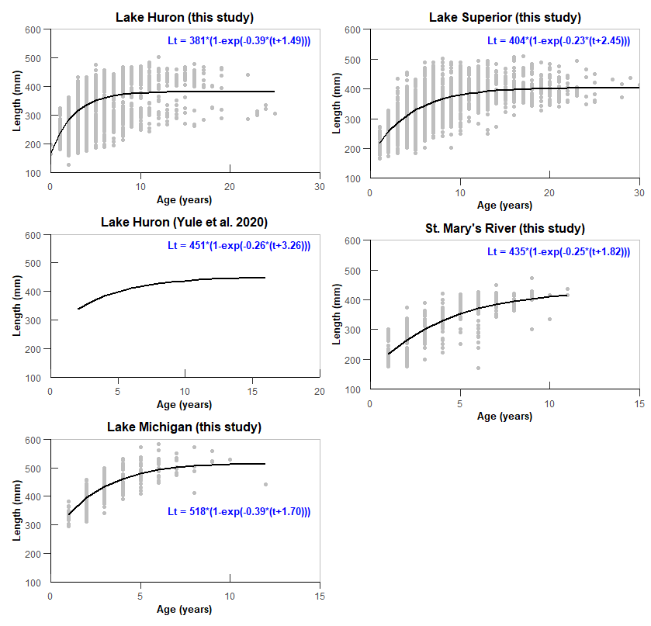

**Figure 1.** von Bertalanffy age-length relationships considered in the Leslie matrix models for Lake Erie Cisco where total length is measured in millimeters. Grey points represent the observed values while the solid black line is the fitted relationship. Note differences in range on x axis. $L_{t}=L_{∞}\left[1-e^{-K\left(t-t_{0}\right)}\right]$

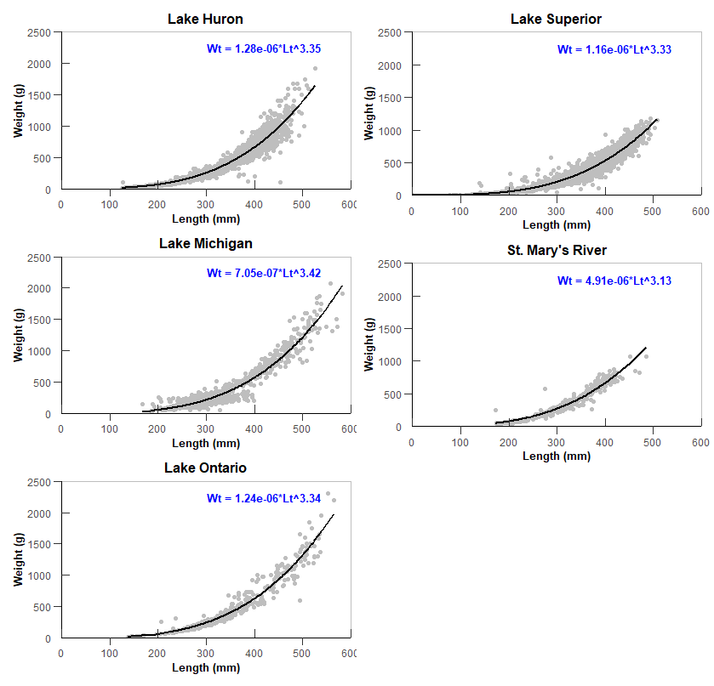

**Figure 2.** Weight-length relationships considered in the Leslie matrix models for Lake Erie Cisco where total length is measured in millimeters and weight is measured in grams. Grey points represent the observed values while the solid black line is the fitted relationship. $W_{t}=aL_{t}^{b}$

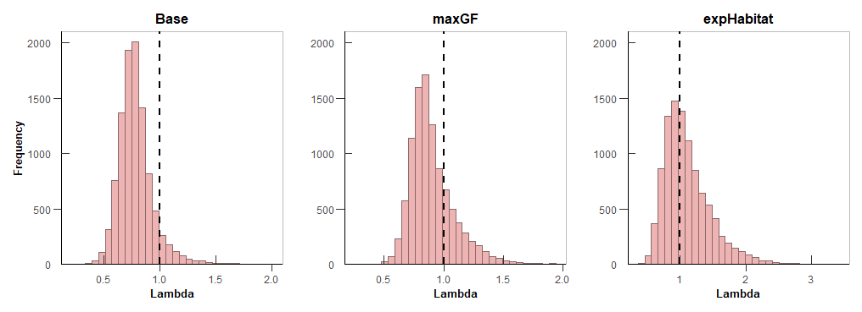

**Figure 3.** Distribution of post-stocking lambda for wild fish, l*wild*,*ps*, from the base (left plot), maxGF (middle plot), and expHabitat (right plot) model scenarios of the Leslie matrix model for Lake Erie Cisco. The vertical dashed lines represent a lambda equal to 1.0.

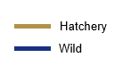 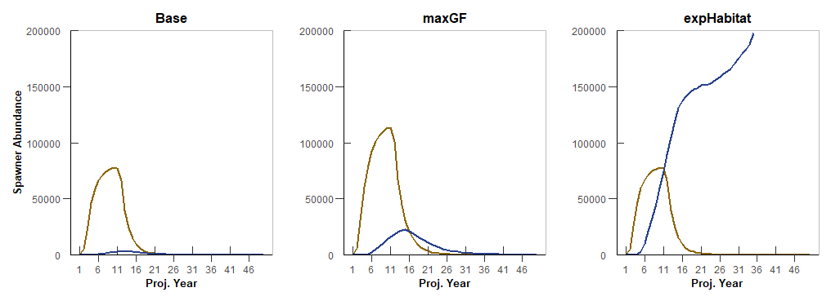

**Figure 4.** Simulated population trajectories for Lake Erie Cisco from the base (left plot), maxGF (middle plot), and expHabitat (right plot) model scenarios of the Leslie matrix model. The lines represent the median values over all simulations.

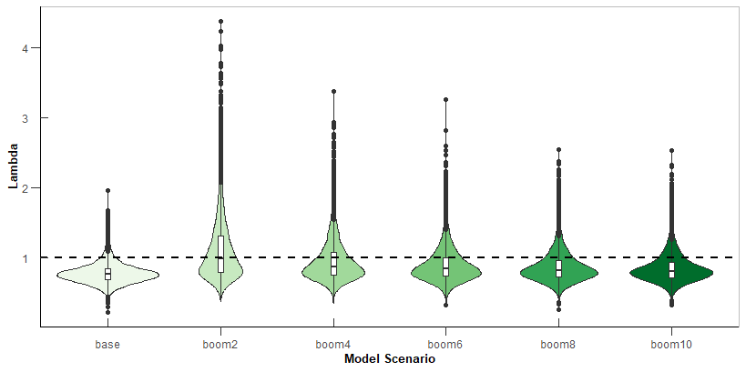

**Figure 5.** Violin plots depicting the post-stocking lambda distributions for wild-origin fish, l*wild*,*ps*, from the model scenarios exploring the intermittent recruitment booms compared to the base model. The horizontal dashed line represents a lambda equal to 1.0.

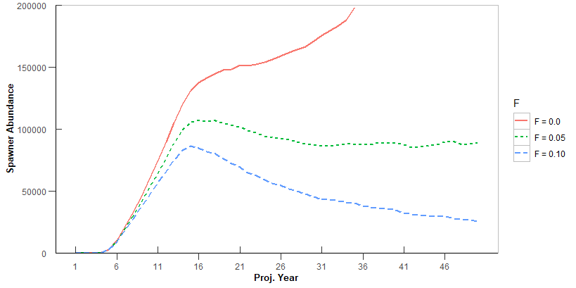

**Figure 6.** Simulated population trajectories of wild-origin Lake Erie Cisco from the expHabitat model scenario of the Leslie matrix model under different assumed values for fishing mortality, *F*.