Destriping DEMs with Jitter

Table of Contents

1 Necessary files 1

1.1 Socet Set DEM in ISIS3 cube format 1

1.2 Global Altimetry 1

2 fx 2

3 Measure the angle between the stripes and the horizontal (sample) direction 3

4 rotate 4

5 Measure the width of the narrowest stripes 5

6 Use mask to shield topography effects from the lowpass filter 7

6.1 Evaluate the DEM DN saturation values 7

6.1.1 Stretch the image to enhance the jitter banding / stripes 8

6.1.2 View the range of saturation values over the image 8

6.2 Identify the range of saturation values to mask 9

6.2.1 Example 11

6.3 Apply mask 15

6.4 Suggested alternative to MASK is TVDOC 15

7 lowpass 16

7.1 Evaluate whether the input cube can accommodate the filter width (SAMPLE dimension) 16

7.2 Calculate Cube Placement (OUTSAMPLE) for handmos 17

7.3 Calculate NSAMPLES for handmos, while using the original input cube lines for NLINES 17

7.4 Handmos 18

7.5 Apply the lowpass filter 20

7.6 Crop to remove padding (skip if not padded) 21

8 rotate 22

9 crop 23

9.1 Determine the SAMPLE and LINE values for crop: 23

10 fx 24

## Necessary files

### Socet Set DEM in ISIS3 cube format

Call this A.

### Global Altimetry

Reproject global altimetry (or other pre-existing DEM covering the same area, the higher resolution the better as long as its control results in it registering precisely to (A) to the same projection, extent, and scale as A. Call this B. If A was not controlled to the same source data as used to make B, use qview and blink between A and B to verify they are properly aligned. If they are inconsistent, choose another source dataset (e.g., fall back from HRSC DEM to MOLA global). There is no need to mask file B so that it has data only where A does.

## fx

Subtract B from A using fx and call the result C

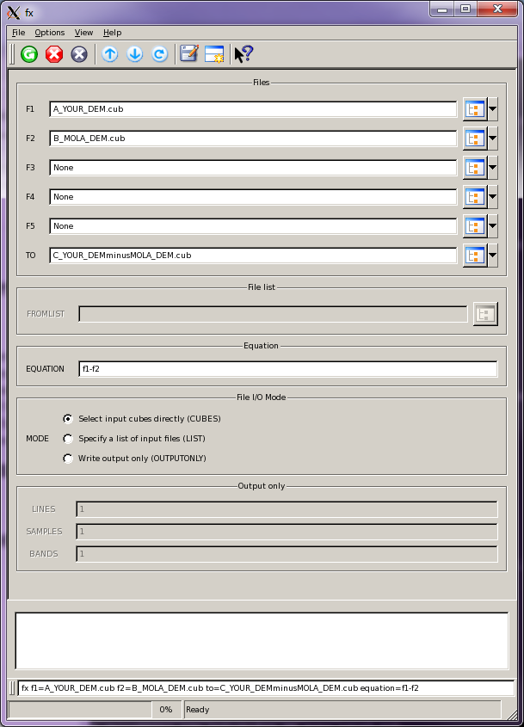

Command Line:

Fx f1=A_YOUR_DEM.cub f2=B_MOLA_DEM.cub to=C_YOUR_DEMminusMOLA_DEM.cub equation=f1-f2

## Measure the angle between the stripes and the horizontal (sample) direction

Display C using qview. Open the measure tool from the menu on the right side of the qview window frame (ruler), then select “Angle” from the top menu dropdown. Make sure to measure in degrees. Using the angle tool, draw a line with its first vertex beginning at the edge of the image, traversing into the image at the same angle as the stripe in the image. Stop and reverse the vertex direction, staying on the same image line so that the image line values at the angle vertex and the upper ray endpoint are equal. The line value is displayed along the bottom of the qview window frame. End the line with another single click. The value reported in the top of the menu is your angle value. Record this value. You will use this value to rotate the image.

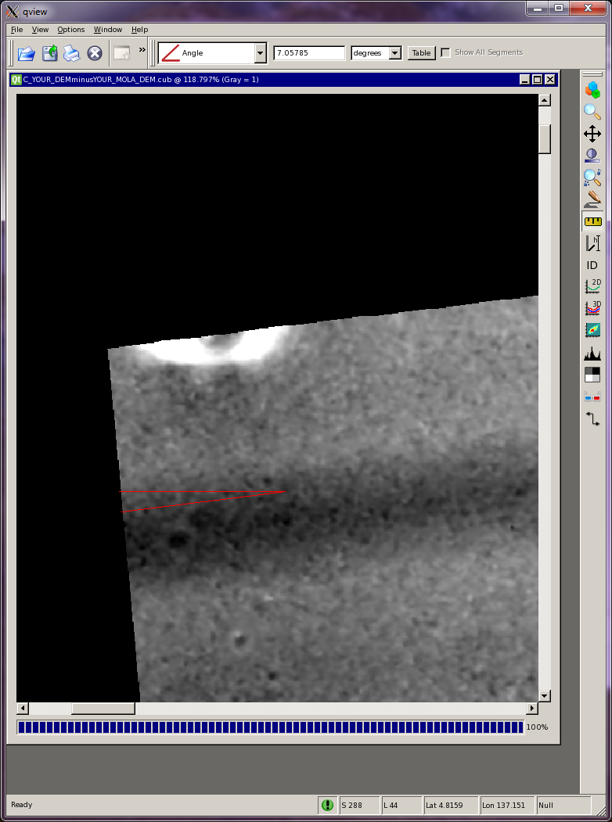

## rotate

Rotate C by the angle measured in step 3, using rotate. Call the output file D.

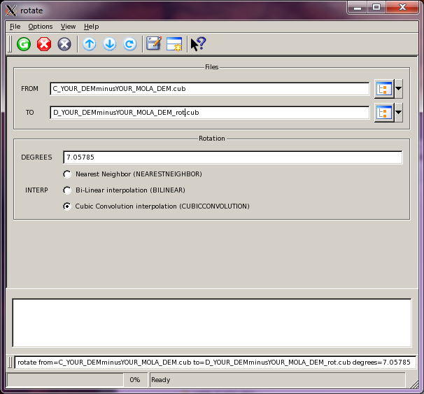

Command line (YOUR ANGLE WILL BE DIFFERENT)

rotate from=C_YOUR_DEMminusYOUR_MOLA_DEM.cub to=D_YOUR_DEMminusYOUR_MOLA_DEM_rot.cub degrees=7.05785

Display D in qview. The stripes should now be horizontal.

The figure below illustrates the difference between the C and D files.

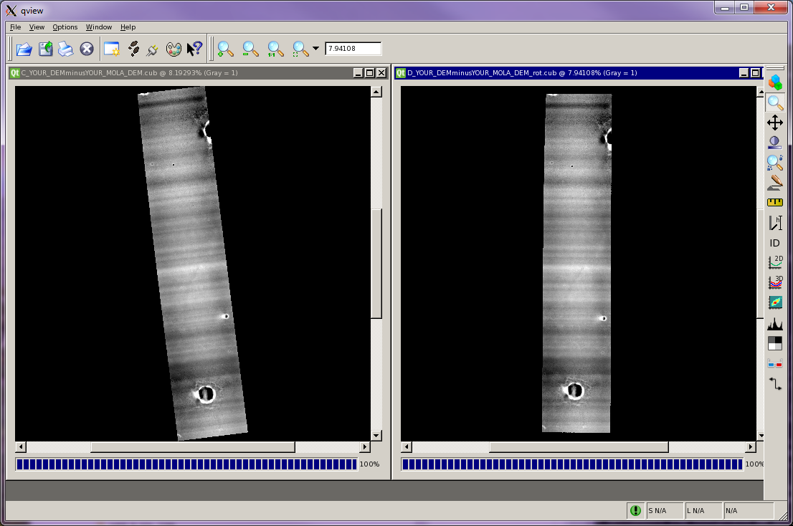

## Measure the width of the narrowest stripes

Next, measure the width of the narrowest stripes. See example below.

This illustrates measuring narrow bands. Select the measure tool from the qview Tool Pad (ruler), then “Line” from the top menu dropdown. Make sure to measure in “pixels”. Measure the average width of the narrowest stripes, approximately from zero through highest point to zero, or zero to lowest point to zero. Call this dimension W.

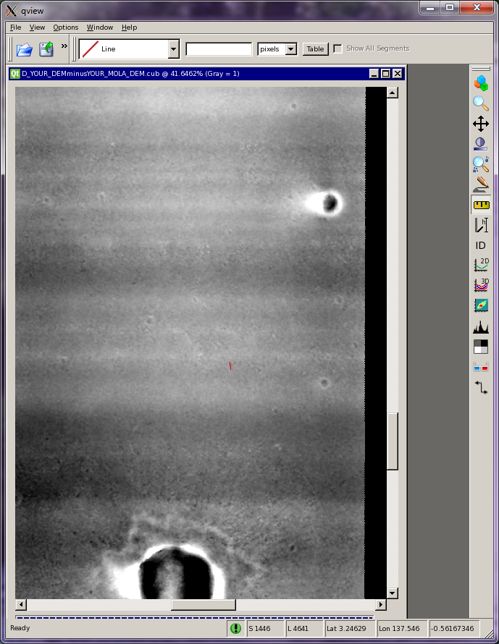

## Use mask to shield topography effects from the lowpass filter

Running lowpass on a DEM without masking features that display very high or very low saturation values can result in a smear effect in the final image product as shown below (left image). Using mask to null these features before running lowpass can improve the final filtering results (right image).

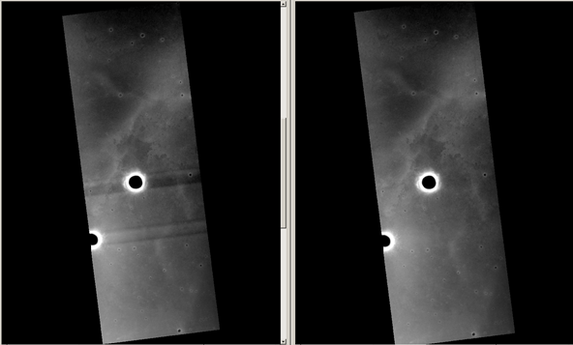

### Evaluate the DEM DN saturation values

Open the CTX DEM “D” in qview. This is the cube file after subtracting the MOLA and rotating it. You will have the correct cube open if the DN values are in the range of 10s, not 1000’s that you would see from elevation values. MOLA subtracted, removes the elevation range from the DEM, leaving only jitter represented as horizontal striping.

#### Stretch the image to enhance the jitter banding / stripes

In qview, open the Stretch tool from the qview Tool Pad. To apply a quick stretch to the image, draw a line across any area of the image. Begin and end the line with a single mouse click. A vertical line drawn across bland image areas toward the center of the image will often reveal any striping if it exists.

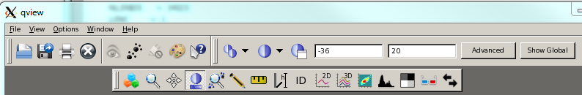

#### View the range of saturation values over the image

Open Statistics from the qview Tool Pad. From the table that opens, turn off “Hide Display”. Select “Show Text” (see example on following page).

Using the top menu of qview (context menu when statistics is active), increase the table rows and columns to about 7 X 20.

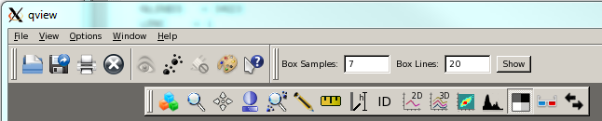

If only zero values are displayed in the statistics table, click in the area of the image where you want to display saturation values. The values in the Statistics table will update. This view will help identify the range of display saturation values across the image.

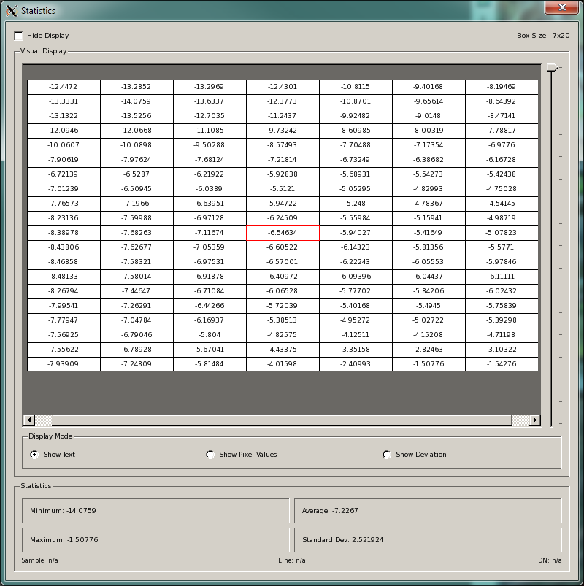

### Identify the range of saturation values to mask

Next, hover over and click on crater centers (black) and rims (white) to identify a range of pixel values that should be “nulled” before applying the lowpass filter. The Statistics view assists this evaluation. Later, you will use mask to apply null DN values to this range of pixels.

In qview, open the Special Pixel Tool to colorize the pixels that will be “nulled”.

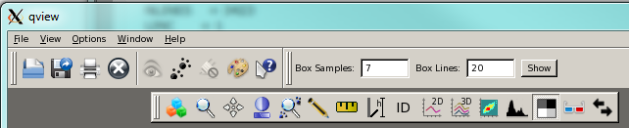

Change the colors of Null, Low Display Saturation, and High Display Saturation as shown below to help identify the range of DN values that will be “nulled” by applying a mask.

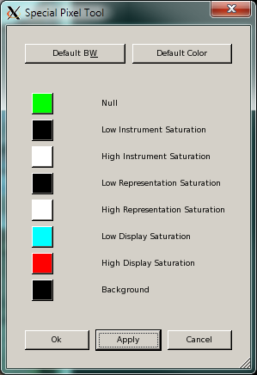

Return to the stretch tool on the qview Tool Pad. Locate saturation ranges (min and max) at the top of the qview main window. As described below, test various saturation ranges to see which range highlights the rims and crater centers without highlighting any of the stripes in the image. This will reveal the optimal range to be nulled using mask.

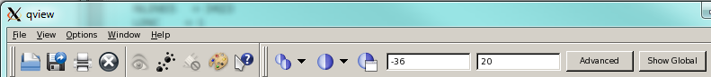

#### Example

For the CTX DEM named InSightE09_XFE we used a range of -36 (min) to 20 (max). The black crater centers were near -100, however using the minimum value -36 captured pixels up to the crater rims. Likewise, using 20 as the max included the bright white crater rims.

The key to getting the most effective mask filter is to find the range of values that highlights the crater centers and rims, without colorizing the banding in the image that is the result of jitter.

Adjust the DN values at the top menu (stretch context menu) until you find the optimal settings. Again, you want the min (low) and max (high) set to highlight all the rims and crater centers. As soon as you start seeing highlighted, colorized pixels in the banding portion of the image, back off on the range settings. Colorized pixels in the banding portion means that you are beginning to pick up banding effects and not just feature effects that will create halos or smears after running lowpass. You want to pick up as much of the rims and centers as you can without getting into the banding.

Example of max too low. Note the red highlighting of the bands throughout the image.

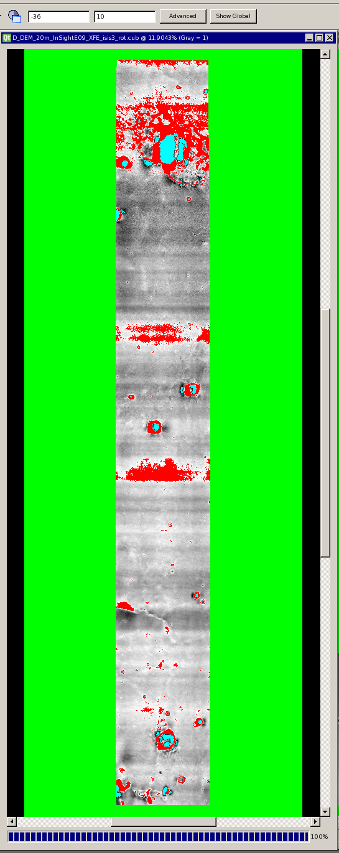

An example of min set too high. Note the cyan highlighting of the bands in the top third of the image

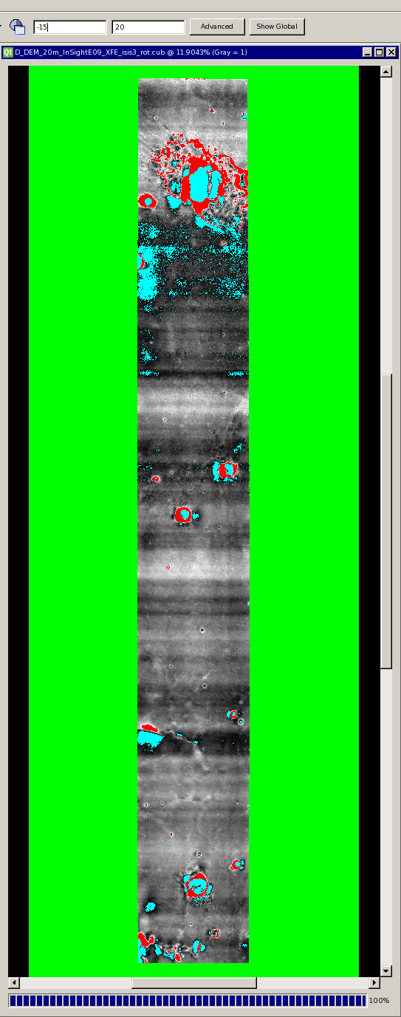

Optimum settings for this image: min: -36, max: 20. Only features are highlighted, no bands.

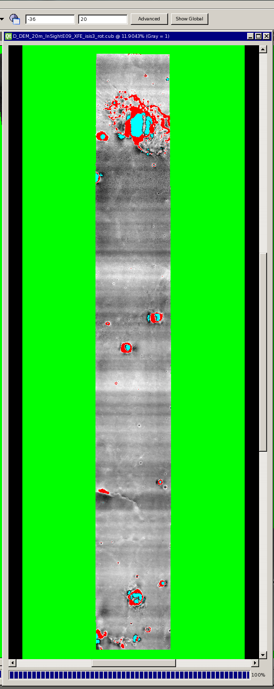

### Apply mask

Run mask using the optimized min and max**, preserving the values inside the range**. In this scenario, pixels outside the set range will be set to “null”. The DTM for this example is InSightE09_XFE. Note it is named “D” and is still appended with _rot to indicate this is the rotated image. In this example, the output filename is further appended with the masking details.

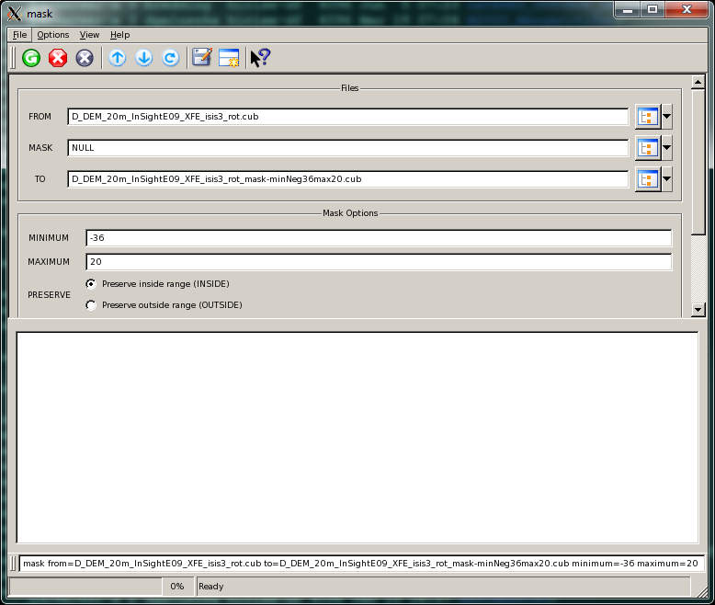

### Suggested alternative to MASK is TVDOC

ISIS3, tvdoc can be used as an alternative to mask for sites that have overall high slope.

## lowpass

### Evaluate whether the input cube can accommodate the filter width (SAMPLE dimension)

The SAMPLE dimension of the filter should be at least twice the width of the valid data in the DTM. To calculate the valid data value using qview, subtract the sample value at the left edge of the visible data range from the sample value at the right edge of the visible data range of the cube**.**

**If the input cube is too narrow, i.e., input cube sample size < (valid data x 2), the *boxcar filter* samples may exceed the maximum filter size permitted. If so, it is necessary to pad the input cube. See handmos instructions (follows) before running lowpass)**.

**The following is an example of how to calculate image padding. Your calculations will be based on your image sample dimensions**.

These are the conditions to be met:

* **Sample dimension of *boxcar filter* must be at least 2x that of valid data of input cube, and must be an odd integer**

**EXAMPLE CALCULATION:**

sample dimension of *boxcar filter*: [Input cube valid data (1172 samples) x 2] = 2344. This value must be an odd integer. Therefore, use 2345

* **Input cube overall samples must be equal to or greater than the *boxcar filter* samples. Therefore the input cube overall samples must also be at least 2x its valid data samples.**

Compare *boxcar filter* sample size to input cube sample size: If the input cube is too narrow the *boxcar* filter samples may exceed the maximum filter samples permitted by the input cube.

Pad input cube if: input cube samples < (input cube valid data samples x 2)

input cube samples < *boxcar filter* samples.

Use the “more” command to display the cube header. Record the lines and samples in the input image:

> more example_original_input_isis3.cub

samples = 1984

lines = 3592

* Conclusion:

Samples of example input image = 1984. Example *boxcar filter* width = 2345. Input image must be as wide as *boxcar filter* width. Therefore, example input image is not wide enough and must be padded.

**If the image does NOT require padding, proceed to section 7.5**

### Calculate Cube Placement (OUTSAMPLE) for handmos

Calculate how much to pad the original cube with the output cube valid data centered.

(*boxcar* *filter* samples – input cube samples)/2

Example OUTSAMPLE Calculation:

*Boxcar Filter* Samples = 2345. We want an even number for the qmos outsample calculation, so round up to 2346.

Subtract samples of original input cube: 2346 – 1984 = 362

Divide this by 2: 362 / 2 = 181

Placement settings in handmos for this example: Note that only OUTSAMPLE is a value other than 1.

INSAMPLE =1

INLINE = 1

INBAND = 1

OUTSAMPLE =181

OUTLINE = 1

OUTBAND = 1

### Calculate NSAMPLES for handmos, while using the original input cube lines for NLINES

* NSamples is the output cube samples. Use input cube samples rounded up to an even number + (OUTSAMPLE x 2). In this example, this should equal the *boxcar filter* samples that was also rounded up to an even number. In this example we used 2346.
* NLINES equals the original input cube lines.

For this example: when setting OUTSAMPLE to 181, and NSAMPLES to 2346, you will pad the original input cube (1984 samples) equally on each side by 181 samples. The image will not be padded above or below the valid data range (lines) because OUTLINE remains 1, and NLINES equals the original input cube lines (3592). Record the OUTSAMPLE value that is used. It will used later to crop the image.

### Handmos

See example below. The 2 screen snapshots are the same session showing the top and bottom of the GUI scroll window. Leave the MOSAIC cube (output cube) prefixed with D, just add *_pad to the name.

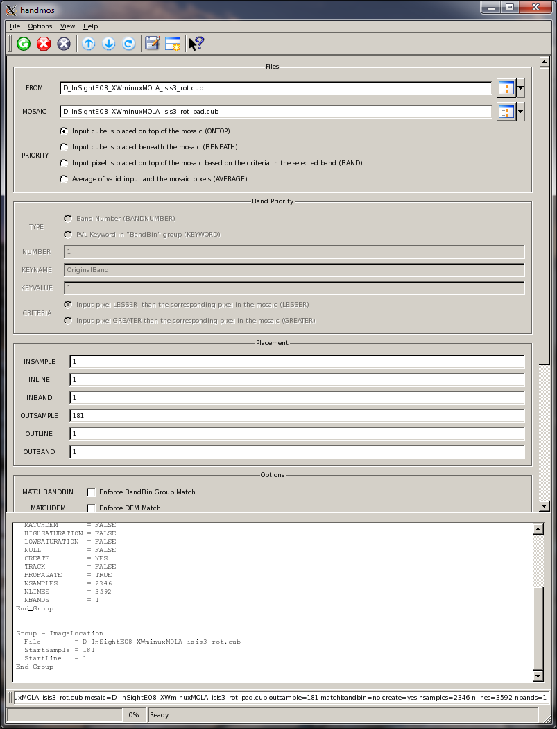

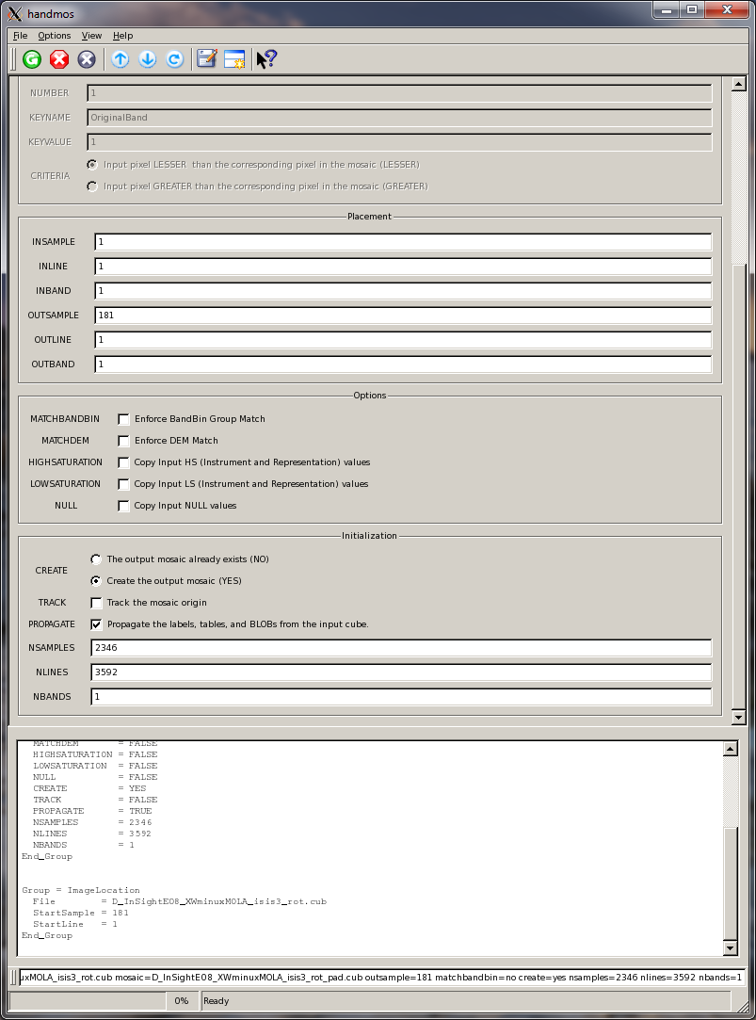

Command Line: (your parameter values will be different): handmos from=D_InSightE08_XWminuxMOLA_isis3_rot.cub mosaic=D_InSightE08_XWminuxMOLA_isis3_rot_pad.cub outsample=181 matchbandbin=no create=yes nsamples=2346 nlines=3592 nbands=1

### Apply the lowpass filter

Filter D with lowpass, yielding E. After applying the lowpass filter, display E using qview to verify that it contains purely horizontal stripes and that these look like they did in D.

The Boxcar Size in samples and lines must be entered as **odd** integers. The LINES dimension of the filter should be W/2 or 3 lines, whichever is greater. “W” was the result of your measurement of a narrow band width (See step 5). Note the “TO” filename is appended with _lp to indicate lowpass.

. 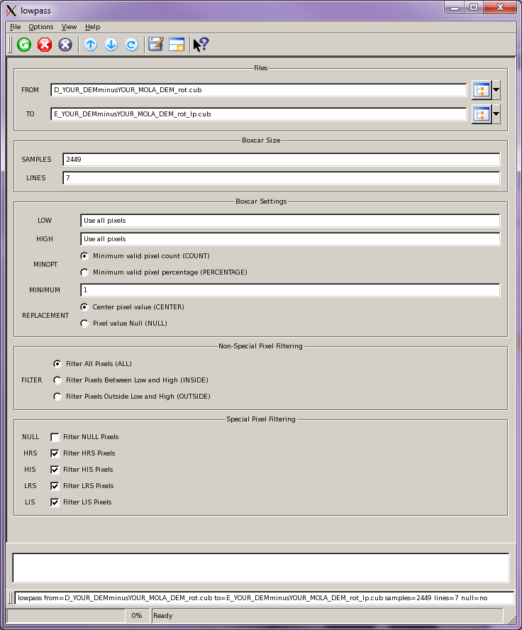

Command Line (Your values will be different)

lowpass from=D_YOUR_DEMminusYOUR_MOLA_DEM_rot.cub to=E_YOUR_DEMminusYOUR_MOLA_DEM_rot_lp.cub samples=2449 lines=7 null=no

### Crop to remove padding (skip if not padded)

Note: This example is specific to the padding instructions in steps 7.1 through 7.4, and the values entered below for SAMPLE and NSAMPLES are the result of those calculations. Your numbers will be different.

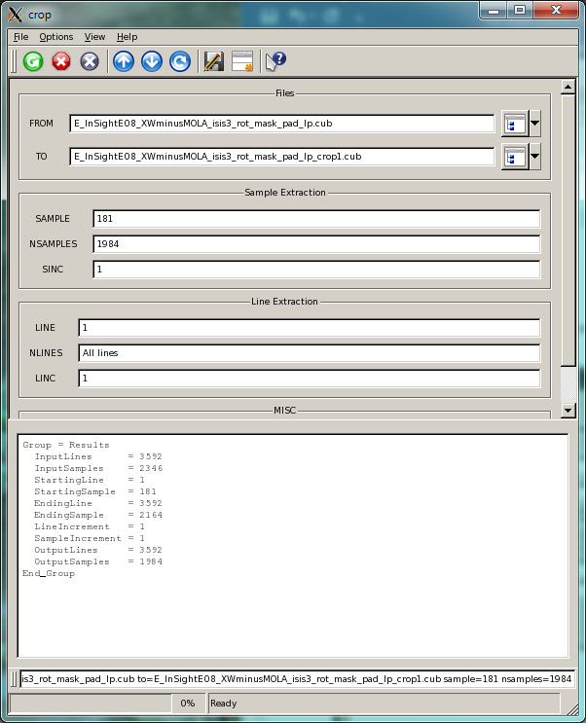

Command line: crop from=E_InSightE08_XWminusMOLA_isis3_rot_mask_pad_lp.cub to=E_InSightE08_XWminusMOLA_isis3_rot_mask_pad_lp_crop1.cub sample=181 nsamples=1984

## rotate

Rotate E by the negative of the angle used in step 4, giving F. Note that _rot has again been appended to the filename to indicate this second rotation returning the image to its original orientation.

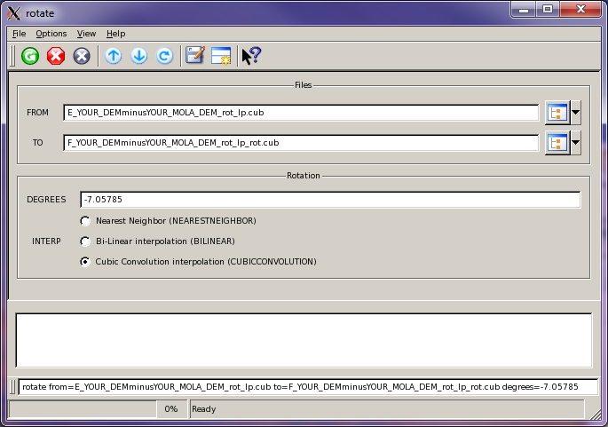

Command line (Your angle will be different)

rotate from=E_YOUR_DEMminusYOUR_MOLA_DEM_rot_lp.cub to=F_YOUR_DEMminusYOUR_MOLA_DEM_rot_lp_rot.cub degrees=-7.05785

## crop

Remove excess lines and samples from F using crop, to obtain G. Parameter values NLINES and NSAMPLES should be the dimensions of A. LINE and SAMPLE are calculated to center the cropped region in the larger file. If the number of pixels across A and G are both even or both odd, this will be exact. If one is even and the other is odd, just round off the value of LINE and the box will be as close to centered as we can make it. Same goes for SAMPLE.

### Determine the SAMPLE and LINE values for crop:

(# SAMPLES from F/2) - (# SAMPLES from A/2) = SAMPLE

(# LINES from F/2) - (# LINES from A/2) = LINE

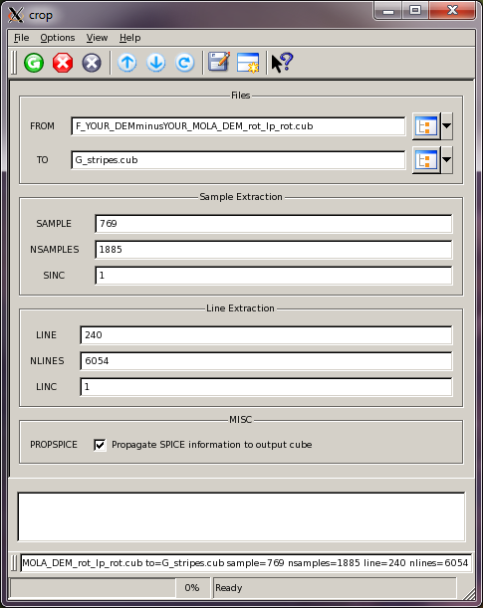

Command line (Your values will be different)

crop from=F_YOUR_DEMminusYOUR_MOLA_DEM_rot_lp_rot.cub to=G_stripes.cub sample=769 nsamples=1885 line=240 nlines=6054

## fx

Subtract G from A using fx to get H which is the desired result.

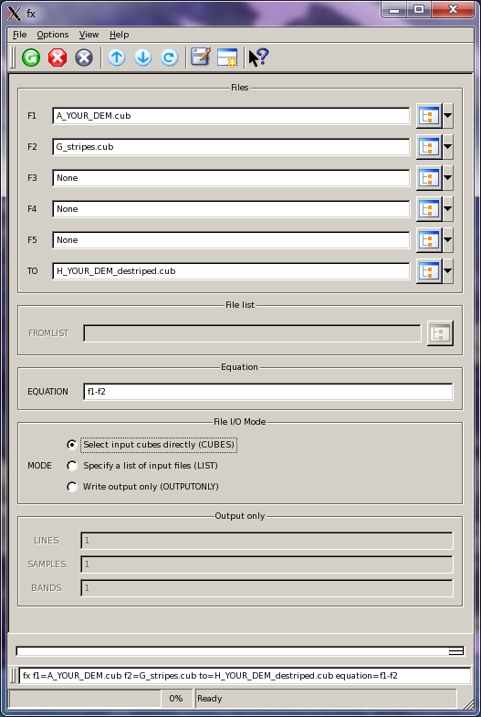

Command line:

fx f1=A_YOUR_DEM.cub f2=G_stripes.cub to=H_YOUR_DEM_destriped.cub equation=f1-f2

This illustrates the difference between an example of A, G and H files. Although all striping is not removed, the CTX DTM is improved.

