Step 0: Create a fork of the repository on gitHub:

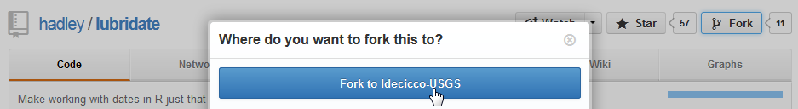

Step 1: Create new project

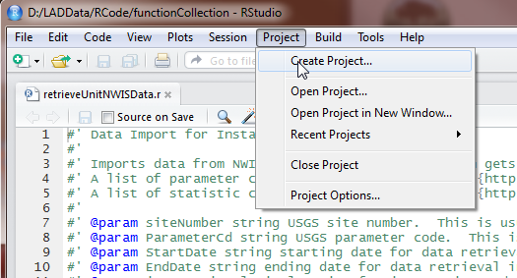

Step 2: Checkout a project from version control:

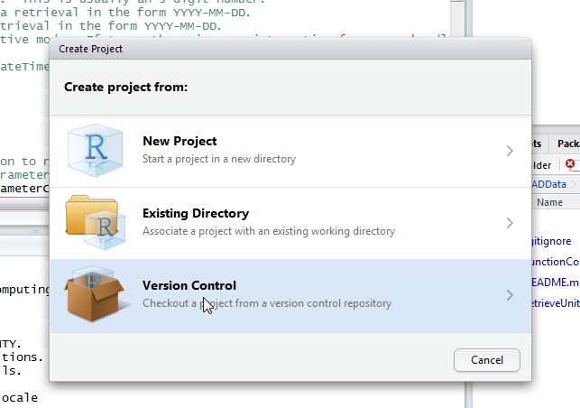

Step 3a: get Repository URL (use SSH from your fork) – this is on gitHub

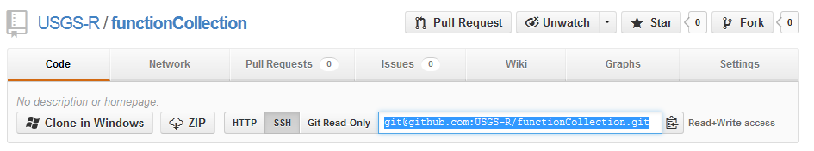

Step 3b: paste address into RStudio:

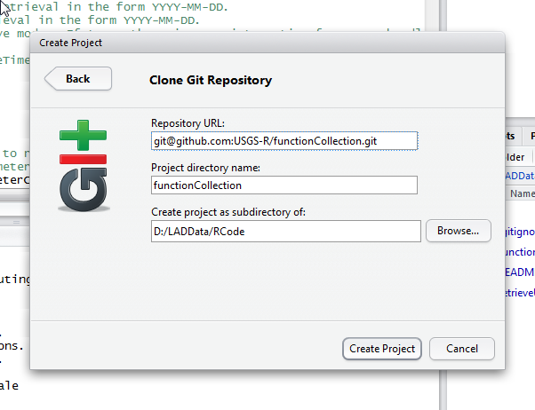

Step 4: Add new files with functions (save a file in the functionCollection folder). In this case, I just added the file getSiteFileData.r:

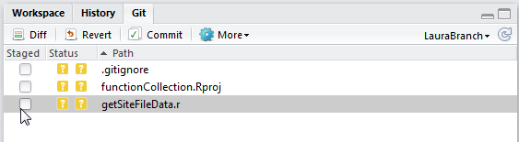

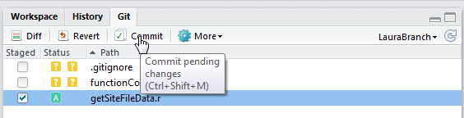

Write a description in the Commit message box. Continue to work locally, committing your work when appropriate.

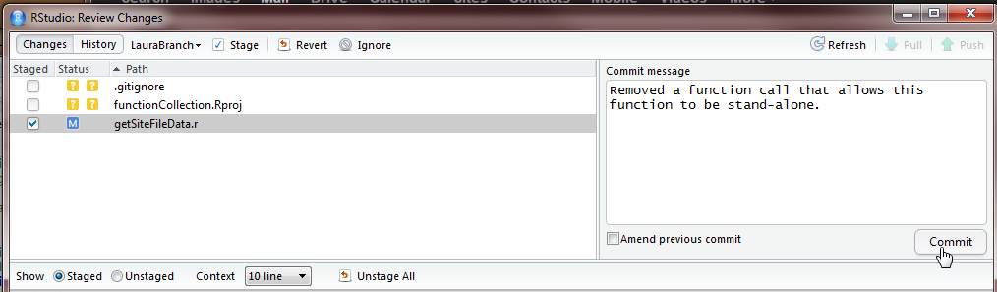

Eventually, you’ll want to merge your changes with the master branch. That’s when you click the ‘Pull Request’ button on gitHub.

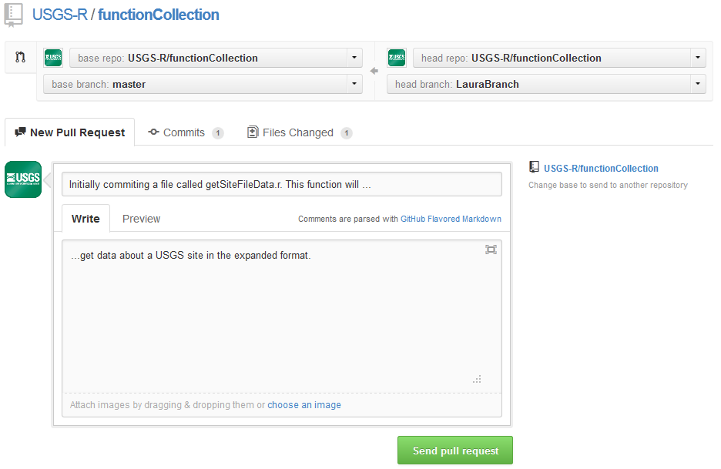

As owner of the functionCollection repository, I would take care of merging the changes between branches.