# Bluetooth Settings:

## Modify module defaults:

To modify HC-05 (Bluetooth) defaults, we need to enter AT-command mode.

To do this, we take the following steps:

1. Open the “**HC05_AT_Commands.ino**” file, and upload the program to the board.

*Note: Pay attention to the Rx/Tx connection pins if they are correct (defaults: 4, 5)*

1. After the upload is complete, switch off the module
2. Connect the pin (as in the picture) to VCC line with a wire

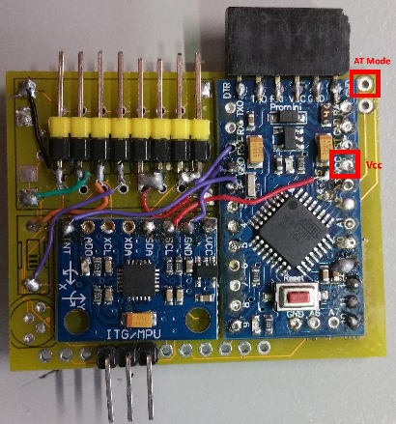

1. Switch on the module while keeping the pin-VCC connection.
2. Open Serial monitor (Baud rate e.g. 115200) and choose “Both NL & CR” as the line-ending
3. Type “AT” and hit Enter, you should get back “OK” if the setup is successful.
4. The main important settings
   1. Check the module name: **AT+NAME**
   2. Setup the module name: **AT+NAME=USI_BalanceBoard_1**
   3. Check the module PassKey: **AT+PSWD**
   4. Setup the module PassKey: **AT+PSWD=1234**
   5. Check the module BaudRate: **AT+UART**
   6. Setup the module BaudRate: **AT+UART=115200,0,0**
5. Disconnect the VCC <--> AT-Pin wire, restart the module (switch on/off) and you are done

## Connect on Windows

1. Open the Device Manager, and scroll to “**Ports (COM & LPT)**”. Remember the available items and their port numbers (i.e. COM##)

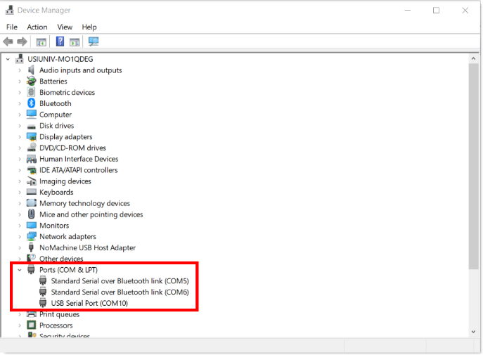

1. Search for the Bluetooth connection of the BalanceBoard, connect and pair with the new board
2. Get back to the Device Manager, you’ll have new COM ports added for the new board.

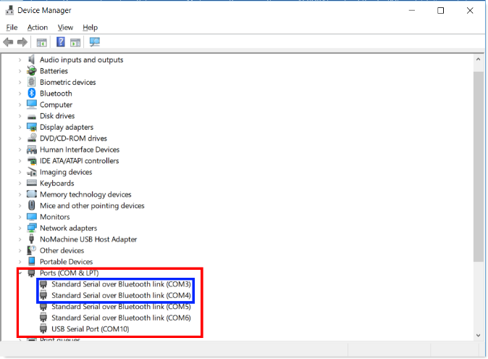

1. In windows, each Serial Bluetooth device will have two COM ports created. We will connect to the one with the lower number of them.

## Bluetooth Number

Depending on the used program, the number of the Bluetooth device defer.

* In Arduino, to connect (serial monitor) we care about the **COM port Number** (e.g. COM3)
* In Processing (the GUI App), we care about the **COM port Order** (we start counting from 0). For example, in the previous list, before adding the new BT device (the new board) COM5 had the order ‘0’. But, after adding the new device, COM5 now has the order ‘2’. So, pay attention when you use Processing to the current order of the port you are trying to connect to.

# Re-programming the board:

## From scratch:

The order of operations to re-program the board from scratch is the following:

1. Run the ‘MPU6050_calibration’ program to generate the Accelerometer and Gyroscope calibration values for that particular board.
2. Copy the resulted calibrations and paste them in the corresponding definition in ‘BalanceBoardSelfNRF_Final’ code.
3. Inside ‘BalanceBoardSelfNRF_Final’ code:
   1. Define the node number (1, 2, 3)
   2. Define which features to switch on/off (e.g. fading LEDs, rainbow, …)
   3. Define any particular timing values (please use the Timing Settings.xlsx file to generate compatible values depending on the number of LEDs available on the board)
4. Compile/upload the code to the board.

## Modify only the timing values

You can just modify the timing values (as described above in 3.c) with the help of the attached excel file.

# Operating the board:

It is possible to operate the board in either standalone or Bluetooth modes. The nRF multi-board mode will be added soon.

## Standalone mode:

Just switch the board on and it will start counting down with the calibration.

## Processing GUI interface:

The GUI code works for both Processing 2.x and 3.x (the later is preferable)

You need to have the following two libraries installed in order for the code to work:

* ToxicLibs
* HTTP Requests for Processing

To install the libraries, go to ”**Sketch -> import library -> add library**” and search for the corresponding two libraries and install them.

## Bluetooth mode (with Processing GUI interface)

1. Switch on the board
2. Make sure you are connected to the board and paired with it.
3. Open the “**Balance_Board_Processing_GUI.pde**’ in Processing
4. Modify the “**PORT_NUM**” parameter to the corresponding port_order (get this from Device Manager).