Quantifying the local and potential energy for wave resource assessments

Gabriel García-Medina1, Zhaoqing Yang1, and Levi Kilcher3

1Marine Sciences Laboratory, Pacific Northwest National Laboratory, Seattle, WA, USA

3National Renewable Energy Laboratory, Golden, CO, USA

Target Journal: Applied Energy

# Abstract

Numerical modeling approach has been widely used in resource assessments as physics-based wave models mature and the computational resources to execute them become increasingly available. However, there is a lack of accurate definition of total theoretically available wave energy and there is no consistent methodology in assessing wave resource in a given system. In this study, the concept of potential resource is introduced to account for the additional energy resource transferred from atmosphere when wave energy is extracted. Consequently, the total theoretically available wave resource for a given region can be estimated as the sum of remote, local, and potential resources. Two methods, one based on energy flux and the other based on source terms, are evaluated and compared for calculating the local and potential resource through idealized and realistic study domains using the third-generation wave spectral model WAVEWATCH III. Modeling analysis indicated that the source term method provided more consistent results in quantifying the local and potential resource. For the U.S. West Coast, the local and potential resources can account up to 53% and 16% of the total theoretically available resource, respectively. Therefore, it is important to consider the local and potential resource in regional resource assessment using the source term method.

# Introduction

Wave resource characterization and assessment is essential for deployment of wave energy converters in any particular site in the real world. Resource assessment generally relies on either field measurement or numerical hindcast, or the combination of both methods. Many global and regional wave resource assessments based on wave model hindcasts have been conducted for the World Ocean. In the early days, global wave resource assessments were conducted with the purpose of documenting the vast amount of energy in the surface gravity waves. For instance, Gunn and Stock-Williams (2012) estimated the global wave energy resource to be 2.1 TW. As the world is shifting towards harnessing energy from renewable resources, in some areas, harvesting the wave energy resource is emerging as a viable alternative.

Regional resource assessments that refine these global estimates have been conducted to respond to these needs. These regional assessments are necessary for the identification of suitable locations for pilot and commercial scale projects, in the growing but still young wave energy conversion market. Recent studies for Australia (Hemer, Zieger et al. 2017), the Red Sea (Aboobacker, Shanas et al. 2017), Uruguay (Alonso, Jackson et al. 2017), are a few examples. The majority of these types of studies rely on numerical model simulations of the sea states given the general scarcity, both temporally and spatially, of observations (e.g. Garcia-Medina, Ozkan-Haller et al. 2014, Hemer, Zieger et al. 2017, Neill, Vogler et al. 2017). Wave energy estimates at a high spatial resolution allow for accurate integration of the resource, or the quantification of the resource crossing a particular isobath or maritime boundary which are then reported to the interested stakeholders and WEC industry.

Reporting the energy flux across a given boundary implies that there is a source of energy whose origin is remote from the domain of interest. This can be, for instance, swell generated by trade winds that reaches the Hawaiian Islands consistently from the northeast (Li, Cheung et al. 2016). This part of the resource can be classified as the remote resource. For a total resource quantification, the wave energy generated inside (landward) of the boundaries must also be accounted for. We refer to this component at the local resource. The distinction between both sources can be important for harvesting technologies and for political reasons. Accurate distinction of the source of energy is thus important. In this study we examine methods to compute and distinguish between them.

As wave energy extraction technologies mature in the future and we shift away from fossil fuels a significant number of wave conversion farms could be installed. When energy is extracted from the system changes from the current state are expected. An example of this are the expected alterations to the nearshore wave and currents expected to occur downwave of these sites (O'Dea, Haller et al. 2018). However, waves also have the potential to recover shoreward of the extraction site if the winds are favorable. Extracting energy in regions where waves have the potential to recover quickly can help mitigate nearshore effects of a smaller wave field or have a suitable wave field ready for harvesting at a downwind location.

The potential for energy recovery can be thought of as a third component, besides the local and remote, of wave energy resource in a region. This concept is introduced to account for the recovery of energy due to energy transfer from the atmosphere to the ocean that would not have been possible with an unperturbed sea state (no energy extraction). Therefore, a total theoretically available wave energy resource contains contributions of the remote, local, and potential resource. In this paper we investigate how to account for these three sources individually using a numerical model and to estimate the total theoretically available resource. The rest of this paper is organized as follows. Section 2 describes the numerical model implementation and methodology used to compute the wave energy resource. Section 3 discusses the concepts of local, potential, and total wave energy resource under idealized conditions. Section 4 shows realistic estimates of the local and potential wave resource under realistic conditions for the U.S. West Coast, including seasonal variations (Section 4.3). Finally, concluding remarks are given in Section 5.

# Methodology

## Wave Model

The overarching goal of this study is to define the wave energy resources and to develop a consistent and accurate methodology to estimate the total theoretically available wave resource for a given region. The wave climate is simulated by implementing WAVEWATCH III® v5.16 (Tolman 2002) in all model simulations in this study. WAVEWATCH III® (hereafter WW3) is a skillful and well established numerical model that has been implemented successfully in many previous wave resource assessments (e.g. Garcia-Medina, Ozkan-Haller et al. 2014, Yang, Neary et al. 2017). WW3 solves the five-dimensional action balance equation:

|  |  |
| --- | --- |
|  | (1) |

where is the wave action, *D* is the variance spectrum, *t* is time, *x* and *y* are the spatial coordinates, *σ* is the radian frequency, and *θ* is the direction of wave propagation. The wave action in conserved in the absence of sinks and sources of energy, their combined effect is represented as *Stot*. In this study we implement the ST4 physics package option in WW3 to simulate wind energy input (*Sin*) and dissipation due to whitecapping (*Sds*) (Ardhuin, Rogers et al. 2010). The non-linear quadruplet interactions (*Snl*) are modeled with the Hasselmann, Hasselmann et al. (1985) formulation. Bottom friction (*Sbot*) and depth induced wave breaking (*Sbrk*) are modeled with the JONSWAP (Hasselmann, Barnett et al. 1973) and Battjes and Janssen (1978) models, respectively. Default parameters are used for all formulations. The wave spectrum is discretized with 24 equally spaced bins in θ space and 29 logarithmically spaced frequency bins from 0.035Hz to 0.5Hz. Details of the spatial grids for the idealized and US West Coast domains are provided in Sections 3 and 4, respectively.

## Wave Energy Resource

An estimate of the wave energy resource starts with computing the wave power. It is possible that the sea state at a given location in the ocean is composed of multiple wave trains travelling with different directions, thus the wave power associated with all of them is termed the omnidirectional wave power (*OWP*) and computed as:

|  |  |
| --- | --- |
|  | (2) |

where *ρ* is the density of the water, *g* the gravitational acceleration, *cg* is the group velocity, *D* is the frequency-direction variance spectrum, *f* is the frequency, and *θ* the spectral direction; with units of W/m. However, when estimating the wave energy resource at a given region only the wave power crossing the regional boundaries (*P*) must be considered, this is computed as:

|  |  |
| --- | --- |
|  | (3) |

where *θn* is the direction perpendicular to the evaluated boundary and *δ* takes the value of 1 when is positive and 0 otherwise.

### Remote Resource

The remote resource (*RR*) represents the wave power entering a given region, which corresponds the power transmitted by waves generated away from the study region. We define it as the wave energy crossing a specific boundary, which, in this study, is defined as an isoline 200 nmi (370.4 km) from coast, following the international definition for exclusive economic zones (EEZ). This is sketched for the US West Coast in Figure 1. After *P* is computed at every model grid point, a line integral is performed to compute the magnitude of *RR*:

|  |  |
| --- | --- |
|  | (4) |

where the line of integration (r) is the EEZ boundary.

### Local Resource

The local resource (*RL*) is the amount of energy generated locally in the domain within a predefined boundary, territorial waters inside the EEZ for this example (see Figure 1). We define the domain for the local resource to extend from the EEZ to the shoreward most location where wave information is available. This definition ensures that the model domain has adequate coverage due to the spatial model resolution chosen. This can be computed in two different ways and the difference between the two approaches is discussed next.

#### Energy Flux Method

The energy flux method applies the same equation as the remote resource to an inner boundary in the domain as shown in Figure 1. The local resource is thus computed as the energy across a given isoline (*RD*) and subtracted from the remote resource (*RR*):

|  |  |
| --- | --- |
|  | (5) |

This term (*RL*) includes the added effect of local wind wave generation, dissipation due to bottom friction and depth induced wave breaking, and energy fluxes across lateral boundaries. The existing wave energy resource (*RE*) for a given region is therefore computed as:

|  |  |
| --- | --- |
|  | (6) |

If the origin of the wave energy resource, remote or local, is not of interest then simply . This method uses the same equations and data used for computing the remote resource. Additionally, the computation can be performed with model output usually stored when performing long term wave hindcasts. On the other hand, the energy flux method has a few shortcomings. The first is that only wave energy that travels in the direction of the coast is considered. Thus, the energy generated inside the domain that leaves across lateral, black lines at the northern and southern ends of the domain in Figure 1, or seaward boundaries is not accounted for. In addition, energy that enters the domain through the seaward boundary and leaves through lateral boundaries will not be counted. Second, energy generated in adjacent regions that enters the domain via the lateral boundaries will be counted as part of the local resource. This might result in an overestimation of the local resource should the neighboring jurisdictions decide to harvest it. Lastly, there is the possibility that energy is generated inside the domain and dissipated before reaching the boundary where the resource is computed, resulting in local energy being unaccounted for.

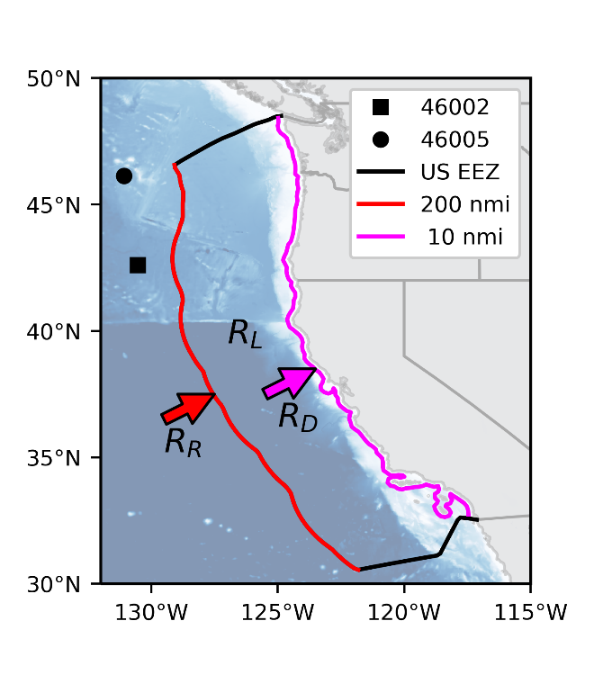

Figure 1 Definition sketch of wave power definitions. The lateral and offshore EEZ boundaries are shown black and red, respectively.

#### Source term method

An alternative method that circumvents most of the shortcomings of the energy flux method consists of using the source terms to directly compute the work done on the ocean in the form of wave generation by the atmosphere. The estimate for the local resource is computed as the integral of the source terms related to wave growth (*SL* = *Sin* + *Snl*+ *Sds*). The non-linear interaction source term is included to account for the energy transfer between the parameterized high frequencies and the modeled ones. These terms are integrated in spectral and spatial directions and then added to compute the local resource over the entire domain:

|  |  |
| --- | --- |
|  | (7) |

In WW3, as it is customary in third-generation spectral wave models, the waves are computed over a specified spectral width after which a spectral tail is appended to represent the energy in the high frequencies. This frequency cutoff is generally the minimum of the highest described frequency and the cutoff supported by the source term formulations. The simulations in this study are performed with the default high frequency cutoff:

|  |  |
| --- | --- |
|  | (8) |

This means that the high frequency cutoff depends on the simulated sea state. Further, the source term integrals must be performed for the range where the wave spectrum is actively simulated (i.e. between the lowest model frequency and the smallest of the highest simulated frequency and *fc*). Finally, the existing wave energy resource is computed with Equation 6.

### Potential Resource

It is well known that local wave growth depends on the atmospheric characteristics and the existing sea state. For instance, if the waves are in equilibrium with the atmosphere no wave growth exists, the sea state is said to be fully developed. In this case extraction of wave energy will take the sea state out of equilibrium and more momentum would be able to be transferred from the atmosphere to the surface gravity waves. Thus, a potential wave energy resource exists which is “stored” in the atmosphere and will be transferred to the waves when wave energy is extracted. A complete theoretically available wave energy resource (*RA*) assessment for a region must also consider the potential source of energy:

|  |  |
| --- | --- |
|  | (9) |

where *RP* represents the potential resource. It is defined as the local resource in a case of offshore wave energy extraction () minus the local resource in the absence of extraction:

|  |  |
| --- | --- |
|  | (10) |

This equation assumes that the local resource computed when wave energy is extracted is larger than that for baseline conditions (i.e. no extraction). In other words, the potential resource is defined as the excess local resource available due to upwind energy extraction and in that case, *RA* is reduced to:

|  |  |
| --- | --- |
|  | (11) |

The assumption that the potential resource is a positive quantity will be tested in the different scenarios discussed next. To assess the nature of the potential resource, multiple levels of energy extraction along a boundary are considered. The energy extraction can be simulated by using the subgrid obstruction module that blocks the energy flux between adjacent model cells in WW3 (Tolman 2003). The obstruction module is traditionally used to simulate the effect of unresolved islands and ice fields on wave propagation due to coarse model grids.

# Idealized Case Study

We start by investigating the effect of wave energy extraction on the wave energy resource by considering idealized conditions. WW3 is implemented over a constant depth bathymetry at 4 km deep that covers a region that is 240° in the zonal direction and 60° in the meridional direction. This removes the effects of energy convergence or divergence by refraction, and shallow water effects such as depth-induced wave breaking. We consider a hypothetical EEZ as a proxy for a region of interest. Energy flux is computed at 200 nautical miles from the eastern end of the domain (Figure 2a), which we approximate in the model as 3°20’ from the eastern boundary given the model domain has been centered at the Equator. This hypothetical EEZ covers 20° in the meridional direction as shown in Figure 2a. The area of this region is 818,000 km2, which is comparable in size to the US West Coast EEZ (825,550 km2). In the meridional direction the model spatial resolution is a constant 1° (111.12 km), while in the zonal direction the spatial resolution is reduced from 1° (111.12 km at the Equator) to 4’ (7.4 km) close to the EEZ (see Figure 2b). The choice of 4’ resolution for this model is made to be consistent with the operational wave models used by the National Oceanic and Atmospheric Administration (NOAA). The realistic simulations performed in Section 4 are based on the NOAA’s operational US West Coast model.

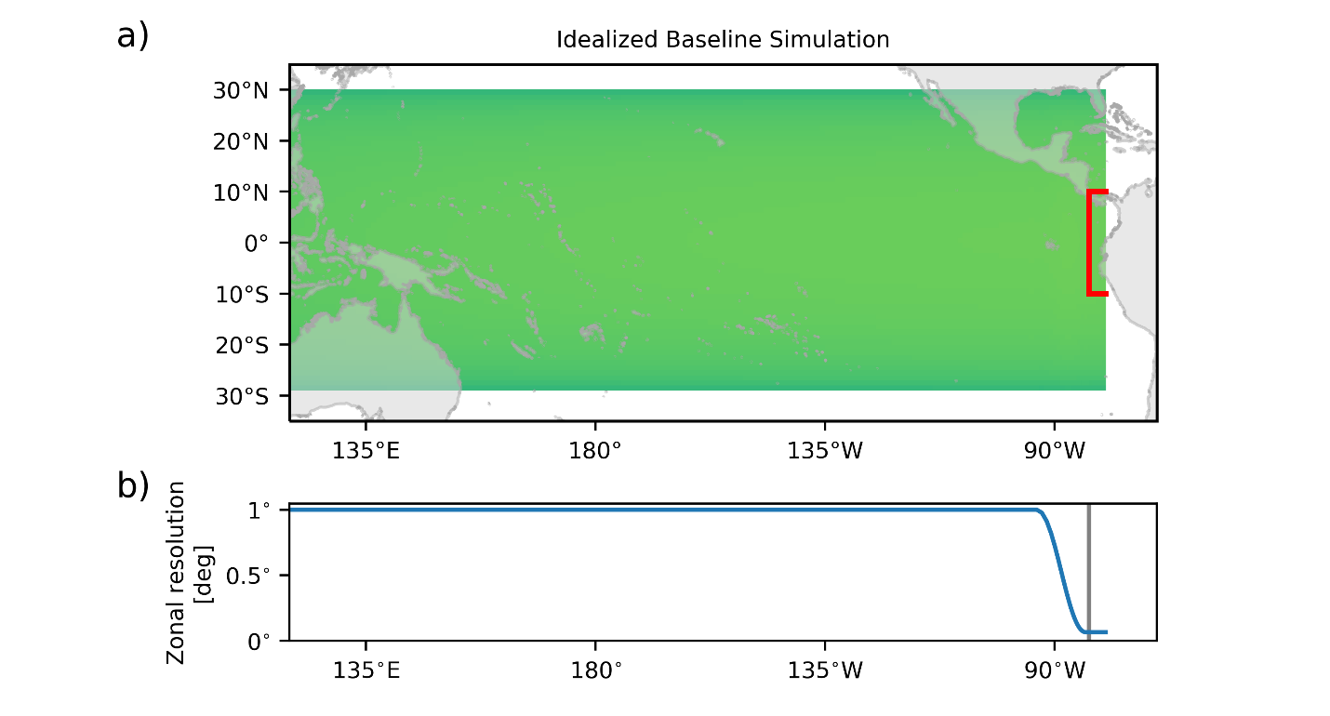

Figure 2 a) Idealized model grid with energy extraction zone identified with a red box. Continents are added for scaling purposes only, the model domain is a basin with constant depth. b) Zonal resolution of the model grid.

For all the idealized simulations, a stationary westerly wind is applied over the entire domain at 7.0 m/s. The value for wind speed is based on the yearly averaged wind speed measured at NDBC stations 46005 and 46002 (shown in Figure 1), which are 7.3 and 7.0 m/s, respectively. The model domain was selected to be long enough such that the waves achieve energy equilibrium (i.e. constant wave height due to long enough fetch) west of the extraction zone. The model is executed for three months, where the results from the first two months are discarded to ensure steady state.

## Local Resource

The two methods of computing the local resource, energy flux and source term, are compared by analyzing two different scenarios of the idealized model. For both scenarios, the model is forced by a constant westerly wind west of the EEZ but only one of them has local wind forcing east of the EEZ. *OWP* collected at the end of the simulation period along the Equator is shown in Figure 3. The results are consistent west of the EEZ where the wind is active in both cases. The remote resource is computed along this line and is very similar for both scenarios as shown in Table 1. There is a decrease of wave power just seaward of the EEZ (where the wind stops acting), which is attributed to the northern and southern model open boundaries having upstream effects on the wave field.

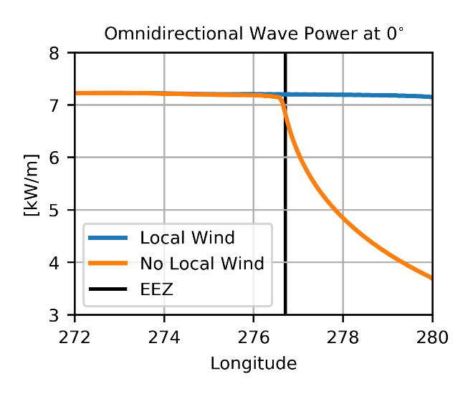

Figure 3 Omnidirectional wave power across the middle of the domain with and without local wind forcing.

In the case of no local wind the wave power starts decreasing quickly eastward of the EEZ. This is because of the swell dissipation component of *Sin* source term (Ardhuin, Chapron et al. 2009). The total dissipation rate decreases eastward due to the propagation of the swell in this direction. The local resource for such a scenario is negative. It is worth noting that the contribution of *Sds* to the total balance is zero because there is no active wave growth that would be balanced by whitecapping. The local wave energy resource from both approaches yield similar results as shown in Table 1. For these conditions the loss of wave energy amounts to 37% of the remote resource.

On the other hand, for a fully developed sea the local wave resource is, by definition, zero. Computing the local resource from both approaches yield results very close to zero as well (Table 1). As observed from Figure 3a, *OWP* is constant with longitude and per Equation 5 computing the energy flux across different meridians and subtracting them will result in no local resource. In this case swell dissipation is countered by wind wave growth at high frequencies which is then transferred to the lower frequencies via the non-linear interactions (not shown).

Table 1 Wave energy resource for idealized basin in GW.

|  |  |  |  |
| --- | --- | --- | --- |
| Local Wind | *RR* | *RL* | |
| Energy Flux Method | Source Term Method |
| No | 12.94 | -5.44 | -5.49 |
| Yes | 13.42 | -0.02 | 0.15 |

Both approaches produce very similar results given that the waves have an eastward travel direction, thus avoiding the shortcomings of the energy flux method discussed in Section 2.2.2. The difference between these methods in real world scenarios are discussed in Section 4.1.

## Potential Resource

In this section the wave recovery is explored by extracting wave energy with varying intensities at the EEZ boundary. As a baseline the wave model is executed without energy extraction at the EEZ, results from the last model snapshot are shown in Figure 4a. For cases where energy is extracted at the EEZ boundary, the waves start recovering due to the constant westerly winds. The extent to which waves recover depends on the distance from coast at which the wave energy is extracted (i.e. the fetch), and the wind speed and direction. The wave recovery comes from energy transfers from the atmosphere to the ocean that otherwise would not have resulted in in wave growth (i.e. in the baseline scenario).

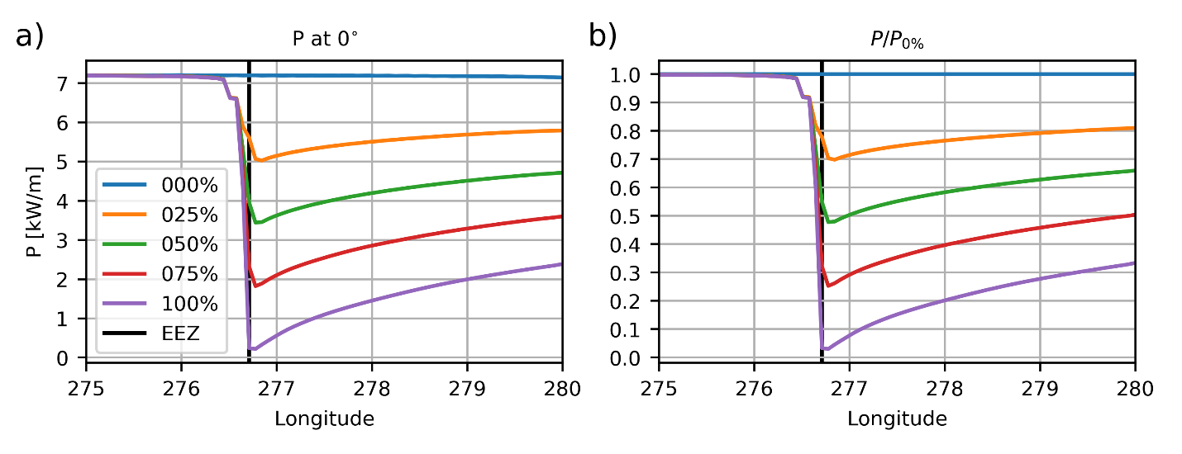

Figure 4 Instantaneous omnidirectional wave power (a) and recovery curves (b) at the equator as a function of extraction levels.

The efficiency of the wave recovery depends on the extraction level when all other conditions are equal. To visualize this, we take the ratio of the wave power between the situations with energy extraction and the baseline conditions (Figure 4b). Wave power recovers up to 33%, evaluated at the eastern end of the domain, of the baseline amount when 100% energy is extracted at the EEZ. The sensitivity analysis of extraction level indicates that the greater the amount of energy extracted, the larger the recovery rate. It is worth noting that, this method does not consider frequency dependent energy extraction. This perhaps can be optimized to further improve the wave energy recovery given that the wave growth is frequency dependent. However, that topic is out of the scope of this work and is suggested as an area of future research.

## Theoretically Available Wave Energy Resource

The implications of energy extraction and recovery for wave energy assessments can be investigated by computing the remote and local wave energy resource for the different energy extraction intensities shown in Table 2. The remote resource is constant in all simulations, as can be inferred from Figure 4a, at 13.42 GW. As discussed in Section 3.1, *RL* for the baseline scenario is 0.15 GW using the source term method. When energy extraction is considered the resource computed inside the domain with Equation 6 varies from 0.15 to 3.37 GW. Following Equation 9, the *RP* varies from 1.34 to 3.22 GW. For a complete quantification of the total wave resource (i.e. *RA*) the scenario with maximum potential should be selected as a value for *RP*. Thus, the wave energy resource is 25% larger than would have been estimated if the potential resource had not been considered. For this scenario, *PA* is of 16.79 GW. Ultimately the magnitude and importance of the potential resource is expected to be site specific, and therefore, a realistic situation is evaluated in next section.

Table 2 Local and remote wave energy resource for the basin domain between 10°S and 10°N as a function of energy extraction level. The local resource is computed using the source term method. All values are reported in GW.

|  |  |  |  |  |
| --- | --- | --- | --- | --- |
| Extraction Level | *RR* | *RL* | *RP* | *RA* |
| 0% | 13.42 | 0.15 | - | 13.57 |
| 25% | 1.34 | 14.91 |
| 50% | 2.27 | 15.84 |
| 75% | 3.06 | 16.63 |
| 100% | 3.22 | 16.79 |

# US West Coast Case Study

As demonstrated in the previous section the amount of energy extraction affects the total wave energy resource. The idealized case considered steady state wind and deep-water conditions with uniform depth. However, the magnitude of the potential resource obtained from the idealized conditions might not be representative for real world conditions. In this section we take the US West Coast as an example to explore the effects of realistic wind forcing and model bathymetry. Several one-month simulations with different extraction levels are performed for January 2009. The wind forcing is taken from NOAA’s Climate Forecast System Reanalysis (Saha, Moorthi et al. 2010) and the WW3 implementation is based on NOAA’s operational forecasting system, where only the model masks have been altered. The World Ocean is simulated with a 30’ resolution model while the EEZ is entirely covered by the 4’ resolution model. An intermediate 10’ resolution model is used to ensure a smooth transition of boundary conditions from the global to the regional model. Figure 5 shows a snapshot of significant wave height for a case where 100% of the wave energy is extracted at the EEZ to illustrate modeling approach. In this case, the small waves inside the EEZ are a result of local generation only.

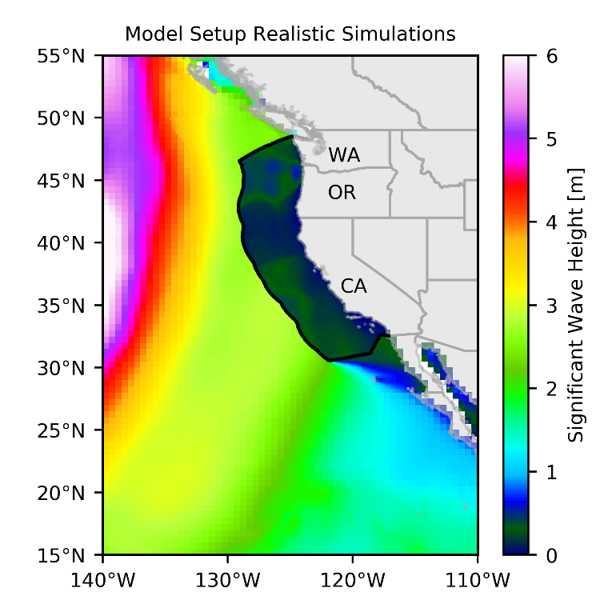

Figure 5 Model setup for realistic simulations with 100% energy extraction at the US West Coast EEZ.

## Local Resource

First, we compare both methods for computing the local resource to explore their differences by evaluating the baseline scenario. Due to the chosen model resolution, the local domain is defined between the EEZ and a line of equal distance from shore at 18.52 km (10 nmi, see Figure 1). *RL* is significantly different depending on the method, with the results from energy flux method being only 8% of those reported by the source term method (Table 3). The difference between both methods are related to energy dissipated before reaching the 10 nmi isoline. The bottom friction source term is integrated following Equation 7 and it is found that the amount of energy lost due to this process is 0.15 GW. Another possibility for this discrepancy is the unaccounted net energy flux through the northern and southern boundaries. After integrating the energy flux at the boundaries using Equation 4, we find that there are 9.57 GW entering the domain and 9.03 GW leaving the domain. This represents a 0.54 GW net flux, which is too small to account for the difference in the methods. However, it is difficult to quantify how much of the outgoing energy came in through the seaward boundary. This energy would have already been accounted for as part of the remote resource. In that case it should be removed from the outgoing energy at the lateral boundaries, this would in turn increase the net amount of energy flux into the domain. Finally, depth-induced wave breaking, and unaccounted energy generated and dissipated inside the domain might also result in unaccounted wave energy. None of these shortcomings, however, are present in the source term method.

Table 3 Wave energy resource for January 2009 for the US West coast in GW with different methods for computing the local resource.

|  |  |  |
| --- | --- | --- |
| *RR* | *RL* | |
| Energy Flux Method | Source Term Method |
| 43.12 | 0.66 | 8.42 |

## Theoretically Available Wave Energy Resource

Similar to the idealized scenario a significant amount of energy that can be transferred from the wind to the waves exists when remote energy is extracted at the EEZ. Different wave energy extraction levels were considered using wind forcing of January 2009 for the realistic domain and the results are summarized in Table 4. The source term method is used for the remainder of this discussion to compute the local resource. As in the idealized scenario, the potential resource is revealed when extracting energy at the EEZ. In contrast to the idealized conditions, the local sea state is not fully developed, resulting in a local resource that is 19.5% of the remote resource for the baseline conditions. The potential resource can be computed from either the 75% or 100% extraction levels given the results are within 2% of each other. From the 100% extraction the potential resource is 87.9% as high as the local resource and represents 12.6% of the theoretically available wave energy resource. Overall, the potential resource is of considerable importance with respect to the other two components (remote and local) of the wave energy resource. For the month of January 2009, the total theoretically available wave energy resource (58.94 GW) is 14% larger than the existing wave energy resource (51.54 GW).

Table 4 Average wave energy during January 2009 for the US West Coast in GW.

|  |  |  |  |  |
| --- | --- | --- | --- | --- |
| Extraction Level | *RR* | *RL* | *RP* | *RA* |
| 0% | 43.12 | 8.42 | - | 51.54 |
| 25% | 4.73 | 56.27 |
| 50% | 6.66 | 58.21 |
| 75% | 7.55 | 59.09 |
| 100% | 7.40 | 58.94 |

## Spatial and Temporal Characteristics

The local and potential wave resource are essentially governed by the wind speed and direction, which vary throughout the year. The winter climate in the US West Coast is characterized by large and energetic swells (e.g. Ruggiero, Komar et al. 2010) driven by extratropical winter storms (e.g. Chang and Fu 2002). Summer conditions are milder with smaller wave heights and shorter periods (e.g. Garcia-Medina, Ozkan-Haller et al. 2014). Following (Ruggiero, Komar et al. 2010), in the context of the regional wave climate summer refers to the period from May to September and winter from October to April, corresponding to the period of larger waves in the region. To better understand the overall importance of the potential resource at the seasonal scale, a full-year simulation for 2009 was conducted with 0% and 100% extraction, the latter was chosen for simplicity given the results are similar to other extraction levels in terms of revealing the maximum potential resource.

The simulated remote resource follows the general wave climate characteristics, with energetic winters and calm summers shown in Figure 6a. The local resource is of similar magnitude to the remote resource in the summer months, at its maximum in May it accounts for 53% of the *RA*. The potential resource is maximum in the winter months. Even though the average wind speed over the local domain is higher during the summer (gray line in Figure 6a), the potential resource is less. This is because the wind growth depends on the local sea state, the ratio of excess wind energy, due to energy extraction, transferred to the waves varies throughout the year. This process can be seen when comparing the ratios of extraction and baseline conditions for *Sin* and *Sds*, as shown in Figure 6b. The growth ratio (*Sin*) increases in the winter months with respect to the summer season while the dissipation ratio (*Sds*) stays mostly constant. The reason for the larger winter ratio is that the larger the waves the less wave growth there is, which is the case in the winter in the absence of energy extraction.

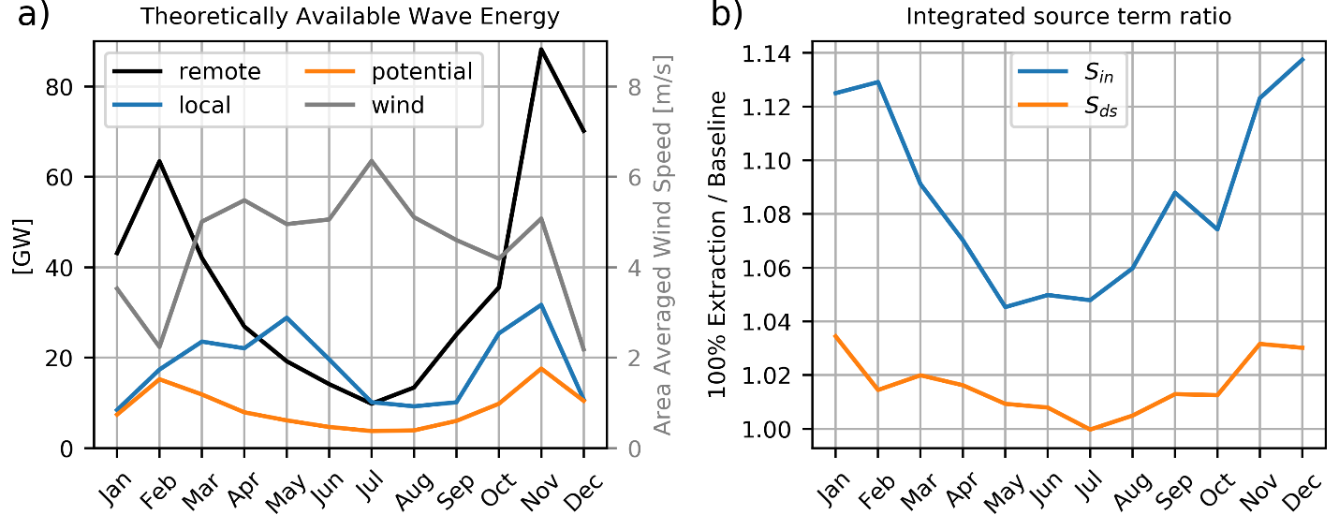

Figure 6 a) Monthly averaged wave energy resource for the West Coast for 2009. The local resource is computed for the baseline condition (0% extraction) and the potential resource from the difference between the 100% and 0% extraction levels. Basin and monthly averaged wind speed is shown in gray with the right axis as the corresponding scale. b) Monthly averaged integrated source term ratio.

So far, we have based the discussion on quantities integrated over a large area. As previous studies have shown the wave climate in the US West Coast has a significant meridional variation (Yang, Wu, et al. 2018). It is expected that the local and potential resources have a corresponding spatial variation. The general characteristics of these components of the total resource are tied to the local the wind direction and speed. Figure 7 shows monthly averaged local and potential resource for selected months to reveal the spatial variability of the resource. In the summer months, wind generally comes from the north, resulting in the well-known upwelling season in the region (e.g. Huyer, Sobey et al. 1979, Barth, Pierce et al. 2000), as shown in the mean wind direction and velocity plots (Figure 7, bottom row). The local resource is in turn maximum offshore of California when compared to the Oregon and Washington (Pacific Northwest, PNW) region. In the winter, the predominant wind direction in the PNW is reversed, which leads to an increased local wave resource and potential wave resource offshore of Washington and northwest Oregon. The wind direction is consistent to the southeast, offshore of California and thus the local and potential resource are relatively constant throughout the year. Finally, OWP for the case of 100% extraction is being shown in Figure 7. This serves to illustrate the regions where the recovered waves travel to. Offshore southern California sees recovered resource consistently throughout the year due to the predominant wave direction which is mostly alongshore. While the recovery in the winter months focuses the waves in the coastal waters of the PNW. The patterns revealed by computing the local resource independent form the remote resource and those emerging from the recovery are spatially heterogeneous and might influence the location of future projects.

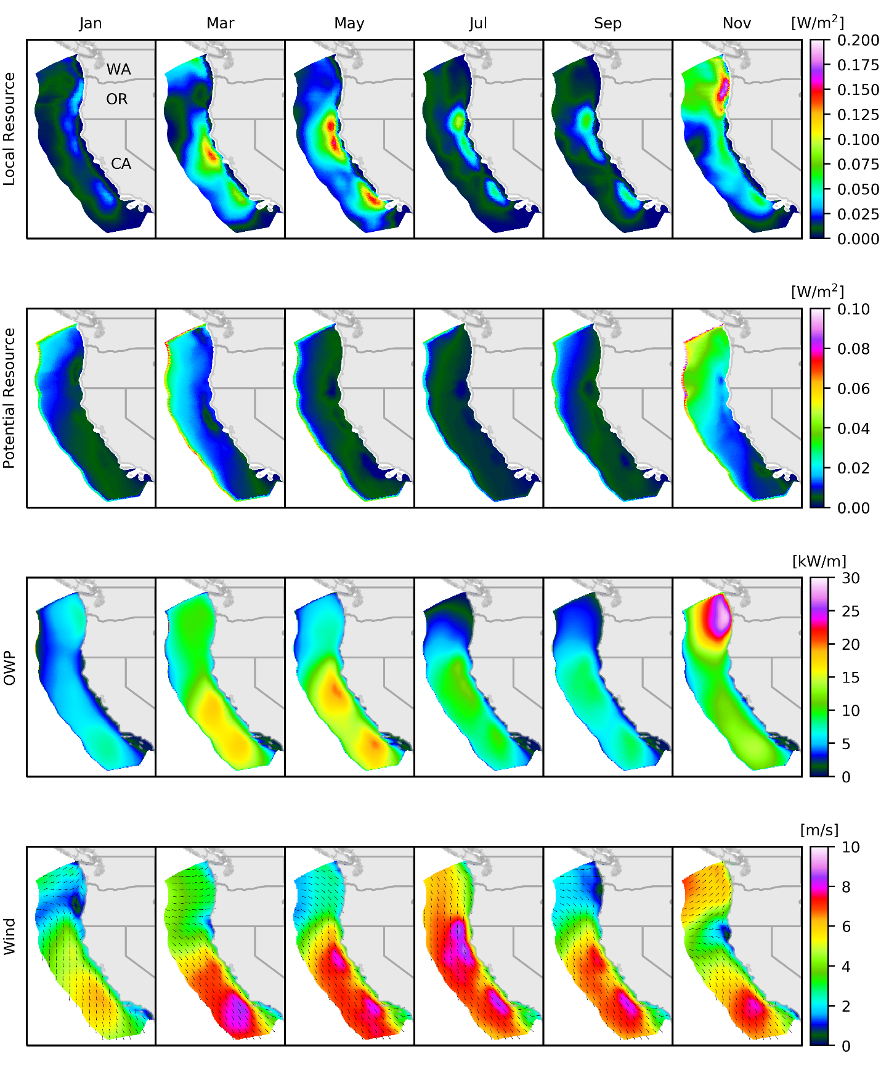

Figure 7 Monthly averages, from top row to bottom row: local resource, potential resource, omnidirectional wave power under 100% energy extraction, and wind speed and direction at 10m above the water surface.

# Concluding Remarks

A methodology to quantify the total theoretically available wave energy resource is presented in this study. The inclusion of the potential resource in wave resource assessment will provide a complete picture of the total resource a region possesses. In addition, the present study helps reveal how significant the potential for wave recovery will be in case of large scale and intense energy extraction. Throughout 2009 the potential resource in the US West Coast EEZ represented 11 – 16% of the total theoretically available wave energy resource (Figure 6).

Two different methods for examining the local resource were compared. Under idealized conditions both methods produce very similar results, which serves to validate the proposed method of spatially integrating the source terms to compute the local resource. Under realistic scenarios the source term method produced consistent results in contrast to the energy flux method, we therefore recommend the former method for calculating the total theoretically available wave resource assessment.

The authors acknowledge that the method used to simulate energy extraction is rather crude but serves as a generic method of assessing the effects of energy harvesting and the recovery potential. Future work involves evaluating frequency dependent energy extraction based on realistic power takeoff ratings from real wave energy converters to examine the implications on wave energy recovery.

Finally, the spatial variations of the local and potential resource were discussed with a one year hindcast. Regions and seasons with potential for wave recovery were identified, longer-term simulations will improve the accuracy of these estimates. The identification of sites where potential wave energy resource is large can be relevant for future technologies that might extract considerable amounts of wave energy. Perhaps these could be located upwave (or upwind) from regions with large potential wave resource.

# Acknowledgments

This study was funded by the U.S. Department of Energy, Office of Energy Efficiency & Renewable Energy, Water Power Technologies Office under contract DE-AC05-76RL01830 to Pacific Northwest National Laboratory. All model simulations were performed using PNNL Institutional Computing (PIC) facility. All information needed to reproduce the results can be found in the manuscript.

# References

Aboobacker, V. M., P. R. Shanas, M. A. Alsaafani and A. M. A. Albarakati (2017). "Wave energy resource assessment for Red Sea." Renewable Energy **114**: 46-58.

Alonso, R., M. Jackson, P. Santoro, M. Fossati, S. Solari and L. Teixeira (2017). "Wave and tidal energy resource assessment in Uruguayan shelf seas." Renewable Energy **114**: 18-31.

Ardhuin, F., B. Chapron and F. Collard (2009). "Observation of swell dissipation across oceans." Geophysical Research Letters **36**.

Ardhuin, F., E. Rogers, A. V. Babanin, J. F. Filipot, R. Magne, A. Roland, A. van der Westhuysen, P. Queffeulou, J. M. Lefevre, L. Aouf and F. Collard (2010). "Semiempirical Dissipation Source Functions for Ocean Waves. Part I: Definition, Calibration, and Validation." Journal of Physical Oceanography **40**(9): 1917-1941.

Barth, J. A., S. D. Pierce and R. L. Smith (2000). "A separating coastal upwelling jet at Cape Blanco, Oregon and its connection to the California Current System." Deep-Sea Research Part Ii-Topical Studies in Oceanography **47**(5-6): 783-810.

Battjes, J. A. and J. Janssen (1978). Energy loss and set-up due to breaking of random waves. Coastal Engineering 1978**:** 569-587.

Chang, E. K. M. and Y. F. Fu (2002). "Interdecadal variations in Northern Hemisphere winter storm track intensity." Journal of Climate **15**(6): 642-658.

Garcia-Medina, G., H. T. Ozkan-Haller and P. Ruggiero (2014). "Wave resource assessment in Oregon and southwest Washington, USA." Renewable Energy **64**: 203-214.

Gunn, K. and C. Stock-Williams (2012). "Quantifying the global wave power resource." Renewable Energy **44**: 296-304.

Hasselmann, K., T. Barnett, E. Bouws, H. Carlson, D. Cartwright, K. Enke, J. Ewing, H. Gienapp, D. Hasselmann and P. Kruseman (1973). "Measurements of wind-wave growth and swell decay during the Joint North Sea Wave Project (JONSWAP)." Ergänzungsheft 8-12.

Hasselmann, S., K. Hasselmann, J. H. Allender and T. P. Barnett (1985). "Computations and Parameterizations of the Nonlinear Energy-Transfer in a Gravity-Wave Spectrum .2. Parameterizations of the Nonlinear Energy-Transfer for Application in Wave Models." Journal of Physical Oceanography **15**(11): 1378-1391.

Hemer, M. A., S. Zieger, T. Durrant, J. O'Grady, R. K. Hoeke, K. L. McInnes and U. Rosebrock (2017). "A revised assessment of Australia's national wave energy resource." Renewable Energy **114**: 85-107.

Huyer, A., E. J. C. Sobey and R. L. Smith (1979). "Spring Transition in Currents over the Oregon Continental-Shelf." Journal of Geophysical Research-Oceans **84**(Nc11): 6995-7011.

Li, N., K. F. Cheung, J. E. Stopa, F. Hsiao, Y. L. Chen, L. Vega and P. Cross (2016). "Thirty-four years of Hawaii wave hindcast from downscaling of climate forecast system reanalysis." Ocean Modelling **100**: 78-95.

Neill, S. P., A. Vogler, A. J. Goward-Brown, S. Baston, M. J. Lewis, P. A. Gillibrand, S. Waldman and D. K. Woolf (2017). "The wave and tidal resource of Scotland." Renewable Energy **114**: 3-17.

O'Dea, A., M. C. Haller and H. T. Ozkan-Haller (2018). "The impact of wave energy converter arrays on wave-induced forcing in the surf zone." Ocean Engineering **161**: 322-336.

Ruggiero, P., P. D. Komar and J. C. Allan (2010). "Increasing wave heights and extreme value projections: The wave climate of the US Pacific Northwest." Coastal Engineering **57**(5): 539-552.

Saha, S., S. Moorthi, H. L. Pan, X. R. Wu, J. D. Wang, S. Nadiga, P. Tripp, R. Kistler, J. Woollen, D. Behringer, H. X. Liu, D. Stokes, R. Grumbine, G. Gayno, J. Wang, Y. T. Hou, H. Y. Chuang, H. M. H. Juang, J. Sela, M. Iredell, R. Treadon, D. Kleist, P. Van Delst, D. Keyser, J. Derber, M. Ek, J. Meng, H. L. Wei, R. Q. Yang, S. Lord, H. Van den Dool, A. Kumar, W. Q. Wang, C. Long, M. Chelliah, Y. Xue, B. Y. Huang, J. K. Schemm, W. Ebisuzaki, R. Lin, P. P. Xie, M. Y. Chen, S. T. Zhou, W. Higgins, C. Z. Zou, Q. H. Liu, Y. Chen, Y. Han, L. Cucurull, R. W. Reynolds, G. Rutledge and M. Goldberg (2010). "The Ncep Climate Forecast System Reanalysis." Bulletin of the American Meteorological Society **91**(8): 1015-1057.

Tolman, H. L. (2002). "Distributed-memory concepts in the wave model WAVEWATCH III." Parallel Computing **28**(1): 35-52.

Tolman, H. L. (2003). "Treatment of unresolved islands and ice in wind wave models (vol 3, pg 219, 2003)." Ocean Modelling **5**(4): 381-384.

Yang, Z., V. S. Neary, T. Wang, B. Gunawan, A. R. Dallman and W.-C. Wu (2017). "A wave model test bed study for wave energy resource characterization." Renewable Energy **114**: 132-144.

Yang, Z., W. Wu, T. Wang, L. Castrucci (2018). “High-resolution Regional Wave Hindcast for the U.S. West Coast”. PNNL-28017.