Final Project Documentation

Section 1: Functionality

Our To-Do List application allows the users to create a list of items that can remind the user of what they need to get done. The application also gives the user the ability to edit and update any item if they need to make changes, as well as to delete them once they are done and no longer needed. We implemented Core Data Database to allow the user’s application information to be stored and saved, allowing them to keep their list intact when they close the application.

Section 2: Architecture & Design

* Database Schema

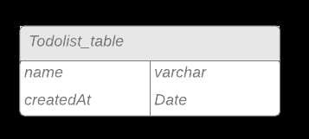

* Design Diagrams

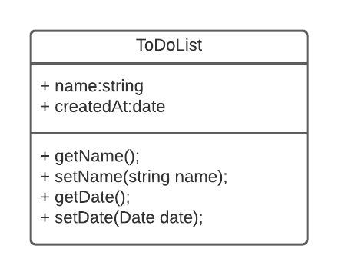  
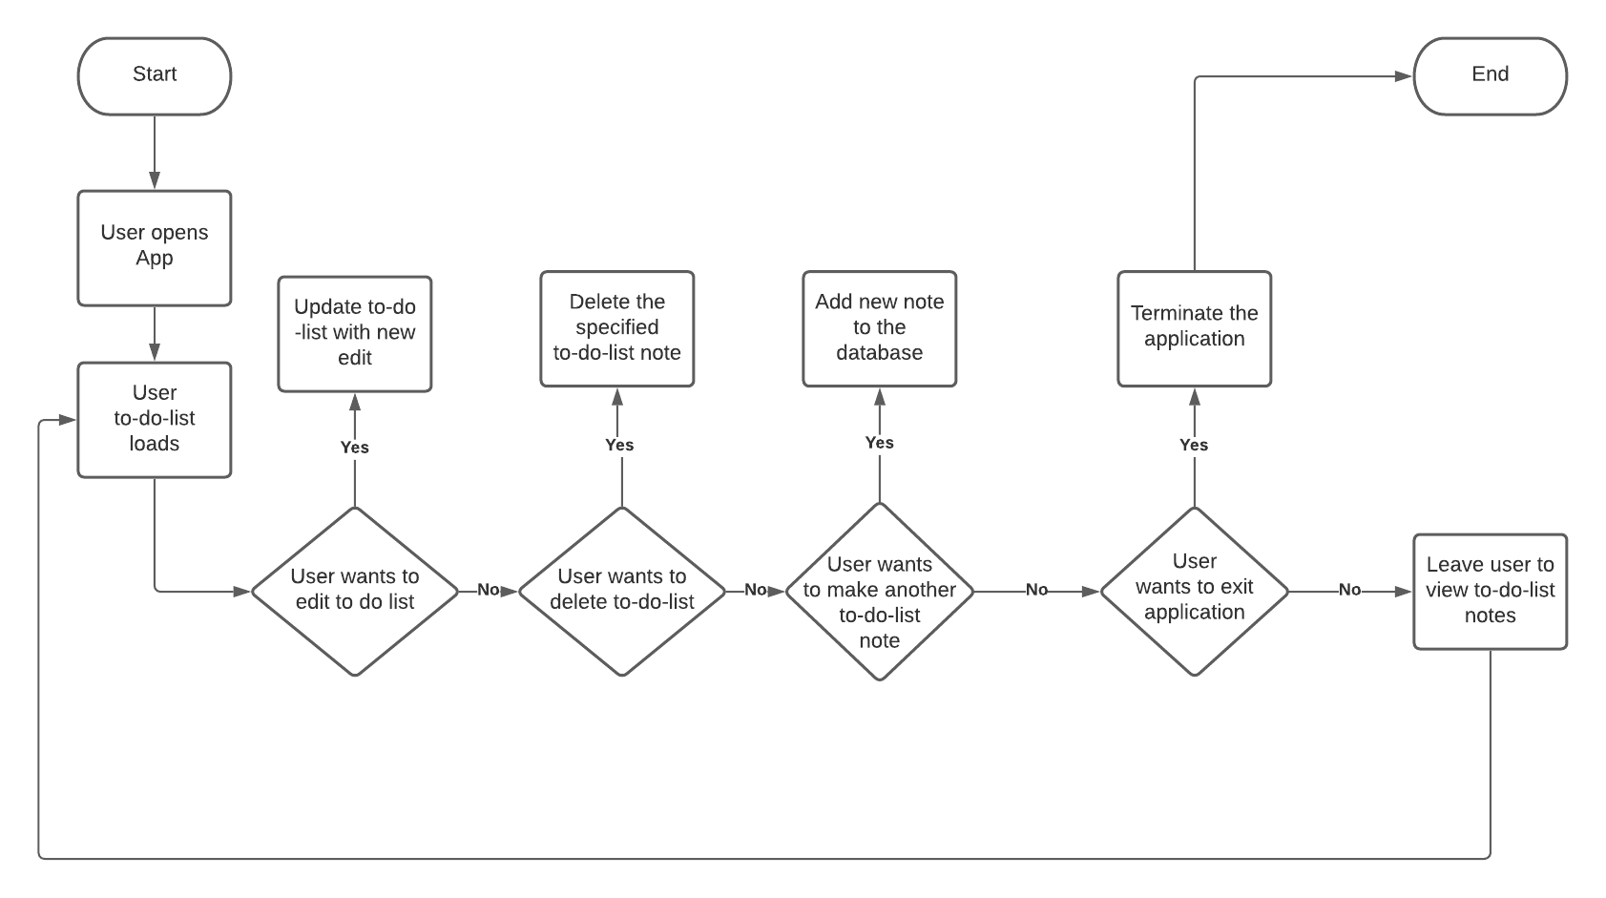

Section 3: GitHub Location of Code

<https://github.com/faithon/ToDoList_Swift>

Section 4: Test Results

* Added “Walk the dog”
* Added “Clean the kitchen”
* Added “Work on project”
* Edited “Clean the kitchen”
* Deleted “Work on project”
* All test scenarios were successful

Section 5: Future Work

* Add a description section to each of the items created.
* Add the ability of putting a date you wanted it done by (due date).
* Add the ability to create and log into an account.
* Attach a unique-login ID to the To-Do list to allow for better organization between other’s To-Do list.
* Functionality to share the To-Do list with others using the same application.