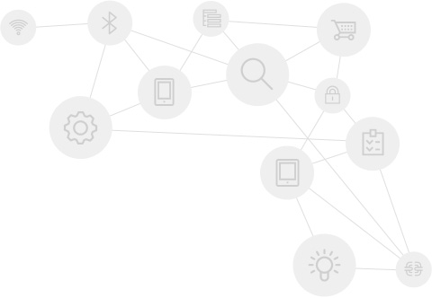

**US EMBASSY MISSION POLAND – BACK-END**

**USER’S   
MANUAL**

1 Introduction 4

1.1 Document purpose 4

1.2 Server functionality 4

1.3 Dictionary 5

2 How – to 6

2.1 Add content into the structure 6

2.2 Rearrange placement of page within the system 7

2.3 Rearrange order of children pages 7

2.4 Update downloadable document 7

2.5 Manage additional content 7

3 Page management 8

3.1 Page types 8

3.2 Tree structure of pages relations 12

3.3 Fields 13

3.4 Special fields 13

4 Content management 15

4.1 Uses for WYSIWYG tools 15

4.2 WYSIWYG interface 15

4.3 Content editing 17

4.4 Additional content 18

5 Banner management 19

5.1 Banner types 19

5.2 Enable/Disable banner 20

6 Push notifications 21

6.1 Update notification 21

6.2 Informative notification 21

7 Video management 22

7.1 Add video 22

7.2 Edit video 23

7.3 Video preview 23

7.4 Remove video 23

8 File management 24

8.1 Add file 24

8.2 Edit file 24

8.3 Remove file 24

9 User management 25

9.1 Permission groups 25

9.2 Add user 25

9.3 Edit user 26

9.4 Change password 27

9.5 Remove user 27

10 Feedback 28

10.1 Fields available in received feedback 28

10.2 Feedback rules 28

|  |
| --- |
| System contains big amount of variables and elements. This is description of methodology used for presentation of these elements in list form.   * This sign will be used for listing rules * Dots are used for listing elements and steps * Squares are used if there are sub-elements of particular element   To access the system, please visit this web address: <http://91.121.155.99/cms/> |

# Introduction

## Document purpose

This document intends to describe main server functionality, its relation to external and internal contents, services it provide for mobile application, and management of mobile application content.

## Server functionality

Main server functionalities:

### CMI

Content Management Interface, main tool of interaction between content editors and the content itself. It contains all page management structures, platform for sharing media files and documents, and editor of content.

### Video Streaming

Server provides functionality of converting videos to iOS/Android formats and streaming them to mobile application. Without converting, it is highly probable that some of the videos (depending on file extension) wouldn’t run on all mobile devices.

### RSS parsing

Back-end is automatically receiving content from selected RSS feeds and presenting them in text format in mobile application.

### API

API module provides communication between server and mobile application. On each time mobile application is started, it communicates with server via API to verify state of local content. If an update is found, it is downloaded onto device. API allows sending push notifications and banners to mobile devices. Banners and Push Notifications are described in sections 5 and 6, respectively.

## Dictionary

Short description of terms used in this document is available below:

* + - * Server related
      * **Parent page** – page from which part of the content structure originates. Each parent page can have multiple child pages.
      * **Child page** – page originating and accessible from its parent. Each page can have only one parent.
      * **Database** – structure organized to store particular types of data
      * Mobile application and devices related

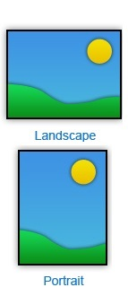

* **Homescreen** – the first screen seen in a mobile device or mobile application, all actions are started from homescreen
* **Landscape mode** – Display mode for mobile devices screen. Portrait assumes that display is longer horizontally than vertically
* **Portrait mode** – Second display mode for mobile device screen
* **Push notification** – short message sent from server to mobile devices. Facebook messages, SMS and application update availability are examples of push notifications
* **Banner** – Short message which appears on application home screen. First thing seen by user after opening the application.
* **External link** – Web address accessed via URL button
* **Internal link** – Address of page within the mobile application, accessed via Jump button.
  + - * User rights management related (for more information, see section 9)
* **“Assigning roles”** - Permission that allows to add/edit/remove users.
* **“Editor” -** Permission that allows to add/edit/remove all pages content.
* **“System administrators” -** Grants all permissions – Assigning roles, and editing rights for all of pages.
* **“Editable Pages”** - Content area privileges, permissions that allow to add/edit/remove pages in specific parts of content tree. Pages displayed in this field are those which have “Is permission parent” checked.

# How – to

This section provides instructions on how to perform basic operations on the CMI system without full knowledge of its possibilities.

## Add content into the structure

* Press “Content” button in main interface panel

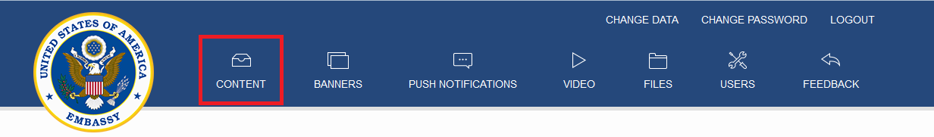

* Expand content tree and access the section in which content should be placed

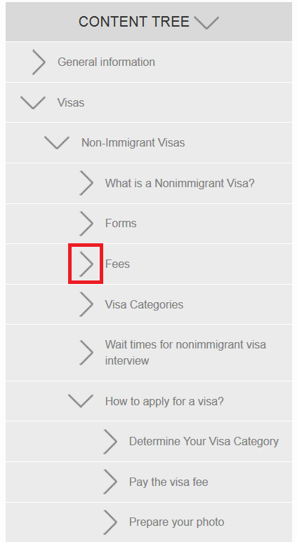

* To see pages originating from particular area, press the page name in Content Tree. Such view allows adding pages and editing or removing currently existing ones
* Content can be implemented to existing page using “Edit” button, or added as a new page via “Add page”. More information about page structure and content editing is available in sections 3 and 4.

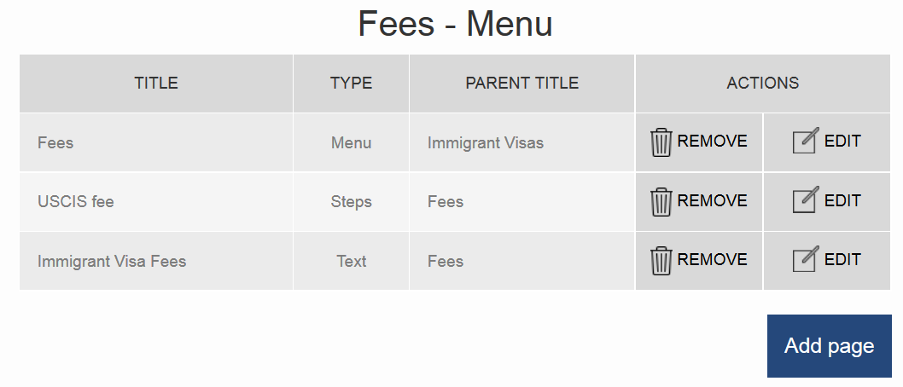

## Rearrange placement of page within the system

* Edit selected page
* Change the Parent page variable
* Save the changes
* Selected page will be now available from its parent page

## Rearrange order of children pages

* Edit Parent page
* In child pages section of parent page, use drag and drop method to configure order of pages

## Update downloadable document

* Press “Files” button in main interface panel

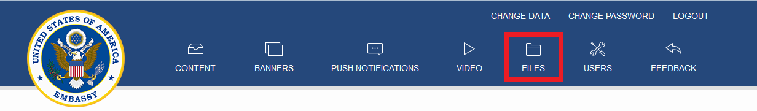

* Press “Edit” button for a particular document
* Upload new files using file browser, confirm the update

## Manage additional content

For convenient organization of buttons and basic – level content, it is possible to display them in additional content column (visible only on tablet devices which screen is oriented in landscape mode). To present content there, use “Additional Content” field in Text, Steps, List or Contact information page.

# Page management

This section covers the structure of application contents, the way they are organized, the relation between what is written in the system and what is displayed in mobile application.

## Page types

There are several types of pages, each fulfilling different role.

### Menu

Enables defining content structure. Pages of type “Menu” can have child pages. Children are displayed as items in a menu. More information about tree structure is available in section 3.2.

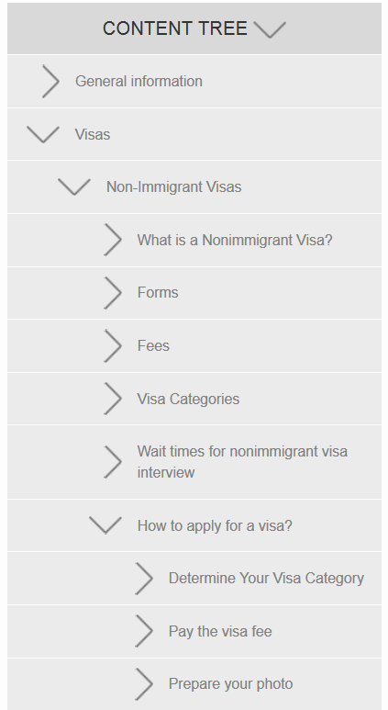 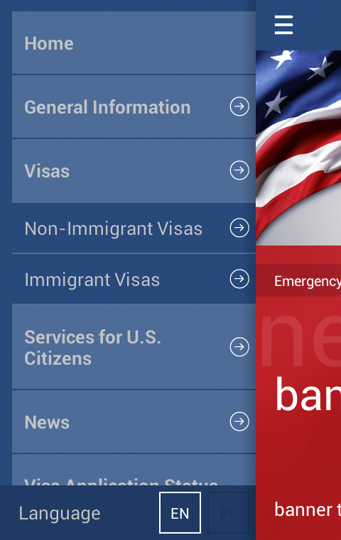 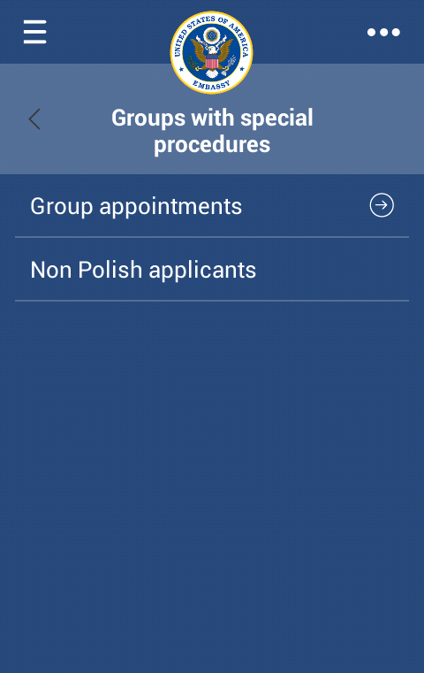

Figure 1 – Content tree structure of the app (left),   
in-app view of First level Menu "Visas" with child pages (middle),   
and deeper level Menu "Groups with special procedures”

### Text

Basic content type. Content is edited in WYSIWYG (What you see is what you get) editor. See section 4 for editor related information.

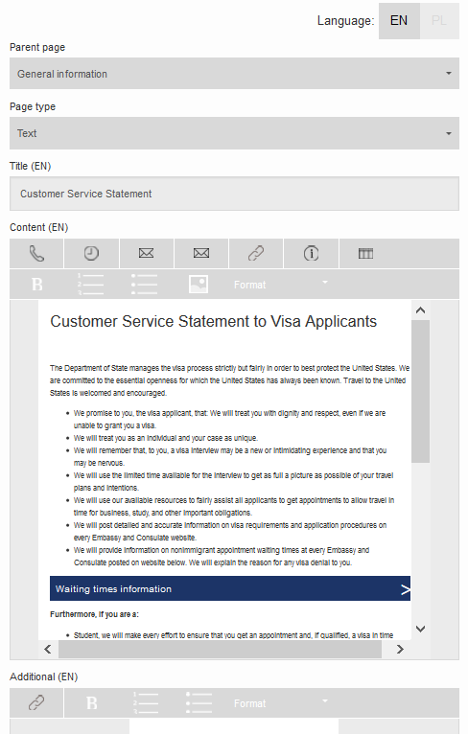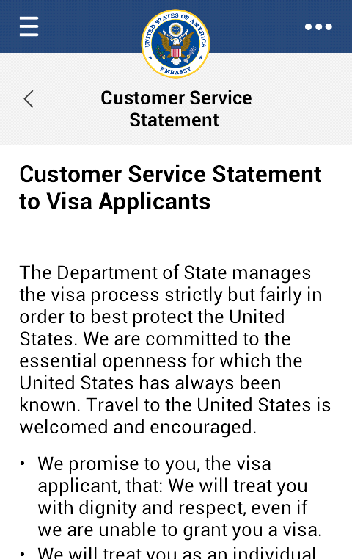

Figure 2 – WYSIWYG Editor (left) and corresponding text page

### List

Extension of “Text” type. It is a content type with child pages. Children are displayed as buttons below text content.

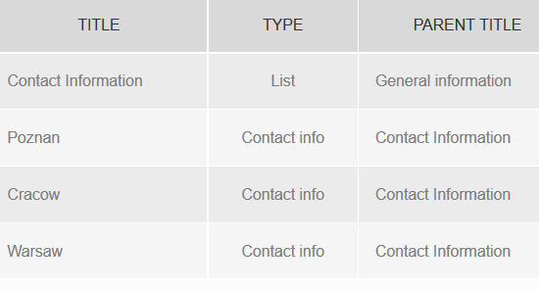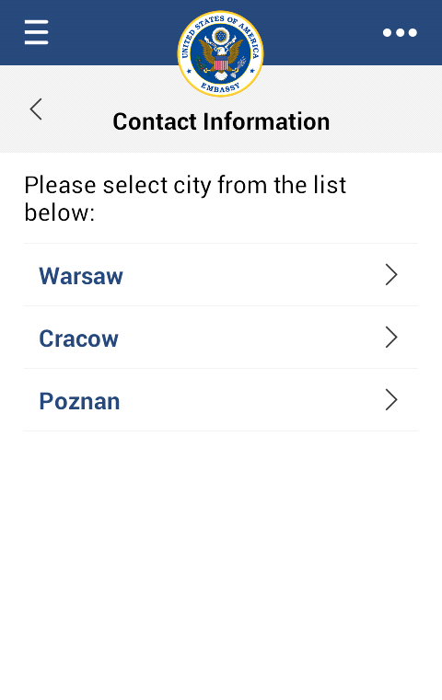

Figure 3 - List page with child pages

„Warsaw”, „Cracow”, „Poznan” as seen in CMI (left) and mobile application (right).

### Steps

Content type with child pages.   
Page of type “Steps” and its children represent a set of steps.

These pages are displayed with a page indicator at the bottom.  
Currently displayed page can be changed by swiping the screen horizontally. Steps page can only be child of menu-type page. Steps page is placed as “Step 0” before its children.

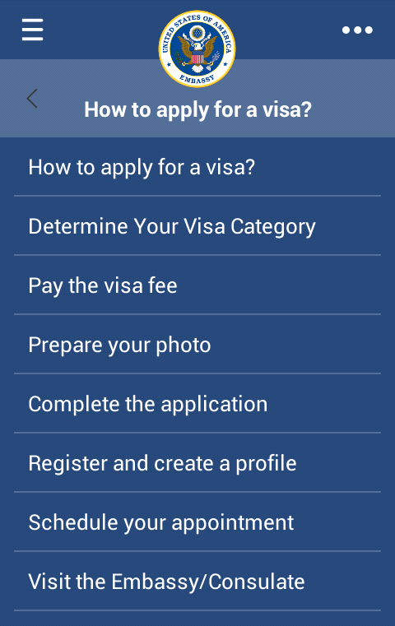 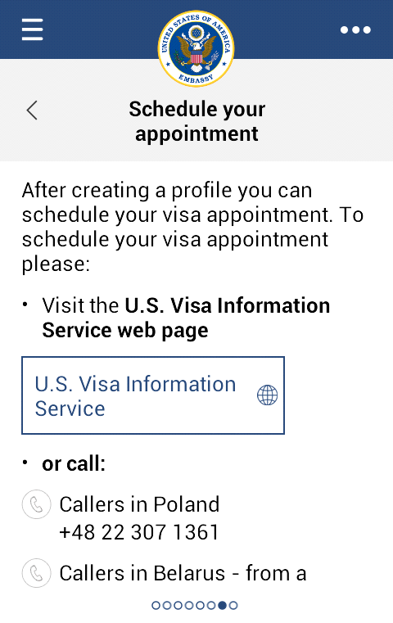

Figure 4 – Steps page "How to apply for a visa?" with its child pages, and interface of particular page.

### Contact info

Content type with map. Map is displayed above text content.   
Centre of the map is determined by latitude and longitude coordinates.

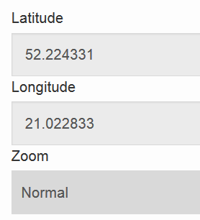 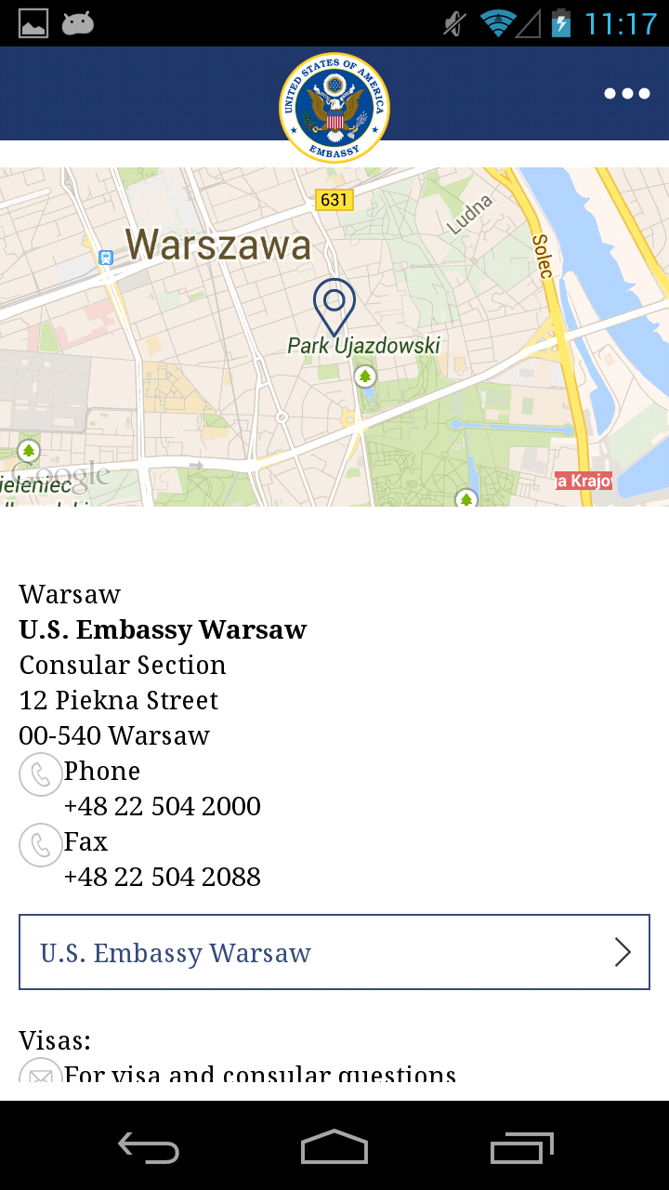

Figure 5 – Variables in page editor, and corresponding page as seen in mobile application.

### Frequently Asked Questions

Page with a list of questions and answers. After opening such page in mobile applications, only the questions are visible. Answers are expanding after a question is pressed.

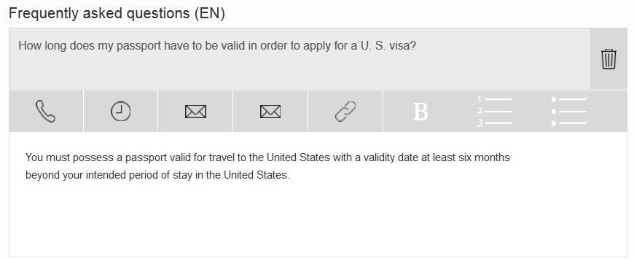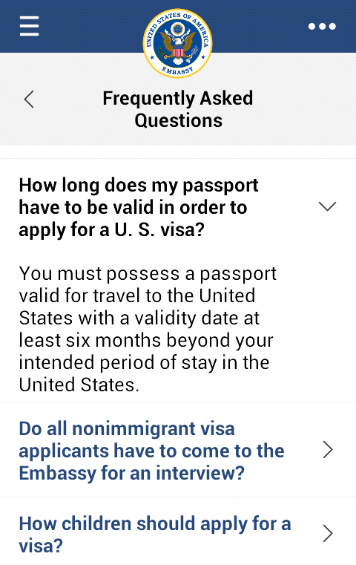

Figure 6 - Sample FAQ Q/A, and in-app page display example.

### Videos

Redirects to Media section of mobile application, where available video content is presented. “Most viewed video” thumbnail is bigger and easier to notice than other available videos.

### File Manager

Redirects to File Manager section of mobile application (for more information, see section 8).

### Headlines

Redirects to News section of mobile applications, where RSS feeds are presented in tiles together with Twitter messages.

### Visa application status

Redirects to Visa application status service (which will be implemented in next version)

### Facebook

Redirects to U.S. Embassy Warsaw Facebook page. (<https://www.facebook.com/USEmbassyWarsaw>)

### Passport tracking status

Redirects to Passport tracking status service.

### Table structure

Extension of text type page, which allows using “Visa Categories” table.

## Tree structure of pages relations

Content of mobile application is organized in a tree structure. Pages of types “Menu”, “Steps” and “List” enable creating nested structures by adding child pages. Differences in presentation of these types are covered in section 3.1.

### Relation between pages

There are five main pages, which are child to no one:

* General information
* Visas
* Services for U.S. Citizens
* News
* Visa Application status

All of the content in the mobile application is organized used parent-child relation

|  |  |  |  |  |  |  |  |
| --- | --- | --- | --- | --- | --- | --- | --- |
| Parent - child relations | | |  | Tree structure relations | | | |
| Page | Parent to | Child to |  | Depth 1 | Depth 2 | Depth 3 | Depth 4 |
| Visas | - Non-Immigrant visas - Immigrant Visas | None |  | Visas | Non-immigrant visas | ... | ... |
| Immigrant Visas | - Introduction & CEAC  - Preparing for Interview  - Legal permanent residents  - etc. | Visas |  |  | Immigrant visas | Introduction & CEAC | N/A |
| Preparing for interview | - Complete DS-260  - Choose a visa pickup location | Immigrant Visas |  |  |  | Preparing for interview | Complete DS-260 |
|  |  |  |  |  |  |  | Choose a visa pick-up location |
|  |  |  |  |  |  |  | ... |
|  |  |  |  |  |  | Legal permanent residents | ... |
|  |  |  |  |  |  | ... | … |

Figure 7 – Relations between pages.

### Operations on page structure

* **“Add page”** button opens page creation form.   
  Some form fields have two language versions – English and Polish. Toggle switch in top right corner enables changing current language version.
* **Edit page -** “Edit” button opens page edit form. Fields are described in sections 3.3 – 3.4.
* **Delete page -** “Remove” button sets page (and its descendants) is_active flag to false. Inactive pages still exist in the database but are not visible in CMI or mobile application anymore.

### Tree structure properties

There exist some requirements on tree structure shape:

* Steps page has to be child of menu page
* If page type is changed (for example from text to list) it is necessary to save page before adding child pages will be possible
* If page type is changed, and target page type does not have fields for values of source page type, content is lost on saving. I.e. If Text page is changed to menu page, text content is lost

## Fields

* **Page type -** Required, available types described in section 3.1.
* **Title (EN) –** Required, 80 characters limit
* **Title (PL) –** Required, 80 characters limit
* **Is Permission Parent** – This checkbox allows placing custom permissions for content editing. If it is checked, only the users with appropriate permission will be able to modify content of this page and its child pages. Permissions are described in section 9.1.

## Special fields

Available only for certain page types

* **Content (EN) -** Required for Text, List, Steps and Contact Info pages, WYSIWYG editor of page content
* **Content (PL) -** As described above, polish version
* **Additional (EN) -** Optional, available on Text, List, Steps and Contact Info pages, WYSIWYG editor of additional content, presented on tablets in right column in landscape mode, for more information see section 4.4.
* **Additional (PL) -** As described above, polish version
* **Latitude -** Required for Contact Info,   
  degrees, floating point number in range <-90.0, 90.0>, South is negative,  
  latitude of map central point
* **Longitude -** Required for Contact Info,   
  degrees, floating point number in range <-180.0, 180.0>, West is negative,  
  longitude of map central point
* **Zoom -** Required for Contact Info, map zoom level,   
  available values: Low, Normal, High
* **Frequently Asked Questions (EN) -** Available on FAQ pages
  + **“Add question” button -** Creates a new question
  + **“Remove” button -** Removes a question
  + **Question -** Question text
  + **Answer -** WYSWIYG editor of answer
* **Frequently Asked Questions (PL) -** As described above, for polish version
* **Children section -** Available on Menu, List and Steps pages
  + **“New” button -** Displays “Add child” pop-up, with options to create a new child page or select an existing one from content tree widget.
  + **List of child pages** - drag and drop items to reorder
  + **“Remove” button** - Drop a child page on this button to remove its is_active flag (described in section 3.2).

# Content management

There are more options of displaying content than just plain text. Mobile application has been optimized for interaction with broad range of contents, allowing user to dial displayed number or start writing email to target address in single click.

## **Uses for WYSIWYG tools**

There are several active elements:

* Phone dialers – allowing to call selected number
* Email message creators – opening mailing client with target address
* URL buttons – opening target web address in mobile browser
* Page Jump buttons – opening particular page of mobile applications
* Info Boxes – Yellow label with “I” sign, which expands with more information after they are pressed

There are also organizational elements, which were adjusted for displaying selected types of contents, such as:

* Working hours
* Addresses
* Visa categories

Text can also be organized using following tools:

* Bold font
* Numerical list
* Bulleted list
* Formats (three types of font settings)

## WYSIWYG interface

List below presents all of the editor features:

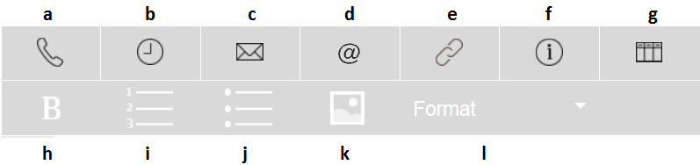

Figure 7 – WYSIWYG editor interface

* 1. dialler**Add a phone number -** Adds a dialer box, allowing user to call presented number with a single click

timer

* 1. **Add working hours -** Adds a box with clock icon

address

* 1. **Add address -** Adds a box with no icon
  2. mailurl**Add email address -** Adds a box with email address, which can open mobile mailing client with a single click
  3. 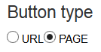**Add button -** Adds a button pointing to specific page of the mobile application, or to external URL.   
     The nature of the button can be adjusted using radio buttons.
  4. visasinfo**Add Info Box –** Adds a box with a title, which expands with more content after being pressed in mobile application
  5. **Add Categories List –** Adds a table used for Visa Categories. Table consist of field for visa category, and its description. This button is only available in pages of “Table structure” type.
  6. bold**Bold –** Bolds used text

numer

* 1. **Numerical List –** Starts numerical list
  2. bullet**Bullet list –** Starts bulleted list
  3. imageformat**Image –** Allows uploading an image to Back-end and displaying it in mobile application page
  4. **Styles –** Allows changing the styles of selected parts of text

## Content editing

* For Text Boxes (Address, Phone, Email, Working Hours), following operations are available via right click:
* Pasting content
* Adding rows (up to 5 for all active boxes except Visa categories)
* Deleting rows
* Editing Active details (Phone number and Email address)
* For URL Buttons:
  + Pasting content
  + Editing Button details
* Active details (Phone, Email, URL/Page button) can also be edited with double-click
* If a button is dimmed and inactive, it is necessary to start new line, as active content must be placed in empty line.
* Since the system uses internal methods for displaying more sophisticated contents, not every pasted content will be displayed properly
  + It is possible to paste entire content from one page to another. Active content (Phone, Email, URL/Page) will be pasted correctly (this may malfunction if 3rd party Clipboard managing tools are present, changing the browser to one without add-ons or different clipboard handling methodology resolves the problem)
  + Only text and Buttons may be pasted into Info Box
  + Pasting tables only works for two-column tables. The result of such pasting is Visa Categories table. Other kind of tables will not be pasted properly.
  + Only text may be pasted into Text Box rows
* Because of mobile screens properties, there is a limitation placed on lists and sub-lists. There should be no more than three levels of lists

Figure 8 – Various contents as seen in WYSIWYG editor

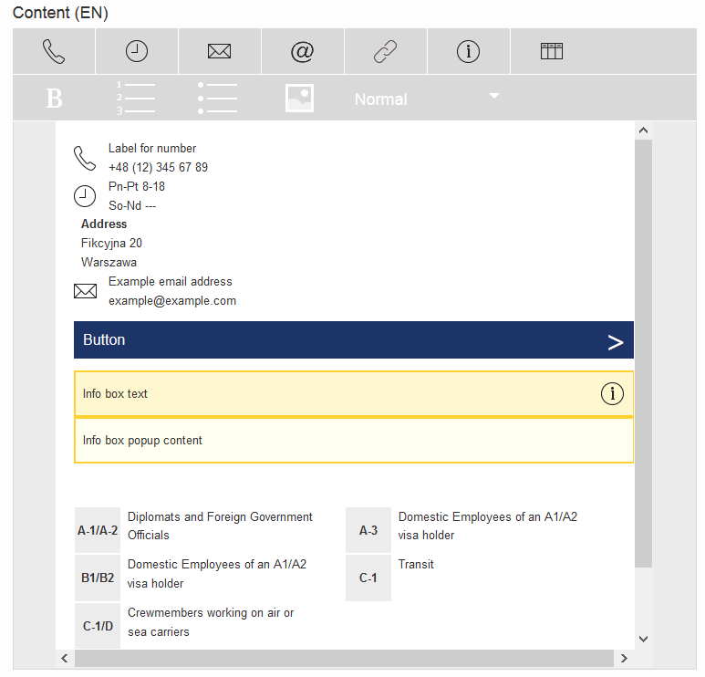

## Additional content

In landscape mode (which is only available for Tablet version of mobile application) there is an additional column on the right side. It usually displays most important headlines and twitter messages, but there is also possibility of manually inputting what should be displayed there. This is the feature enabled by “Additional content” fields. Note that these information won’t be visible at all on phone devices, and therefore they should only serve organizational purposes (such as displaying shortcuts in one place).

# Banner management

Mobile application allows displaying large banners on their home screen. These messages will be the first thing seen by user after the application is opened (provided that he accepted initial terms and conditions). They are good tool for messages of high importance.

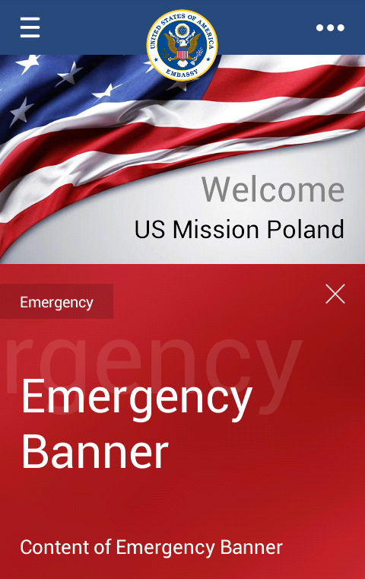 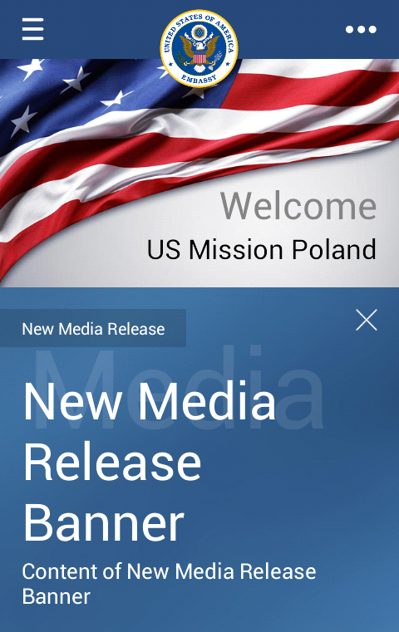 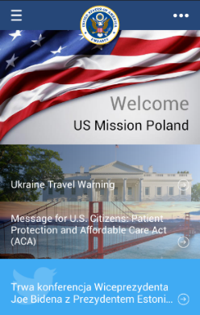

Figure 9 – Emergency banner enabled, other type of banner enabled, no banner enabled

## Banner types

* **Security advisory**
* **Calendar Update**
* **New Media Release**
* **General Update**
* **Emergency** - Enabling/updating banner of type “Emergency” automatically sends push notifications to all devices.  
  NOTE: Push notification is one of the highest levels of app capabilities on mobile device. It is able to wake up the phone, play a sound, vibrate the device, or wake up its sleeping owner. Do not use emergency banners outside of real emergency situations. Abusing push notifications is one of most common reasons for removing the application from mobile device**.**

### Banner editing fields

* + **Title (EN)** – required
  + **Title (PL)** – required
  + **Description (EN)** – required
  + **Description (PL)** – required

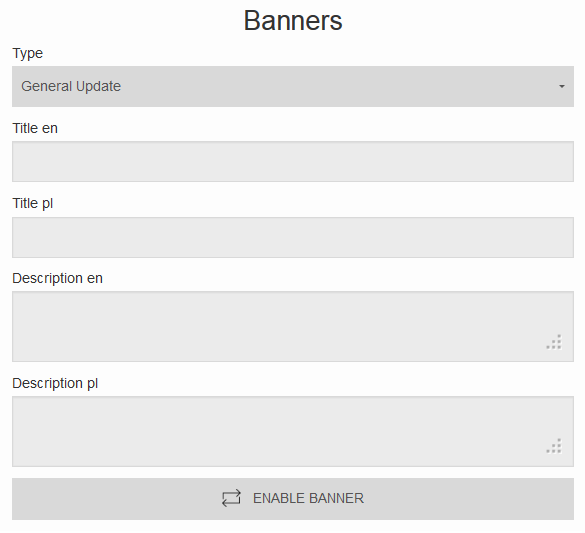

Figure 10– Banner input fields

## Enable/Disable banner

* If banner is enabled “Update banner” and “Disable banner” buttons are available.
* If banner is disabled “Enable banner” button is available.  
  After enabling/updating banner is displayed on mobile application home screen.
* After disabling banner is no longer displayed.

# Push notifications

Push notifications are short messages which appears in mobile device notification panel, or which send information and requests to mobile application.  
Back-end provides two types of push notifications:

## Update notification

After hitting “Send update notification” button update information will be sent to all mobile devices with US Embassy application. This message sends a push notification to the application, and as a result, popup about downloading new contents shows up.

## Informative notification

After hitting “Send” button push notification will be sent to all mobile devices with US Embassy application. This message will be shown as banner on device (appearance depends on device operating system)

### Notification fields

* + - * **Title (EN) –** Required, 50 characters limit
      * **Title (PL) –** Required, 50 characters limit
      * **Message (EN) -** Required
      * **Message (PL) -** Required

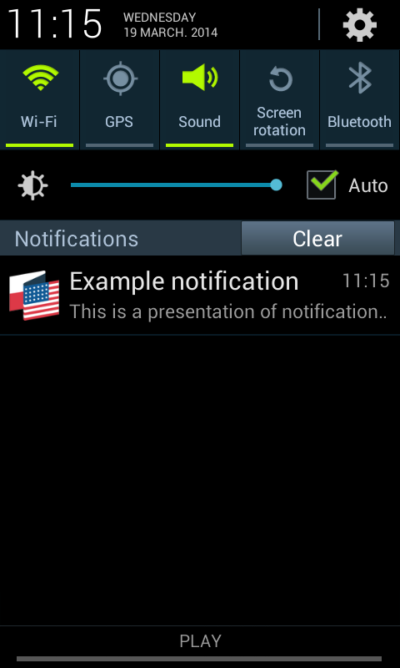

Figure 11 – Push Notification on Android's Notification panel

# Video management

Server provides capabilities of providing and streaming videos to mobile devices. It is possible to stream video file previously uploaded on server, or to display movie from YouTube. All the files are converted to format readable by mobile devices, so it is possible to upload files of various extensions.

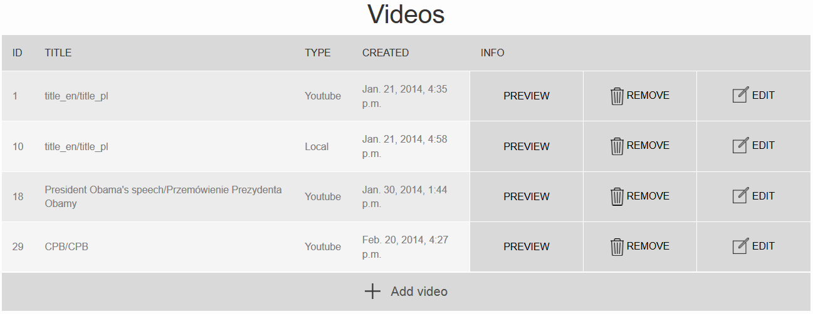

Figure 12 – Video management screen

## Add video

“Add video” button opens pop-up with video form.

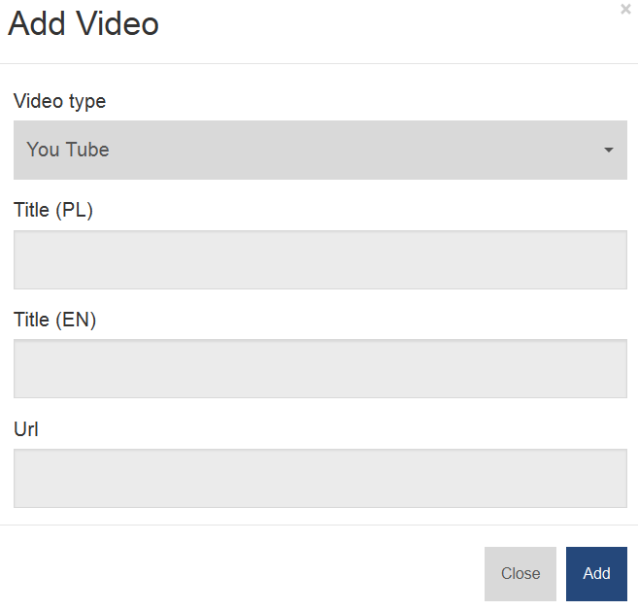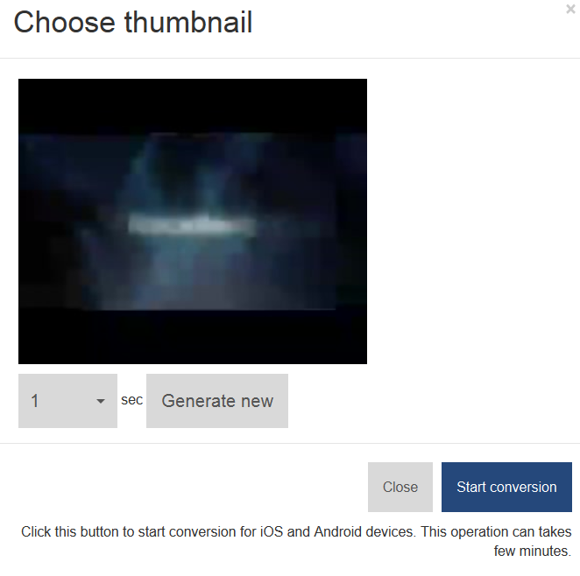

Figure 13 – Video adding popup (step 1) and thumbnail generation popup (step 2, does not apply to YouTube videos)

### Add video - fields

* + - **Video type -** Required, determines type of video (Local/YouTube).
    - **Title (PL) -** Required, Polish title of video.
    - **Title (EN) -** Required, English title of video.
    - **Video original -** Required if local video type is selected, dialog box to selecting file from local file system.
    - **URL -** Required if YouTube video type is selected, URL to video (ex: <http://www.youtube.com/watch?v=9tuztHPq95o>)

### Thumbnails

In case of selecting local video type there is additional thumbnail form (step 2). Dropdown menu and “Generate new” button allows to capture thumbnail from specified moment of video (1 sec. time interval).

## Edit video

“Edit” button opens pop-up with form analogous to add video form described in 7.1.1.

## Video preview

“Preview” button opens pop-up with video preview (stream from YouTube server or back-end server). There is also a direct link to video file available in Video Preview popup

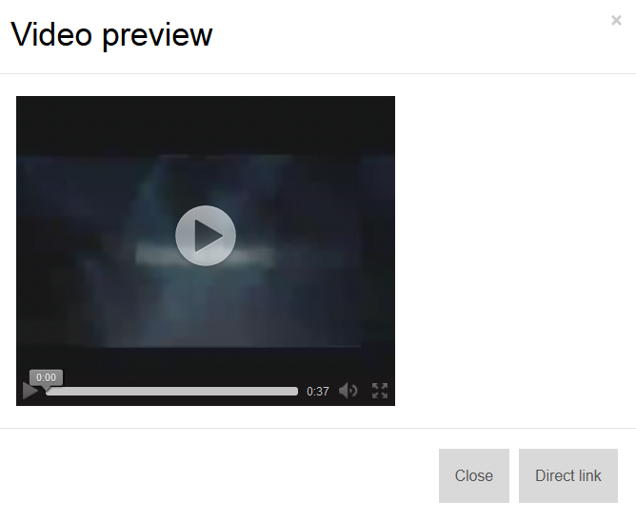

Figure 14 – Video preview popup

## Remove video

“Remove” button deletes all video information from database and all files (videos, thumbnails) from file system. Before deletion is performed, confirmation popup appears.

# File management

This module allows to manage *.pdf files in system. After uploading file object and updating application end-user has access to it. It will be displayed in File Manager of the app, and will be available to download directly into the mobile application; or to an email address as a .pdf file via “send” button.

## Add file

“Add file” button opens pop-up with new file form. There is a built-in PDF file viewer available in the mobile application.

### File adding fields

* + - **Name (EN) -** Required, English title.
    - **Name (PL) -** Required, Polish title.
    - **File (EN) -** Required, English file, *.pdf extension.
    - **File (PL) -** Required, Polish file, *.pdf extension.

## Edit file

It is possible to update the file without removing entry in the system. “Edit” button opens pop-up with form analogous to add new file form described in 8.1.1, which allows

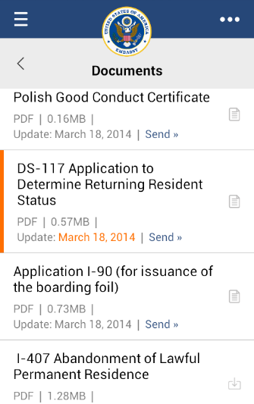 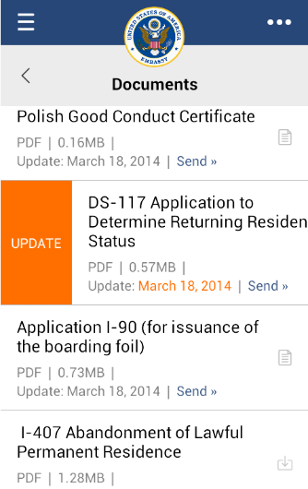

Figure 15 – Mobile view of updated document. Orange indicator appears on a file tile after the file was updated, sliding the tile to the right shows “Update” button.

## Remove file

“Remove” button deletes all file information from database and file system. Before deletion is performed, confirmation popup appears.

# User management

Multiple users may be allowed to edit content available on mobile application. It is possible to set different editing and administrative permissions using the CMI system.

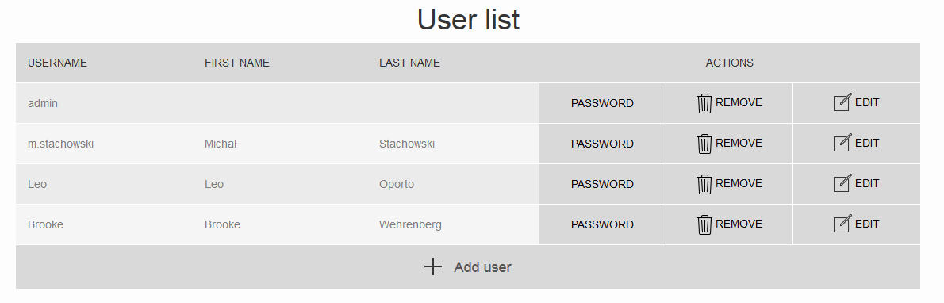

Figure 16 – User management page

## Permission groups

* **“Assigning roles”** - Permission that allows to add/edit/remove users.
* **“Editor” -** Permission that allows to add/edit/remove content from all the pages.
* **“System administrators” -** Grants all permissions – Assigning roles, and editing rights for all of pages.
* **“Editable Pages”** - Content area privileges, permissions that allow to add/edit/remove pages in specific parts of content tree. Pages displayed in this field are those which have “Is permission parent” checked.

## Add user

“Add user” button opens pop-up with user form.

### Add user - fields

* **Username -** Required, 30 characters or fewer. Letters, digits and @/./+/-/_ only.
* **Email address -** Required, standard email validation.
* **First name -** Optional
* **Last name -** Optional
* **Permission groups -** Optional. Each permission group is described in section 9.1.
* **Edited Pages -** Optional. This section allows setting editing rights for specific parts of the content.
* **Password and Password confirmation -** Password must be at least 8 characters long, it must contain a minimum of one lowercase character, one uppercase character, one digit and one non-alphanumeric character.

## Edit user

“Edit” button opens pop-up with form analogous to add user form described in section 9.2.1.

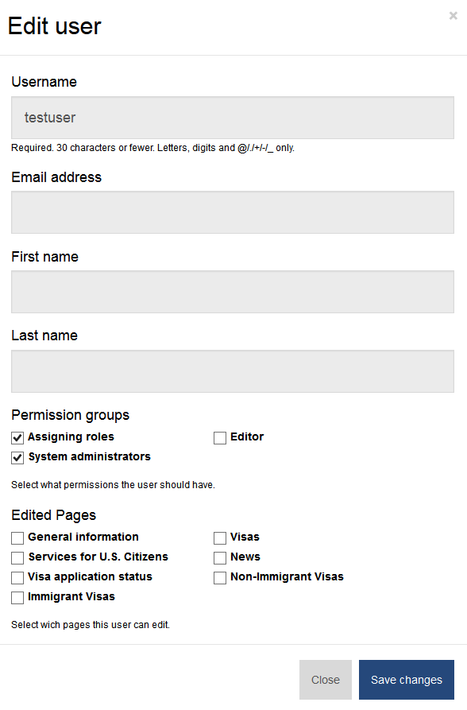

Figure 17 – User data editing form

## Change password

“Password” button opens pop-up with password changing form. Submitting this form sets a new password for selected user.

* Password must be at least 8 characters long,
* It must contain a minimum of one lowercase character,
* One uppercase character,
* One digit,
* One non-alphanumeric character.

## Remove user

“Remove” button deletes all user information from database. This does not affect content edited by this user. It removes the ability to log into the system using particular credentials. Before deletion is performed, confirmation popup appears.

# Feedback

Users can share their thoughts regarding mobile application or their contents using the Feedback form. List of feedback messages sent from mobile application.

## Fields available in received feedback

* Date of creation
* Source page (link to particular page in CMI system)
* Feedback content
* User information

## Feedback rules

* Default author name is displayed if there is no user specified (“Anonymous user”).
* Feedback messages are displayed in list with pagination (10 feedbacks/page).
* Every message can be archived. (Feedback won’t be deleted from database).
* There is also a possibility of removing feedback messages from the system manually, using “Remove button”. Before deletion is performed, confirmation popup appears.

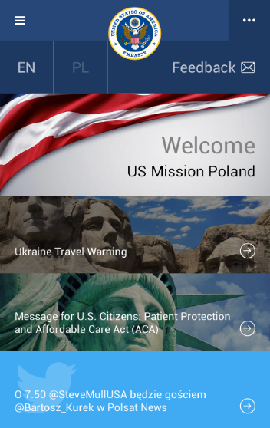

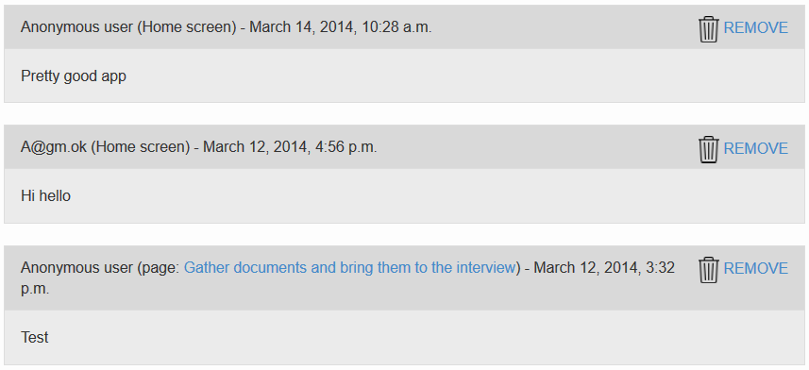

Figure 18 – Feedback button in mobile application (left) and feedback screen in CMI