**Cusco GeoNode: cuscogeonode.state.gov**

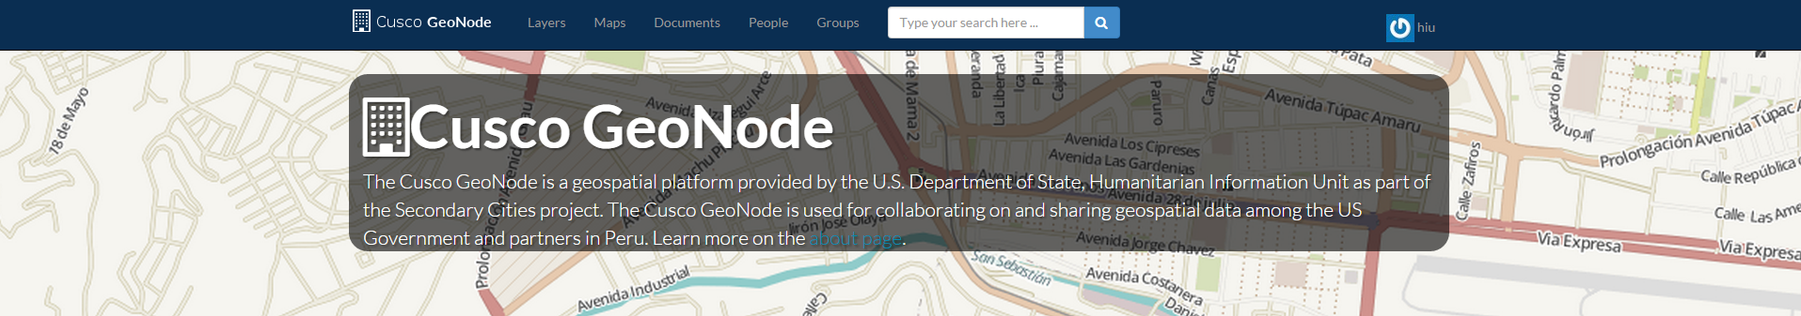

**A GeoNode is an open source platform for data sharing and collaboration.** GeoNodes enable users to upload and visualize geospatial information in a web browser (or download it into their desktop environment) and share that geospatial data among individuals in an organization, or among organizations. Learn more at <http://geonode.org/>. The [Cusco GeoNode](http://cuscogeonode.state.gov) is a geospatial platform provided as part of the [Secondary Cities](http://secondarycities.state.gov/) project. It can host spatial datasets and finished map products (Adobe PDF maps).

**Key Capabilities**

* Web environment for editing and sharing geospatial information among individuals in an organization and across organizations. Can exist as an enterprise “shared-drive” for geospatial information and enable co-production and data publishing. The value of good data is multiplied when others can use it, too.
* Supports variety of network configurations (local, intranet, cloud, or internet).
* Scales to accommodate data from thousands of users. Allow aggregating of geospatial data related to a crisis.
* Standard OGC services, which lead to seamless integration with Google Earth, ArcMap, QGIS, etc.
* Utilization encourages strong data organization, consistent metadata content, and can improve access to data.

|  |  |  |
| --- | --- | --- |
| Uploading Data | Adding Metadata | Finding and Downloading Data |
| - We strongly recommend only uploading shps and finished map products so you can more easily manage your workflow.   * Be sure to select all components of a shapefile. * The default permission settings on the Cusco GeoNode’s upload page allow for any users to view and download data.   - Once uploaded, data can be downloaded in multiple formats.   * Once uploaded, the layer’s page will include metadata about the layer as well as options to download data, edit metadata, and other options. | - Metadata gives context and adds credibility to your data.  - Including metadata enables searching and browsing.  - At minimum, include a descriptive title, date, abstract, keywords, region, and category.  - Information about a data layer’s projection and datum will be uploaded automatically.  - To edit metadata, go to “Edit Layer” on a layer’s page, and select “Edit Metadata.”  - To view metadata, look at the “Info” tab or select “download metadata” on a layer’s page. | - Users can search by ISO category, keywords, date.  - From a layer’s page, you can easily share, rate, and comment on the data.  - On a layers’s page, click “Download Layers” and select the desired format to use it in your workspace.  - On a layer’s page, you can click “Create Map” to visualize and overlay the layer with other data in the Cusco GeoNode and with OpenStreetMap. |

* We **STRONGLY RECOMMEND** using Google Chrome or Mozilla Firefox

**Accounts:**

If you go to <http://cuscogeonode.state.gov> for the first time, you should be prompted to sign in. Check that you are using the appropriate account. User accounts can be set up by requesting a new account to: [HIU_DATA@state.gov](mailto:HIU_DATA@state.gov). If you would like more guidance on how you, your colleagues, or your organization can utilize GeoNode, please contact ________.

**Feedback?**

If you have any suggestions on how to make the GeoNode’s web interface more dynamic or useful to your workflows, please send your suggestions to ______ and we will work to incorporate your feedback!