**Exercise 5: Data Sharing and MetaData – Geonode**

**Lecture:** What is GeoNode?

**Description:** This exercise will introduce you to Geonode – an open source platform for data sharing and collaboration. The [Cusco GeoNode](http://cuscogeonode.state.gov) is a geospatial platform provided by the [U.S. Department of State, Humanitarian Information Unit](https://hiu.state.gov/Pages/Home.aspx) as part of the [Secondary Cities](http://secondarycities.state.gov/) project. Users of the Cusco GeoNode can access uploaded data from all of the world. The Cusco GeoNode can host spatial datasets and finished map products (Adobe PDF maps).

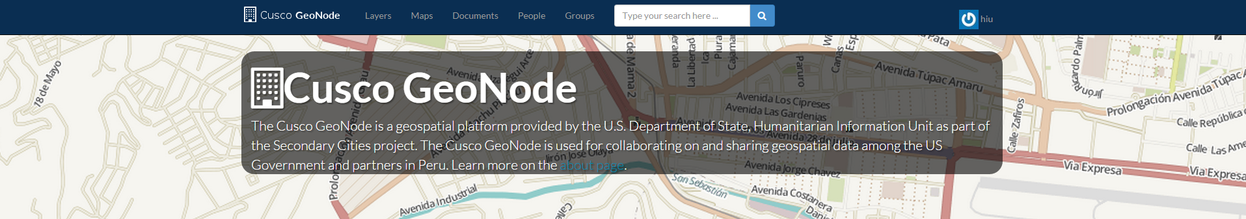

**What is GeoNode?**

GeoNode is a user interface and security wrapper around GeoServer, an open source server for sharing geospatial data, and other common open source GIS software. GeoNode enables users to visualize geospatial information in a web browser or download it into their desktop environment. GeoNode is supported by a large community of developers. Learn more at <http://geonode.org/>, and explore <http://cuscogeonode.state.gov>.

**Key Capabilities**

· Web environment for editing and sharing geospatial information among individuals in an organization and across organizations.

· Supports variety of network configurations (local, intranet, cloud, or internet).

· Scales to accommodate data from thousands of users.

· Standard OGC services, which lead to seamless integration with Google Earth, ArcMap, QGIS, and other common GIS applications.

**Use Cases**

· Co-production and data publishing

· Aggregating geospatial data related to a crisis

· Enterprise “Shared-Drive” for geospatial information

· Many more…

**Objective:** In this exercise, users will learn how to upload, find, and download uploaded data and documents. Students will learn about metadata and best practices for data sharing.

**Skills:** Data organization, metadata content, data access issues

**Data:** Peru_OSMExtract_Landuse_20150505.shp

These data are from OpenStreetMap Peru. OpenStreetMap is a community of mappers using local knowledge to map the world. The data is free and can be used for any purpose. Check out OSM: <https://www.openstreetmap.org/about>

Redhum-PE-Mapa_de_Afectacion_Loreto-20150527-CV-16495.pdf

Source: <http://reliefweb.int/map/peru/loreto-distritos-con-declaratoria-de-emergencia-vigente-190515>.

**Before we start..**

Teams will need a user account. We will do this in class. But user accounts can be set up by contacting the Humanitarian information Unit at [HIU_DATA@state.gov](mailto:HIU_DATA@state.gov), to request a new user account.

HIU will send you an email with your new user and password.

If you go to <http://cuscogeonode.state.gov> for the first time, you should be immediately prompted to sign in. If another user has already signed in, sign them out, and then login yourself.

**Sign in button** is in the top-right corner.

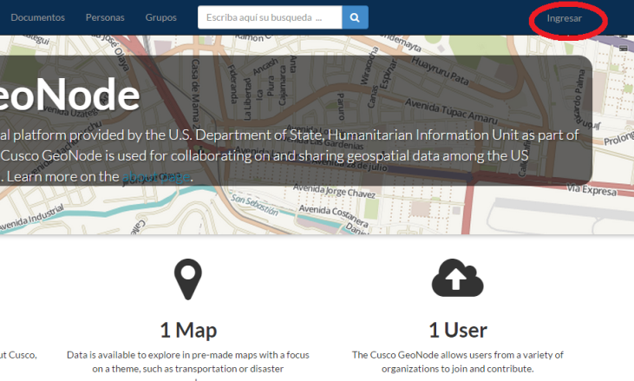

We **STRONGLY RECOMMEND**, using Google Chrome or Mozilla Firefox

**Step 1: Uploading Data**

After creating geospatial data via desktop analysis, field data collection, or imagery analysis, it is important to share the data for other to use. The value of good data is multiplied when others can use it, too.

Upload data to the Cusco GeoNode (<http://cuscogeonode.state.gov>) to share with others. You can upload shapefiles, CSV, Google Earth KML, and GeoJSON to the Cusco GeoNode. We **STRONGLY RECOMMEND** only uploading shapefiles so you can more easily manage your workflow. Once uploaded, data can be downloaded in multiple formats.

Go to: <http://cuscogeonode.state.gov>

We will use the example file “Peru_OSMExtract_Landuse_20150505.shp” for this exercise. From the home page, click on the **LAYERS** in the header.

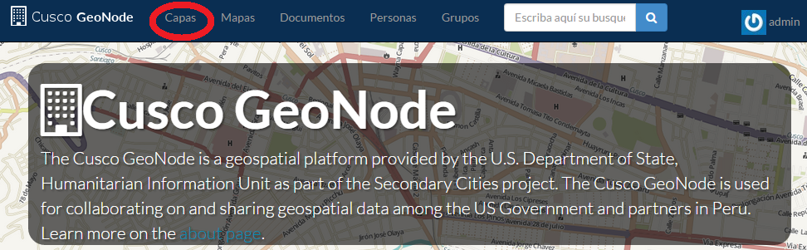

On the **Layers** page, click on the **Upload Layers** button.

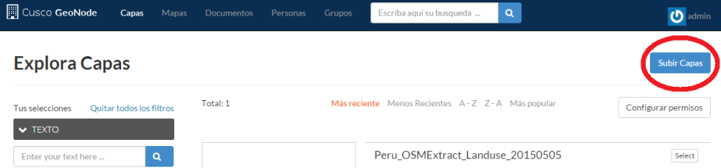

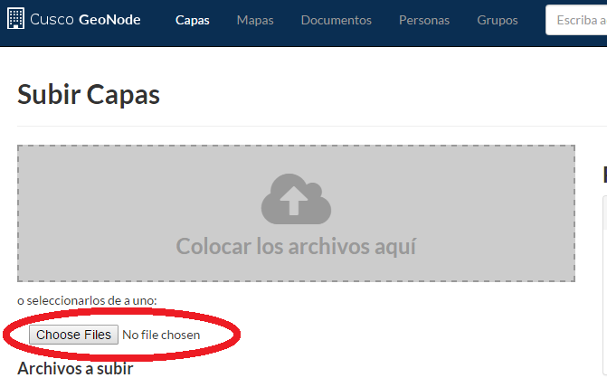On the **Upload Layers** page, click on **Browse… no files selected** or **Choose Files No file chosen**. You can upload one shapefile at a time. Select all the components of a shapefile to upload (.shp, .shx, .dbf, .prj, .cpg, etc.). **IMPORTANT**: Be sure to select all files associated with a shapefile.

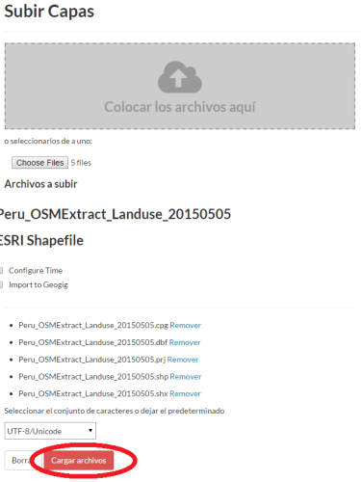

Once all the files are listed, click **Upload Files**.

Once the upload starts, you’ll see a progress bar.

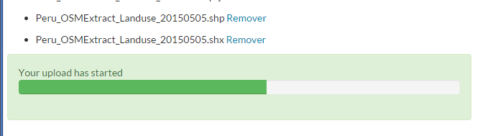

After the upload is complete click **Edit Metadata**. Editing metadata is important to enable searching and browsing.

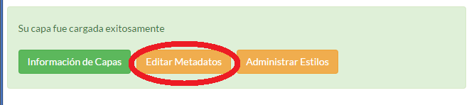

At minimum, fill in relevant metadata for title, date, description, keywords, and category. Be sure to include information about the data’s projection and datum. *Where would you find that information?*

For example, for the landuse polygons, select category **Planning Cadastre** and add keywords: **OSM**, **ex5**, **workshop**, and **landuse**. Once done, click **Update**.

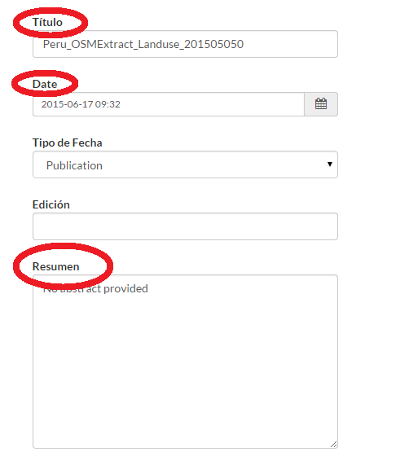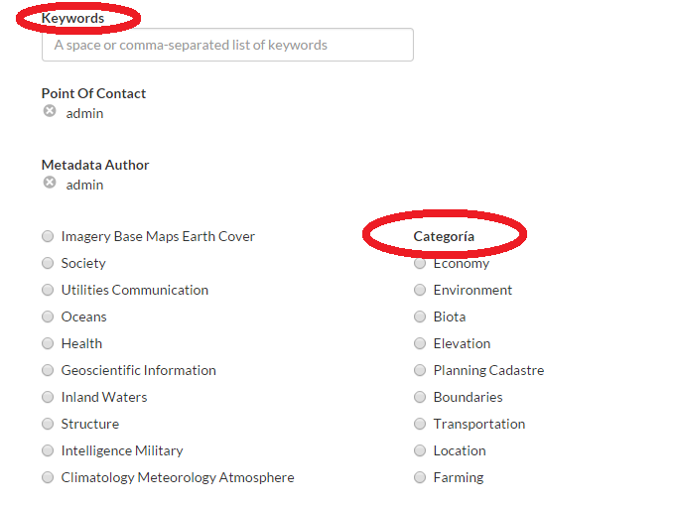**Step 2: Uploading Documents**

The Cusco GeoNode can be used to share documents, such as finished PDF map products. The process for uploading documents to the Cusco GeoNode is very similar to uploading shapefiles. The map products uploaded to GeoNode can be tagged via the same metadata fields as used for geospatial data.

Go to **Documents** in the header, then upload documents, select the file to upload, and then click **Upload**. Edit the relevant metadata (category, keywords) as you did for shapefiles. There is an example file “Redhum-PE-Mapa_de_Afectacion_Loreto-20150527-CV-16495.pdf”.

**Step 3: Finding Data and Documents**

The Cusco GeoNode has a rich metadata system that allows users to easily search and browse for data and documents.

Users can search by ISO category, keywords, and date. If you click **Layers** or **Documents** in the header, you will be shown to the search page for each. Additionally, you can use the global search box in the header to search over everything.



On each search page, the filters on the left side can be used to filter by category, keywords, and date range. The filters will adjust what is shown in the list on the right. Click on the thumbnail or name to go to the layer.

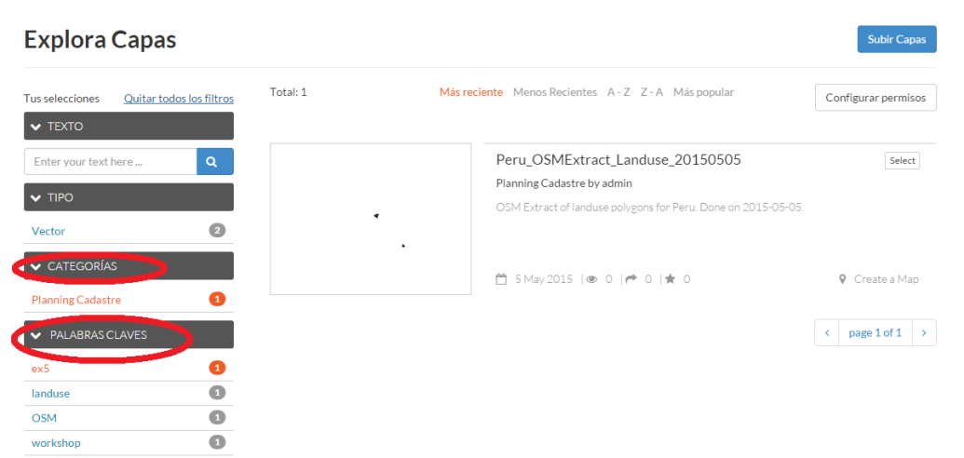

The layer’s page will include metadata about the layer as well as options to download data, edit metadata, and other options.

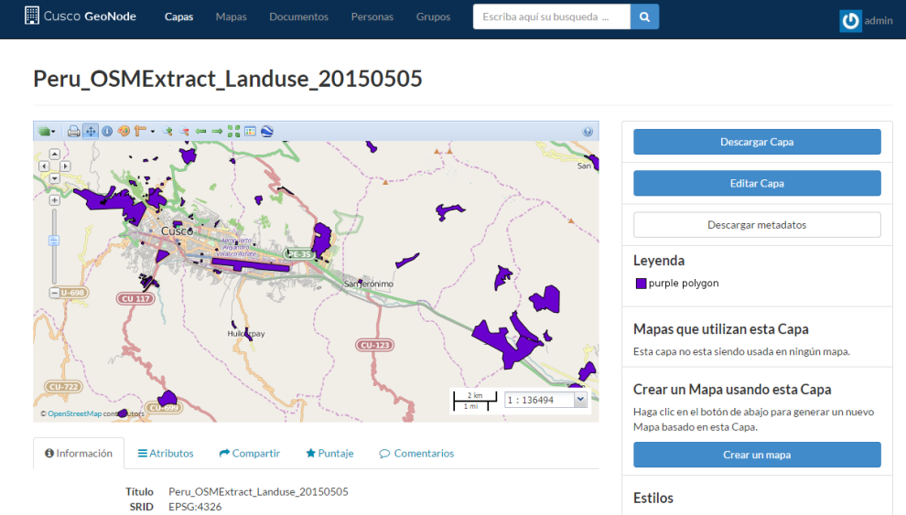

**Step 4: Downloading Data**

The Cusco GeoNode supports most geospatial data formats, including zipped shapefile, Google Earth KML, and Excel. Once a user uploads a layer, other users can download the data in multiple formats. On a layers’s page, click **Download Layers**. This will display a popup. Click on the format you want (most likely shapefile) and it will start the download. Once the data is downloaded, move it to your workspace.

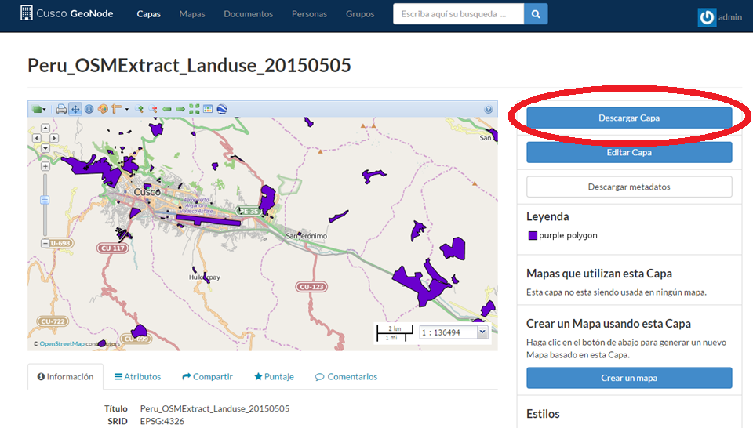

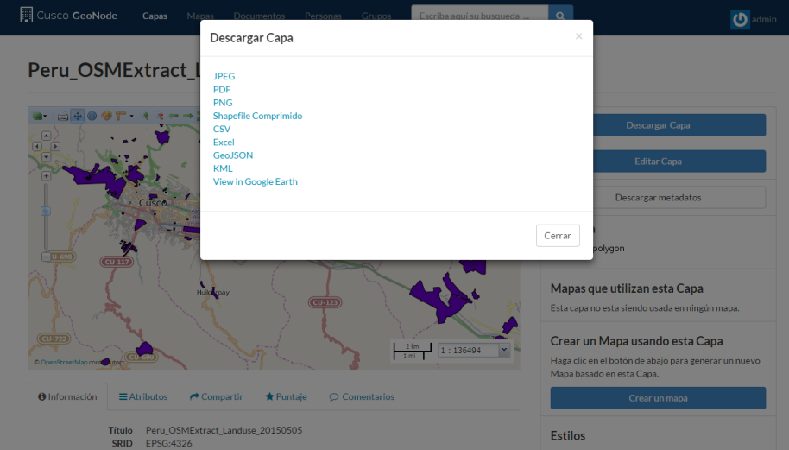

**Step 5: Downloading Documents**

The Cusco GeoNode allows users to download uploaded documents in their original format. Unlike the geospatial data, it does not convert between formats. The download process is similar to geospatial data. On a document page. click the **Download Document** button to begin the download process.