**“MapGive” Campaign: Social Media Toolkit**

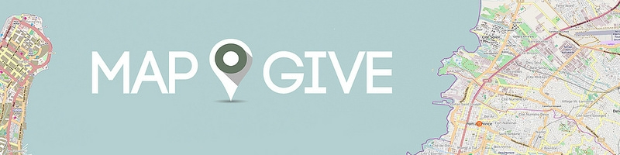

Table of Contents

Introduction

Campaign Website

Accounts to follow and reference

Topline Messages  
General Messages: Twitter **I**  Facebook

Shareables: Flickr **I** YouTube

Additional Resources

**Introduction**

The Humanitarian Information Unit (HIU) is engaging potential new volunteer mappers by explaining the value of creating open map data and how easy it is to contribute. The “MapGive” campaign launched on March 2014. MapGive aims to increase the number of mapping volunteers by lowering the barriers for entry to mapping. Through the website [mapgive.state.gov](http://www.mapgive.state.gov/), MapGive provides training to learn how to map and directs volunteers to mapping tasks with imagery provided by the HIU’s Imagery to the Crowd project (IttC). Additionally, this campaign will serve as a case study for how to turn an international social media audience into a global community of activists.

**We’re asking you to help us spread the word and grow the community of volunteer mappers!** Please consider sharing the messages below with your social media network.

For questions or concerns, please contact the [Humanitarian Information Unit](mailto:HIU_Info@state.gov).

**Campaign Website**

Please direct all traffic to the MapGive website: [MapGive.state.gov](http://www.mapgive.state.gov/)

**Accounts to follow and reference**

[@MapGive](http://www.twitter.com/mapgive)

**Topline Messages**

* Mapping is important for humanitarian and development efforts, and for preparedness, not just in a disaster.
* Anyone with an internet connection can be a volunteer mapper in OpenStreetMap, and you do NOT need to be located in or have specific knowledge of the place you are mapping.
* With crowdsourcing, every effort makes a big difference. You can contribute 20 minutes or an hour to creating open map data.

**General Messages**

**Twitter**

You can help map places you’ve never been before! Learn to #MapGive <http://goo.gl/M93H8l>

Digital humanitarians #MapGive online to give others data they need to build a more sustainable future. <http://goo.gl/SkKhPk>

Join the movement: #MapGive in 3 steps! Anyone with a computer & an Internet connection can help <http://goo.gl/twjn4T>

Curious about how crowdsourced open mapping works? #MapGive explains <http://goo.gl/SkKhPk>

What's the difference between satellite imagery, map data, and the map itself? #MapGive explains <http://goo.gl/eoxBBj>

.@hotosm mappers helped after the 2013 typhoon in the Philippines. Join them. Learn to #MapGive <http://goo.gl/twjn4T>

Volunteer mappers helped Haiti 4 years ago. Now they #MapGive to help before disasters. Join them: <http://goo.gl/SkKhPk>

How did Kenya’s @mapkibera use @openstreetmap to #MapGive & bring change to the community? <http://goo.gl/inELrv>

**Facebook**

#MapGive makes it easy for new volunteers to learn to map. Help give others the data they need to build a more sustainable future. <http://goo.gl/SkKhPk>

Do you have a computer and an Internet connection? Help create open map data! No special skills are needed. Learn how you can help humanitarian and development efforts through #MapGive. <http://goo.gl/twjn4T>

What's the difference between satellite imagery, map data, and the map itself? #MapGive explains <http://goo.gl/eoxBBj>

What's an important cause you've contributed to? The World Bank is leading a crowdsourced mapping effort to help the earthquake-prone Kathmandu Valley in Nepal. With more than 500,000 buildings left to map, they still need your help! Become a digital humanitarian with the #MapGive Campaign. <http://goo.gl/yWz2eU>

Typhoon Haiyan's destruction in the Philippines continues to affect millions, but volunteers like you are still helping save lives! Read how one volunteer made a difference from thousands of miles away using only his laptop. How could your community benefit from open source mapping? <http://goo.gl/wMTggV>

Visit #MapGive to learn how a map helps communities, like Kibera in Nairobi, Kenya, develop better safety for women and access to education. <http://goo.gl/inELrv>

**Shareables: Photos and Video**

**Flickr: MapGive**

# <http://www.flickr.com/photos/mapgive>

**YouTube:**

# <http://www.youtube.com/mapgive>

# Additional Resources

[Humanitarian Information Unit’s Imagery to the Crowd](http://mapgive.state.gov/ittc/)

[Humanitarian OpenStreetMap Team](http://hot.openstreetmap.org/about)

[OpenStreetMap](http://www.openstreetmap.org/#map=18/32.58471/-117.11776)