EDMM Metamodel
This document summarizes the EDMM (Essential Deployment Metamodel) metamodel and provides short definitions of the core entities.

Metamodel diagram
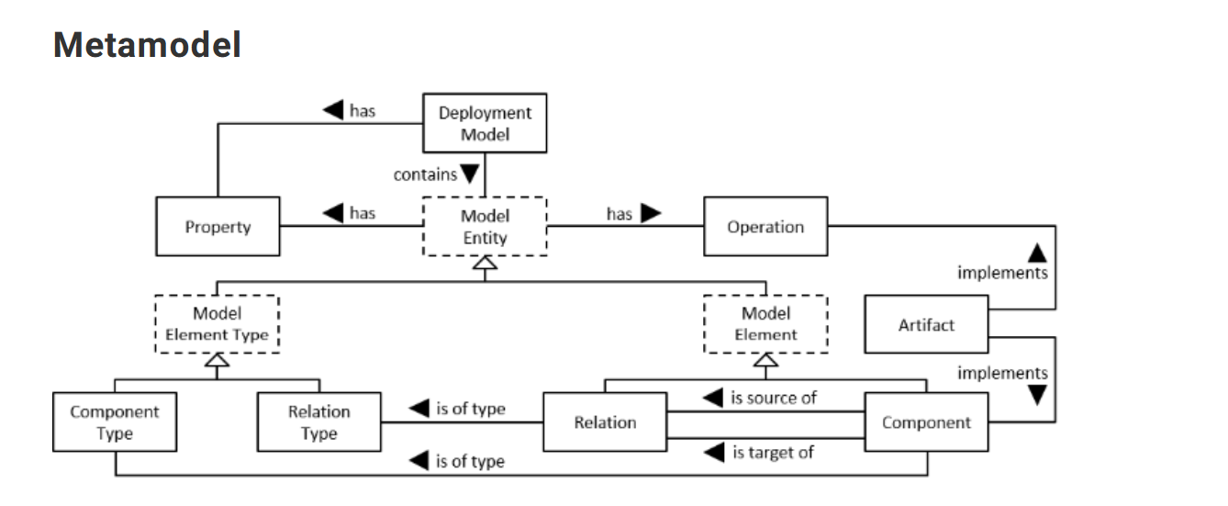

Core entity definitions
Component: A component is a physical, functional, or logical unit of an application.
Component Type: A component type is a reusable entity that specifies the semantics of a component that has this type assigned.
Relation: A relation is a directed physical, functional, or logical dependency between exactly two components.
Relation Type: A relation type is a reusable entity that specifies the semantics of a relation that has this type assigned.
Operation: An operation is an executable procedure performed to manage a component or relation described in the deployment model.
Property: A property describes the current state or prescribes the desired target state or configuration of a component or relation.
Artifact: An artifact implements a component or operation and is required for their execution.
Deployment Model: A deployment model describes declaratively the desired target state of an application including all necessary model entities.

How this maps to the EDMM YAML
In EDMM YAML, the deployment model is represented via top-level sections such as component_types, relation_types, components, and relations. Properties and operations are attached to either types or concrete assignments. Artifacts implement components and operations.

