Image Security & Workload Security
1. Overview

This document explains how we ensure container image security and secure workload practices during deployment in staging and production environments.

The goal is to:

* Prevent vulnerabilities in container images
* Secure running workloads in Kubernetes
* Ensure compliance before release

2. Image Security Process

Step 1: Image Build & Tagging

Developers build Docker images for services
Use proper version tagging:
service-name:version (e.g., crm:3.14.4)

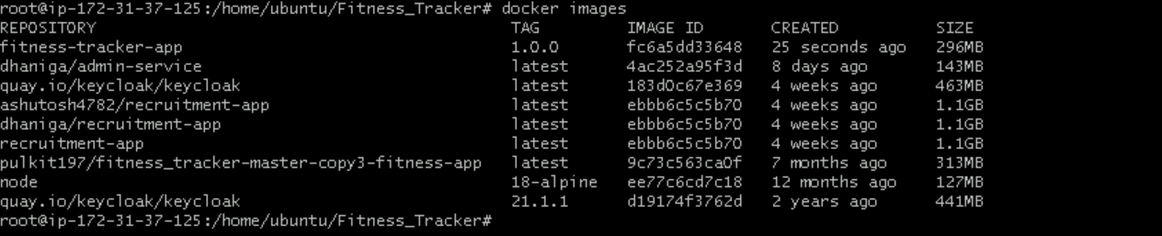

Step 2: Image Scanning

Before pushing to registry:
Scan images using tools like:
Trivy
Clair
Anchore

Check for:
* Critical vulnerabilities
* High CVEs
* Outdated packages
Only approved images should be used

Step 3: Push to Secure Registry
* Push images to private registry (ECR / Docker Hub Private / ACR)
* Ensure:
* Authentication enabled
* No public access
Example:
docker push repo/service:3.14.4

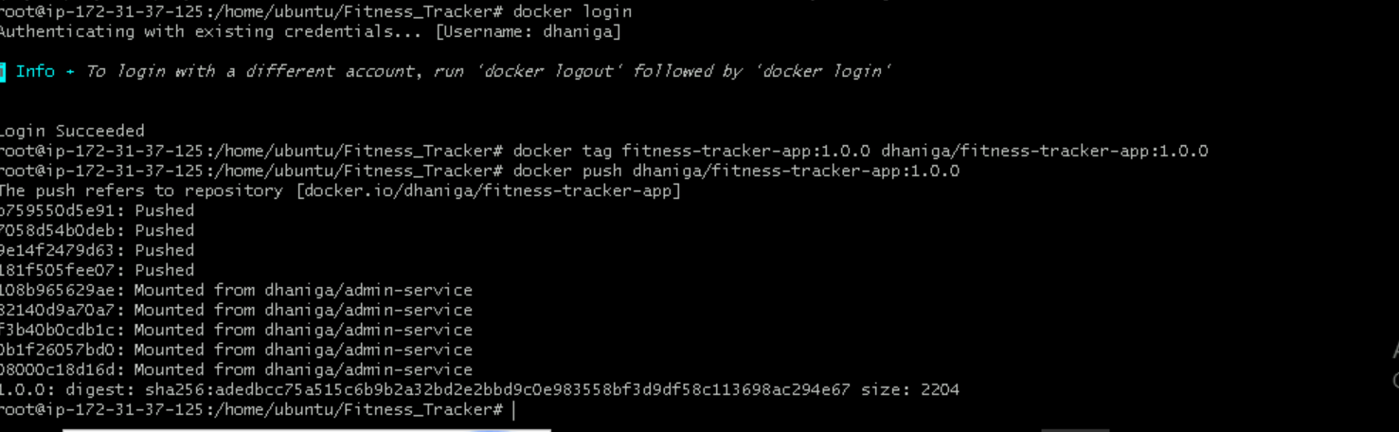

Step 4: Update Image in values.yaml

Clone the repository:
git clone <repo-url>

* Update image tags in `values.yaml`:

Example:
image:
repository: repo/crm
tag: 3.14.4

* Apply changes for:

* CRM services
* Platform services
* Notification services
* Telephony services

3. Workload Security Practices
Step 1: Secure Deployment Configuration

In deployment.yaml:
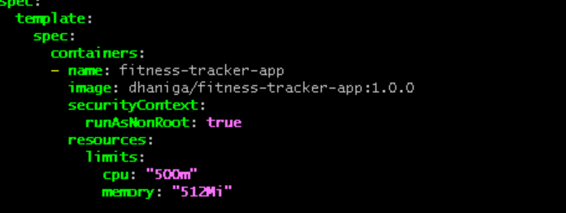

Step 2: Use RBAC (Role-Based Access Control)
* Define roles and permissions
* Avoid giving cluster-admin access

Example:
* Read-only access for monitoring
* Limited access for services
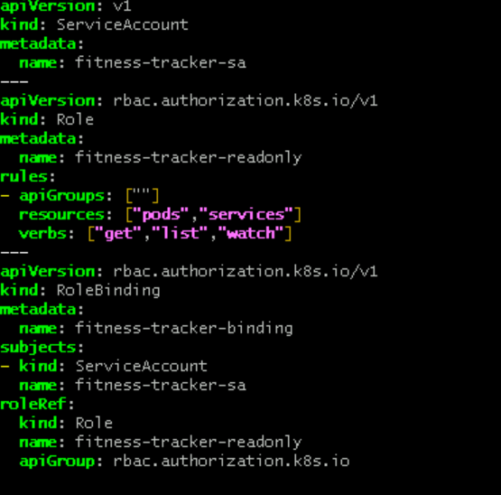

Step 3: Secrets Management
* Do NOT hardcode secrets in code
* Use:
* Kubernetes Secrets
* External secret managers

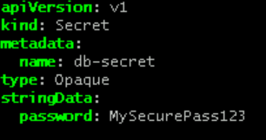
Step 4: Network Security

* Use Network Policies to restrict traffic
* Allow only required communication between services
Example:

* Frontend → Backend
* External → Internal DB
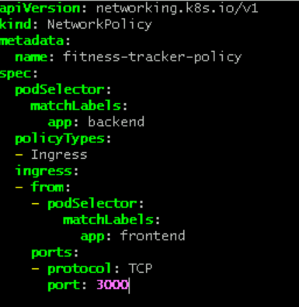

Step 5: Enable Pod Security
* Use Pod Security Standards:
* Restricted policy
* Disable privilege escalation:
securityContext:
allowPrivilegeEscalation: false
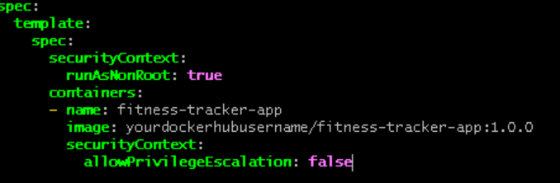

4. Adding New Secure Service
Step 1: Clone Repository

git clone <staging-repo>

Step 2: Add Service in values.yaml

Under services section:

* Add:

* image
* port
* replica count
* environment variables

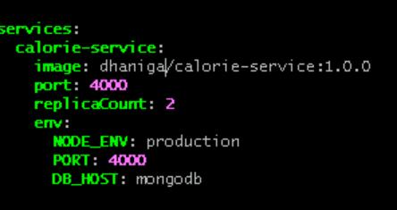

Step 3: Configure Security

Ensure:

* Non-root user
* Secrets used
* Resource limits defined

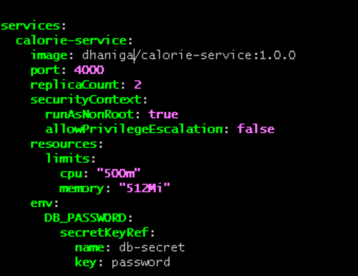

Step 4: Update Helm Charts

* Add deployment.yaml in templates
* Follow existing structure
* Update chart version

5. Deployment Process

Step 1: Create Branch
git checkout -b staging-3.14.4
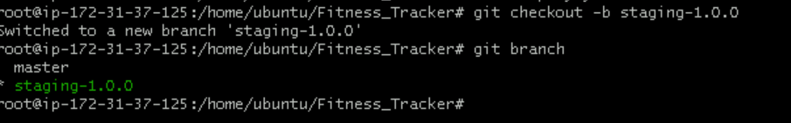

Step 2: Commit Changes

git add .
git commit -m "Updated secure image and workload configs"
git push origin staging-3.14.4

Step 3: Raise PR

* Create PR to staging branch
* Get approval from:

* Developers
* Managers

Step 4: ArgoCD Sync

* After merge:

* ArgoCD automatically syncs
* Deploys to cluster

Step 5: Verification

Check:

* Pods are running
* No security violations
* Logs are clean
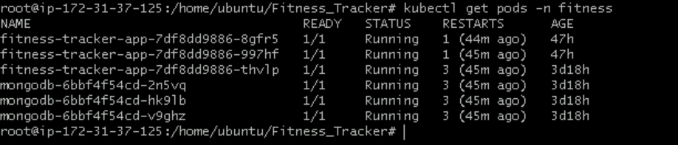

6. Important Notes

* Never deploy unscanned images
* Always test in staging before production
* Follow RBAC strictly
* Avoid exposing sensitive services publicly
* Ensure proper YAML indentation

7. Conclusion

By following these steps:

* We ensure secure container images
* We protect Kubernetes workloads
* We maintain safe production deployments

