Kubernetes Networking Demonstration Guide

1. Kubernetes Network Model Demonstration

Concept Overview
# The Kubernetes network model has 4 key requirements:
# 1. Pods can communicate with all other pods without NAT
# 2. Nodes can communicate with all pods without NAT
# 3. The IP a pod sees itself as is the same IP others see it as
# 4. Container-to-container communication within a pod via localhost

Demo: Pod-to-Pod Communication
# Create two demo pods
# pod1.yaml
apiVersion: v1
kind: Pod
metadata:
name: pod1
labels:
app: demo
spec:
containers:
- name: nginx
image: nginx
ports:
- containerPort: 80
# pod2.yaml
apiVersion: v1
kind: Pod
metadata:
name: pod2
spec:
containers:
- name: busybox
image: busybox
command: ['sh', '-c', 'sleep 3600']
# Apply the pods
kubectl apply -f pod1.yaml
kubectl apply -f pod2.yaml

# Get pod IPs
kubectl get pods -o wide
# Test connectivity from pod2 to pod1
kubectl exec -it pod2 -- wget -qO- <POD1_IP>
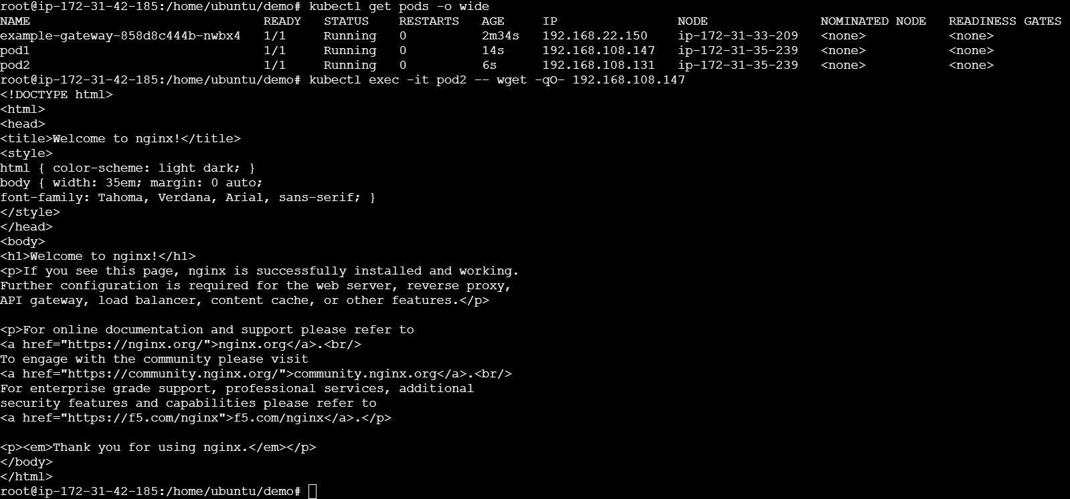

2. CNI Plugins Demonstration

Check Current CNI Plugin
# Check which CNI is installed
kubectl get pods -n kube-system | grep -E 'calico|flannel|weave|cilium'
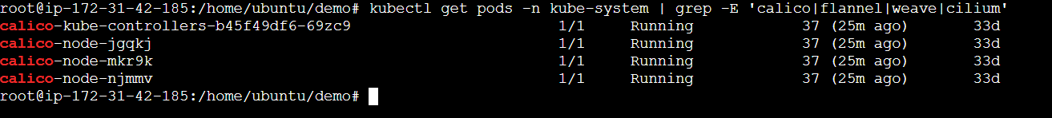
# Check CNI configuration
ls /etc/cni/net.d/
# View CNI config (example)
cat /etc/cni/net.d/10-calico.conflist
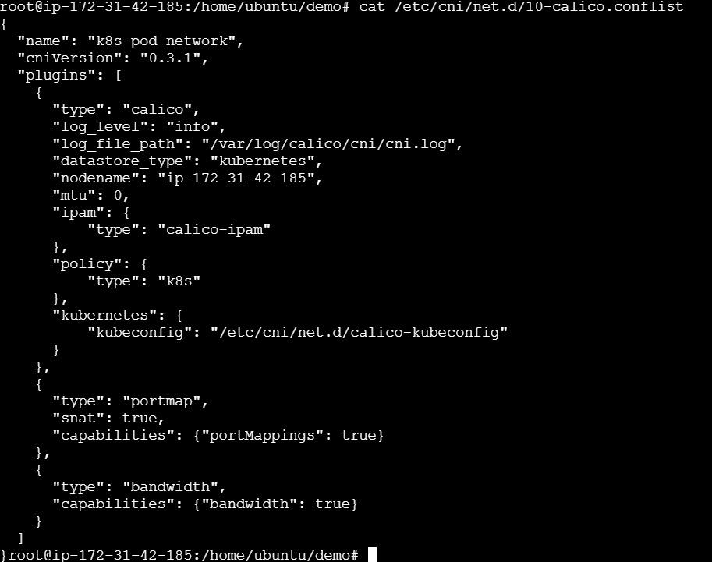

Install Calico CNI (Example)
# Download Calico manifest
curl https://raw.githubusercontent.com/projectcalico/calico/v3.26.1/manifests/calico.yaml -O
# Apply Calico
kubectl apply -f calico.yaml
# Verify installation
kubectl get pods -n kube-system -l k8s-app=calico-node
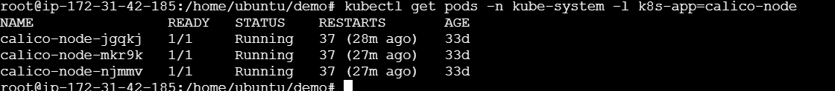

3. DNS in Kubernetes Demonstration

CoreDNS Exploration
# Check CoreDNS pods
kubectl get pods -n kube-system -l k8s-app=kube-dns
# View CoreDNS configuration
kubectl get configmap coredns -n kube-system -o yaml
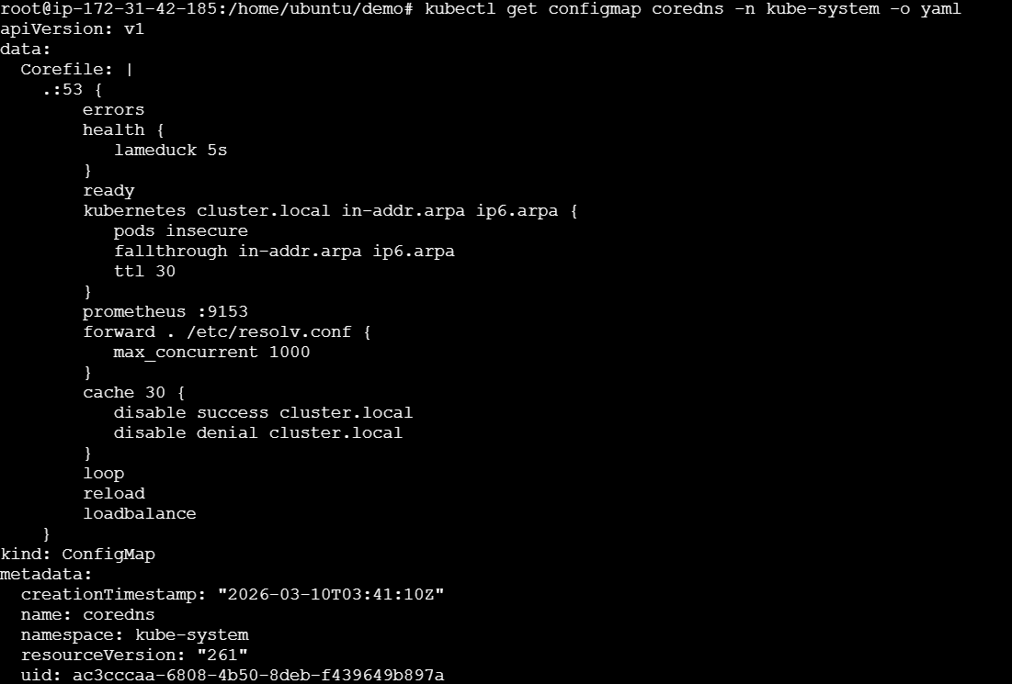
# Check DNS service
kubectl get svc -n kube-system kube-dns

DNS Resolution Demo
# Create a service
# demo-service.yaml
apiVersion: v1
kind: Service
metadata:
name: my-service
namespace: default
spec:
selector:
app: demo
ports:
- port: 80
targetPort: 80
# Apply service
kubectl apply -f demo-service.yaml
# Create a test pod
kubectl run dnstest --image=busybox --restart=Never -- sleep 3600
# Test DNS resolution
kubectl exec -it dnstest -- nslookup my-service
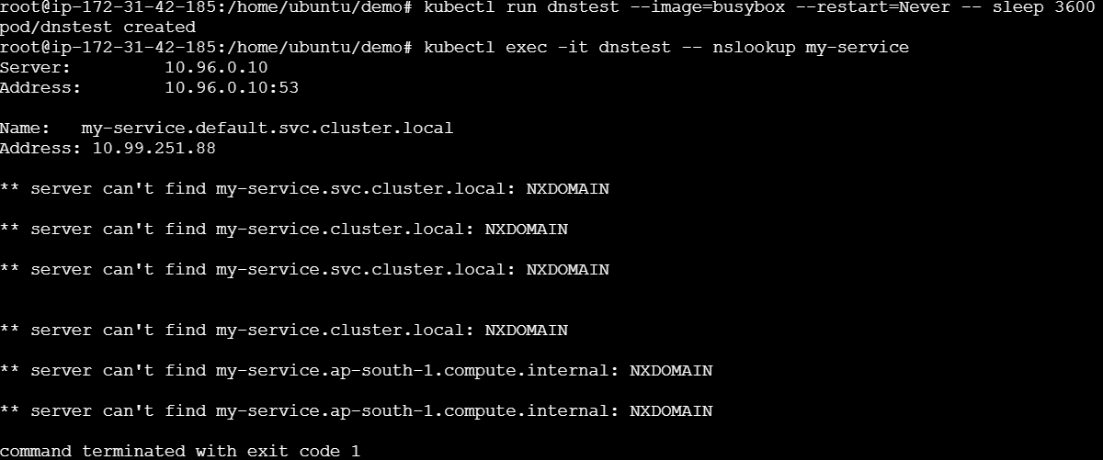

kubectl exec -it dnstest -- nslookup my-service.default
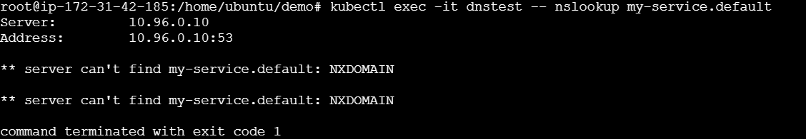
kubectl exec -it dnstest -- nslookup my-service.default.svc.cluster.local
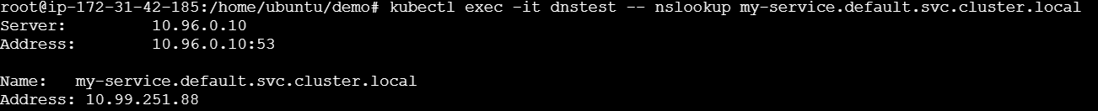
# Test external DNS
kubectl exec -it dnstest -- nslookup google.com
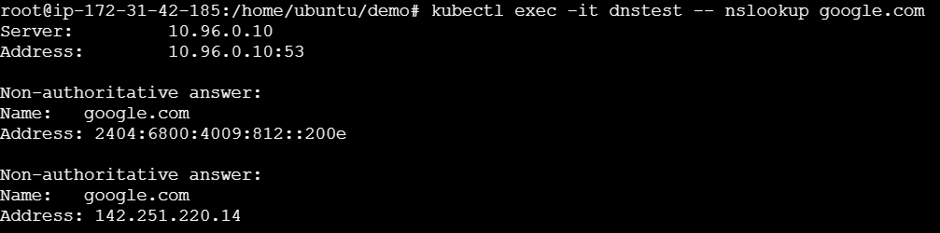
# Check DNS configuration in pod
kubectl exec -it dnstest -- cat /etc/resolv.conf

DNS Debugging
# Deploy a debug pod with DNS tools
kubectl apply -f - <<EOF
apiVersion: v1
kind: Pod
metadata:
name: dnsutils
spec:
containers:
- name: dnsutils
image: registry.k8s.io/e2e-test-images/jessie-dnsutils:1.3
command:
- sleep
- "3600"
EOF

# Use dig for detailed DNS queries
kubectl exec -it dnsutils -- dig my-service.default.svc.cluster.local
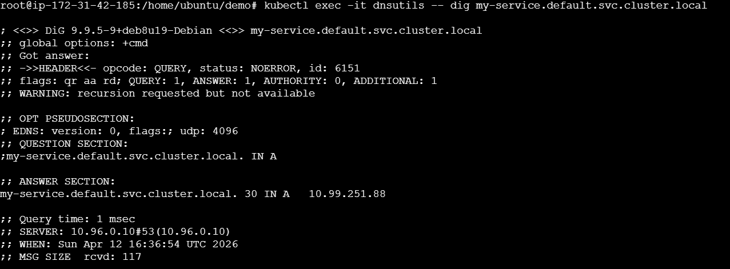
kubectl exec -it dnsutils -- nslookup kubernetes.default
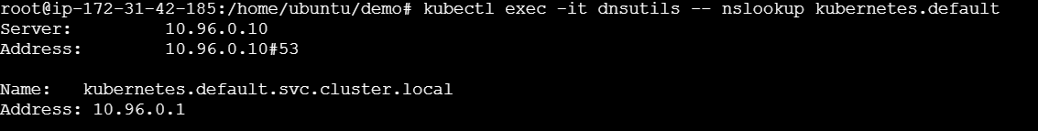

4. Network Policies Demonstration

Complete Demo Setup
# Create namespaces
apiVersion: v1
kind: Namespace
metadata:
name: production
---
apiVersion: v1
kind: Namespace
metadata:
name: development
---
# Backend pod
apiVersion: v1
kind: Pod
metadata:
name: backend
namespace: production
labels:
app: backend
tier: api
spec:
containers:
- name: nginx
image: nginx
ports:
- containerPort: 80
---
# Frontend pod
apiVersion: v1
kind: Pod
metadata:
name: frontend
namespace: production
labels:
app: frontend
tier: web
spec:
containers:
- name: busybox
image: busybox
command: ['sh', '-c', 'sleep 3600']
---
# Test pod (unauthorized)
apiVersion: v1
kind: Pod
metadata:
name: test-pod
namespace: production
labels:
app: test
spec:
containers:
- name: busybox
image: busybox
command: ['sh', '-c', 'sleep 3600']
---
# Network Policy - Allow only frontend to backend
apiVersion: networking.k8s.io/v1
kind: NetworkPolicy
metadata:
name: backend-policy
namespace: production
spec:
podSelector:
matchLabels:
app: backend
policyTypes:
- Ingress
ingress:
- from:
- podSelector:
matchLabels:
app: frontend
ports:
- protocol: TCP
port: 80

Testing Network Policies
# Apply the complete demo
kubectl apply -f network-policy-demo.yaml
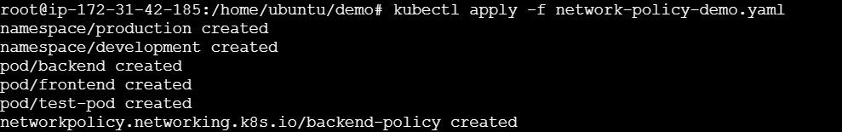
# Get all pods and their IPs
kubectl get pods -n production -o wide

# Test 1: Frontend to Backend (Should work)
kubectl exec -n production frontend -- wget -qO- --timeout=2 <BACKEND_IP>
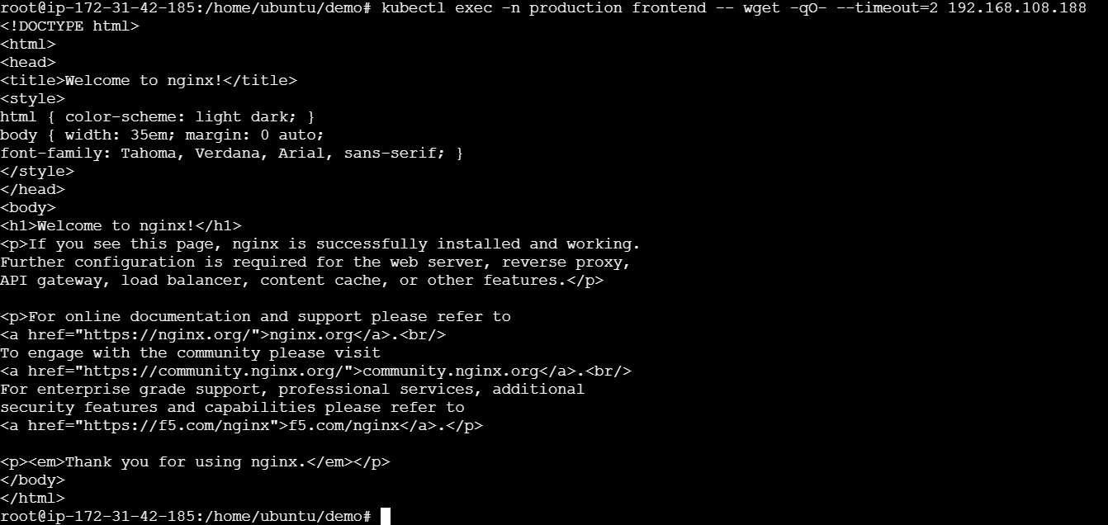
# Test 2: Test-pod to Backend (Should fail)
kubectl exec -n production test-pod -- wget -qO- --timeout=2 <BACKEND_IP>
# Check network policies
kubectl get networkpolicies -n production
kubectl describe networkpolicy backend-policy -n production
