[2006-5-14 16:36 "/Graph1" (2453869)]
Data: Data1_B
Model: Exp3P1
Equation:
y =a*exp(b/(x+c))
Weighting:
y No weighting

Chi^2/DoF R^2
----------------------------------------
83.55086 0.99973
----------------------------------------

Parameter Value Error
----------------------------------------
a 0.02085 0.00125
b 3423.16655 18.58807
c 273.15 0
----------------------------------------

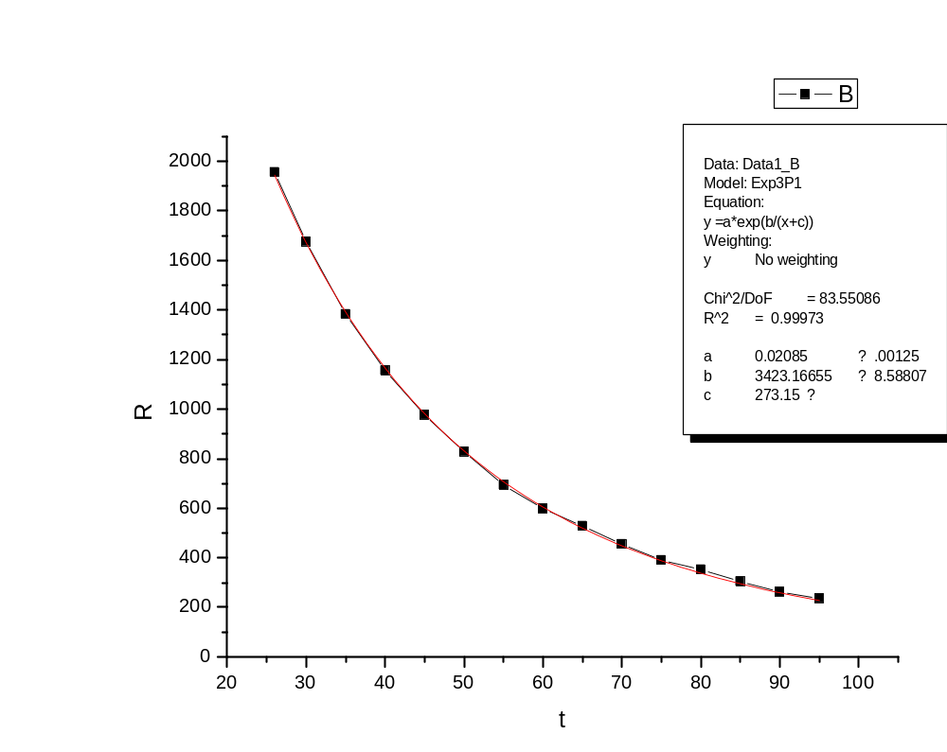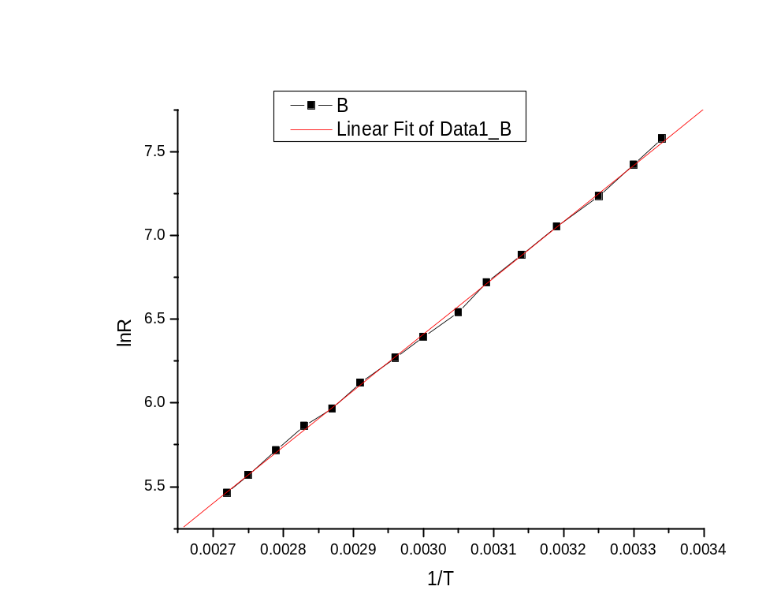

Linear Regression for Data1_B:

Y = A + B * X

Parameter Value Error
------------------------------------------------------------
A -3.67822 0.06761
B 3362.86495 22.39396
------------------------------------------------------------

R SD N P
------------------------------------------------------------
0.99971 0.01694 15 <0.0001
------------------------------------------------------------

[2006-5-14 16:45 "/Graph1" (2453869)]

