Hi professor

This week I have combined the launch optical program with our receiver optical control program .It now looks loke that ,we can choose Interaction Region (IR) or receiver antenna as input parameters ,than we can get the correspond position of IR and antenna position and also the launch mirror position .we can set the position of all our optical system in computer mode ,which only need click the move2position if we satisfied with the calculated results, or we can also control the position manually.

As for mode-conversion program, I have finished the 1 Dimensional Full Wave code (1DFW) and I will combined the 1DFW with Ray Tracing code, where the ray tracing code using to calculated the main path of EMW and the 1DFW using to calculate the polarization in the wave path . The motivation for doing this is to analysis the effect of the sheared magnetic field to our high-k scattering polarization and TIRTIP system. I have tested the code with classical physics, such as faraday rotation, X-mode, O-mode and Cutoff .Since 3D simulation require too much computational source in TOKAMAK size problem ,1d simulation would greatly reduce the computation time while can retain the main physical characteristics which we are interested in. I have attached the main results in the ppt, but I am sorry it hasn’t be finished ,it just look like draft.

Have a good weekend!

Gpt

Hi Professor,

This week, I combined the launch optical program with our receiver optical control program. It now allows us to choose either the Interaction Region (IR) or the receiver antenna as input parameters, after which we can obtain the corresponding positions of the IR, antenna, and launch mirror. We can set the positions of our entire optical system in computer mode by simply clicking "Move to Position" if we are satisfied with the calculated results, or we can control the positions manually.

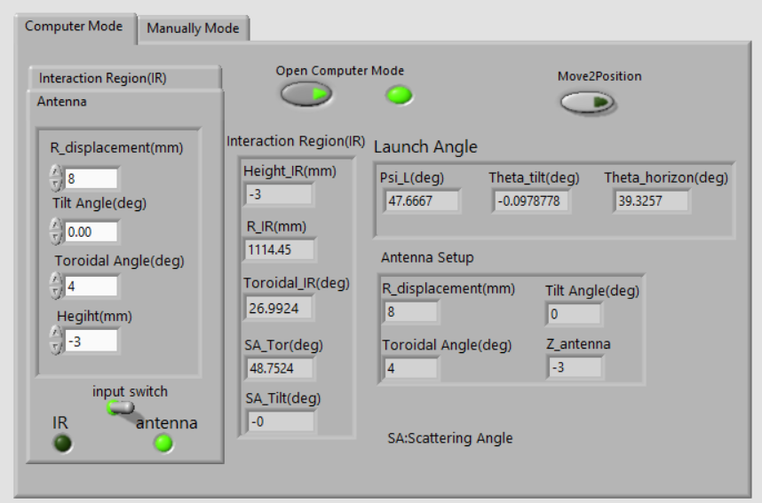

Regarding the mode-conversion program, I have completed the 1-Dimensional Full Wave (1DFW) code and plan to combine it with the Ray Tracing code. The Ray Tracing code calculates the main path of the electromagnetic wave (EMW), while the 1DFW code is used to calculate the polarization along the wave path. The motivation for this is to analyze the effect of the sheared magnetic field on our high-k scattering polarization and TIRTIP system. I have tested the code with classical physics scenarios, such as Faraday rotation, X-mode, O-mode, and Cutoff. Since 3D simulations require significant computational resources for problems of TOKAMAK size, 1D simulations can greatly reduce computation time while retaining the main physical characteristics that interest us.

I have attached the main results in the PowerPoint presentation. However, I apologize as it is still in draft form and not yet complete.

Have a good weekend!

Best regards,  
Xinhang Xu