Hi professor

This week I try to add the statue check function into our control program. After talking with Yilun on zoom we both feel it is important to add a checking status page on the side of control program to display all motors current position. However, the progress is not going fluently. After modifying the program, I found that the computer became very sluggish, I will figure out the reason and work with Jon, maybe change the structure of the program or other method.

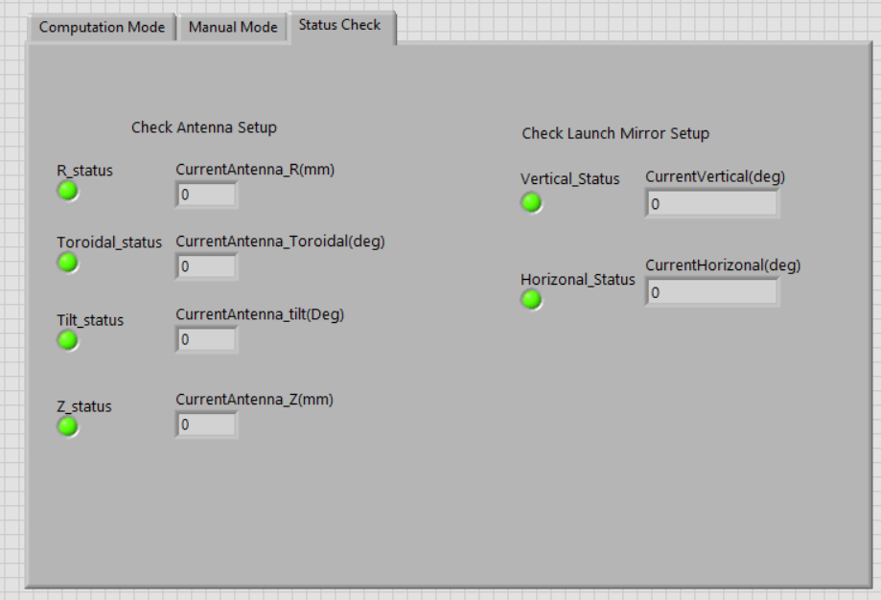

Besides, I am also going to combine the ray-tracing code with polarization analysis, I will write word about how to achieve that in the next week. and if time allow I will give some real polarization analysis. Yilun give me some example to try, like the polarization of DBS in BEST tokamak , I also going to simulate the one-dimensional full wave analysis using follow equations:

This equation can help us to simulate wave package propagation in the plasma, while cold plasma dielectric tensor only can be used in one frequency wave simulation

GPT

This week, I tried to add the status check function to our control program. After discussing it with Yilun on Zoom, we both agreed that it is important to include a status checking page on the side of the control program to display the current positions of all motors. However, progress has not been smooth. After modifying the program, I noticed that the computer became very sluggish. I will figure out the reason and work with Jon to address this, possibly by changing the program's structure.



Additionally, I am planning to combine the ray-tracing code with polarization analysis. I will give a word about how to achieve that next week, and if everything goes well, I will perform some real polarization analysis. Yilun gave me some examples to try, such as the polarization of DBS in the BEST tokamak. I am also going to simulate the one-dimensional full-wave analysis using the following equations:

This equation can help us simulate wave packet propagation in the plasma, while the cold plasma dielectric tensor can only be used for single-frequency wave simulations.