Hi Professor

This week I have one good news and one bad news. Good news is we can run the Formic acid laser and find the best position where it has maximum output power, bad news is the CO2 power supply is out of order, where the inductance in power supply burned and emits stink smell again.

After realigning laser path ,The formic acid laser could reach to approximately 40mW , The beam intensity was measured along the length of the cavity.distance from peak to peak is about half of wavelength (432um).the beam profile with a lens in front of formic acid windows looks like figure 2,it is not a perfect guass beam ,still need improve the beam quality .however things are not going as well ,the power supply get trouble again.

In order to fix the problem ,We swap the old CO2 laser with the new CO2 laser,combined with Power supply .and realignment laser optical .than we could continue optimize laser profile and measure the basic parameters. The detail testing log has been uploaded on UCDbox at

https://app.box.com/s/jalawhqed1nu62nvllzvz42pfxcfq5do



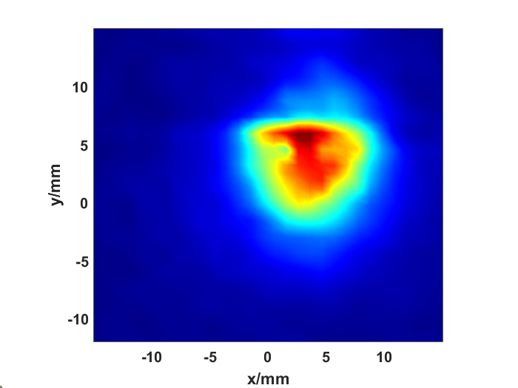

**Hi Professor,**

This week, I have one piece of good news and one piece of bad news. The good news is that we were able to run the formic acid laser and find the best position where it reaches maximum output power. The bad news is that the CO2 power supply is out of order; the inductance in the power supply burned out, and it emitted a strong odor again.

Basic results

After realigning the laser path, the formic acid laser could reach approximately 40 mW. The beam intensity was measured along the length of the cavity. The distance from peak to peak is about half of the wavelength (432 µm) (as shown in figure 1). The beam profile, with a lens in front of the formic acid windows, looks like the one in Figure 2. It is not yet a perfect Gaussian beam, so we still need to improve the beam quality. However, things are not going well, as the power supply encountered trouble again.





Solution methods:

To fix the problem, we swapped the old CO2 laser with a new CO2 laser, combined with a new power supply, and we are doing the the laser optics realignement. After that, we could continue optimize the laser profile and measure the basic parameters. The detailed testing log has been uploaded to UCDbox:https://app.box.com/s/jalawhqed1nu62nvllzvz42pfxcfq5do