Hi Professor

This week I have improved the receiver optical control program of high-k scattering system ,now it looks like this :

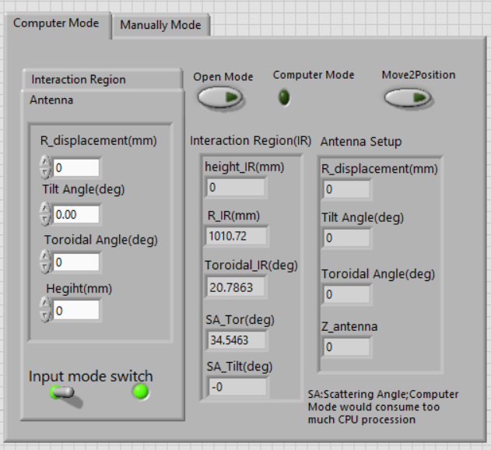

Based on the last week’s work ,I add the input switch for setup .we can input the Antenna position or the Intercation Region position ,and than the program will automatically calculate the corresponding position .If we feel good about the position on the right side of the panel ,we can click the Move2Position button and than the four axis receiver optical motor will run to the designated destination.

I also check the program in the lab with motor ,It works well .I believe the function of this control program is enough for using in high-k scattering experiment .

Next week ,I will work on the control system of launch beam optical ,and beside this ,I also get ready to analysis the mode conversion under sheared magnetic field ,which is import for analyzing the polarization of the launch beam in plasma in NXTX-U tokamak

GPT

Hi Professor,

This week, I have improved the receiver optical control program of the high-k scattering system. Now, it looks like this:



Based on last week’s work, I added an input switch for setup. We can input the Antenna position or the Interaction Region position, and then the program will automatically calculate the corresponding position. If we feel good about the position on the right side of the panel, we can click the Move2Position button, and then the four-axis receiver optical motor will run to the designated destination.

I also checked the program in the lab with the motor; it works well. I believe the function of this control program is sufficient for use in the high-k scattering experiment.

Next week, I will work on the control system of the launch beam optical. Additionally, I am ready to analyze the mode conversion under a sheared magnetic field, which is important for analyzing the polarization of the launch beam in plasma in the NXTX-U tokamak.