The LabVIEW program of high-k scattering system on NSTX-U

Xinhang Xu,8/17/2024

The program contains the monitor module and control module. The control module is used for Launch, Receiver optical setup and formic acid laser adjustment while the monitor system is used for monitor the power supply, laser output, temperature and humidity of vicinal environment, flow velocity and temperature of cooling liquid, and the acid formic gas pressure in the laser tube.

**The Control Module**

1.1 FIR monitor and control

In the Control Module like figure 1, we have the laser power adjustment and Receiver optical and Launch optical control panel.

Figure 1High-k Scattering System Control panel

The laser power adjustment is driven by Thorlabs motor, the stepper motor controls the cavity length via a belt driven micrometer with 0.5um resolution as figure 2, where the cavity length is determined by the position of the coupler. We need to adjust the coupler position from remote control to achieve the maximum output of laser power. The motor can be controlled by the FIRLaserAdjustment as shown in figure 3. During control of the motor, the FIR laser power monitor could simultaneously show the laser power and help us to find where the best position of coupler position is. The move range in our control is from 0mm to 12 mm.

Figure 2 FIR laser output coupler.

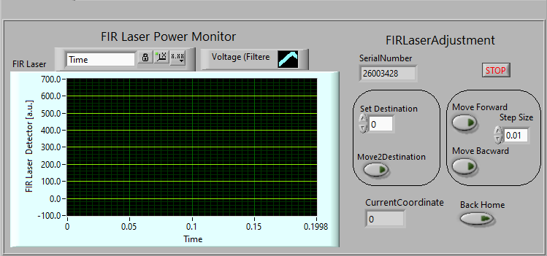

Figure 3 FIR Power monitor and motor adjustment

1.2 Receiver and Launch optical control

1.2.1 Receiver optical control

The Receiver and Launch optical control panel is shown in Figure 3. For Receiver optical, we have four

Axis to control, there are Z axis, Radial axis ,tilt axis and toroidal axis as shown in figure 4.

Figure 4 Receiver Optical arrangement

The four-axis adjustment will determine the focus position of our receiver optical, the relationship between the focus position and the four optical positions has already been discussed in the ppt (link).

The control panel includes computer mode, manual mode and status check. In the computer mode, we can select antenna input and set receiver antenna position and calculate the focus position, which also called as Interaction Region(IR) .Also we could select IR input ,set the IR and then calculate the corresponding antenna .if all the position is in our arrangement and we satisfied with the results, we can press the button “AutomoveAntenna “,than all the motor will move to the designated position immediately .same as “AutomoveLaunch”, where the launch angle is determined by the IR. (I need illustrate how to install the launch mirror, since the availably angle is only (-6 6) deg. If it does not propel installed, it won’t be able to adjust to correct position)

In the manual mode ,we can choose the different stepper motor independently and adjust the position .we could set the destination and than move to the destination or just jog around the destination to find the best position.

In the Status Check mode, we can observe each position of the corresponding stepper motor and check if the position is same with the calculated results according to the computation mode.

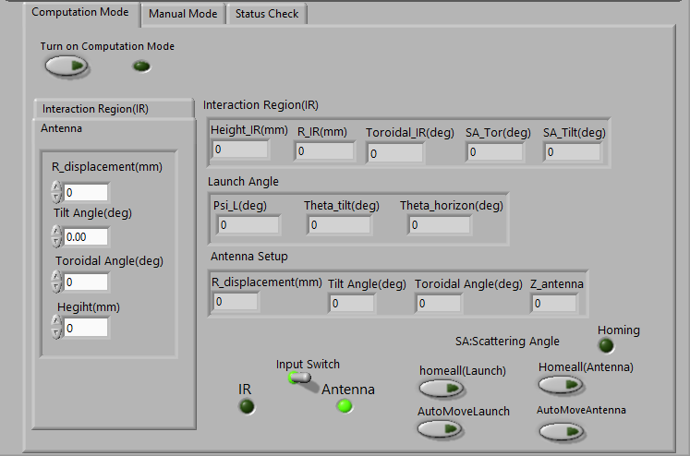

Figure 5 Computation Mode panel

Figure 6 The Sketch of Receive optical(a) and Launch optical(b)

Table 1 Output parameters in Computation mode

|  |  |  |
| --- | --- | --- |
| Parameters in Pannel | Note in sketch | explanation |
| Interaction Region (IR) | | |
| Height_IR(mm) | none | The relative height of IR above the midplane of NSTX-U |
| R_IR(mm) |  | Major radius of interaction region |
| Toroidal_IR (mm) |  | Toroidal angle of interaction region (refer to plane of vacuum window) |
| SA_Tor(deg) |  | Toroidal angle between receiver beam and Radius vector |
| SA_Tilt(deg) | none | The tilt angle between the receiver direction and the midplane |
| Launch Angle | | |
| Psi_L(deg) | ψL | Toroidal angle between launch beam and Radius vector |
| Theta_tilt | none | Tilt angle between launch beam and midplane |
| Theta_horizon |  | Horizontal angle between radius vector and launch beam in the midplane |
| Input Switch/Antenna | | |
| R_displacement(mm) | Figure4:R motor | R antenna Motor adjustment |
| Tilt Angle(deg) | Figure4:tilt motor | Tilt antenna Motor adjustment |
| Toroidal Angle(deg) | Figure4: Toroidal motor | Toroidal antenna motor adjustment |
| Height(mm) | Figure4:Z motor | Z antenna motor adjustment |
| Input Switch/IR | | |
| Height_IR(mm) | none | The relative height of IR above the midplane of NSTX-U |
| R_IR(mm) |  | Major radius of interaction region |
| Toroidal_IR (mm) |  | Toroidal angle of interaction region (refer to plane of vacuum window) |
| SA_Tor(deg) |  | Toroidal angle between receiver beam and Radius vector |
| SA_Tilt(deg) | none | The tilt angle between the receiver direction and the midplane |

1.2.2 Receiver optical control

Monitor Module

2.1 CO2 Power Supply and Laser Monitor

When the CO2 laser is operating normally, the voltage on the power supply display should be 16keV, and the current should be 40 mA. We have 2 monitor channels corresponding to 2 power supply, as shown in figure 7(b),only current monitor is used in the LabVIEW program, as shown in figure 8.CO2 power monitor need to be done for a while.

2.2 Cooling Water &Formic acid gas monitor

Figure* shows the Cooling water’s the temperature and flow monitor ,the Model Number is 0V7008STA32 .the input DC voltage is 24V and the relationship between flow velocity and voltage output is

The relationship between temperature (OC)and voltage is

2.3 Atmospheric Environment

The atmospheric environment is monitor by sensor connected to the computer ,to check the Vicinal temperature and humility of the system, as shown in figure *