1. My state income higher than federal income ,and I don’t know the reason

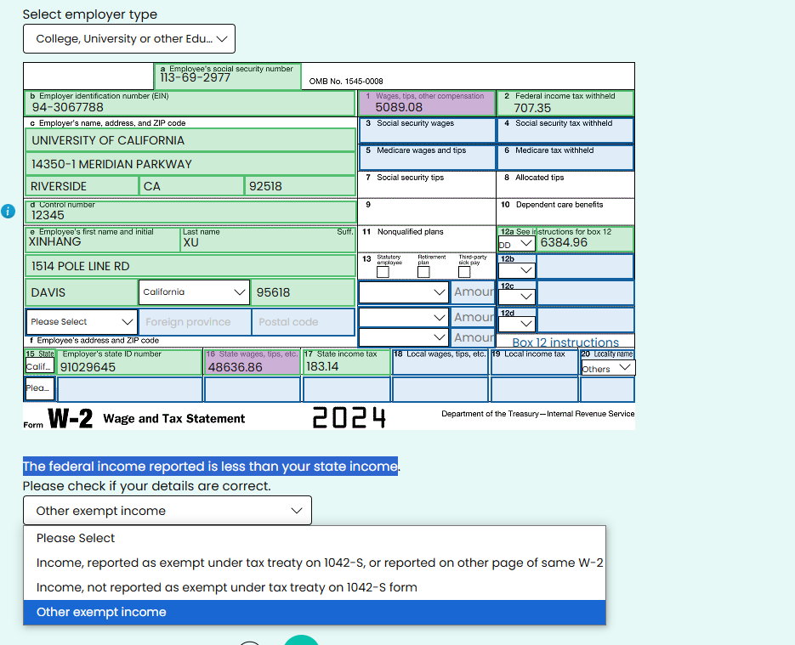

2.I have ask ucpath for the reason and I am now waiting the reply. the deadline of tax report is April 15th.

3.There is no state tax report in 1040 -NR form. but maybe I can have some refund from state tax report.

The key question is list 2

4.wait answer from list 2 ,the total refund is

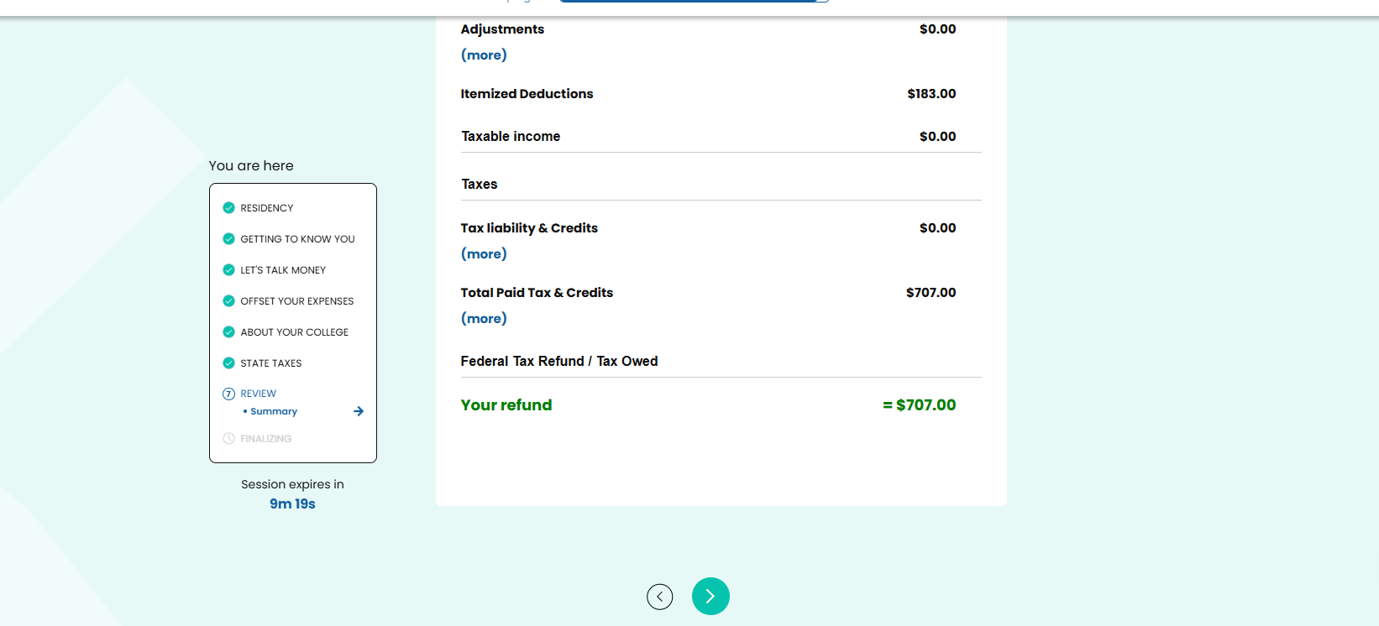

5. ask sha sha about 1040-nr fill in instruction.