**SF EEL YEAR 2 ECO/BIO SURVEYING PROTOCOLS**

The sampling layout described here provides a framework for systematically collecting a variety of physical data using uniform sampling. The standard sampling layout for Year 2 protocols consists of a stream length 15x bankfull width (measured along the thalweg) divided into 8 equidistant transects that are arranged perpendicular to the stream channel (Fig. 1).

|  |  |  |  |
| --- | --- | --- | --- |
| **Survey Task** | **Parameter(s)** | **Comments** | **Equipment** |
| **Reach delineation** | Record GPS coordinates of upstream and downstream ends; Record reach length | Determine average bankfull width and multiply by 15 to determine reach length. Divide reach length by 7 to determine distance between 8 transects | GPS, handheld laser rangefinder (HLR), calculator |
| Notable field conditions | Dominant local land use, human influence |  |
| **Cross-sectional transects** |  |  |  |
| Bankfull width and depth, lateral slope breaks | Based on field-identified stage of transition from channel to floodplain and floodplain/terrace levels | HLR, stadia rod |
| Sediment composition | 8 sample substrate count across transect | gravelometer |
| **Longitudinal measurements** | Channel bed slope | Height between every other transect and at major slope breaks or if no line of sight | surveyor's level w/ tripod, stadia rod, HLR |

|  |
| --- |
| **Field Equipment Checklist** |
| * Data collection sheets and pencils |
| * GPS unit |
| * Surveyor's level w/ tripod |
| * Stadia rod (1-2) |
| * Measuring tape (50m, SI units) (1-2) * Handheld laser rangefinder (HLR) |
| * Gravelometer (1-2) * Chaining pins or stakes and hammer |
| * Marking tape/flags * Field camera |

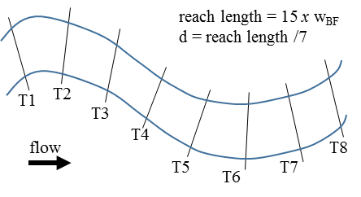

Figure 1. Sampling reach layout consists of 8 evenly spaces transects numbered from up to downstream

|  |
| --- |
| **Personal Equipment Checklist** |
| * Water and food * Proper clothing and footwear |
| * Sunscreen and hat |
| * Backpack |

**Key Definitions Bankfull margin:** Dominant elevation of local slope break providing flow access to overbank areas, change from annual to perennial vegetation, or change in size distribution of sediments

**Active margin:** The limit of coarse bedload sediment (including sand size and greater)

**Cross-sectional slope breaks:** Major slope changes occurring laterally between the bankfull margins and the toe of the confining margin

**Steps for each field site:**

**[#] indicates where to record on Data Collection Sheet**

1. Record date, field site BIN_FID, stream/river name, names of field crew members, GPS coordinates [top of datasheet], and any other pertinent information (e.g. site access notes, potential hazards) **[14]**
2. Navigate to provided coordinates using GPS. Draw a conceptualization of the site **[15]** making note of floodplain and terrace surfaces to aid in delineation of bankfull dimensions and depositional surface levels. Label floodplain and terrace features by their relative surface level at or above bankfull (i.e. S1, S2, S3, etc.). Surface levels may exist on both left and right sides of the channel (e.g. S1 and S2 in Fig. 2b), or may exist only on one side of the channel (e.g. S3 and S4 in Fig. 2b). For large sites, a conceptualization can be conducted prior to arrival using aerial imagery, however, time should be taken to confirm the conceptual layout as best as possible before surveying begins. A detailed example of floodplain, terrace, and valley side conceptualization can be found in Figure 2a. A simpler version, capturing the most important lateral breaks and most applicable to this protocol can be found in Figure 2b.



**Figure 2.** a) **A detailed conceptual drawing of a stream reach prior to surveying (from Harrelson et al. 1994). b) For this surveying protocol, focus should be place on floodplain, terrace, and valley side delineation. Note the relative heights of terraces (a) which would then be related to a level relative to the channel margin (b).**

1. Examine at least 30m of channel length and estimate bankfull width at various locations **[1a]**. If no bankfull indicators exist, look for signs of active margins and use this width in place of bankfull width. Indicate whether bankfull or active width was used at the site by circling Bankfull or Active **[1a]**. For the remainder of the sampling protocols, the term *bankfull margin* refers to either the bankfull or the active margin depending on which is selected here. Determine average bankfull width **[1b]** by calculating the mean of bankfull width estimates. Multiply average bankfull width by 15 to calculate total reach length **[1c]** and divide total reach length by 7 to calculate transect spacing **[1d]**.
2. Record GPS coordinates of the upstream (T1) and downstream (T8) transects (indicate transect in notes: “T1”) at the inside of lowest left floodplain/terrace surface (*1Li*) as surveying.
3. Record dominant land use (e.g. agricultural, forest) **[2a]**, estimated proportional areas of land cover in the bankfull river corridor along the reach **[2b]**, and major human influences (e.g. logging, mining) **[2c]** in the immediate surrounding area.

**Longitudinal survey:**

1. Due to logistical issues, surveying may begin at the upstream or downstream end of the site. Therefore, the location of the first survey point should always be T1 or T8 **[12]**. The starting transect location should always be placed at a riffle-crest in streams with repeating geomorphological forms. Set up surveyor’s level with line of sight to current transect. Remember to backsight level position *every* time level is moved, and record *both* surveyor’s level readings of *single* stadia rod position**.** Locations to be included in the longitudinal surveys include: the starting riffle crest (i.e. T1 or T8), transects T3, 5, 7, the nearest riffle crest to the ending transect, and all riffle crests and all pool troughs (location of maximum pool depth) between the starting and ending riffle crest. An example of longitudinal transect locations is shown in Figure 3. Record the following information at each survey location **[12]**:

* Transect (T), riffle crest (RC), or pool (P) number. Riffle crests and pools should be numbered sequentially starting after the first surveyed transect (i.e. Transect 1 or 8 is not Riffle Crest 1). The ending riffle crest should be numbered as the maximum riffle crest number.
* Distance from previous survey point.
* Surveyor’s level reading
* Water depth (m)
* Backsight reading (if needed)



**Figure 3. Locations for longitudinal slope measurement and sample identification.**

**Steps for each transect:**

(8 transects in total, labeled T1-T8 from upstream to downstream, as shown in Figure 1)

1. At each transect, scout along the banks to identify the location of the bankfull margins on either side and indicate habitat type **[3]**. This can be pool (*P*), riffle (*Rf*), run (*Ru*), cascade (*Cs*), split channel (*SI* or *SII* \*\**see split channel protocols*), riffle crest (*RC*), or other (*O*). If Other, indicate in notes (**[14]**) including associated transect number. Look for sediment, topographic, vegetative, or geologic cues (changes in bank slope, size distribution of surface sediments, etc.) to identify bankfull elevation.
2. At thalweg, record distance from thalweg to left **[4]** and right **[5]** bankfull margins. Bankfull margins may be within larger channel margins (e.g. cut bank or incised channel) (1Li and 1Ri, Fig. 4). Record bankfull depth **[6]** (distance from bed to bankfull margin elevation) using stadia rod. Also, record the level of confidence associated with bankfull margin delineation at the transect (1 – high, 2 – mid, 3 – low confidence) **[7]**. If split channel is visible, see Split Channel Protocols below. Finally, record the depth to which lateral slope breaks will be assessed at a given transect, *dlat*, **[8]**. This value can be calculated by adding the bankfull depth at the current transect, *i*, (T*i***[6]**) to bankfull depth at the starting riffle-crest transect (the value will be equal to T1**[6]** or T8**[6]** depending on upstream or downstream starting location).



Figure 4. Measurement locations along transect, including thalweg, bankfull margins, channel margins, and slope breaks within valley constraints. Relative floodplain/terrace levels are represented by index above channel (i.e. 1, 2, 3, etc.). These indices are independent on left (L) and right (R) sides of the channel. Key survey points on each level are the inside (i) and outside (o) margins.

1. **Pebble Count** (8 equidistant particles per transect) **[9]**:
   1. Divide the bankfull width by 7 to get the approximately distance between the 8 points
   2. Lower a single finger to the channel bed without looking to objectively select the particle located at the tip of finger
   3. Remove the particle from the streambed (if possible), then measure and record the particle class size (i.e. the smallest hole in the gravelometer that the particle CAN fit through)
2. Determine whether the channel exists within an alluvial setting. If the channel does not exist within an alluvial setting (e.g. confined colluvial material or bedrock), skip to Step 6. If the channel does exist within an alluvial setting and lateral slope breaks (LSBs) exist adjacent to the bankfull margins, complete the subsequent protocol at every other transect (T1, 3, 5, 7) until *any* of the following are true. The field crew:

* will be in danger of injury.
* has measured all LSBs to the valley margin (i.e. a slope break defined by a non-alluvial surface). If the valley margin is encountered, the last recorded measurement will be for the outside edge of the highest alluvial surface.
* has measured all LSBs to the inside edge of the surface immediately above a vertical distance of *dlat* **[8]**.
* has measured all LSBs to the inside of the 4th alluvial surface (4Li or 4Ri) (i.e. the datasheet is full).
* determines, at site specific discretion, that measurement to the inside edge of the surface immediately above *dlat* would require time and effort detrimental to the remaining site survey (i.e. the surface is extremely wide and much greater than 5x bankfull width). If this is the case, please estimate offsets.

If bankfull margins are not the same as 1Li and/or 1Ri, record horizontal and vertical offsets from left bankfull margin to 1Li **[10]** and/or right bankfull margin to 1Ri **[11]** (likely easier to record from opposite side of channel or in channel). Also record the associated confidence for each offset measurement, defined by the following numerical scale:

1. Direct laser measurement
2. Laser measurement informed (i.e. able to measure part of the surface distance with the laser and the remainder estimated)
3. Field crew estimate as laser measurements were not possible

Navigate to the middle of the floodplain or terrace surface between inner (i) and outer (o) level margins (i.e. toe of first slope break) (Fig. 4). Measure and record horizontal and vertical offsets from the inner margin (either 1Lior 1Ri) to the outer level margin (either 1Lo or 1Ro) using the HLR (**[10]** or **[11]**). Next, measure and record horizontal and vertical offsets from the bottom (1Lo or 1Ro) to the top (2Li or 2Ri) of the first slope break margin using the HLR. If a second floodplain/terrace level exists, record horizontal and vertical offsets from interior floodplain/terrace margin (2Li or 2Ri) to the outer level margin (2Lo or 2Ro) and from the outer level margin (2Lo or 2Ro) to the inner margin of the next geomorphic level (3Li or 3Ri). Repeat relative procedure if third geomorphic level exists.

1. Take photos of reach looking downstream from T1, looking up and downstream from T5, and looking upstream from T8 while sampling at each transect. Record photo file numbers **[13]**
2. Navigate to next transect along the thalweg with HLR or measuring tape.

**Steps for each riffle crest and location of maximum pool depth:**

1. At each riffle crest **[16]** and pool trough **[17]**, record bankfull depth at the thalweg and lateral distances from the thalweg to left and right bankfull margins.

Reference:

Harrelson, Cheryl C; Rawlins, C. L.; Potyondy, John P. 1994. Stream channel reference sites: an illustrated guide to field technique. Gen. Tech. Rep. RM-245. Fort Collins, CO: U.S. Department of Agriculture, Forest Service, Rocky Mountain Forest and Range Experiment Station. 61 p.

**\*\*Split Channel Protocols:**

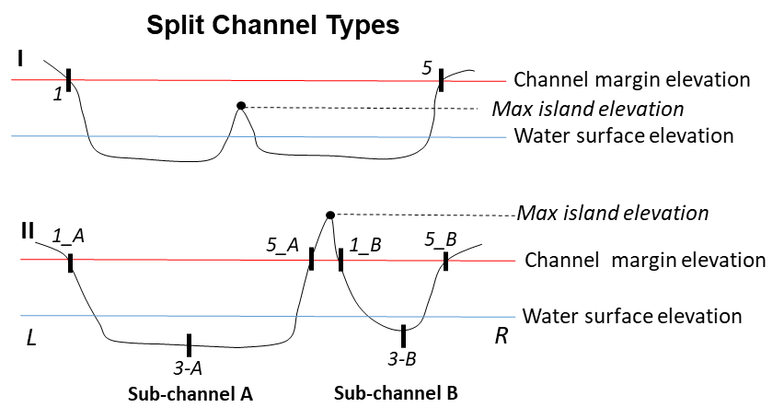

Figure 5. Two possible split channel types I and II with different sampling protocols

If bankfull elevation > mid-channel island/braid max elevation (**Type I**),

Measure bankfull width across the dominant channel and take measurements at the same three locations from river L to R as done in a single channel setting, except omitting thalweg location (see Fig. 5); measure sediment across the dominant channel from station 1 to 5.

Indicate “*SI*” as habitat type, referring to Type I Split Channel.

If bankfull elevation < mid-channel island/braid max elevation (**Type II**),

Measure each sub-channel separately using a slash to differentiate channel A from channel B to capture the bankfull width and depth of both channels in the transect; measure sediment across the entire bankfull width from station 1_A to 5_B (Fig. 5).

Indicate “*SII*” as habitat type, referring to Type II Split Channel.

