UNDERSTANDING MENTAL HEALTH: AWARENESS, CHALLENGES, AND AI-ASSISTED EARLY SUPPORT SYSTEMS
Aditya Narayan  Information Technology  Gl Bajaj Institute of Technology and Management  Greater Noida, 201306 | Utkarsh Kumar Singh  Information Technology  Gl Bajaj Institute of Technology and Management  Greater Noida, 201306 | Vinayak Srivastava  Information Technology  Gl Bajaj Institute of Technology and Management  Greater Noida, 201306 | Vipul Upadhyay  Information Technology  Gl Bajaj Institute of Technology and Management  Greater Noida, 201306

ABSTRACT

Mental health has quietly moved beyond clinical settings. It shows up in college dorms, office break rooms, and family dinners — often unnamed, often unaddressed. Millions of young adults across the country are dealing with stress, anxiety, and depression without really knowing what it is they’re experiencing, let alone where to get help. This study looks at how aware youth aged 18–35 actually are about mental health, what kind of psychological struggles they face, and whether AI-based tools could realistically offer some early support. A structured survey of 180 participants was used alongside secondary literature. The findings, though not entirely surprising, are still sobering: stigma, cost, and simple unawareness remain the biggest barriers to care. At the same time, a good number of respondents said they’d be open to digital tools — often the same people who wouldn’t consider going to a therapist. The paper tries to make sense of what all this means going forward.

keywords: Mental Health, Psychological Distress, AI Chatbot, Depression, Anxiety, Stigma, Awareness, Youth

Introduction:
How we think about mental health today looks almost nothing like how it looked a few generations ago. For most of history, psychological suffering was treated as a moral failing, a spiritual problem, or simply evidence of weak character. The idea that a person’s mental state could be studied, diagnosed, or treated like a physical illness wasn’t really taken seriously until the late 1800s. Wilhelm Wundt’s psychology laboratory in 1879 was an early turning point, and Freud’s work on psychoanalysis helped move mental illness further into the realm of medicine — still imperfectly, but meaningfully.
The 20th century moved fast on this front. Antipsychotic medications appeared in the 1950s, giving clinicians something concrete to offer patients with severe conditions who had previously had no pharmaceutical options at all. The DSM was published in 1952 and gave practitioners a shared language for diagnosis, which mattered more than it might sound. Then, by the 1970s and 80s, Cognitive Behavioral Therapy had been tested enough to show real results across depression, anxiety, and a range of other conditions. The evidence base was building, even if public understanding lagged behind.
Despite all that progress, the gap between people who need help and people who actually get it has stayed frustratingly large. The WHO (2022) puts the global figure at over 970 million people living with a mental disorder, and estimates that less than half of them receive any treatment. In lower-income countries the picture is even worse. India’s National Mental Health Survey from 2017 found that around 150 million people needed active intervention — but fewer than 30 million were getting any kind of support. That’s a staggering gap, and it hasn’t closed as quickly as one might hope.
What’s different now is the possibility that technology might close some of that gap. AI chatbots, mood-tracking apps, and sentiment-based tools are increasingly being positioned as low-barrier options for people who can’t afford therapy or simply won’t seek it out. They’re not replacements for clinical care — that needs to be said clearly — but for people in the mild-to-moderate range who are currently getting nothing, they could make a real difference. This study looks at both the scale of the problem and whether these tools hold any genuine promise.
Review of Literature:
Academic work on mental health has grown substantially over the past couple of decades, drawing from public health, clinical psychology, and more recently — and interestingly — human-computer interaction. The range of disciplines now contributing to this conversation reflects how complex the problem actually is.
Murray and Lopez’s (1996) Global Burden of Disease study was something of a wake-up call. Using large-scale data, they showed that depression ranked among the leading causes of disability globally — something that hadn’t really been established at that scale before. That finding forced mental health into global public health conversations in a way that prior advocacy alone hadn’t managed. Later editions of the same research kept reinforcing the same point.
For India specifically, Gururaj et al. (2016) conducted one of the most thorough national mental health surveys the country has seen. What stood out wasn’t just the overall numbers, but the regional disparities — rural populations, women, and lower-income groups showed higher levels of distress but were much less likely to receive any support. The inequality isn’t incidental; it’s built into how the healthcare system is structured.
Corrigan (2004) did important work on stigma that’s still widely cited. He drew a distinction between public stigma — the stereotypes and discrimination that come from outside — and self-stigma, where a person turns those judgments inward and begins to believe they’re less deserving of help. In practice, what this means is that people put up with a lot of psychological pain rather than risk being labeled. They wait. Often too long.
On the technology side, Linardon et al. (2020) pulled together a meta-analysis of smartphone-based interventions and found moderate support for their effectiveness with depression and anxiety. The catch, as with most digital health tools, was that engagement tended to drop off quickly. People would download an app, use it for a bit, and move on. Abd-Alrazaq et al. (2020) looked specifically at chatbots and found users generally reported feeling better, though many of the underlying studies were small and didn’t follow participants for long.
COVID-19 changed things in ways researchers are still working through. Rajkumar (2020) documented sharp increases in anxiety, depression, and post-traumatic stress across multiple countries during the early pandemic period. What also happened, almost by necessity, was a rapid uptake of digital mental health tools — people had fewer options and turned to what was available. That created a lot of real-world usage data that the field is still making sense of.
Taken together, the literature traces a fairly consistent arc: mental illness is widespread, structural and social barriers keep most people from getting help, and digital tools offer a partial — not complete — response to that problem. The gap between knowing something is wrong and actually doing something about it remains the hardest part to close.
Objectives of the Study:
- To assess how aware young adults (18–35) actually are about mental health, and where the gaps or misconceptions tend to cluster.
- To look at what kinds of psychological stressors come up most frequently and how they affect everyday life for this age group.
- To understand how open people are to trying AI-based mental health tools — particularly those who haven’t sought professional help.
- To identify the main barriers — social, cultural, and structural — that stop people from seeking care in the first place.

Research Methodology:
A mixed-methods approach was used here — quantitative survey data alongside qualitative responses and secondary literature. Mental health is one of those areas where numbers alone don’t capture the full picture, so both components felt necessary.
1. Research Design: The design is both descriptive and exploratory. The descriptive part maps what awareness and distress actually look like among the people surveyed. The exploratory part asks what role, realistically, AI tools might play — drawing on the survey data and on published work about tools already in use.
2. Data Collection: A structured questionnaire went out to 180 participants across university campuses and urban residential areas in Delhi NCR. Three sources informed the study: the primary survey responses, secondary data from WHO, NIMHANS, and published journals, and some informal input from two practicing counselors who helped shape the questionnaire. The counselor input was useful for grounding the questions in what actually comes up in clinical work.
3. Tools and Techniques: Adapted versions of the PHQ-9 and GAD-7 were used for screening depressive and anxiety symptoms respectively. A basic lexicon-based sentiment tool was run on 50 anonymized open-ended responses to get a sense of the emotional tone across them. Quantitative items were analyzed using descriptive statistics — frequencies, percentages, means — and open-ended responses were coded thematically.
4. Implementation Steps: Before the main survey went out, it was piloted with 15 participants and revised based on what came back. The full survey ran over three weeks and yielded 180 usable responses. PHQ-9 and GAD-7 scores were categorized by severity, sentiment analysis was run on the qualitative data as a proof-of-concept, and the findings were then compared against national and international reference datasets.
5. Evaluation Metrics: Outcomes were tracked across four areas: how well participants could identify mental health conditions (awareness score); how many exceeded clinical thresholds on the PHQ-9 or GAD-7 (distress prevalence); whether and why they had sought help before (help-seeking behavior); and how open they were to digital tools, rated on a 5-point scale.
6. Analysis: MATLAB and Excel handled the statistical computation and visualizations. Thematic coding was applied to the qualitative responses. Observed patterns were then benchmarked against what the existing literature would lead one to expect.

Data Analysis and Findings:
The survey produced responses across a fairly wide range on most of the key indicators. The main findings are laid out below.

Table 1: Mental Health Awareness and Distress Screening (n = 180)
Mental Health Indicator | Respondents (%) | Moderate–Severe (%)
Clearly aware of depression | 62.2% | —
PHQ-9: Mild symptoms (5–9) | 33.9% | —
PHQ-9: Moderate (10–14) | 21.1% | —
PHQ-9: Mod-Severe (15–19) | 10.6% | —
GAD-7: Anxiety ≥ 10 | 40.0% | 40.0%
Chronic stress (self-reported) | 71.7% | 41.0%
Sleep disturbances | 57.2% | 28.9%

Table 2: Barriers to Seeking Mental Health Support (n = 180)
Barrier Cited by Respondents | % Who Cited It
Fear of stigma / social judgment | 67.2%
Cost of professional therapy | 60.0%
Unaware of where to seek help | 52.2%
Family would not understand | 48.3%
Problem 'not serious enough' | 43.9%
Prior bad counseling experience | 17.2%
Open to AI-based support tool | 62.8%

Interpretation:
The first table is telling in its own way. Around 62% of respondents said they had a clear understanding of depression — which sounds decent until you remember this is an educated, urban sample, where you’d expect that number to be higher. Awareness of other conditions like PTSD or bipolar disorder was noticeably lower. But what’s arguably more concerning is the clinical screening data. Over a third scored in the mild-to-moderate depression range, and 40% showed moderate-to-severe anxiety. These aren’t small numbers for a group of reasonably young, otherwise functional adults.
Chronic stress at 71.7% was the figure that stood out most. There’s something worth noting here: sustained stress tends to normalize itself. People adapt to feeling overwhelmed and stop registering it as a problem. That makes it easier to miss the point at which stress tips into something clinically significant. The sleep disturbance data (57.2%) connects to this — poor sleep and chronic stress feed into each other, and together they compound over time in ways that aren’t always obvious from the inside.
Table 2 mostly confirms what mental health researchers have been saying for a long time. Stigma leads the list of barriers, followed by cost and not knowing where to turn. None of that is new. What’s more interesting is the last row: 62.8% said they’d be willing to try an AI-based tool. That’s a meaningful number. The same people who won’t walk into a counselor’s office will often engage with a digital tool precisely because it’s private, available at any hour, and carries no social cost.
The ‘not serious enough’ response (43.9%) also deserves some attention. It’s a pattern that shows up repeatedly in the mental health literature: people downplay what they’re going through, wait, and by the time they seek help, things have gotten more difficult than they needed to be. Part of it is an awareness gap — not having the vocabulary to recognize clinical distress when it’s happening to you. Part of it is cultural — a tendency to frame struggling as something to push through rather than address.

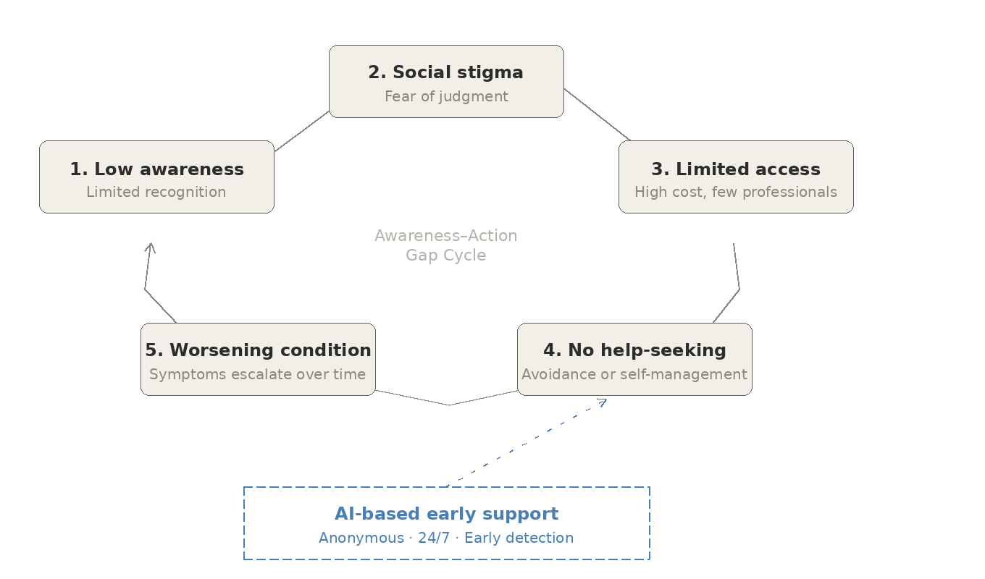
Mental Health Awareness–Action Gap Cycle

Figure 1: Mental Health Awareness–Action Gap Cycle
The cycle illustrates how lack of awareness, stigma, and limited access create a barrier to help-seeking. AI-based tools can act as an early intervention point to break this cycle.

Conclusion
What this study ends up confirming is familiar but still worth stating clearly: mental health among young adults is under-addressed, even as public conversation around it has grown. The people surveyed showed high rates of stress, anxiety, and depressive symptoms — yet most hadn’t looked for formal support. Stigma, cost, and the feeling that their problems weren’t serious enough kept them from doing so. That last point, in particular, comes up again and again.
The more hopeful finding is the openness to digital tools. Nearly 63% said they’d be willing to try one. That’s not a small number. These tools aren’t therapy and shouldn’t be marketed as such — but for the many people in the mild-to-moderate distress range who are currently getting no support at all, they represent a real entry point.
Getting this right will require movement on several fronts at once — awareness campaigns that actually reach non-urban populations, more investment in training professionals, institutional policies that treat mental health as genuinely important, and careful integration of technology that extends reach without sacrificing quality. None of that is quick or easy. But the cost of not doing it is real, and the tendency to treat mental health as somehow less important than physical health is a choice that carries consequences.
Future Scope
The current research opens up several directions for follow-up work:
- Multilingual AI Tools: Almost all existing mental health apps work in English. Building tools in Hindi, Bengali, Tamil, and other regional languages — with content that’s actually adapted to those cultural contexts, not just translated — could dramatically expand who can access them in a country as linguistically diverse as India.
- Longitudinal Studies: The current research captures a snapshot. Following the same participants over a year or two would give a much clearer picture of how distress develops over time without intervention, and whether digital tools actually produce changes that last.
- Rural and Semi-Urban Populations: This study was limited to urban settings. The pressures, cultural norms, and available resources in rural communities are quite different, and that context deserves its own dedicated research rather than being assumed to mirror urban findings.
- Emotion and Voice Analysis: Future tools could go further and incorporate voice-based sentiment analysis to pick up on distress signals that users don’t explicitly report. That said, the ethical questions around consent and data privacy in that space are serious and would need to be worked through carefully before anything gets deployed.
- Workplace Mental Health Integration: Burnout is increasingly being treated as a clinical condition, which opens up interesting territory for AI-based check-in tools designed for professional environments. The challenge is building something genuinely supportive rather than something that feels intrusive or performative.
- Outcome Evaluation of Existing Apps: Tools like Woebot and Wysa now have real user bases. Independent, longer-term evaluations of their effectiveness — especially for moderate rather than just mild distress — would go a long way toward establishing what digital mental health tools can actually deliver, and what they can’t.

References:
1. World Health Organization. (2022). World Mental Health Report: Transforming Mental Health for All. WHO Press, Geneva.
2. Gururaj, G., Varghese, M., Benegal, V., Rao, G. N., Pathak, K., Singh, L. K., & NMHS Collaborators Group. (2016). National Mental Health Survey of India, 2015–16. NIMHANS Publication No. 128.
3. Murray, C. J. L., & Lopez, A. D. (1996). The Global Burden of Disease. Harvard University Press.
4. Corrigan, P. W. (2004). How stigma interferes with mental health care. American Psychologist, 59(7), 614–625.
5. Linardon, J., Cuijpers, P., Carlbring, P., Messer, M., & Fuller-Tyszkiewicz, M. (2020). The efficacy of app-supported smartphone interventions for mental health problems: A meta-analysis. World Psychiatry, 18(3), 325–336.
6. Rajkumar, R. P. (2020). COVID-19 and mental health: A review of existing literature. Asian Journal of Psychiatry, 52, 102066.
7. Abd-Alrazaq, A. A., Alajlani, M., Ali, N., Denecke, K., Bewick, B. M., & Househ, M. (2020). Perceptions and opinions of patients about mental health chatbots: Scoping review. Journal of Medical Internet Research, 22(3), e17828.
8. Kroenke, K., Spitzer, R. L., & Williams, J. B. (2001). The PHQ-9: Validity of a brief depression severity measure. Journal of General Internal Medicine, 16(9), 606–613.

