Title: | Development of an Optical Monitoring Framework for Real-time Reactor Power Estimation via Cherenkov Radiation
Technical Topic Area: | Topic Area 2 – Existing Plant Optimization
PI: | William S. Charlton (University of Texas)
Collaborators: | Jeongwon Seo (University of Texas)
 | Ryan Hunter Steward (Idaho National Lab)
 | Meharban Sobti (Antares)
 | Julijan Peric (JSI)

Project Summary and Mission Relevance

Reliable reactor power monitoring is essential for operational safety, yet conventional instrumentation remains tethered to legacy neutron and gamma detectors. These systems are not only expensive and prone to radiation-induced degradation but also provide only localized, point-wise measurements that are susceptible to spatial bias. Under challenging conditions such as flux tilting or asymmetric control rod configurations, the limited representativeness of these detectors can obscure the true global state of the core, complicating real-time decision-making and increasing safety margin uncertainty.

To address these challenges, this project proposes a transformative monitoring paradigm based on Cherenkov radiation [1]. By utilizing commercial-grade imaging devices to capture emissions directly from the reactor core, this approach treats the moderator as a massive radiator. This enables the reconstruction of full-core spatial flux distributions and provides a power estimation closely coupled with actual energy deposition, including gamma-induced heating, rather than being restricted to localized neutron counts.

Built upon successful experimental foundations at the UT TRIGA Mk-II reactor [2], preliminary demonstrations confirm that camera-based signals correlate robustly with reactor power while offering a dramatic cost reduction, e.g., averaging hundreds of dollars compared to tens of thousands per traditional channel. This shift to dense, low-cost optical arrays enables unprecedented redundancy and enhanced diagnostics for research reactors, the existing commercial fleet, and advanced Small Modular Reactors (SMRs).

This research directly aligns with the DOE-NE mission to modernize U.S. nuclear infrastructure by improving safety and economic competitiveness. By providing a scalable, energy-grounded solution, the project supports the development of next-generation autonomous and digital-twin-enabled control systems, ensuring the long-term sustainability of carbon-free nuclear energy.

Technical Background: The Optical Monitoring Advantage

Limitations of Conventional Instrumentation

Standard reactor power monitoring relies on fixed ex-core neutron and gamma detectors, such as ionization and fission chambers, which suffer from inherent localized measurement bias. Because these sensors sample flux only at specific coordinates, they often fail to capture global shifts in neutron population during asymmetric operations, such as "flux tilts" caused by non-uniform control rod positioning. Beyond spatial limitations, conventional detectors exhibit excessive signal noise at high-power levels above 300 kW. This instability can trigger spurious scrams even within safe limits, often forcing facilities to operate below their licensed maximum power. Furthermore, the high cost of nuclear-grade equipment and its susceptibility to radiation-induced degradation limit the degree of redundancy that can be economically maintained.

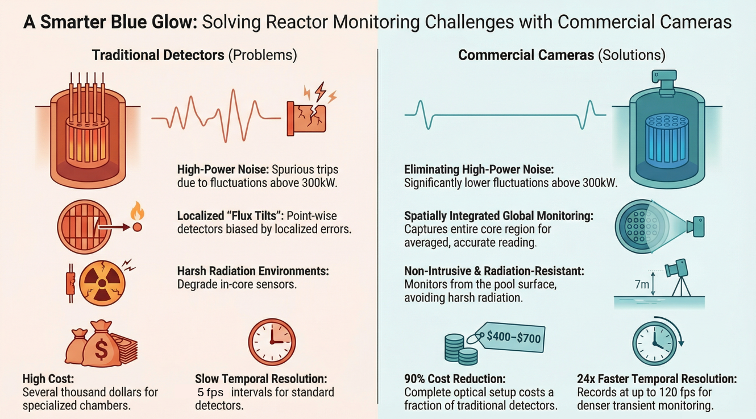

Cherenkov Intensity: A Robust Proxy for Total Energy Deposition

In contrast to traditional particle counting, this project utilizes Cherenkov radiation as a transformative monitoring signal. This characteristic blue glow, emitted by charged particles traveling faster than the phase velocity of light in the moderator, serves as a real-time indicator of energy deposition within the core. Because prompt gamma-rays provide the dominant contribution to Cherenkov intensity, the signal is closely coupled to actual thermal power and total energy deposition, offering an estimation more physically fundamental than neutron counts alone. Experimental validation at the UT TRIGA reactor confirms that optical signals from commercial cameras exhibit a superior signal-to-noise ratio in high-power regimes. Additionally, while standard channels operate at approximately 5 fps, modern imaging sensors can record at up to 120 fps, providing a 24-fold increase in temporal resolution for analyzing rapid transients.

Spatial Diagnostics and 3D Flux Reconstruction

The transition from sparse sensing to dense optical arrays enables a new level of spatially integrated monitoring. By utilizing the moderator as a massive radiator, the camera captures a holistic view of the core that is inherently resistant to localized flux distortions, ensuring a representative indication of reactor power regardless of internal asymmetries. Looking forward, this rich spatial data can be leveraged through multi-camera configurations to achieve 3D Flux Distribution Reconstruction. By identifying power peaks and reactivity anomalies invisible to point-wise detectors, this non-intrusive framework provides the essential data layer for advanced Digital Twins. This technology ensures a 90% reduction in equipment costs—averaging between $400 and $700—while enhancing the safety and economic competitiveness of both the existing fleet and advanced reactor concepts.

Technical Objectives:

Objective 1 — Establish global Cherenkov – power correlation:
Develop robust models that quantify the relationship between globally integrated Cherenkov light intensity and reactor power
- Evaluate robustness of the Cherenkov–power correlation under flux-tilt and asymmetric control rod conditions
- Characterize linear and nonlinear regimes arising from video signal and saturation effect
- Quantify noise characteristics relative to conventional detector channels

Objective 2 — Link Cherenkov intensity to total energy deposition:
Evaluate Cherenkov-based power monitoring as a global, energy-grounded observable beyond neutron-count calibration.
- Quantify the relationship between Cherenkov intensity and total energy deposition (gamma-induced electrons and radiative heating)
- Compare Cherenkov-derived power against neutron-based detector readings under flux-tilt and asymmetric conditions
- Assess whether Cherenkov signals provide a closer proxy to true thermal power, particularly at high power and during transient

Objective 3 — Reconstruct and validate flux distribution:
Extend the optical framework beyond scalar power estimation to infer spatial flux distribution.
- Utilize multi-camera configurations and image-based features
- Validate reconstructed flux shapes against simulations and available instrumentation
- Assess sensitivity to control rod asymmetry and transient conditions
Objective 4 — Cross-reactor testing and validation:
Demonstrate generality and scalability by applying the Cherenkov-based methodology to other research reactors and selected commercial reactor configurations.
- Evaluate applicability across different core geometries, pool depths, and operating conditions
- Identify reactor classes where Cherenkov-based monitoring provides the greatest value
- Establish transferability and limitations of the approach

Anticipated Benefits

If successful, this project will deliver a disruptive paradigm for reactor monitoring that addresses the economic and technical bottlenecks of current nuclear instrumentation:
- Dramatic Cost Reduction and Accessibility: By shifting from specialized nuclear detectors costing tens of thousands of dollars to commercial action cameras and mounting hardware totaling approximately $400 to $700, this technology lowers the barrier for comprehensive monitoring. This allows even small-scale research facilities to implement high-level redundancy.
- Enhanced Operational Stability and Noise Mitigation: Conventional detectors exhibit elevated noise at high power, which frequently triggers spurious scrams. Optical signals have demonstrated substantially lower noise levels above 300 kW, allowing reactors to operate closer to their licensed limits without the risk of unnecessary shutdowns.
- Robustness Against Spatial Asymmetries: Unlike point-wise detectors that are blinded by local flux tilts during asymmetric rod movements, the camera captures the spatially integrated Cherenkov intensity from the entire core region. This provides a representative indication of actual reactor power regardless of internal flux distortions.
- High-Temporal Resolution for Transient Analysis: While standard detector channels provide data at roughly 5 Hz, commercial-grade cameras can record at up to 120 fps. This 24-fold increase in temporal resolution enables the capture of rapid transients and pulse-mode behavior with unprecedented granularity.
- Non-Intrusive Integration for Digital Twins: The system is completely non-intrusive, utilizing approximately 7 meters of water shielding to protect electronics from radiation degradation. This makes it an ideal data source for Digital Twins, providing a resilient, data-rich observational layer for real-time state estimation and anomaly detection.

Work Plan

Task 1 — Experimental Benchmarking and High-Fidelity Data Acquisition
- Establish a comprehensive experimental matrix at the NETL TRIGA reactor spanning various control rod configurations (banked vs. intentionally asymmetric) and power levels up to 1.1 MW.
- Deploy the GoPro HERO13 system in Professional Mode with fixed ISO and bitrate settings to ensure stable, reproducible optical measurements.
- Utilize TACC repository synchronization to manage large-scale video and console log datasets for collaborative analysis.

Task 2 — Model Optimization and Non-Linear Calibration
- Refine the polynomial between blue-channel intensity and reactor power to account for pixel saturation effects at high operating levels.
- Conduct quantitative noise comparisons between optical signals and ex-core detectors to identify the crossover point where optical monitoring becomes the superior signal.
- Develop a data-fusion framework to separate electrical detector noise from genuine core dynamics.

Task 3 — Multi-Camera 3D Flux Reconstruction
- Extend the current single-camera framework to a distributed multi-camera configuration to infer two- and three-dimensional spatial flux distributions.
- Validate reconstructed flux shapes against high-fidelity simulations, e.g., MCNP [3], MPACT [4], and fuel temperature thermocouple readings.
- Evaluate the sensitivity of image-based features to local perturbations in advanced reactor geometries.

Task 4 — Long-Term Continuous Monitoring and Cross-Reactor Validation
- Transition from battery-limited action cameras to underwater systems with continuous power delivery and real-time video transmission.
- Execute validation tests at collaborating research facilities to establish the transferability of the Cherenkov-power correlation across different pool depths and core designs.
- Finalize best-practice guides for integrating optical monitoring into modern reactor safety and digital twin architectures.

Estimated Project Timeframe

The budget for this project will be $1M over 3 years. A preliminary timeframe to execute the tasks described above is shown as follows:

Task | Year 1 |  |  |  | Year 2 |  |  |  | Year 3
 | Q1 | Q2 | Q3 | Q4 | Q1 | Q2 | Q3 | Q4 | Q1 | Q2 | Q3 | Q4
1
2
3
4

References

[1] M. F. L’Annunziata, “Chapter 17 - cherenkov radiation,” in Radioactivity (third edition), Third Edition., M. F. L’Annunziata, Ed., Boston: Elsevier, 2023, pp. 823–864. doi: https://doi.org/10.1016/B978-0-323-90440-7.00009-0.
[2] “University of Texas at Austin TRIGA Research Reactor Safety Analysis Report: Updated Safety Analysis Report in Support of the License Renewal Application (Redacted Version),” Nuclear Engineering Teaching Laboratory, The University of Texas at Austin, License No. R-129, Docket No. 50-602, Aug. 2023.
[3] J. A. Kulesza et al., “MCNP® code version 6.3.1 theory & user manual,” Los Alamos National Laboratory, Los Alamos, NM, USA, LA-UR-24-24602, Rev. 1, May 2024.
[4] B. K. Kochunas, B. S. Collins, S. G. Stimpson, D. E. Jabaay, and others, “VERA core simulator: MPACT user’s manual,” Consortium for Advanced Simulation of Light Water Reactors (CASL), Oak Ridge, TN, CASL-U-2016-1094-000, 2016.

University of Texas (Lead, TRIGA application)
- Lead overall project direction and experimental design
- Conduct Cherenkov experiments at the UT TRIGA reactor
- Develop data processing, modeling, and validation workflows
- Demonstrate operational relevance, cost reduction, and performance benefits

William S. Charlton

Dr. William S. Charlton is the Director of the Nuclear Engineering Teaching Laboratory (NETL) and the John J. McKetta Energy Professor at the University of Texas at Austin. Since joining the faculty in 2018, he has overseen the university’s advanced nuclear research facilities, including the TRIGA Mark II research reactor. A recognized expert in nuclear science and national security, his work focuses on nuclear nonproliferation, deterrence, and security system analysis.

His distinguished career includes serving as the Research Director for the National Strategic Research Institute at the University of Nebraska and as the founding Director of the Nuclear Security Science & Policy Institute (NSSPI) at Texas A&M University. Dr. Charlton’s technical expertise spans over 20 years, during which he has led major research initiatives for the NNSA, DHS, and DoD. He has authored over 200 technical publications and received numerous awards, including the INMM Special Service Award. He holds B.S., M.S., and Ph.D. degrees in Nuclear Engineering from Texas A&M University.

Jeongwon Seo

Dr. Jeongwon Seo is Postdoctoral Fellow at the University of Texas at Austin, specializing in the study of Nuclear Reactor Digital Twins, Machine-Learning-based Reduced Order Modeling (ROM), and Verification, Validation, and Uncertainty Quantification (VVUQ). He earned his Ph.D. in Nuclear Engineering from Purdue University, where his research focused on bridging the gap between high-fidelity physics simulations and real-time operational requirements through innovative AI methodologies.

Prior to his current role, Dr. Seo developed expertise in reactor physics and data-driven modeling during his doctoral studies at Purdue University. He also holds an M.S. in Nuclear Physics (with honors) from Lomonosov Moscow State University and a B.A. in Applied Chemistry from the Korea Military Academy. His research involved the development of novel regression frameworks using Softmax-based Deep Neural Networks, specifically designed to enhance interpretability and physical consistency in nuclear applications.

Dr. Seo’s professional background is distinguished by his experience with a wide array of industry-standard nuclear codes and high-performance computing. He has successfully led the development of the TRIGA Digital Twin web application at UT Austin, establishing real-time data pipelines that leverage the TACC LoneStar6 supercomputer for large-scale synthetic data generation and GPU-accelerated training.

Idaho National Laboratory (Collaborating Institution)
- Provide access to a diverse portfolio of reactor types and facilities
- Enable testing of Cherenkov-based monitoring concepts across multiple reactor classes
- Support evaluation of scalability, generalization, and deployment feasibility
- Contribute comparative insights relevant to advanced and commercial reactor systems

Ryan Stewart

Ryan Stewart is a Nuclear Engineer at Idaho National Laboratory (INL), where his research focuses on the computational analysis of advanced reactor designs, digital twin development, and autonomous reactor operations. This work has involved determine methodologies and approaches for synthesizing operational data and physics-informed data with machine learning and statistical analyses for understanding the state of a nuclear system.

His work spans the modeling and simulation of advanced reactor systems, including sodium fast reactors, pebble-bed reactors, and heat pipe microreactors, with applications in reactor safeguards and nuclear non-proliferation. A central thrust of his current research involves developing digital twins that can accurately predict both normal and off-normal reactor operations, enabling pathways toward remote monitoring for international safeguards and autonomous control systems.

Ryan Stewart will lead the INL team and focus on transferability and generalizability of the approach for future deployment. This will include acting as a liaison between the UT-Austin team and the NRAD team to determine the feasibility in transferring the technology to NRAD for additional testing. Ryan will provide continual insights on future deployment for both current and advanced reactor systems, where we can determine what fields (such as international safeguards, research reactor optimization, etc.) this technology can be most useful.

